Supplement of

Marine nitrogen fixation as a possible source of atmospheric water-soluble organic nitrogen aerosols in the subtropical North Pacific

Tsukasa Dobashi et al.
Correspondence to: Yuzo Miyazaki (yuzom@lowtem.hokudai.ac.jp)

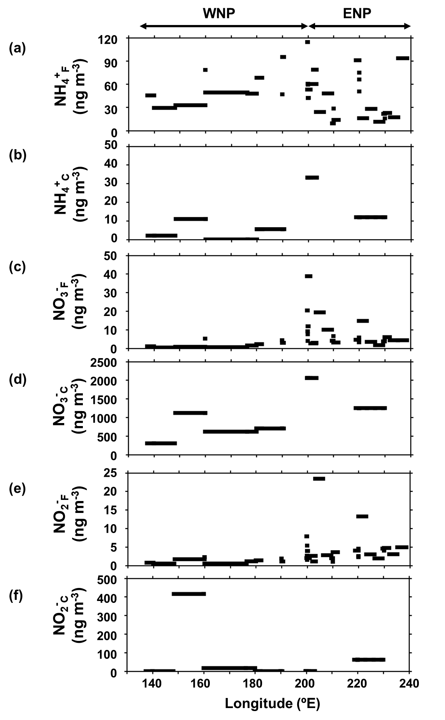

Figure S1: Longitudinal distributions of mass concentrations of (a) NH₄⁺_{F}, (b) NH₄⁺_{C}, (c) NO₃⁻_{F}, (d) NO₃⁻_{C}, (e) NO₂⁻_{F}, and (f) NO₂⁻_{C} along 23ºN.

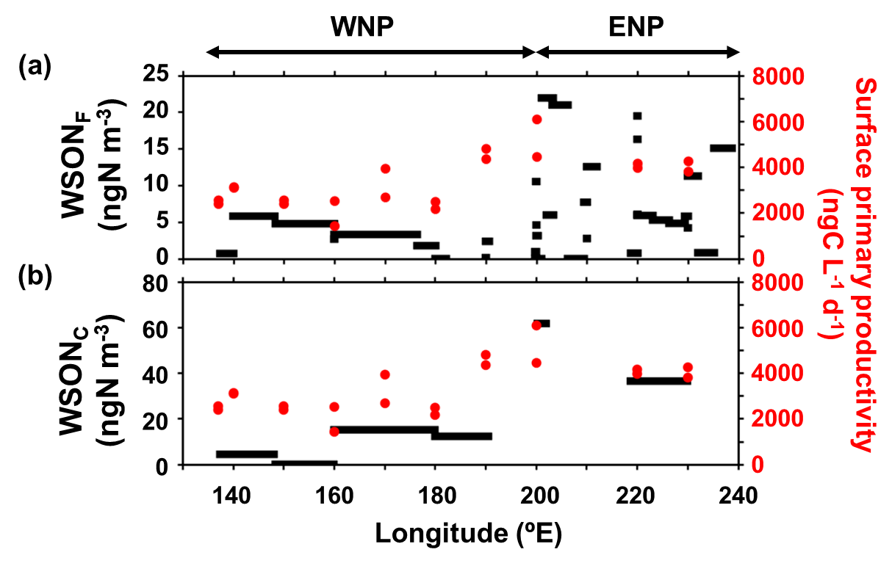

Figure S2: Longitudinal distributions of mass concentrations of (a) WSON_{F} and (b) WSON_{C}, together with primary productivity in the SSW samples during the entire cruise.

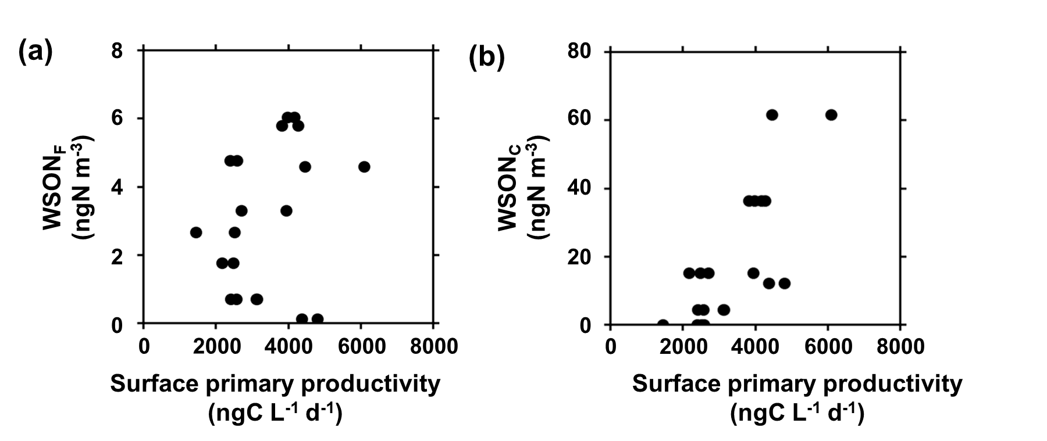

Figure S3: The mass concentrations of (a) WSON_{F} and (b) WSON_{C} as a function of primary productivity in SSW.

Table S1: The data of fine particles analysed in this study.
Sample ID | Start Date | Start Time | End Date | End Time | WSON | WSOC | δ¹³C _{WSOC} | NH₄⁺ | NO₃⁻ | NO₂⁻ | Na⁺ | MSA
Sample ID | (UTC) | (UTC) | (UTC) | (UTC) | (ngN m⁻³) | (ngC m⁻³) | (‰) | (ng m⁻³) | (ng m⁻³) | (ng m⁻³) | (ng m⁻³) | (ng m⁻³)
HV3 | 2017/8/13 | 04:29 | 2017/8/13 | 15:07 | 19.1 | 16.7 | LOD | 98.6 | 35.9 | 3.6 | 58.4 | 94.3
HV4 | 2017/8/13 | 15:18 | 2017/8/14 | 03:04 | 37.1 | LOD | LOD | 113.6 | 10.8 | 1.7 | 185.2 | 205.3
HV5 | 2017/8/14 | 03:21 | 2017/8/14 | 15:02 | 22.7 | 25.7 | LOD | 124.1 | 0.8 | 1.2 | 141.8 | 202.2
HV7 | 2017/8/15 | 03:08 | 2017/8/15 | 14:53 | 15.6 | 25.0 | LOD | 67.9 | 1.1 | 1.5 | 88.7 | 160.4
HV8 | 2017/8/15 | 15:08 | 2017/8/16 | 02:52 | 18.5 | 11.8 | LOD | 62.3 | 5.1 | 0.7 | 63.9 | 176.5
HV11 | 2017/8/16 | 15:16 | 2017/8/17 | 02:56 | 34.5 | 72.1 | -22.2 | 118.6 | 6.7 | 2.4 | 83.9 | 184.2
HV12 | 2017/8/17 | 03:39 | 2017/8/17 | 14:53 | 95.1 | 1160.3 | -23.1 | 371.9 | 6.2 | 1.7 | 151.0 | 249.9
HV14 | 2017/8/17 | 15:10 | 2017/8/18 | 02:53 | 95.0 | 1739.7 | -22.5 | 365.3 | 5.7 | 1.6 | 166.3 | 179.1
HV15 | 2017/8/18 | 03:07 | 2017/8/18 | 15:53 | 28.6 | 117.0 | LOD | 192.1 | 6.1 | 3.5 | 62.4 | 106.3
HV16 | 2017/8/18 | 16:10 | 2017/8/19 | 03:52 | 28.5 | 111.5 | LOD | 127.8 | 2.3 | 1.3 | 39.7 | 74.6
HV17 | 2017/8/19 | 04:16 | 2017/8/19 | 15:54 | 44.8 | 551.5 | -21.6 | 256.4 | 2.9 | 1.6 | 55.0 | 94.1
HV18 | 2017/8/19 | 16:04 | 2017/8/20 | 03:52 | 12.1 | 311.3 | -20.4 | 192.1 | 4.9 | 1.6 | 68.2 | 73.6
HV19 | 2017/8/20 | 04:08 | 2017/8/20 | 15:55 | 17.7 | LOD | LOD | 164.4 | 5.4 | 1.3 | 34.9 | 63.0
HV2 | 2017/8/20 | 16:10 | 2017/8/21 | 03:51 | 74.7 | 116.0 | LOD | 257.3 | 13.0 | 1.9 | 10.7 | 49.7
HV22 | 2017/8/21 | 16:04 | 2017/8/22 | 03:50 | 18.5 | LOD | LOD | 258.1 | 13.2 | 2.2 | 59.7 | 54.6
HV23 | 2017/8/22 | 04:08 | 2017/8/22 | 16:25 | 18.6 | 38.2 | LOD | 275.2 | 11.8 | 1.6 | 10.6 | 40.5
HV24 | 2017/8/22 | 16:43 | 2017/8/23 | 03:51 | 19.2 | 364.0 | -18.8 | 292.4 | 9.4 | 4.2 | 22.1 | 62.6
HV25 | 2017/8/23 | 04:11 | 2017/8/23 | 17:09 | 15.1 | 178.4 | -20.1 | 93.4 | 4.3 | 4.9 | 14.3 | 19.0
HV26 | 2017/8/23 | 17:20 | 2017/8/24 | 04:54 | 0.8 | LOD | LOD | 17.2 | 4.3 | 3.0 | LOD | 5.6
HV27 | 2017/8/24 | 05:14 | 2017/8/24 | 17:01 | 11.3 | LOD | LOD | 22.8 | 6.0 | 4.7 | LOD | 5.7
HV29 | 2017/8/24 | 17:18 | 2017/8/25 | 05:03 | 4.2 | LOD | -20.2 | 15.8 | 5.1 | 4.0 | 7.3 | 5.1
HV31 | 2017/8/25 | 06:08 | 2017/8/25 | 16:57 | 5.8 | 51.0 | -20.8 | 21.6 | 3.7 | 4.6 | 0.4 | 6.2
HV32 | 2017/8/25 | 17:10 | 2017/8/26 | 04:56 | 4.8 | 2.4 | -21.8 | 11.4 | 1.7 | 1.9 | LOD | 5.2
HV33 | 2017/8/26 | 05:15 | 2017/8/26 | 16:59 | 5.3 | LOD | LOD | 28.0 | 3.5 | 3.0 | 4.9 | 18.4
HV34 | 2017/8/26 | 17:18 | 2017/8/27 | 05:34 | 5.9 | LOD | LOD | 16.0 | 14.7 | 13.2 | 9.4 | 10.3
HV35 | 2017/8/27 | 05:55 | 2017/8/27 | 16:53 | 16.3 | 186.9 | -25.5 | 50.5 | 4.4 | 4.5 | 20.9 | 11.9
HV36 | 2017/8/27 | 17:05 | 2017/8/28 | 04:57 | 19.5 | 151.3 | -21.6 | 66.0 | 5.8 | 2.2 | 26.4 | 14.3
HV37 | 2017/8/28 | 05:13 | 2017/8/28 | 17:19 | 6.0 | 99.5 | -22.3 | 74.8 | 3.2 | 2.5 | 13.3 | 12.3
HV38 | 2017/8/28 | 17:33 | 2017/8/29 | 04:58 | 0.7 | 142.3 | -21.7 | 90.8 | 4.6 | 4.0 | 4.2 | 26.2
HV41 | 2017/8/30 | 06:18 | 2017/8/30 | 17:53 | 12.5 | LOD | LOD | 13.8 | 3.1 | 3.6 | 24.6 | 23.9
HV42 | 2017/8/30 | 18:03 | 2017/8/31 | 05:57 | 2.7 | LOD | LOD | 28.5 | 6.5 | 1.0 | 62.0 | 19.1
HV43 | 2017/8/31 | 06:20 | 2017/8/31 | 18:00 | 7.7 | LOD | LOD | 9.3 | 4.0 | 2.0 | 38.8 | 12.0
HV44 | 2017/8/31 | 18:11 | 2017/9/1 | 06:02 | LOD | LOD | -22.4 | 48.0 | 10.0 | 2.8 | 36.9 | 21.4
HV45 | 2017/9/1 | 06:16 | 2017/9/1 | 17:55 | 21.0 | LOD | LOD | 24.0 | 19.3 | 23.4 | 31.8 | 55.5
HV47 | 2017/9/2 | 05:42 | 2017/9/2 | 18:41 | 3.1 | LOD | -24.2 | 42.2 | 11.8 | 3.9 | 22.3 | 13.0
HV48 | 2017/9/2 | 18:52 | 2017/9/3 | 05:48 | LOD | LOD | -23.2 | 59.4 | 7.5 | 5.4 | 38.6 | 71.0
HV49 | 2017/9/3 | 06:04 | 2017/9/3 | 17:52 | 4.6 | 0.9 | LOD | 42.1 | 4.0 | 1.5 | 12.1 | 14.1
HV5 | 2017/9/3 | 18:04 | 2017/9/4 | 06:03 | 10.5 | LOD | LOD | 60.5 | 9.1 | 2.6 | 7.2 | 25.1
HV51 | 2017/9/4 | 06:18 | 2017/9/4 | 18:32 | 0.9 | LOD | LOD | 114.3 | 20.4 | 7.9 | 24.5 | 42.0
HV52 | 2017/9/4 | 18:42 | 2017/9/5 | 07:19 | LOD | LOD | LOD | 53.0 | 38.8 | 2.0 | 17.5 | 22.9
HV53 | 2017/9/5 | 07:48 | 2017/9/5 | 17:02 | 21.9 | LOD | LOD | 60.1 | 2.6 | 2.6 | 3.7 | 13.0
HV54 | 2017/9/5 | 17:22 | 2017/9/6 | 04:00 | 6.0 | LOD | LOD | 78.6 | 2.9 | 1.1 | 7.4 | 20.7
HV57 | 2017/9/12 | 20:22 | 2017/9/13 | 20:21 | 2.4 | LOD | LOD | 95.0 | 2.9 | 1.1 | 13.7 | 15.8
HV58 | 2017/9/13 | 20:41 | 2017/9/15 | 00:29 | 0.1 | LOD | -24.2 | 46.8 | 4.3 | 1.9 | 44.4 | 11.6
HV6 | 2017/9/16 | 6:47 | 2017/9/17 | 08:05 | LOD | 9.5 | -22.6 | 68.2 | 2.2 | 1.4 | 59.2 | 12.8
HV61 | 2017/9/17 | 09:15 | 2017/9/18 | 7:39 | 1.8 | LOD | -24.2 | 47.7 | 1.5 | 1.1 | 33.6 | 16.3
HV63 | 2017/9/18 | 7:55 | 2017/9/22 | 9:57 | 3.3 | 18.3 | -22.6 | 49.2 | 0.6 | 0.5 | 30.5 | 10.4
HV64 | 2017/9/22 | 10:48 | 2017/9/24 | 7:34 | 2.7 | LOD | LOD | 78.3 | 5.2 | 2.3 | 25.9 | 31.1
HV65 | 2017/9/24 | 7:58 | 2017/9/28 | 2:08 | 4.8 | 8.8 | -23.3 | 32.8 | 0.8 | 1.7 | 13.0 | 6.6
HV66 | 2017/9/28 | 3:09 | 2017/9/29 | 21:08 | 5.8 | LOD | -26.7 | 29.3 | 0.4 | 0.5 | 8.7 | 6.5
HV67 | 2017/9/29 | 21:20 | 2017/10/2 | 15:50 | 0.7 | 10.9 | LOD | 45.4 | 1.1 | 0.8 | 13.3 | 9.4
HV68 | 2017/10/2 | 16:12 | 2017/10/4 | 21:12 | 61.3 | 537.9 | -23.0 | 424.4 | 92.8 | 3.2 | 558.0 | 22.1

Table S2: The data of coarse particles.
Sample ID | Start Date  (UTC) | Start Time  (UTC) | End Date  (UTC) | End Time  (UTC) | WSON  (ngNm⁻³) | NH₄⁺  (ng m⁻³) | NO₃⁻  (ng m⁻³) | NO₂⁻  (ng m⁻³) | Na⁺  (ng m⁻³) | MSA  (ng m⁻³)
HVS 9-12 | 2017/8/13 | 04:29 | 2017/8/17 | 02:56 | LOD | 58.8 | 4987.3 | 341.2 | 53950.1 | 1073.6
HVS 13-16 | 2017/8/17 | 03:39 | 2017/8/21 | 03:51 | LOD | 27.5 | 5938.1 | 58.1 | 16308.0 | 236.4
HVS 21-24 | 2017/8/25 | 06:08 | 2017/8/29 | 04:58 | 36.4 | 11.9 | 1249.4 | 61.6 | 5380.0 | 32.2
HVS 33-36 | 2017/9/12 | 20:22 | 2017/9/17 | 08:05 | 12.2 | 5.5 | 701.5 | LOD | 8372.2 | 25.9
HVS 37-40 | 2017/9/17 | 09:15 | 2017/9/22 | 9:57 | 15.1 | LOD | 616.0 | 16.5 | 6271.5 | 23.9
HVS 41-44 | 2017/9/22 | 10:48 | 20179/28 | 2:08 | LOD | 11.0 | 1118.6 | 415.3 | 7810.3 | 36.7
HVS 45-48 | 2017/9/28 | 3:09 | 2017/10/2 | 15:50 | 4.4 | 2.0 | 302.0 | LOD | 917.7 | 6.6
HVS 49-52 | 2017/10/2 | 16:12 | 2017/10/4 | 21:12 | 7.9 | 31.0 | 1040.7 | LOD | 12990.7 | LOD

Table S3: The surface seawater data.
Station No. | Sampling Date and  Time | Longitude (°E) | Latitude (°N) | N₂-fixation rate  (ngN L⁻¹ day⁻¹) | Primary Production  (ngC L⁻¹ day⁻¹)
7 | 2017/8/25 14:06 | 230.0 | 23.0 | 41.75 | 4040
8 | 2017/8/28 14:03 | 220.0 | 23.0 | 31.47 | 4068
10 | 2017/9/3 15:02 | 200.0 | 21.5 | 42.60 | 5270
11 | 2017/9/14 15:59 | 190.0 | 21.5 | 26.50 | 4580
12 | 2017/9/17 17:03 | 180.0 | 23.0 | 11.18 | 2326
13 | 2017/9/20 17:03 | 170.0 | 23.0 | 16.17 | 3314
14 | 2017/9/23 18:00 | 160.0 | 23.0 | 5.16 | 1983
15 | 2017/9/27 19:00 | 150.0 | 23.0 | 10.26 | 2485
16 | 2017/9/30 18:58 | 140.0 | 23.0 | 8.59 | 3119
17 | 2017/10/1 19:38 | 137.0 | 23.0 | 2.86 | 2493

