Supplementary Information for the manuscript

Marine Nitrogen Fixation as a Possible Source of Atmospheric Water-Soluble Organic Nitrogen Aerosols in the subtropical North Pacific

Tsukasa Dobashi^{1,2}, Yuzo Miyazaki², Eri Tachibana², Kazutaka Takahashi³, Sachiko Horii^{3,4}, Yoko Iwamoto⁵, Shu-Kuan Wong^{6,7}, and Koji Hamasaki⁶

¹Graduate School of Environmental Science, Hokkaido University, Sapporo, 060-0810, Japan
²Institute of Low Temperature Science, Hokkaido University, Sapporo, 060-0819, Japan
³Graduate School of Agricultural and Life Sciences, The University of Tokyo, Tokyo, 113-8657, Japan
⁴Now at Fisheries Resources Institute, Japan Fisheries Research and Education Agency, Nagasaki 851-2213, Japan
⁵Graduate School of Integrated Sciences for Life, Hiroshima University, Hiroshima, 739-8521, Japan
⁶Atmosphere and Ocean Research Institute, The University of Tokyo, Kashiwa, 277-8564, Japan
⁷Now at National Institute of Polar Research, Tokyo, 190-8518, Japan

Correspondence and requests for materials should be addressed to Y. M. (email: yuzom@lowtem.hokudai.ac.jp)

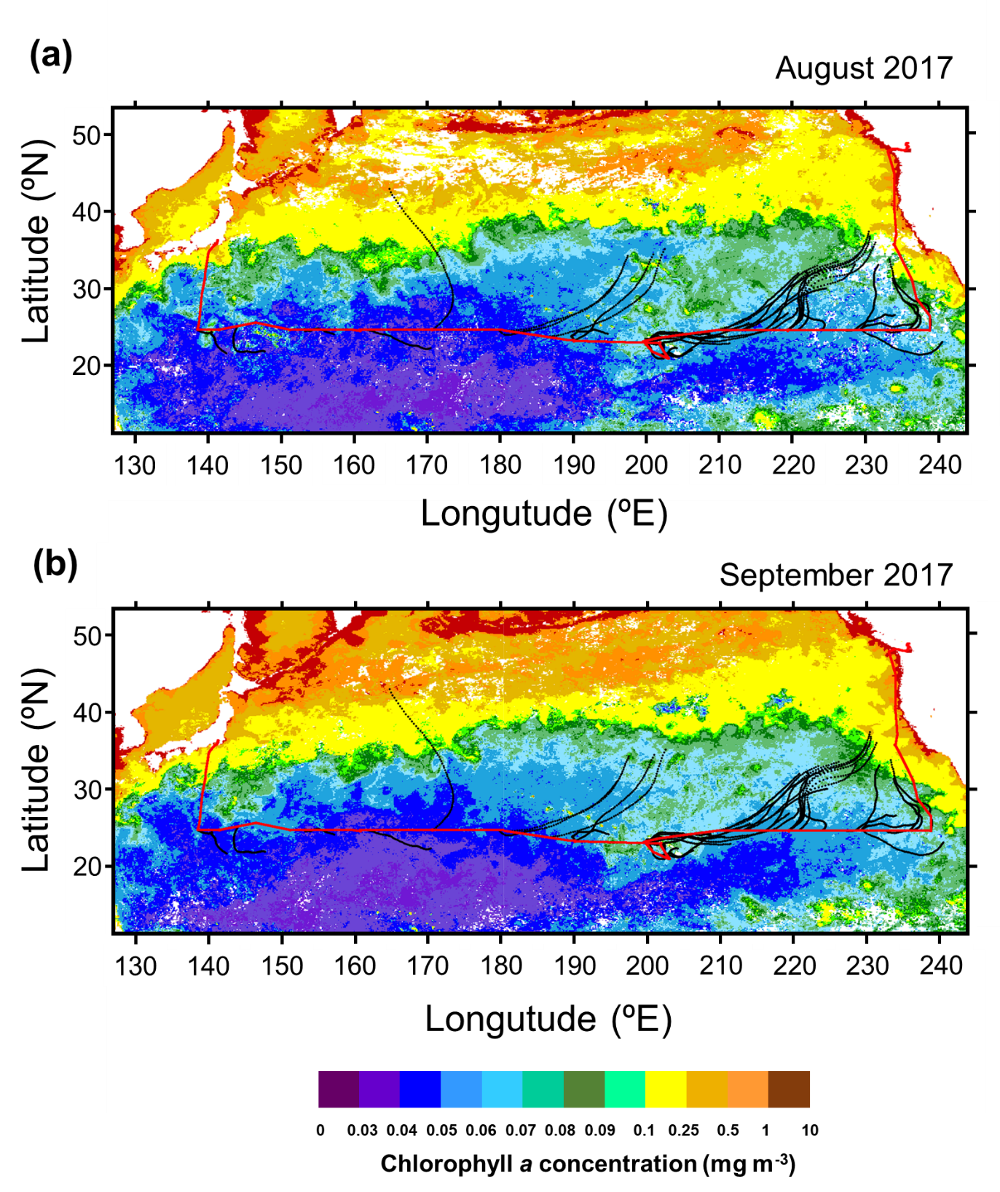

Figure S1. R/V Hakuho cruise track in the subtropical North Pacific between 12 August and 5 October 2017 (red), together with typical 3-day back trajectories (black). Also shown are monthly averaged concentrations of chl a for (a) August and (b) September 2017 derived from the MODIS-Aqua (https://neo.sci.gsfc.nasa.gov/view.php?datasetId=MY1DMM_CHLORA&year=2017). Area in which data is missing is shown in white.

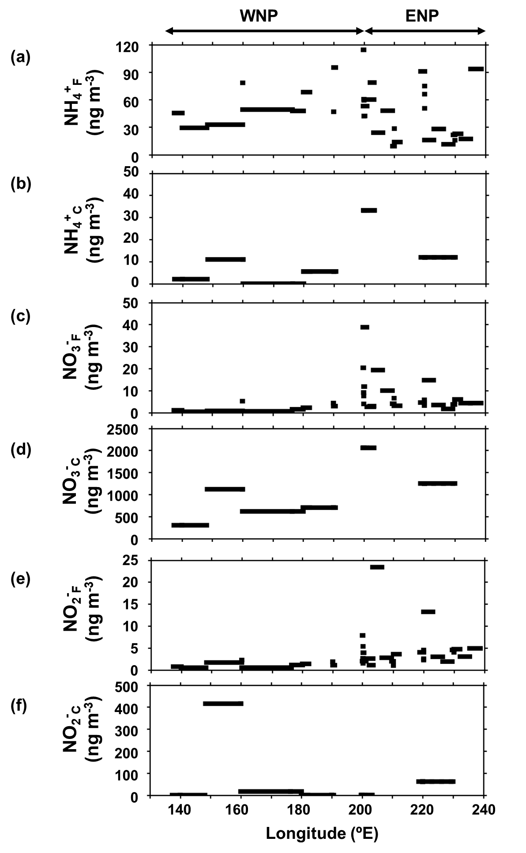

Figure S2. Longitudinal distributions of mass concentrations of (a) NH₄⁺_{F}, (b) NH₄⁺_{C}, (c) NO₃⁻_{F}, (d) NO₃⁻_{C}, (e) NO₂⁻_{F}, and (f) NO₂⁻_{C} along 23ºN.

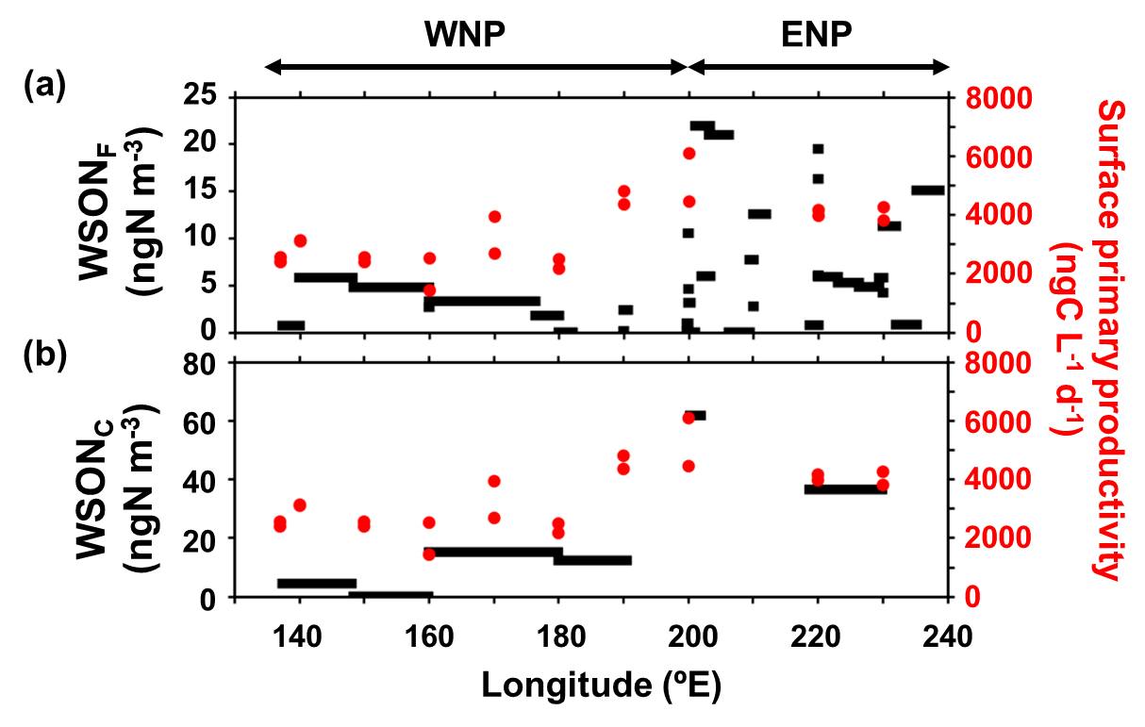

Figure S3. Longitudinal distributions of mass concentrations of (a) WSON_{F} and (b) WSON_{C}, together with primary productivity in the SSW samples during the entire cruise.

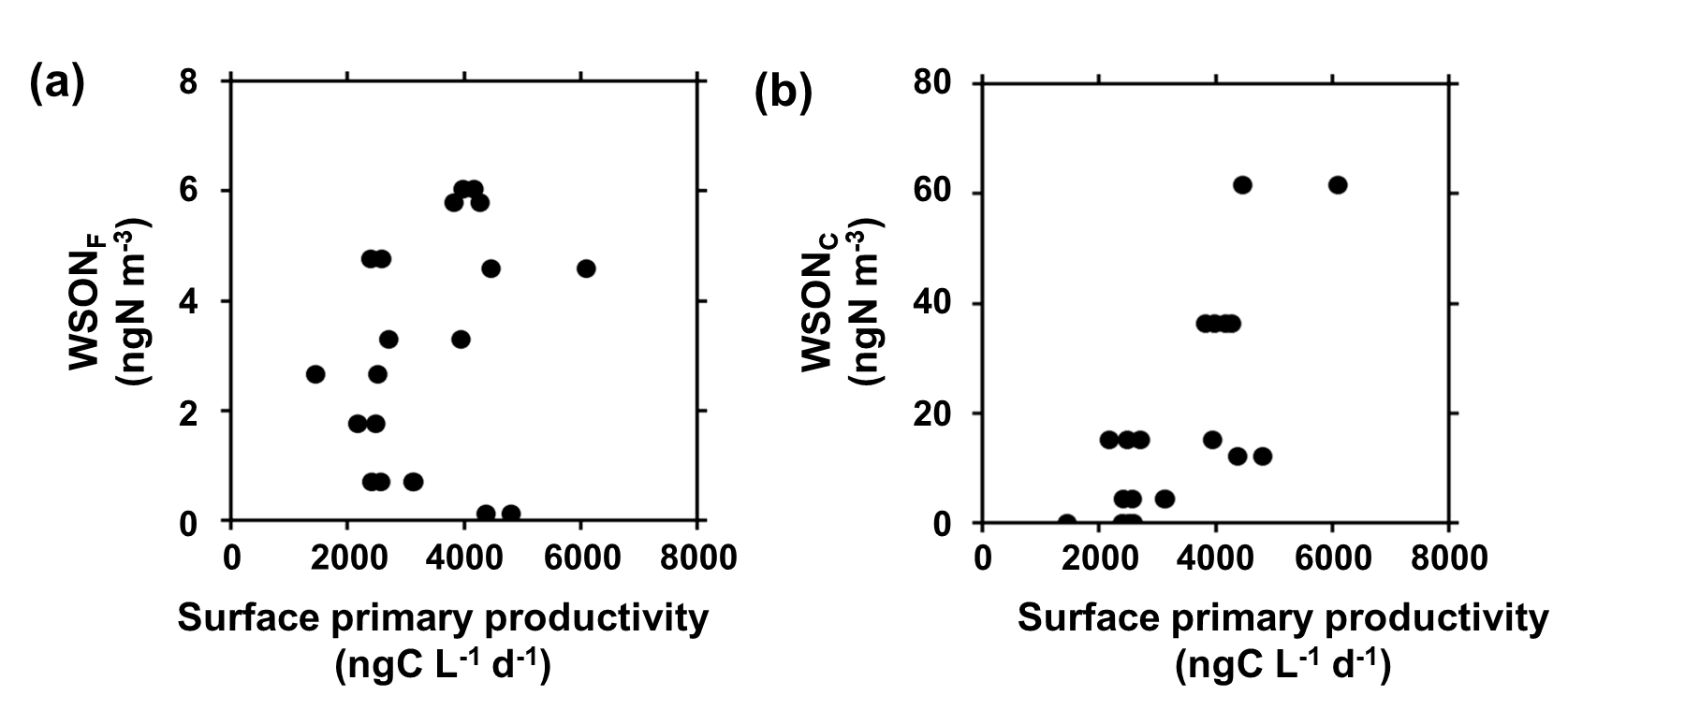

Figure S4. The mass concentrations of (a) WSON_{F} and (b) WSON_{C} as a function of primary productivity in SSW.

Table S1. The data of fine particles analysed in this study.

Table S2. The data of coarse particles.

Table S3. The surface seawater data.

