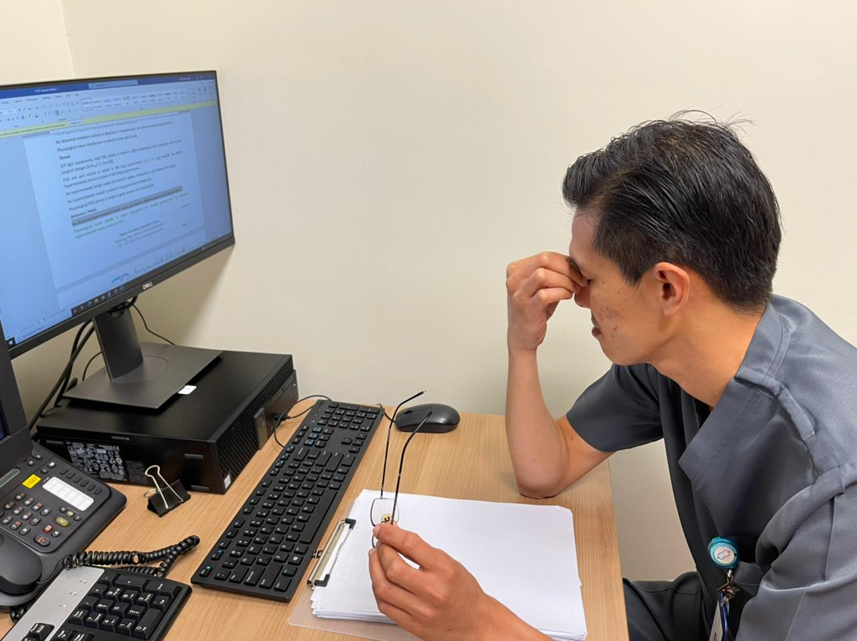

Digital Eye Strain and Risk Level
Questionnaire
(DESRIL-27)

February-2022

AUTHORS

Zubda Hamid¹, MBBS, MPH
Shahrimawati Sharbini¹, BMedSci, MPhil, PhD
Hanif Abdul Rahman¹, PhD
Fazean Irdayati Idris¹, MBBS, MSc
Lin Naing¹, MBBS, MPH, MMedStat

¹ PAPRSB Institute of Health Sciences, Universiti Brunei Darussalam, Brunei

Suggested citation: (will be available once it is published)
xxxxxxxx

INTRODUCTION
Digital eye strain (DES), also known as computer vision syndrome, consists of a range of eye and related musculoskeletal problems faced by people working with digital screens including desktops, laptops, tablets or cell phones. Symptoms develop due to prolonged use of the devices and improper working conditions.¹ Common symptoms of DES are ﻿eyestrain, tired eyes, sore eyes, dry eyes, watery eyes, irritated eyes, blurred vision, and double vision. Musculoskeletal symptoms associated with it are headache, neck pain, back pain, and shoulder pain. A review of multiple studies, reported the prevalence of DES to range between 64-90% of the population.² Globally 60 million people suffer from DES and an estimated 1 million new cases occur each year.³ DES is on a rise with increasing use of computers, and if not controlled, will have a devastating effect on human health and economy.
Keeping in view the rising prevalence of the problem with increasing use of digital screens, we have designed and validated a questionnaire DESRIL-27. This tool will help to assess the symptoms and risk factors associated with DES and related musculoskeletal disorders.
The questionnaire is available on our website. Researchers can freely download it, use it as such or adopt to their social or cultural needs. A manual is also provided which contains information about using and scoring the questionnaire. The link to our website is https://sites.google.com/view/thedesril-27project/

Note:
We may revise and improve this manual from time to time.

DESRIL-27
The DESRIL-27 questionnaire has 27 items with two (2) scales, namely symptom severity scale (16 items) and risk level scale (11 items). The instrument can be used in future studies to assess the ocular and musculoskeletal symptoms associated with the use of digital screens and to determine the associated risk factors.

RESEARCH OBJECTIVES
By using DESRIL-27, the researchers can fulfill the following objectives:
- To determine the symptom prevalence for digital eye strain and to detect the most common and least common symptoms
- To identify the subgroups in the population (by age, gender, ethnicity, education level, socio-economic status, duration of computer work, and many others) with regards to symptom severity
- To determine the prevalence of digital eye strain by setting a cut point of symptom severity scale either by statistical analysis or by literature review and expert opinion.
- To determine the association of risk factors for digital eye strain
- To evaluate the effects of health education and ergonomic and environmental modifications to improve these problems, by comparing the scores pre and post intervention.

The results of these studies can assist individuals as well as policymakers to identify the gravity of the condition and to develop strategies for controlling these problems.

SCORING STRATEGY
Scoring is done in a direction that higher score reflects higher symptom severity and higher risk level.
Symptom severity Items (S1 to S16):
Symptom Severity Scale has two components, frequency and intensity. There are four responses for frequency of symptom: never, occasionally, often and almost always, and are given scores 0, 1, 2 and 3 respectively. Intensity scale has four responses: mild, moderate, intense and very intense, and are given scores 1, 2, 3 and 4 respectively. Each item score is calculated by multiplying frequency and intensity scores, and value of each item score ranges from 0 to 12. Therefore, the Symptom Severity Scale ranges from 0 to 192 for the 16 item-scale. Higher the score, greater will be the symptom severity.
Risk level Items (RL1 to RL11):
For Risk Level Scale, there are 11 items with 4 responses. Three (3) items have the following responses: very comfortable, comfortable, slightly uncomfortable, and very uncomfortable, and are given a score of 0, 1, 2 and 3 respectively. Remaining eight (8) items have the following responses: more than adequate, adequate, slightly inadequate, and very inadequate and are given a score of 0, 1, 2 and 3 respectively. Therefore, the Risk Level Scale ranges from 0 to 33 for the 11 item-scale. Higher the score, greater will be the risk level.

REFERENCES
- American Optometric Association: Computer vision syndrome. Accessed November 27, 2021. https://www.aoa.org/healthy-eyes/eye-and-vision-conditions/computer-vision-syndrome?sso=y
- Akinbinu T, YJ Mashalla. Impact of computer technology on health : Computer Vision Syndrome ( CVS ). Med Pract Rev. 2014;5(3):20-30. doi:10.5897/MPR.2014.0121
- Cantó-Sancho N, Sánchez-Brau M, Ivorra-Soler B, Seguí-Crespo M. Computer vision syndrome prevalence according to individual and video display terminal exposure characteristics in Spanish university students. Int J Clin Pract. 2021;75(3):e13681. doi:10.1111/ijcp.13681

(End of the document)

DIGITAL EYE STRAIN AND RISK LEVEL QUESTIONNAIRE
(DESRIL-27)
Symptom severity (Items 1 to 16)
Frequency: Never, Occasionally, Often, Almost always
Intensity: Mild, Moderate, Intense, Very intense
- Burning in eyes
- Itching in eyes
- Feeling of something in eyes
- Watering of eyes
- Excessive blinking
- Eye pain
- Blurred vision
- Double vision
- Difficulty focusing
- Increased sensitivity to light
- Coloured circles of light around objects
- Feeling that eyesight is getting weak
- Headache
- Pain, stiffness (difficulty in movement), numbness (loss or decreased sensation), or tingling sensations (pins and needles) in neck
- Pain, stiffness (difficulty in movement), numbness (loss or decreased sensation), or tingling sensations (pins and needles) in shoulders
- Pain, stiffness (difficulty in movement), numbness (loss or decreased sensation), or tingling sensations (pins and needles) in back
Risk level (Items 1 to 11)
For items 1 to 3: Very comfortable, Comfortable, Slightly uncomfortable, Very uncomfortable
For items 4 to 11: More than adequate, Adequate, Slightly inadequate, Very inadequate
- How is the temperature of your workplace
- How do you feel about your work hours
- Position of your computer, table height, adjustable chair etc.
- Distance from computer screen while working
- Backward inclination of screen
- Size of the screen
- Quality of display
- Text size
- Use of glare reduction cover
- Short breaks during computer work
11. Stretching exercises during work

SCORING
Symptom Severity Scale
Frequency: Never = 0, Occasionally = 1, Often = 2, Almost always = 3
Intensity: Mild = 1, Moderate = 2, Intense = 3, Very intense = 4
Risk Level Scale
Very comfortable = 0, Comfortable = 1, Slightly uncomfortable = 2, Very uncomfortable = 3
More than adequate = 0, Adequate = 1, Slightly inadequate = 2, Very inadequate = 3

