Supplementary Information

Ferroelectric-tuned van der Waals heterojunction with band alignment evolution
Yan Chen^{1,2#}, Xudong Wang^{1#}, Le Huang³, Xiaoting Wang³, Wei Jiang¹, Zhen Wang¹, Peng Wang¹, Binmin Wu¹, Tie Lin¹, Hong Shen¹, Zhongming Wei^{3*}, Weida Hu^{1,4*}, Xiangjian Meng¹, Junhao Chu^{1,2}, Jianlu Wang^{1,4*}
¹State Key Laboratory of Infrared Physics, Shanghai Institute of Technical Physics, Chinese Academy of Sciences, 500 Yu Tian Road, 0.0Shanghai 200083, China.
²School of Physics and Electronic Science, East China Normal University, Shanghai 200241, China.
³State Key Laboratory of Superlattices and Microstructures, Institute of Semiconductors, Chinese Academy of Sciences, Beijing 100083, China
⁴Hangzhou Institute for Advanced Study, University of Chinese Academy of Sciences, Chinese Academy of Sciences, Hangzhou 310024, China
*Corresponding authors:
*Corresponding authors:
Jianlu Wang (email: jlwang@mail.sitp.ac.cn)
Weida Hu (email: wdhu@mail.sitp.ac.cn)
Zhongming Wei (email: zmwei@semi.ac.cn)

Table of contents
Supplementary Figure 1. Schematic diagram of GeSe structure.
Supplementary Figure 2. Electrical properties of MoS₂ and GeSe FeFET.
Supplementary Figure 3. Effect of P(VDF-TrFE) on the hysteresis in transfer curves of GeSe FET.
Supplementary Figure 4. Evolution of electronic properties of GeSe tuned by P(VDF-TrFE).
Supplementary Figure 5. Photoresponse characterization of GeSe FeFET.
Supplementary Figure 6. Layer-dependent electronic structures of GeSe.
Supplementary Figure 7. Effect of external electric field on the band structure of bulk GeSe calculated by DFT with GGA-PBE functional.
Supplementary Figure 8. Effect of external electric field on the band structure of bulk GeSe calculated by DFT with HSE06 functional.
Supplementary Figure 9. Carrier transport at the interface of GeSe/MoS₂ heterojunction at different polarization states.
Supplementary Figure 10. The effect of the amorphous layer on carrier transport in heterojunction.
Supplementary Figure 11. Analysis of photoresponse mechanisms at different wavelengths.
Supplementary Figure 12. Additional photoresponse performance in NIR.
Supplementary Table 1. Comparisons of polarization-sensitive photodetectors with related materials and structures.
Supplementary Note 1: Calculation on band gap evolution of GeSe under elecrical field.
Supplementary Note 2: Evolution of electronic properties of GeSe tuned by P(VDF-TrFE).
Supplementary Note 3: Analysis of band alignment of GeSe/MoS₂ Fe-VHJ.

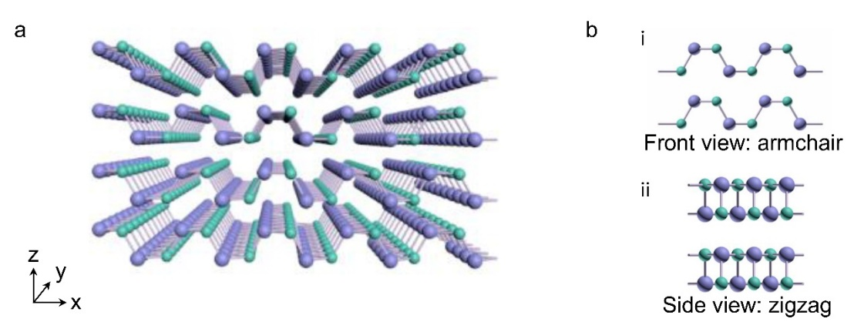
Supplementary Figure 1. Schematic diagram of GeSe structure. (a) Atomic structure of few-layer GeSe. The lattice shows an in-plane wrinkle along x-axis, resulting in anisotropic structure and properties. (b) Front view and side view of GeSe.

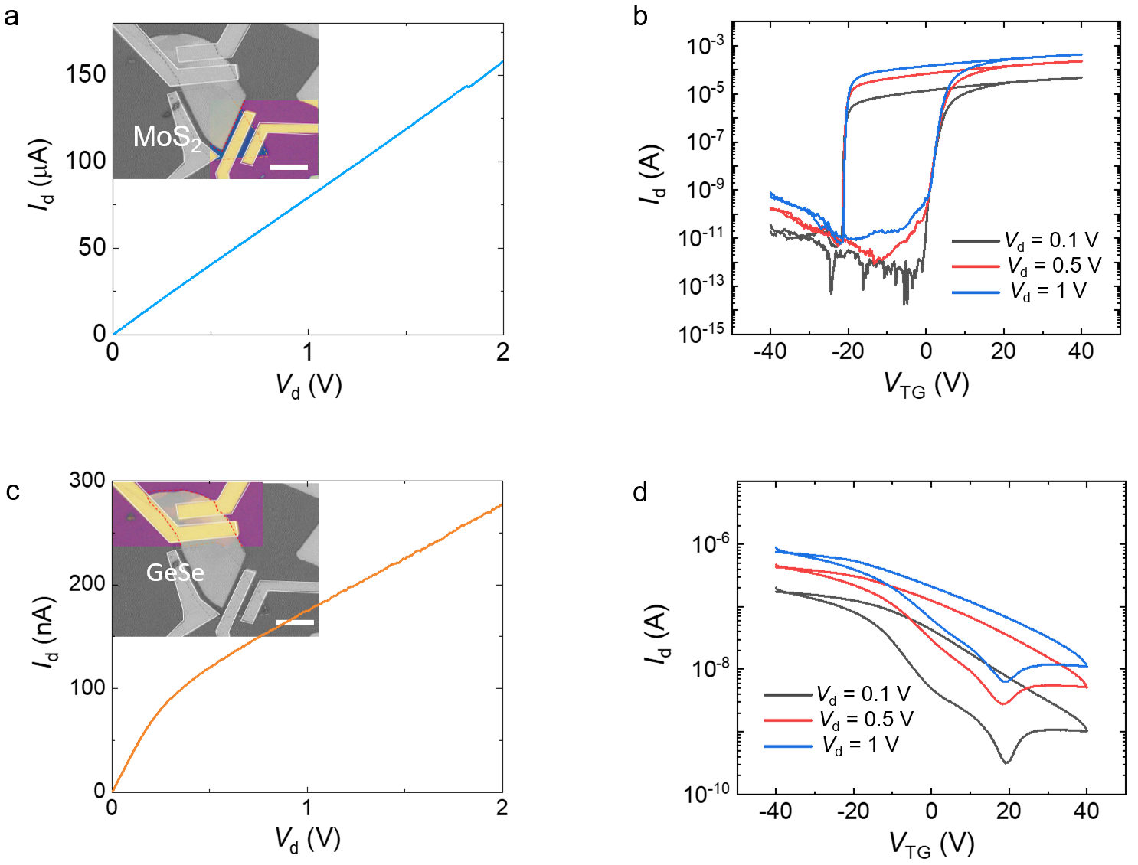
Supplementary Figure 2. Electrical properties of MoS₂ and GeSe FeFET. (a) The output characteristic curve of MoS₂ measured when P(VDF-TrFE) is not polarized. (b) The transfer characteristic curves of MoS₂ FeFET with P(VDF-TrFE) top gate. (c) The output characteristic curve of GeSe measured when P(VDF-TrFE) is not polarized. (d) The transfer characteristic curves of GeSe FeFET tuned by P(VDF-TrFE) top gate.

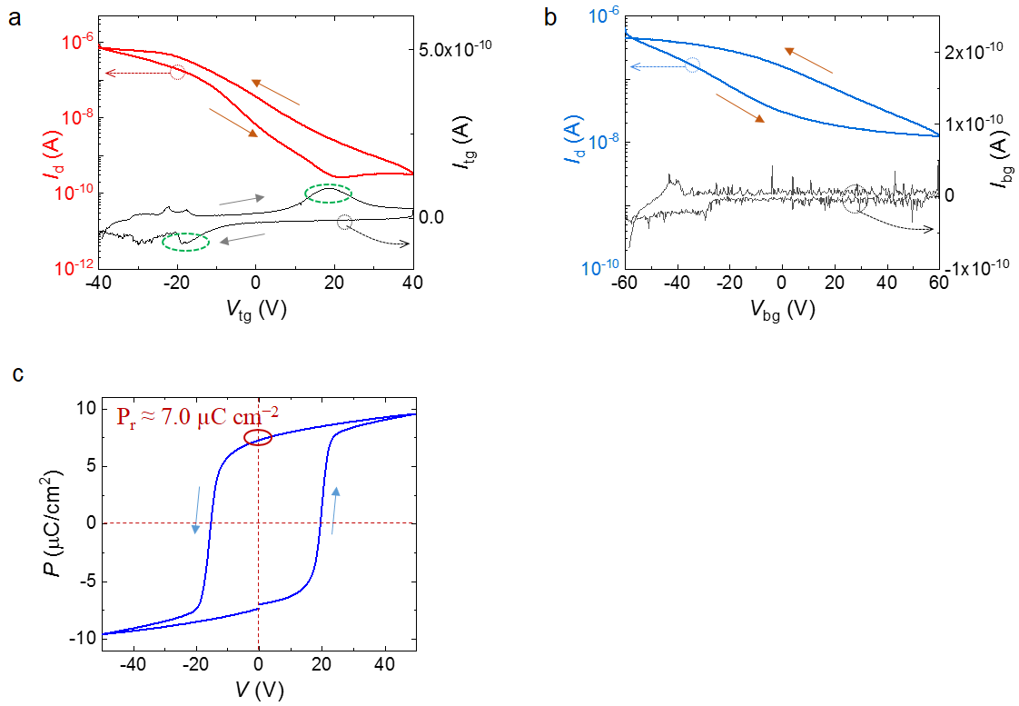
Supplementary Figure 3. Effect of P(VDF-TrFE) on the hysteresis in transfer curves of GeSe FET. Transfer characteristics of GeSe FET tuned by (a) P(VDF-TrFE) top gate and (b) SiO₂ back gate, V_{d} = 1 V. (c) Ferroelectric hysteresis loop of 200 nm-thick P(VDF-TrFE) film. The coercive voltage is approximately ±20 V.

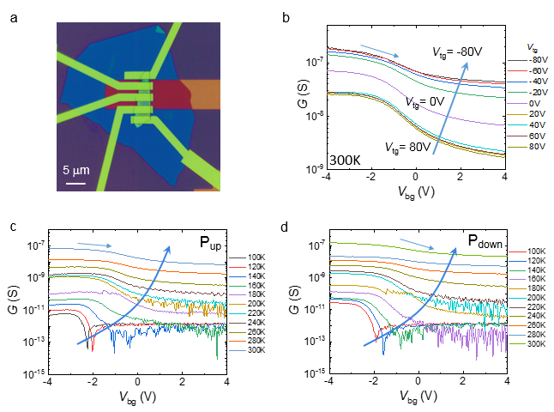
Supplementary Figure 4. Evolution of electronic properties of GeSe tuned by P(VDF-TrFE). (a) The optical image of double-gated GeSe FET with a BN back gate and P(VDF-TrFE) top gate. (b) The conductance as a function of top gate voltage. The temperature-dependency of conductance vs. back gate voltage at (c) P_{up} state and (d) P_{down} state.

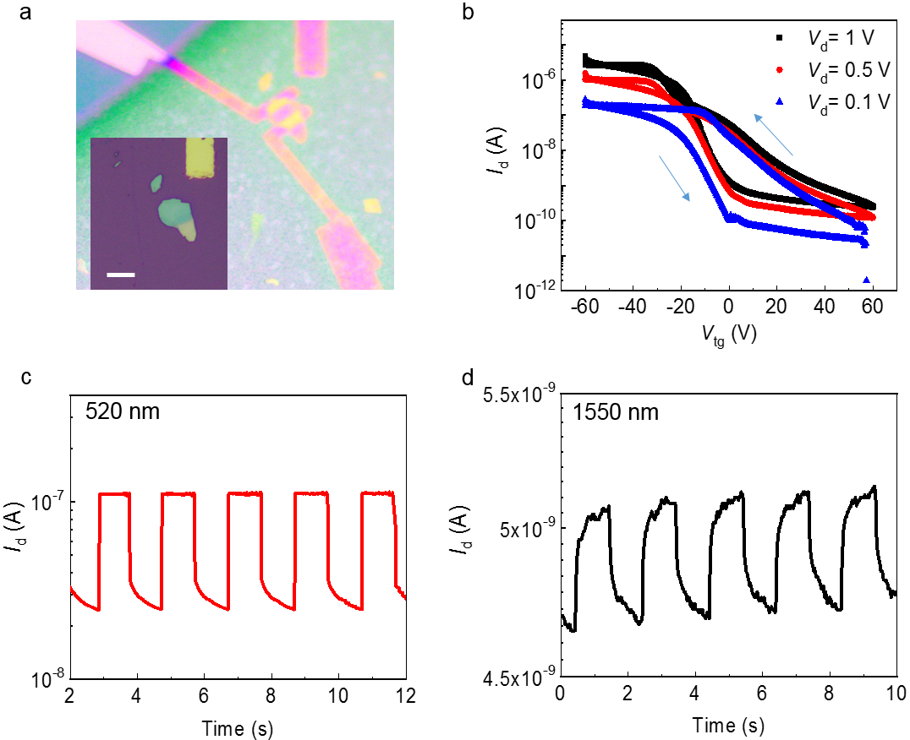
Supplementary Figure 5. Photoresponse characterization of a GeSe FeFET. (a) Optical micrograph of a completed device and the inset is the optical image of the GeSe nanoflake. Scale bar, 10 μm. (b) Transfer characteristics of GeSe FeFET at V_{d} = 0.1 V, 0.5 V and 1 V. Time-resolved photoresponse with illuminations of (c) 520 nm and (d) 1550 nm.

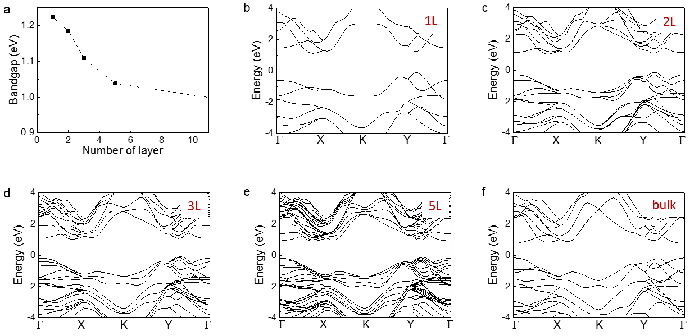
Supplementary Figure 6. Layer-dependent band structures of GeSe. (a) Band gap as a function of the number of layer. (b) - (f) Electronic band structures of GeSe with differentthicknesses calculated by DFT with PBE functional. The band gap of bulk GeSe is approximately 0.9 eV.

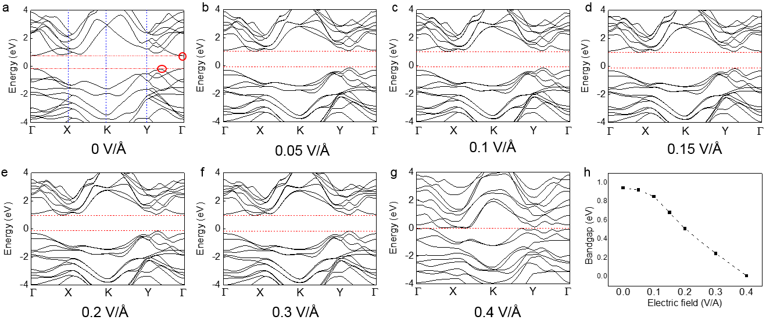
Supplementary Figure 7. Effect of external electric field on the band structure of bulk GeSe calculated by DFT with PBE functional. (a)-(g) Calculated band structures of bulk GeSe under external electric field. (h) Electronic band gap reduces linearly with respect to the external electric field. The slope is approximately 2.2 eVÅV⁻¹.

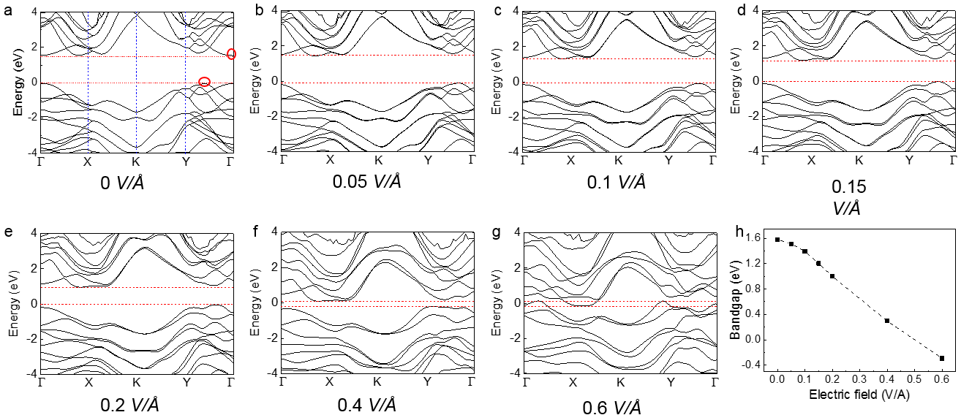
Supplementary Figure 8. Effect of external electric field on the band structure of bulk GeSe calculated by DFT with HSE06 functional. (a)-(g) Calculated band structures of bulk GeSe under external electric field. (h) Electronic band gap as a function of applied electric field. The slope is 3.3 eVÅV⁻¹ approximately.

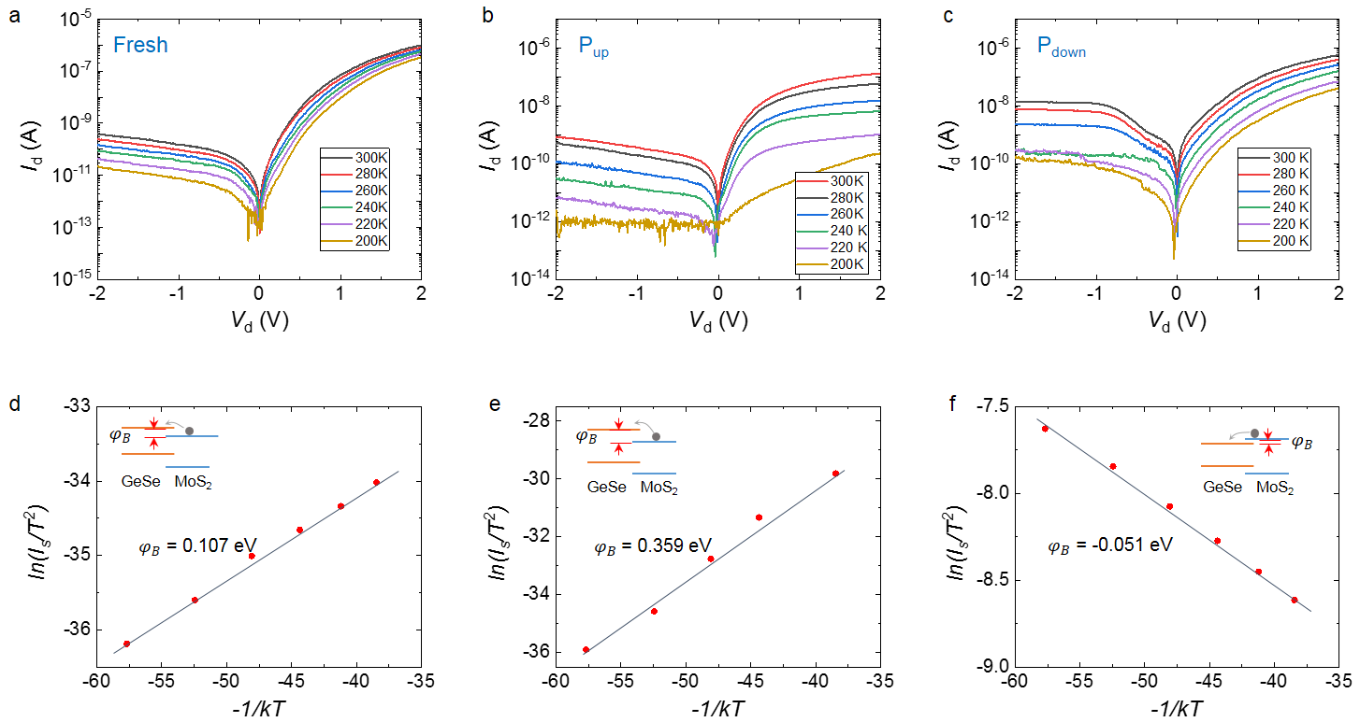
Supplementary Figure 9. Carrier transport at the interface of GeSe/MoS₂ heterojunction at different polarization states. Temperature-dependent output characteristics at (a) Fresh state, (b) P_{up} state and (c) P_{down} state. (d)-(f) The thermionic emission model is used to extract band offset at different states. The insets depict the simplified band structure at the interface.

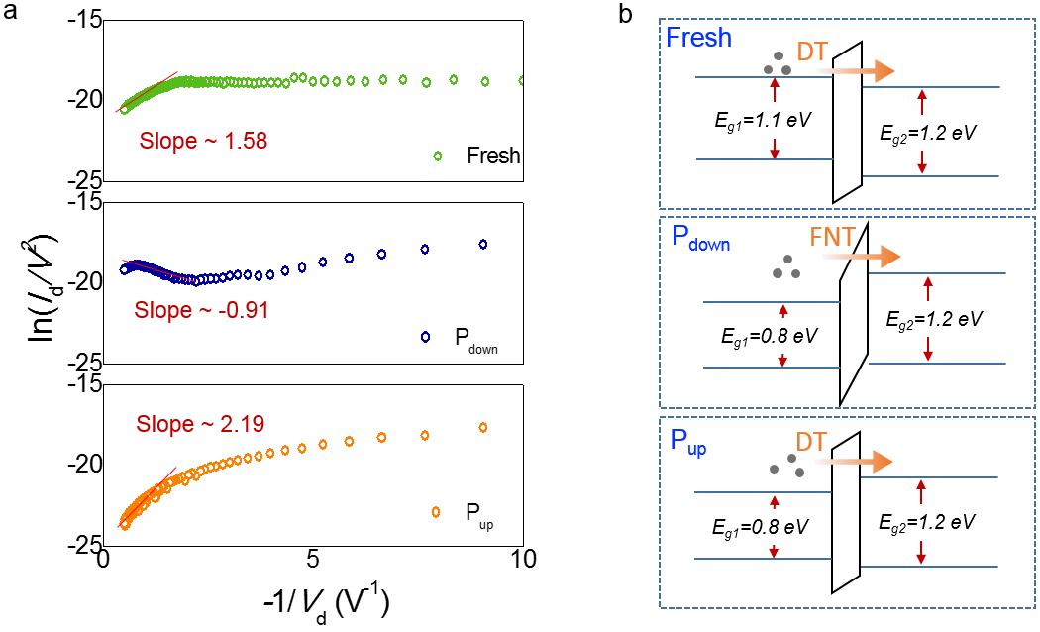
Supplementary Figure 10. The effect of the amorphous layer on carrier transport in heterojunction. (a) ln(I_{d}/V²) vs. –1/V curve in the reverse bias regime at different polarization states. (b) Corresponding band diagrams of the heterojunction under different polarization states. The depletion region and the organic residue layer are simplified as a barrier. At fresh state and P_{up} state, the reverse current is dominated by direct tunneling (DT). At P_{down} state, Fowler-Northeim tunneling (FNT) dominates.

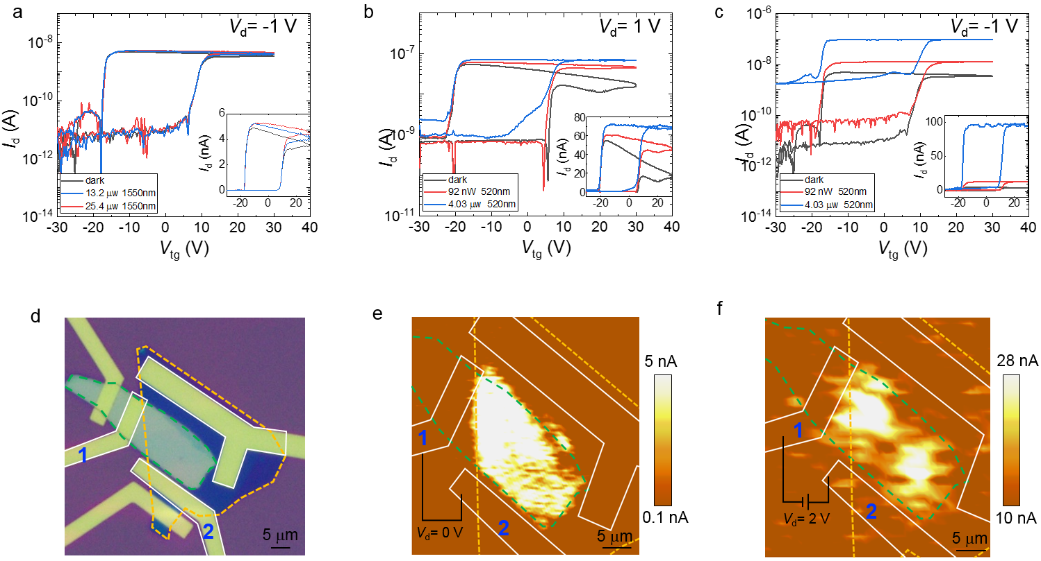
Supplementary Figure 11. Analysis of photoresponse mechanisms at different wavelengths. (a)Transfer characteristics at reverse bias (V_{d} = -1 V) with illumination wavelength of 1550 nm. Transfer characteristics at (b) forward bias (V_{d} = 1V) and (c) reverse bias (V_{d} = -1V) under 520 nm laser illumination. The insets show them in linear coordinates. (d) The optical image of a device used to perform photocurrent mapping. Photocurrent mapping images scanning by (e) 520 nm light and (f) 1310 nm light.

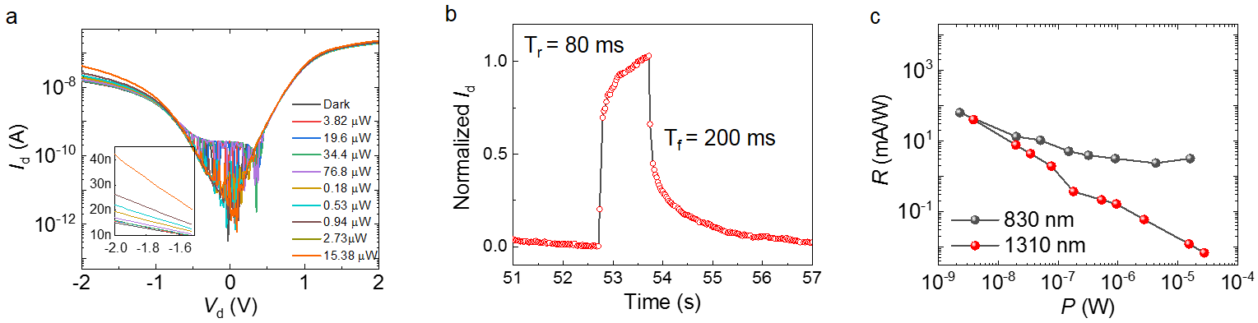
Supplementary Figure 12. Additional photoresponse performance in NIR. (a) output characteristics under the illumination of 1550 nm with different power. (b) Response time measured with illumination of 1550 nm. The rise time is 80 ms and fall time is approximately 200 ms. (c) Responsivities as a function of incident light power. Excitation is performed with 830 nm and 1310 nm laser diodes.

Supplementary Table 1. Comparisons of polarization-sensitive photodetectors with related materials and structures.¹⁻⁸
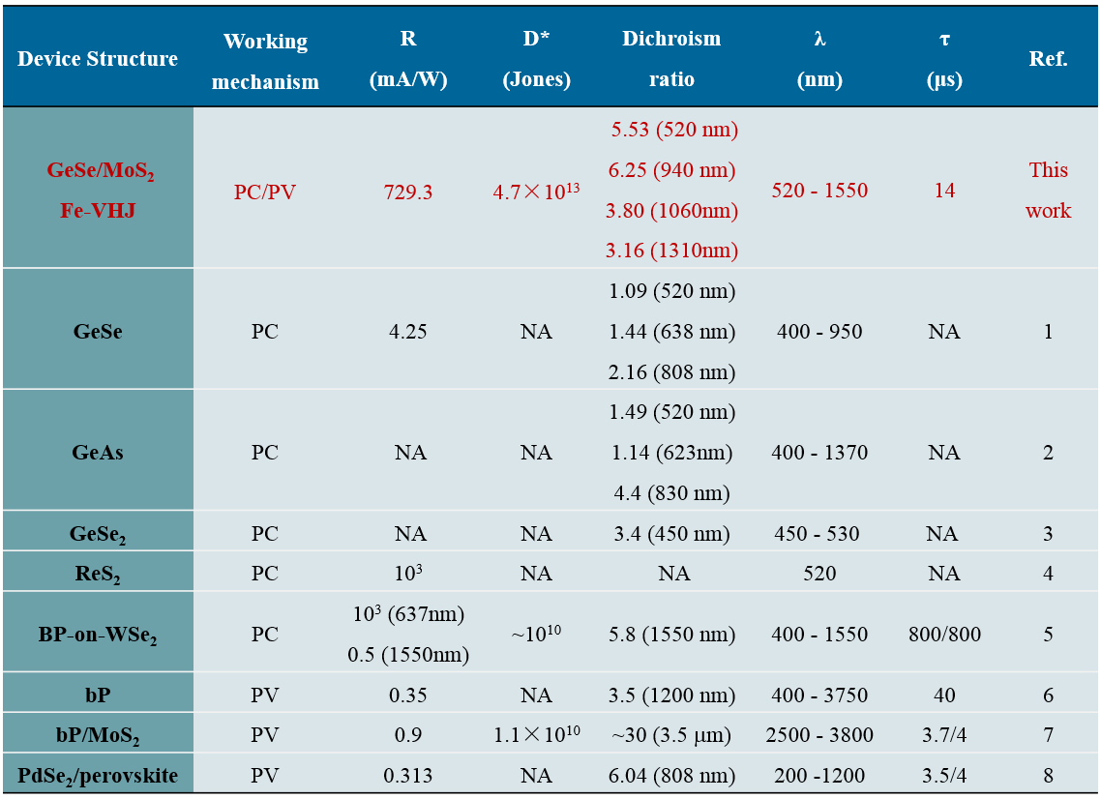
*PV represents photovoltaic effect and PC represents photoconductive effect.

Supplementary Note 1: Calculation on band gap evolution of GeSe under elecrical field.
The band gap modulation effect of P(VDF-TrFE) on MoS₂ has been demonstrated in our previous work.^{11,12} We can verify the band gap reduction by measure the cutoff wavelength of photoresponse. The band gap of bulk GeSe is approximately 1.1−1.2 eV, which makes its intrinsic response with the cutoff wavelength of 1100 nm. With the modulation of P(VDF-TrFE), however, the detection range of GeSe is broadened to 1550 nm as shown in Supplementary Fig. 5.
In order to estimate the magnitude of band gap reduction by Stark effect, we calculate the electronic structure of bulk GeSe under different external electrical fields. First-principle calculations are performed in VASP code within the projector-augmented plane-wave method.¹³⁻¹⁵ The general gradient approximation (GGA) of Perdew, Burke and Ernzerhof (PBE) is adopted to describe the exchange-correlation potential.¹⁶ To overcome the problem of bandgap underestimation in PBE functionals, the HSE06 hybrid functional¹⁷⁻¹⁹ is used to calculate the band structures of layered GeSe. Energy cutoff of 450 eV is employed for the plane-wave basis. In calculations of few-layer GeSe, a vacuum larger than 15 Å is used to eliminate the interaction between adjacent images. The first Brillouin zone is sampled with a (8 × 8 × 1) Monkhorst-Pack grid for relaxation of layered GeSe.²⁰ All the structures are fully relaxed with a force tolerance of 0.01 eV/Å.
From the electronic structures calculated by PBE method as shown in Supplementary Fig. 6, the bandgap of GeSe shows a strong dependence on its thickness, which is attributed to quantum confinement effect. With increasing thickness of GeSe, quantum confinement effect becomes less significant, resulting in decreasing bandgap of GeSe. The band gap of GeSe is calculated to be 0.94 eV, which is close to the reported results.¹⁰ HSE06 calculations obtain larger bandgap of 1.6 eV.
Supplementary Fig. 7 reveals PBE calculation results that bandgap of bulk GeSe exhibits rigid modulation by the external electric field. Following the giant Stark effect, nearly linear decreasing trend is observed in the bandgap of bulk GeSe. According to the linear dependency of bandgap reduction, the bandgap of bulk GeSe shrinks 0.3 eV with an external electric field of approximately 0.13 V/Å. The PBE functional calculations were also performed. The result shows that an external field of 0.1 V/Å can make 0.3 eV reduction of GeSe bandgap. From the electronic structures of bulk GeSe, it is found that general features of band structures are well preserved when on the GGA-PBE and HSE06 levels. The results given by two calculation methods are similar and reliable.
The electrostatic ﬁeld derived from the ferroelectric polarization is estimated by σ = εε₀Ε, where σ is the charge density at the surface of P(VDF-TrFE) ﬁlm, which is related to the remnant polarization (P_{r}) of the ferroelectric materials, ε is the dielectric constant of material (the dielectric constant of GeSe is 6.3), ε₀ is the vacuum permittivity, E is the electric ﬁeld strength, and P_{r} is approximately 7.0 µC/cm² extracted from the ferroelectric hysteresis loop as shown in Supplementary Fig. 3c. The remnant polarization electric field intensity is calculated to be 1.26 × 10⁹ V/m, which may induce 0.3 eV bandgap reduction in GeSe according to the calculated value.

Supplementary Note 2: The evolution of electronic properties of GeSe tuned by P(VDF-TrFE).
We explored the evolution in the electronic properties of GeSe with the applied top gate voltage (V_{tg}). Conductance measurements were performed in dual-gated GeSe transistors with a BN back gate and P(VDF-TrFE) top gate as shown in Supplementary Fig. 8. The tendency of the minimal conductance moves in the same direction as the top gate voltage. When a negative top gate voltage is applied (V_{tg} < 0 V, holes accumulate in the GeSe), the conductance increases with additional holes filling the valence states. As a result of the holes accumulation, the gate electric field is screened and the bandgap of GeSe remains approximately constant. On the other hand, a positive top gate voltage injects electrons into the GeSe flake and the conductance reduces. The depleted GeSe facilitates the ferroelectric field penetrate into the whole GeSe flake, causing the bandgap reduction due to the giant Stark effect.²¹
The impact of remnant polarization field on the GeSe was also investigated. The density of thermally generated intrinsic carriers (n_{i}) reveal the bandgap of a semiconductor. Their relationship is given by n_{i} $∝$ exp(-E_{g}/2kT), where E_{g} is the bandgap of GeSe and k is the Boltzmann constant. Meanwhile, the intrinsic carrier density can be obtained by the minimal conductance at charge neutrality state.²² They follow the equation of σ_{m} = qn_{i}μ_{h}. The temperature-dependency of conductance at P_{up} and P_{down} states are plotted in Supplementary Fig. 8c and 8d. At high temperatures, it is difficult to find the minimum conductance, but the data shows an increase trend of conductance with increasing temperature. More importantly, the conductance at P_{down} state is always larger than that of P_{up} state. Consequently, the density of intrinsic carriers at P_{down} state is higher, indicating a smaller E_{g} of GeSe.

: Analysis on band alignment of GeSe/MoS₂ VHJ.
1. In order to better understand the transport properties of the GeSe/MoS₂ heterojunction, we analyzed the electrical properties of MoS₂ and GeSe, respectively. To determine its band alignment, we calculated the mobility, carrier concentration and the Fermi level positions of these two materials based on the measured data as shown in Supplementary Fig. 2. The specific methods are as follows.
2. The mobility of MoS₂ and GeSe were calculated by μ = (L/(W·ε₀ε_{r}/d·V_{d})) × dI/dV_{tg}, where L and W are the channel length and width, ε_{r} and d are the dielectric constant and thickness of P(VDF-TrFE), respectively. μ_{MoS2} = 92.16 cm²V⁻¹s⁻¹, μ_{GeSe} = 0.135 cm²V⁻¹s⁻¹.
The carrier concentration was calculated by n(p) = σ/μe, where σ is the conductivity derived from I_{d}-V_{d} curves, and e is the elementary electronic charge. The concentrations of MoS₂ (electrons) and GeSe (holes) were 3.21 × 10¹⁰ cm⁻² and 1.63 × 10¹² cm⁻², respectively.
3. The carrier concentration of conduction band and valence band can be also calculated as follows⁹:
n =(g_{2D}k_{B}T)ln{1+exp[(E_{F}-E_{C})/ k_{B}T]}, (1)
p =(g_{2D}k_{B}T)ln{1+exp[-(E_{F}-E_{V})/ k_{B}T]}, (2)
where g_{2D} is the density of states, k_{B} is the Boltzmann constant, T is the temperature, E_{F}-E_{C} and E_{F}-E_{V} are the separations from Fermi level to conduction band minima (CBM) and valence band maxima (VBM), which we need to obtain by calculation.
4. The density of states can be estimated by formula:
g_{2D} = 4πm_{e/h}*/h² (3)
according to references, m_{e,} _{MoS2}* = 0.48m₀, m_{h}, _{GeSe}* = 0.75m₀, the Plank constant h = 6.626 × 10⁻³⁴ J·s,
g_{2D,MoS2} = 4 × 3.14 × 0.48 × 9.11 × 10⁻³¹ /(6.626 × 10⁻³⁴)² = 1.25 × 10³⁷,
g_{2D,GeSe} = 4 × 3.14 × 0.75 × 9.11 × 10⁻³¹/(6.626 × 10⁻³⁴)² =1.95 × 10³⁷.
The Boltzmann constant k_{B} = 1.38 × 10⁻²³ J/K, temperature T = 300 K, the calculated carrier concentration (n, p), and density of states g_{2D} are taken into equation (1) and (2). As a result, the E_{F}-E_{v} of GeSe is 0.27 eV, E_{C}-E_{F} of MoS₂ is 0.38 eV.
The band gap and the electron affinity energy of GeSe is 1.1 eV and 4.1 eV, respectively. The band gap and the electron affinity energy of MoS₂ is 1.2 eV and 4.2 eV, respectively. Therefore, the band structure of GeSe/MoS₂ heterojunction at Fresh state can be illustrated as shown in Fig. 2f.
As shown in Supplementary Figure 9, the I-V characteristics of the heterojunction is temperature-dependent. Here, we use the thermionic emission model to extract the band offset:¹⁰
$I= I_{S}\left[\exp\left(\frac{eV}{ηk_{B}T}\right)-1\right]$,
$I_{S}{∝T}^{2}exp⁡(-\frac{eφ_{B}}{k_{B}T})$,
where I_{s} is the saturation current, k_{B} is the Boltzmann constant, V is the applied voltage, T is the temperature, η is the ideality factor, and e is the electron charge. $φ_{B}$ is the barrier that electrons need to overcome as shown in Supplementary Figure 9d-f. It can be extracted from the slope in the plot of ln(I_{s}/T²) vs -1/kT. The band offset under Fresh state is 0.107 eV, which is consistent with our previous result (0.1 eV). The band offsets at “P_{up}” state and “P_{down}” state are fitted to be 0.359 eV and -0.051 eV, respectively. It indicates that the polarization of P(VDF-TrFE) effectively tuned the band structure of the GeSe/MoS₂ heterojunction. The variation tendency of the band offset is illustrated in Fig. 2g and Fig. 2h.

References:
1. Wang, X. et al. Short-wave near-infrared linear dichroism of two-dimensional germanium selenide. J. Am. Chem. Soc. 139, 14976-14982 (2017).
2. Yang, Y. et al. Air-stable in-plane anisotropic GeSe₂ for highly polarization-sensitive photodetection in short wave region. J. Am. Chem. Soc. 140, 4150-4156 (2018).
3. Zhou, Z. et al. Perpendicular optical reversal of the linear dichroism and polarized photodetection in 2D GeAs. ACS Nano 12, 12416-12423 (2018).
4. Liu, F. et al. Highly sensitive detection of polarized light using anisotropic 2D ReS₂. Adv. Func. Mater. 26, 1169-1177 (2016).
5. Ye, L. et al. Highly polarization sensitive infrared photodetector based on black phosphorus-on-WSe₂ photogate vertical heterostructure. Nano Energy 37, 53-60 (2017).
6. Yuan, H. et al. Polarization-sensitive broadband photodetector using a black phosphorus vertical p-n junction. Nat. Nanotechnol. 10, 707-713 (2015).
7. Bullock, J. et al. Polarization-resolved black phosphorus/molybdenum disulfide mid-wave infrared photodiodes with high detectivity at room temperature. Nat. Photon. 12, 601-607 (2018).
8. Zeng, L. H. et al. Multilayered PdSe₂/perovskite schottky junction for fast, self-powered, polarization-sensitive, broadband photodetectors, and image sensor application. Adv. Sci. 6, 1901134 (2019).
9. Chen, J. W. et al. A gate-free monolayer WSe2 pn diode. Nat. Commun. 9, 3143 (2018).
10. Yap, W. C. et al. Layered material GeSe and vertical GeSe/MoS₂ p-n heterojunctions. Nano Res. 11, 420-430 (2017).
11. Wang, X. et al. Ultrasensitive and broadband MoS₂ photodetector driven by ferroelectrics. Adv. Mater. 27, 6575-6581 (2015).
12. Chen, Y. et al. Optoelectronic properties of few-layer MoS₂ FET gated by ferroelectric relaxor polymer. ACS Appl. Mater. Interfaces 8, 32083-32088 (2016).
13. Blochl, P. E. Projector augmented-wave method. Phys. Rev. B 50, 17953-17979 (1994).
14. Kresse, G. et al. Efficient iterative schemes for ab initio total-energy calculations using a plane-wave basis set. Phys. Rev. B 54, 11169-11186 (1996).
15. Kresse, G. et al. From ultrasoft pseudopotentials to the projector augmented-wave method. Phys. Rev. B 59, 1758-1775 (1999).
16. Perdew, J. P. et al. Generalized gradient approximation made simple. Phys. Rev. Lett. 77, 3865-3868 (1996).
17. Heyd, J. et al. Hybrid functional based on a screened coulomb potential. J. Chem. Phys. 118, 8207 (2003).
18. Heyd, J. et al. Energy band gaps and lattice parameters evaluated with the Heyd-Scuseria-Ernzerhof screened hybrid functional. J. Chem. Phys. 123, 174101 (2005).
19. Heyd, J. et al. Hybrid functionals based on a screened Coulomb potential. J.Chem. Phys. 118, 8207-8215 (2003).
20. Chadi, D. J. et al. Special points in the Brillouin zone. J. Phy. Rev. 8, 5747-5753 (1976).
21. Liu, Y. et al. Gate-tunable giant Stark effect in few-layer black phosphorus. Nano Lett. 17, 1970-1977 (2017).
22. Deng, B. et al. Efficient electrical control of thin-film black phosphorus bandgap. Nat. Commun. 8, 14474 (2017).

