Supplementary Material for: Takane Y, K Nakajima, and Y Kikegawa:
Urban climate changes due to extreme modification of human behaviour
during the COVID-19 pandemic: Integration of urban physics with social big data

a
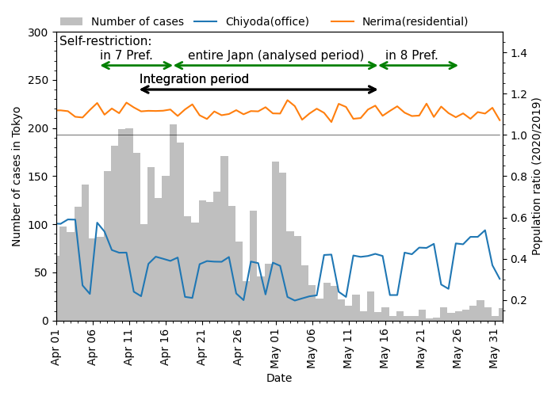
b
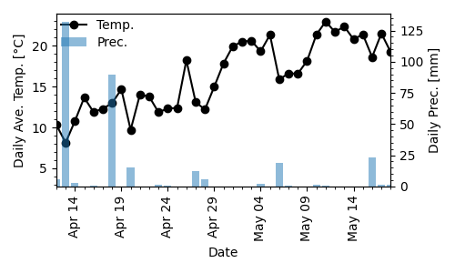
c
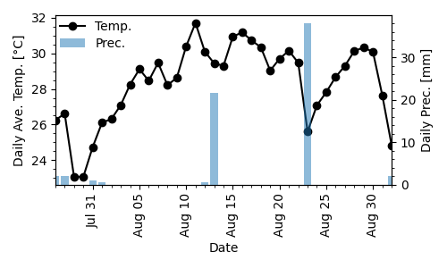
Figure S1 Daily variation in (a) the number of COVID-19 cases in Tokyo for the 1 April–31 May 2020 and the population change ratio (2020/2019) for Chiyoda (office) and Nerima (residential) for the same period. Changes in daily average temperature and daily precipitation observed at Tokyo (Kitanomaru) station for (b) April–May 2020 and (c) August 2020.
Table S2 Parameters for equations (1), (2) and (3).
 | a | b | c | d | e | f
C (office buildings) | 0.15745 | 0.1264 | 0.50028 | -0.7852 | 0.00155 | -0.0035
Rm (concrete fireproof apartments) | 0.09564 | -0.0101 | 0.09324 | -0.7361 | 0.00047 | -0.0005
Rd (detached wooden dwellings) | 0.07757 | 0.0332 | 0.04369 | 0.3382 | 0.00026 | 0.0023

a ΔEC  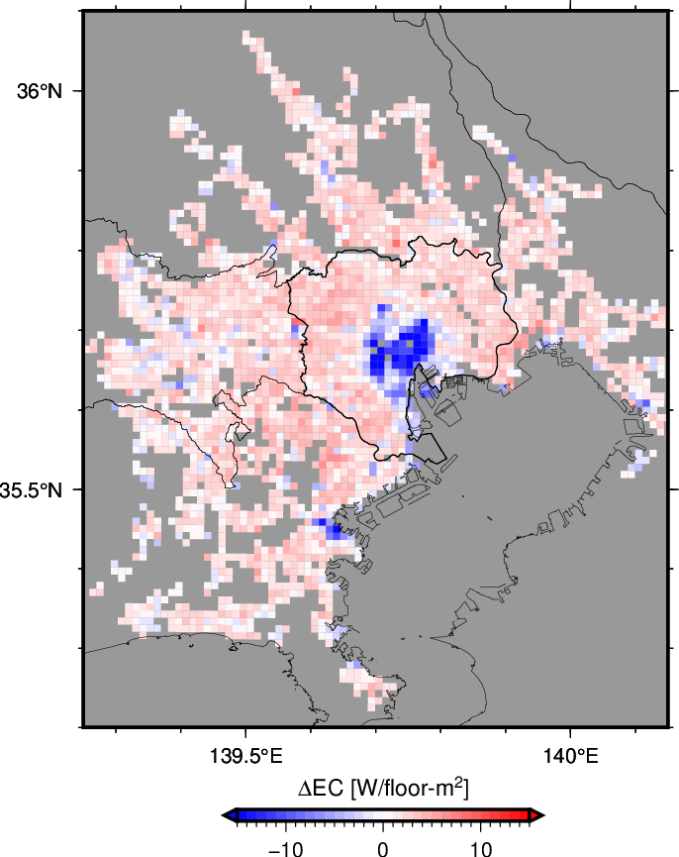 | d ΔQ_{F}  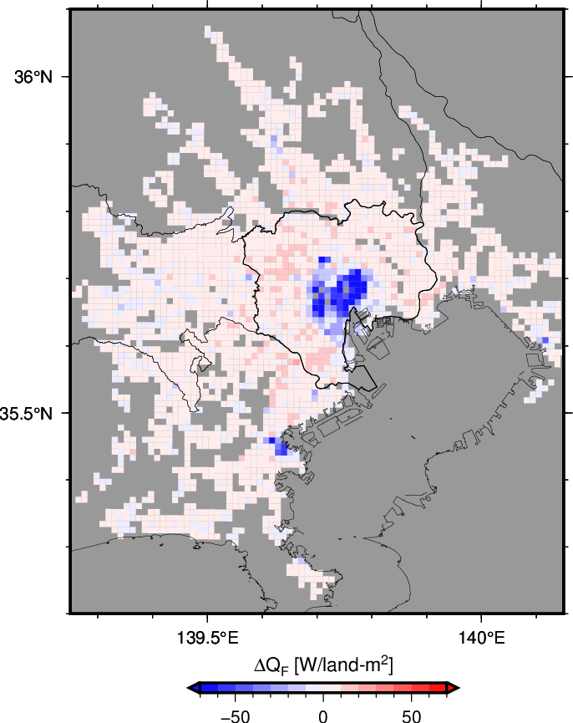 | g ΔT  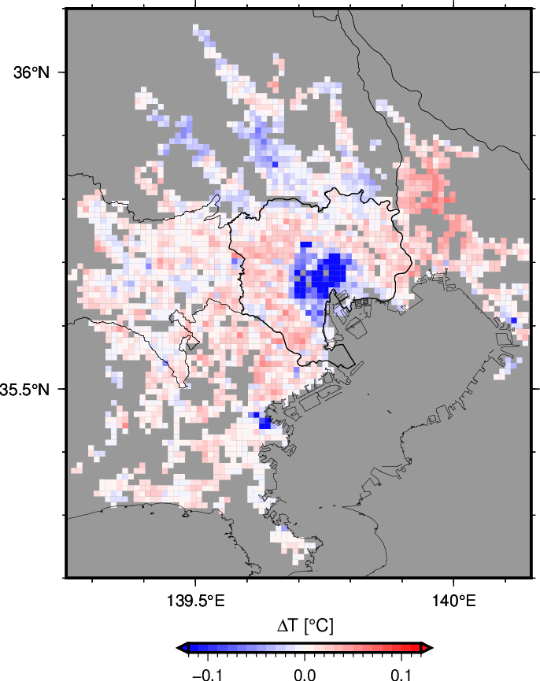
b  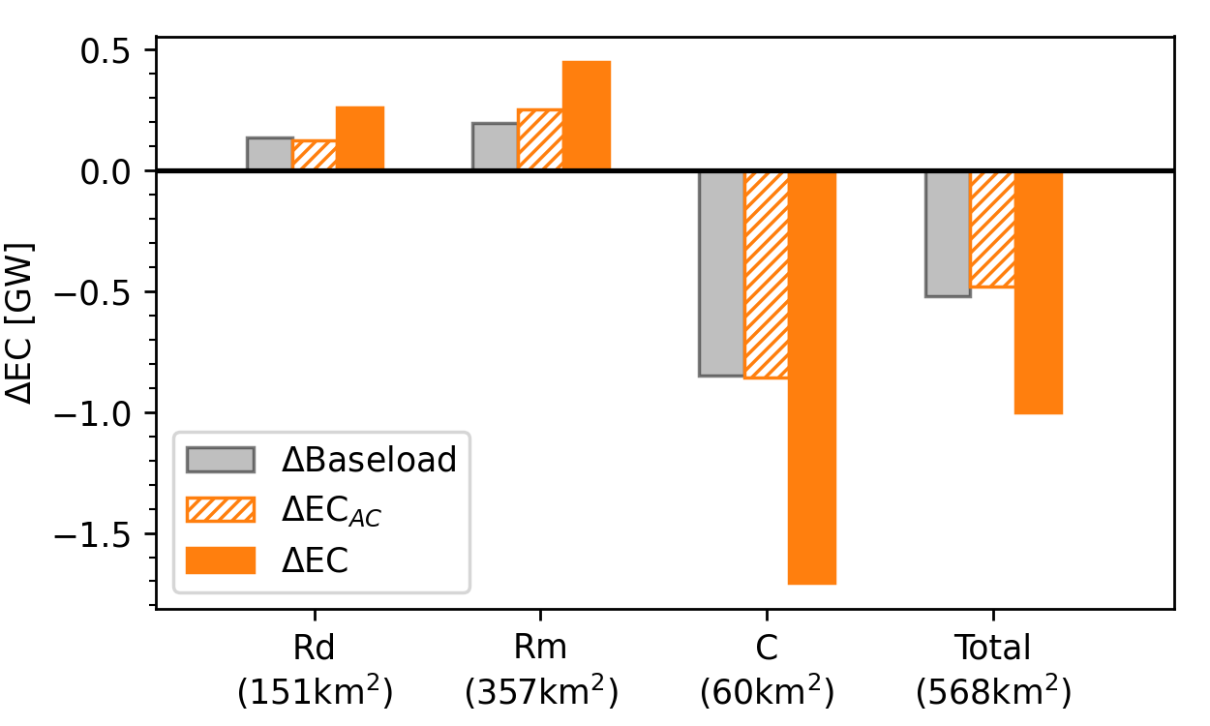 | e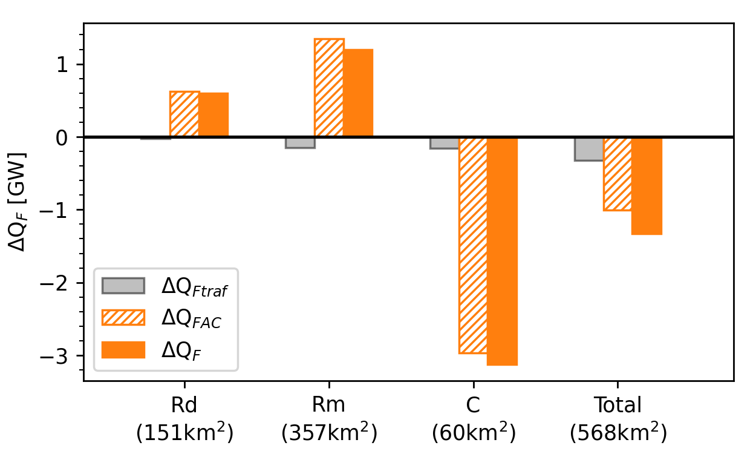 | h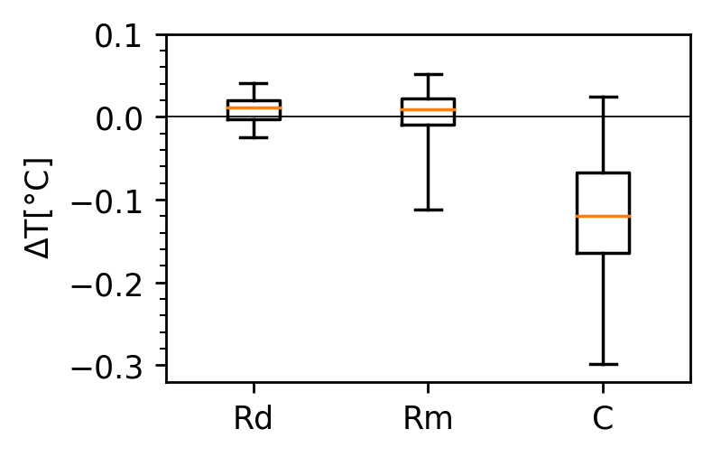
c  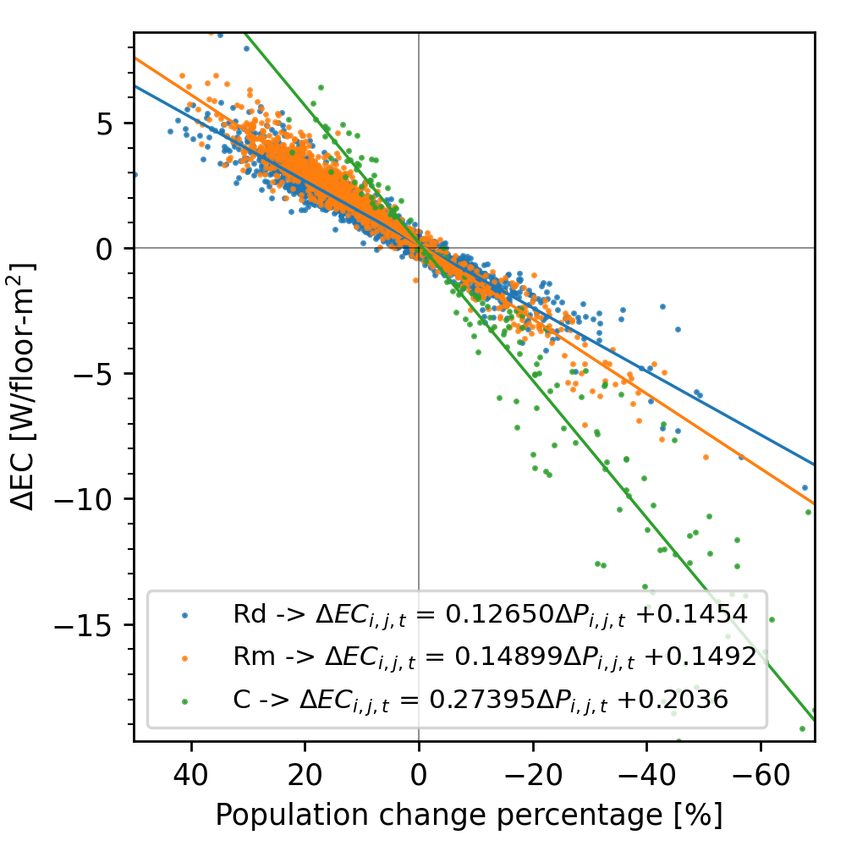 | f  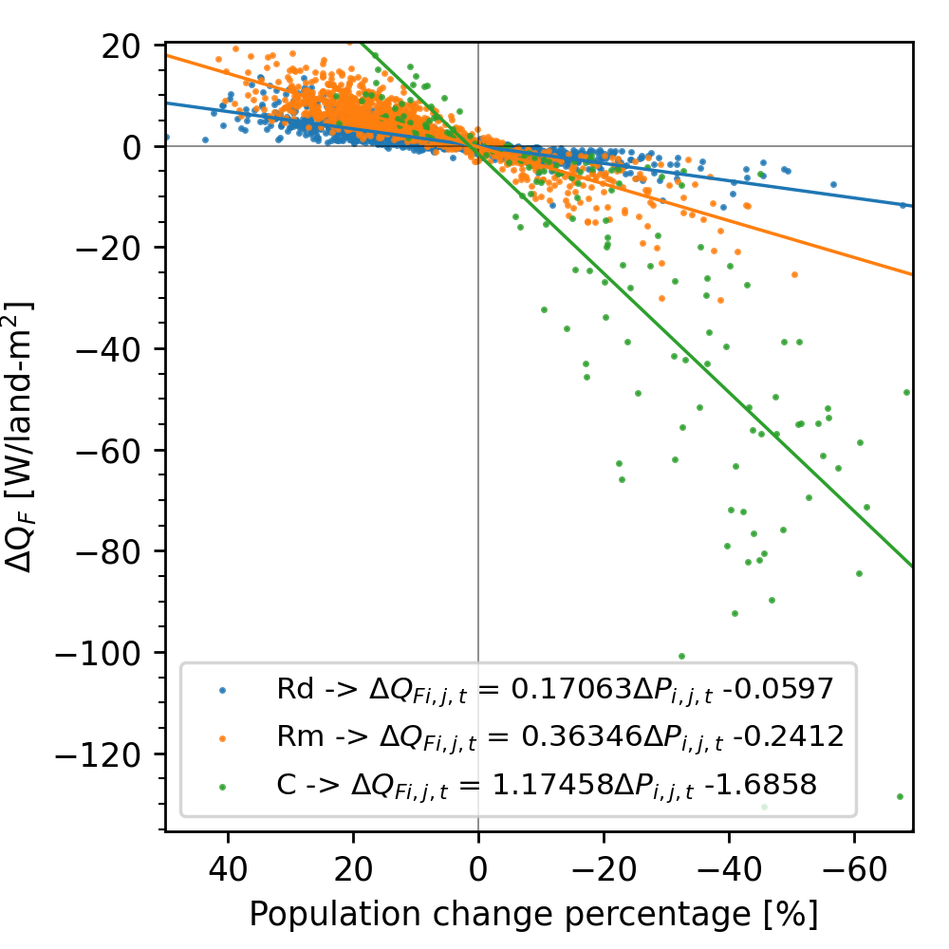 | i  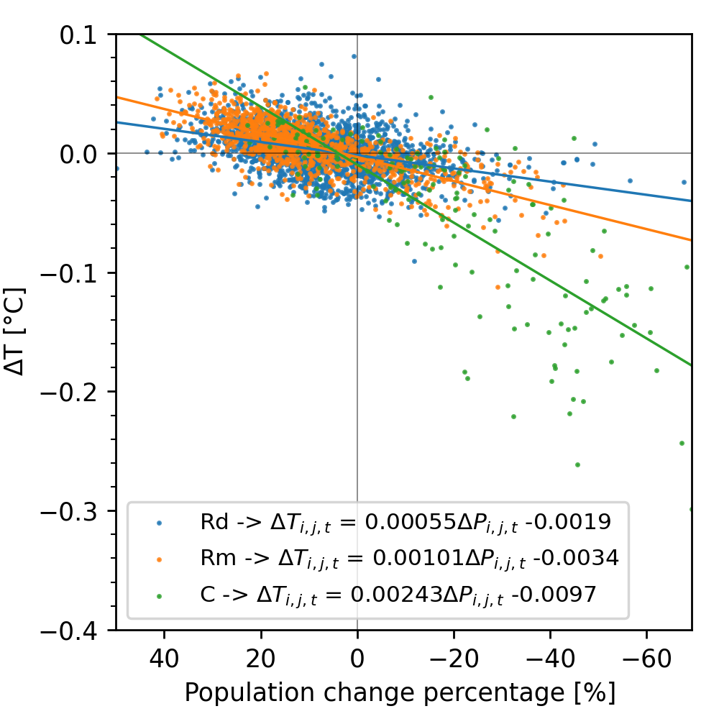
Figure S2 Same as Figure 2 but for the daytime average of August 2020.

Model settings

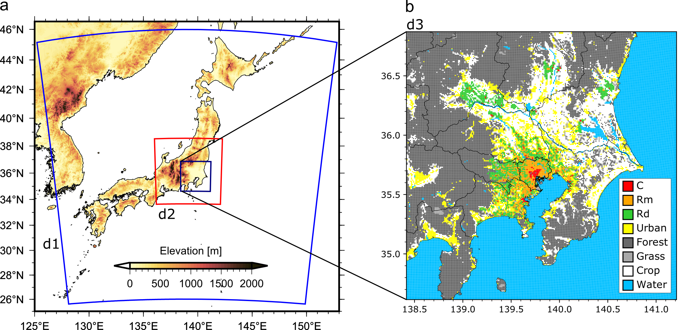
Figure S3 Study area: a, domains (d01 and d02) and b, land-use in the Tokyo Metropolitan Area (TMA) (d02) with urban land-use categories, including commercial and office buildings (C, blue circle), fireproof apartments (Rr, square) and wooden detached dwellings (Rw, triangle), as well as administrative boundaries (lines).

Table S2 Parameter settings for CM-BEM.
Urban grid category | Facetª (thickness and the number of layers) and AC systems |  | Material^{b} |  | Thermal conductivity  (W m⁻¹ K⁻¹) | Volumetric heat capacity  (×10⁶ J m⁻³ K⁻¹) | Surface albedo  (-) | Surface emissivity  (-)
Commercial and office buildings  (C) |  | Roof  (0.301 m)  (16 layers) | – Lightweight concrete/concrete/rock-wool board (except 14th to 15th layers) |  | 0.520 | 1.470 | 0.2 | 0.97
 |  | Roof  (0.301 m)  (16 layers) | – Insulation (air gap/styrene foam) (14th to 15th layers) |  | 0.014 | 0.093 | – | –
 |  | Wall  (0.225 m)  (16 layers) | – Tile/mortar/concrete/sealed air gap/plasterboard (except 14th layer) |  | 0.710 | 1.700 | 0.12 | –
 |  | Wall  (0.225 m)  (16 layers) | – Insulation (air gap/styrene foam) (14th layers) |  | 0.019 | 0.068 | – | –
 |  | Wall  (0.225 m)  (16 layers) | – Window (glass) areal fraction on the walls: 0.33
 |  | AC system | – System 1: Natural-gas-driven absorption type hot and chilled water generators (rated COP = 0.97) with water-cooled cooling towers placed on the rooftops on the buildings.
 |  |  | – System 2: Electric air-source heat-pumps (rated COP = 3.48) with air-cooled heat exchangers placed at each storey of the buildings.
 |  |  | – Target room temperature: 27.0°C
Fireproof apartments  (Rm) |  | Roof  (0.277 m)  (16 layers) | – Lightweight concrete/concrete/rock-wool board (except 4th to 8th layers) |  | 0.866 | 1.88 | 0.2 | 0.97
 |  | Roof  (0.277 m)  (16 layers) | – Insulation (air gap/styrene foam) (4th to 8th layers) |  | 0.037 | 0.0353 | – | –
 |  | Wall  (0.246 m)  (16 layers) | – Tile/mortar/concrete/sealed air gap/plasterboard (except 14th to 15th layer) |  | 1.11 | 1.84 | 0.12 | 0.97
 |  | Wall  (0.246 m)  (16 layers) | – Insulation (air gap/styrene foam) (14th to 15th layers) |  | 0.031 | 0.0419 | – | –
 |  | Wall  (0.246 m)  (16 layers) | – Window (glass) areal fraction on the walls: 0.14
 |  | AC system | – Electric air-source heat-pumps (rated COP = 3.26) with air-cooled heat exchangers placed at each storey of the buildings
 |  | AC system | – Target room temperature: 28.0°C
Woodend detached dwellings  (Rd) |  | Roof  (0.205 m)  (5 layers) | – Lightweight concrete/concrete/rock-wool board (except 2nd to 4th layers) |  | 0.082 | 0.532 | 0.2 | 0.97
 |  | Roof  (0.205 m)  (5 layers) | – Insulation (air gap/styrene foam) (2nd to 4th layers) |  | 0.042 | 0.0201 | – | –
 |  | Wall  (0.125 m)  (5 layers) | – Tile/mortar/concrete/sealed air gap/plasterboard (except 3rd to 4th layer) |  | 0.158 | 0.888 | 0.12 | 0.97
 |  | Wall  (0.125 m)  (5 layers) | – Insulation (air gap/styrene foam) (3rd to 4th layers) |  | 0.042 | 0.0201 | – | –
 |  | Wall  (0.125 m)  (5 layers) | – Window (glass) areal fraction on the walls: 0.11
 |  | AC system | – Electric air-source heat-pumps (rated COP = 3.26) with air-cooled heat exchangers placed at each storey of the buildings
 |  | AC system | – Target room temperature: 28.0°C
 |  | Ground  (1.55 m)  (31 layers) | – Vegetation | – Areal fraction on the ground: grid-by-grid settings based on Open Street Map (https://www.openstreetmap. org/)  – Plant canopy conductance: 5.0 (mm/s) |  |  | 0.15 | 0.97
 |  |  | – Pavement | – asphalt/macadam (1st to 6th layer) | 1.390  (composite) | 1.930  (composite) | 0.12 | 0.97
 |  |  | – Soil | – (7th to 31st layer) | 1.000 | 1.740 | – | –
ªRoofs, walls, and ground are divided into multi-layers with spacing given by the thickness / number of layers.
^{b}The 1st layer was placed on the outside surface, whereas the layer with the maximum number was on the indoor surface.

Verification of the model
We checked the reproducibility of T simulated by the COVID case at major sites in the TMA during April–May. The mean bias error (MBE) was 0.68°C, mean absolute error (MAE) was 1.44°C and root mean square error (RMSE) was 2.64°C in central Tokyo, and MBE was 0.87°C, MAE was 1.48°C and RMSE was 2.76°C in Nerima, a suburb within the 23 wards of Tokyo (Figure S4, Table S3). These values are as good as those obtained by Kikegawa et al. [47] for Osaka City using the same model (results included clear-sky days and cloudy and overcast days). The range of diurnal variation in temperature and the histogram also agreed with the observations (Figure S4). In terms of daytime temperature, which is the main focus of this study, the MBE, MAE, and RMSE at locations near the city centre (Tokyo, Yokohama and Chiba) were all improved compared to the values for all periods (Table S2). For the temperature calculated in this model, Nakajima et al. [42] validated the model under the same calculation settings and achieved the same accuracy.
The EC simulated by the model was also verified by Nakajima et al. [42]. The diurnal variation and horizontal distribution of EC and the ΔEC due to the temperature (sensitivity) of each building use category (C, Rm and Rd) were well reproduced. In 2020, which was the target year of this study, EC data for verification were not available, and it was therefore impossible to verify EC for this period. However, the fact that we could not confirm the EC using the data for 2020 does not alter the conclusion of this study because the EC for 2015–2019, including the sensitivity, was well reproduced, and here we focused on the differences between the COVID and No-COVID cases.
We evaluated the effects of the stay-at-home advisories due to the spread of the COVID-19 infection on temperature. Human activity significantly differs between weekdays and holidays, with a similar pattern observed between usual days and the stay-at-home advisories period. The model used in this study reproduced the effects of the differences in human activity between weekdays and holidays on temperature (a slight difference in temperature between weekdays and holidays) [47], and therefore the effects of the stay-at-home advisories could be calculated.

Table S3 Mean bias error (MBE), mean absolute error (MAE) and root mean square error (RMSE) at seven stations.
 |  | Tokyo | Chiba | Funabashi | Abiko | Koshigaya | Nerima | Yokohama
MBE (ºC) | Daily | 0.68 | –0.73 | –0.09 | 0.80 | 0.83 | 0.87 | –0.02
 | Daytime | 0.14 | –0.48 | –0.38 | 0.61 | 0.22 | 0.19 | –0.32
MAE (ºC) | Daily | 1.44 | 1.37 | 1.34 | 1.38 | 1.47 | 1.48 | 1.35
 | Daytime | 1.44 | 1.28 | 1.38 | 1.44 | 1.49 | 1.50 | 1.33
RMSE (ºC) | Daily | 2.64 | 2.32 | 2.33 | 2.51 | 2.72 | 2.76 | 2.26
 | Daytime | 2.52 | 2.06 | 2.35 | 2.65 | 2.75 | 2.76 | 2.19

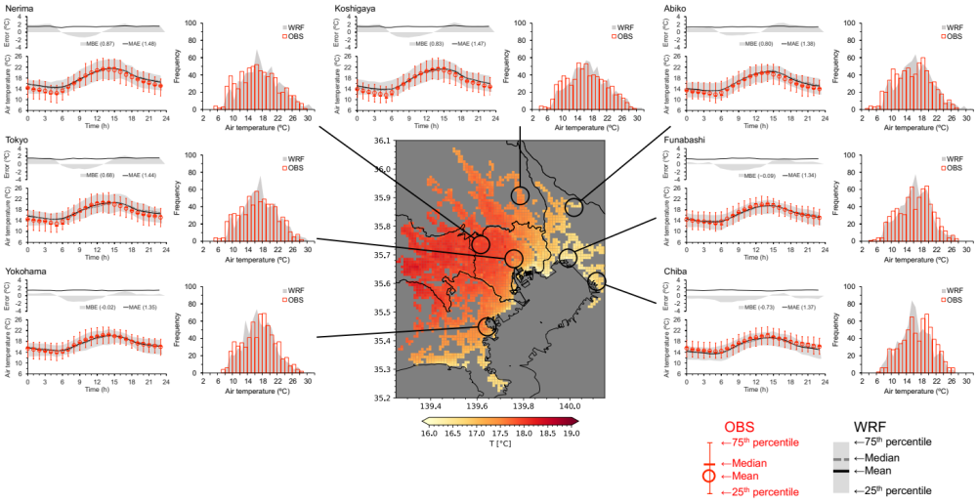
Figure S4 Model verification of the near-surface surface air temperature (T) for 18 April–14 May 2020 observed at seven stations (red) and simulated by the COVID case. Diurnal variation (left), frequency (right). The centre figure is the same as Fig. 2a.

Uncertainty with the AC setting for offices
In the simulation results described above, three parameters were varied according to the actual rate of population change (i.e., MSS) used to reflect the COVID situation (see the Methods section). There was uncertainty among the settings of these parameters, particularly of the AC schedule. Specifically, some offices always use AC to maintain a cool room temperature for computers and other equipment, regardless of the number of people present. It was likely many such office buildings were operated this way during the COVID period. The estimated results for the offices in the simulation results described above (calculated by setting the AC according to the building occupancy in the office district) may change (overestimating the ΔEC, ΔQ_{F} and ΔT). Therefore, another case (COVID_office-AC) was performed assuming that all office buildings used AC as usual regardless of changes in the building occupancy. The results were compared to those of COVID assuming AC use according to the changes in population described above, enabling the uncertainty of the impact associated with this setting to be estimated. Because April–May is a season when AC is not used much, there was little uncertainty related to this setting, and the results were robust. Therefore, in the following analysis we mainly considered the results of the summer case.
The results of the comparison between the COVID_office-AC and COVID cases are shown in Figure S5. The values of ΔEC were smaller in COVID_office-AC than in COVID because the former used AC as usual (Figure S5a). As a result, the ΔQ_{F} of COVID_office-AC was also smaller than that of COVID (Figure S5b), and ΔT was also smaller (Figure S5c). The range of uncertainty in the office district due to the AC setting above was ΔEC: -1.7 to -1.2 GW, ΔQ_{F}: -3.1 to -1.6 GW and ΔT: -0.3 to -0.2°C. Despite the uncertainty due to the settings associated with AC, it is important to note that the trends and conclusions of the results are consistent. Consequently, the results of this study are considered robust.

a ΔEC 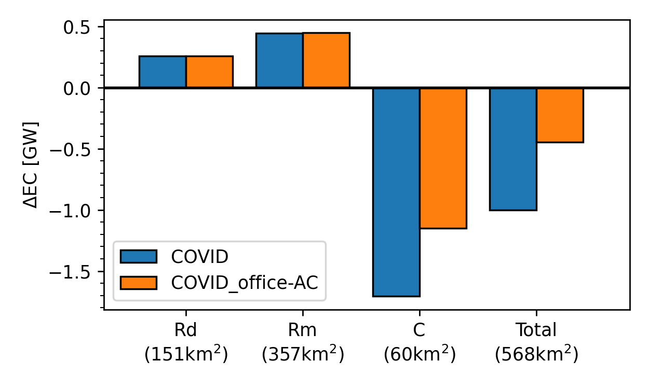 | b ΔQ_{F} 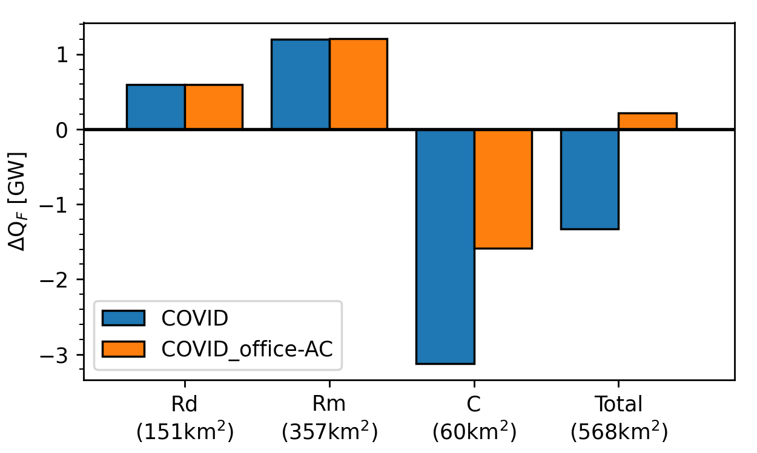 | c ΔT 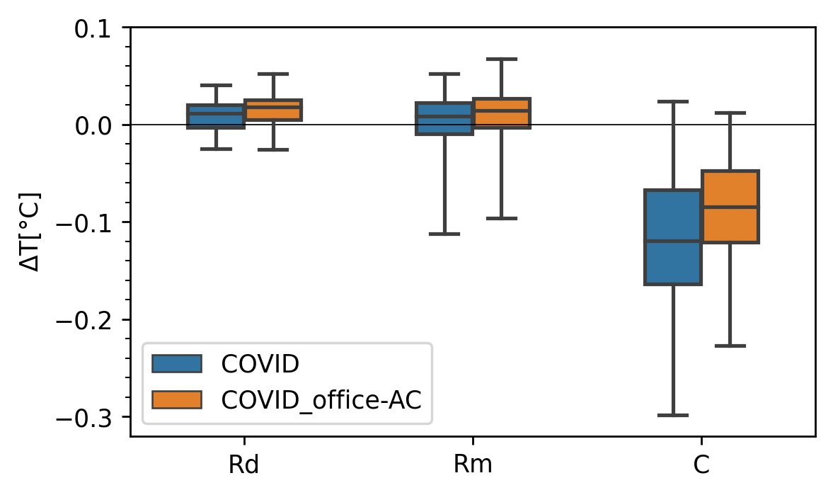
Figure S5 Bar charts and a box plot of the change in energy consumption ΔEC (a), anthropogenic heat (ΔQ_{F}) (b) and near-surface temperature ΔT (c) for each urban category and the total of the 23 wards of Tokyo estimated for the COVID (blue) and COVID_office-AC (orange) cases.

