Supplementary File

Figure S1: Survival percentages per every 1 hour of admission-to-shock time (till 48 hours and more).

Figure S2: Survival percentages per every 12 hours of admission-to-shock time (till 300 hours and more)

Figure S3: Numbers of missing values that were imputed in the analyses in this study.

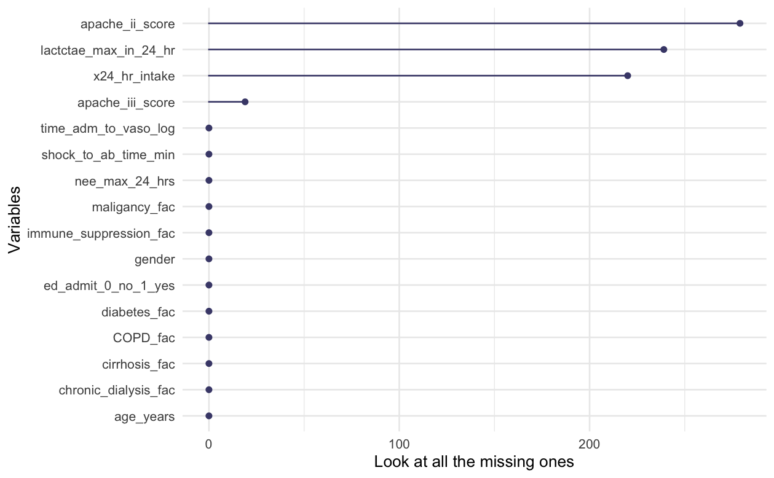

Figure S4: The association between the log-transformed time from hospital admission to recognition of septic shock and adjusted odds ratio of in-hospital mortality in patients who were admitted to the medical ICU from the emergency department.

Figure S5: The association between the log-transformed time from hospital admission to recognition of septic shock and adjusted odds ratio of in-hospital mortality in patients who were admitted to the medical ICU from non-emergency department.

Table S1: The fraction of survivors of each 12 hours-bin

time | Number of survivors | Total number of patients | The fraction of survivors
[0,12] | 832 | 1155 | 0.72
(12,24] | 165 | 220 | 0.75
(24,36] | 86 | 122 | 0.7
(36,48] | 43 | 82 | 0.52
(48,60] | 35 | 56 | 0.62
(60,72] | 28 | 53 | 0.53
(72,84] | 20 | 36 | 0.56
(84,96] | 18 | 44 | 0.41
(96,108] | 19 | 36 | 0.53
(108,120] | 20 | 38 | 0.53
(120,132] | 11 | 25 | 0.44
(132,144] | 12 | 28 | 0.43
(144,156] | 13 | 19 | 0.68
(156,168] | 11 | 25 | 0.44
(168,180] | 14 | 30 | 0.47
(180,192] | 8 | 20 | 0.4
(192,204] | 7 | 17 | 0.41
(204,216] | 11 | 21 | 0.52
(216,228] | 10 | 20 | 0.5
(228,240] | 12 | 28 | 0.43
(240,252] | 13 | 24 | 0.54
(252,264] | 8 | 15 | 0.53
(264,276] | 13 | 24 | 0.54
(276,288] | 7 | 16 | 0.44
(288,300] | 11 | 18 | 0.61
(300,+) | 153 | 348 | 0.44

Table S2: The poisson regression model using offset variables.

Analysis Of Maximum Likelihood Parameter Estimates
Parameter |  | DF | Estimate | Standard error | Wald 95% Confidence Limits | Wald 95% Confidence Limits | Wald Chi-Square | P value
Intercept |  | 1 | -0.328 | 0.0347 | -0.396 | -0.2601 | 89.52 | <.0001
time | (12,24] | 1 | 0.0403 | 0.0852 | -0.1267 | 0.2074 | 0.22 | 0.6359
time | (24,36] | 1 | -0.0217 | 0.1133 | -0.2437 | 0.2004 | 0.04 | 0.8484
time | (36,48] | 1 | -0.3175 | 0.1564 | -0.624 | -0.011 | 4.12 | 0.0423
time | (48,60] | 1 | -0.142 | 0.1725 | -0.4802 | 0.1962 | 0.68 | 0.4106
time | (60,72] | 1 | -0.3101 | 0.1921 | -0.6866 | 0.0665 | 2.6 | 0.1066
time | (72,84] | 1 | -0.2598 | 0.2263 | -0.7033 | 0.1837 | 1.32 | 0.251
time | (84,96] | 1 | -0.5658 | 0.2382 | -1.0327 | -0.0989 | 5.64 | 0.0176
time | (96,108] | 1 | -0.3111 | 0.232 | -0.7658 | 0.1437 | 1.8 | 0.18
time | (108,120] | 1 | -0.3138 | 0.2263 | -0.7573 | 0.1297 | 1.92 | 0.1655
time | (120,132] | 1 | -0.493 | 0.3035 | -1.0878 | 0.1019 | 2.64 | 0.1043
time | (132,144] | 1 | -0.5193 | 0.2907 | -1.0891 | 0.0506 | 3.19 | 0.0741
time | (144,156] | 1 | -0.0515 | 0.2795 | -0.5993 | 0.4964 | 0.03 | 0.8539
time | (156,168] | 1 | -0.493 | 0.3035 | -1.0878 | 0.1019 | 2.64 | 0.1043
time | (168,180] | 1 | -0.4341 | 0.2695 | -0.9623 | 0.0941 | 2.59 | 0.1072
time | (180,192] | 1 | -0.5883 | 0.3552 | -1.2845 | 0.108 | 2.74 | 0.0977
time | (192,204] | 1 | -0.5593 | 0.3796 | -1.3032 | 0.1846 | 2.17 | 0.1406
time | (204,216] | 1 | -0.3186 | 0.3035 | -0.9134 | 0.2762 | 1.1 | 0.2938
time | (216,228] | 1 | -0.3651 | 0.3181 | -0.9886 | 0.2584 | 1.32 | 0.2511
time | (228,240] | 1 | -0.5193 | 0.2907 | -1.0891 | 0.0506 | 3.19 | 0.0741
time | (240,252] | 1 | -0.2851 | 0.2795 | -0.8329 | 0.2627 | 1.04 | 0.3078
time | (252,264] | 1 | -0.3006 | 0.3552 | -0.9969 | 0.3957 | 0.72 | 0.3975
time | (264,276] | 1 | -0.2851 | 0.2795 | -0.8329 | 0.2627 | 1.04 | 0.3078
time | (276,288] | 1 | -0.4987 | 0.3796 | -1.2426 | 0.2453 | 1.73 | 0.1889
time | (288,300] | 1 | -0.1645 | 0.3035 | -0.7593 | 0.4304 | 0.29 | 0.5879
time | (300,+) | 1 | -0.4937 | 0.088 | -0.6661 | -0.3213 | 31.5 | <.0001
time | [0,12] | 0 | 0 | 0 | 0 | 0 | . | .

#. DF: degrees of freedom

Table S3: Comparison of two sequential time-intervals.

Differences of time Least Squares Means
time | _time | Estimate | Standard Error | z Value | P value
[0,12] | (12,24] | -0.04034 | 0.08522 | -0.47 | 0.6359
(12,24] | (24,36] | 0.06199 | 0.133 | 0.47 | 0.6411
(24,36] | (36,48] | 0.2958 | 0.1868 | 1.58 | 0.1132
(36,48] | (48,60] | -0.1755 | 0.2277 | -0.77 | 0.4407
(48,60] | (60,72] | 0.1681 | 0.2535 | 0.66 | 0.5074
(60,72] | (72,84] | -0.0503 | 0.2928 | -0.17 | 0.8636
(72,84] | (84,96] | 0.306 | 0.3249 | 0.94 | 0.3462
(84,96] | (96,108] | -0.2547 | 0.3289 | -0.77 | 0.4387
(96,108] | (108,120] | 0.002774 | 0.3204 | 0.01 | 0.9931
(108,120] | (120,132] | 0.1791 | 0.3754 | 0.48 | 0.6332
(120,132] | (132,144] | 0.02632 | 0.4174 | 0.06 | 0.9497
(132,144] | (144,156] | -0.4678 | 0.4003 | -1.17 | 0.2426
(144,156] | (156,168] | 0.4415 | 0.4097 | 1.08 | 0.2812
(156,168] | (168,180] | -0.05884 | 0.4029 | -0.15 | 0.8839
(168,180] | (180,192] | 0.1542 | 0.4432 | 0.35 | 0.728
(180,192] | (192,204] | -0.02899 | 0.5175 | -0.06 | 0.9553
(192,204] | (204,216] | -0.2407 | 0.4835 | -0.5 | 0.6186
(204,216] | (216,228] | 0.04652 | 0.4369 | 0.11 | 0.9152
(216,228] | (228,240] | 0.1542 | 0.4282 | 0.36 | 0.7188
(228,240] | (240,252] | -0.2342 | 0.4003 | -0.59 | 0.5585
(240,252] | (252,264] | 0.0155 | 0.4494 | 0.03 | 0.9725
(252,264] | (264,276] | -0.0155 | 0.4494 | -0.03 | 0.9725
(264,276] | (276,288] | 0.2136 | 0.4688 | 0.46 | 0.6487
(276,288] | (288,300] | -0.3342 | 0.4835 | -0.69 | 0.4894
(288,300] | (300,+) | 0.3293 | 0.3122 | 1.05 | 0.2915

