Supplementary methods. The healthy eating index 2015 (HEI-2015) and the adapted dietary inflammatory index (ADII)

The Adapted Dietary Inflammatory Index (ADII) was constructed to measure the inflammatory potential of the diet.(23) Briefly, the ADII index proposed by Woudenberg et al (61) was used in combination with the updated dietary components inflammatory weights designed by Shivappa et al (62) instead of the weights proposed by Cavicchia et al.(63) These updated inflammatory weights, based on 3 additional years of published data (2008–2010, inclusive), resulted in a doubling of the total number of articles scored. The ADII was based on a nutritional rationale: first, the inflammatory weights of dietary components are multiplied by the standardized energy adjusted intake,(64) which acts to reduce between-person variation; second, the intakes of all components are standardized; third, the ADII calculation did not include alcoholic beverages such as beer, wine, and liquor, total fat, and energy, to avoid overestimation of the inflammatory effects of ethanol, fat and energy. A total of 24 of the 35 possible dietary components were used for the ADII calculation (carbohydrates, proteins, alcohol, fibers, cholesterol, saturated fatty acids, monounsaturated fatty acids, omega 3, omega 6, niacin, thiamin, riboflavin, vitamin B6, vitamin B12, iron, magnesium, zinc, vitamin A, vitamin C, vitamin D, vitamin E, folic acid, beta carotene, and caffeine). A positive ADII score indicates an anti-inflammatory diet and negative values correspond to a pro-inflammatory diet.
The Healthy Eating Index 2015 (HEI-2015) was developed to measure overall diet quality.(22, 65) Briefly, HEI-2015 is a composite measure of conformance to the 2015–2020 Dietary Guidelines for Americans and has been well validated in the US population.(66) The adequacy components (maximum score) were total fruits (5), whole fruits (5), total vegetables (5), greens and beans (5), whole grains (10), dairy (10), total protein foods (5), seafood and plant proteins (5), and fatty acids (ratio of the sum of polyunsaturated and monounsaturated fatty acids to saturated fatty acids, 10). The moderation components were refined grains (10), sodium (10), added sugars (10), and saturated fats (10). HEI-2015 is a 100-point scale, with a higher score indicating a better quality of overall diet.

1. Laouali N, Mancini FR, Hajji-Louati M, et al. Dietary inflammatory index and type 2 diabetes risk in a prospective cohort of 70,991 women followed for 20 years: the mediating role of BMI. Diabetologia 2019; 62: 2222-32.
2. van Woudenbergh GJ, Theofylaktopoulou D, Kuijsten A, et al. Adapted dietary inflammatory index and its association with a summary score for low-grade inflammation and markers of glucose metabolism: the Cohort study on Diabetes and Atherosclerosis Maastricht (CODAM) and the Hoorn study. Am J Clin Nutr 2013; 98: 1533-42.
3. Shivappa N, Steck SE, Hurley TG, Hussey JR, Hebert JR. Designing and developing a literature-derived, population-based dietary inflammatory index. Public Health Nutr 2014; 17: 1689-96.
4. Cavicchia PP, Steck SE, Hurley TG, et al. A new dietary inflammatory index predicts interval changes in serum high-sensitivity C-reactive protein. J Nutr 2009; 139: 2365-72.
5. Willett WC, Howe GR, Kushi LH. Adjustment for total energy intake in epidemiologic studies. Am J Clin Nutr 1997; 65: 1220S-8S; discussion 9S-31S.
6. Krebs-Smith SM, Pannucci TE, Subar AF, et al. Update of the Healthy Eating Index: HEI-2015. J Acad Nutr Diet 2018; 118: 1591-602.
7. Panizza CE, Shvetsov YB, Harmon BE, et al. Testing the Predictive Validity of the Healthy Eating Index-2015 in the Multiethnic Cohort: Is the Score Associated with a Reduced Risk of All-Cause and Cause-Specific Mortality? Nutrients 2018; 10.
8. Reedy J, Lerman JL, Krebs-Smith SM, et al. Evaluation of the Healthy Eating Index-2015. J Acad Nutr Diet 2018; 118: 1622-33.

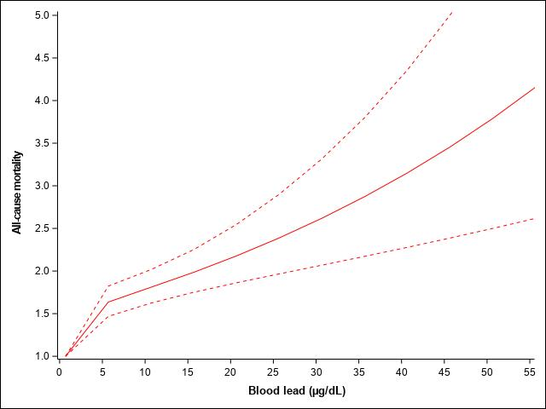
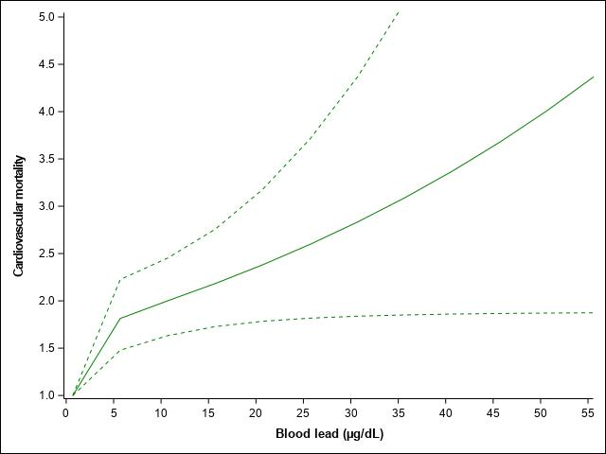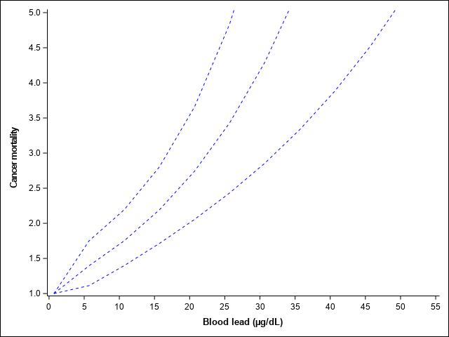
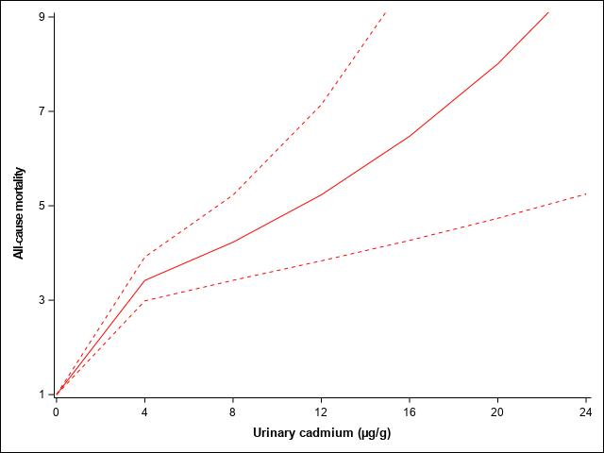
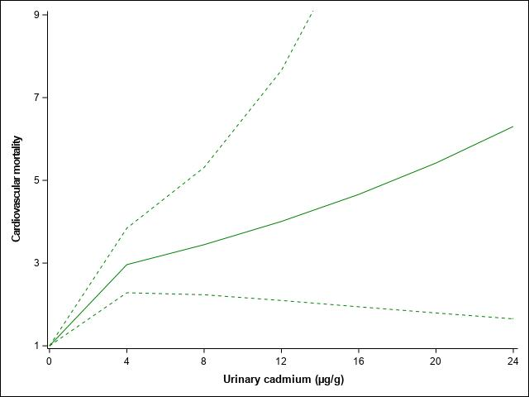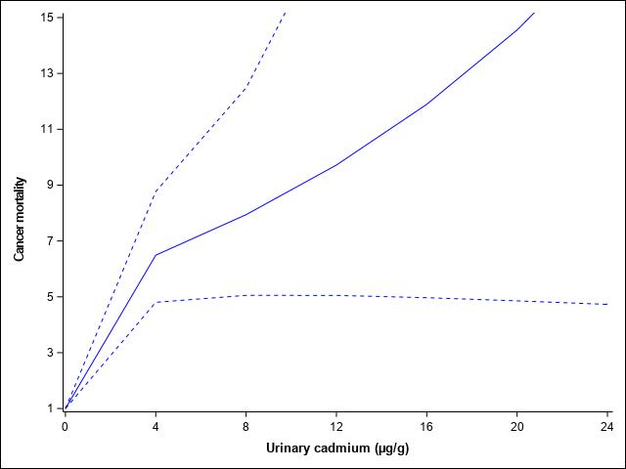
Figure S1: Adjusted all-cause (red), cardiovascular disease (green) and cancer (blue) mortality associated to blood lead and urinary cadmium concentrations using restricted cubic spline (three knots placed at the 10th, 50th, and 90th percentiles). Models were adjusted for age, sex, ethnicity, poverty index, educational level, area of residence, smoking status, BMI, physical activity, diet quality evaluated by the healthy eating index and metals concentrations (mutual adjustment). Reference values for HRs: minimum concentrations; the solid lines represent the HR and the dashed lines the lower and upper 95% CI.

A Blood lead: Age < 50 B Blood lead: Age ≥ 50
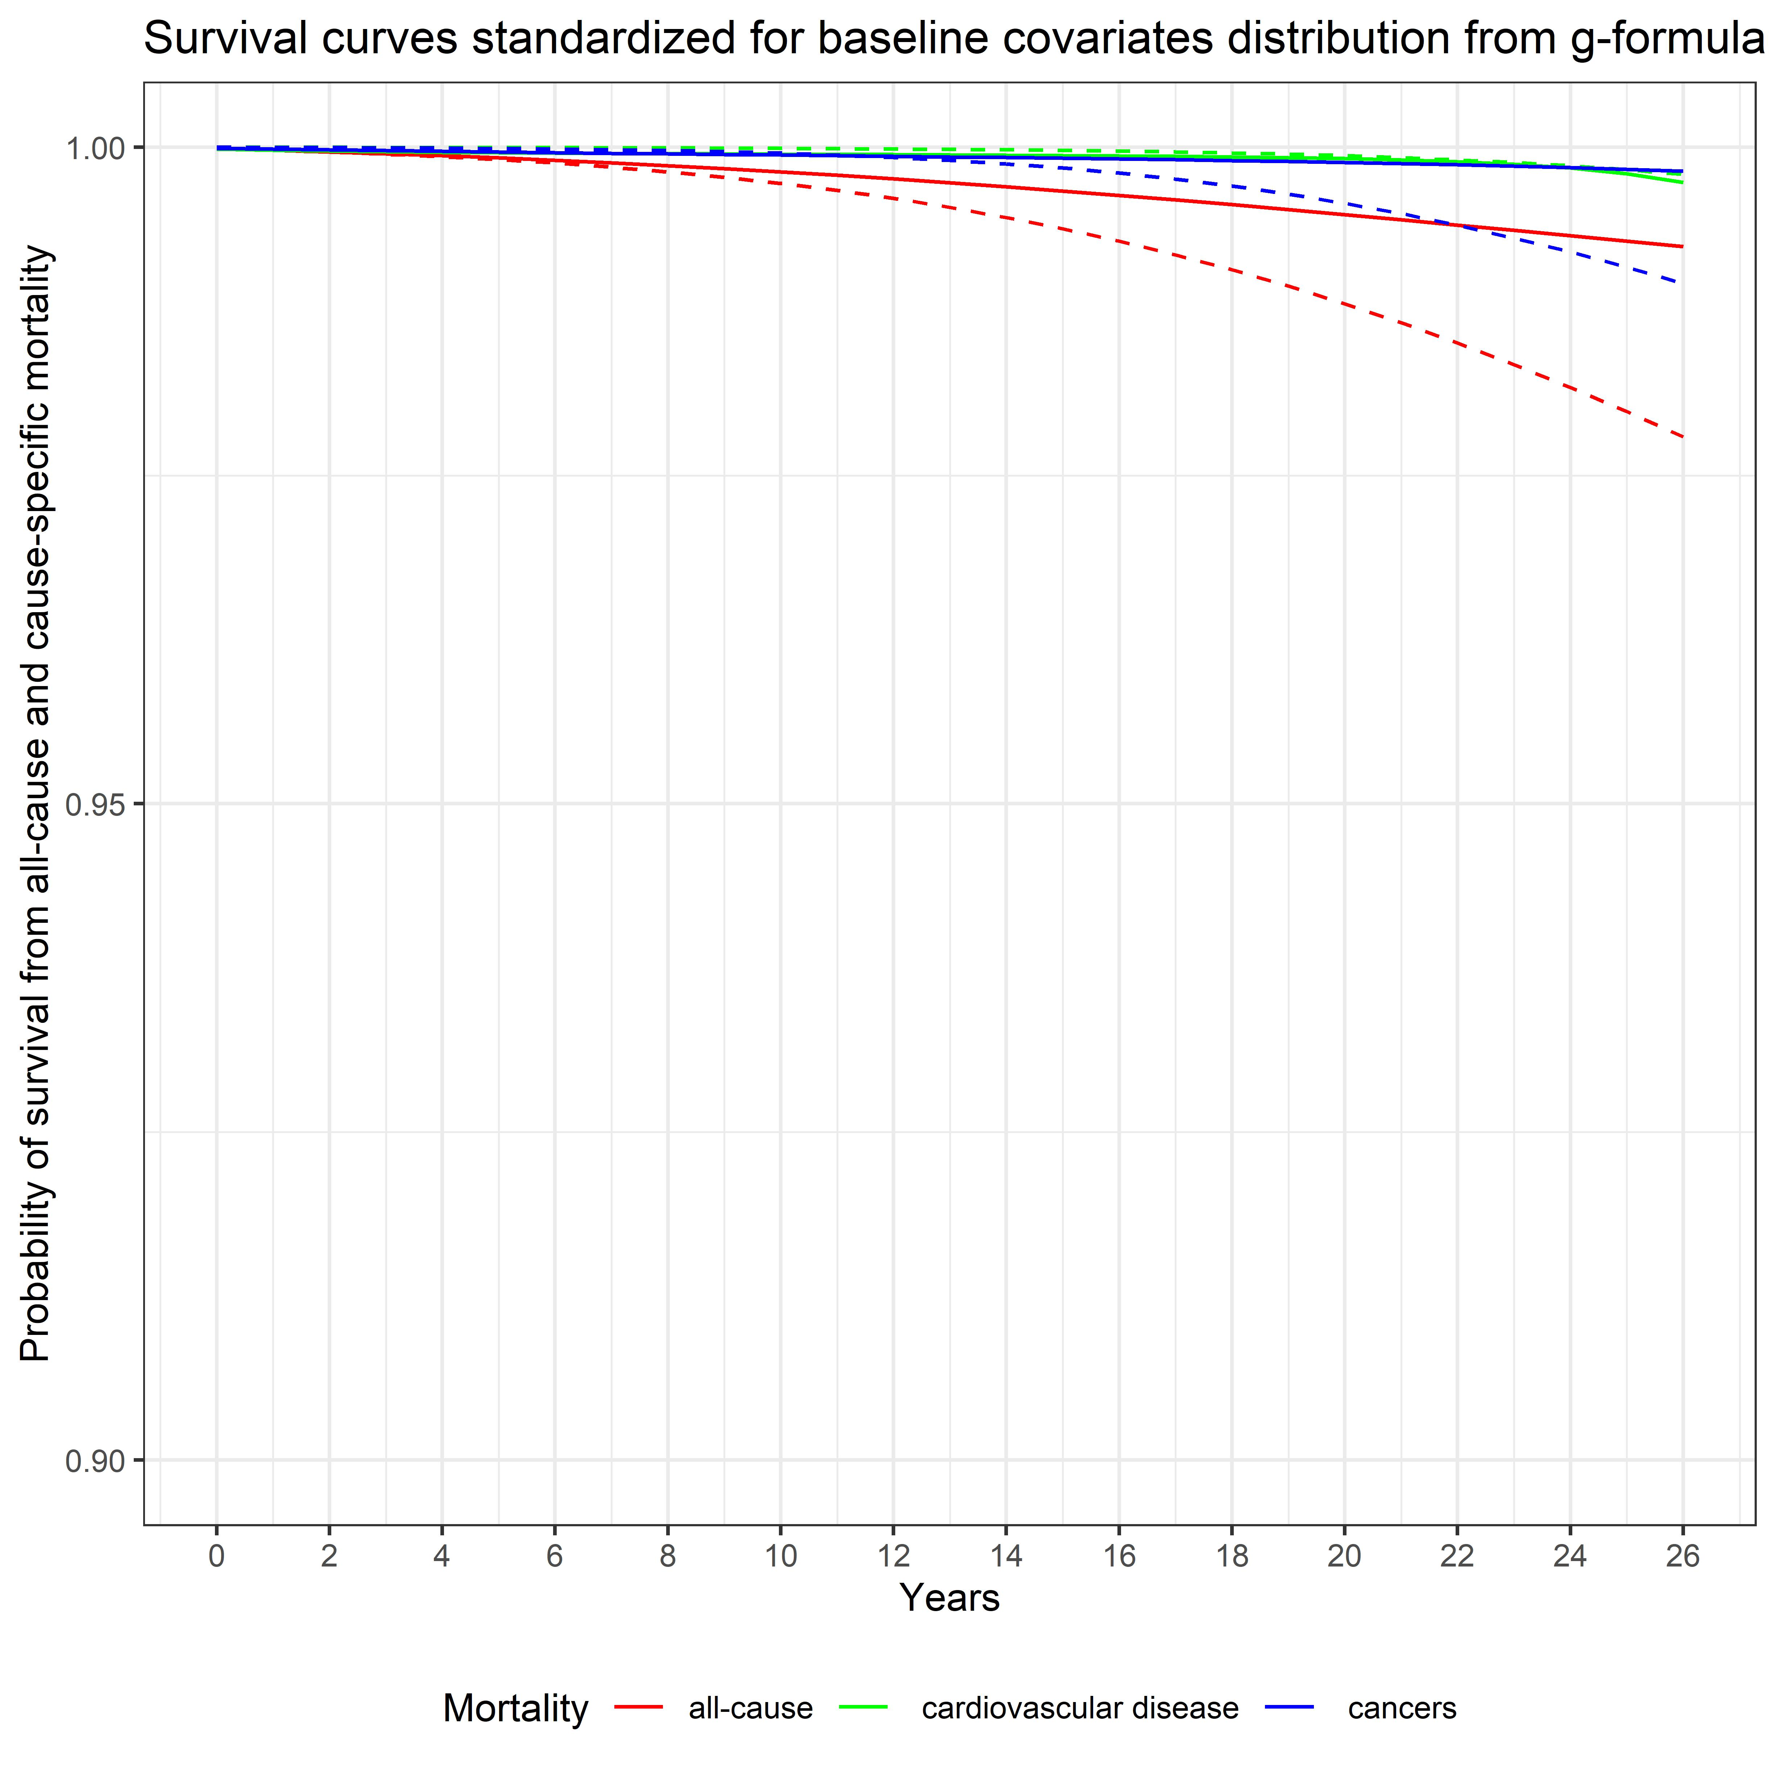
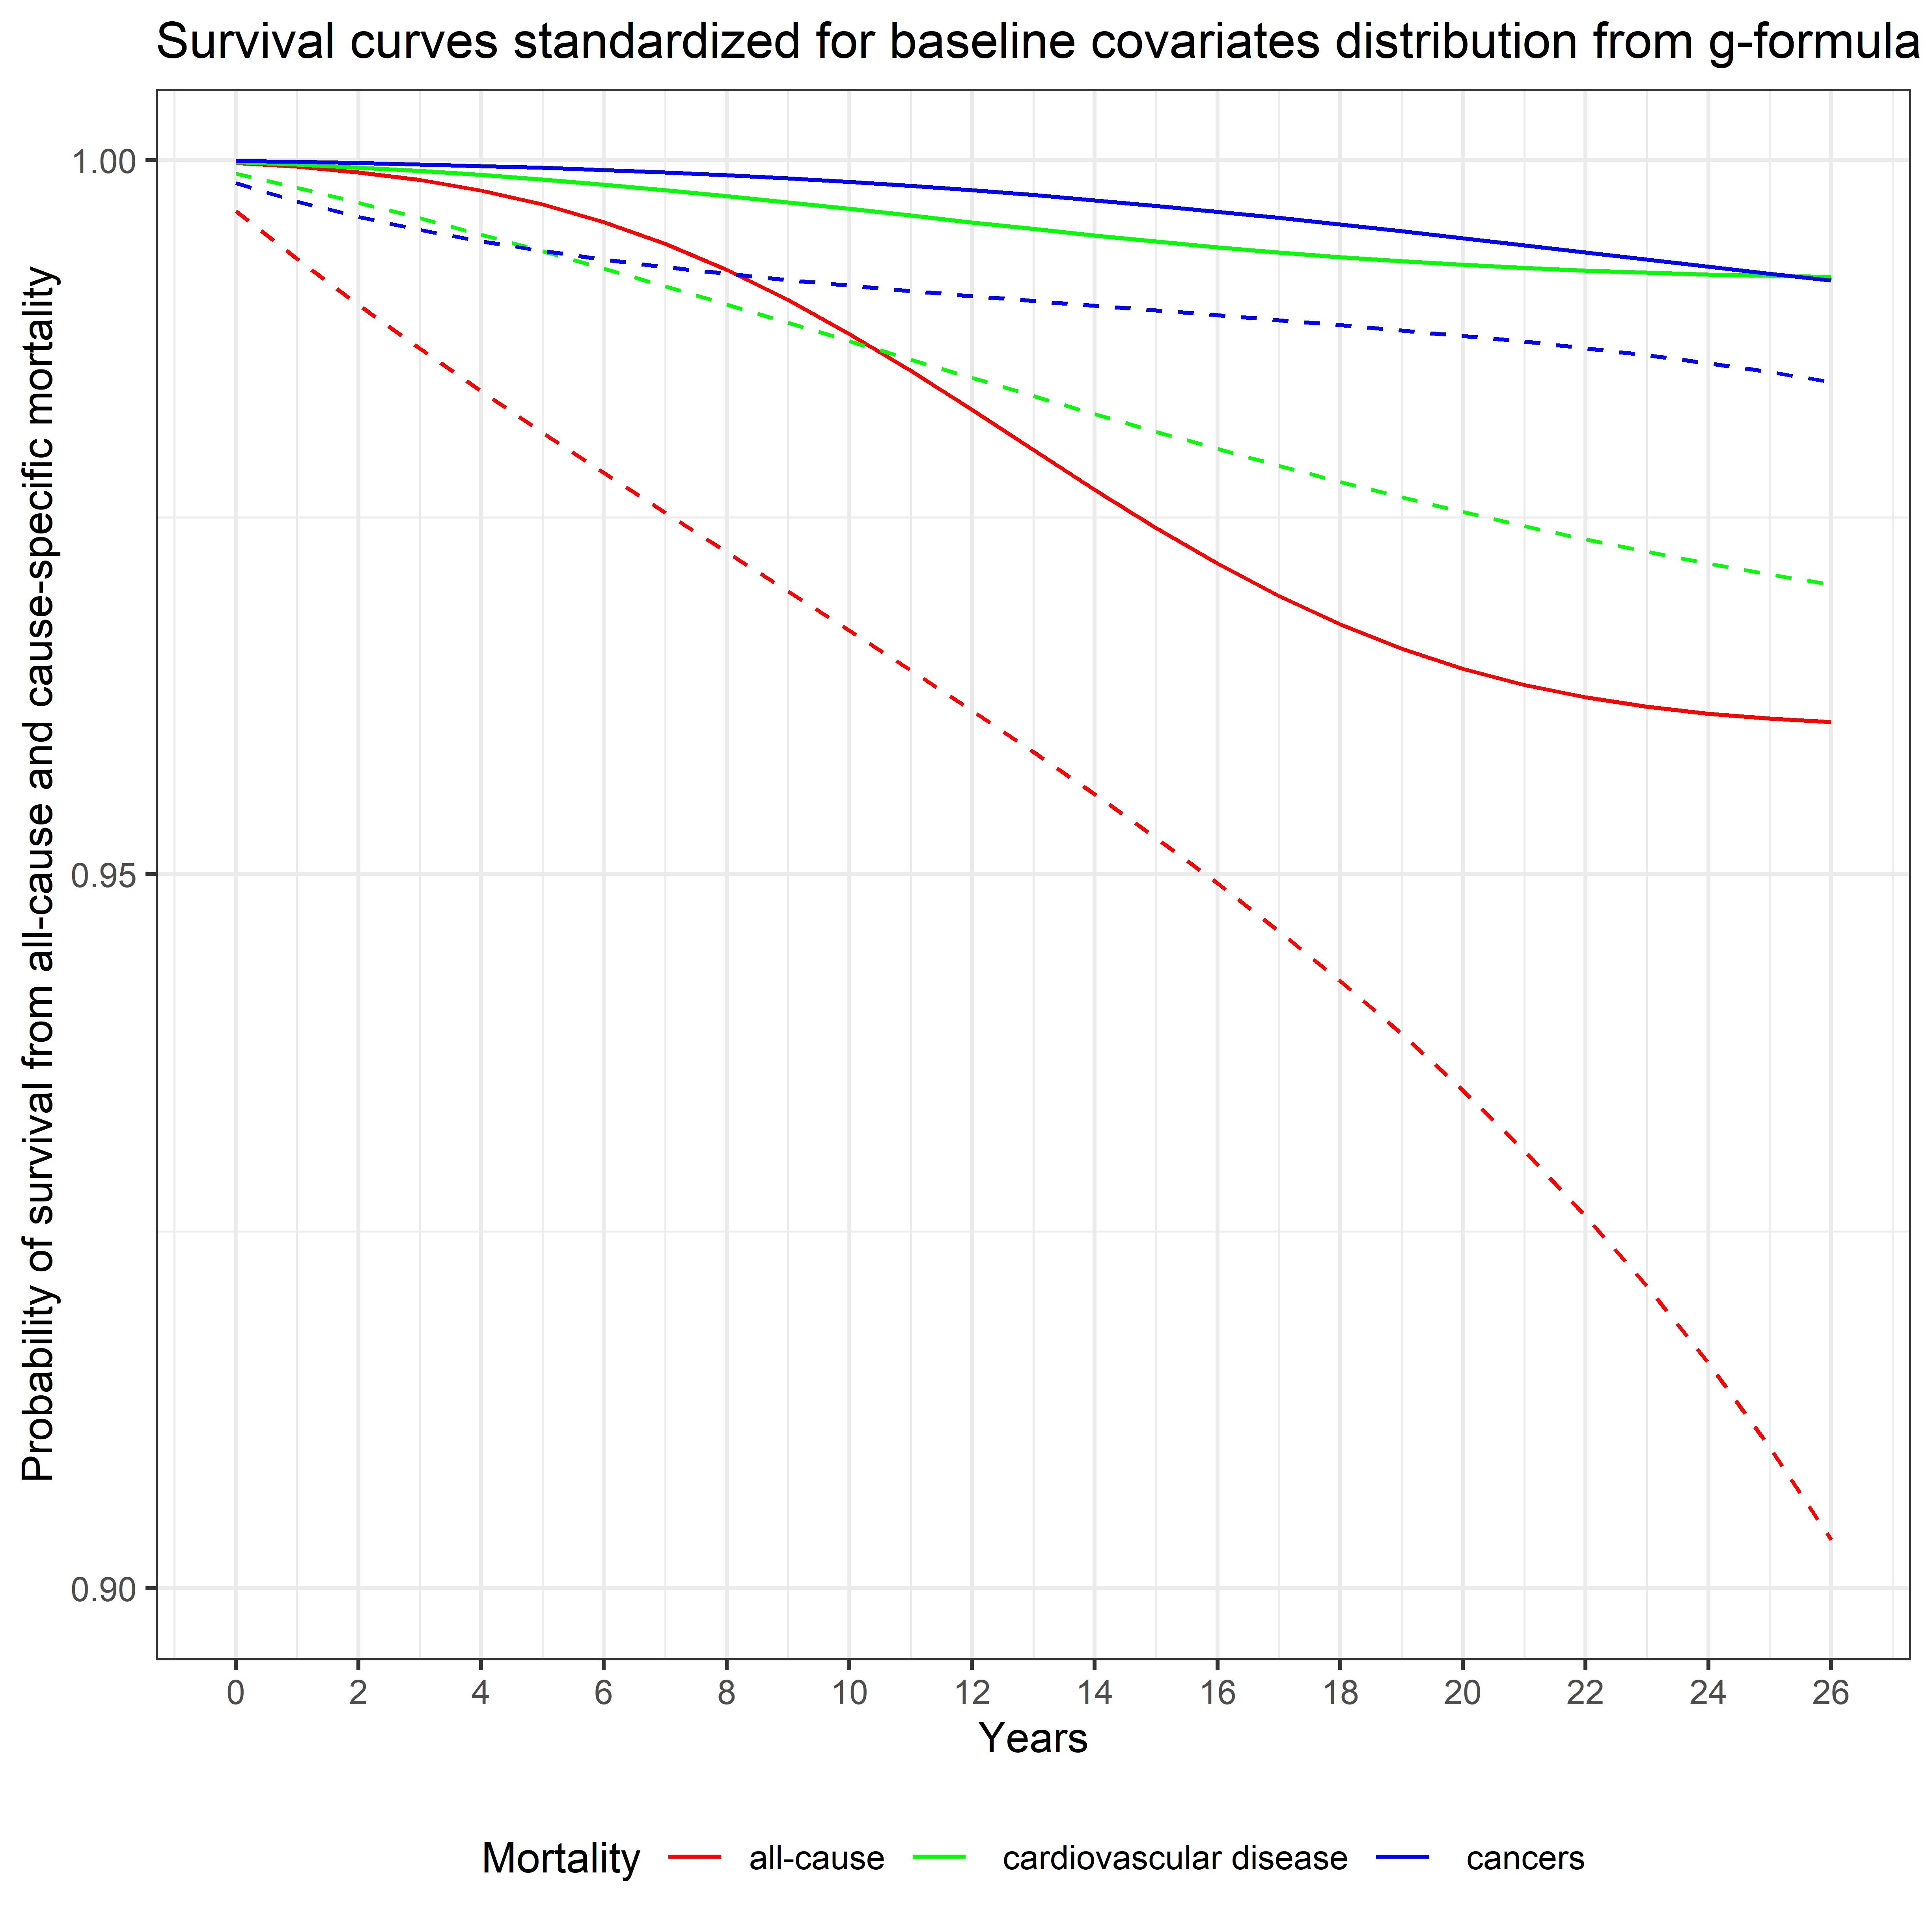

A Urinary cadmium: Age < 50 B Urinary cadmium: Age ≥ 50
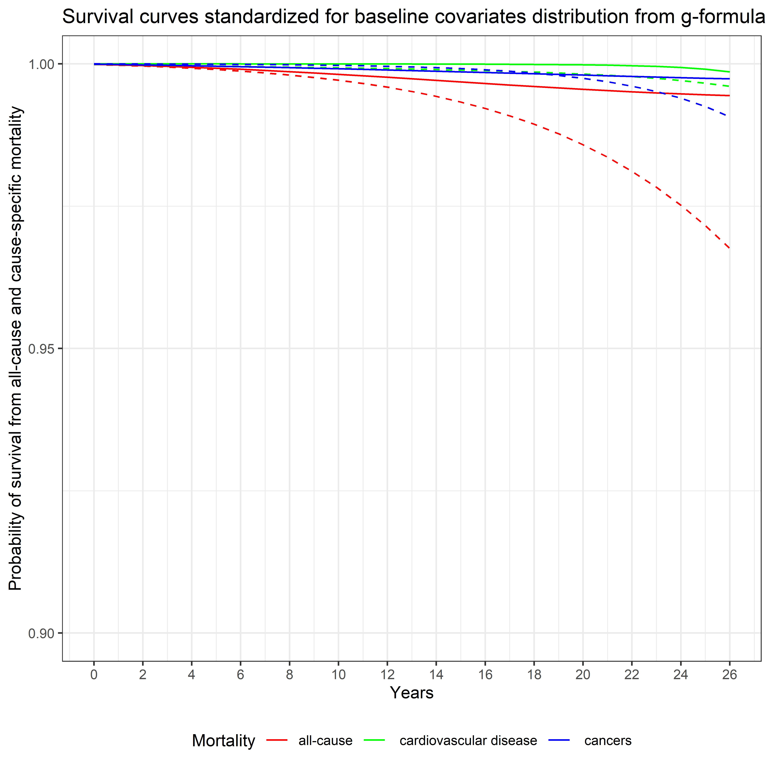
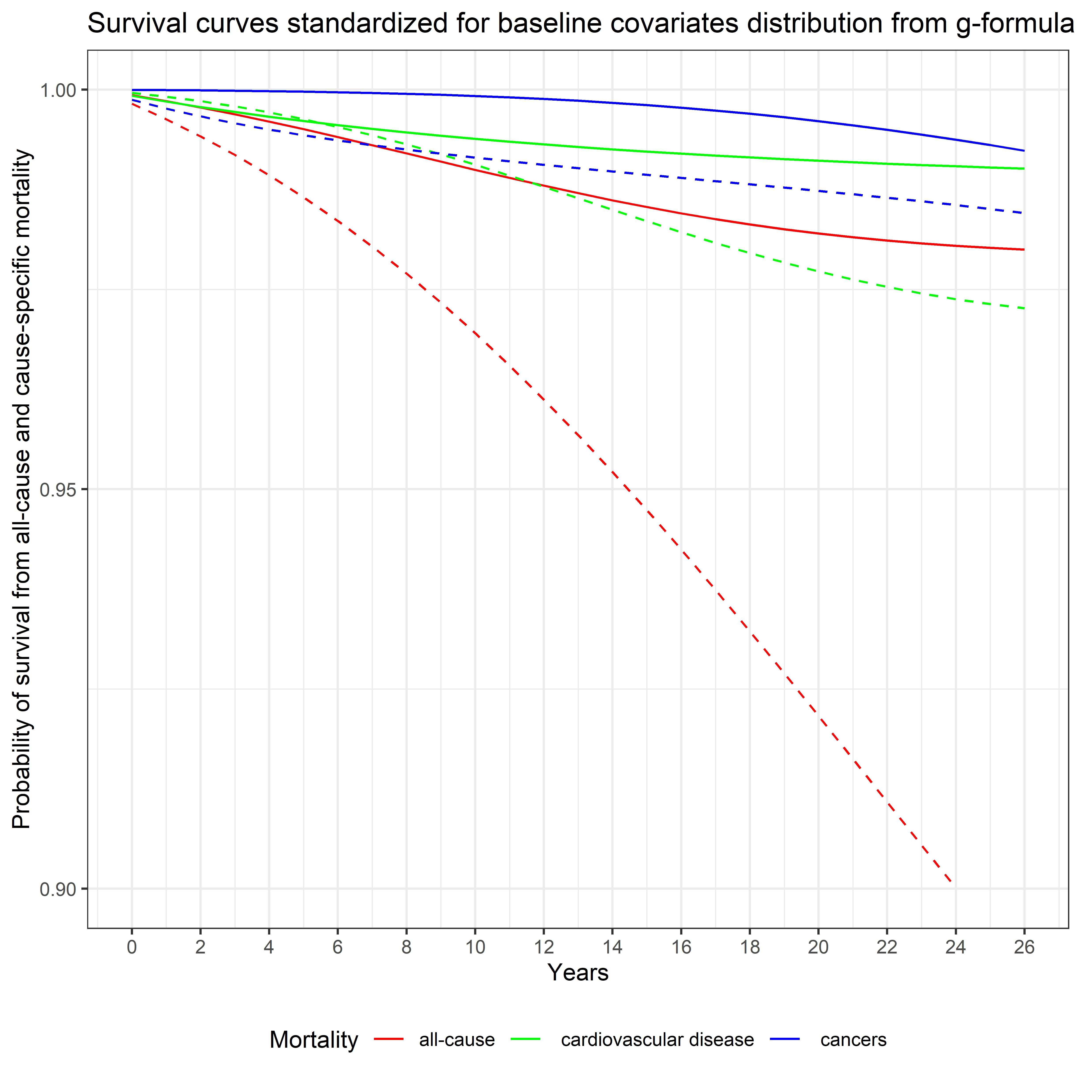

Figure S2: Adjusted all-cause and specific-cause of mortality risk stratified by age using parametric g-formula with pooled logistic regression models. The solid line represents the percentile 5 (0.70 μg/dL for lead and 0.04 μg/g for cadmium) and the dashed lines the percentile 95 (9.70 μg/dL for lead and 1.63 μg/g for cadmium). Robust 95% confidence intervals (CIs) for each exposure category estimated by bootstrapping (in the pooled logistic regression model) are presented in Table S1.

Table S1: Adjusted all-cause and specific-cause of mortality risk ratio and risk difference at the end of follow-up stratified by age using parametric g-formula with pooled logistic regression modelsª

 | Blood lead |  |  | Urinary cadmium
 | Baseline age |  |  | Baseline age
Outcomes | < 50 years | >= 50 years |  | < 50 years | >= 50 years
All-cause mortality
Number of events (%) among low level | 59/944 (6.3%) | 118/273 (43.2%) |  | 60/542 (11.1%) | 62/140 (44.3%)
Number of events (%) among high level | 1082/7851 (13.8%) | 3685/5752 (64.1%) |  | 1104/8006 (13.8%) | 3541/5592 (63.3%)
Adjusted risk ratio (95% CI) | 2.82 (1.02 to 5.81) | 2.34 (1.41 to 3.91) |  | 5.77 (1.97 to 13.39) | 4.16% (1.82 to 8.60)
Adjusted risk difference (95% CI) | +1.38% (0.06 to 3.78) | +5.73% (3.14 to 14.15) |  | +2.25% (1.32 to 5.65) | +9.35% (5.66 to 24.93)
Cardiovascular mortality
Number of events (%) among low level | 8/944 (0.9%) | 27/273 (9.9%) |  | 12/542 (2.2%) | 18/140 (12.9%)
Number of events (%) among high level | 228/7851 (2.9%) | 1195/5752 (20.8%) |  | 233/8006 (2.9%) | 1172/5592 (21.0%)
Adjusted risk ratio (95% CI) | 0.78 (0.07 to 6.38) | 3.18 (1.40 to 7.46) |  | 2.74 (1.08 to 38.06) | 2.43 (1.21 to 5.02)
Adjusted risk difference (95% CI) | -0.06% (-2.62 to 0.54) | +2.11% (0.98 to 5.78) |  | +0.22% (0.04 to 1.22) | +1.73% (0.49 to 5.62)
Cancer mortality
Number of events (%) among low level | 24/944 (2.5%) | 25/273 (9.2%) |  | 12/542 (2.2%) | 10/140 (7.1%)
Number of events (%) among high level | 277/7851 (3.5%) | 750/5752 (13.0%) |  | 286/8006 (3.6%) | 721/5592 (12.9%)
Adjusted risk ratio (95% CI) | 5.36 (1.01 to 21.15) | 1.85 (0.65 to 6.48) |  | 3.13 (0.58 to 12.73) | 2.09 (0.80 to 9.39)
Adjusted risk difference (95% CI) | +0.80% (0.01 to 2.38) | 0.74% (-0.81 to 3.23) |  | +0.54% (-0.27 to 2.42) | +0.88% (-0.42 to 4.00)
ª200 iterations were performed for bootstrapping the estimates 95% confidence interval
Low level: 5th percentiles of blood lead (0.70 μg/dL or 0.03 umol/L) and urinary cadmium (0.04 μg/g) distributions
High level: 95th percentiles of blood lead (9.70 μg/dL or 0.47 umol/L) and urinary cadmium (1.63 μg/g) distributions

A Blood lead: Women B Blood lead: Men
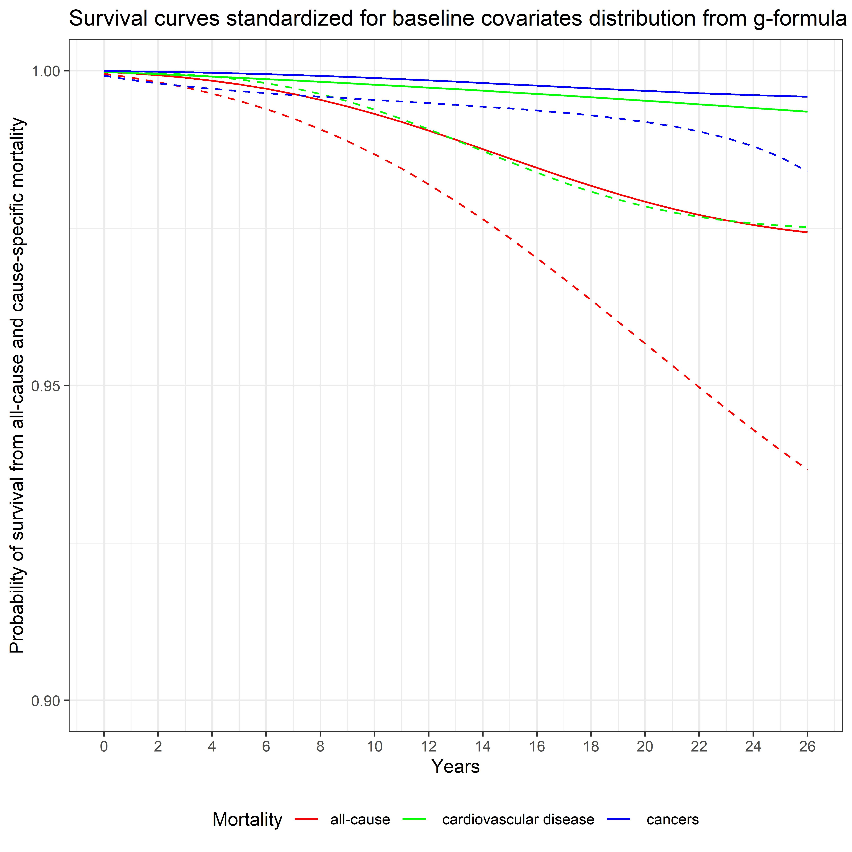
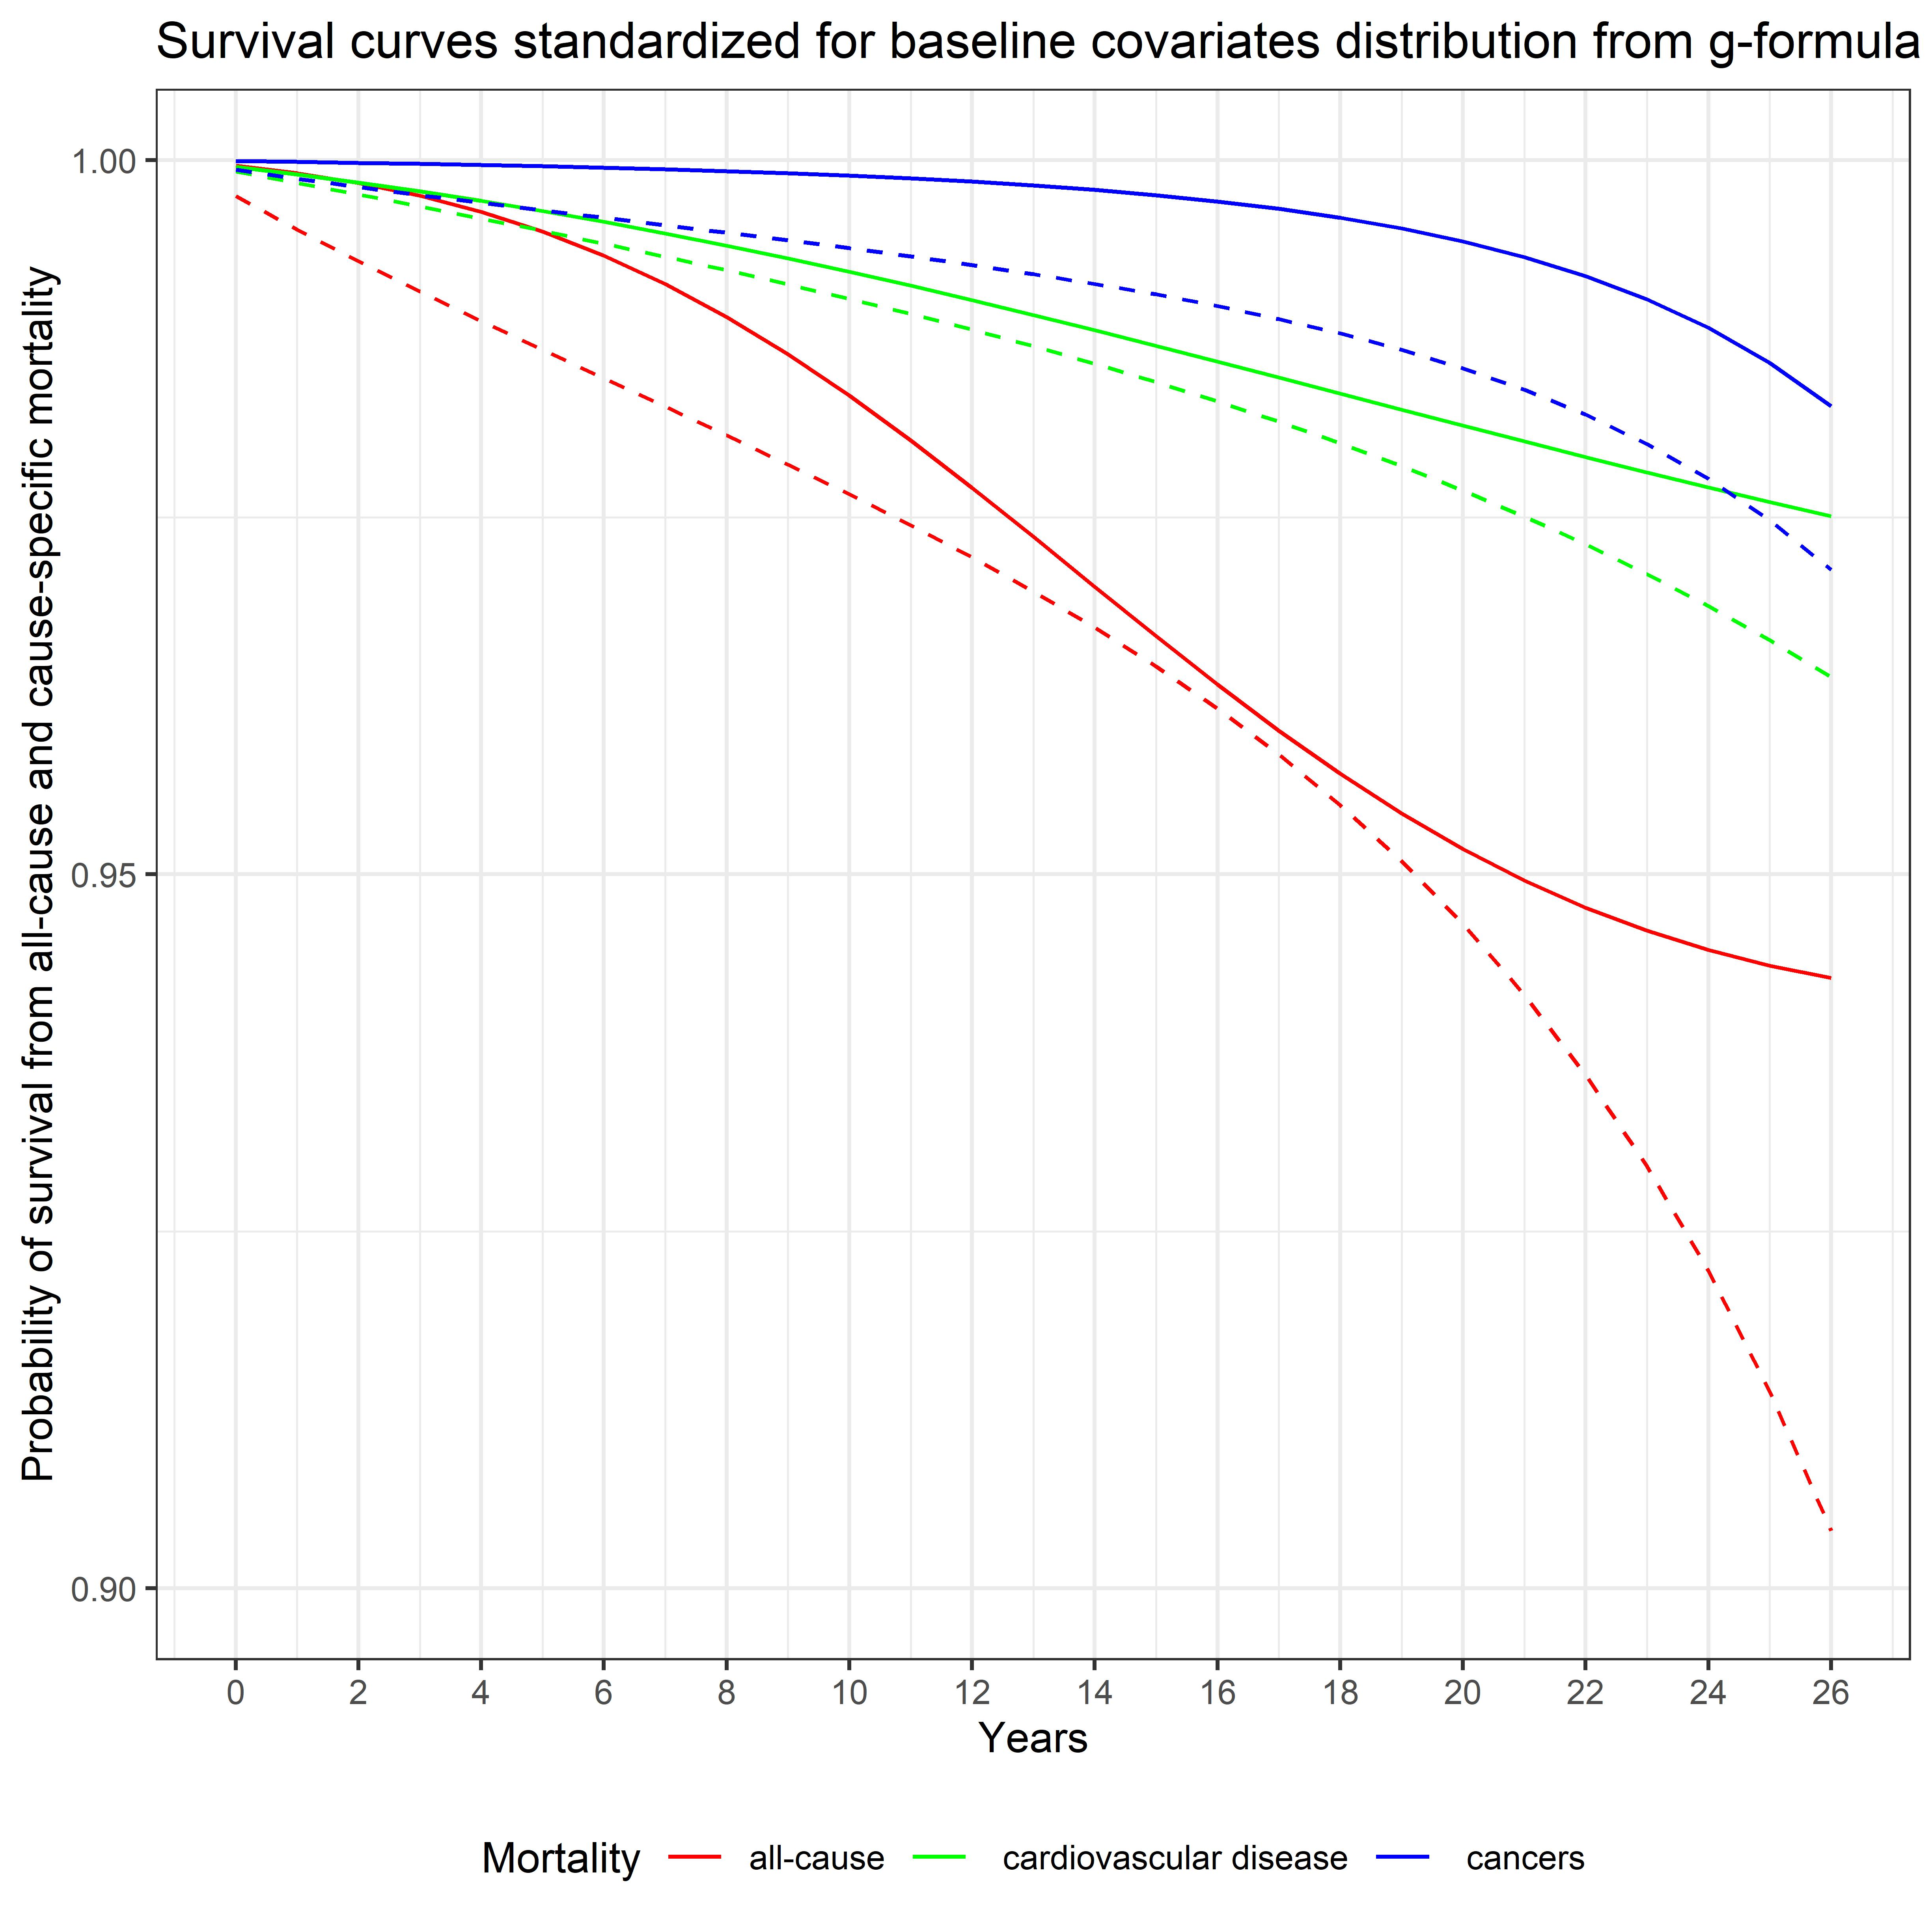

A Urinary cadmium: Women B Urinary cadmium: Men
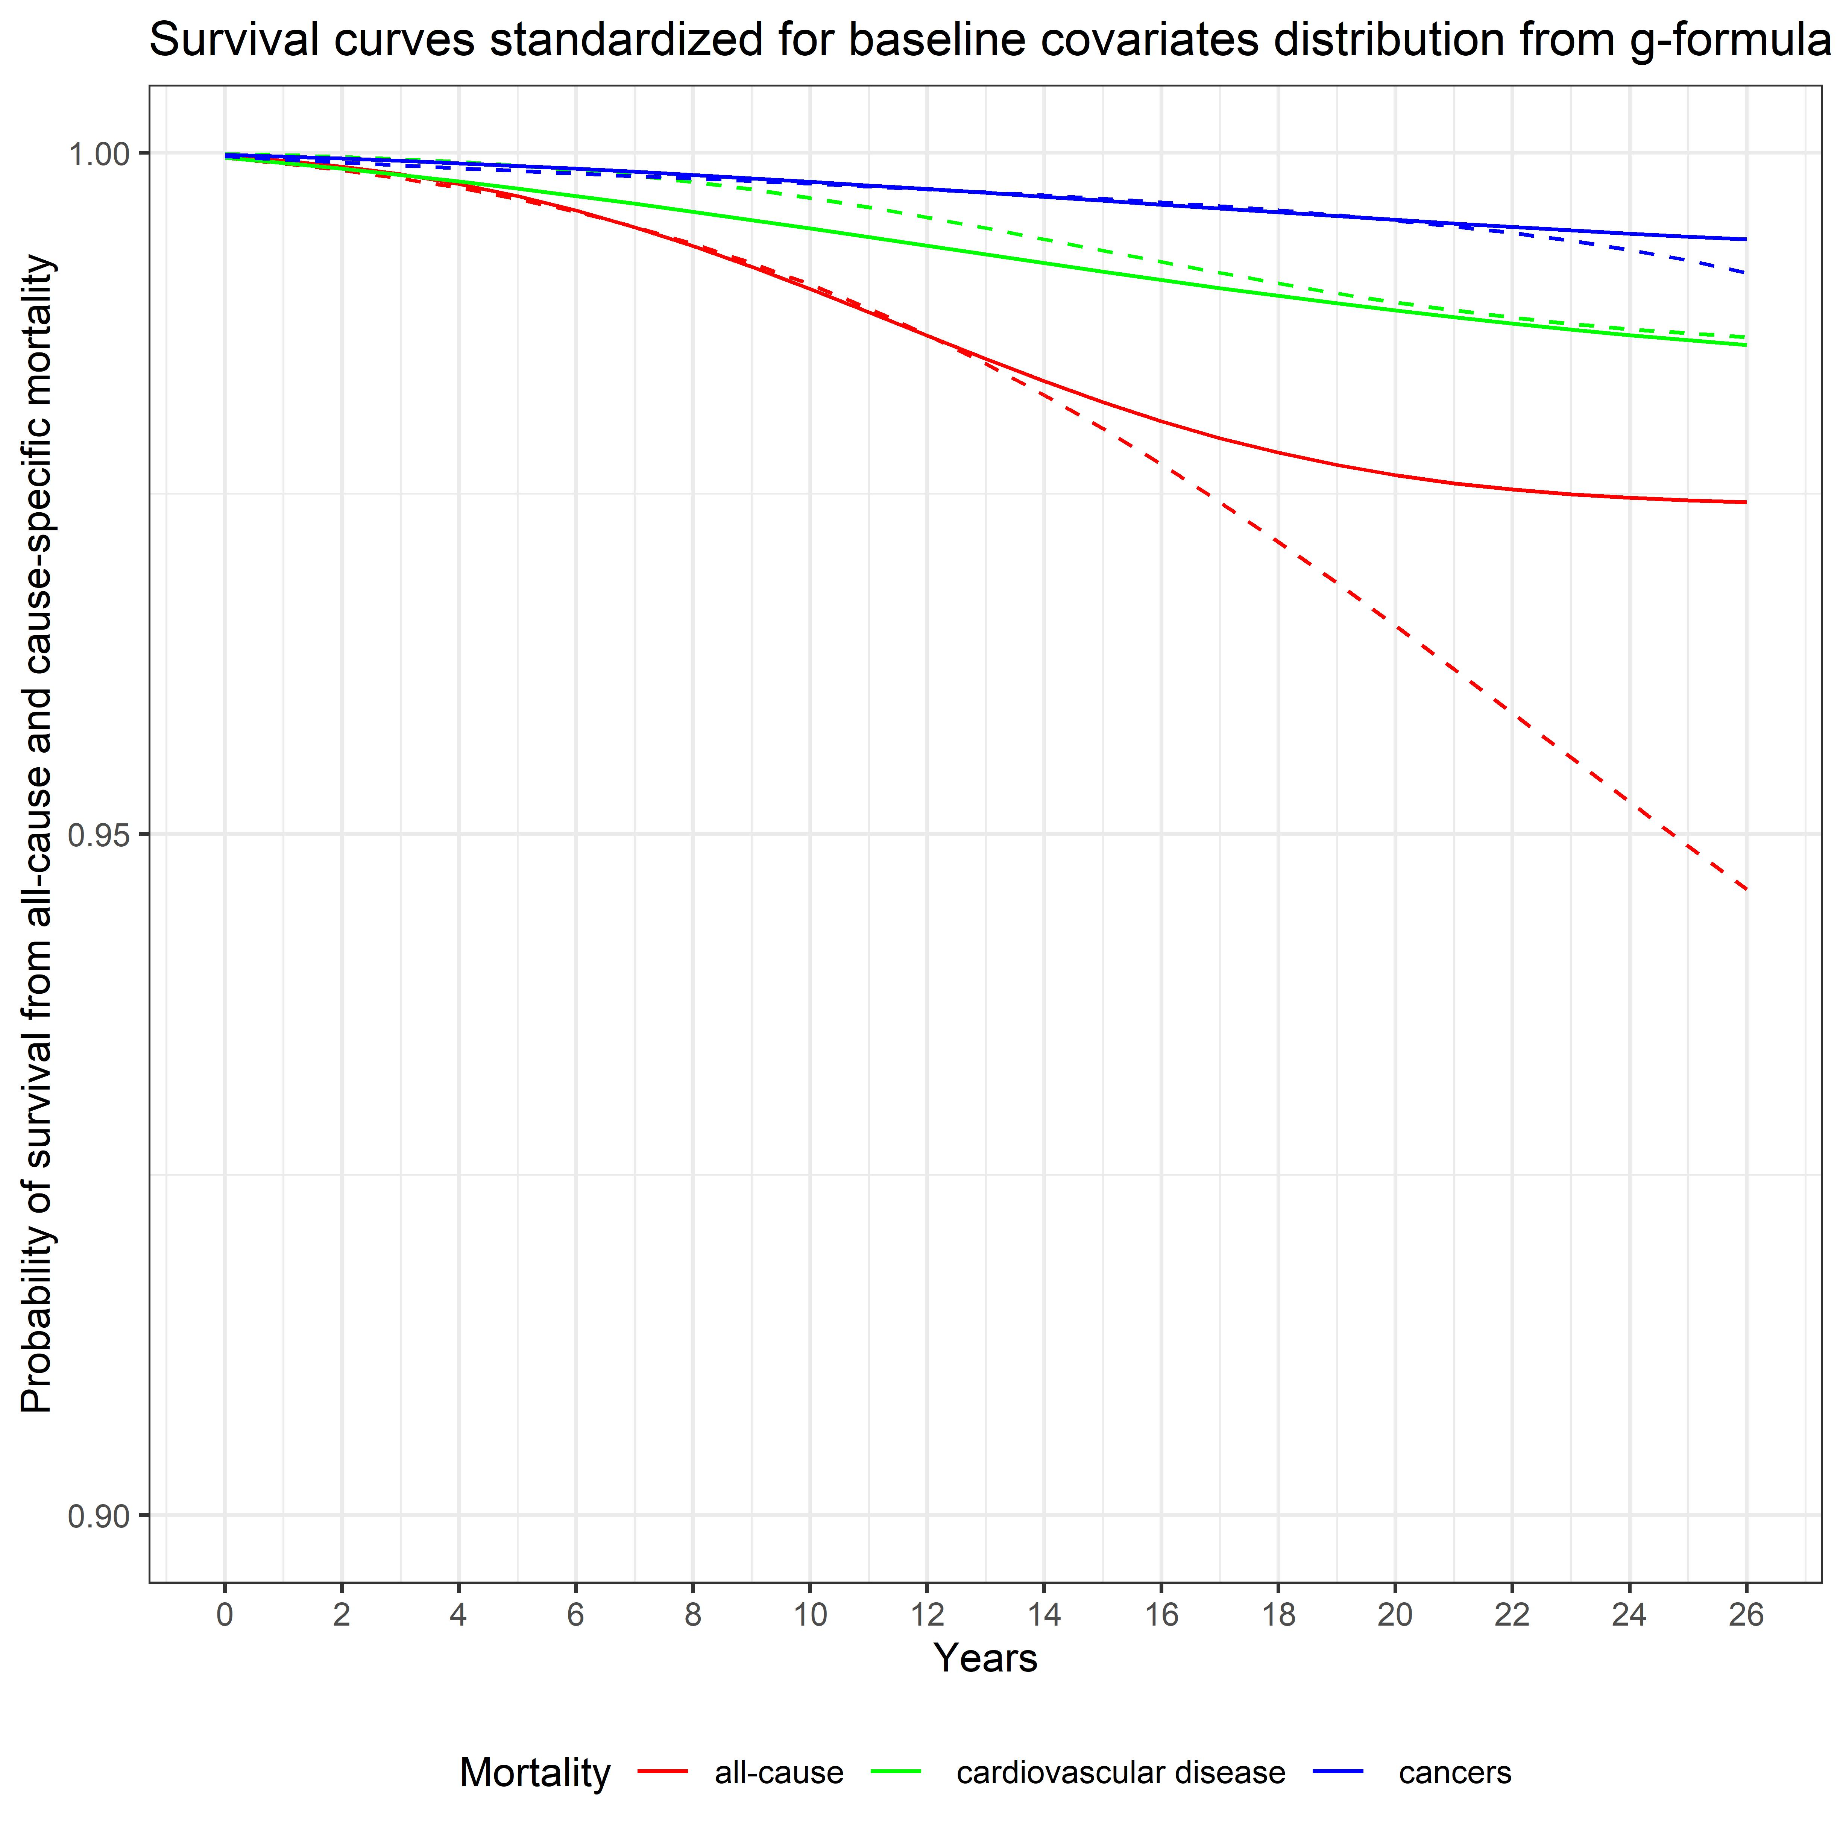
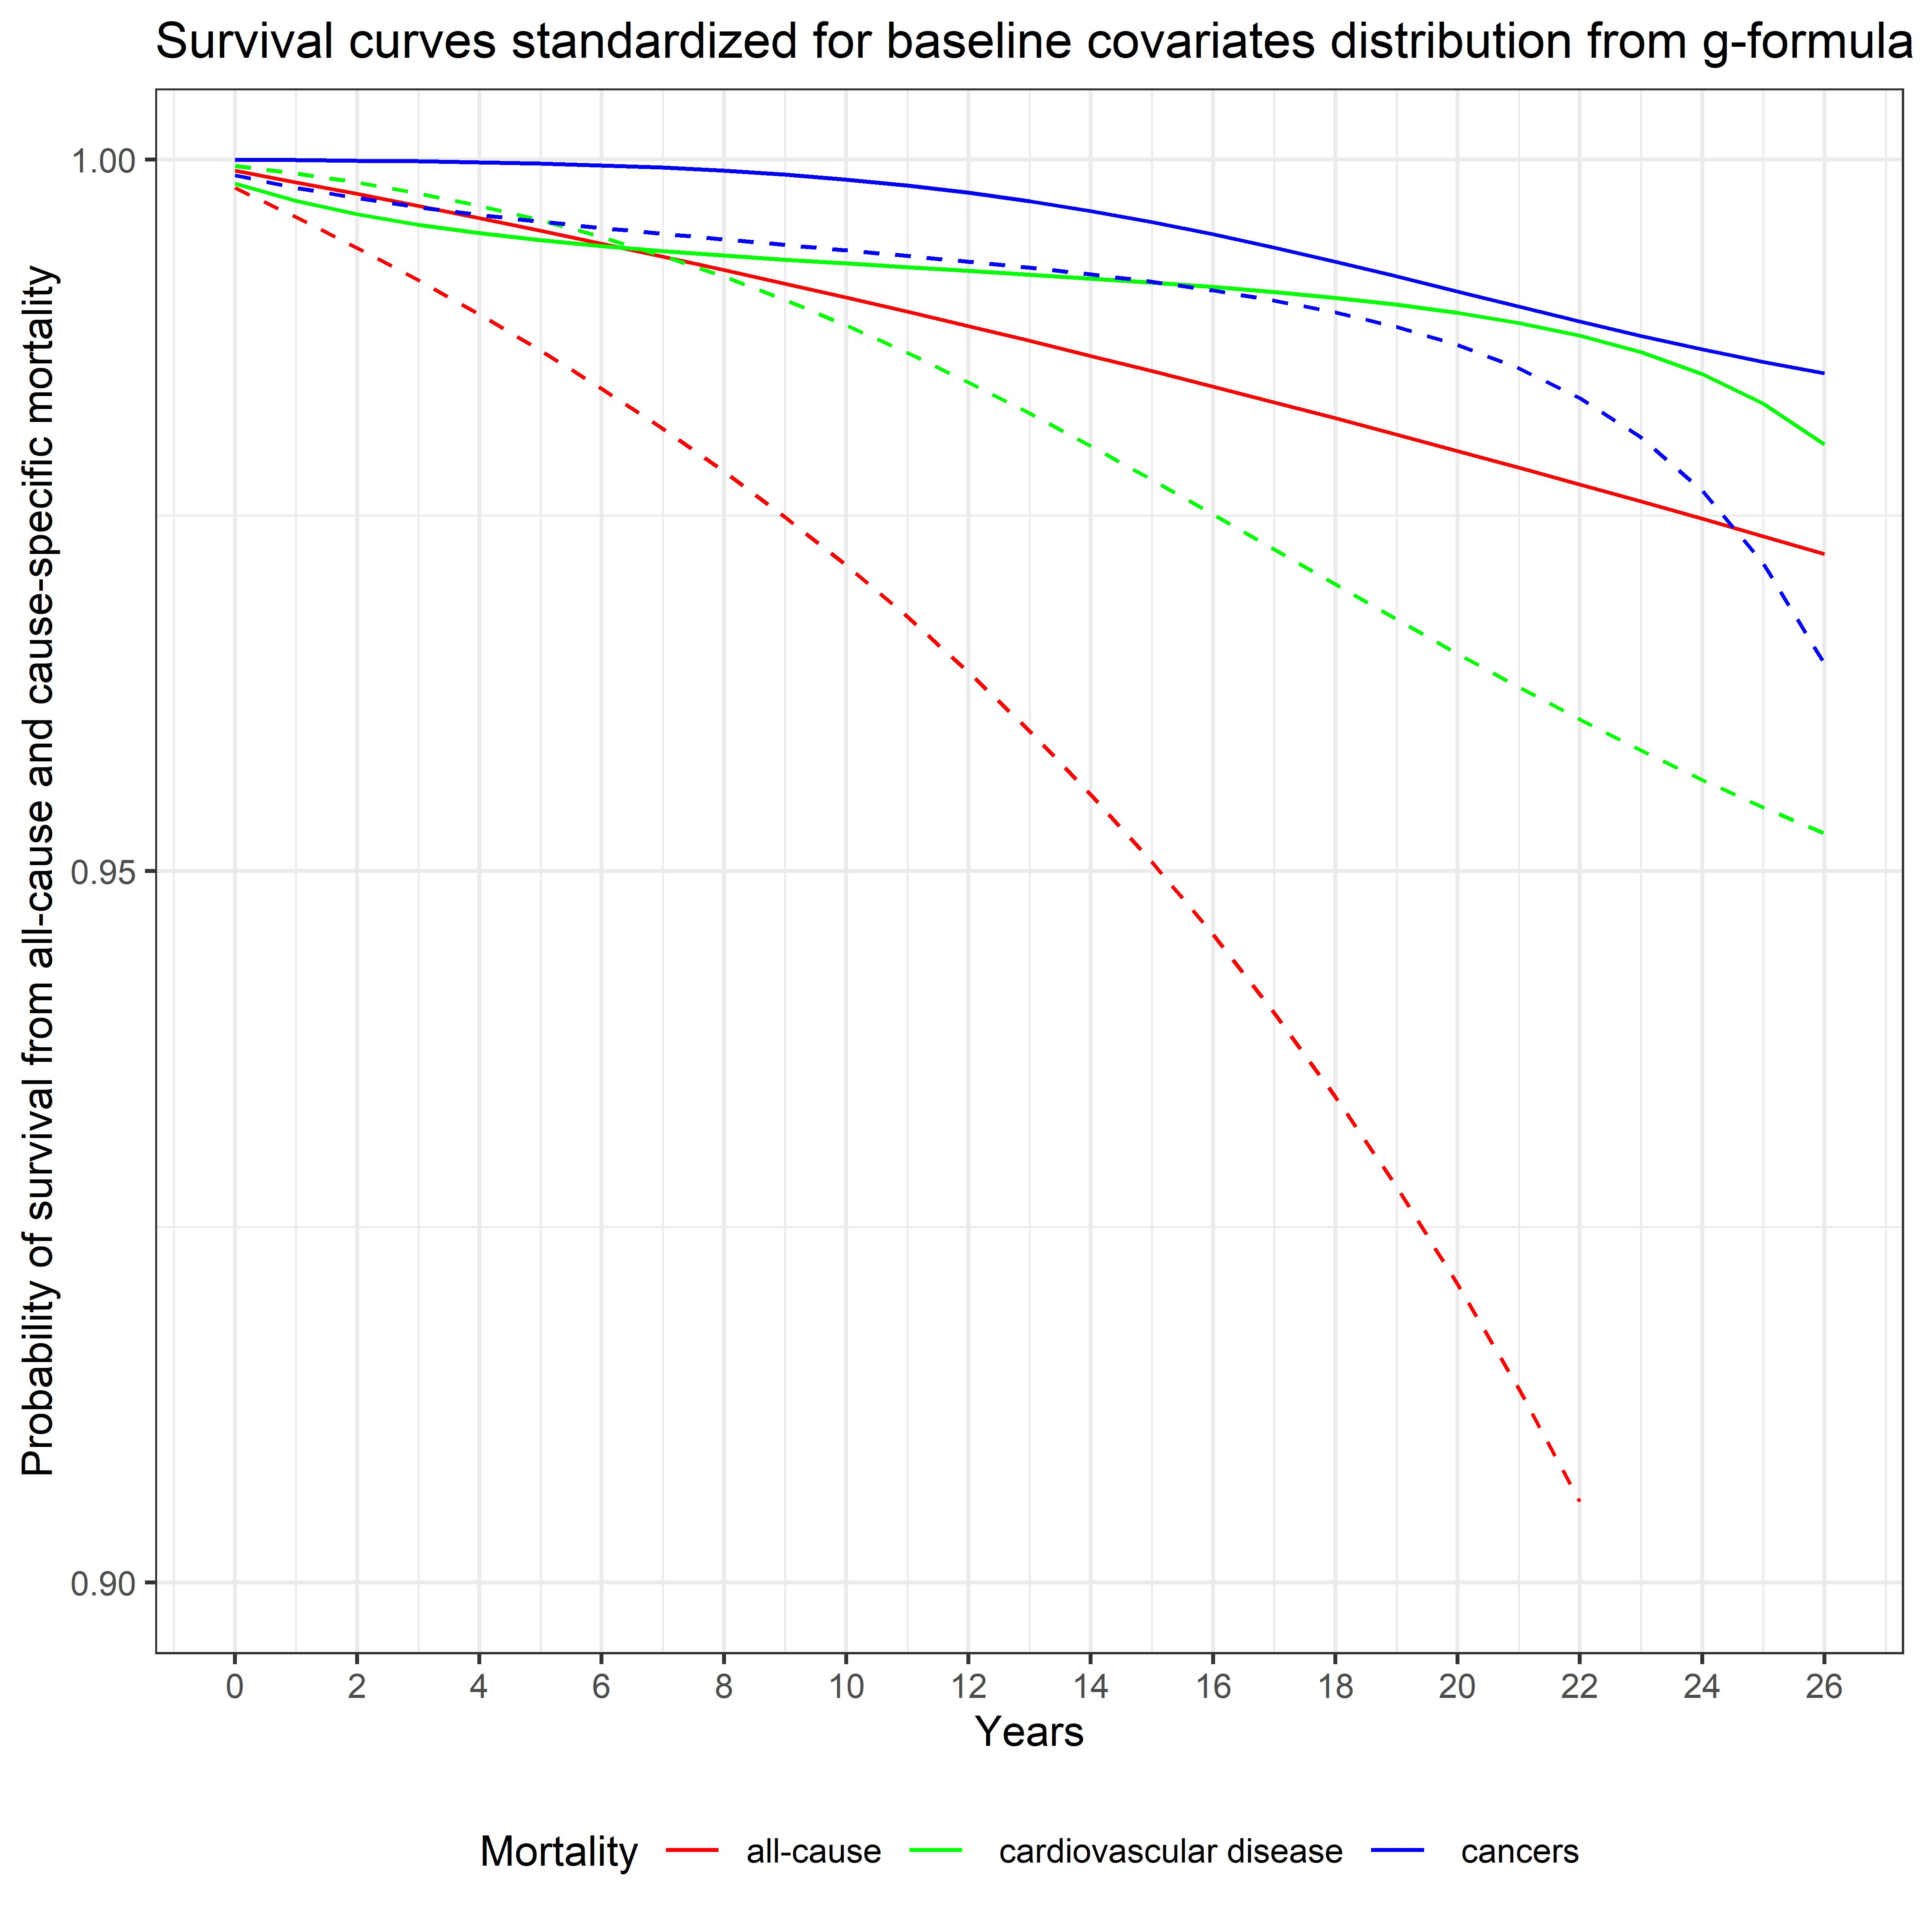

Figure S3: Adjusted all-cause and specific-cause of mortality risk stratified by sex using parametric g-formula with pooled logistic regression models. The solid line represents the percentile 5 (0.70 μg/dL for lead and 0.04 μg/g for cadmium) and the dashed lines the percentile 95 (9.70 μg/dL for lead and 1.63 μg/g for cadmium). Robust 95% confidence intervals (CIs) for each exposure category estimated by bootstrapping (in the pooled logistic regression model) are presented in Table S2.

Table S2: Adjusted all-cause and specific-cause of mortality risk ratio and risk difference at the end of follow-up stratified by sex using parametric g-formula with pooled logistic regression modelsª

 | Blood lead |  |  | Urinary cadmium
Outcomes | Women | Men |  | Women | Men
All-cause mortality
Number of events (%) among low level | 146/1060 (13.8%) | 31/157 (19.8%) |  | 52/296 (17.8%) | 70/386 (18.1%)
Number of events (%) among high level | 2332/7424 (31.4%) | 2435/6179 (39.4%) |  | 2067/7073 (29.2%) | 2578/6525 (39.5%)
Adjusted risk ratio (95% CI) | 2.22 (1.01 to 3.70) | 1.65 (0.99 to 2.32) |  | 2.11 (0.90 to 5.02) | 5.11 (2.20 to 9.95)
Adjusted risk difference (95% CI) | +3.13% (0.03 to 7.31) | +4.01% (-0.21 to 8.79) |  | +2.93% (-0.65 to 10.03) | +10.06% (6.56 to 18.06)
Cardiovascular mortality
Number of events (%) among low level | 29/1060 (2.7%) | 6/157 (3.8%) |  | 13/296 (4.4%) | 17/386 (4.4%)
Number of events (%) among high level | 690/7424 (9.3%) | 733/6179 (11.9%) |  | 618/7073 (8.7%) | 787/6525 (12.1%)
Adjusted risk ratio (95% CI) | 3.24 (1.19 to 6.42) | 1.37 (0.71 to 2.70) |  | 0.97 (0.37 to 2.65) | 2.34 (1.02 to 6.52)
Adjusted risk difference (95% CI) | +1.46% (0.28 to 3.95) | +1.01% (-1.57 to 4.19) |  | -0.04% (-2.24 to 1.72) | +2.59% (0.07 to 7.13)
Cancer mortality
Number of events (%) among low level | 45/1060 (4.3%) | 4/157 (2.6%) |  | 15/296 (5.1%) | 7/386 (1.8%)
Number of events (%) among high level | 487/7424 (6.6%) | 540/6179 (8.7%) |  | 435/7073 (6.2%) | 572/6525 (8.8%)
Adjusted risk ratio (95% CI) | 3.20 (0.78 to 10.28) | 1.57 (0.56 to 5.17) |  | 1.38 (0.46 to 5.67) | 2.33 (0.45 to 11.48)
Adjusted risk difference (95% CI) | +0.91% (-0.23 to 3.42) | +1.09% (-2.05 to 4.60) |  | +0.25% (-0.72 to 1.80) | +1.92% (-0.03 to 6.76)
ª200 iterations were performed for bootstrapping the estimates 95% confidence interval
Low level: 5th percentiles of blood lead (0.70 μg/dL or 0.03 umol/L) and urinary cadmium (0.04 μg/g) distributions
High level: 95th percentiles of blood lead (9.70 μg/dL or 0.47 umol/L) and urinary cadmium (1.63 μg/g) distributions

Table S3: Unweighted adjusted all-cause and specific-cause of mortality risk ratio and risk difference of metals percentile 95 and 5 values using parametric g-formula with weighted pooled logistic regression modelsª

Outcomes | Blood lead |  | Urinary cadmium
All-cause mortality
Number of events (%) among low level | 177/1217 (14.5%) |  | 122/682 (17.9%)
Number of events (%) among high level | 4767/13603 (35.0%) |  | 4645/13598 (34.2%)
Adjusted risk ratio (95% CI) | 1.60 (1.20 to 2.40) |  | 2.70 (2.07 to 4.87)
Adjusted risk difference (95% CI) | +3.91% (1.84 to 8.36) |  | +6.90% (6.00 to 11.88)
Cardiovascular mortality
Number of events (%) among low level | 35/1217 (2.9%) |  | 30/682 (4.4%)
Number of events (%) among high level | 1423/13603 (10.5%) |  | 1405/13598 (10.3%)
Adjusted risk ratio (95% CI) | 1.02 (0.52 to 2.80) |  | 2.64 (1.47 to 5.58)
Adjusted risk difference (95% CI) | +0.69% (-2.72 to 3.85) |  | +0.22% (1.13 to 5.32)
Cancer mortality
Number of events (%) among low level | 49/1217 (4.0%) |  | 22/682 (3.2%)
Number of events (%) among high level | 1027/13603 (7.6%) |  | 1007/13598 (7.4%)
Adjusted risk ratio (95% CI) | 2.41 (0.70 to 3.69) |  | 3.30 (1.03 to 7.00)
Adjusted risk difference (95% CI) | +0.49% (-1.66 to 2.42) |  | +1.11% (0.05 to 3.23)
ª200 iterations were performed for bootstrapping the estimates 95% confidence interval
low level: 5th percentiles of blood lead (0.70 μg/dL or 0.03 umol/L) and urinary cadmium (0.04 μg/g) distributions
high level: 95th percentiles of blood lead (9.70 μg/dL or 0.47 umol/L) and urinary cadmium (1.63 μg/g) distributions

Table S4: Mid-follow-up (13 years) adjusted all-cause and specific-cause of mortality risk ratio and risk difference of metals percentile 95 and 5 values using parametric g-formula with pooled logistic regression modelsª

Outcomes | Blood lead |  | Urinary cadmium
All-cause mortality
Adjusted risk ratio (95% CI) | 3.17 (1.26 to 3.24) |  | 1.80 (1.76 to 4.95)
Adjusted risk difference (95% CI) | +0.85% (0.44 to 4.28) |  | +2.03% (1.14 to 5.47)
Cardiovascular mortality
Adjusted risk ratio (95% CI) | 2.10 (1.09 to 3.65) |  | 0.86 (0.74 to 2.98)
Adjusted risk difference (95% CI) | +0.47% (0.01 to 1.96) |  | +0.27% (-0.45 to 1.69)
Cancer mortality
Adjusted risk ratio (95% CI) | 5.27 (1.18 to 8.38) |  | 3.51 (0.67 to 4.34)
Adjusted risk difference (95% CI) | +0.35% (0.10 to 1.94) |  | +0.18% (-0.41 to 1.39)
ª200 iterations were performed for bootstrapping the estimates 95% confidence interval
low level: 5th percentiles of blood lead (0.70 μg/dL or 0.03 umol/L) and urinary cadmium (0.04 μg/g) distributions
high level: 95th percentiles of blood lead (9.70 μg/dL or 0.47 umol/L) and urinary cadmium (1.63 μg/g) distributions

Table S5: Mid-follow-up (13 years) adjusted all-cause and specific-cause of mortality risk ratio and risk difference of metals extreme quartiles using parametric g-formula with pooled logistic regression modelsª
Outcomes | Blood lead |  | Urinary cadmium
All-cause mortality
Adjusted risk ratio (95% CI) | 1.76 (1.16 to 3.69) |  | 1.83 (1.75 to 5.65)
Adjusted risk difference (95% CI) | +0.42% (0.38 to 7.45) |  | +2.42% (1.03 to 11.22)
Cardiovascular mortality
Adjusted risk ratio (95% CI) | 3.82 (1.42 to 24.26) |  | 7.33 (3.06 to 100.04)
Adjusted risk difference (95% CI) | +0.91% (0.46 to 19.84) |  | +3.74% (2.85 to 50.26)
Cancer mortality
Adjusted risk ratio (95% CI) | 2.86 (1.07 to 15.31) |  | 3.23 (0.47 to 34.71)
Adjusted risk difference (95% CI) | +0.21% (0.08 to 9.42) |  | +0.12% (-0.55 to 18.23)
ª200 iterations were performed for bootstrapping the estimates 95% confidence interval

