Supplementary information

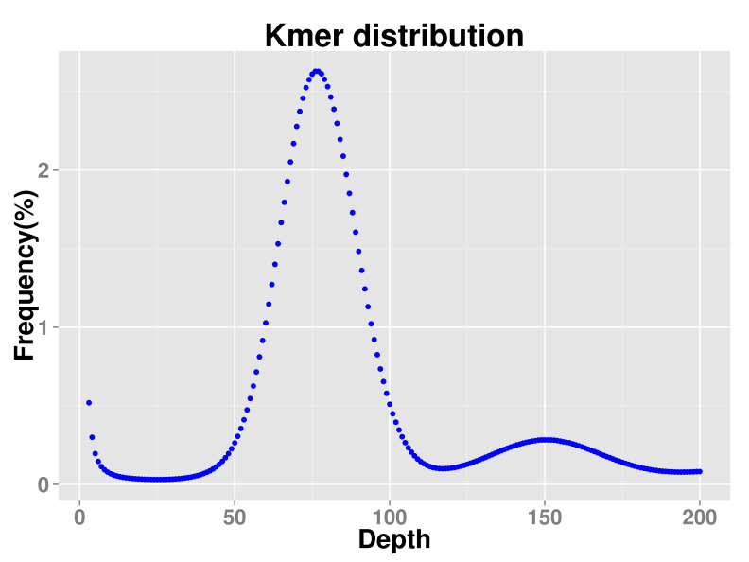
Fig. S1 Frequency distribution of the 19-mer graph for C. tora.

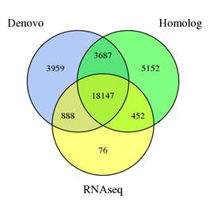
Supplementary Fig. S2 Distribution of integrated genes from three prediction modes

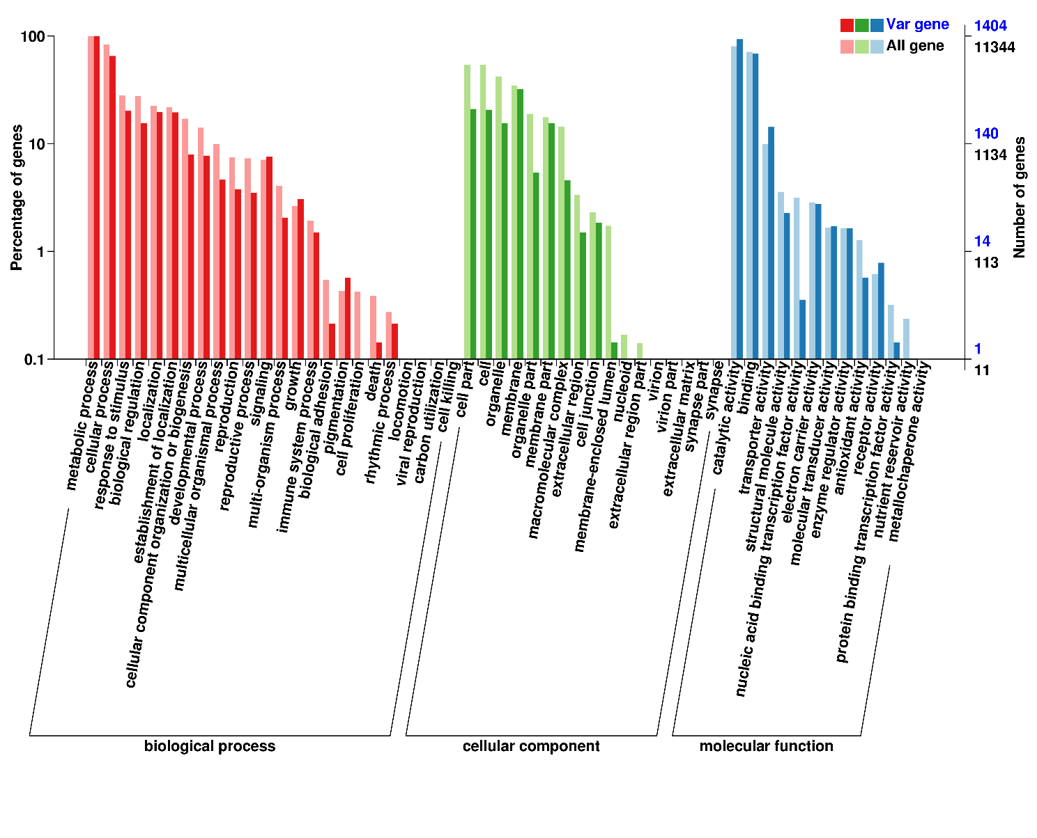
Supplementary Fig. S3 GO classification of expansion gene
Note: All genes represent all genes and Var genes represent positive selection genes.

Supplementary Tables

Table S1. Sequencing results statistics of the Illumina two 270 bp libraries.
Library | Data (Gb) | Depth (×) | Q20 (%) | Q30 (%)
270 bp_1 | 27.86 | 25.52 | 42.43 | 96.16
270 bp_2 | 33.47 | 30.66 | 50.98 | 96.39
Total | 61.33 | 56.18 | 93.41 | ---

Table S2 Length distribution statistics of subreads.
Length (bp) | Num | Total length (bp) | Average length (bp)
500~2000 | 1,041,278 | 1,242,654,305 | 1,193
2000~4000 | 970,908 | 2,854,950,288 | 2,941
4000~6000 | 754,012 | 3,745,887,385 | 4,968
6000~8000 | 648,042 | 4,529,389,798 | 6,989
8000~10000 | 662,009 | 5,948,395,416 | 8,985
10000~12000 | 511,593 | 5,603,944,227 | 10,954
12000~14000 | 393,619 | 5,099,773,958 | 12,956
14000~16000 | 302,602 | 4,525,995,350 | 14,957
16000~18000 | 232,007 | 3,933,694,836 | 16,955
18000~ | 723,192 | 17,753,666,609 | 24,549
Total | 6,239,262 | 55,238,352,172 | 8,853
Note: Length (BP): the range of the subreads length; Num: the number of sequences in each length range; Total length (BP): the total length of sequences in each length range. Average length (BP): the average length of sequences in each length range.

Table S3. Genome assembly data with different assembly software.
Software | Contig number | Contig  length (bp) | Contig  N50 (bp) | Contig  N90 (bp) | Contig  max (bp) | GC  content (%)
Wtdbg | 4,914 | 592,309,792 | 756,633 | 41,412 | 13,245,817 | 36.05
Canu | 1,255 | 528,710,341 | 3,744,858 | 148,057 | 20,582,738 | 35.44
Wtdbg+Canu+ Quickmerge | 4,320 | 621,069,510 | 4,163,294 | 43,789 | 22,312,621 | 35.96

Table S4. Statistics of various types of Hi-C sequencing data
Mapping Type | Number | Ratio（%）
Total Read Pairs | 119,954,672 | 100
Mapped Reads | 212,043,223 | 88.38
Unique Mapped Read Pairs | 63,460,050 | 52.90
Unique Paired Alignments | 63,460,050 | 100
Valid Interaction Pairs | 52,850,976 | 83.28
Dangling End Pairs | 3,813,115 | 6.01
Re-ligation Pairs | 1,390,041 | 2.19
Self-cycle Pairs | 1,610,713 | 2.54
DumpedPairs | 3,795,205 | 5.98

Table S5 Summary of Illumina reads mapping to the scaffolds
Library | Total reads | Mapped reads | Mapped (%) | Properly mapped reads | Properly mapped (%)
270_1 bp | 190,440,054 | 182,793,060 | 95.98% | 158,524,512 | 85.21%
270_2 bp | 228,688,855 | 219,630,572 | 96.04% | 190,959,884 | 85.45%

Table S6 Statistical information of repeated sequences
Type | Number | Length（bp） | Percentage (%)
ClassI/?/? | 3,351 | 785,229 | 0.13
ClassI/DIRS/? | 9,330 | 16,658,170 | 2.68
ClassI/LARD/? | 16,354 | 44,211,415 | 7.12
ClassI/LINE/? | 3,682 | 20,864,804 | 3.36
ClassI/LINE/L1 | 2,558 | 5,979,940 | 0.96
ClassI/LINE/RTE | 350 | 826,946 | 0.13
ClassI/LTR/? | 92 | 150,411 | 0.02
ClassI/LTR/Copia | 18,169 | 42,284,129 | 6.81
ClassI/LTR/Gypsy | 48,574 | 123,466,375 | 19.88
ClassI/PLE/? | 6,949 | 3,123,570 | 0.5
ClassI/PLE/Penelope | 230 | 23,030 | 0
ClassI/SINE/? | 3,081 | 681,359 | 0.11
ClassI/TRIM/? | 8,686 | 25,609,386 | 4.12
ClassII/?/? | 3,047 | 652,578 | 0.11
ClassII/?/Academ | 3 | 136 | 0
ClassII/?/ISL2EU | 2 | 136 | 0
ClassII/?/Kolobok | 441 | 38,707 | 0.01
ClassII/?/MuDR | 2,099 | 300,245 | 0.05
ClassII/?/Novosib | 14 | 1,030 | 0
ClassII/?/Sola | 10 | 716 | 0
ClassII/Crypton/Crypton | 7 | 446 | 0
ClassII/Helitron/? | 918 | 187,045 | 0.03
ClassII/Helitron/Helitron | 33,411 | 8,647,495 | 1.39
ClassII/MITE/? | 3,947 | 930,557 | 0.15
ClassII/Maverick/? | 7,769 | 1,321,567 | 0.21
ClassII/TIR/? | 17,861 | 5,883,171 | 0.95
ClassII/TIR/CACTA | 20,203 | 10,412,756 | 1.68
ClassII/TIR/P | 269 | 25,364 | 0
ClassII/TIR/PIF-Harbinger | 2,780 | 1,006,609 | 0.16
ClassII/TIR/Tc1-Mariner | 22 | 11,871 | 0
ClassII/TIR/hAT | 1,227 | 1,748,669 | 0.28
PotentialHostGene | 54,196 | 10,779,340 | 1.74
SSR | 7,091 | 42,360,951 | 6.82
Unknown | 201,025 | 72,272,204 | 11.64
Unknown/Helitron|LARD/? | 75 | 18,465 | 0
Total | 477,823 | 361,168,716 | 58.15

‘’

Table S7 Gene prediction result
Method | Software | Species | Gene number
Ab initio | Genscan | - | 30,806
Ab initio | Augustus | - | 37,498
Ab initio | GlimmerHMM | - | 54,857
Ab initio | GeneID | - | 48,919
Ab initio | SNAP | - | 36,314
Homology-based | GeMoMa | Arabidopsis thaliana | 24,774
Homology-based | GeMoMa | Oryza sativa | 23,431
Homology-based | GeMoMa | Trifolium pratense | 32,957
Homology-based | GeMoMa | Vigna radiata | 28,218
Homology-based | GeMoMa | Aradu | 26,249
Homology-based | GeMoMa | Araip | 26,651
RNAseq | PASA | - | 55,199
 | TransDecoder | - | 75,601
 | GeneMarkS-T | - | 45,070
Integration | EVM | - | 32,361

Table S8 Statistical table of gene information
Software | Gene Num | Gene Len | Gene Length percentage of the genome Len (%) | Ave Gene Len (bp) | Exon Len | Ave Exon Num Per Gene | Ave Exon Len (bp) | Intron Len | Ave Intron Len (bp)
Software | Gene Num | (bp) |  | Ave Gene Len (bp) | (bp) |  | Ave Exon Len (bp) | (bp) | Ave Intron Len (bp)
EVM | 32,361 | 126,518,039 | 20.37 | 3,909.58 | 39,388,890 | 5.09 | 239.09 | 87,129,149 | 528.87

Table S9 Statistical information on functional annotation of genes
database | Annotated number | Percentage (%)
GO_Annotation | 17,028 | 52.62%
KEGG_Annotation | 9,704 | 29.99%
KOG_Annotation | 16,417 | 50.73%
TrEMBL_Annotation | 29,101 | 89.93%
nr_Annotation | 29,122 | 89.99%
All_Annotated | 29,164 | 90.12%

Table S10 Statistical results of noncoding RNAs
noncoding RNA classification | Number | Family
miRNA | 88 | 19
rRNA | 446 | 4
tRNA | 632 | 24
pseudogene | 2,782
Motif | 2,980
Domain | 34,761

Table S11 Statistics of gene families
Species  name | Total gene  number | Cluster gene  number | Total family  number | Unique gene  family number
G.uralensis | 34,445 | 24,002 | 16,486 | 629
V.vinifera | 26,346 | 19,003 | 12,907 | 826
C.tora | 32,361 | 26,757 | 15,619 | 780
P.vulgaris | 27,663 | 25,124 | 16,991 | 154
V.angularis | 26,590 | 24,820 | 16,709 | 133
C.arietinum | 24,702 | 23,320 | 15,630 | 232
C.cajan | 28,543 | 26,311 | 16,614 | 300
V.radiata | 26,886 | 24,972 | 16,680 | 174
G.max | 47,747 | 42,764 | 17,285 | 513
A.ipaensis | 41,840 | 29,319 | 17,856 | 1,104
L.japonicus | 29,878 | 22,260 | 14,126 | 1,019
A.duranensis | 36,734 | 26,966 | 17,324 | 594
M.truncatula | 50,212 | 36,576 | 18,159 | 1,875

