Association of Killer Cell Immunoglobulin-like Receptors with endemic Burkitt Lymphoma in Kenyan Children.

Beatrice M. Muriuki^{1,2}, Catherine S. Forconi³, Peter O. Oluoch^{2,3}, Jeffrey A. Bailey⁴, Anita Ghansah⁵, Ann M. Moormann³, and John M. Ong'echa^{2*}

¹West African Center for Cell Biology of Infectious Pathogens, College of Basic and Applied Sciences, University of Ghana, Accra, Ghana.
²Center for Global Health Research, Kenya Medical Research Institute, Kisumu, Kenya. ³Division of Infectious Diseases and Immunology, Department of Medicine, University of Massachusetts Medical School, Worcester, MA, USA.
⁴Department of Pathology and Laboratory Medicine, Warren Alpert Medical School, Brown University, Providence, RI, USA.
⁵Noguchi Memorial Institute for Medical Research, College of Health Sciences, University of Ghana, Legon, Accra, Ghana.

Correspondence and requests for materials should be addressed to JMO (email:michaelongecha@yahoo.com).

Supplemental Data

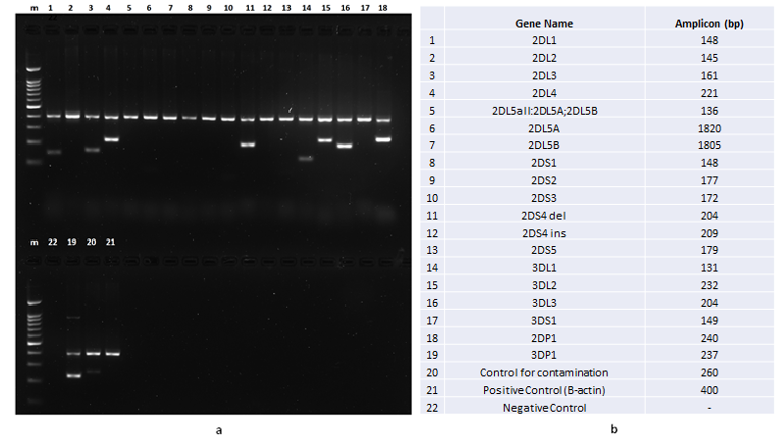

Figure S1: a. Agarose gel electrophoresis analysis of one sample to detect 16 KIR genes. PCR amplified products were run on a 2% agarose gel. Lane m indicates the DNA ladder (100 bp DNA ladder, catalogue number D001, Gold Biotechnology). b. The gel images were interpreted according to the manufacturer's manual provided in the kit (Miltenyi, Biotec, Inc, Germany).

Table S1. Distribution of KIRs based on centromeric and telomeric gene content

Gene | eBL n=104 (%) | HC n=104 (%) | OR (95% CI) | p value
Centromere
cA1/ cA1 | 40 (38.5) | 46 (44.2) | 0.928 (0.477-1.808) | 0.826
cA1/ cB1 | 37 (35.6) | 33 (31.7) | 0.880 (0.436-1.755) | 0.719
cA1/ cB2 | 7 (6.7) | 5 (4.8) | 2.502 (0.635-10.400) | 0.191
cA1/ cB3 | 13 (12.5) | 12 (11.5) | 0.961 (0.363-2.585) | 0.937
cB1/cB1 | 7 (6.7) | 7 (6.7) | NA | NA
cB2/cB2 | 0 | 1 (0.96) | NA | NA
Telomere
tA1/tA1 | 97 (93.3) | 99 (95.2) | 0.594 (0.147-2.293) | 0.448
tA1/tB1 | 7 (6.7) | 5 (4.8) | 0.594 (0.147-2.293) | 0.448

Table S1. n represents the number of individuals; Comparisons were performed with the healthy controls as the reference group. p-value less than or equal to 0.05 were considered statistically significant. p≤0.05 and the OR (95% CI) were adjusted by age and sex. AA= homozygous to A. Bx= homozygous or heterozygous to B. c = centromeric region. t = telomeric region.

Table S2. Distribution of KIR B content in the centromere (cB) and telomere (tB)

Genotype | B  score | Centromere-Telomere | eBL  n =104 (%) | HC  n=104 (%) | OR (95% CI) | p  value
AA | 0 | cAcA-tAtA | 40 (38.5) | 46 (44.2) | 0.928 (0.477-1.808) | 0.826
Bx | 1 | cAcA-tAtB | 0 | 0 | 1.005 (0.516-1.941) | 0.988
Bx | 1 | cAcB-tAtA | 52 (50.0) | 45 (43.3) | 1.005 (0.516-1.941) | 0.988
Bx | 2 | cAcA-tBtB | 0 | 0 | 1.201 (0.392- 3.579) | 0.743
Bx | 2 | cAcB-tAtB | 5 (4.8) | 5 (4.8) | 1.201 (0.392- 3.579) | 0.743
Bx | 2 | cBcB-tAtA | 5 (4.8) | 8 (7.7) | 1.201 (0.392- 3.579) | 0.743
Bx | 3 | cAcB-tBtB | 0 | 0 | NA | NA
Bx | 3 | cBcB-tAtB | 2 (1.9) | 0 | NA | NA

Table S2. n represents the number of individuals; Comparisons were performed with the healthy controls as the reference group. p-value less than or equal to 0.05 were considered statistically significant. p≤0.05 and the OR (95% CI) were adjusted by age and sex. AA= homozygous to A. Bx = homozygous or heterozygous to B. c = centromeric region. t = telomeric region.

