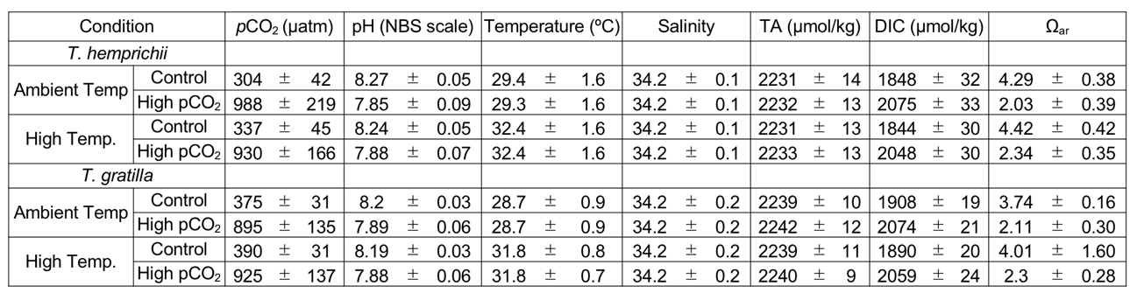

Table 1. Seawater carbonate chemistry during seagrass Thalassia hemprichii and sea urchin Tripneustes gratilla culture. Seawater pCO₂, DIC and Ω_{ar} were calculated from the measured pH and total alkalinity (TA) using CO2SYS. Values represent mean ± SD.

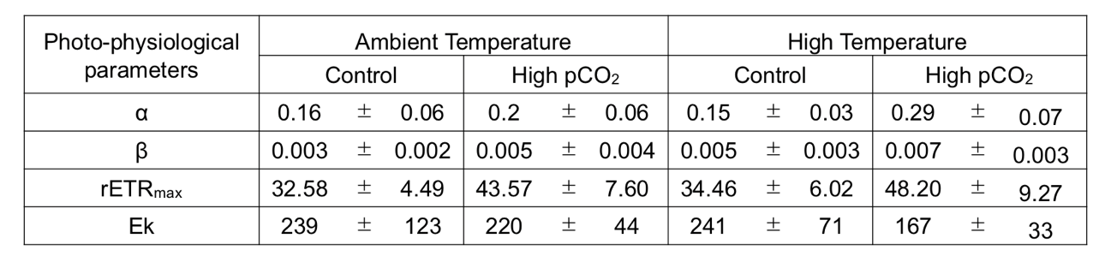
Table 2. Effect of high temperature (+3 °C than ambient) and high pCO₂ (1,000 µatm) on photo-physiological parameters of seagrass Thalassia hemprichii. Values represent mean ± SD. n = 6.

