Supplementary material

Supplementary Figure S1. Patient distribution and mortality by gender and age groups
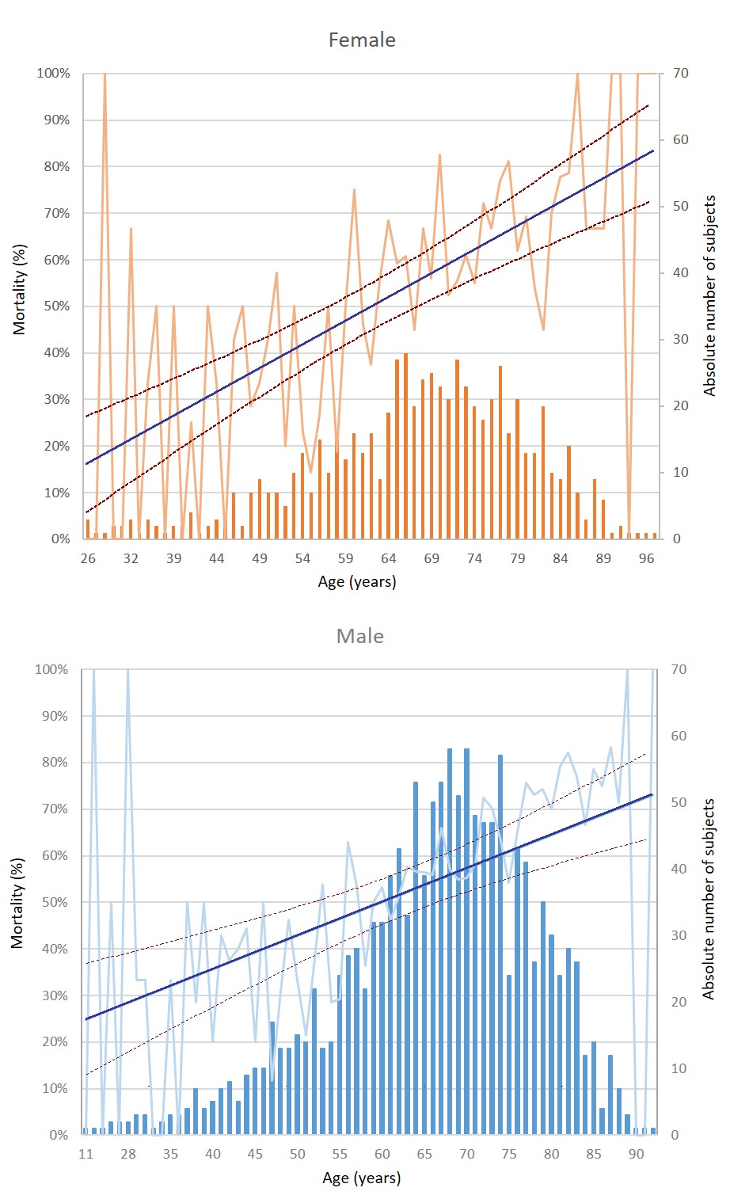
Columns depict absolute number of patients (right-sided Y-axis) by 1-year of age group (X-axis). Calculated mortality (left-sided Y-axis, light blue/orange line) with regression line and 95% confidence intervals (solid blue and dashed red lines) is shown.

Supplementary Figure S2. Patient distribution based on ventilator support.
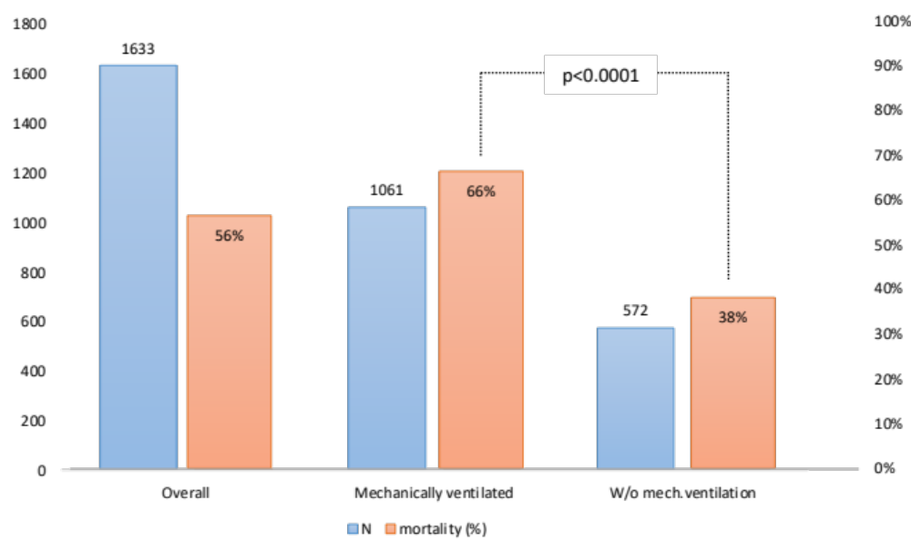
Absolute numbers (blue bars, left-sided Y-axis), and mortality (orange bars, right-sided Y-axis) are shown for the following groups: patients with known organ support without ECMO patients (Overall), patients with need for invasive mechanical ventilation (Mechanically ventilated), patients without invasive ventilator support, i.e.: non-invasive ventilation, high-flow nasal oxygen, conventional oxygen therapy (W/o invasive ventilation).

Supplementary Table 1. Screened variables
 | Centre ID*
 | Patient ID*
DATES | Disease onset*
DATES | Proved SARS CoV2 positivity (PCR or AG)*
DATES | Hospital admission*
DATES | ICU admission*
DEMOGRAPHICS | Age*
DEMOGRAPHICS | Gender (M/F)*
DEMOGRAPHICS | BMI
DEMOGRAPHICS | Heigh (only if BMI is not known)
DEMOGRAPHICS | Weight (only if BMI is not known)
PATIENT HISTORY (mark only positive with "Y" or "X") | Obesity
PATIENT HISTORY (mark only positive with "Y" or "X") | Diabetes mellitus (I or II)
PATIENT HISTORY (mark only positive with "Y" or "X") | Arterial hypertension
PATIENT HISTORY (mark only positive with "Y" or "X") | Immunocompromised (transplant, long term medication etc.)
PATIENT HISTORY (mark only positive with "Y" or "X") | Chronic kidney disease (incl. Dialysis)
PATIENT HISTORY (mark only positive with "Y" or "X") | Chronic respiratory disease
PATIENT HISTORY (mark only positive with "Y" or "X") | Chronic heart disease
PATIENT HISTORY (mark only positive with "Y" or "X") | Peripheral arterial disease
PATIENT HISTORY (mark only positive with "Y" or "X") | Cancer/hemato-oncological treatment
PATIENT HISTORY (mark only positive with "Y" or "X") | CPR before admission
PATIENT HISTORY (mark only positive with "Y" or "X") | No of chronic medication
PATIENT HISTORY (mark only positive with "Y" or "X") | SARS CoV2 vaccinated
PATIENT HISTORY (mark only positive with "Y" or "X") | COVID re-infection
ORGAN SUPPORT (mark only positive with "Y" or "X"/or give DATE) | Invasive ventilation (Y/N or date of onset)
 | Length of invasive ventilation (days)
 | Extracorporeal support (ECMO/ECCO2R) (Y/N or date of onset)
 | Length of extracorporeal support (ECMO/ECCO2R) (days)
 | High flow oxygen
 | Noninvasive ventilation
 | Vasopressors
 | Inotropes/chronotropes
 | Dialysis
COMPLICATIONS (mark only positive with "Y" or "X") | Venous thrombosis
COMPLICATIONS (mark only positive with "Y" or "X") | Pulmonary embolism
COMPLICATIONS (mark only positive with "Y" or "X") | Hospital acquired pneumonia
COMPLICATIONS (mark only positive with "Y" or "X") | Other nosocomial infection (not pneumonia)
COMPLICATIONS (mark only positive with "Y" or "X") | Hemophagocytic lymphohistiocytosis
COMPLICATIONS (mark only positive with "Y" or "X") | CPR (including before as a cause for admission)
COMPLICATIONS (mark only positive with "Y" or "X") | Other…………
DISCHARGE AND DEATH  (cause of death: describe in plain words into the relevant group collumn) | Date of ICU discharge*
 | Where (standard, long-term facility, home)*
 | Date of death*
 | WITHHOLD treatment order – no escalation
 | WITHDRAWN treatment order - palliative care
 | Respiratory failure
 | Cardiovascular collapse incl. arrhythmias
 | Sepsis/infection/multiorgan failure
 | Neurological (both bleeding and ischemic)
 | Other …………..
ICU ADMISSION SCORING AND LABORATORY ( | SOFA
ICU ADMISSION SCORING AND LABORATORY ( | PaO2/FiO2 (spontaneous/ on respiratory support)
ICU ADMISSION SCORING AND LABORATORY ( | APACHE II
ICU ADMISSION SCORING AND LABORATORY ( | Lymphocyte count (minimal)
ICU ADMISSION SCORING AND LABORATORY ( | CRP
ICU ADMISSION SCORING AND LABORATORY ( | PCT
ICU ADMISSION SCORING AND LABORATORY ( | IL6
ICU ADMISSION SCORING AND LABORATORY ( | Ferritin
ICU ADMISSION SCORING AND LABORATORY ( | D-Dimer
ICU ADMISSION SCORING AND LABORATORY ( | Lactate
ICU SPECIFIC TREATMENTS | Corticosteroids (standard dosing)
ICU SPECIFIC TREATMENTS | Corticosteroids (higher dosing)
ICU SPECIFIC TREATMENTS | Tocilizumab
ICU SPECIFIC TREATMENTS | Remdesivir
ICU SPECIFIC TREATMENTS | Other antivirotic agent (name)
ICU SPECIFIC TREATMENTS | Monoclonal antibody (name)
ICU SPECIFIC TREATMENTS | Covalescent plasma
ICU SPECIFIC TREATMENTS | Isoprinosine
ICU SPECIFIC TREATMENTS | Ivermectine
ICU SPECIFIC TREATMENTS | Hydroxychlorochine
ICU SPECIFIC TREATMENTS | Vitamine D
ICU SPECIFIC TREATMENTS | Vitamine C + Thiamine
ICU SPECIFIC TREATMENTS | Heparin
ICU SPECIFIC TREATMENTS | LMWH prophylactic dose
ICU SPECIFIC TREATMENTS | LMWH full therapeutic dose
ICU SPECIFIC TREATMENTS | Other anitcoagulants / fibrinolytics / antiaggregants (descibe)
ICU SPECIFIC TREATMENTS | Sel- proning during HFO/NIV
ICU SPECIFIC TREATMENTS | Proning after intubation
ICU SPECIFIC TREATMENTS | Muscle relaxants (prolonged use to facilitate ventilation)
ICU SPECIFIC TREATMENTS | Cytokine removal (i.e. CytoSorb)
Mandatory variables are indicated by asterisks; collection of the remaining variables was based on availability.ICU admission data are relevant for all lab/scoring variables

Supplementary Table 2. Survey questionnaire

To which extent the following factors affected the unfavourable outcome in your centre based on your opinion | NOT important | Slightly important | Important | Fairly important | Very important
The disease itself was deadly
– no other confounders
Lack of personnel in general
Lack of specialised nurses
Lack of intensivists
Poor infrastrurcture in general
Poor infrastructure of the COVID ICUs*
Late referral to ICU
Late admission to ICU
Extremely high rate of admissions within a very short period of time
Lack of „not fit for ICU” decisions
Lack of equipment (ventilators, ECMO, pumps, etc.)
Lack of drugs (tocilizumab, steroids, etc.)
Lack of following international guidelines
Lack of communication (centres, health authorities, etc)
Other comment….
The questionnaire was circulated among participating centers using Surveymonkey.com web application. The principal investigator was responsible for filling in the questionnaire.
* These are ICUs outside the regular critical care area, usually located in wards temporarily allocated for caring of critically ill patients with COVID-19

Supplementary Table 3. Supplementary references
Reference no. | Website address
S1 | World Health Organization. Coronavirus disease (COVID-19) situation reports. Geneva, Switzerland: World Health Organization;2020 [accessed 2020 Jul 30]. Available from: https://www. who.int/emergencies/diseases/novel-coronavirus-2019/situation- reports
S2 | ICNARC (Intensive Care National Audit and Research Centre) Case Mix Programme database report 24 April 2020. Accessed from https://www.icnarc.org
S3 | https://ourworldindata.org/coronavirus [assessed 2022 Jan 1].
S4 | https://www.arcgis.com/apps/dashboards/bda7594740fd40299423467b48e9ecf6 [accessed 2022 Jan 13]
S5 | ICNARC (Intensive Care National Audit and Research Centre) Case Mix Programme database report 21 February 2021. Accessed from https://www.icnarc.org
S6 | https://data.worldbank.org/indicator/SH.XPD.CHEX.GD.ZS?name_desc=false [accessed 2022 Jan 24]
S7 | https://apps.who.int/nha/database/ViewData/Indicators/en [accessed 2022 Jan 24]
S, source

