Table S1 The latitude and longitude coordinates of the sampling point
ID | Latitude/N | Longitude/E | Altitude/m | Cultivation cycle/year | film change cycle/year | Mulch film/shed film material | Mulch film/shed film color | crop | Fertilizer
FC1 | 35º54´55.0″ | 117º12´09.7″ | 110 | 1 | 1 | PE/EVA, DO | Black/White | Lycopersicon esculentum Miller/Phaseolus vulgaris | Bio-Organic Fertilizers (Chicken dung, cow dung) and Fertilizers
FC2 | 35º54´54.3″ | 117º12´09.6″ | 110 | 1 | 1 | PE/PVC | White/White | Lycopersicon esculentum Miller/Vigna unguiculata | /
FC3 | 35º54´53.1″ | 117º12´09.4″ | 106 | 1 | 1 | PE/PVC | White/black | Lycopersicon esculentum Miller | Water Soluble Fertilizer
FC4 | 35º54´54.4″ | 117º12´03.9″ | 107 | 1 | 1 | PE/PVC | White/White | Lycopersicon esculentum Miller | /
FC5 | 35º54´53.5″ | 117º12´04.7″ | 106 | 1 | 1 | PE/PVC | White/White | Lycopersicon esculentum Miller | Seaweed Fertilizers
FC6 | 35º54´52.9″ | 117º12´01.1″ | 107 | 1 | 1 | PE/PVC | White/White | Phaseolus vulgaris | Bio-Organic Fertilizers (Chicken dung)
FC7 | 35º54´27.1″ | 117º11´53.5″ | 109 | 1 | 1 | PE/PVC | White/White | Lycopersicon esculentum Miller | /
FC8 | 35º54´27.1″ | 117º11´53.4″ | 110 | 1 | 1 | PE/PVC | White/White | Lycopersicon esculentum Miller/Cucumis sativus L | Bio-Organic Fertilizers (Chicken dung)
FC9 | 35º54´11.2″ | 117º13´12.7″ | 117 | 1 | 1 | PE/PE | White/White | Lycopersicon esculentum Miller | /
FC10 | 35º54´25.0″ | 117º11´55.0″ | 107 | 1 | 1 | PE/PE | White/White | Lycopersicon esculentum Miller/Phaseolus vulgaris | Bio-Organic Fertilizers (Chicken dung, cow dung) and Fertilizers
FC11 | 35º54´46.7″ | 117º12´00.9″ | 106 | 1 | 1 | PE （PVC） | White/White | Lycopersicon esculentum Miller | Bio-Organic Fertilizers (Chicken dung, cow dung and Fertilizers)
FC12 | 35º54´58.7″ | 117º11´58.9″ | 107 | 1 | 1 | PE （PVC） | White/black/ | Lycopersicon esculentum Miller | /

Table S2 The information of six typical phthalates
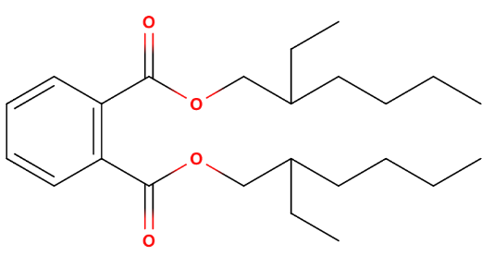  C₂₄H₃₈O₄ | Name | Di-(2-ethylhexyl) phthalate
 | Abbreviation | DEHP
 | Molar mass | 390.6 g/mol
 | CAS | 117-81-7
 | Water solubility | 2.49×10⁻³ mg/L (25 ℃)
 | Vapor pressure | 2.52×10⁻⁵ Pa
 | logK_{ow} | 7.73
 | Application | Plasticizer, Condensation agent, Friction reducer
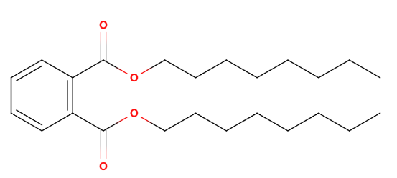  C₂₄H₃₈O₄ | Name | Di-no-octyl phthalate
 | Abbreviation | DOP
 | Molar mass | 390.6 g/mol
 | CAS | 117-84-0
 | Water solubility | 2.49×10⁻³ mg/L (25 ℃)
 | Vapor pressure | 2.52×10⁻⁵ Pa
 | logK_{ow} | 7.73
 | Application | Plastic plasticizers, solvents, gas chromatography stationary liquids
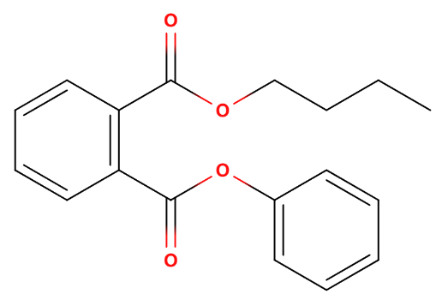  C₁₉H₂₀O₄ | Name | Benzyl butyl phthalate
 | Abbreviation | BBP
 | Molar mass | 312.4 g/mol
 | CAS | 85-68-7
 | Water solubility | 3.8 mg/L (25 ℃)
 | Vapor pressure | 2.49×10⁻³ Pa
 | logK_{ow} | 4.70
 | Application | Organic pigment additives, plasticizers, co-solvents
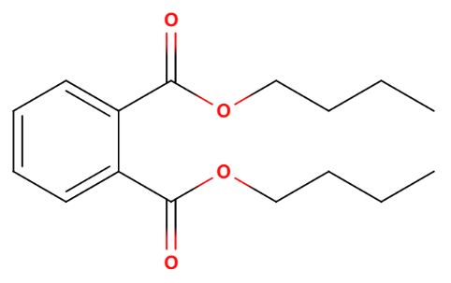  C₁₆H₂₂O₄ | Name | Dibutyl phthalate
 | Abbreviation | DBP
 | Molar mass | 278.34 g/mol
 | CAS | 84-74-2
 | Water solubility | 9.9 mg/L (25 ℃)
 | Vapor pressure | 4.73×10⁻³ Pa
 | logK_{ow} | 4.27
 | Application | Plasticizer, softener, PVC plasticizer

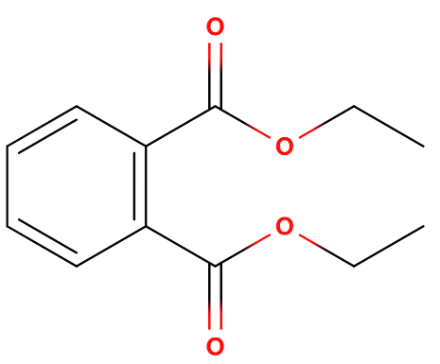  C₁₂H₁₄O₄ | Name | Diethyl phthalate
 | Abbreviation | DEP
 | Molar mass | 222.24 g/mol
 | CAS | 84-66-2
 | Water solubility | 591 mg/L (25 ℃)
 | Vapor pressure | 6.48×10⁻² Pa
 | logK_{ow} | 2.54
 | Application | Plasticizer, pharmaceutical solvents, cellulose and ester solvents
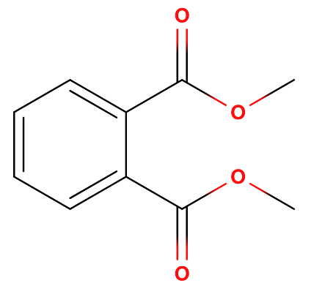  C₁₀H₁₀O₄ | Name | Dimethyl phthalate
 | Abbreviation | DMP
 | Molar mass | 194.18 g/mol
 | CAS | 131-11-3
 | Water solubility | 5220 mg/L (25 ℃)
 | Vapor pressure | 0.263 Pa
 | logK_{ow} | 1.61
 | Application | Coating solvent, plasticizer, mosquito repellent solvent

Table S3 Concentrations of six PAEs in protected agriculture soil in Fangcun, Shandong Peninsula (μg/kg)
 | DBP | BBP | DEP | DOP | DMP | DEHP | ∑₆PAEs
FC1 | 126.81 ± 5.93 | 19.43 ± 0.41 | nd | 21.03 ± 1.29 | nd | 297.34 ± 28.14 | 464.62 ± 29.30
FC2 | 145.45 ± 4.58 | 19.49 ± 0.13 | nd | 20.51 ± 0.43 | nd | 219.33 ± 26.17 | 404.79 ± 24.00
FC3 | 149.76 ± 1.92 | 19.61 ± 0.26 | nd | 22.21 ± 0.77 | nd | 344.63 ± 9.70 | 536.21 ± 20.85
FC4 | 155.10 ± 7.49 | 20.75 ± 1.81 | nd | 27.20 ± 2.88 | nd | 564.04 ± 28.32 | 767.10 ± 35.59
FC5 | 132.23 ± 2.91 | 22.16 ± 2.77 | nd | 20.17 ± 0.17 | nd | 421.22 ± 26.75 | 595.79 ± 13.53
FC6 | 149.32 ± 6.72 | 21.24 ± 1.37 | nd | 20.54 ± 0.20 | nd | 273.78 ± 28.87 | 464.88 ± 30.97
FC7 | 136.13 ± 2.1 | 19.78 ± 0.36 | nd | 20.24 ± 0.09 | nd | 245.77 ± 14.74 | 421.92 ± 7.84
FC8 | 166.31 ± 14.39 | 19.73 ± 0.36 | nd | 20.33 ± 0.32 | nd | 374.06 ± 26.10 | 580.43 ± 30.22
FC9 | 110.47 ± 6.35 | 19.40 ± 0.30 | nd | 20.42 ± 0.09 | nd | 199.82 ± 18.70 | 350.11 ± 11.28
FC10 | 117.41 ± 1.63 | 20.43 ± 1.56 | nd | 20.74 ± 0.26 | nd | 275.90 ± 11.870 | 434.49 ± 8.89
FC11 | 124.12 ± 0.91 | 20.01 ± 1.12 | nd | 20.76 ± 0.43 | nd | 310.08 ± 10.42 | 474.97 ± 10.68
FC12 | 137.54 ± 17.49 | 19.39 ± 0.29 | nd | 21.30 ± 0.86 | nd | 298.12 ± 6.14 | 476.34 ± 12.59
Note: FC means FangCun; nd means not detected.

Table S4 The allowable concentration standards, cleanup objective value of six typical PAEs and environmental risk limits of DEHP and DBP (μg/kg)
Congener | Allowable concentration standards | Cleanup objective value | Environmental risk limits (ERLs) (van Wezel et al., 2000)
DEHP | 4350 | 50000 | 1000
DBP | 81 | 8100 | 700
BBP | 1220 | 50000 | -
DOP | 1200 | 50000 | -
DMP | 20 | 2000 | -
DEP | 70 | 7100 | -

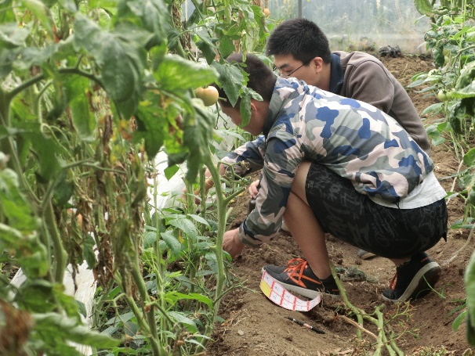
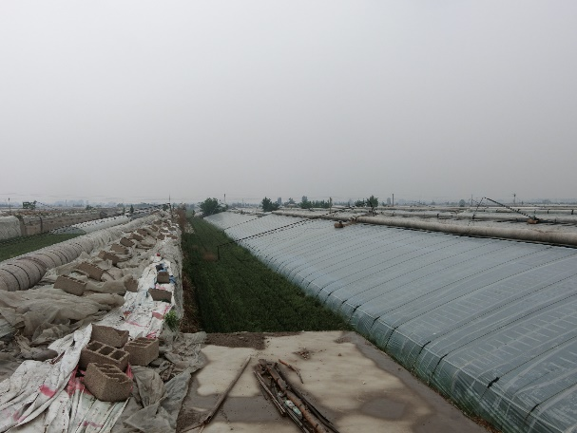
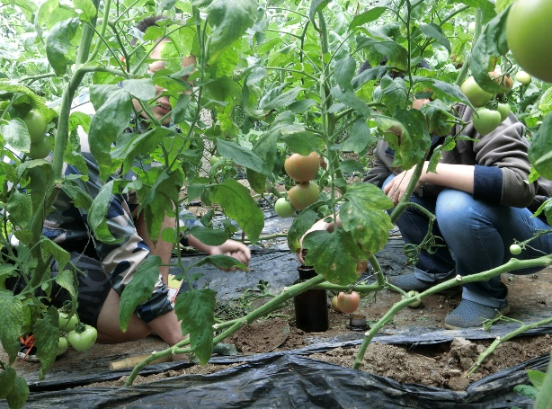
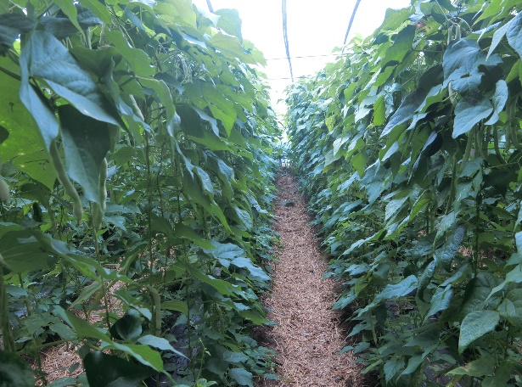
Figure S1 Study area and sample collection

Figure S2 Ion chromatograms of six PAEs

