Use of Natural Deep Eutectic Systems as new cryoprotectant agents in the vitrification of mammalian cells
Acknowledgements
This project has received funding from the European Research Council (ERC) under the European Union’s Horizon 2020 Research and Innovation Programme, under grant agreement No ERC-2016-CoG 725034. This work was also supported by the Associate Laboratory for Green Chemistry – LAQV, financed by national funds from FCT/MCTES (UID/QUI/50006/2019) and by FCT/MCTES through the project CryoDES (PTDC/EQU-EQU/29851/2017).
Ana Rita Jesus¹, Ana Rita C. Duarte¹, Alexandre Paiva^{1*}
¹ LAQV-REQUIMTE, Campus da Caparica, Monte da Caparica, 2825-149 Caparica, Portugal
* alexandre.paiva@fct.unl.pt

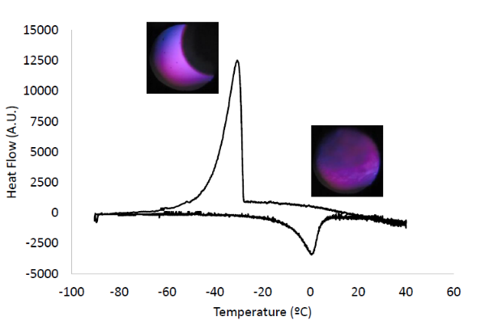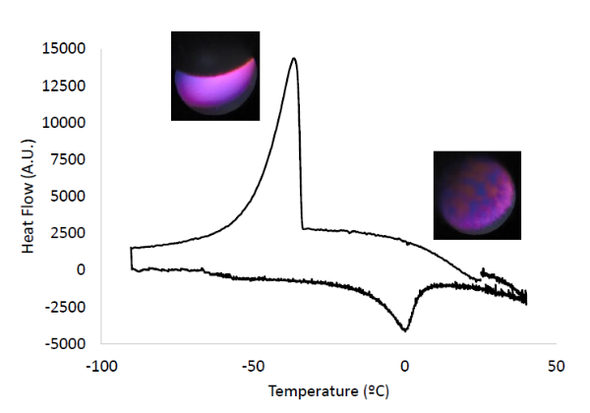
A B
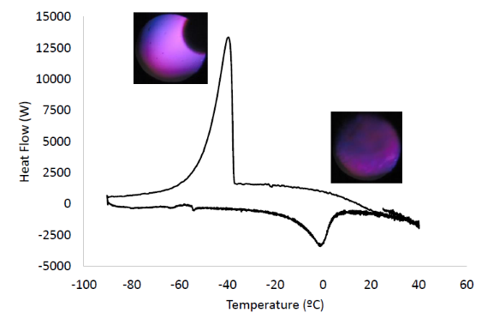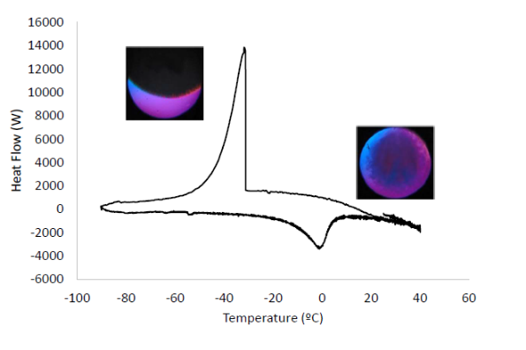
C D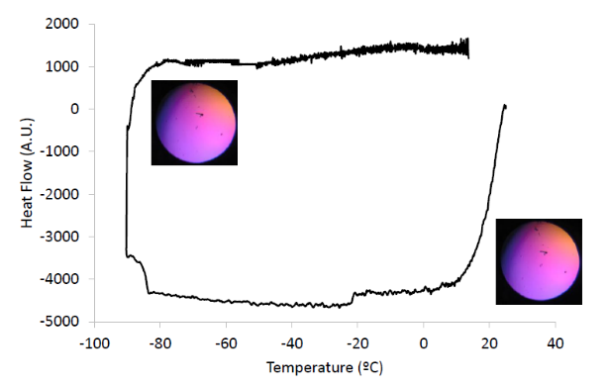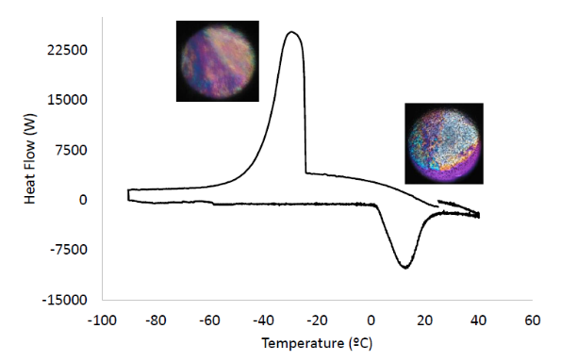
E F
Figure S1. Thermograms and POM images of A. BetSucProW, B. BetTreW, C. BetTreGlyW, D. E. DMSO and F. distilled water, between 40 ºC and 90 ºC. Physical changes at the T_{c} and T_{m}, are also showed.

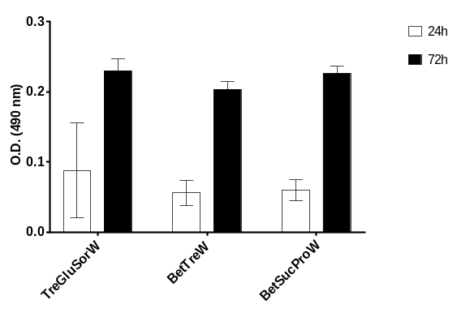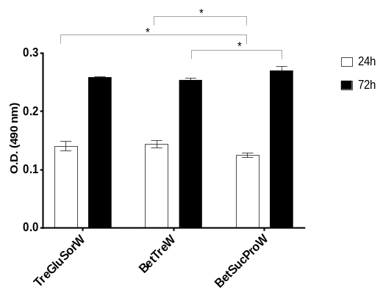
A B

Figure S2. Post-thawing Cell Viability at different passages at different timepoints, for both cell lines. A. L929 P1; B. L929 P2; Data represent means ± SD (n = 3). Statistically significant differences were obtained by Turkey’s multiple comparison test and are represented in asterisks: * p < 0.05; ** p < 0.005, two-way ANOVA. The absence of asterisks means that there are no significant differences when compared with values of Me₂SO at the corresponding time points. C. Post-thawing DAPI/Phalloidin assay (cells nuclei were stained blue by DAPI and F-actin filaments in red by phalloidin) (C1), Live/Dead fluorescence assay (living cells were stained green by calcein AM and dead cells red by PI) (C2) and Optical microscopy (C3) of L929 P1 cells at 24h and 72h. D. Post-thawing DAPI/Phalloidin assay (cells nuclei were stained blue by DAPI and F-actin filaments in red by phalloidin) (D1), Live/Dead fluorescence assay (living cells were stained green by calcein AM and dead cells red by PI) (D2) and Optical microscopy (D3) of L929 P2 cells at 24h and 72h.

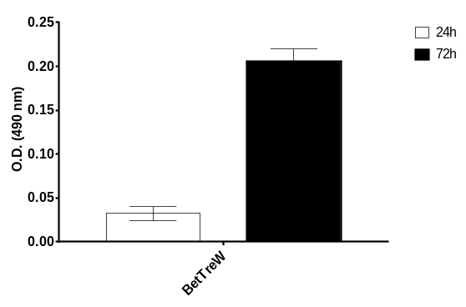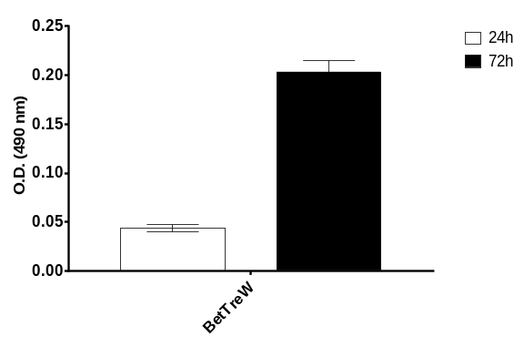
A B
Figure S3. Post-thawing Cell Viability at different passages at different timepoints, for both cell lines. A. HacaT P1; B. HacaT P2; C. Post-thawing DAPI/Phalloidin assay (cells nuclei were stained blue by DAPI and F-actin filaments in red by phalloidin) (C1), Live/Dead fluorescence assay (living cells were stained green by calcein AM and dead cells red by PI) (C2) and Optical microscopy (C3) of HacaT P1 cells at 24h and 72h. D. Post-thawing DAPI/Phalloidin assay (cells nuclei were stained blue by DAPI and F-actin filaments in red by phalloidin) (D1), Live/Dead fluorescence assay (living cells were stained green by calcein AM and dead cells red by PI) (D2) and Optical microscopy (D3) of HacaT P2 cells at 24h and 72h.

