SUPPLEMENTARY INFORMATION

Study title:
Medical nutrition therapy and clinical outcomes in critically ill adults: A European multinational, prospective observational cohort study (EuroPN)
Authors:
Matejovic M, Huet O, Dams K, Elke G, Vaquerizo C, Csomos A, Krzych LJ, Tetamo R, Puthucheary ZA, Rooyackers O, Tjäder I, Hartl W, Kuechenhoff H, Hiesmayr M.
Corresponding author:
Michael Hiesmayr, MD. Division of Cardiac, Thoracic, Vascular Anesthesia and Intensive Care, and Center for Medical Statistics, Informatics and Intelligent Systems, Medical University Vienna, Spitalgasse 23, Vienna, Austria.
Email: michael.hiesmayr@meduniwien.ac.at

Annex 1. Concept of the statistical methods

The calculation of the associations of medical nutrition therapy with time to weaning from IMV and with overall survival (up to day 90 after ICU admission) was based on a complex survival model, where the hazard is a piecewise constant function depending on the caloric intake and confounder variables, as previously introduced by Bender et al. 2018, and Hartl et al. 2019 (1, 2). In order to analyze the impact of both the timing and the time–dependent substrate intake, this novel approach allows for the estimation of cumulative effects and time-varying effects on hazards.
The confounder model was defined based on substantive and methodological considerations, resulting in a flexible nonlinear model with partially time-varying and partially time-constant associations (1-5). Nonlinear associations were estimated using penalized splines. The analysis on time to weaning was based on a subgroup of patients receiving invasive mechanical ventilation between day 1 and day 3 of ICU admission. Death while intubated was defined as a competing event in the time-to-weaning analysis (competing risk analysis) (5).
We included a random effect for the ICUs in the model to account for heterogeneity of the different ICUs. Except for nutrition variables, predictors were cumulated up to day 5 after ICU admission and were included as time-constant covariates in the confounder model. Subsequently, we modeled the association of the nutritional variables with the risk of weaning/dying by adding those variables to the final confounder model. To assess the association between nutrition and weaning or survival we used a time lag of 2 and 4 days, respectively, (lag-time) to minimize endogeneity (confounding by indication), and to account for treatment time required until effects of nutritional therapies on outcome might be seen. In addition, we used a lead time which should account for the fact that a short duration of medical nutrition therapy is unlikely to affect outcome throughout prolonged periods of time. These lag and lead times constituted a time window in which substrate intake on a specific day of medical nutrition therapy could have affected subsequent hazards of time until death or extubation. (dynamic lead time with a maximum of 12 days for weaning, and a maximum of 44 days for survival).
For the modelling of the caloric intake, level I of caloric intake (<10 kcal/kg) was defined as the reference category. Associations of levels II and III with outcome were modelled as bivariate smooth functions (smoothly time-varying effects of time-dependent covariates) that depict partial associations between substrate intake on nutrition days 1 to 15, and the chance of extubation /risk of dying during the follow up.
To assess the overall association of nutrition with weaning/mortality risk for a specific interval of the follow up, these partial associations of levels II or III were added up. The specific partial associations that were cumulated for each interval of the follow-up are circumscribed by the lag-time of two and four days, respectively. For example, mortality risk on day 13 after ICU admission was assumed to be associated only with the partial nutrition effects of nutrition days 1 to 9.

Interval structure and Lag specification

For the implementation of the method, we discretized the time-scale into days (24h periods) after ICU admission (see Table S1). The following aspects were important for the complex modeling of the association between substrate intake and the hazard rate: a) The model should allow the association between a certain level of substrate intake and the outcome to be cumulative over the relevant period of exposure as well as potentially time-varying; b) we assumed that substrate intake on a certain nutrition day t_{e} can only be associated with individual hazard rates after a certain lag time (t_{lag}), i.e., caloric intake on nutrition day $t_{e}$ is associated with the chance of extubation /risk of dying within a certain time window during the follow up, and is not associated with that risk outside that time window.
To facilitate the interpretation of these time-varying hazard ratios (HR) between nutrition and outcome, we constructed 6 pairwise comparisons of hypothetical medical nutrition therapies, reflecting different time-varying calorie and protein intakes over days 1-15, thereby differentiating between an early (day 1 to 4) and a late (after day 4) period.
Daily nutrient intake per kg BW was therefore classified using established thresholds for calories and protein, respectively: low: <10 kcal/kg, <0.8 g/kg; moderate: 10-20 kcal/kg, 0.8-1.2 g/kg; high: >20 kcal/kg, >1.2 g/kg.
For reader´s interpretation, a detailed explanation on the translation of these pairwise comparisons into the cox-type models are provided in this eSupplement (eFigure 1).

eTable 1.
Confounder-adjusted association between hospital, patient, and clinical variables, and daily average calorie intake on d1 to d5 with time to weaning from invasive mechanical ventilation. A HR < 1 indicates a longer time until extubation.

 | Variable name | HR | LL CI 95% | UL CI 95% | p-value
Predictor variables | Age | 1.00 | 0.99 | 1.00 | 0.245
Predictor variables | Female vs. male | 1.23 | 0.98 | 1.55 | 0.079
Predictor variables | Body weight (kg) | 1.00 | 0.99 | 1.00 | 0.189
Predictor variables | Surgical vs. non-surgical ICU admission | 1.45 | 1.12 | 1.90 | 0.006
Predictor variables | Main reason for ICU admission: Infection | 1.25 | 0.99 | 1.59 | 0.066
Predictor variables | Main reason for ICU admission: Respiratory | 0.59 | 0.46 | 0.75 | <0.001
 | Number of severe comorbidities | 1.13 | 1.00 | 1.28 | 0.046
 | APACHE II | 1.00 | 0.99 | 1.01 | 0.847
 | Average SOFA score of preceding days (d1-d5) | 0.89 | 0.85 | 0.92 | <0.001
 | Sum of preceding days with HAIs (d1-d5) | 0.90 | 0.83 | 0.97 | 0.006
 | Baseline functional status | 0.97 | 0.91 | 1.03 | 0.316
 | % of total calories given via the enteral and oral route (d1-d5) | 1.00 | 1.00 | 1.01 | 0.075
Random effect | Study site |  |  |  | <0.001
Smooth terms | Time spline | - | - | - | 0.479
Smooth terms | Daily average caloric intake <10 kcal/kg (ref.)
Smooth terms | Daily average caloric intake 10-20 kcal/kg spline | - | - | - | 0.006
Smooth terms | Daily average caloric intake >20 kcal/kg spline | - | - | - | 0.583
APACHE: Acute Physiology and Chronic Health Evaluation; ICU: Intensive care unit; HR: Hazard ratio; LL: Lower limit; UL: Upper Limit; CI: Confidence interval, HAI: hospital acquired infection

eTable 2.
Confounder-adjusted analysis on the association between hospital, patient, and clinical variables, and daily average calorie intake on d1 to d5 with survival time up to day 90 after ICU admission. A HR > 1 indicates a shorter survival time.

 | Variable name | HR | LL CI 95% | UL CI 95% | p-value
Predictor variables | Age | 1.04 | 1.03 | 1.05 | <0.001
Predictor variables | Body weight (kg) | 0.99 | 0.98 | 1.00 | 0.048
Predictor variables | Surgical vs. non-surgical ICU admission | 0.62 | 0.45 | 0.86 | 0.004
Predictor variables | Main reason for ICU admission: Respiratory | 1.36 | 1.02 | 1.80 | 0.035
 | APACHE II | 1.00 | 0.99 | 1.02 | 0.832
 | Average SOFA score of preceding days (d1-d5) | 1.15 | 1.10 | 1.20 | <0.001
 | Sum of preceding days with HAIs (d1-d5) | 1.04 | 1.02 | 1.07 | 0.002
 | Sum of preceding days with delirium (d1-d5) | 0.97 | 0.92 | 1.01 | 0.169
 | Sum of preceding days on invasive mechanical ventilation (d1-d5) | 1.01 | 0.98 | 1.03 | 0.663
 | Limited medical support | 3.91 | 2.28 | 6.72 | <0.001
 | % of total calories given via the enteral and oral route (d1-d5) | 1.00 | 0.99 | 1.00 | 0.095
Random effect | Study site |  |  |  | 0.002
Smooth terms | Time spline | - | - | - | <0.001
Smooth terms | Daily average caloric intake <10 kcal/kg (ref.)
Smooth terms | Daily average caloric intake 10-20 kcal/kg spline | - | - | - | 0.001
Smooth terms | Daily average caloric intake >20 kcal/kg spline | - | - | - | 0.009
APACHE: Acute Physiology and Chronic Health Evaluation; ICU: Intensive care unit; HR: Hazard ratio; LL: Lower limit; UL: Upper Limit; CI: Confidence interval, HAI: hospital acquired infection

eTable 3.

Confounder-adjusted association between hospital, patient, and clinical variables, and daily average protein intake on d1 to d5 with time to weaning from invasive mechanical ventilation. A HR < 1 indicates a longer time until extubation.

 | Variable name | HR | LL CI 95% | UL CI 95% | p-value
Predictor variables | Age | 1.00 | 0.99 | 1.00 | 0.233
Predictor variables | Female vs. male | 1.20 | 0.96 | 1.51 | 0.117
Predictor variables | Body weight (kg) | 1.00 | 0.99 | 1.00 | 0.181
Predictor variables | Surgical vs. non-surgical ICU admission | 1.47 | 1.13 | 1.92 | 0.004
 | Main reason for ICU admission: Infection | 1.27 | 1.00 | 1.61 | 0.049
 | Main reason for ICU admission: Respiratory | 0.61 | 0.48 | 0.77 | <0.001
 | Number of severe comorbidities | 1.14 | 1.01 | 1.29 | 0.036
 | APACHE II | 1.00 | 0.99 | 1.01 | 0.724
 | Average SOFA score of preceding days (d1-d5) | 0.89 | 0.85 | 0.92 | <0.001
 | Sum of preceding days with HAIs (d1-d5) | 0.90 | 0.83 | 0.97 | 0.007
 | Baseline functional status | 0.96 | 0.90 | 1.02 | 0.203
 | % of total calories given via the enteral and oral route (d1-d5) | 1.00 | 1.00 | 1.01 | 0.091
Random effect | Study site |  |  |  | <0.001
Smooth terms | Time spline | - | - | - | 0.350
Smooth terms | Daily average protein intake <0.8g/kg (ref.)
 | Daily average protein intake 0.8-1.2 g/kg spline | - | - | - | 0.041
 | Daily average protein intake >1.2 g/kg spline | - | - | - | 0.575
APACHE: Acute Physiology and Chronic Health Evaluation; ICU: Intensive care unit; HR: Hazard ratio; LL: Lower limit; UL: Upper Limit; CI: Confidence interval, HAI: hospital acquired infection

eTable 4.
Confounder-adjusted analysis on the association between hospital, patient, and clinical variables, and daily average protein intake on d1 to d5 with survival time up to day 90 after ICU admission. A HR > 1 indicates a shorter survival time.

 | Variable name | HR | LL CI 95% | UL CI 95% | p-value
Predictor variables | Age | 1.03 | 1.02 | 1.05 | <0.001
Predictor variables | Body weight (kg) | 0.99 | 0.98 | 1.00 | 0.055
Predictor variables | Surgical vs. non-surgical ICU admission | 0.65 | 0.46 | 0.90 | 0.011
Predictor variables | Main reason for ICU admission: Cardiac | 1.18 | 0.88 | 1.59 | 0.269
Predictor variables | Main reason for ICU admission: Infection | 1.23 | 0.93 | 1.64 | 0.146
 | Main reason for ICU admission: Respiratory | 1.27 | 0.95 | 1.69 | 0.105
 | APACHE II | 1.00 | 0.99 | 1.02 | 0.604
 | Average SOFA score of preceding days (d1-d5) | 1.14 | 1.09 | 1.20 | <0.001
 | Sum of preceding days with HAIs (d1-d5) | 1.04 | 1.01 | 1.07 | 0.007
 | Sum of preceding days on invasive mechanical ventilation (d1-d5) | 1.01 | 0.98 | 1.04 | 0.549
 | Limited medical support | 3.66 | 2.15 | 6.24 | <0.001
 | % of total calories given via the enteral and oral route (d1-d5) | 1.00 | 0.99 | 1.00 | 0.149
Random effect | Study site |  |  |  | <0.001
Smooth terms | Time spline | - | - | - | <0.001
Smooth terms | Daily average protein intake <0.8 g/kg (ref.)
Smooth terms | Daily average protein intake 0.8-1.2 g/kg spline | - | - | - | 0.112
Smooth terms | Daily average protein intake >1.2 g/kg spline | - | - | - | 0.055
APACHE: Acute Physiology and Chronic Health Evaluation; ICU: Intensive care unit; HR: Hazard ratio; LL: Lower limit; UL: Upper Limit; CI: Confidence interval, HAI: hospital acquired infection

eTable 5.
Recruitment per country

Country | Sites (No.) | Patients (No.)
Austria | 1 | 11
Belgium | 9 | 148
Czech Republic | 13 | 322
France | 13 | 187
Germany | 9 | 126
Hungary | 6 | 111
Italy | 6 | 35
Poland | 6 | 78
United Kingdom | 3 | 24
Spain | 10 | 115
Sweden | 1 | 15
Total | 77 | 1172

eTable 6.

Number and percentage of days patients received nutrition in the predefined calorie and protein classifications
Calorie and protein classifications | Days (%)
Total days with information on calorie intake: 11,152
Low, <10 kcal/kg  Moderate, 10-20 kcal/kg  High, >20 kcal/kg | 3,089 days (27.7%)  3,187 days (28.6%)  4,876 days (43.7%)
Total days with information on protein intake: 11,038
Low, < 0.8 g protein/kg  Moderate, 0.8-1.2 g protein/kg  High, >1.2 g protein/kg | 5,300 days (48.0%)  2,599 days (23.5%)  3,139 days (28.5%)

eTable 7.

Mixed-effect model with repeated measures to assess the confounder-adjusted association between hospital, patient, and clinical variables and daily caloric intake (kcal/kg BW). An Estimate > 0 indicates that the variable was associated with a higher caloric intake.

 | Variable name | Estimate | LL 95% CI | UL 95% CI | p-value
Predictor variables | Surgical vs. non-surgical ICU admission | 0.136 | -0.716 | 0.989 | 0.754
Predictor variables | Average SOFA score of preceding days | 0.021 | -0.061 | 0.103 | 0.613
Predictor variables | Patient not nourished the preceding day | -2.744 | -3.281 | -2.206 | <0.001
Predictor variables | Respiratory reason for ICU admission | 2.426 | 1.604 | 3.249 | <0.001
Predictor variables | Invasive mechanical ventilation on the preceding day | 1.164 | 0.716 | 1.612 | <0.001
Predictor variables | Nutritional needs regularly assessed for patients | -2.861 | -4.442 | -1.279 | <0.001
Predictor variables | Female vs. male | 1.594 | 0.819 | 2.368 | <0.001
Predictor variables | Hematologic reason for ICU admission | 3.955 | 1.720 | 6.191 | <0.001
Predictor variables | Hepatic reason for ICU admission | 2.293 | 1.357 | 3.229 | <0.001
Smooth terms | Age | - | - | - | 0.408
Smooth terms | APACHE II | - | - | - | 0.551
Study site was included as random effect. APACHE: Acute Physiology and Chronic Health Evaluation; ICU: Intensive care unit; LL: Lower limit; UL: Upper Limit; CI: Confidence interval.

eTable 8.
Mixed-effect model with repeated measures to assess the confounder-adjusted association between hospital, patient, and clinical variables and daily protein intake (g/kg BW). An Estimate > 0 indicates that the variable was associated with a higher protein intake.

 | Variable name | Estimate | LL 95% CI | UL 95% CI | p-value
Predictor variables | Surgical vs. non-surgical ICU admission | 0.033 | -0.021 | 0.087 | 0.234
Predictor variables | Average SOFA score of preceding days | 0.003 | -0.002 | 0.008 | 0.246
Predictor variables | Patient not nourished the preceding day | -0.121 | -0.150 | -0.091 | <0.001
Predictor variables | Invasive mechanical ventilation on the preceding day | 0.083 | 0.058 | 0.108 | <0.001
Predictor variables | Respiratory reason for ICU admission | 0.143 | 0.091 | 0.195 | <0.001
Predictor variables | Nutritional needs regularly assessed for patients | -0.219 | -0.319 | -0.120 | <0.001
Predictor variables | Hepatic reason for ICU admission | 0.125 | 0.066 | 0.184 | <0.001
Smooth terms | Age | - | - | - | 0.422
Smooth terms | APACHE II | - | - | - | 0.539
Study site was included as random effect. APACHE: Acute Physiology and Chronic Health Evaluation; ICU: Intensive care unit; LL: Lower limit; UL: Upper Limit; CI: Confidence interval.

eTable 9.
Proportion of patients with ICU Mobility (IMS) score of 0 and 10
 | No. (%)
IMS before ICU admission, n=1168
Score 0 | 73 (6.3)
Score 10 | 770 (65.9)
IMS D15, n=1057
Score 0 | 212 (20.0)
Score 10 | 270 (25.5)
IMS D30, n=949
Score 0 | 74 (7.8)
Score 10 | 383 (40.4)
IMS D90, n=844
Score 0 | 9 (1.1)
Score 10 | 524 (62.1)

eFigure 1.
Explanation of the pairwise comparison of two hypothetical medical nutrition therapies and their associations with time to weaning from invasive mechanical ventilation
- Design of the therapy comparison.
Grey areas indicate days with an identical calorie intake. Due to specifications of the model this intake could have been at any intake level.
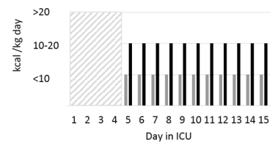
Comparison of a late (> D4) moderate with a late (> D4) low calorie intake.

- Confounder-adjusted association between hypothetical medical nutrition therapies and time until extubation. Reference medical nutrition therapy is the one providing less calories.
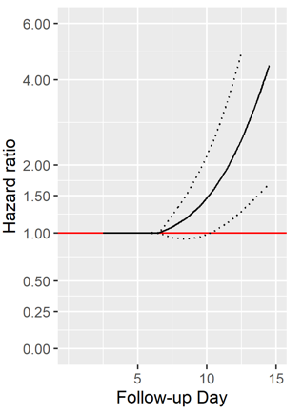
Solid lines: hazard ratios (HR), hatched lines: corresponding 95% confidence bands (CI).
Significant association when red line (HR=1) is not crossed

Lag-time two days.

A patient in the moderate intake group who has not yet been weaned on day 12 has a 3x higher chance of being weaned on day 13 compared to someone in the low intake group.
HR=1 because the two hypothetical medical nutrition therapies did not differ for the first four days

Interpretation of hazard ratio (HR):
  - HR >1 indicates a shorter survival time but also a shorter time until extubation associated with the medical nutrition therapy providing more calories
  - HR <1 indicates a longer survival time but also a longer time until extubation associated with the medical nutrition therapy providing more calories

eFigure 2.
Study diagram
Number of enrolled patients:
N=1213
Final Analysis Set:
N=1172
Caloric Analysis Set: N=1152*
Protein Analysis Set: N=1131*
7 drop-outs_
28 with no ICF/LAR consent
6 with ICU LOS <5 days
Number of screened patients:
N=3086
875 failed incl. crit. 2
(ICU LOS <5 days)
462 met excl. crit. 2 and 3
401 due to other incl/excl criteria
135 no reason provided

*: No values on caloric and protein intake were provided for 20 and 41 patients who received oral nutrition only
ICF, Informed consent form; LAR, legal representative

eFigure 3.
Kaplan-Meier Plot showing survival rates over the study period

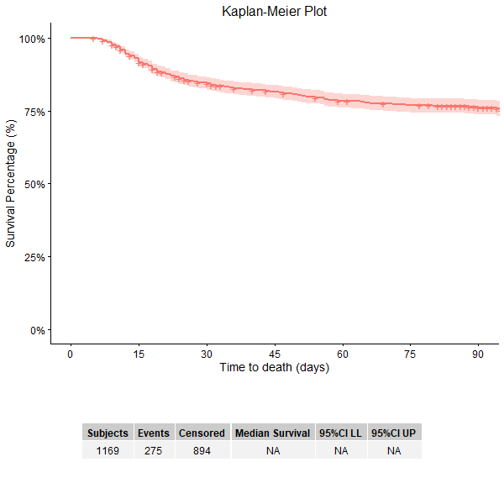

eFigure 4.

Cumulative incidence plot showing weaning events and deaths up to the end of the follow-up period for weaning

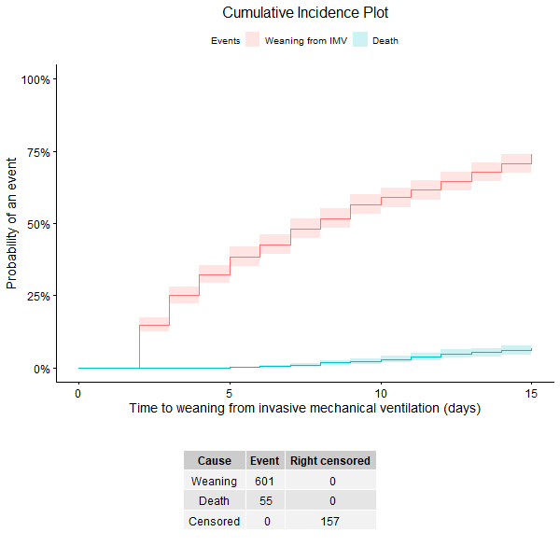

eFigure 5.
Daily caloric intake, excluding patients without any nutrition

Intake is presented as median, interquartile range, minimum and maximum values with outliers versus pre-defined targets (blue horizontal bars) based on the 2019 ESPEN Guideline on clinical nutrition in critical care (6).

eFigure 6.
Daily protein intake, excluding patients without any nutrition

Intake is presented as median, interquartile range, minimum and maximum values with outliers versus pre-defined targets (blue horizontal bars) based on the 2019 ESPEN Guideline on clinical nutrition in critical care (6).

eFigure 7.

Median ICU mobility (IMS) score at different timepoints for patients still in hospital vs. discharged from hospital
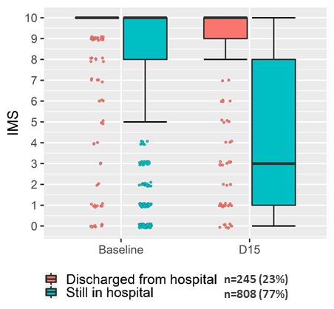
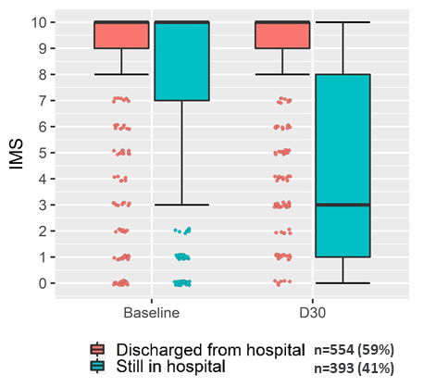

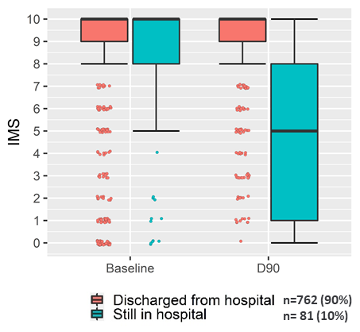

Analysis based on surviving patients with available IMS scores at respective time points.
Graph shows median, IQR, min and max with outliers.

REFERENCES

1. Hartl WH, Bender A, Scheipl F, Kuppinger D, Day AG, Küchenhoff H. Calorie intake and short-term survival of critically ill patients. Clinical Nutrition. 2019;38(2):660-667.
2. Bender A, Scheipl F, Hartl W, Day AG, Küchenhoff H. Penalized estimation of complex, non-linear exposure-lag-response associations. Biostatistics. 2019;20(2):315-331.
3. Bender A, Groll A, Scheipl F. A generalized additive model approach to time-to-event analysis. Statistical Modelling. 2018;18(3-4):299-321.
4. Bender A, Scheipl F. pammtools: Piece-wise exponential additive mixed modeling tools. arXiv preprint arXiv. 2018:180601042.
5. Kopper P: Flexible estimation of complex effects in the context of competing risks survival analysis. 2020; DOI: 10.5282/ubm/epub.72320.
6. Singer P, Blaser AR, Berger MM, Alhazzani W, Calder PC, Casaer MP, et al. ESPEN guideline on clinical nutrition in the intensive care unit. Clinical nutrition. 2019;38(1):48-79.

