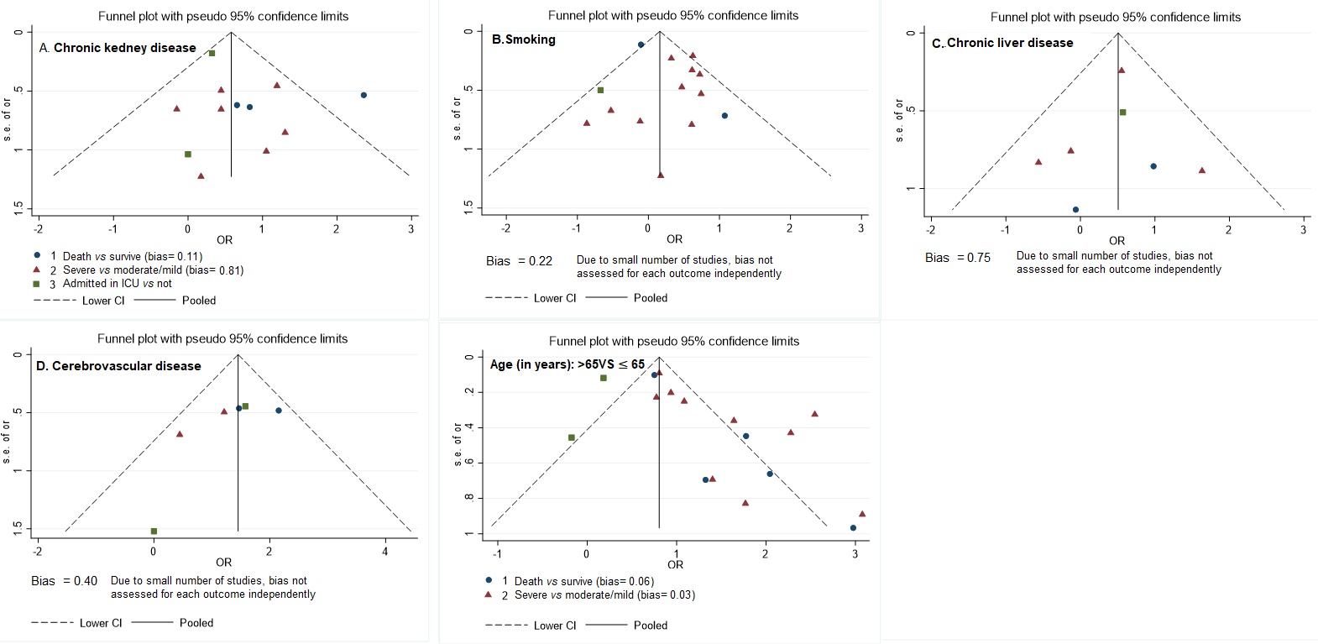
S6 Fig. Funnel plots showing the odds ratio of death, severe illness and admission in ICU against the standard errors based on comorbidity and age status

