Risk factors for severe illness and death in COVID-19: a systematic review and meta-analysis
Abraham Degarege^{1*}; Zaeema Naveed¹; Josiane Kabayundo¹; David Brett-Major¹

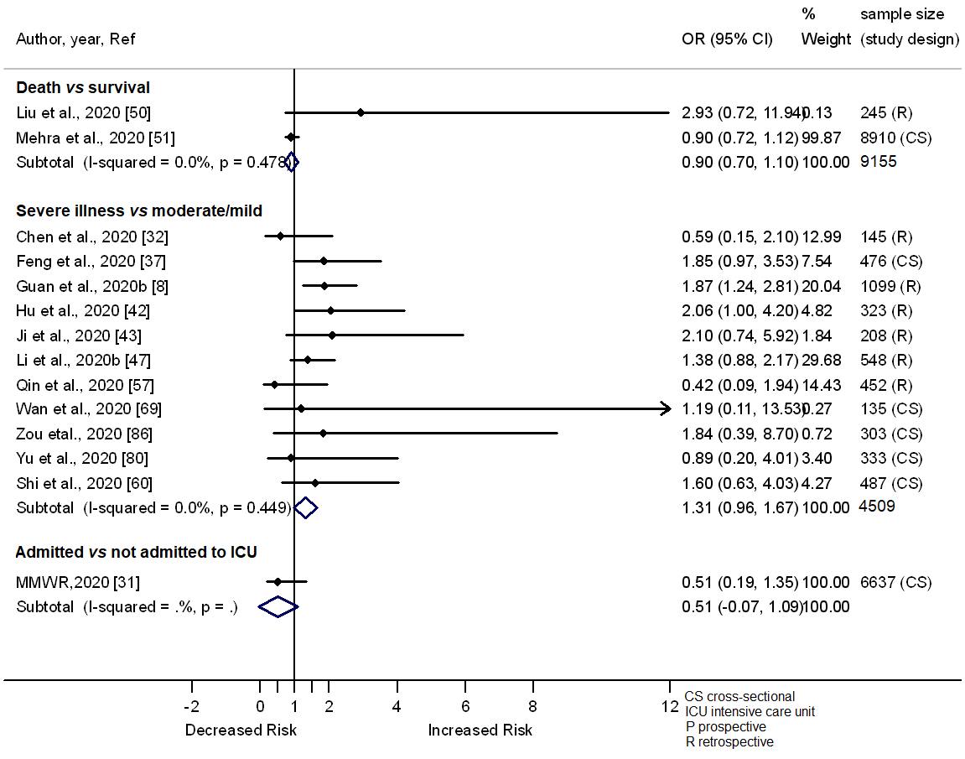

5 Fig. Forest plot showing the relationship of smoking with the odds of death, severe illness and admission in ICU among COVID-19 patients.

