Table for the manuscript:
Table.1 Simulation parameters of key devices
Device | Parameters
Laser | Linewidth: 1MHz Output Power: 10dBm
Laser | Central Wavelength: 1550nm
MZM | Half-wave voltage: 4V Insertion loss: 5.5dB
MZM | Extinction ratio: 30dB
SMF | Length: 1.5km Attenuation: 0.2 dB/km
SMF | Dispersion: 1.23×104 ps²

Figures for the manuscript:
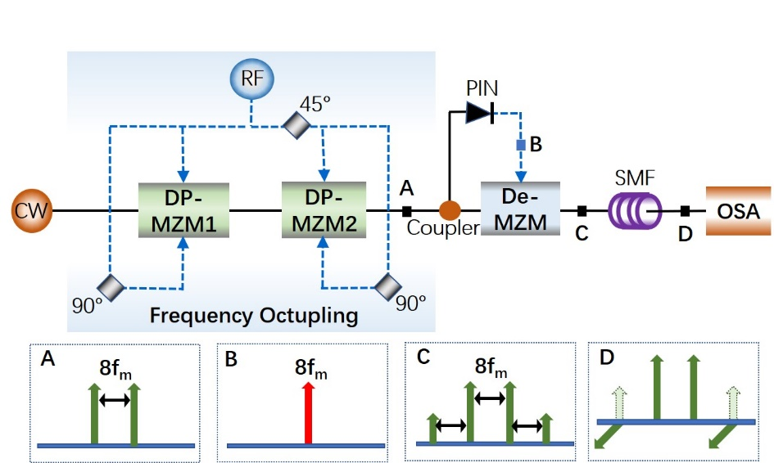
Fig. 1. Schematic diagram of the proposed triangular waveform generator.
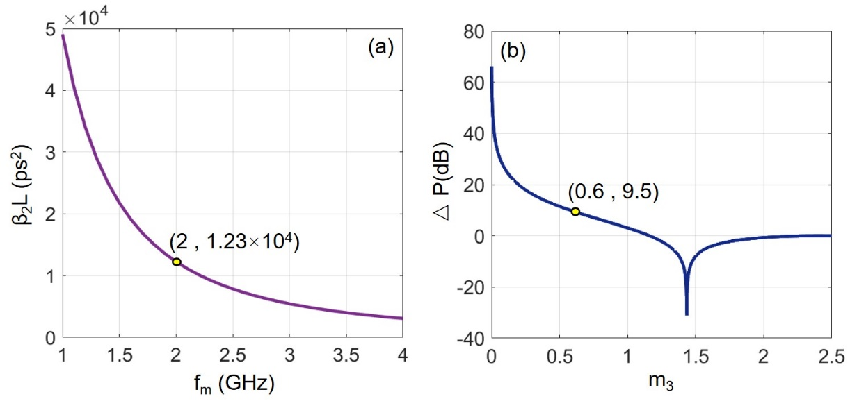
Fig. 2. (a) Values of β₂L versus RF driving frequency, f_{m}. (b) Values of ΔP (dB) versus modulation index of De-MZM, m₃.
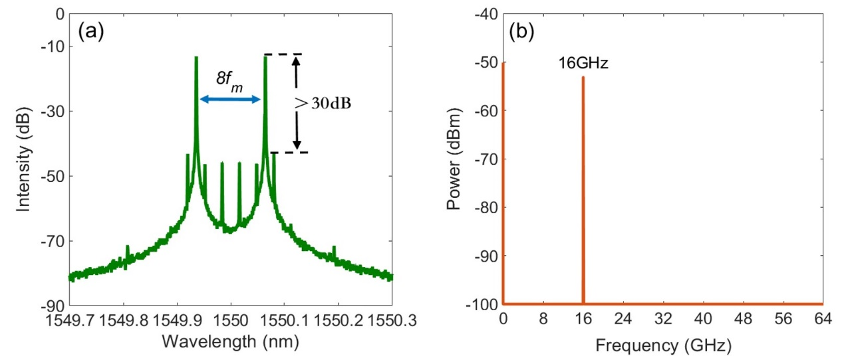
Fig. 3. Signal spectra after frequency octupling (a) optical spectrum at Point A, (b) Electrical spectrum at Point B.
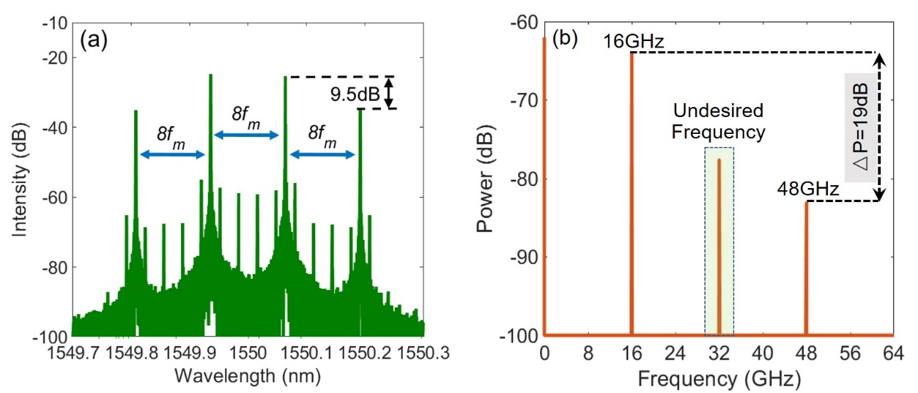
Fig. 4. Simulation results at output of De-MZM: (a) optical spectrum, (b) corresponding spectrum.
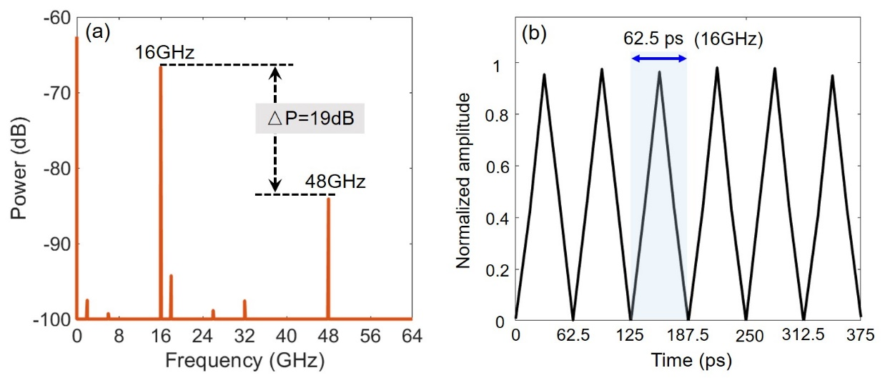
Fig. 5. (a) Optical spectrum, (b) the corresponding temporal waveform of the generated 16-GHz triangular waveform.
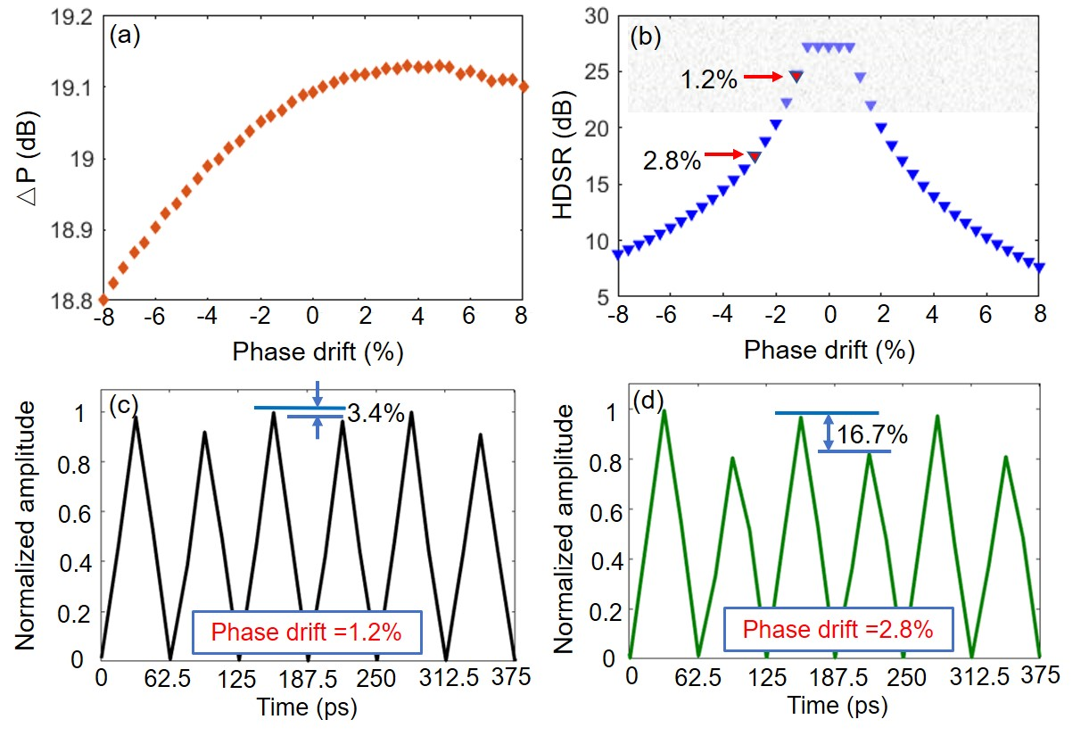
Fig. 6. (a-b) △P and HDSR versus phase drift within a range of ±8%. (c-d) Temporal waveforms of the generated signal when phase drifts are 1.2% and 2.8%.
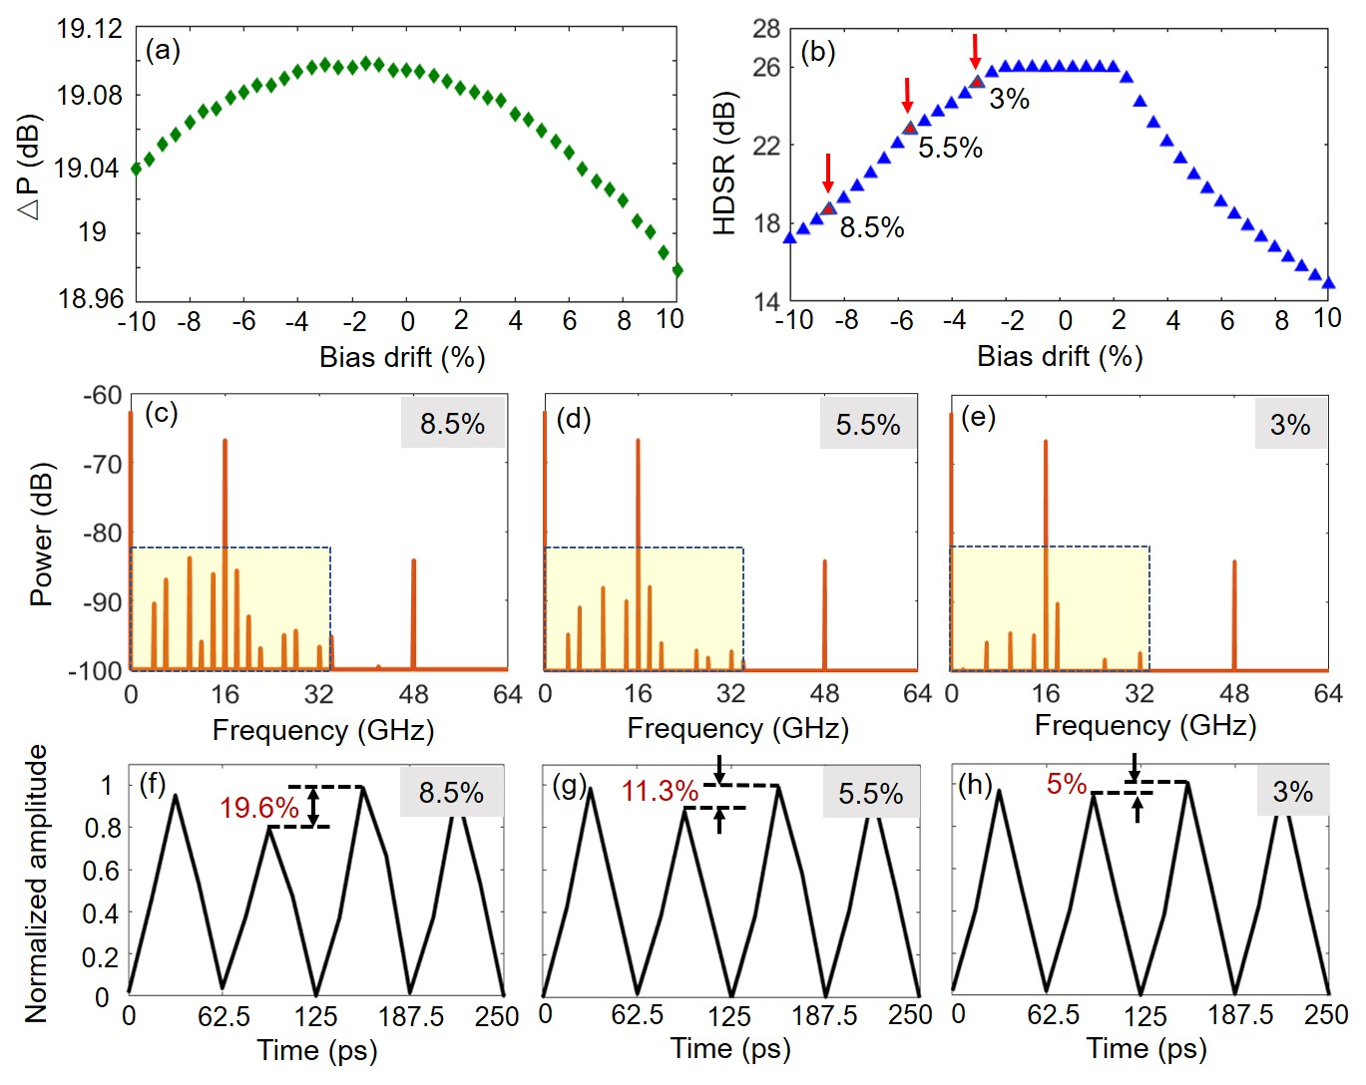
Fig.7 Simulated optical spectrum (a) and corresponding normalized intensity profile (b) of signal after DD-MZM2.

