Spatial distribution and extent of environmental risks of strontium metal concentration in water and bottom sediments of Nile River, Egypt

 | Table (1): Strontium (Sr) concentration and pollution indices as Contamination factor (CF), enrichment factor (EF) and geo-accumulation index (Igeo) along Nile River main stream.
 |  | West |  |  |  |  |  | Middle |  |  |  |  |  |  | East
Location | Latitude |  | longitude | Sr(ppm) | CF | EF | I_{geo} |  | Latitude | longitude | Sr(ppm) | CF | EF | I_{geo} |  | Latitude | longitude | Sr(ppm) | CF | EF | I_{geo}
Giza | 29°53'40.1"N |  | 31°16'48.0"E | 342 | 2.00 | 1.87 | 0.42 |  | 29°53'37.2"N | 31°16'51.7"E | 333 | 1.95 | 2.40 | 0.38 |  | 29°53'38.0"N | 31°16'55.6"E | 347 | 2.03 | 1.90 | 0.44
Cairo | 29°49'00.8"N |  | 31°17'34.2"E | 395 | 2.31 | 2.20 | 0.62 |  | 29°49'01.1"N | 31°17'38.5"E | 323 | 1.89 | 1.75 | 0.33 |  | 29°48'58.7"N | 31°17'43.6"E | 316 | 1.85 | 1.44 | 0.30
Helwan | 29°46'09.3"N |  | 31°17'11.2"E | 322 | 1.88 | 1.63 | 0.33 |  | 29°46'10.9"N | 31°17'19.4"E | 332 | 1.94 | 1.88 | 0.37 |  | 29°46'11.0"N | 31°17'27.2"E | 356 | 2.08 | 2.07 | 0.47
Naser | 29°07'32.0"N |  | 31°09'00.0"E | 354 | 2.07 | 2.14 | 0.46 |  | 29°07'42.7"N | 31°09'20.2"E | 336 | 1.96 | 2.04 | 0.39 |  | 29°07'37.0"N | 31°09'35.2"E | 348 | 2.04 | 1.85 | 0.44
Beni Suef | 29°03'36.7"N |  | 31°05'53.6"E | 328 | 1.92 | 1.77 | 0.35 |  | 29°03'31.9"N | 31°06'09.3"E | 338 | 1.98 | 1.85 | 0.40 |  | 29°03'21.3"N | 31°06'04.8"E | 392 | 2.29 | 1.97 | 0.61
Biba | 28°54'30.8"N |  | 30°59'29.8"E | 347 | 2.03 | 1.97 | 0.44 |  | 28°54'22.6"N | 30°59'32.1"E | 341 | 1.99 | 2.08 | 0.41 |  | 28°54'15.3"N | 30°59'41.3"E | 343 | 2.01 | 2.06 | 0.42
Minya | 28°03'25.8"N |  | 30°48'19.2"E | 330 | 1.93 | 2.11 | 0.36 |  | 28°03'33.6"N | 30°48'30.7"E | 326 | 1.91 | 1.70 | 0.35 |  | 28°03'39.9"N | 30°48'41.9"E | 320 | 1.87 | 1.77 | 0.32
Bni Mazar | 28°29'56.0"N |  | 30°49'12.0"E | 280 | 1.64 | 1.36 | 0.13 |  | 28°29'50.3"N | 30°49'26.5"E | 335 | 1.96 | 1.64 | 0.39 |  | 28°29'52.2"N | 30°49'38.7"E | 337 | 1.97 | 1.74 | 0.39
Samalut | 28°18'46.5"N |  | 30°44'24.2"E | 344 | 2.01 | 1.78 | 0.42 |  | 28°18'35.2"N | 30°44'28.6"E | 348 | 2.04 | 2.04 | 0.44 |  | 28°18'44.5"N | 30°44'43.5"E | 397 | 2.32 | 2.92 | 0.63
Asyut | 27°11'37.6"N |  | 31°11'23.1"E | 331 | 1.94 | 1.79 | 0.37 |  | 27°11'33.1"N | 31°11'34.1"E | 343 | 2.01 | 2.01 | 0.42 |  | 27°11'44.3"N | 31°11'38.3"E | 338 | 1.98 | 2.01 | 0.40
Abu Tij | 27°02'31.8"N |  | 31°20'07.6"E | 347 | 2.03 | 1.64 | 0.44 |  | 27°02'31.4"N | 31°20'17.8"E | 312 | 1.82 | 2.18 | 0.28 |  | 27°02'33.8"N | 31°20'25.1"E | 319 | 1.87 | 1.64 | 0.31
Sidaf | 26°57'55.1"N |  | 31°23'44.6"E | 326 | 1.91 | 1.27 | 0.35 |  | 26°57'57.0"N | 31°24'03.6"E | 370 | 2.16 | 1.95 | 0.53 |  | 26°57'59.1"N | 31°24'18.5"E | 333 | 1.95 | 1.54 | 0.38
Girga | 26°21'17.0"N |  | 31°53'23.0"E | 345 | 2.02 | 1.88 | 0.43 |  | 26°21'06.8"N | 31°53'46.6"E | 342 | 2.00 | 1.59 | 0.42 |  | 26°21'01.0"N | 31°54'11.4"E | 368 | 2.15 | 1.88 | 0.52
Sohag | 26°33'02.0"N |  | 31°42'10.0"E | 358 | 2.09 | 1.79 | 0.48 |  | 26°33'46.8"N | 31°42'11.8"E | 333 | 1.95 | 2.15 | 0.38 |  | 26°33'32.0"N | 31°42'19.0"E | 333 | 1.95 | 1.70 | 0.38
Tahta | 26°47'05.0"N |  | 31°31'17.0"E | 326 | 1.91 | 1.97 | 0.35 |  | 26°46'45.7"N | 31°31'29.6"E | 338 | 1.98 | 1.93 | 0.40 |  | 26°47'07.0"N | 31°31'28.0"E | 316 | 1.85 | 2.28 | 0.30
Nagaa Hammadi | 26°01'21.0"N |  | 32°16'55.0"E | 331 | 1.94 | 1.99 | 0.37 |  | 26°01'26.1"N | 32°17'03.2"E | 349 | 2.04 | 1.99 | 0.44 |  | 26°01'31.2"N | 32°16'50.7"E | 361 | 2.11 | 1.99 | 0.49
Qena | 26°08'58.1"N |  | 32°41'38.0"E | 363 | 2.12 | 1.98 | 0.50 |  | 26°08'35.4"N | 32°43'00.9"E | 319 | 1.87 | 2.16 | 0.31 |  | 26°08'31.0"N | 32°43'32.0"E | 325 | 1.90 | 2.17 | 0.34
Luxor | 25°43'44.5"N |  | 32°38'59.4"E | 332 | 1.94 | 1.47 | 0.37 |  | 25°43'44.0"N | 32°39'06.0"E | 317 | 1.85 | 2.14 | 0.31 |  | 25°43'23.0"N | 32°39'09.0"E | 352 | 2.06 | 1.87 | 0.46
Armant | 25°35'55.0"N |  | 32°28'39.0"E | 328 | 1.92 | 1.75 | 0.35 |  | 25°35'30.7"N | 32°28'30.3"E | 335 | 1.96 | 1.81 | 0.39 |  | 25°35'05.0"N | 32°29'52.0"E | 339 | 1.98 | 2.07 | 0.40
Esna | 25°18'06.0"N |  | 32°33'19.0"E | 322 | 1.88 | 1.48 | 0.33 |  | 25°18'32.6"N | 32°33'28.9"E | 322 | 1.88 | 1.56 | 0.33 |  | 25°18'18.9"N | 32°33'41.6"E | 335 | 1.96 | 1.54 | 0.39
Edfu | 24°02'57.0"N |  | 32°51'36.0"E | 346 | 2.02 | 1.69 | 0.43 |  | 24°03'10.8"N | 32°51'56.7"E | 317 | 1.85 | 2.11 | 0.31 |  | 24°03'01.9"N | 32°52'08.1"E | 359 | 2.10 | 2.80 | 0.49
KomUmbu | 24°27'35.5"N |  | 32°54'40.6"E | 346 | 2.02 | 1.75 | 0.43 |  | 24°27'37.2"N | 32°55'03.2"E | 338 | 1.98 | 1.66 | 0.40 |  | 24°27'46.0"N | 32°55'02.0"E | 350 | 2.05 | 1.62 | 0.45
Aswan | 24°11'22.8"N |  | 32°52'02.5"E | 340 | 1.99 | 1.84 | 0.41 |  | 24°22'17.7"N | 32°52'08.3"E | 187 | 1.09 | 1.87 | -0.46 |  | 24°22'22.0"N | 32°52'11.0"E | 335 | 1.96 | 1.96 | 0.39
Average |  |  |  | 338.39 | 1.98 | 1.79 | 0.40 |  |  |  | 327.57 | 1.92 | 1.93 | 0.34 |  |  |  | 344.30 | 2.01 | 1.95 | 0.42
Maximum |  |  |  | 395.00 | 2.31 | 2.20 | 0.62 |  |  |  | 370.00 | 2.16 | 2.40 | 0.53 |  |  |  | 397.00 | 2.32 | 2.92 | 0.63
Minimum |  |  |  | 280.00 | 1.64 | 1.27 | 0.13 |  |  |  | 187.00 | 1.09 | 1.56 | -0.46 |  |  |  | 316.00 | 1.85 | 1.44 | 0.30
 | Sr | SiO₂ | TiO₂ | Al₂O₃ | Fe₂O₃ | MnO | MgO | CaO | Na₂O | K₂O | P₂O₅ | Clay%
Sr | 1.00
SiO₂ | -0.48 | 1.00
TiO₂ | 0.06 | -0.66 | 1.00
Al₂O₃ | -0.08 | 0.42 | -0.26 | 1.00
Fe₂O₃ | 0.03 | -0.57 | 0.95 | -0.04 | 1.00
MnO | -0.31 | -0.21 | 0.54 | -0.32 | 0.52 | 1.00
MgO | 0.18 | -0.56 | 0.76 | 0.05 | 0.84 | 0.32 | 1.00
CaO | 0.42 | -0.50 | -0.19 | -0.66 | -0.38 | -0.19 | -0.28 | 1.00
Na₂O | 0.04 | -0.04 | 0.42 | 0.39 | 0.53 | 0.10 | 0.72 | -0.60 | 1.00
K₂O | -0.58 | 0.65 | -0.31 | 0.31 | -0.25 | 0.03 | -0.10 | -0.49 | 0.36 | 1.00
P₂O₅ | -0.61 | 0.40 | -0.22 | 0.09 | -0.22 | 0.24 | -0.29 | -0.22 | -0.13 | 0.70 | 1.00
Clay% | 0.16 | 0.34 | -0.34 | 0.57 | -0.23 | -0.60 | -0.05 | -0.28 | 0.35 | 0.30 | -0.10 | 1.00

Table (2): Results of the Pearson's correlation analysis of Nile River sediments Strontium concentration with major oxides and clay %.
Table (4): Strontium concentration in water (µg/l) with other water quality parameters as (Temperature, ORP, TDS and PH) and Result of the five steps of sequential extraction of Strontium (%) in the studied Nile sediments. F1: Acid soluble; F2: Reducible; F3: Oxidizable fraction; F4: Residual fraction.

 |  |  |  |  |  | Fractions %
Location | Sr (µ/L) | PH | TDS (mg/g) | ORP(MV) | Temp. | F1 | F2 | F3 | F4
Giza | 267.4 | 8 | 188 | 313 | 31.3° | 68.18 | 4.59 | 0.25 | 26.99
Cairo | 261.8 | 7.96 | 186 | 352 | 30° | 70.28 | 6.87 | 0.38 | 22.47
Helwan | 298.5 | 7.9 | 181 | 372 | 29.8° | 60.77 | 8.83 | 0.34 | 30.07
Naser | 208.7 | 8.28 | 162 | 362 | 28.6° | 64.40 | 7.29 | 0.24 | 28.06
Beni Suef | 233.9 | 8.61 | 157 | 372 | 28.7° | 51.77 | 7.09 | 0.23 | 40.91
Biba | 193.3 | 8.44 | 149 | 352 | 28.5° | 32.33 | 11.08 | 0.13 | 56.47
Minya | 212.2 | 8.54 | 151 | 435 | 28° | 31.44 | 8.38 | 0.17 | 60.01
Bni Mazar | 239.1 | 8.66 | 158 | 441 | 28° | 50.14 | 8.39 | 0.35 | 41.12
Samalut | 213.0 | 8.7 | 162 | 356 | 27.8° | 43.57 | 10.28 | 0.30 | 45.85
Asyut | 197.0 | 8.43 | 153 | 331 | 27° | 30.72 | 13.68 | 0.15 | 55.45
Abu Tij | 213.1 | 8.4 | 156 | 322 | 27.7° | 49.06 | 13.57 | 0.40 | 36.97
Sidaf | 224.7 | 8.5 | 154 | 328 | 27.3° | 51.43 | 10.02 | 0.49 | 38.06
Girga | 224.0 | 8.6 | 154 | 330 | 27.1° | 51.26 | 6.64 | 0.24 | 41.86
Sohag | 218.0 | 8.43 | 150 | 391 | 27.5° | 49.19 | 9.39 | 0.30 | 41.11
Tahta | 198.8 | 8.41 | 166 | 342 | 27.4° | 26.22 | 9.76 | 0.36 | 63.65
Nagaa Hammadi | 231.0 | 8.65 | 158 | 352 | 28° | 54.77 | 7.10 | 0.17 | 37.96
Qena | 204.6 | 9 | 152 | 335 | 29° | 31.15 | 6.88 | 0.10 | 61.87
Luxor | 205.3 | 8.68 | 148 | 239 | 30° | 68.40 | 8.19 | 0.23 | 23.18
Armant | 183.3 | 8.36 | 155 | 300 | 29.5° | 37.82 | 10.19 | 0.48 | 51.51
Esna | 230.0 | 8.37 | 157 | 340 | 26.5° | 65.08 | 9.11 | 0.09 | 25.71
Aswan | 213.0 | 8.1 | 149 | 392 | 26° | 39.63 | 10.54 | 0.17 | 49.66
Edfu | 202.4 | 8.43 | 151 | 308 | 26.1° | 29.07 | 6.58 | 0.17 | 64.18
KomUmbu | 223.2 | 8.3 | 146 | 290 | 26° | 46.93 | 13.18 | 0.27 | 39.62
Average | 221.58 | 8.42 | 158.39 | 345.87 | 28.8° | 47.98 | 9.03 | 0.26 | 42.73
Maximum | 298.54 | 9.00 | 188.00 | 441.00 | 31.3° | 70.28 | 13.68 | 0.49 | 64.18
Minimum | 183.29 | 7.90 | 146.00 | 239.00 | 26° | 26.22 | 4.59 | 0.09 | 22.47

 | Sr | PH | TDS | ORP | Temp.
Sr | 1.00
PH | -0.54 | 1.00
TDS | 0.75 | -0.62 | 1.00
ORP | 0.22 | -0.02 | 0.07 | 1.00
Temp. | 0.41 | -0.19 | 0.64 | -0.13 | 1.00

Table (5): Correlation matrix between Strontium concentration (µg/g) in water and PH, ORP, TDS, and Temp.

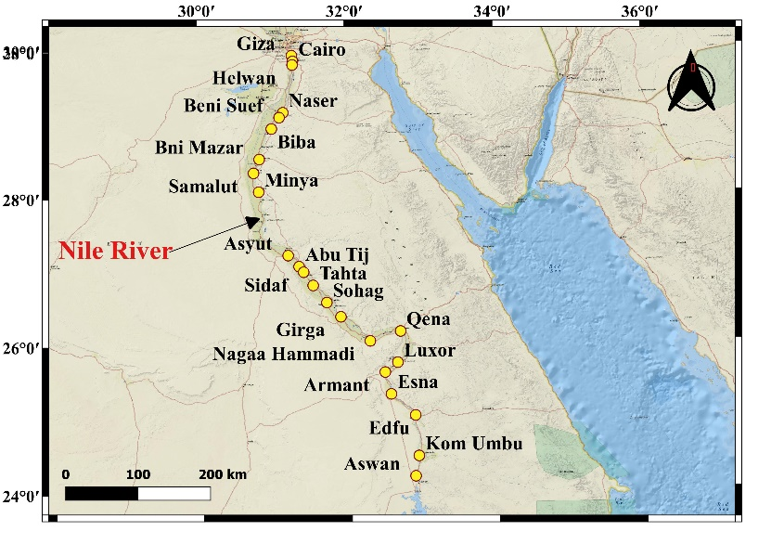
Fig. (1): Location map of sampling stations along main river stream.

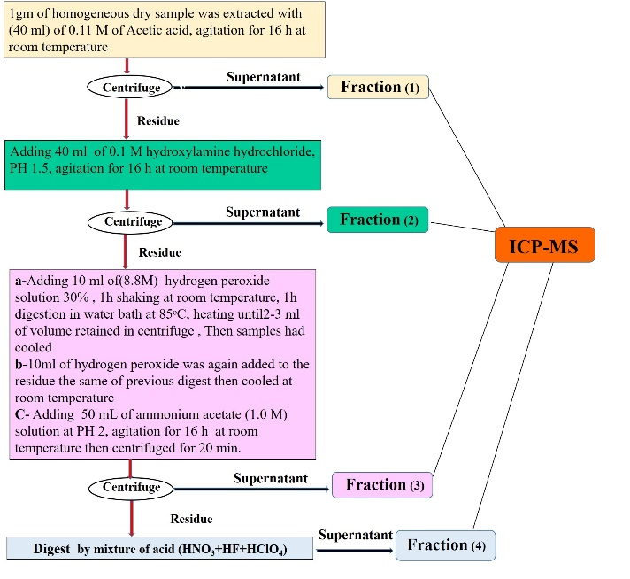
Figure 2: Flowchart of sequential extraction procedures.

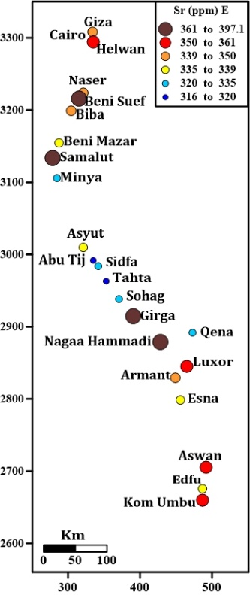
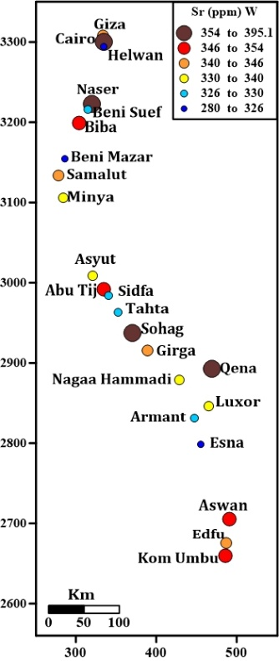
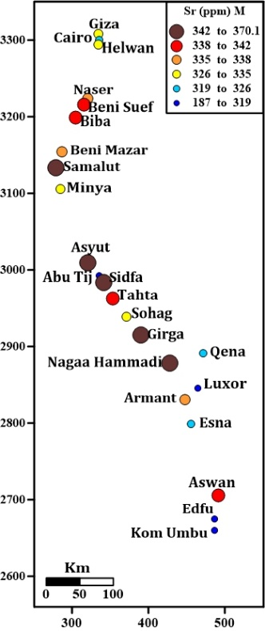
Fig.(3): Crossed map of strontium concentration (ppm) of the Nile river main stream sediments from West, Middle and East.

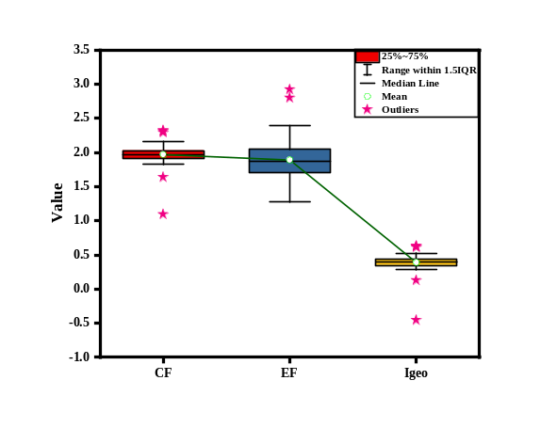
Fig. (4): Box plot of Contamination factor (CF), geo-accumulation index (Igeo)and enrichment factor (EF) of Nile River sediments.

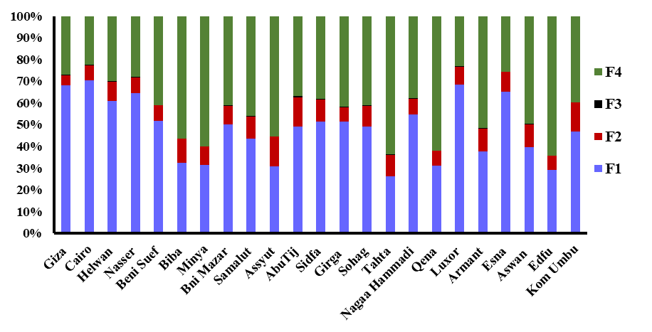
Fig. (5): Fractions distribution of Sr in the Nile sediments. F1: Acid soluble; F2: Reducible; F3: Oxidizable fraction; F4: Residual fraction.

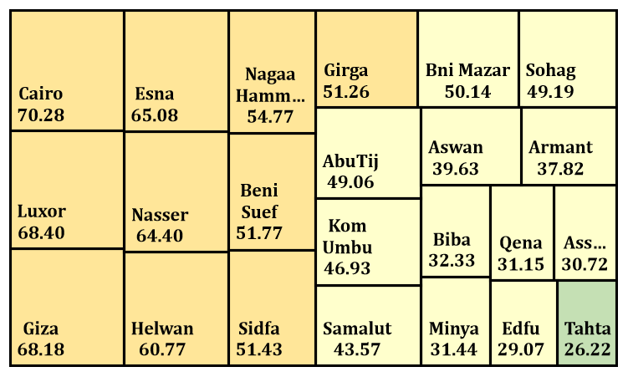
Fig. (6): Risk assessment code (RAC) at samples location along Nile River main stream.

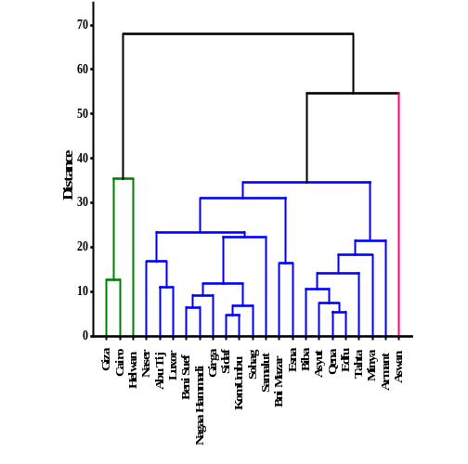
Fig. (7): Dendrogram showing cluster of variables on the basis of similarity of strontium.

