Theoretical prediction system of p53 stabilization complex conformation and binding affinity for several DNA sequence.

Jun Koseki^{1, *}, Haruka Hirose¹, Masamitsu Konno², Ayumu Asai³, Takahito Ohshiro³, Masaki Taniguchi³, Teppei Shimamura^{1,} *

¹ Division of Systems Biology, Graduate School of Medicine, Nagoya University, Aichi, 466-8550 Japan.
² Department of Frontier Science for Cancer and Chemotherapy, Graduate School of Medicine, Osaka University, Osaka, 565-0871 Japan.
³ The institute of Scientific and Industrial Research, Osaka University, Osaka, 576-0047 Japan.

Supplementary Figure

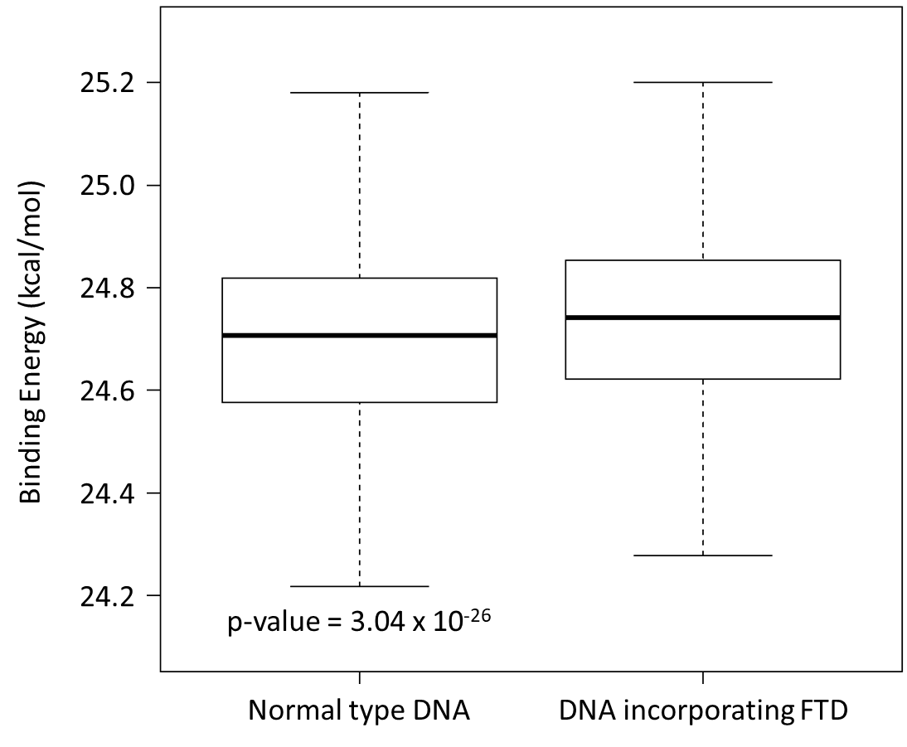
Supplementary Figure 1. P53 binding energy distribution for the BAX response elements’ sequences incorporating FTD or not. The p-value between the two distributions is 3.04 x 10⁻²⁶.

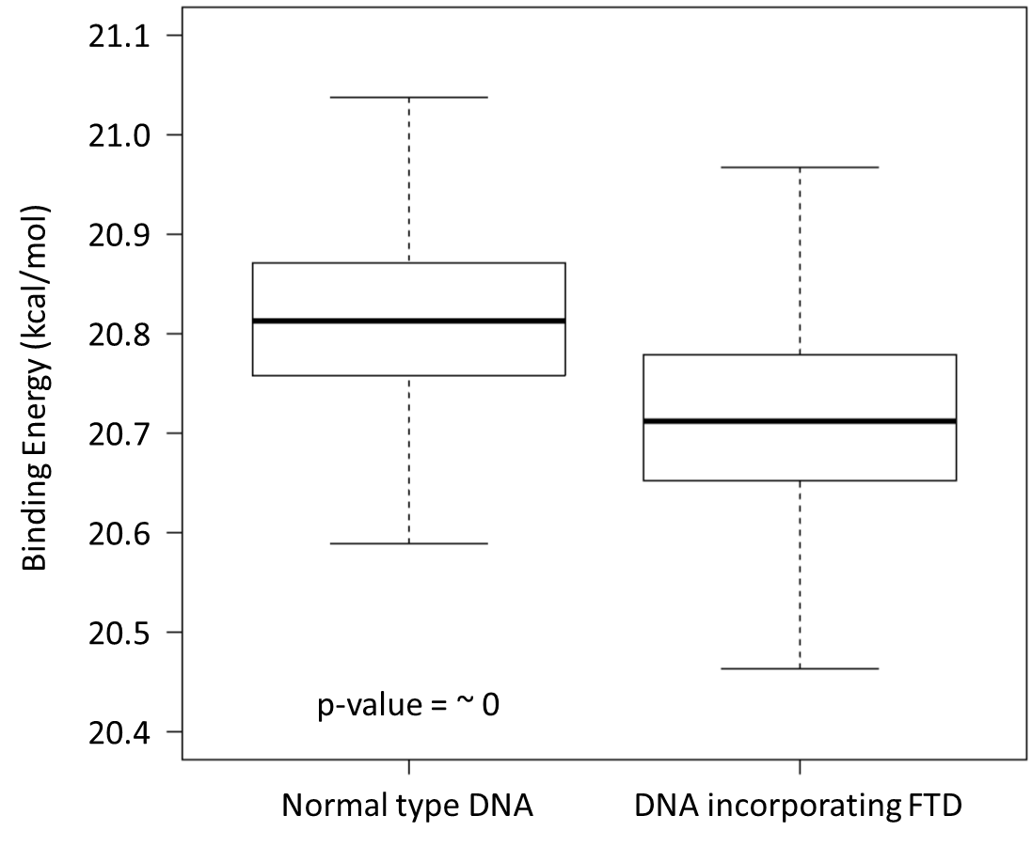
Supplementary Figure 2. P53 binding energy distribution for the p53-binding sequences extracted from FTD-resistant cells incorporating FTD or not. The p-value between the two distributions is ~0.

Supplementary Structural Legends

Supplementary Conformational data 1. Predicted binding complex structure of a p53 tetramer and a BAX sequence.
Supplementary Conformational data 2. Predicted binding complex structure of a p53 tetramer and a BAX sequence including FTD.
Supplementary Conformational data 3. Predicted binding complex structure of a p53 tetramer and a p53 binding sequence extracted from FTD-resistant cells.
Supplementary Conformational data 4. Predicted binding complex structure of a p53 tetramer and a p53 binding sequence including FTD extracted from FTD-resistant cells.

