Supplementary Information

Reliability and Feasibility of Visual Grading Systems and Quantitative Indexes on [^{99m}Tc]Tc-DPD Imaging for Cardiac Amyloidosis

Supplementary Table 1. Inter-observer agreement of DS and PS between the two readers
Reader 1 | Reader 2
Reader 1 | 0 | 1 | 2 | 3
DS
0 | 132 | 0 | 0 | 0
1 | 3 | 4 | 0 | 0
2 | 0 | 0 | 2 | 0
3 | 0 | 0 | 1 | 10
PS
0 | 132 | 0 | 0 | 0
1 | 3 | 4 | 0 | 0
2 | 0 | 0 | 6 | 0
3 | 0 | 0 | 0 | 7

Supplementary Table 2. ICC values for [^{99m}Tc]Tc-DPD indexes between the two readers
Modality | Indexes | ICC | 95% CI
Planar | H/WB | 0.918 | 0.403–0.977
 | H/CL | 0.901 | 0.706–0.964
SPECT/CT | SUVmax | 1.000 | 1.000–1.000
 | SUVmean | 0.999 | 0.995–1.000
 | TMU | 0.997 | 0.984–0.999
 | C-index | 0.958 | 0.810–0.987
ICC, intraclass correlation coefficient; CI, confidence interval

Supplementary Table 3. Descriptions on each scoring system
Scoring | Descriptions
DS
0 | no myocardial uptake and normal rib uptake
1 | myocardial uptake is less than rib uptake
2 | myocardial uptake is equal to rib uptake
3 | myocardial uptake is greater than rib uptake with mild or absent rib uptake
PS
0 | absent myocardial uptake and normal bone uptake
1 | mild myocardial uptake that is inferior to bone uptake
2 | moderate myocardial uptake accompanied by attenuated bone uptake
3 | strong myocardial uptake with mild or absent bone uptake

Supplementary Fig. 1. Bland-Altman plot for the two readers’ measurements on quantitative indexes (for those with DS ≥ 1)
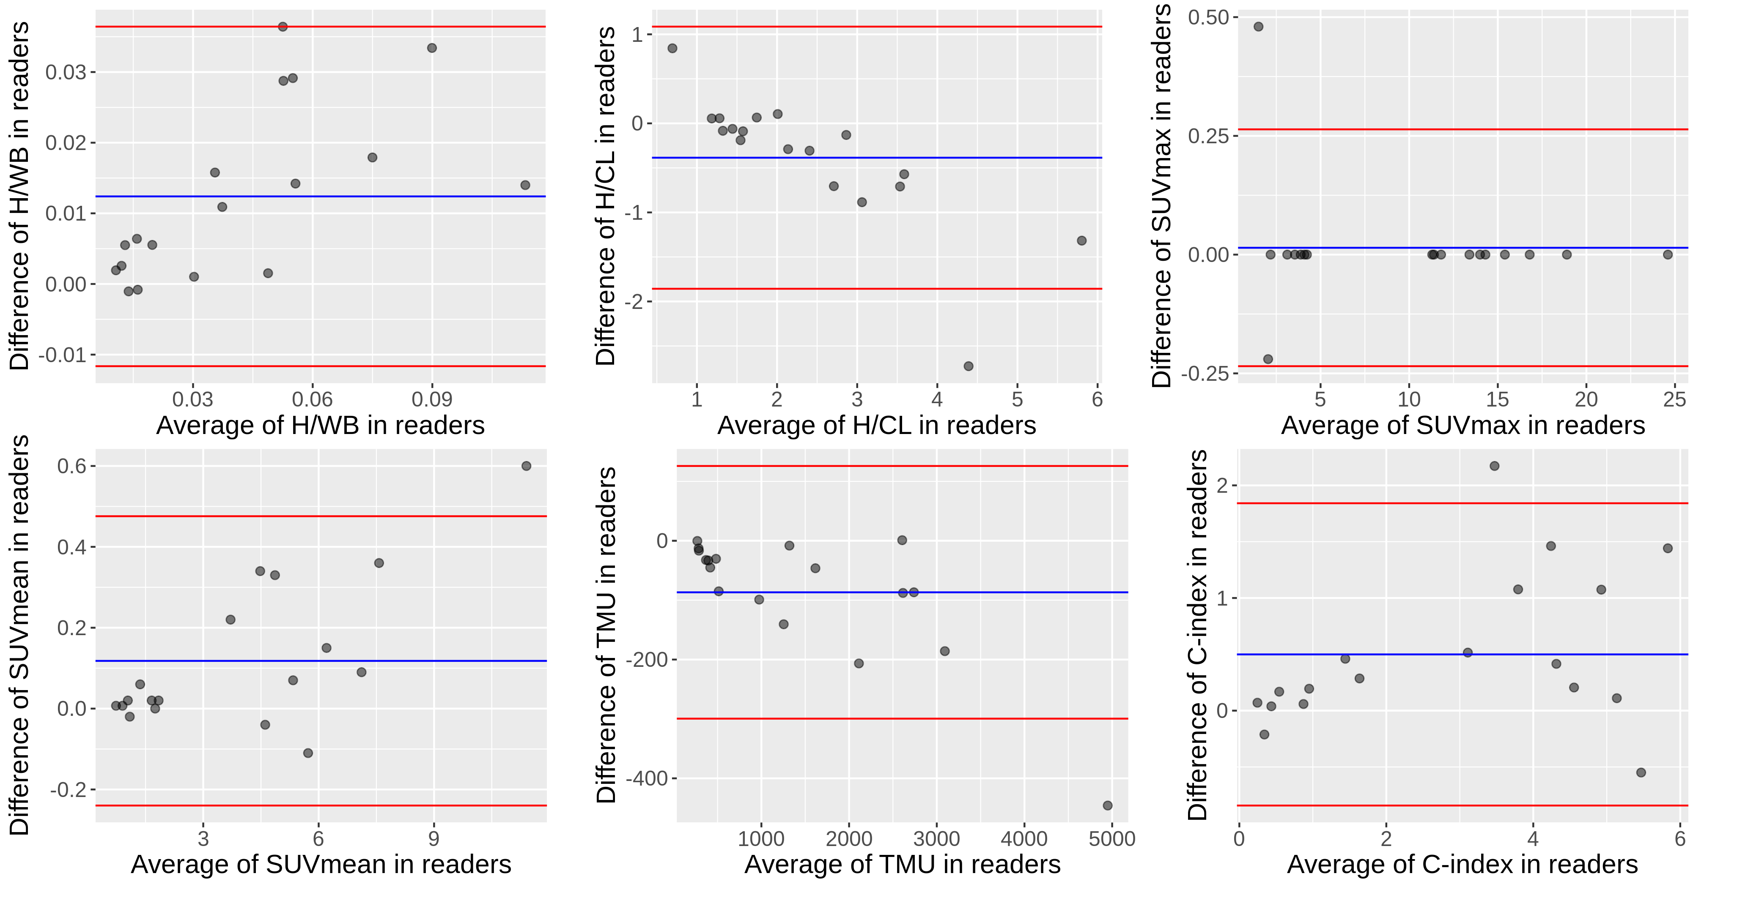Blue lines represent the mean difference between the two readers and red lines represent 1.96 × SD of the differences.

Supplementary Fig. 2. Correlations of SPECT/CT indexes with planar indexes (for those with DS ≥ 1)
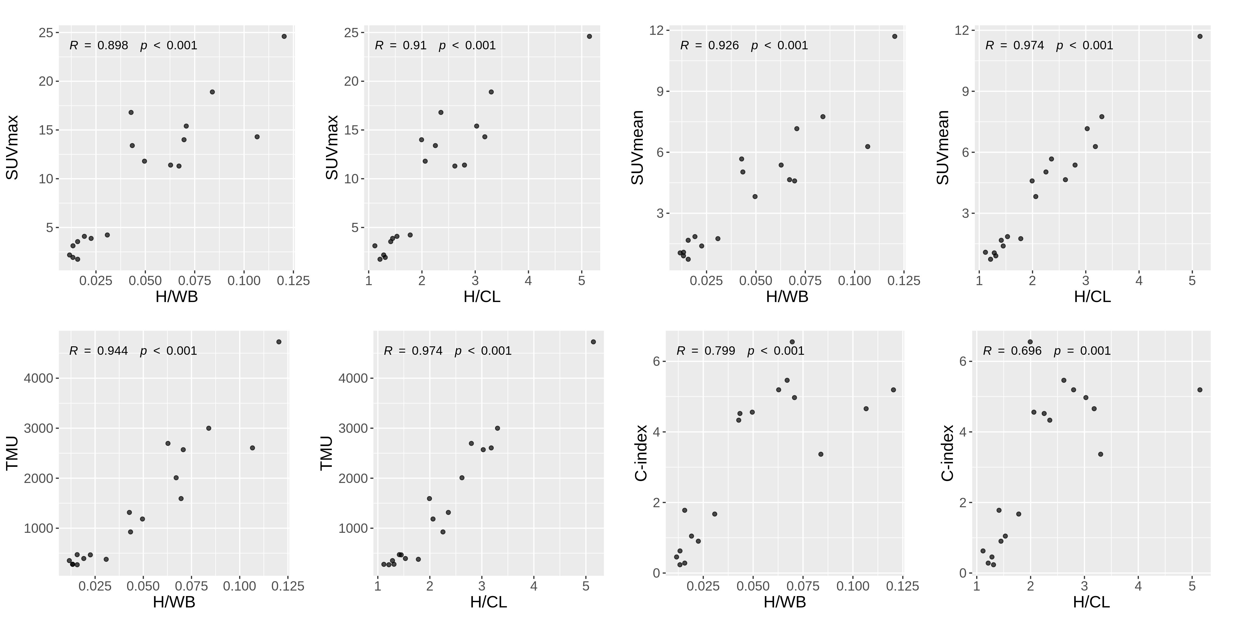Pearson’s correlation coefficients (R) and p-values are shown on top-left corners.
a b

c d
Supplementary Fig. 3. Association of echocardiographic parameters with visual score and SUVmax
(a) E/A and E/e’ did not show significant difference between different DS groups.
(b) Scatter plots presenting correlation between the echocardiography indexes with SUVmax. A weak correlation was observed between E/A and SUVmax.
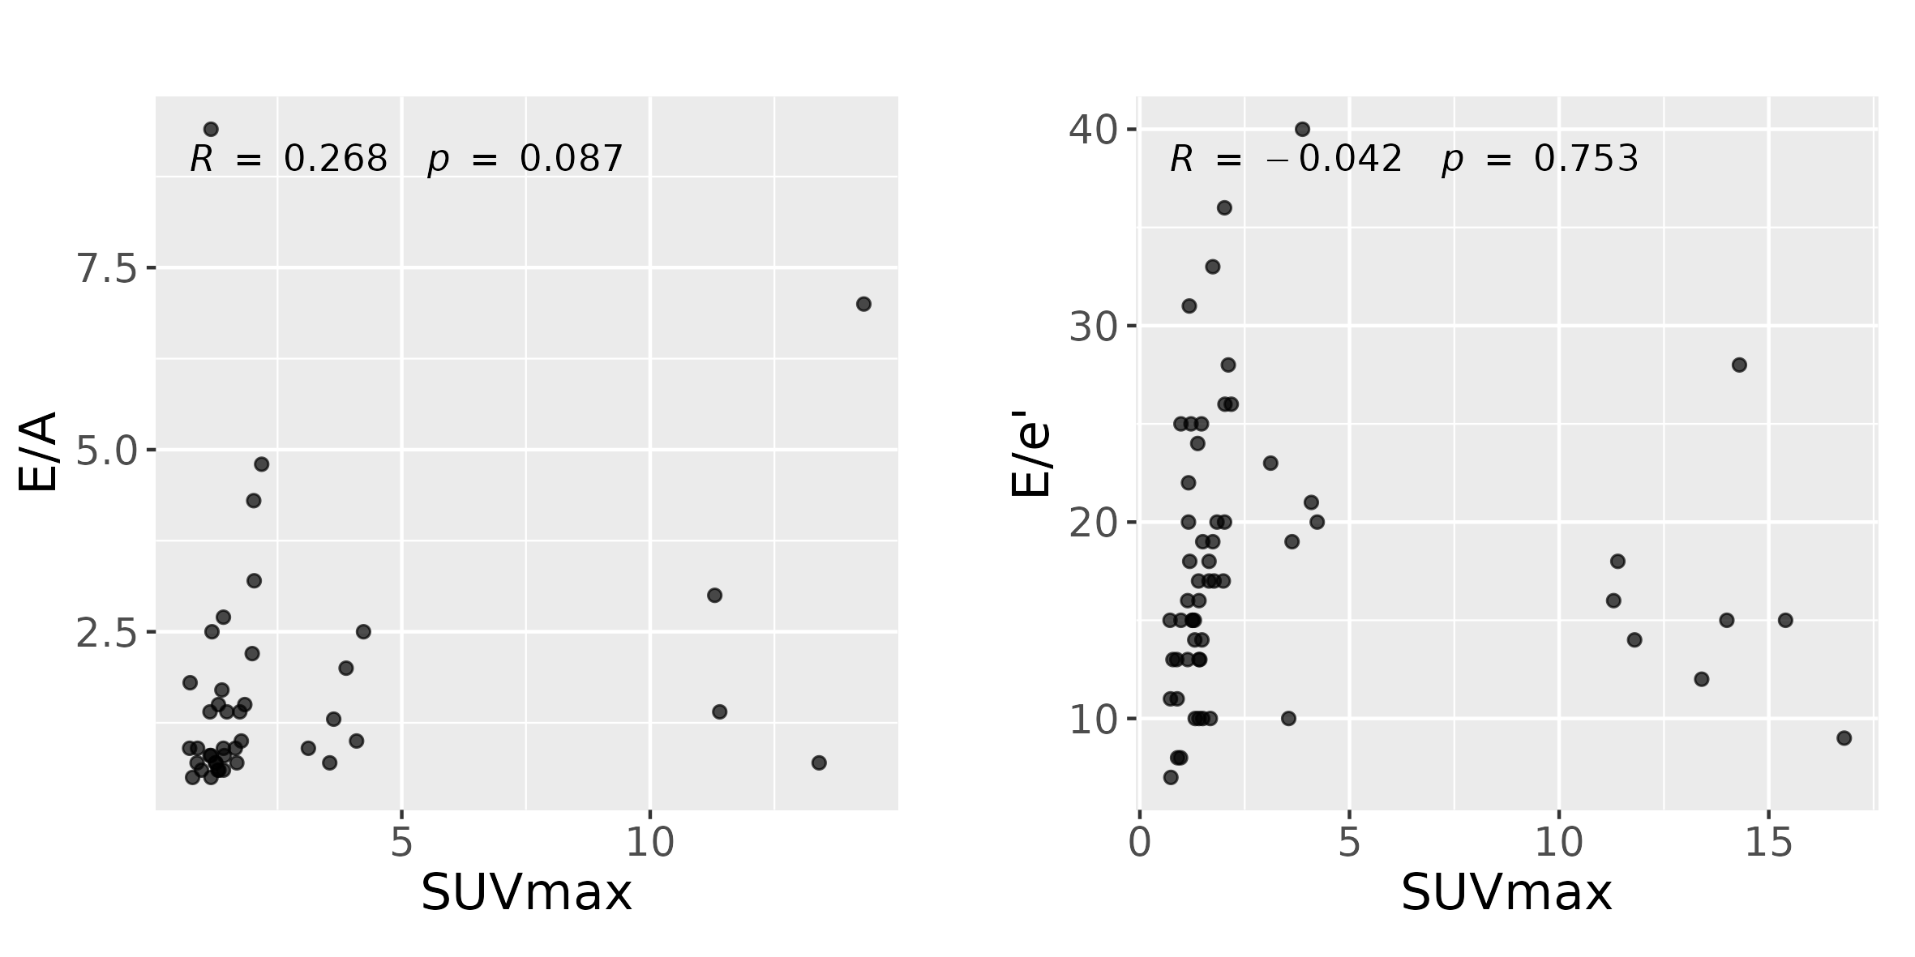
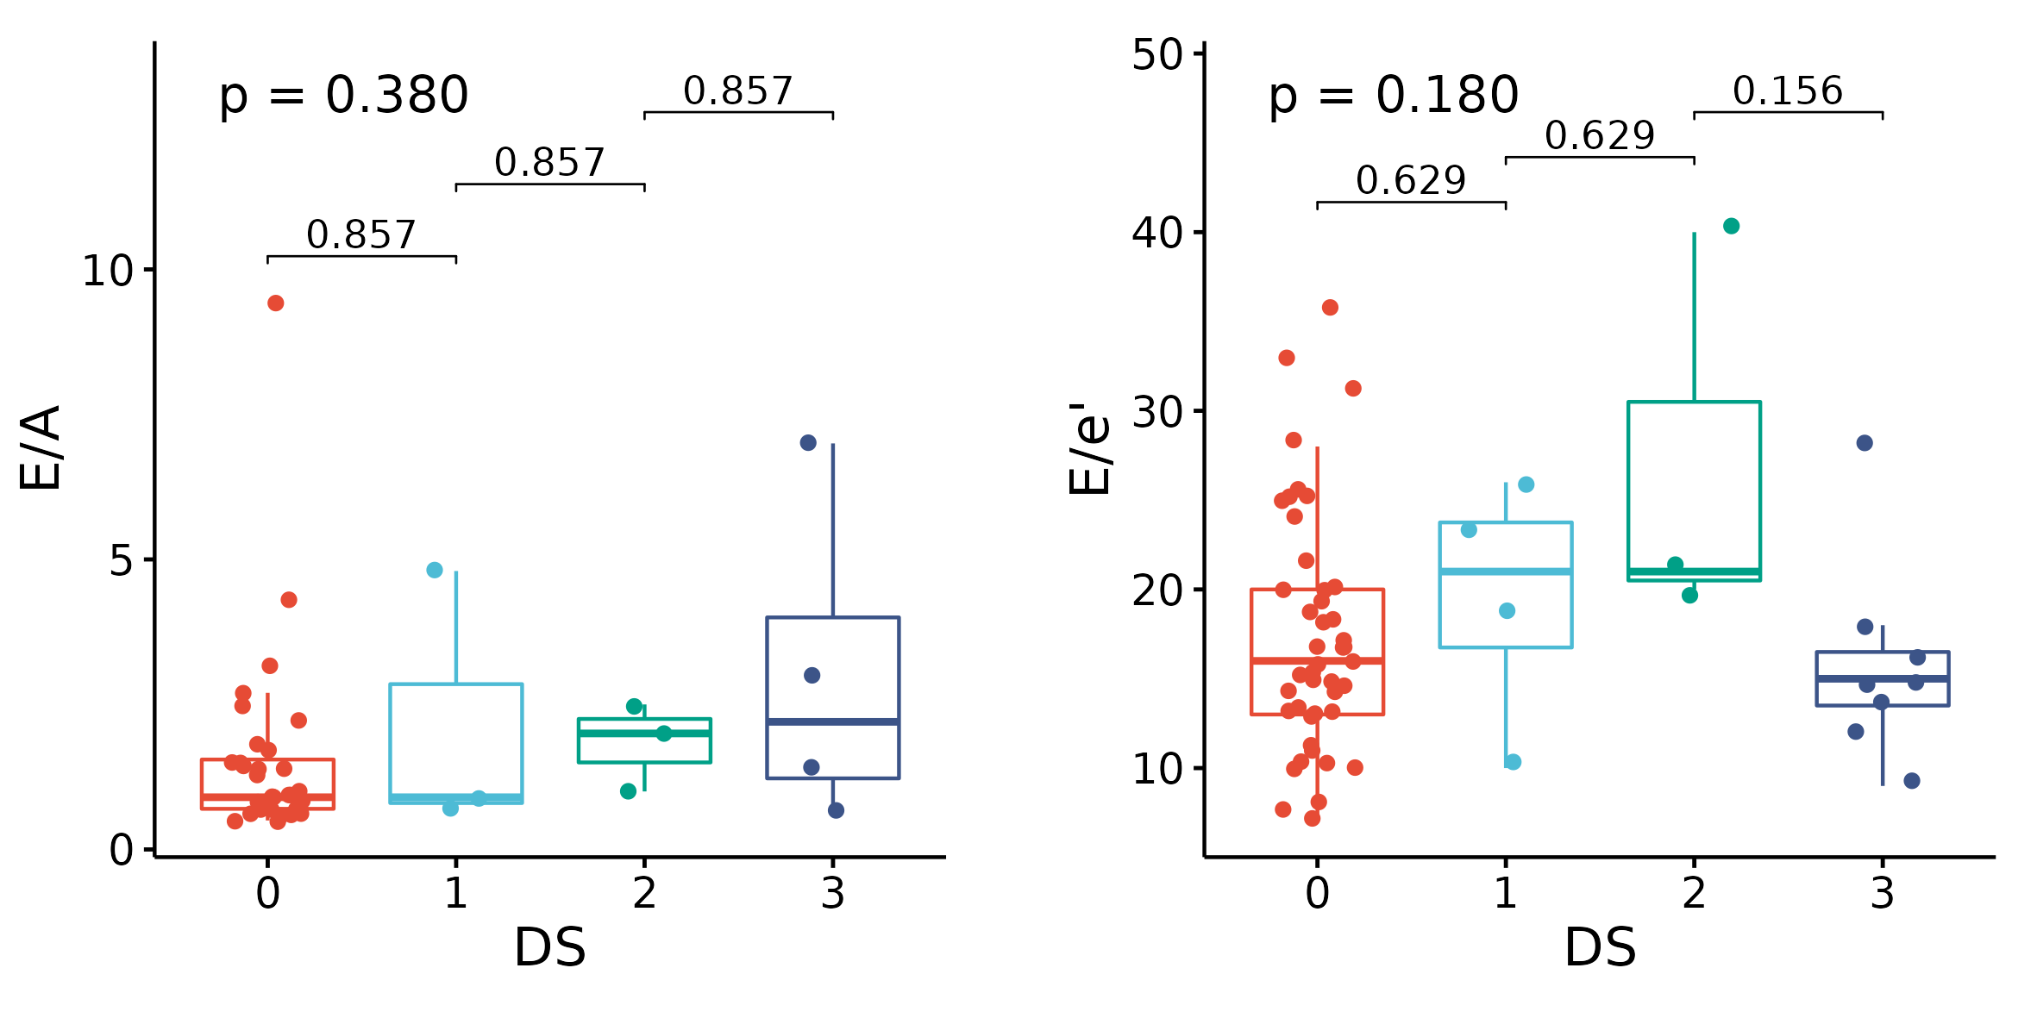 (a) (b)

Supplementary Fig. 4. Association of ECV with DS and SUVmax
(a) ECV was significantly different between DS 0 and 3 (P = 0.015), although the difference was not significant between DS 0/1, and between 1/2, due to small sample sizes.
(b) Scatter plots presenting correlation between ECV and SUVmax. ECV showed a significant correlation with SUVmax (P < 0.001).
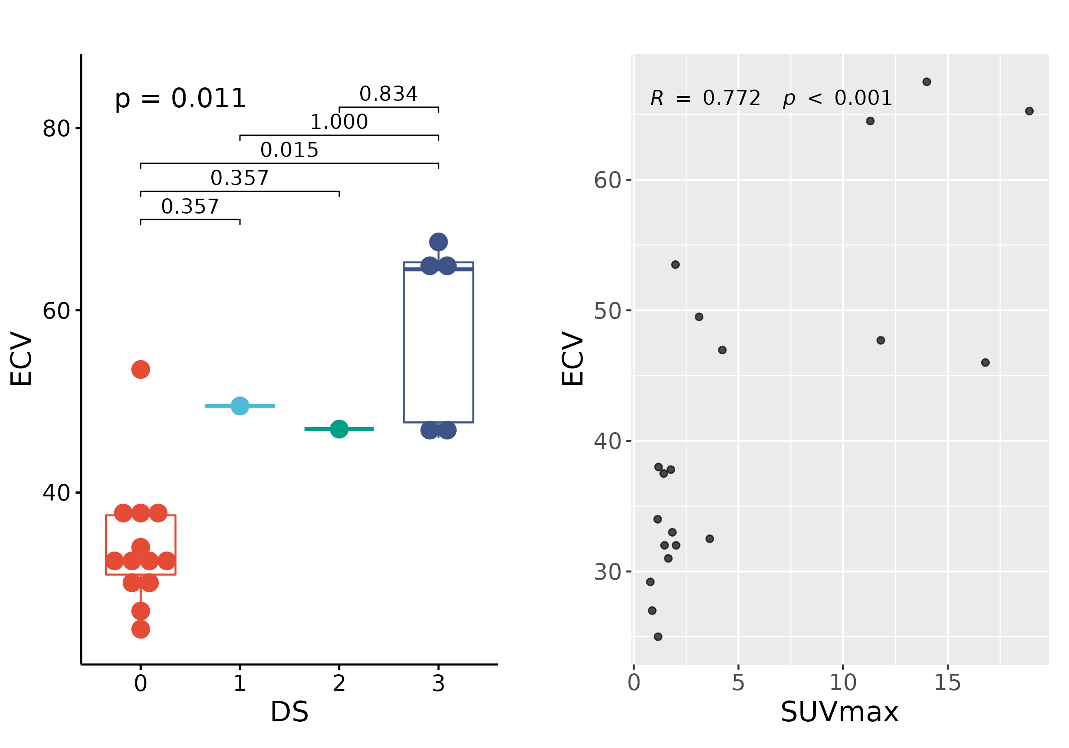
(a) (b)

Supplementary Fig. 5. Study scheme and analysis methods of [^{99m}Tc]Tc-DPD images.
