Supplementary Information

Antisense oligonucleotides selectively enter human-derived antibiotic-resistant bacteria through ATP-binding cassette transporter

Mingzhu Liu,^{1, ‡} Rong Sun,^{1, ‡} Jiali Ding,¹ Han Ye,² Binbin Chu,¹ Yunmin Yang,¹ Yuqi Wu,¹ Haoliang Shi,¹ Bin Song,¹ Jiaxu Hong,^{2, *} Houyu Wang^{1, *} & Yao He^{1, *}

¹Suzhou Key Laboratory of Nanotechnology and Biomedicine, Institute of Functional Nano & Soft Materials & Collaborative Innovation Center of Suzhou Nano Science and Technology (NANO-CIC), Soochow University, Suzhou 215123, China

²Department of Ophthalmology and Vision Science, Shanghai Eye, Ear, Nose and Throat Hospital, Fudan University, Shanghai, China.

* Corresponding authors. Email: jiaxu.hong@fdeent.org; houyuwang@suda.edu.cn; yaohe@suda.edu.cn

‡ These authors contributed equally to this work.

Supplementary Table 1 Sequences of asPNA and (KFF)₃K-asPNA
Nucleic acid | Sequence
asPNA | Cy7.5-CTCATACTCTCCATGATTTA-Glu
(KFF)₃K-asPNA | Cy7.5-CTCATACTCTCCATGATTTA-Glu-KFFKFFKFFK

Supplementary Table 2 Primer sequences of relevant genes designed for RT-PCR
mRNA | primer pairs
16sRNA | forward 5’-TCGTGTCGTGAGATGTTGGG-3’
 | reverse 5’-GTTTGTCACCGGCAGTCAAC-3’
acpP | forward 5’-GCGGATTCTCTTGACACCGT-3’
 | reverse 5’-CAGCCTGAACGGTGGTGATT-3’
fmhB | forward 5’-TGCTTCAAAAGTGCGCTTGG-3’  reverse 5’-CACGCGTTAAGAAGCCATCG-3’

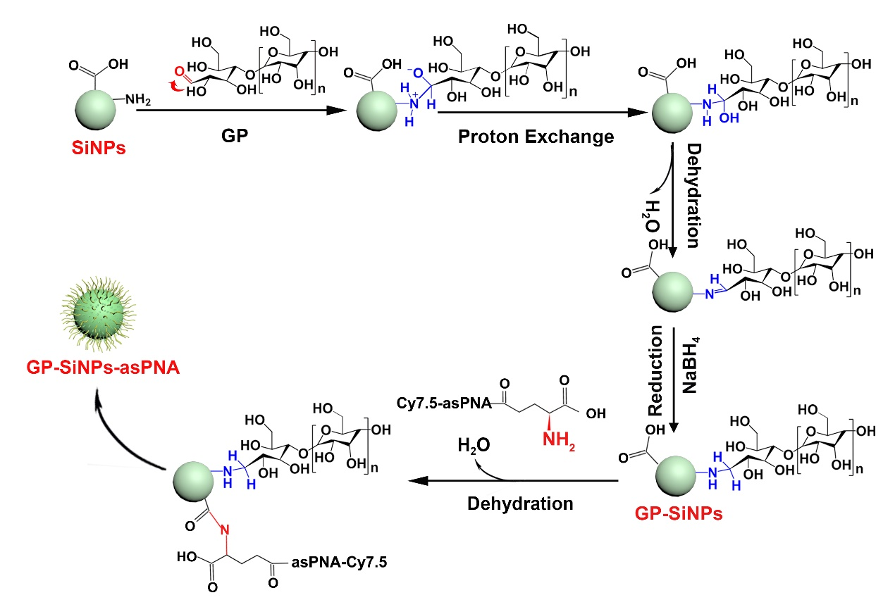
Supplementary Fig. 1 Scheme illustrating the step-by-step synthesis of GP-SiNPs-asPNA.

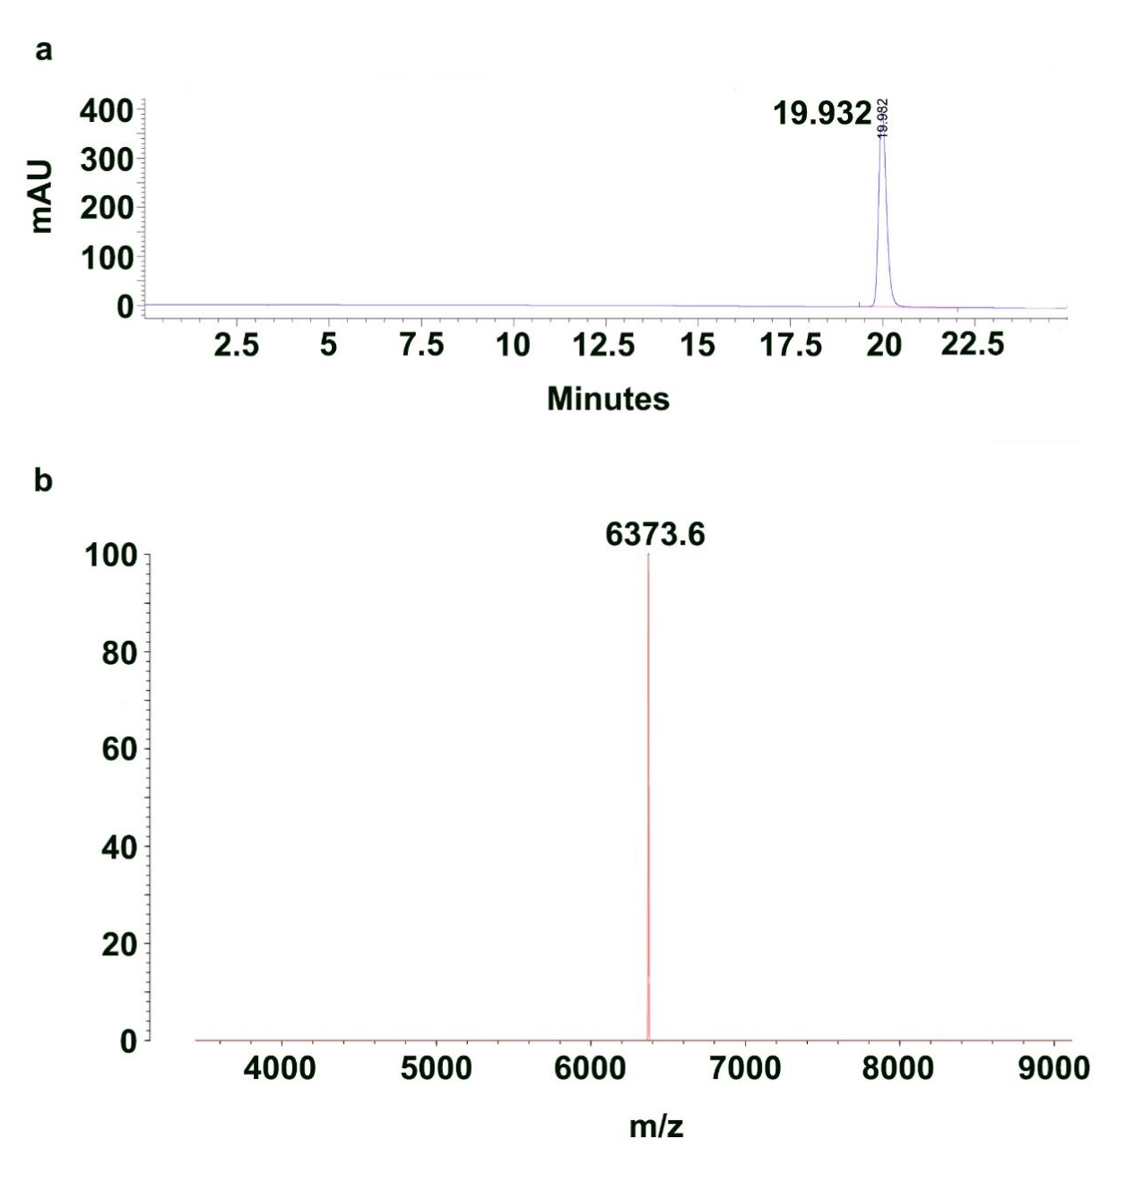
Supplementary Fig. 2 Characterization of asPNA-cy7.5. High-performance liquid chromatography (HPLC) (a) and MS spectra of asPNA-cy7.5 (b).

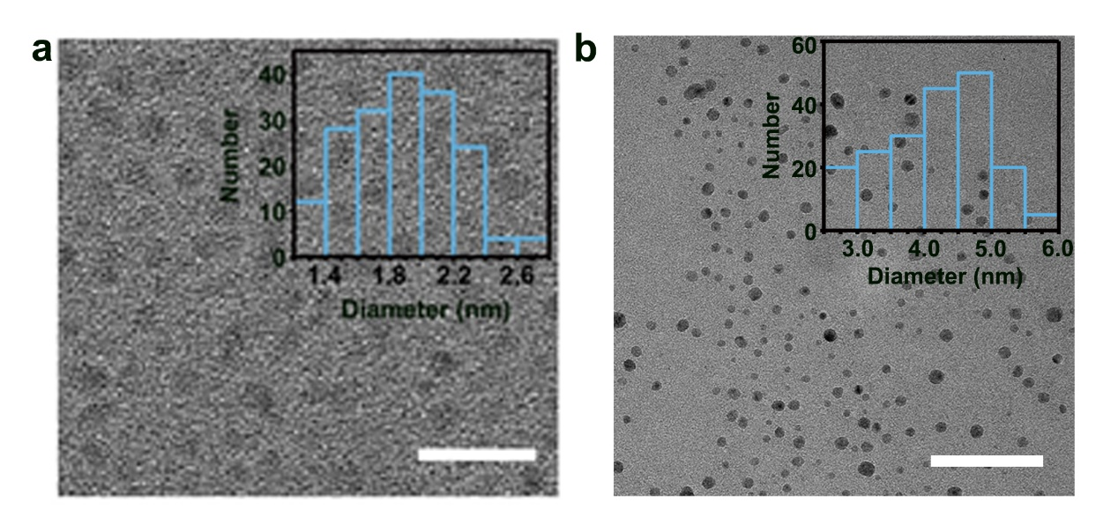

Supplementary Fig. 3 TEM image and corresponding size distribution (Inset) of SiNPs (a) and GP-SiNPs-asPNA (b). Scale bars: 20 nm.

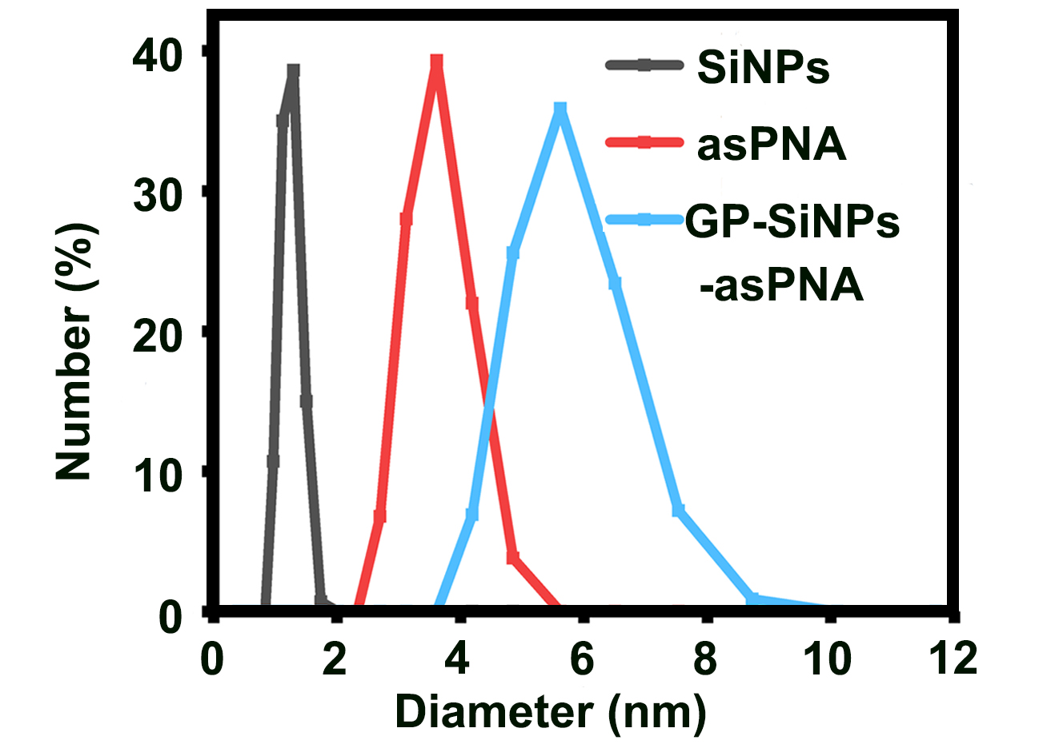

Supplementary Fig. 4 DLS data of SiNPs, asPNA and GP-SiNPs-asPNA.

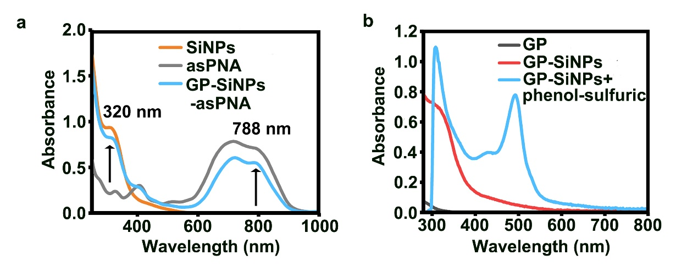
Supplementary Fig. 5 (a) UV-vis absorption spectra of SiNPs, asPNA and GP-SiNPs-asPNA. (b) UV-vis absorption spectra of GP, GP-SiNPs, and GP-SiNPs treated with phenol-sulfuric acid (GP-SiNPs+phenol-sulfuric).

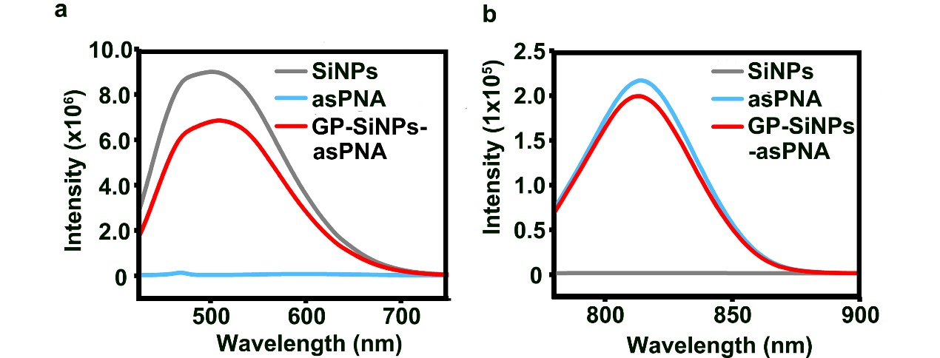
Supplementary Fig. 6 Photoluminescence (PL) spectra of SiNPs, asPNA and GP-SiNPs-asPNA under excitation at 405 nm (a) and 788 nm (b).

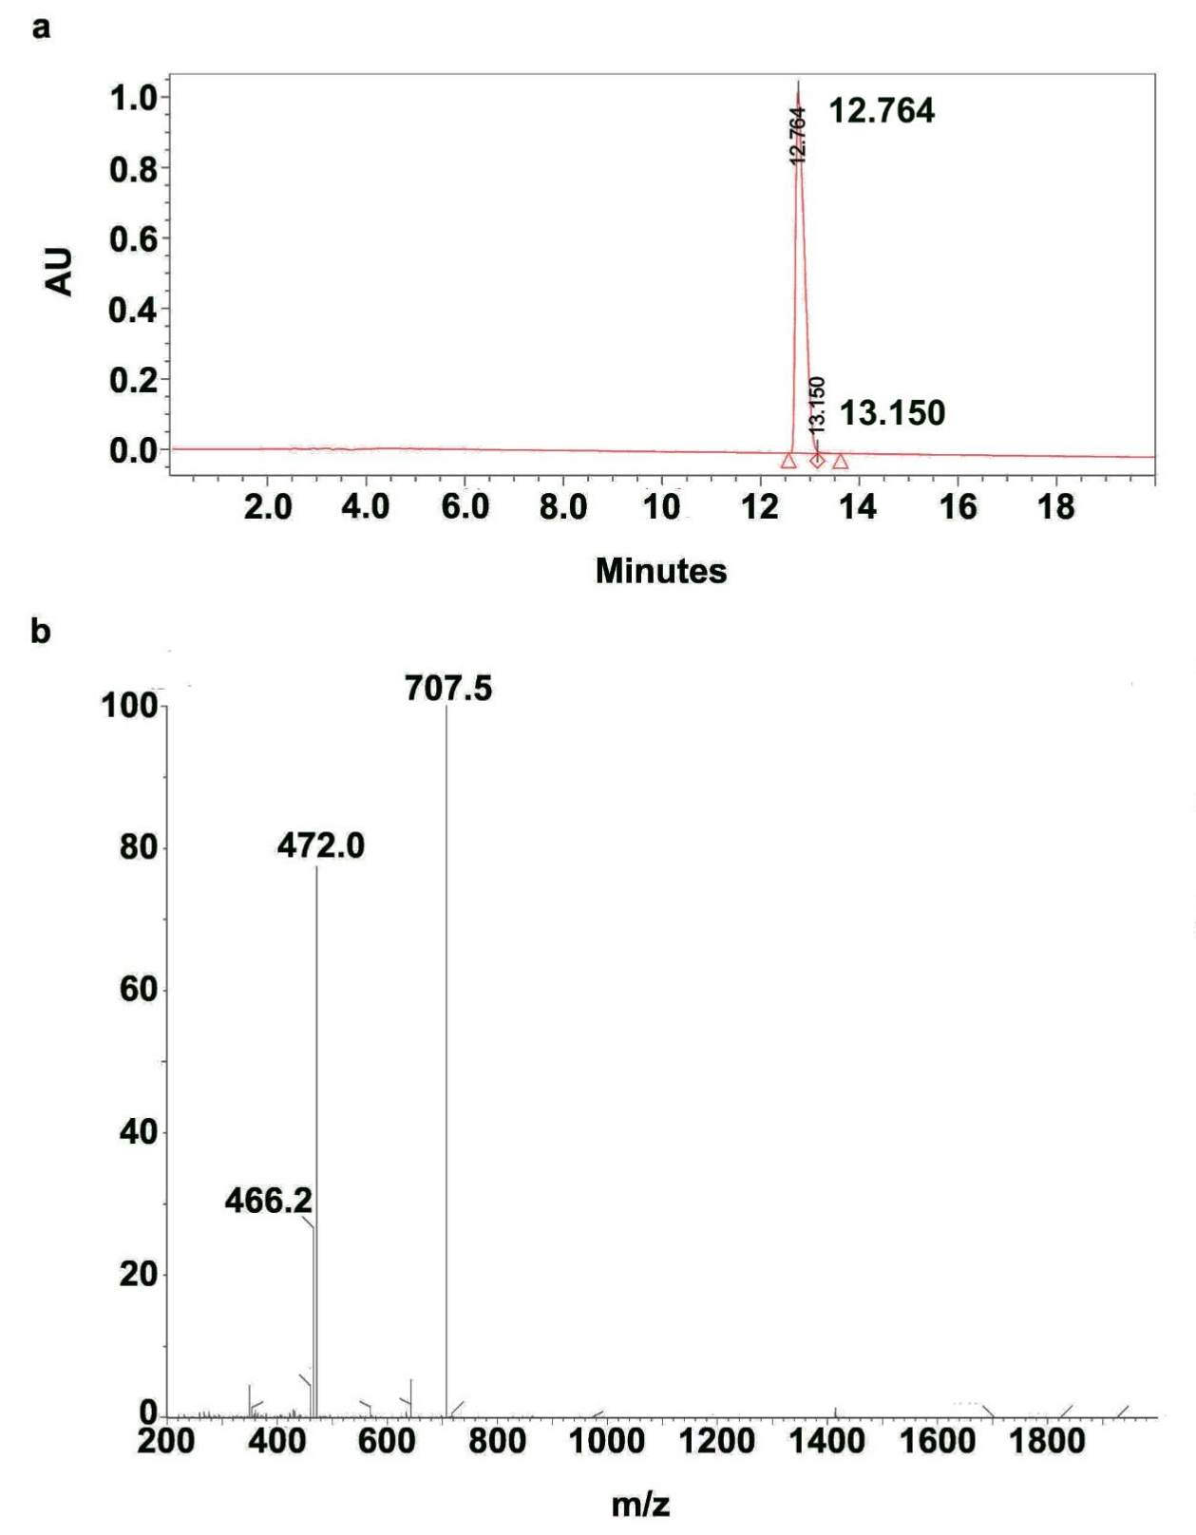
Supplementary Fig. 7 Characterization of (KFF)₃K. High-performance liquid chromatography (HPLC) (a) and mass spectra of (KFF)₃K (b).

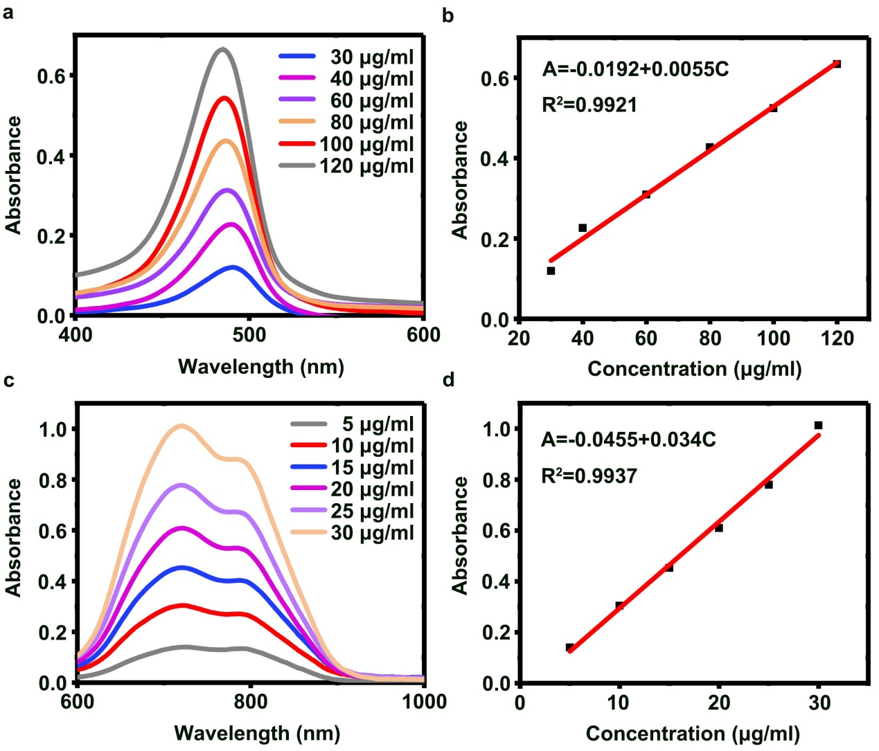
Supplementary Fig. 8 Quantification of GP and asPNA-Cy7.5. UV-vis absorption spectra of GP with various concentrations ranged from 30 to 120 μg/mL treated by the same amount of phenol-sulfuric acid (a) and corresponding calibration curve (b). UV-vis absorption spectra of asPNA-Cy7.5 with various concentrations ranged from 0 to 30 μg/mL (c) and corresponding calibration curve (d).

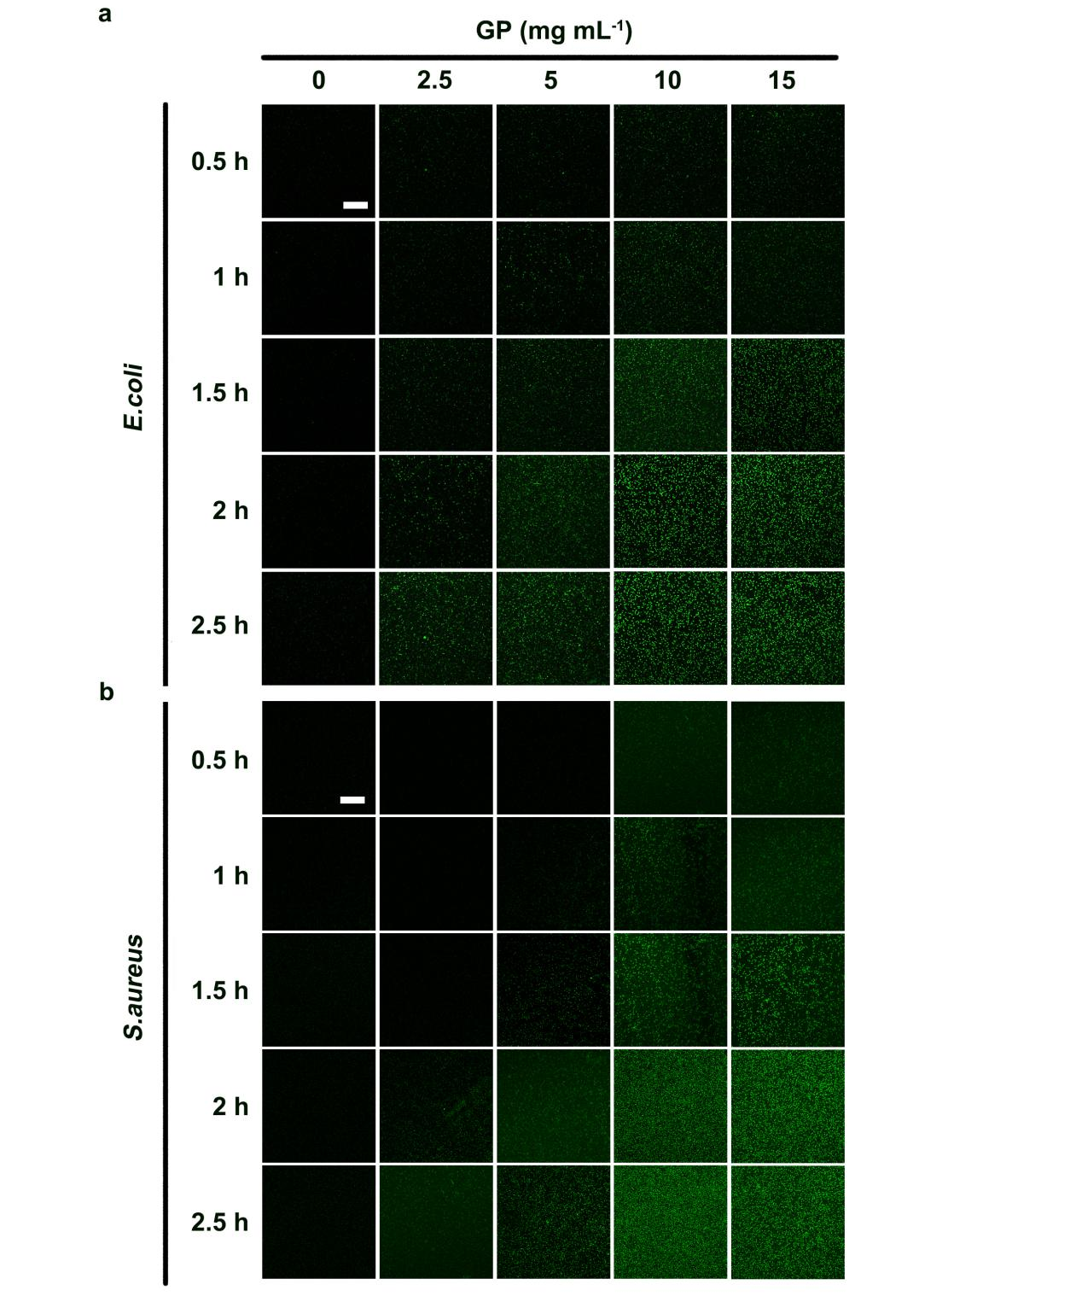
Supplementary Fig. 9 The effects of GP concentration and incubation time on the uptake of GP-SiNPs-asPNA by bacteria. a, The confocal images of E. coli co-incubated with GP-SiNPs-asPNA with GP concentration (0, 2.5, 5, 10, 15 mg/mL) at 37 ºC for 0.5 h, 1 h, 1.5 h, 2 h and 2.5 h, respectively. Scale bar: 10 μm. b, The confocal images of S. aureus co-incubated with GP-SiNPs-asPNA with GP concentration (0, 2.5, 5, 10, 15 mg/mL) at 37 ºC for 0.5 h, 1 h, 1.5 h, 2 h and 2.5 h, respectively. Scale bar: 10 μm.

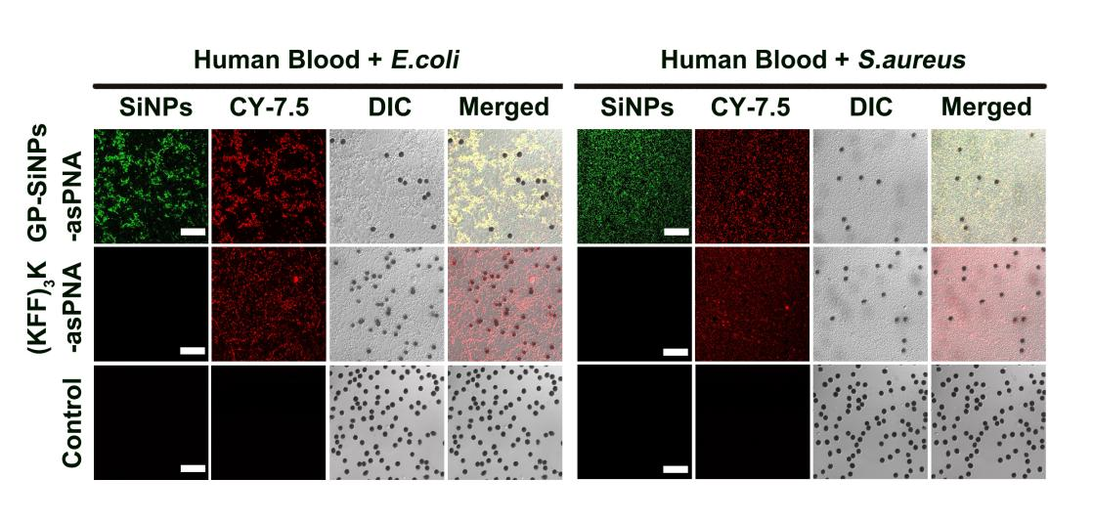
Supplementary Fig. 10 Confocal fluorescence images of the mixture of human blood and bacteria (E. coli or S. aureus) after incubation with GP-SiNPs-asPNA or (KFF)₃K-asPNA. Scale bar: 10 μm.

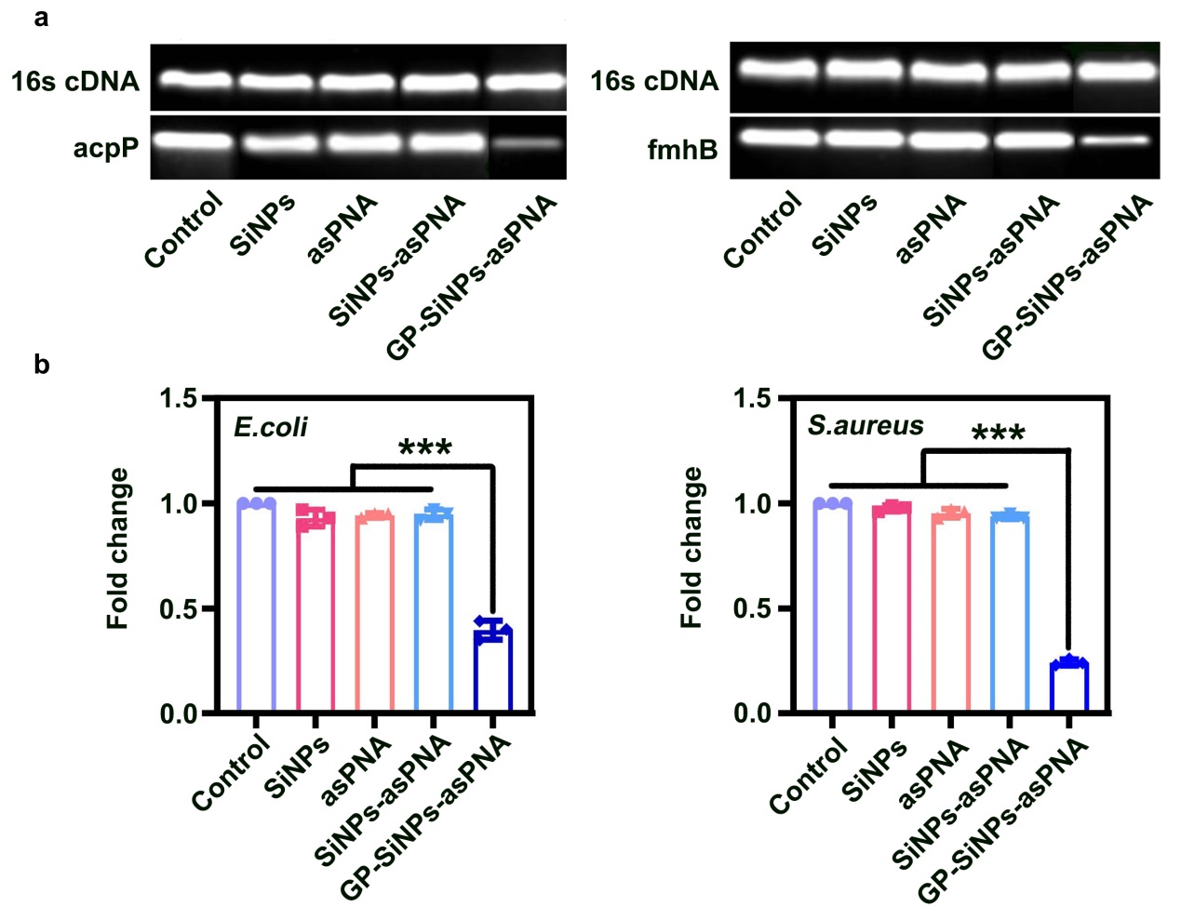
Supplementary Fig. 11 The inhibition of gene expression in E. coli and S. aureus. a, Semiquantitative analysis of gene expressions of acpP gene and fmhB gene in bacteria incubated with GP-SiNPs-asPNA for 12 h by gel electrophoresis. b, Quantitative analysis of gene expressions of acpP gene and fmhB gene in bacteria incubated with GP-SiNPs-asPNA for 12 h by real-time PCR (RT-PCR). Error bars represent the standard deviation obtained from three independent measurements (*** means p < 0.001).
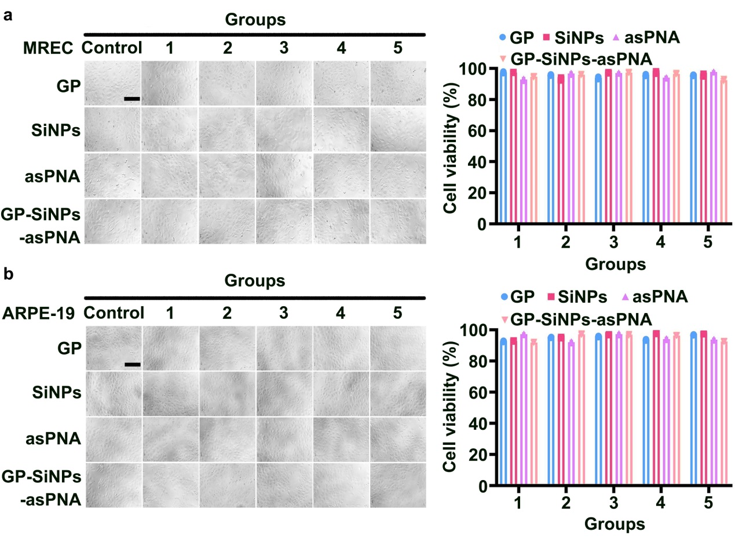
Supplementary Fig. 12 In vitro toxicity assays. a-b, Cell morphology and viability of MREC (a) and ARPE-19 cells (b) treated with different dosages of GP, SiNPs, asPNA and GP-SiNPs-asPNA for 24 h, respectively. The groups of “Control, 1, 2, 3, 4, 5”represent series of concentrations of GP (0, 0.313, 0.625, 1.25, 2.5, 5 mg mL⁻¹), SiNPs (0, 0.625, 1.25, 2.5, 5, 10 mg mL⁻¹), asPNA (0, 62.5, 125, 250, 500, 1000 nM) and GP-SiNPs-asPNA (0, 62.5, 125, 250, 500, 1000 nM). All error bars represent the standard deviation determined from three independent assays.

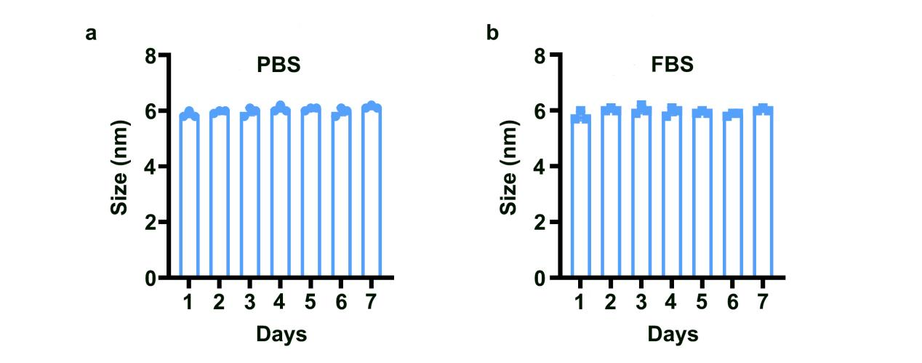
Supplementary Fig. 13 Stability of GP-SiNPs-asPNA and Loading efficacy of asPNA. a, DLS analysis of GP-SiNPs-asPNA after an incubation in PBS (pH = 7.4) for 0-7 day. b, DLS analysis of GP-SiNPs-asPNA after an incubation in 10% FBS for 0-7 day. Error bars represent the standard deviation obtained from three independent measurements.

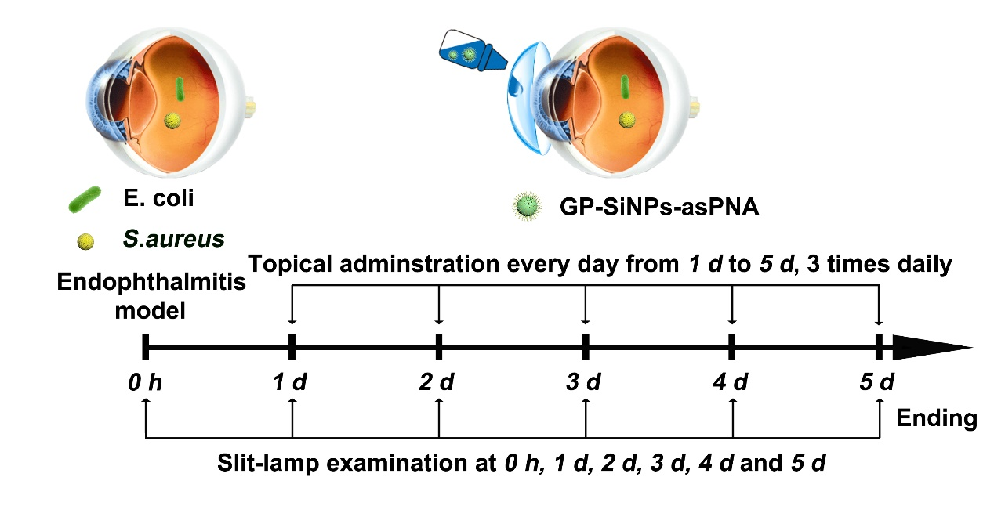
Supplementary Fig. 14 Scheme illustrating the construction of the model of bacterial endophthalmitis in mice and the corresponding treatment procedures.

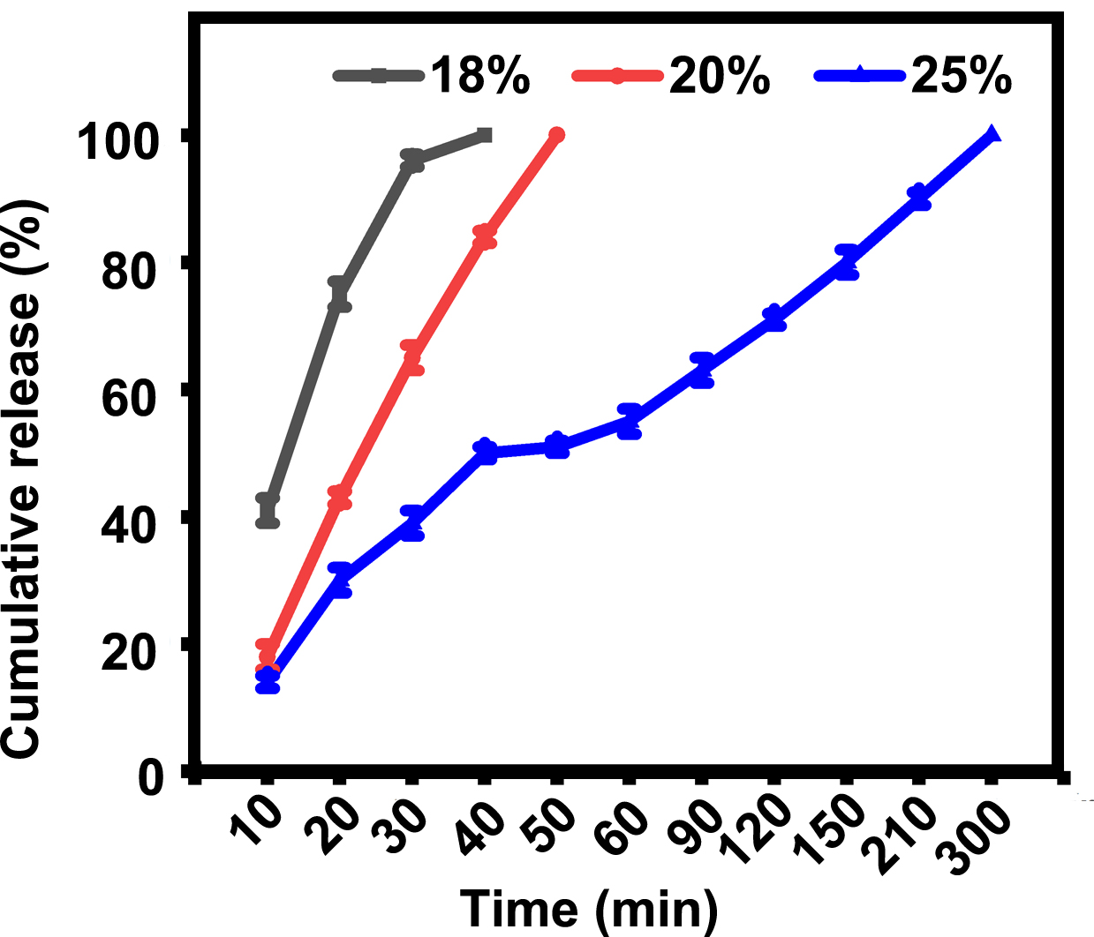
Supplementary Fig. 15 Time-dependent release curves of GP-SiNPs-asPNA in gelling systems with different mass fractions. Error bars represent the standard deviation obtained from three independent measurements

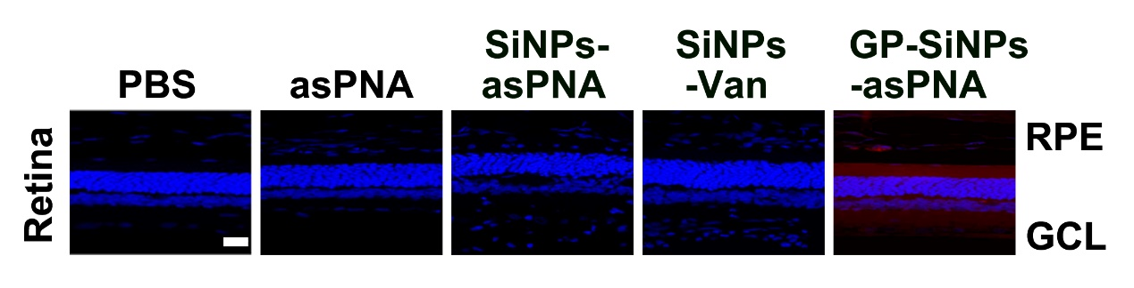
Supplementary Fig. 16 Intraocular distribution of GP-SiNPs-asPNA in retinas from 3.0×10⁶ CFU E. coli- and S. aureus (E. coli + S. aureus)-induced endophthalmitis mice with different treatments (e.g., PBS, asPNA (1 μM), SiNPs-asPNA (1 μM), SiNPs-Van (10 mg mL⁻¹) or GP-SiNPs-asPNA (1 μM) (1 drop per time, 3 times per day)). RPE, retinal pigment epithelium; GCL, ganglion cell layer.

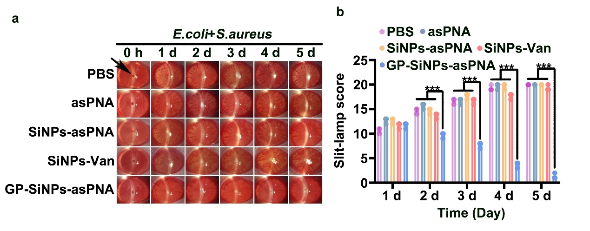
Supplementary Fig. 17 Daily slit-lamp microscopic images of anterior segment of (E. coli + S. aureus)-induced endophthalmitis mice with different treatments (a), and corresponding histograms of silt-lamp examination scores (b). The black arrow in slit-lamp images indicates the position of the pupil. Statistical analysis was performed using one-way ANOVA. Error bars represent the standard deviation obtained from three independent measurements (*** means p < 0.001, n = 3).

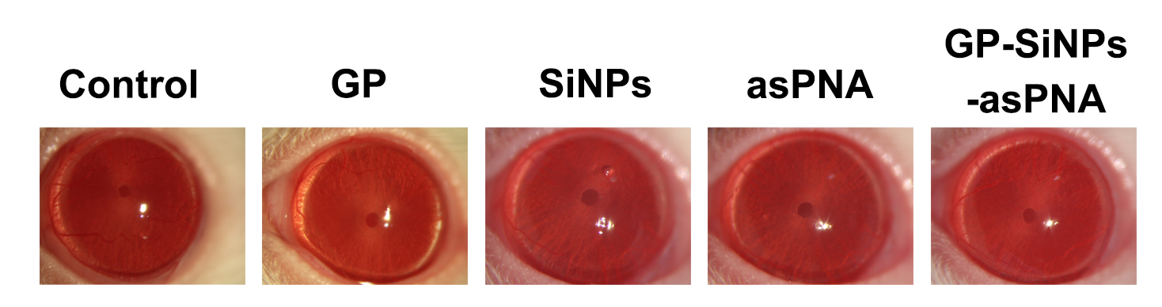
Supplementary Fig. 18 Slit-lamp microscope image of eyeballs of healthy mice treated with GP (5 mg mL⁻¹), SiNPs (10 mg mL⁻¹), asPNA (1 μM) and GP-SiNPs-asPNA (1 μM) for 24 h, respectively.

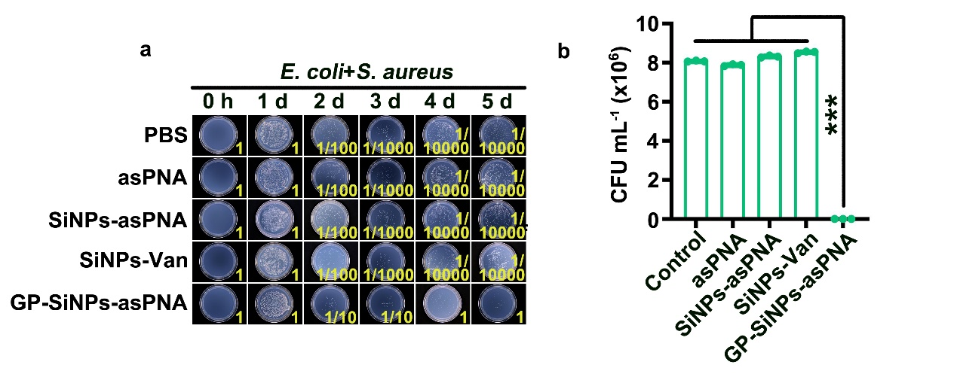
Supplementary Fig. 19 Homogenates of eyeball of (E. coli + S. aureus)-induced endophthalmitis mice with different treatments for 0, 1, 2, 3, 4 and 5 d cultured on the solid LB agar (n=3) (a) and corresponding quantification of bacterial colonization (b). Error bars represent the standard deviation obtained from three independent measurements (*** means p < 0.001).

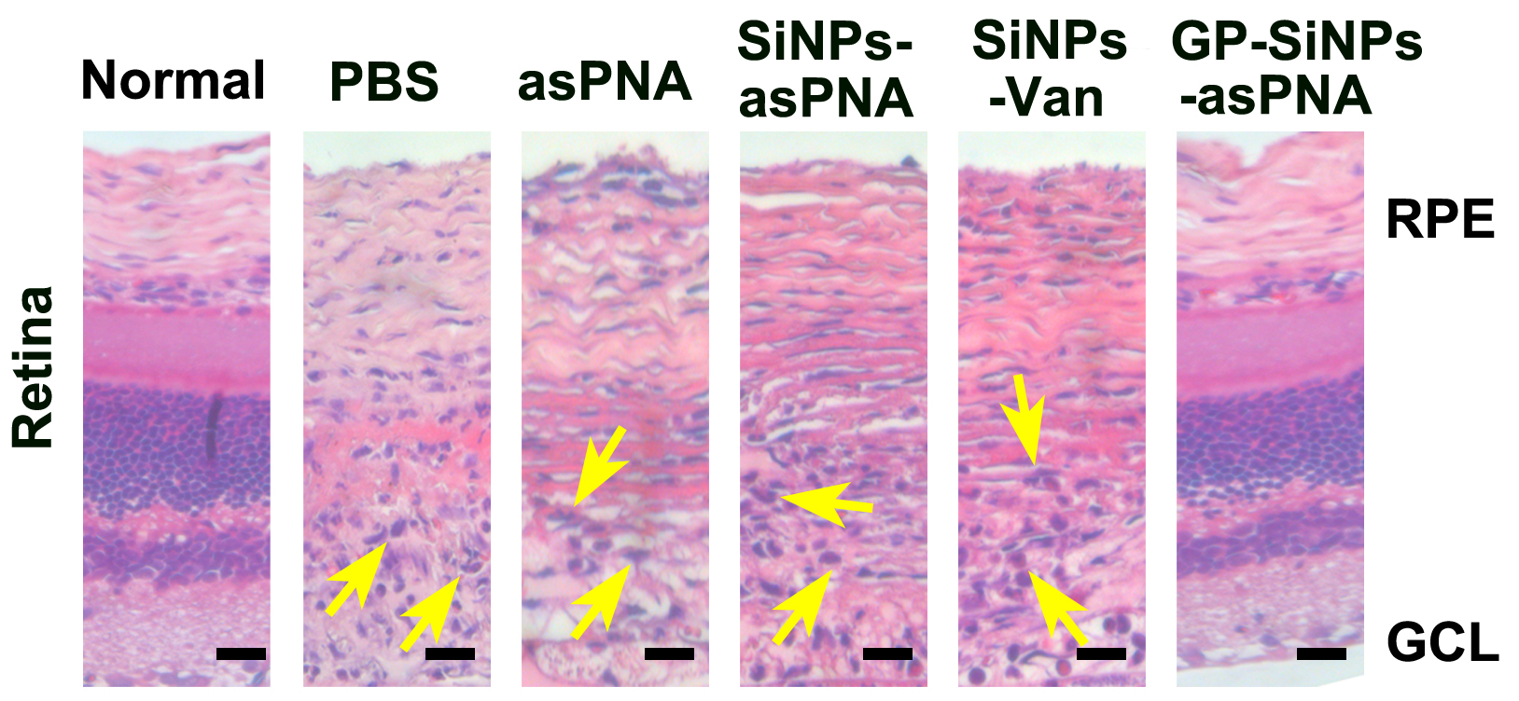
Supplementary Fig. 20 H&E staining images of retina of (E. coli + S. aureus)-induced endophthalmitis mice with different treatments for 5 days. The yellow arrows in H&E staining indicate granulocyte infiltration. Scale bars: 25 μm.

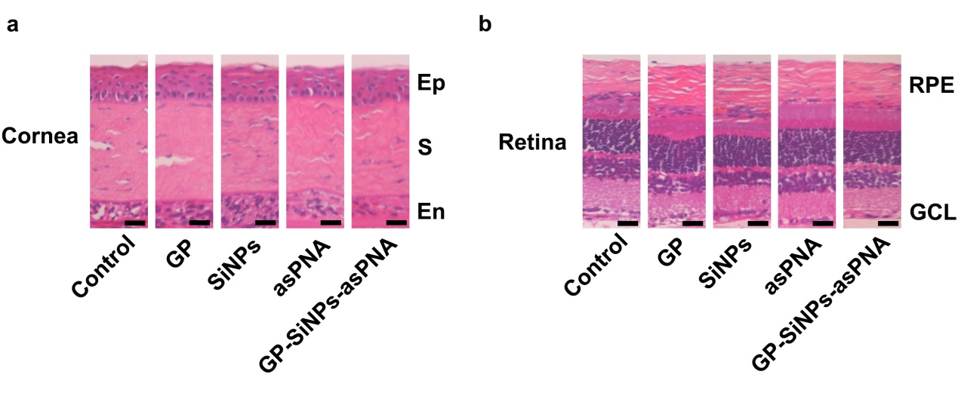
Supplementary Fig. 21 a, H&E staining images of corneal tissues of healthy mice treated with GP (5 mg mL⁻¹), SiNPs (10 mg mL⁻¹), asPNA (1 μM) and GP-SiNPs-asPNA (1 μM) for 24 h, respectively. Ep, epithelium; S, stroma; En, endothelium. b, H&E staining images of retina tissues of healthy mice treated with GP (5 mg mL⁻¹), SiNPs (10 mg mL⁻¹), asPNA (1 μM) and GP-SiNPs-asPNA (1 μM) for 24 h, respectively. RPE, retinal pigment epithelium；GCL, ganglion cell layer. Scale bar: 25 μm.

