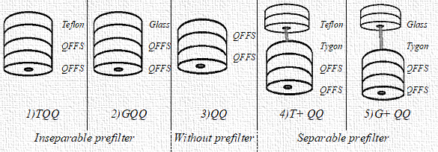
Figure S1- Diagram of the different cassettes prepared in the laboratory TQQ: Cassette assembly consisting of (T) Teflon prefilter (Q) Quartz fibre filter and second (Q) Quartz fibre filter. G indicating glass fibre filter. QFFs show quartz fibre filters.

