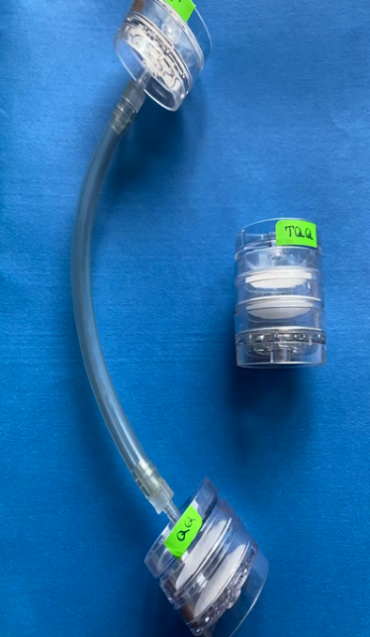
Figure S2- Separable cassette (T+QQ) and inseparable cassette (TQQ)

