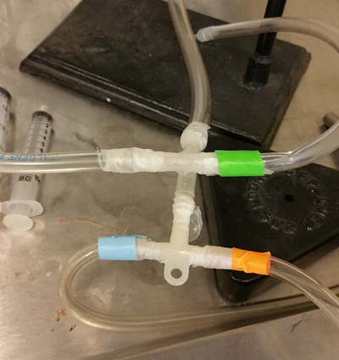  a |  | 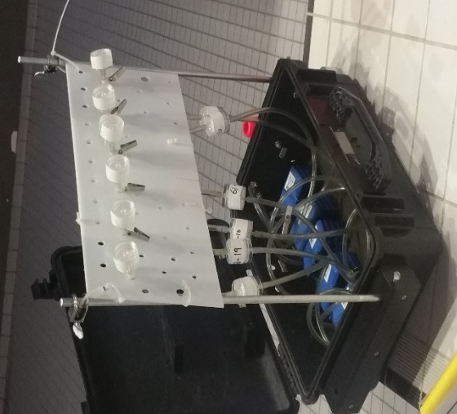  b
Figure S3- parallel sampling designs a) laboratory b) swimming pools

