SUPPLEMENTARY INFORMATION
N: Number of pools; A: competition pool; B: Recreation Pool
Pool Code | Hall volume (m³) | N | Water volume (m³) | Water surface (m²) | Max. number of swimmers | Average swimmers per year
1 | 10400 | 1 | 800 | 500 | 225 | 29000
2 | 2890 | 2 | A:950 B:180 | A:313 B: 120 | A:150 B:50 | 30000
3 | 3340 | 2 | A:700 B:95 | A:312 B:50 | A:188 B:29 | 30000
4 | 13556 | 2 | A: 1200 B:300 | A:547 B:340 | A: 264 B:160 | 40000
Table S1-Characteristics of the four public indoor swimming pools participating in this study

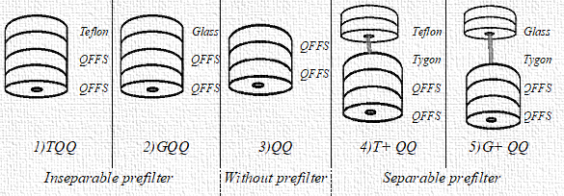
Figure S1- Diagram of the different cassettes prepared in the laboratory TQQ: Cassette assembly consisting of (T) Teflon prefilter (Q) Quartz fibre filter and second (Q) Quartz fibre filter. G indicating glass fibre filter. QFFs show quartz fibre filters.
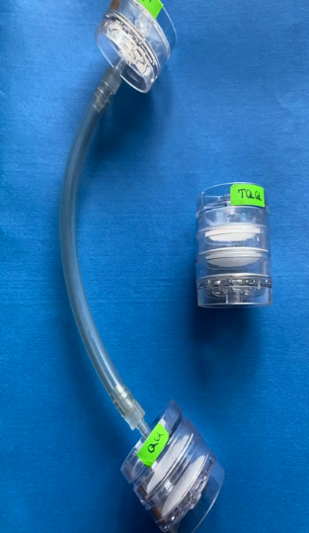
Figure S2- Separable cassette

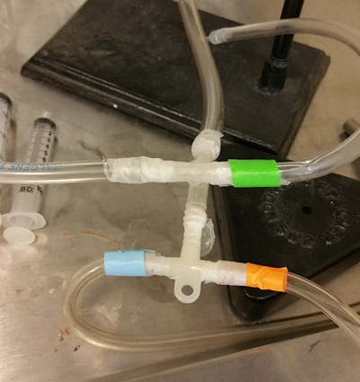  a |  | 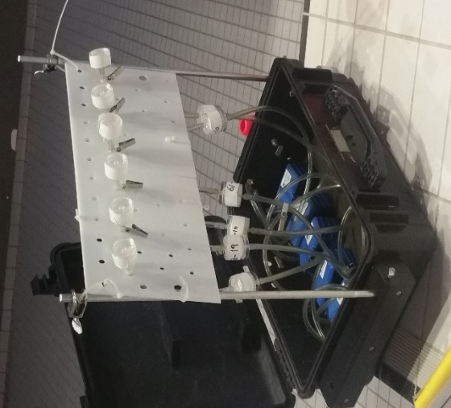  b
Figure S3- parallel sampling designs a) laboratory b) swimming pools

