Supplemental Figure S1. Glucose tolerance curves.
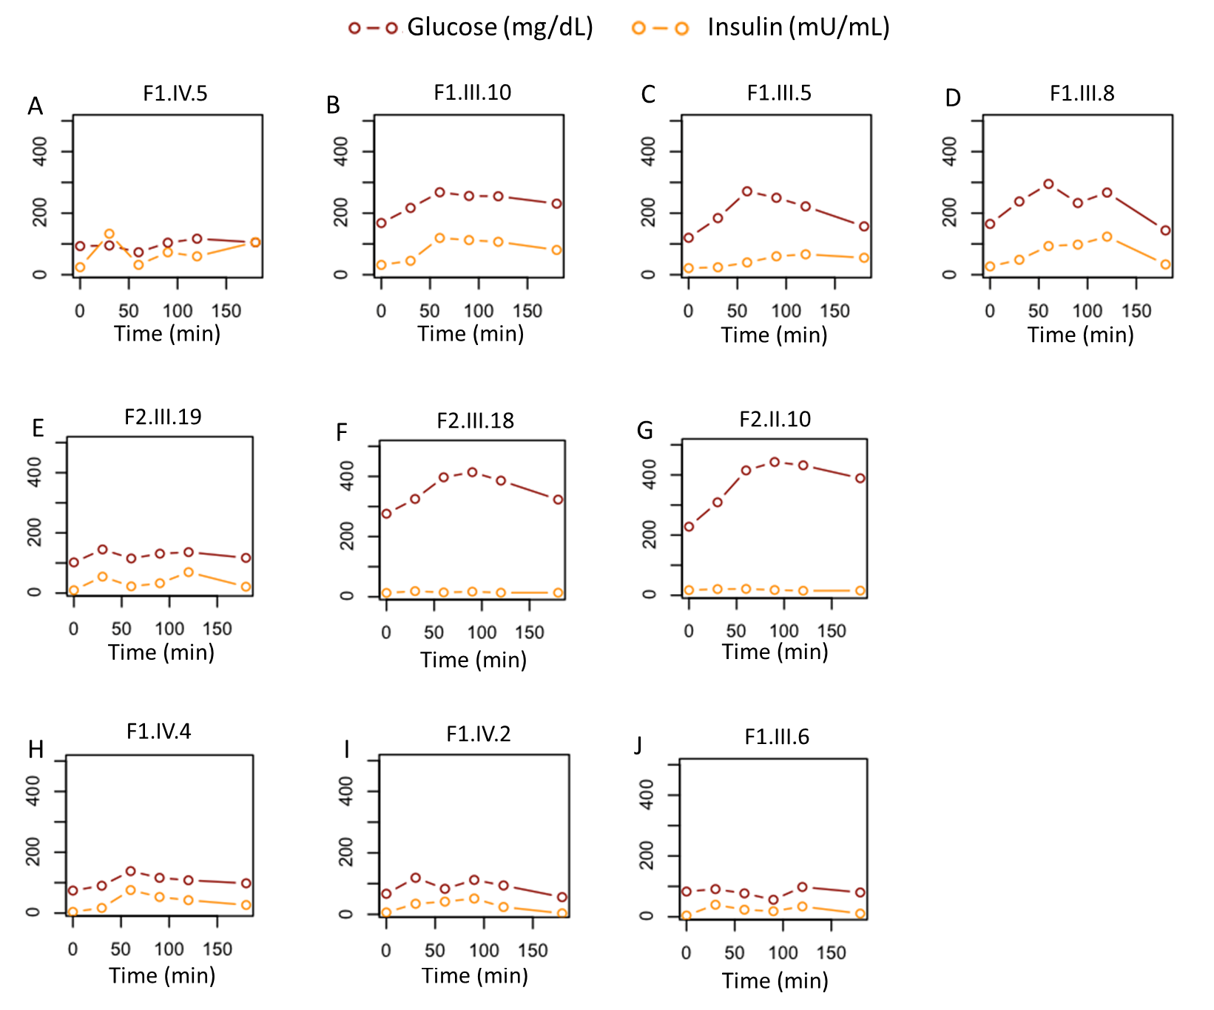
Blood glucose (brown) and plasma insulin levels (yellow) in response to a 75 g oral dextrosol charge measured at 0, 30, 60, 90, 120, and 180 minutes. (A-D) Carriers of p.Arg252His, (E-G) carriers of p.Lys68Gln, and (H-J) non-carriers.

Supplemental Table S1. Variants in DYRK1B in a sample of 968 Mexican Mestizos.
Variant | Position | Allele Frequency % (allele number) | Major/minor allele | Annotation | Consequence
rs746933234 | 40318989 | 0.052 (1) | C/T | Missense | p.Arg252His
rs373850179 | 40321185 | 0.052 (1) | T/G | Missense | p.Lys68Gln
rs34587974 | 40321404 | 0.258 (5) | A/G | Missense | p.Leu28Pro
rs752428936 | 40317417 | 0.052 (1) | C/T | Missense | p.Asp436Asn
rs148788670 | 40316512 | 0.052 (1) | G/A | Missense | p.Pro578Leu
rs144370928 | 40321178 | 0.052 (1) | C/T | Missense | p.Arg70Gln
rs771417583 | 40316579 | 0.052 (1) | T/G | Missense | p.Thr556Pro
rs149054894 | 40321322 | 0.052 (1) | G/A | Synonymous | p.Thr55Thr
rs146996483 | 40318018 | 0.362(7) | G/A | Synonymous | p.Ala334Ala
rs779778950 | 40318985 | 0.052 (1) | G/A | Synonymous | p.Ser253Ser
rs759826670 | 40319144 | 0.052 (1) | G/C | Synonymous | p.Leu200Leu
rs758562354 | 40320638 | 0.052 (1) | C/T | Synonymous | p.Gln134Gln
rs538648311 | 40321054 | 0.052 (1) | G/A | Synonymous | p.Tyr111Tyr
rs371524346 | 40321087 | 0.052 (1) | G/A | Synonymous | p.Ile100Ile
rs370695515 | 40317421 | 0.103 (2) | C/T | Synonymous | p.Thr434Thr
rs751446560 | 40316679 | 0.207 (4) | G/A | Synonymous | p.Pro522Pro
rs765204866 | 40320714 | 0.103 (2) | G/C | Non coding transcript exon | NA
rs56077108 | 40319227 | 2.738 (53) | C/T | Splice region | NA
rs201207939 | 40318138 | 0.052 (1) | G/A | Intron | NA
rs377517922 | 40316949 | 0.052 (1) | G/A | Intron | NA
rs147939499 | 40316754 | 0.052 (1) | T/C | Intron | NA
rs76318664 | 40319232 | 0.155 (3) | G/A | Intron | NA
rs112350522 | 40319260 | 0.258 (5) | C/T | Intron | NA
rs118167426 | 40318132 | 0.620 (12) | C/T | Intron | NA
rs56110449 | 40318087 | 28.822 (558) | G/A | Intron | NA
rs772833215 | 40316742 | 0.052 (1) | A/G | Intron | NA
rs780638095 | 40318314 | 0.052 (1) | G/A | Intron | NA
rs755640697 | 40318332 | 0.052 (1) | C/T | Intron | NA
rs769863099 | 40316954 | 0.052 (1) | G/T | Intron | NA
NA: Not apply

Supplemental Table S2. Pulse wave velocity and other biochemical studies.
Variant status | ID | PWV | AORTIC  AU | AIx | AIx_75% | LDL-c (mg/dL) | Uric Acid (mg/dL) | CR-S (mg/dL) | ALT (IU/L) | AST (IU/L) | GGT (IU/L) | APO_B (mg/dL) | ACR  (mg/dL) | HOMA-IR | Matsuda Index | Insulinogenic Index
p.Arg252His | IV.5 | 4.3 | 15 | 31 | 32 | 63 | 7.7 | 0.7 | 13 | 22 | 13 | 59.8 | - | 5.61 | 2.58 | 54.37
p.Arg252His | III.10 | 7.1 | 12 | 28 | 28 | - | 4.1 | 0.54 | 55 | 43 | 30 | 108.1 | 18.7 | 13.191 | 0.95 | 0.27
p.Arg252His | III.8 | 6.1 | 25 | 45 | 43 | - | 3.9 | 0.62 | 24 | 25 | 25 | 109.9 | 1.8 | 10.959 | 1.07 | 0.29
p.Arg252His | III.5 | 6.6 | 15 | 47 | 42 | - | 5.4 | 0.88 | 54 | 47 | 38 | 69.2 | 4.9 | 6.341 | 2.06 | 0.04
p.Lys68Gln | III.19 | 5.6 | 4 | 9 | 12 | 70 | 6.5 | 0.75 | 22 | 22 | 22 | 65.6 | - | 2.367 | 5.03 | 1.05
p.Lys68Gln | III.18 | 6.6 | 6 | 15 | 17 | 108 | 5.4 | 0.55 | 25 | 23 | 30 | 110.4 | 163.1 | 8.723 | 2.2 | 0.12
p.Lys68Gln | II.10 | 6.3 | 23 | 47 | 43 | 79 | 8 | 0.95 | 21 | 21 | 16 | 89.2 | 252.4 | 9.627 | 1.9 | 0.04
F1. non-carrier | IV.4 | 3.6 | 6 | 19 | 12 | 52 | 5.8 | 0.8 | 35 | 32 | 17 | 52.8 | - | 0.72 | 8.6 | 0.8
F1. non-carrier | IV.2 | 4.7 | 14 | 35 | 26 | 114 | 3 | 0.63 | 16 | 21 | 8 | 83.9 | - | 0.84 | 12.21 | 4.45
F1. non-carrier | III.6 | 5.4 | 20 | 53 | 50 | 95 | 3.1 | 0.42 | 12 | 17 | 6 | 79.5 | - | 1.026 | 8.28 | 0.54
ID, identification; PVW, pulse wave velocity; AU, augmentation; Alx, augmentation index; AIx_75%, corrected augmentation index to 75%; LDL-c, low density lipoprotein cholesterol; CR-S, creatinine serum; ALT, alanine aminotransferase; AST, aspartate aminotransferase; GGT, gamma glutamine transferase; APO_B, apolipoprotein B; ACR, albumin/creatinine ratio; HOMA-IR; homeostatic mass a.

