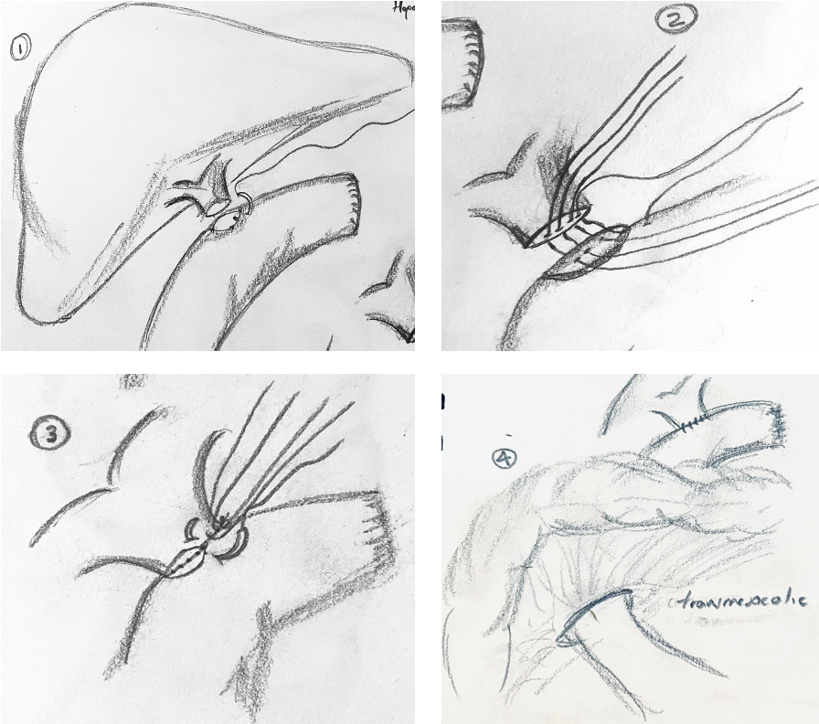Graphic 1. Standardized HJ technique. 1. Posterior layer anastomosis, performed with polidioxanona 4-0 or 5-0 suture. 2. separate stitches of the posterior layer. 3. anterior layer with separate stitches. 4. final view of the transmesocolic ascended jejunum.

