Supplementary Material

Water-air exchanges in the lower estuary of the Patos Lagoon: seasonal variability, drivers, and sources of CO₂

Cíntia Albuquerque^{1,2,3,*}, Rodrigo Kerr^{1,2,3,*}, Thiago Monteiro^{1,2,3}, Eunice da Costa Machado^{3,4}, Andréa da Consolação de Oliveira Carvalho^{1,2,3}, Carlos Rafael B. Mendes^{1,5}

¹ Laboratório de Estudos dos Oceanos e Clima – LEOC, Instituto de Oceanografia, Universidade Federal do Rio Grande - FURG, Av. Itália km 8 s/n, Campus Carreiros, Rio Grande, RS, 96203-900, Brazil.

² Brazilian Ocean Acidification Network – BrOA, Av. Itália km 8, Rio Grande, 96203-900, RS, Brazil.

³ Programa de Pós-Graduação em Oceanologia – PPGO, Instituto de Oceanografia, Universidade Federal do Rio Grande - FURG, Av. Itália km 8 s/n, Campus Carreiros, Rio Grande, RS, 96203-900, Brazil.

⁴ Laboratório de Hidroquímica, Instituto de Oceanografia, Universidade Federal do Rio Grande - FURG, Av. Itália km 8 s/n, Campus Carreiros, Rio Grande, RS, 96203-900, Brazil.

⁵ Laboratório de Fitoplâncton e Micro-organismos Marinhos, Instituto de Oceanografia, Universidade Federal do Rio Grande - FURG, Av. Itália km 8 s/n, Campus Carreiros, Rio Grande, RS, 96203-900, Brazil.

Contents of this file
Text S1: Methodology of time series wavelet analysis.
Figure S1. Wavelet spectrum of the CO₂ net fluxes time series in the lower estuary.
Figure S2. Seasonal cycle of wind speed, freshwater discharge, pCO₂ atmosphere and pCO₂ surface water.

Text S1. Time series wavelet analysis
We used wavelet transform analysis to evaluate the temporal pattern of variability in the FCO₂ time series, allowing the identification of the periods of variability and how those evolved/changed during the years investigated. The mother wavelet used was the Morlet function. The scale used for the wavelet transform was 12 months because there was one sample per month, and the length (i.e., spacing between discrete scales) was 0.125. The length of the Morlet function must be smaller than 0.5 to identify variability at the annual scale, with smaller values providing better resolutions (Torrence and Compo 1998). The cone of influence was determined based on the red noise process with a lag coefficient of 0.72 (Gilman et al. 1963). The results of wavelet analysis provided energy values in base-2 logarithmic form and revealed the period (months) with the highest intensity in the variability.

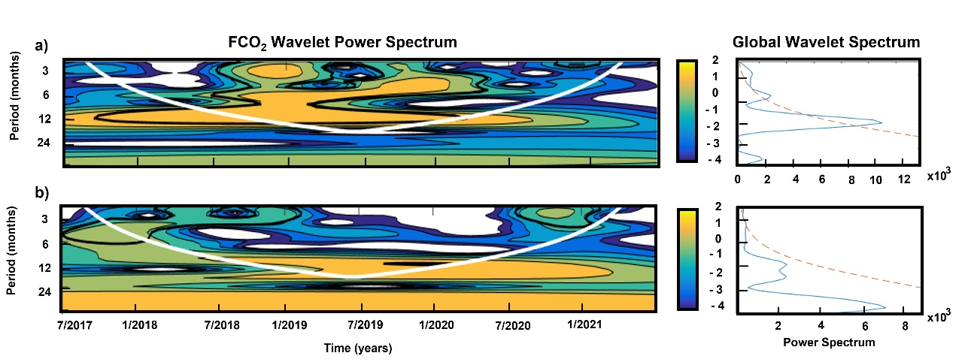
Figure S1: Wavelet spectrum of the CO₂ net flux (FCO₂) in the (a) BrOA #1 (pier-fixed station) and (b) BrOA #2 (pier-fixed station), considering the Morlet function as a mother wavelet. In the left, the area bounded by the white line indicates the region of the cone of influence, where the variance is reduced, and the solid black lines denote the regions with a significance level higher than 95%. The yellow colors represent high energy, and the blue colors indicate low energy. The color bar shows the units of energy in log₂ form. In the right, the cone of influence is represented by the red dashed line and the sum of energy for each period is in the blue line.
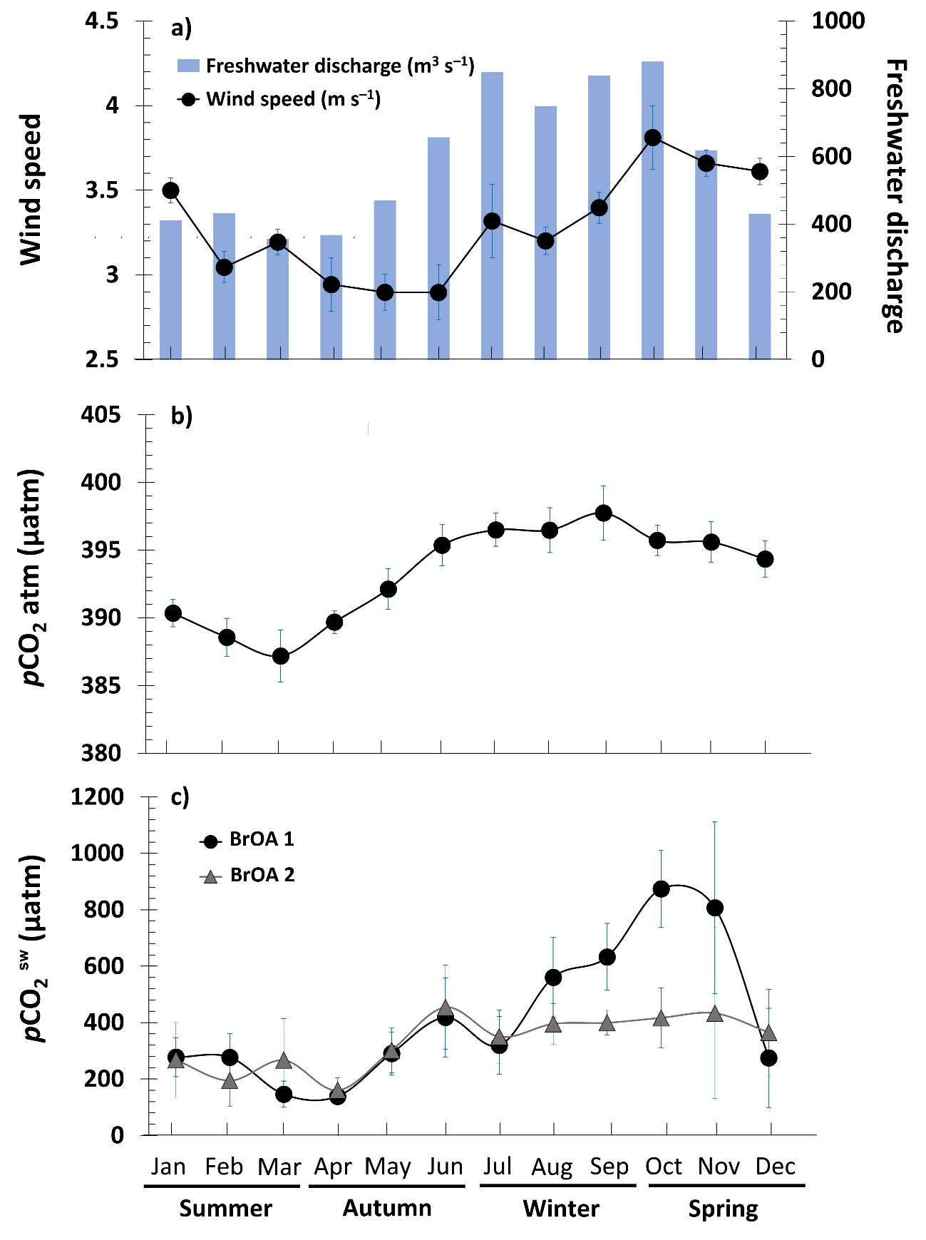
Figure S2: Seasonal cycle of (a) wind speed and riverine freshwater discharge (m³ s^{–1}; blue bars), (b) partial pressure of CO₂ (pCO₂) of atmosphere and (c) partial pressure of CO₂ (pCO₂) of surface water for the stations located in the BrOA #1 (black line and dots) and BrOA #2 (gray line and triangles) of the lower zone of the Patos Lagoon Estuary obtained from May 2017 to June 2021. The errorbars indicated the standard error of each month.

