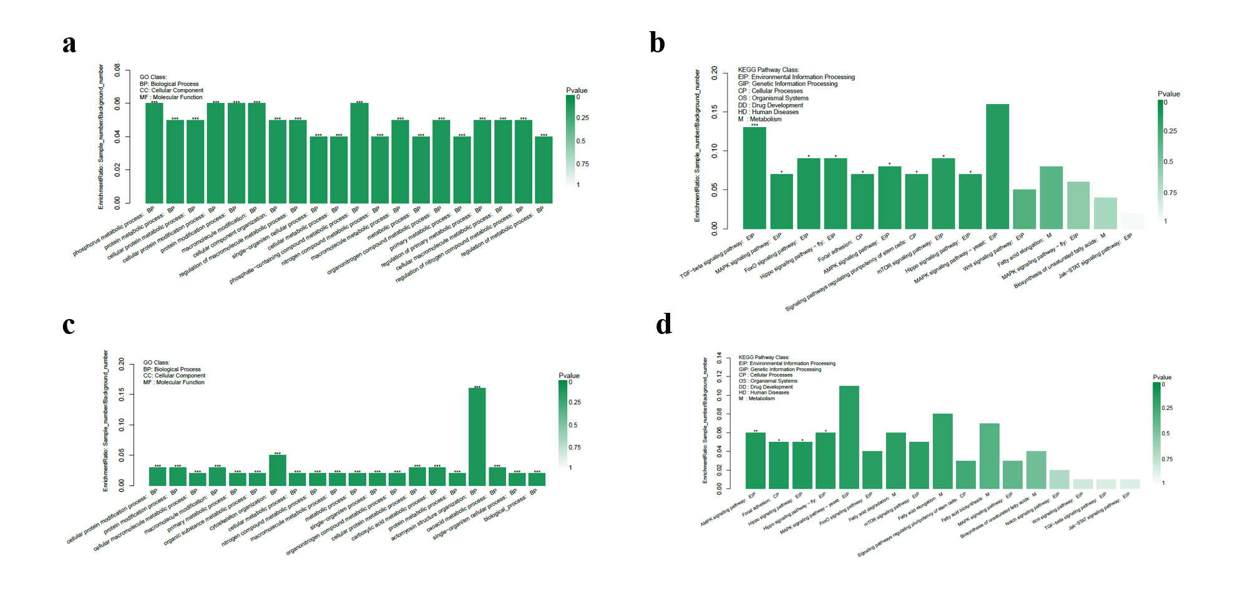
Figure S1 GO and KEGG results of DEcircRNAs in LW and MS pigs. (a) and (b) are GO and KEGG results of LW pigs; (c) and (d) are GO and KEGG results of MS pigs.

