Original Figures

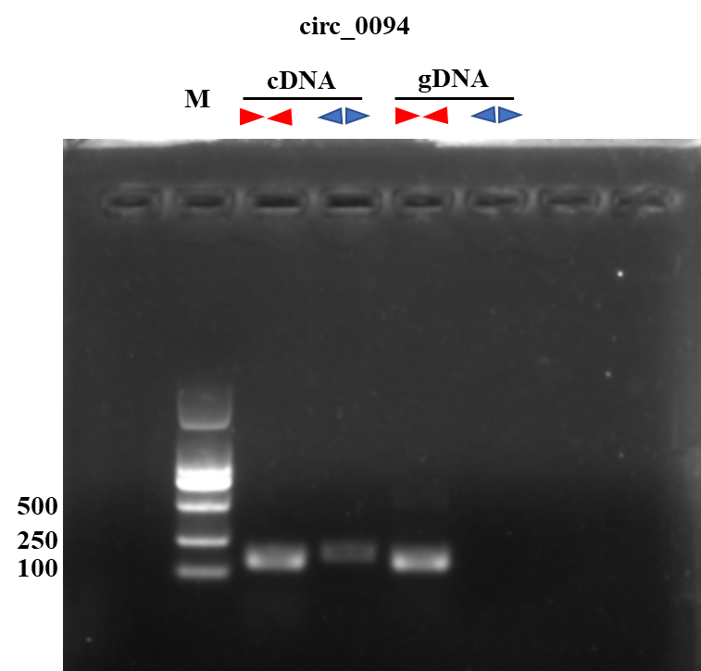
Figure S2 Divergent and convergent primers amplify circ_0094 results in cDNA and gDNA samples.

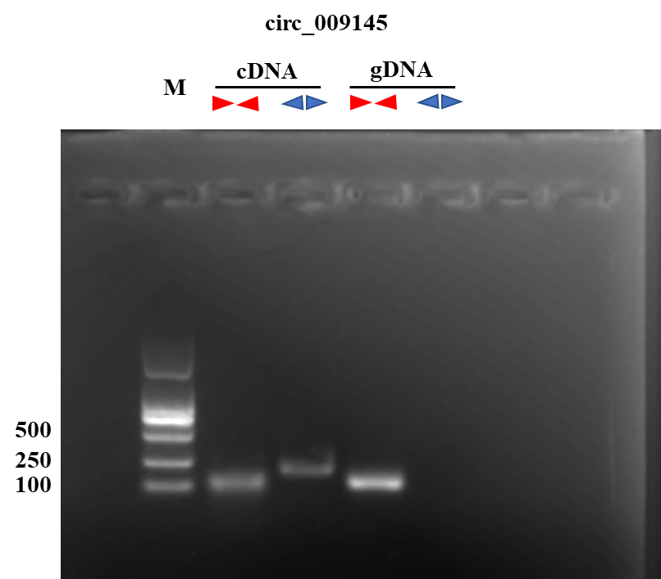
Figure S3 Divergent and convergent primers amplify circ_009145 results in cDNA and gDNA samples.

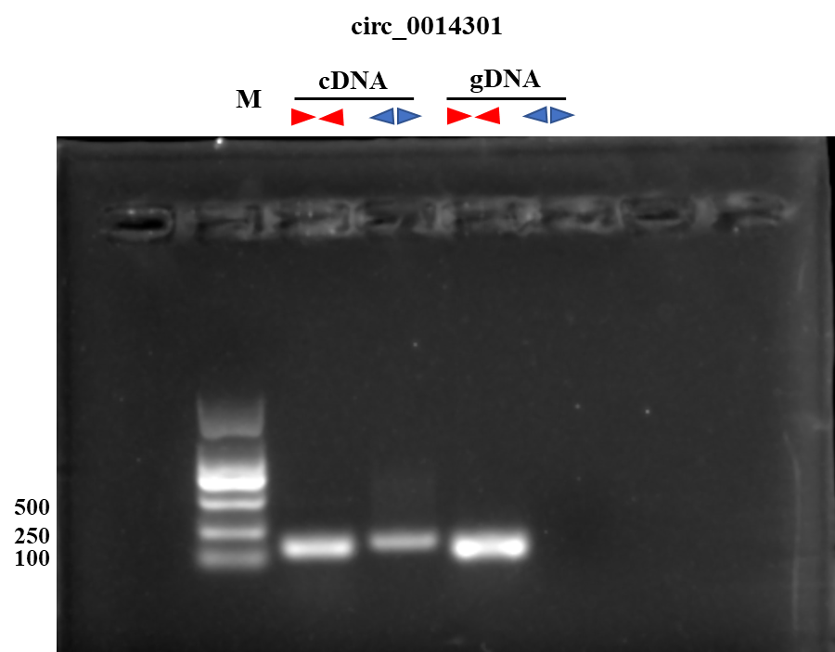
Figure S4 Divergent and convergent primers amplify circ_0014301 results in cDNA and gDNA samples.

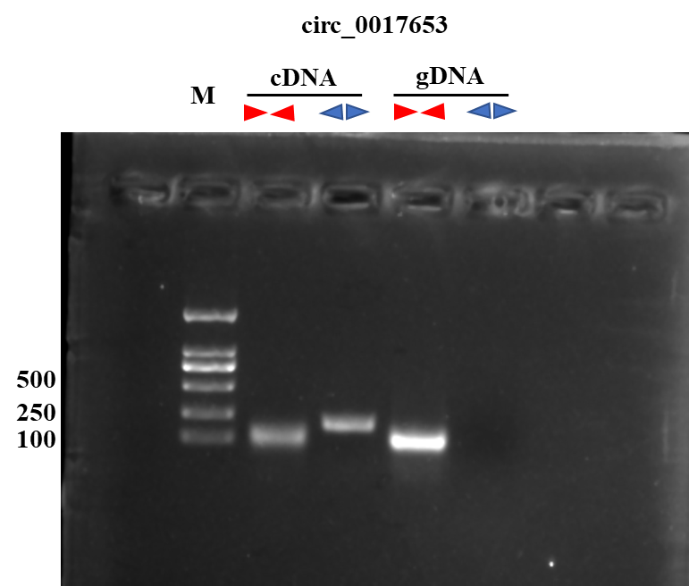
Figure S5 Divergent and convergent primers amplify circ_0017653 results in cDNA and gDNA samples.

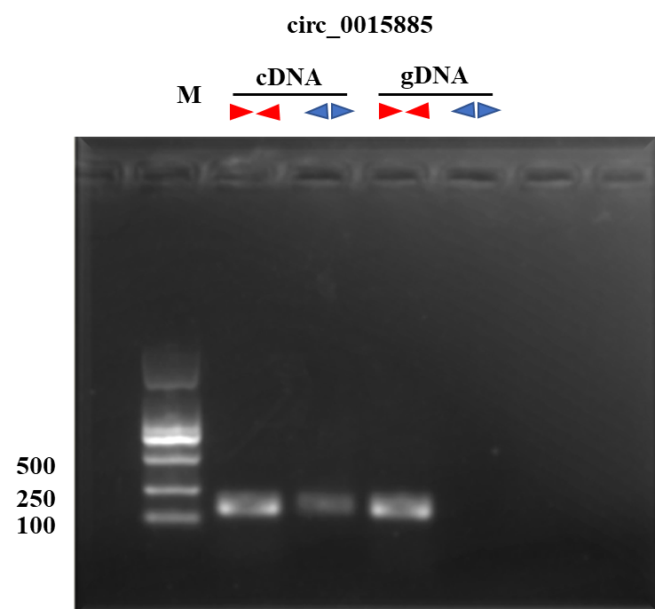
Figure S6 Divergent and convergent primers amplify circ_0015885 results in cDNA and gDNA samples.

