Figure E1. Flow diagram of the systematic literature review
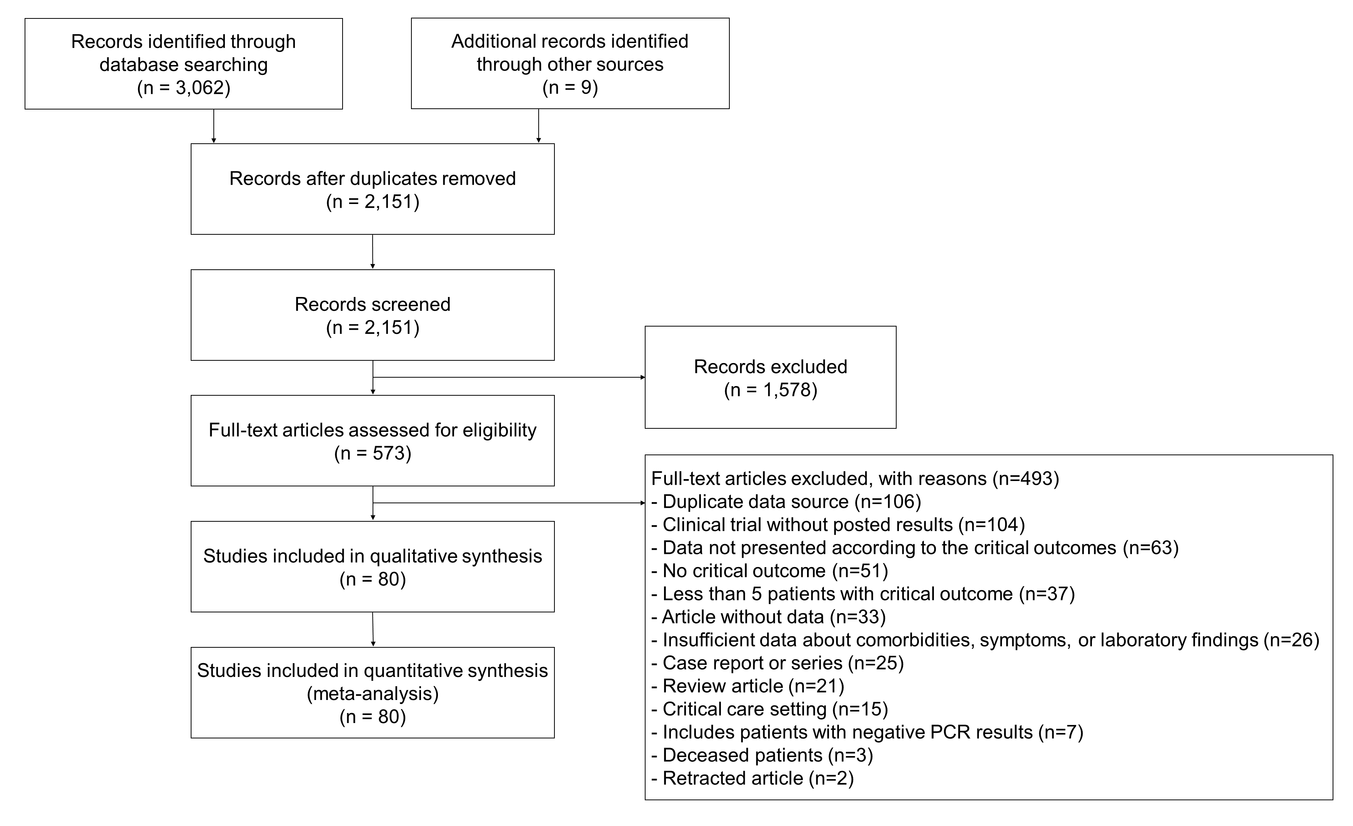
Figure E2. Impact of male sex on composite outcome including death, intensive care unit admission, and critical type of COVID-19.
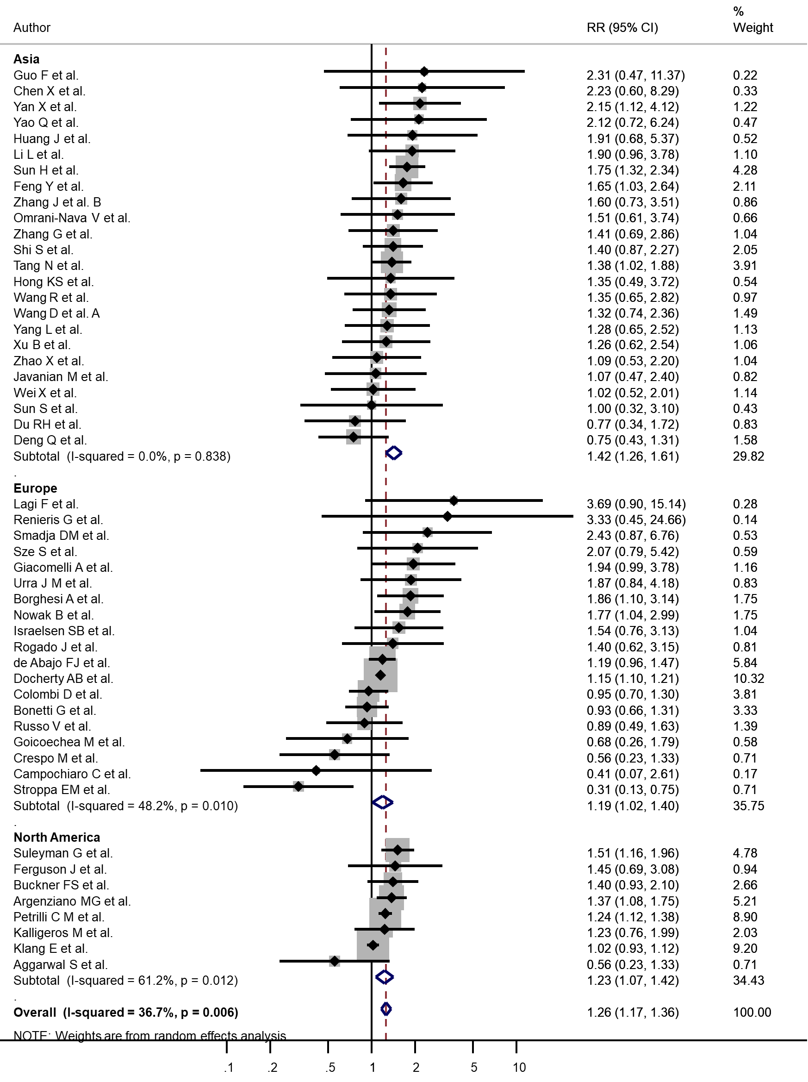
Abbreviation: RR, relative risk

Figure E3. Impact of patient age on the critical outcome including death, intensive care unit admission, and critical type of COVID-19.
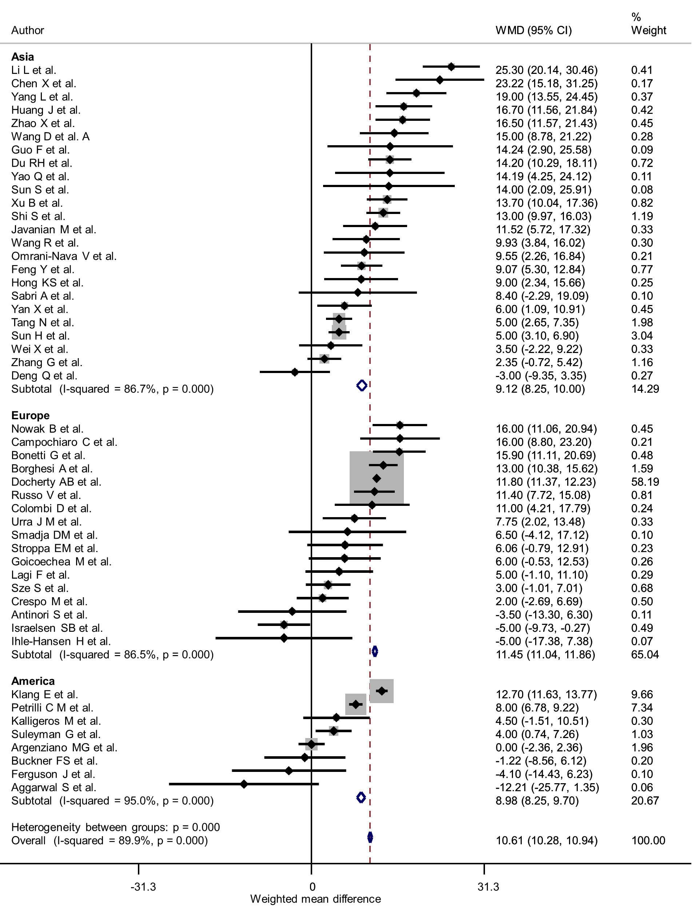
Abbreviation: WMD, weighted mean difference

Figure E4. Association between ethnicity and the critical outcome including intensive care unit admission and death compared to non-Hispanic white ethnicity with a random effects model. a) Hispanic ethnicity. b) non-Hispanic black ethnicity. c) Asian ethnicity.
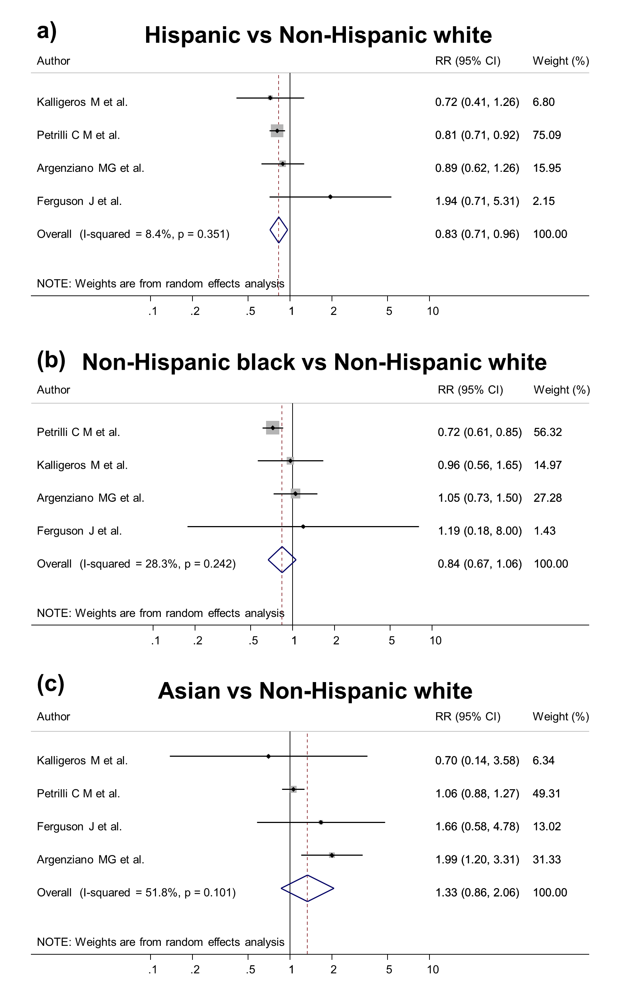

Table E1. Definition of underlying disease mentioned in each study
Study | Cardiac disease | Renal disease | Malignancy | Respiratory disease | Hepatic disease | Cerebral disease
Aggarwal S et al. | Coronary artery disease | Chronic kidney disease | Malignancy | COPD | – | Cerebrovascular disease
Antinori S et al. | – | – | Cancer | – | – | –
Argenziano MG et al. | Coronary artery disease | Renal disease | Active cancer | Pulmonary disease | Cirrhosis | History of stroke
Bonetti G et al. | Cardiovascular disease | Chronic kidney diseases | Cancer | Chronic respiratory diseases | – | –
Borghesi A et al. | Cardiovascular disease | – | Oncological history within the past 5 years | Chronic obstructive/restrictive lung disease | – | –
Buckner FS et al. | Cardiovascular disease | Chronic kidney disease | Cancer | COPD | – | –
Campochiaro C et al. | Coronary artery disease | Chronic kidney disease | Cancer | COPD | – | –
Chen C et al. | Past coronary heart disease history | – | – | – | – | –
Chen X et al. | Heart disease | – | Malignancy | Pulmonary disease | Hepatic disease | Cerebral disease
Colombi D et al. | Cardiovascular disease | Chronic kidney failure | Oncological disease | Pulmonary disease | Hepatic failure | Neurological disease
Crespo M et al. | Heart disease | End-stage renal disease with kidney transplant | Cancer | Lung disease | – | –
de Abajo FJ et al. | Ischemic heart disease | Chronic renal failure | Malignancy | COPD | – | Cerebrovascular disease
Deng Q et al. | Coronary heart disease | – | – | COPD | – | –
Docherty AB et al. | Chronic cardiac disease | Chronic kidney disease | Malignancy | Chronic pulmonary disease | Moderate/severe liver disease | Chronic neurological disorder
Du RH et al. | – | – | Malignancy | – | – | –
Feng Y et al. | Not mentioned | Chronic nephrophathy | Malignancy | COPD | – | Cerebrovascular disease
Ferguson J et al. | Coronary artery disease | Chronic kidney disease | – | Pulmonary disease | – | Cerebrovascular disease
Giacomelli A et al. | – | – | – | – | – | –
Goicoechea M et al. | Coronary heart disease | – | – | COPD | – | –
Guo F et al. | – | – | – | – | – | –
He W et al. | – | – | – | – | – | –
Hong KS et al. | Cardiovascular disease | – | Malignancy | Chronic lung disease | Liver disease | Cerebrovascular disease
Huang C et al. | Cardiovascular disease | – | Malignancy | COPD | Chronic liver disease | –
Huang J et al. | Coronary heart disease | – | Cancer | COPD | – | Cerebrovascular disease
Huang JT et al. | – | – | – | – | – | –
Ihle-Hansen H et al. | – | – | – | – | – | –
Israelsen SB et al. | Cardiovascular disease | – | – | COPD | – | –
Javanian M et al. | Cardiovascular disease | Chronic kidney disease | Malignancy | COPD | Liver disease | Cerebrovascular disease
Ji M et al. | – | – | – | – | – | –
Kalligeros M et al. | Heart disease | Chronic renal disease | Cancer | Lung disease | Cirrhosis | –
Klang E et al. | Coronary artery disease | Chronic kidney disease | Cancer | – | – | –
Lagi F et al. | Coronary heart disease | Chronic renal failure | Former or still oncologic diseases | COPD | Chronic hepatitis B | Cerebrovascular disease
Lee LYW et al. | Cardiovascular disease | – | – | COPD | – | –
Li J et al. A | Coronary heart disease | Chronic renal disease | Solid tumor | Pulmonary disease | – | Neurological disease
Li J et al. B | – | – | – | – | – | –
Li L et al. | Cardiovascular disease | – | Malignancy | COPD | – | –
Luo X et al. | – | – | – | – | – | –
Lv Z et al. | Coronary heart disease | – | Carcinoma | COPD | – | –
Nowak B et al. | Cardiovascular disease | Chronic renal disease | Malignancy | COPD | – | –
Omrani-Nava V et al. | Cardiac disease | – | Malignancy | Asthma | – | –
Pan F et al. | Cardiovascular disease | – | – | COPD | – | –
Pan L et al. | – | – | Malignant tumor | Respiratory system disease | – | Nervous system disease
Pei G et al. | – | – | – | – | – | –
Peng Y et al. | – | – | – | – | – | –
Pereira MR et al. | – | Chronic kidney disease | Active cancer | Chronic lung disease | – | –
Petrilli C M et al. | Coronary artery disease | Chronic kidney disease | Cancer | Asthma | – | –
Renieris G et al. | Coronary heart disease | Chronic renal disease | – | COPD | – | –
Rogado J et al. | Cardiovascular disease | Chronic kidney disease | Cancer | COPD | – | –
Russo V et al. | Heart failure | Chronic kidney disease | – | COPD | – | Previous ischemic stroke
Sabri A et al. | Ischemic heart disease | – | – | – | – | –
Shi Q et al. | Cardiovascular disease | Chronic kidney disease | Malignancy | Chronic pulmonary disease | Chronic liver disease | Cerebrovascular disease
Shi S et al. | Coronary heart disease | Chronic renal disease | Cancer | COPD | – | Cerebrovascular disease
Smadja DM et al. | Coronary heart disease | Chronic kidney disease | Cancer | – | – | Stroke
Stroppa EM et al. | – | – | Malignancy | Chronic obstructive pulmonary disease | – | –
Suleyman G et al. | Coronary artery disease | Chronic kidney disease | Cancer | COPD | – | –
Sun H et al. | Coronary heart disease | – | – | Previous respiratory disease | – | Consciousness disorders
Sun S et al. | – | – | – | – | – | –
Sze S et al. | Ischemic heart disease | Chronic kidney disease | Cancer | COPD | – | Stroke
Tambe M P et al. | Cardiovascular disease | Chronic kidney disease | – | COPD | Alcoholic liver disease | –
Tang N et al. | – | – | – | – | – | –
Urra J M et al. | Cardiovascular disease | – | Cancer | COPD | – | –
Valeri A M et al. | Coronary artery disease | Chronic kidney disease | – | Pulmonary disease | – | –
Wang D et al. A | Cardiovascular disease | Chronic kidney disease | Malignancy | COPD | Chronic liver disease | Cerebrovascular disease
Wang D et al. B | Cardiovascular disease | Chronic kidney disease | – | COPD | Chronic liver disease | Cerebrovascular disease
Wang F et al. | Cardiovascular disease | Chronic kidney disease | – | Chronic pulmonary disease | Chronic liver disease | Cerebrovascular disease
Wang K et al. | Coronary heart disease | Chronic kidney disease | Cancer | COPD | – | Cerebrovascular disease
Wang R et al. | – | – | – | – | – | –
Wei X et al. | Cardiovascular disease | – | – | – | – | –
Xu B et al. | – | Kidney disease | – | Lung disease | – | –
Yan X et al. | CHD (abbreviation not defined) | Kidney diseases other than acute kidney injury | Tumor | COPD | Liver cirrhosis | Cerebrovascular disease
Yang L et al. | Chronic heart disease | Chronic kidney disease | Malignancy | Chronic lung disease | Chronic liver disease | –
Yao Q et al. | Any patient with hyperlipidemia, coronary heart disease, hemorrhagic stroke, or ischemic stroke | – | Cancer | Any patient with bronchiectasis, COPD, or asthma | Chronic liver disease | –
Yuan M et al. | Cardiac disease | – | Tumor | – | – | Cerebral infarction
Zhang F et al. | – | – | – | – | – | –
Zhang G et al. | – | – | – | – | – | –
Zhang J et al. A | Cardiovascular disease | – | Malignancy | COPD | Chronic liver disease | –
Zhang J et al. B | Cardiovascular disease | Urinary system disease | Malignant tumor | Pulmonary disease | – | –
Zhang J et al. C | Cardiovascular disease | Urinary system disease | Malignant tumor | Respiratory system disease | – | Cerebrovascular disease
Zhang X et al. | – | – | – | – | – | –
Zhao X et al. | – | – | – | – | – | –

Table E2. Evaluation of the quality of studies included in the systematic review
Study | Study participation | Study attrition | Prognostic factor measurement | Outcome measurement | Confounding measurement and account | Analysis
Aggarwal S et al. | Partly | Partly | Yes | Yes | Partly | Yes
Antinori S et al. | Partly | Yes | Yes | Yes | Partly | Yes
Argenziano MG et al. | Yes | Partly | Yes | Yes | Yes | Yes
Bonetti G et al. | Yes | Yes | Yes | Yes | Partly | Yes
Borghesi A et al. | Partly | Yes | Partly | Yes | Partly | Yes
Buckner FS et al. | Partly | Partly | Yes | Yes | Partly | Yes
Campochiaro C et al. | Partly | Yes | Partly | Yes | Partly | Yes
Chen C et al. | Yes | Partly | Partly | Yes | Partly | Yes
Chen X et al. | Yes | Partly | Partly | Yes | Partly | Yes
Colombi D et al. | Partly | Partly | Partly | Yes | Partly | Yes
Crespo M et al. | Partly | Partly | Partly | Yes | Partly | Yes
de Abajo FJ et al. | Yes | Partly | No | Yes | No | Yes
Deng Q et al. | Yes | Partly | Partly | Yes | Partly | Yes
Docherty AB et al. | Yes | Yes | Partly | Yes | Partly | Yes
Du RH et al. | Yes | Partly | Yes | Yes | Partly | Yes
Feng Y et al. | Yes | Partly | Yes | Yes | Yes | Yes
Ferguson J et al. | Yes | Partly | Yes | Yes | Yes | Yes
Giacomelli A et al. | Yes | Partly | Yes | Yes | Partly | Yes
Goicoechea M et al. | Partly | Partly | Partly | Yes | Partly | Yes
Guo F et al. | Partly | Partly | Partly | Yes | Partly | Yes
He W et al. | Partly | Partly | Partly | Yes | Partly | Yes
Hong KS et al. | Partly | Partly | Yes | Yes | Partly | Yes
Huang C et al. | Yes | Partly | Yes | Yes | Yes | Yes
Huang J et al. | Yes | Partly | Partly | Yes | Partly | Yes
Huang JT et al. | Yes | Yes | Yes | Yes | Partly | Yes
Ihle-Hansen H et al. | Partly | Partly | Partly | Yes | Partly | Yes
Israelsen SB et al. | Partly | Partly | Yes | Yes | Partly | Yes
Javanian M et al. | Partly | Partly | Yes | Yes | Partly | Yes
Ji M et al. | Yes | Yes | Partly | Yes | No | Yes
Kalligeros M et al. | Partly | Partly | Partly | Yes | Partly | Yes
Klang E et al. | Yes | Yes | Partly | Yes | Partly | Yes
Lagi F et al. | Partly | Partly | Partly | Yes | Partly | Yes
Lee LYW et al. | Partly | Partly | Yes | Yes | Partly | Yes
Li J et al. A | Partly | Partly | Yes | Yes | Partly | Yes
Li J et al. B | Partly | Partly | Partly | Yes | Partly | Yes
Li L et al. | Partly | Partly | Yes | Yes | Yes | Yes
Luo X et al. | Yes | Partly | Yes | Yes | Yes | Yes
Lv Z et al. | Partly | Yes | Partly | Yes | Partly | Yes
Nowak B et al. | Partly | Partly | Partly | Yes | Partly | Yes
Omrani-Nava V et al. | Partly | Partly | No | Yes | No | Yes
Pan F et al. | Yes | Yes | Yes | Yes | Yes | Yes
Pan L et al. | Partly | Partly | Yes | Yes | Partly | Yes
Pei G et al. | Yes | Partly | Partly | Yes | Partly | Yes
Peng Y et al. | No | Partly | Partly | Yes | Partly | Yes
Pereira MR et al. | Partly | Partly | Partly | Yes | Partly | Yes
Petrilli C M et al. | Yes | Yes | Partly | Yes | Partly | Yes
Renieris G et al. | Partly | Partly | Partly | Yes | No | Yes
Rogado J et al. | Partly | Partly | Partly | Yes | Partly | Yes
Russo V et al. | Yes | Partly | Partly | Yes | Partly | Yes
Sabri A et al. | Yes | Partly | Partly | Yes | No | Yes
Shi Q et al. | Partly | Partly | Yes | Yes | Yes | Yes
Shi S et al. | Yes | Partly | Yes | Yes | Partly | Yes
Smadja DM et al. | Partly | Partly | Yes | Yes | Partly | Yes
Stroppa EM et al. | Partly | Partly | Partly | Yes | Partly | Yes
Suleyman G et al. | Yes | Partly | Yes | Yes | Yes | Yes
Sun H et al. | Partly | Partly | Partly | Yes | Partly | Yes
Sun S et al. | Partly | Partly | Partly | Yes | Partly | Yes
Sze S et al. | Yes | Partly | Partly | Yes | Partly | Yes
Tambe M P et al. | Yes | Partly | Partly | Yes | No | Yes
Tang N et al. | Yes | Partly | Partly | Yes | No | Yes
Urra J M et al. | Partly | Partly | Partly | Yes | Partly | Yes
Valeri A M et al. | Partly | Partly | Partly | Yes | Partly | Yes
Wang D et al. A | Yes | Partly | Yes | Yes | Yes | Yes
Wang D et al. B | Yes | Partly | Yes | Yes | Yes | Yes
Wang F et al. | No | Partly | Yes | Yes | Partly | Yes
Wang K et al. | Yes | Partly | Yes | Yes | Partly | Yes
Wang R et al. | Yes | Partly | Partly | Yes | Partly | Yes
Wei X et al. | Yes | Partly | Yes | Yes | Partly | Yes
Xu B et al. | Yes | Partly | Partly | Yes | Partly | Yes
Yan X et al. | Yes | Yes | Partly | Yes | Partly | Yes
Yang L et al. | Yes | Partly | Partly | Yes | Partly | Yes
Yao Q et al. | Yes | Partly | Partly | Yes | Partly | Yes
Yuan M et al. | Partly | Yes | Partly | Yes | Partly | Partly
Zhang F et al. | Partly | Partly | Partly | Yes | Partly | Yes
Zhang G et al. | Partly | Partly | Partly | Yes | Partly | Yes
Zhang J et al. A | Yes | Partly | Partly | Yes | Partly | Yes
Zhang J et al. B | Yes | Partly | Partly | Yes | Partly | Yes
Zhang J et al. C | Yes | Yes | Partly | Yes | Partly | Yes
Zhang X et al. | Yes | Yes | Partly | Yes | No | Yes
Zhao X et al. | Yes | Partly | Partly | Yes | No | Yes

Table E3. Degree of heterogeneity and publication bias according to each analysis
Variables |  | Number of studies included in analysis | I² for heterogeneity | P for heterogeneity | P for Egger's test
Male sex |  | 51 | 36.70% | 0.006 | 0.042
Age |  | 50 | 83.50% | <0.001 | 0.346
Underlying condition
 | Diabetes | 46 | 58.00% | <0.001 | 0.001
 | Hypertension | 45 | 71.20% | <0.001 | 0.432
 | Cardiac disease | 45 | 74.70% | <0.001 | 0.324
 | Respiratory disease | 44 | 64.90% | <0.001 | 0.755
 | Malignancy | 36 | 51.60% | <0.001 | 0.020
 | Renal disease | 31 | 78.00% | <0.001 | 0.542
 | Smoking | 23 | 0.10% | 0.458 | 0.825
 | Cerebral disease | 22 | 82.80% | <0.001 | 0.042
 | Hepatic disease | 16 | 64.50% | <0.001 | 0.668
Patient symptom
 | Fever | 32 | 14.60% | 0.235 | 0.200
 | Cough | 31 | 55.10% | <0.001 | 0.994
 | Dyspnea | 28 | 85.70% | <0.001 | 0.019
 | Diarrhea | 25 | 0.00% | 0.609 | 0.724
 | Myalgia | 22 | 37.20% | 0.042 | 0.630
 | Headache | 19 | 26.60% | 0.139 | 0.844
 | Fatigue | 17 | 62.80% | <0.001 | 0.066
 | Sputum | 16 | 65.10% | <0.001 | 0.808
 | Sore throat | 15 | 45.50% | 0.029 | 0.063
 | Nausea | 12 | 59.70% | 0.004 | 0.682
 | Chest tightness | 10 | 43.00% | 0.072 | 0.568
 | Anorexia | 8 | 69.80% | 0.002 | 0.074
 | Vomiting | 7 | 48.80% | 0.069 | 0.045
 | Rhinorrhea | 5 | 21.00% | 0.281 | 0.441
 | Dizziness | 5 | 5.10% | 0.378 | 0.050
 | Abdominal pain | 5 | 87.00% | <0.001 | 0.554
Laboratory findings
 | Lymphocyte count | 37 | 76.80% | <0.001 | 0.003
 | WBC count | 34 | 92.60% | <0.001 | 0.585
 | Creatinine | 32 | 84.30% | <0.001 | 0.546
 | Platelet count | 31 | 72.50% | <0.001 | 0.489
 | ALT | 30 | 30.20% | 0.062 | 0.012
 | Neutrophil count | 28 | 92.70% | <0.001 | 0.859
 | Hemoglobin | 26 | 67.80% | <0.001 | 0.215
 | AST | 26 | 87.40% | <0.001 | 0.023
 | LDH | 23 | 91.00% | <0.001 | 0.097
 | Total bilirubin | 19 | 54.80% | 0.002 | 0.183
 | CK | 18 | 89.50% | <0.001 | 0.371
 | BUN | 15 | 93.60% | <0.001 | 0.858
 | PT | 12 | 32.20% | 0.133 | 0.240
 | Monocyte count | 11 | 79.60% | <0.001 | 0.778
Abbreviations: WBC, white blood cell; ALT, alanine transaminase; AST, aspartate transaminase; LDH, lactate dehydrogenase; CK, creatine kinase; BUN, blood urea nitrogen; PT, prothrombin time.
Figure E5. Impact of (a) underlying condition, (b) patient symptom, and (c) laboratory findings on death of patients with COVID-19.
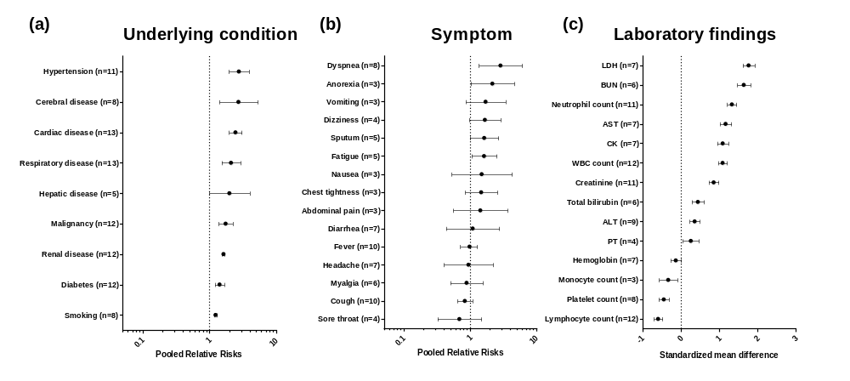
The number in the parenthesis represents the number of studies included in the meta-analysis.
Abbreviations: LDH, lactate dehydrogenase; BUN, blood urea nitrogen; AST, aspartate transaminase; CK, creatine kinase; WBC, white blood cell; ALT, alanine transaminase; PT, prothrombin time.

Table E4. Detailed results from the sensitivity analysis with selected studies
Variables |  | Asia | n | I² | Europe | n | I² | North America | n | I² | Total | n | I²
Male sex |  | 1.567 (1.118–2.199) | 8 | 22.50% | 1.133 (0.923–1.391) | 6 | 29.80% | 1.022 (0.928–1.125) | 1 | – | 1.168 (1.022–1.335) | 15 | 44.80%
Age, WMD |  | 13.311 (11.540–15.081) | 8 | 79.60% | 11.743 (11.316–12.169) | 5 | 82.30% | 12.700 (11.635–13.765) | 1 | – | 11.943 (11.557–12.329) | 14 | 79.00%
Underlying condition
 | Hypertension | 3.495 (2.384–5.123) | 7 | 36.90% | 1.989 (1.059–3.736) | 3 | 21.20% | 1.724 (1.527–1.946) | 1 | – | 2.757 (1.947–3.903) | 11 | 65.10%
 | Cerebral disease | 5.067 (3.219–7.975) | 5 | 25.30% | 1.335 (1.249–1.427) | 3 | 0.00% | – | 0 | – | 2.719 (1.405–5.263) | 8 | 87.20%
 | Cardiac disease | 4.997 (3.749–6.66) | 7 | 0.00% | 1.557 (1.307–1.855) | 5 | 19.80% | 1.660 (1.510–1.825) | 1 | – | 2.452 (1.971–3.052) | 13 | 82.30%
 | Respiratory disease | 3.368 (1.984–5.72) | 8 | 16.80% | 1.579 (1.201–2.076) | 5 | 46.50% | – | 0 | – | 2.105 (1.518–2.92) | 13 | 56.10%
 | Hepatic disease | 2.89 (1.264–6.61) | 4 | 18.80% | 1.292 (1.104–1.513) | 1 |  | – | 0 | – | 1.991 (0.995–3.983) | 5 | 52.00%
 | Malignancy | 4.579 (2.708–7.741) | 7 | 11.60% | 1.401 (1.309–1.500) | 4 | 0.00% | 1.231 (1.094–1.384) | 1 | – | 1.747 (1.369–2.228) | 12 | 70.40%
 | Renal disease | 2.321 (1.469–3.667) | 6 | 0.00% | 1.625 (1.541–1.714) | 5 | 0.00% | 1.582 (1.434–1.746) | 1 | – | 1.622 (1.548–1.699) | 12 | 0.00%
 | Diabetes | 2.374 (1.655–3.406) | 6 | 0.00% | 1.160 (1.096–1.227) | 5 | 0.00% | 1.412 (1.283–1.554) | 1 | – | 1.418 (1.205–1.67) | 12 | 58.80%
 | Smoking | 1.577 (1.089–2.282) | 4 | 0.00% | 1.242 (1.181–1.306) | 3 | 0.00% | 1.188 (1.069–1.319) | 1 | – | 1.236 (1.182–1.293) | 8 | 0.00%
Symptoms
 | Dyspnea | 4.505 (2.374–8.549) | 6 | 59.80% | 0.853 (0.544–1.340) | 2 | 0.00% | – | 0 | – | 2.864 (1.351–6.072) | 8 | 82.90%
 | Anorexia | 2.164 (1.016–4.609) | 3 | 5.80% | – | 0 | – | – | 0 | – | 2.164 (1.016–4.609) | 3 | 5.80%
 | Vomiting | 1.708 (0.858–3.397) | 3 | 0.00% | – | 0 | – | – | 0 | – | 1.708 (0.858–3.397) | 3 | 0.00%
 | Dizziness | 1.67 (0.97–2.875) | 4 | 0.00% | – | 0 | – | – | 0 | – | 1.67 (0.970–2.875) | 4 | 0.00%
 | Sputum | 1.631 (0.997–2.666) | 5 | 34.50% | – | 0 | – | – | 0 | – | 1.631 (0.997–2.666) | 5 | 34.50%
 | Fatigue | 1.621 (1.049–2.505) | 5 | 0.00% | – | 0 | – | – | 0 | – | 1.621 (1.049–2.505) | 5 | 0.00%
 | Nausea | 1.492 (0.524–4.251) | 3 | 28.00% | – | 0 | – | – | 0 | – | 1.492 (0.524–4.251) | 3 | 28.00%
 | Chest tightness | 1.463 (0.837–2.557) | 3 | 0.00% | – | 0 | – | – | 0 | – | 1.463 (0.837–2.557) | 3 | 0.00%
 | Abdominal pain | 1.421 (0.553–3.653) | 3 | 14.10% | – | 0 | – | – | 0 | – | 1.421 (0.553–3.653) | 3 | 14.10%
 | Diarrhea | 1.309 (0.533–3.213) | 6 | 62.00% | 0.179 (0.013–2.438) | 1 | – | – | 0 | – | 1.09 (0.432–2.746) | 7 | 64.30%
 | Fever | 0.885 (0.61–1.284) | 8 | 0.00% | 1.385 (0.470–4.075) | 2 | 64.80% | – | 0 | – | 0.952 (0.709–1.279) | 10 | 0.00%
 | Headache | 1.099 (0.484–2.496) | 6 | 41.00% | 0.176 (0.011–2.698) | 1 | – | – | 0 | – | 0.941 (0.401–2.205) | 7 | 45.50%
 | Myalgia | 0.94 (0.518–1.705) | 5 | 37.60% | 0.392 (0.059–2.603) | 1 | – | – | 0 | – | 0.882 (0.503–1.549) | 6 | 32.50%
 | Cough | 0.902 (0.656–1.24) | 8 | 0.00% | 0.705 (0.450–1.103) | 2 | 0.00% | 0.830 (0.64–1.076) | 10 | 0.00% | 0.83 (0.640–1.076) | 10 | 0.00%
 | Sore throat | 0.766 (0.351–1.67) | 3 | 0.00% | 0.192 (0.013–2.922) | 1 | – | – | 0 | – | 0.688 (0.321–1.472) | 4 | 2.10%
Laboratory findings
 | LDH | 2.347 (2.133–2.56) | 4 | 83.60% | 1.067 (0.830–1.304) | 3 | 81.40% | – | 0 | – | 1.773 (1.614–1.932) | 7 | 93.40%
 | BUN | 1.877 (1.677–2.077) | 4 | 97.40% | 1.017 (0.687–1.348) | 2 | 54.90% | – | 0 | – | 1.646 (1.475–1.818) | 6 | 96.30%
 | Neutrophil count | 1.623 (1.48–1.766) | 8 | 95.60% | 0.615 (0.389–0.841) | 3 | 26.00% | – | 0 | – | 1.334 (1.213–1.455) | 11 | 95.40%
 | AST | 1.317 (1.146–1.488) | 6 | 88.10% | 0.610 (0.276–0.944) | 1 | – | – | 0 | – | 1.17 (1.018–1.322) | 7 | 89.20%
 | CK | 1.231 (1.046–1.416) | 5 | 86.40% | 0.873 (0.636–1.110) | 2 | 89.90% | – | 0 | – | 1.095 (0.950–1.241) | 7 | 86.60%
 | WBC count | 1.352 (1.216–1.488) | 9 | 96.20% | 0.391 (0.167–0.614) | 3 | 0.00% | – | 0 | – | 1.092 (0.976–1.208) | 12 | 95.80%
 | Creatinine | 0.952 (0.798–1.107) | 8 | 86.80% | 0.659 (0.432–0.886) | 3 | 0.00% | – | 0 | – | 0.859 (0.731–0.987) | 11 | 83.10%
 | Lymphocyte count | -0.642 (-0.774–-0.511) | 9 | 70.40% | -0.453 (-0.680–-0.227) | 3 | 81.70% | – | 0 | – | -0.595 (-0.708–-0.481) | 12 | 72.50%
 | Platelet count | -0.676 (-0.844–-0.508) | 5 | 71.50% | -0.044 (-0.266–0.178) | 3 | 0.00% | – | 0 | – | -0.446 (-0.580–-0.312) | 8 | 80.40%
 | Total bilirubin | 0.527 (0.346–0.709) | 5 | 77.60% | 0.177 (-0.151–0.504) | 1 | – | – | 0 | – | 0.445 (0.286-0.604) | 6 | 76.50%
 | ALT | 0.391 (0.231–0.551) | 7 | 67.00% | 0.299 (0.070–0.528) | 2 | 48.80% | – | 0 | – | 0.361 (0.230-0.492) | 9 | 61.00%
 | Monocyte count | -0.331 (-0.57–-0.092) | 3 | 92.20% | – | 0 | – | – | 0 | – | -0.331 (-0.570–-0.092) | 3 | 92.20%
 | PT | 0.26 (0.049–0.47) | 4 | 69.70% | – | 0 | – | – | 0 | – | 0.260 (0.049-0.470) | 4 | 69.70%
 | Hemoglobin | 0.012 (-0.164–0.188) | 4 | 50.80% | -0.364 (-0.588–-0.141) | 3 | 40.70% | – | 0 | – | -0.132 (-0.270–0.007) | 7 | 63.00%
Numbers are presented as pooled risk ratios or pooled standardized mean difference unless specified otherwise. The numbers under the column name "n" represents the number of studies included in the meta-analysis in the previous column, and I² represents the degree of heterogeneity.
Abbreviations: WMD, weighted mean difference; LDH, lactate dehydrogenase; BUN, blood urea nitrogen; AST, aspartate transaminase; CK, creatine kinase; WBC, white blood cell; ALT, alanine transaminase; PT, prothrombin time.

