[Geoscience Letter]
Supporting Information for

Trend in temperature extreme indices over Mongolia and associated large-scale circulations
Baljinnyam Nyamjantsan^{1, 2*} and Changhyun Yoo¹

¹ Dept. of Climate and Energy Systems Engineering,
Ewha Womans University, Seoul, Korea
² Information & Research Institute of Meteorology, Hydrology and
Environment (IRIMHE), Ulaanbaatar, Mongolia

Contents of this file

Text S1 to S1
Figures S1 to S6

Text S1.Climate of Mongolia
Mongolia has geographically different natural zones and temperature variation is clearly dependent on the latitudinal gradient. The regional climate is characterized by the influence of the Altai and Khangai mountains, desert plains, and broad steppes area (Munkhjargal et al., 2019). Mongolia has short (lasting from June to mid-August), dry summers, very cold and long (lasting from November to April) winters, and the duration of spring and autumn varies widely from year to year (MARCC, 2014). Winter mean temperature is -15° to -30°C and summer mean temperature is 10° to 26.7°C. Annual mean air temperature in mountainous region of Altai, Khangai, Khentii, Khuvsgul is -4°C, in lowlands between mountains and large river valleys it is -6° to -8°C, in desert- steppe region 2°C and in southern Gobi region 6°C. The annual mean temperature of 0°C line is roughly located at the northern boundary of desert-steppe, Gobi region of Mongolia along the northern latitude of 46°. In addition, permafrost is distributed in areas where the annual mean air temperature is lower than -2°C. The mean air temperature of the coldest month January is -30 to -55.3°C (MARCC, 2014).

Reference
MARCC. (2014) Dagvadorj, D., Batjargal, Z. and Natsagdorj, L., et al. (2014). Mongolia second assessment report on climate change 2014: 302
Munkhjargal, E., et al. (2020). "Recently increased cold air outbreaks over Mongolia and their specific synoptic pattern." International Journal of Climatology 40(13): 5502-5514
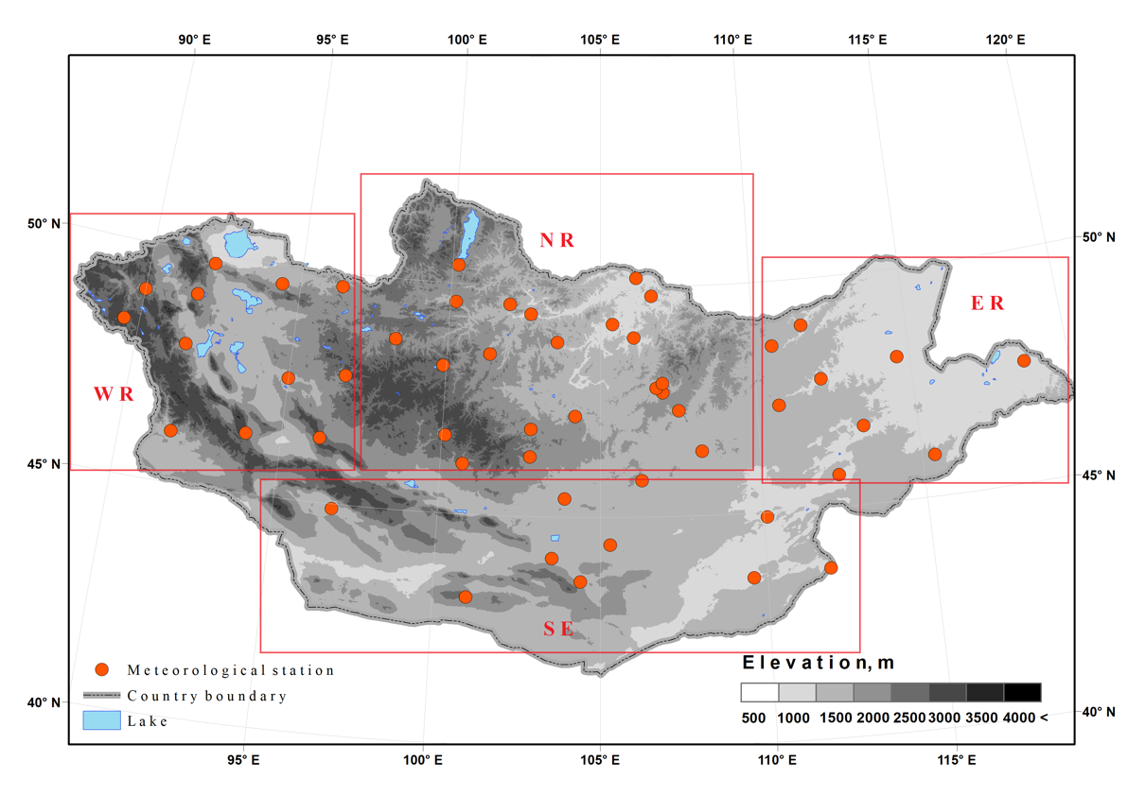
Figure S1: Meteorological stations (orange circles) and elevation of Mongolia are shown. The number of stations is 54 in total, and their regions can be divided in to four by regional climate: High Mountain Altay mountain (Western Region), Khangai and Khentiyn mountains forest (Northern Region), Gobi Desert plains (Southern Region), and broad steppes area (Eastern region). Elevations of Mongolia ranges from approximately 560 m to 4,360 m.

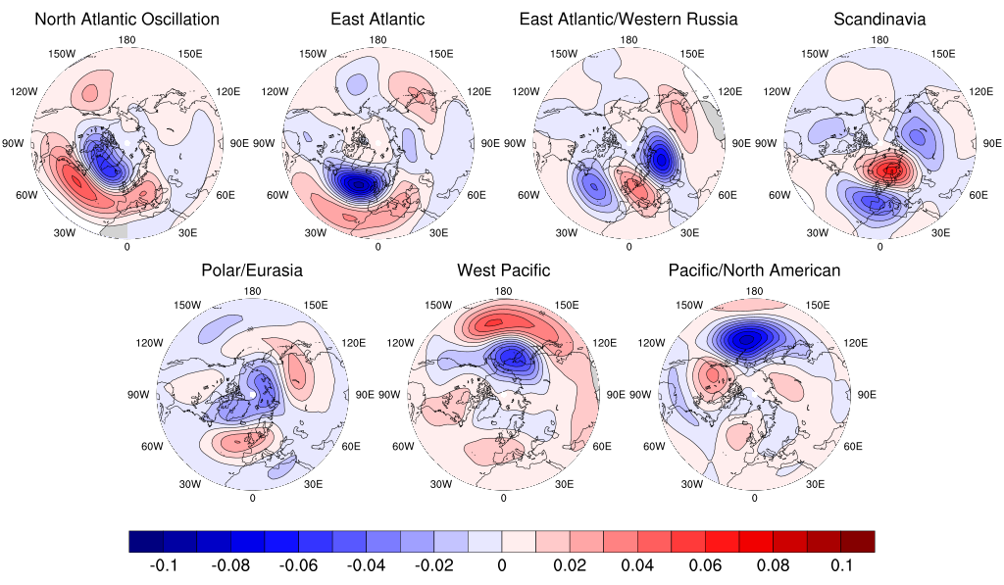
Figure S2: The wintertime 500-hPa geopotential height anomalies associated with seven major teleconnection patterns are shown. The patterns are obtained by regressing the NOAA/CPC teleconnection indices onto the height anomalies obtained from ERA-Interim dataset. The contour interval is 0.01 m, while warm and cold colors indicate positive and negative anomalies, respectively.

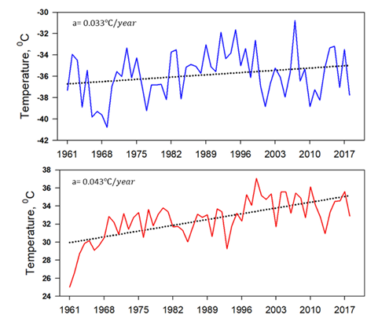
Figure S3: (top) Annual minimum value of daily minimum temperature (TNn) and (bottom) annual maximum value of daily maximum temperature (TXx) averaged over Mongolia are shown between 1961 and 2018, along with their long-term linear trend. Note that the shown range of y-axis is greater for the annual maximum temperature than that for the minimum.

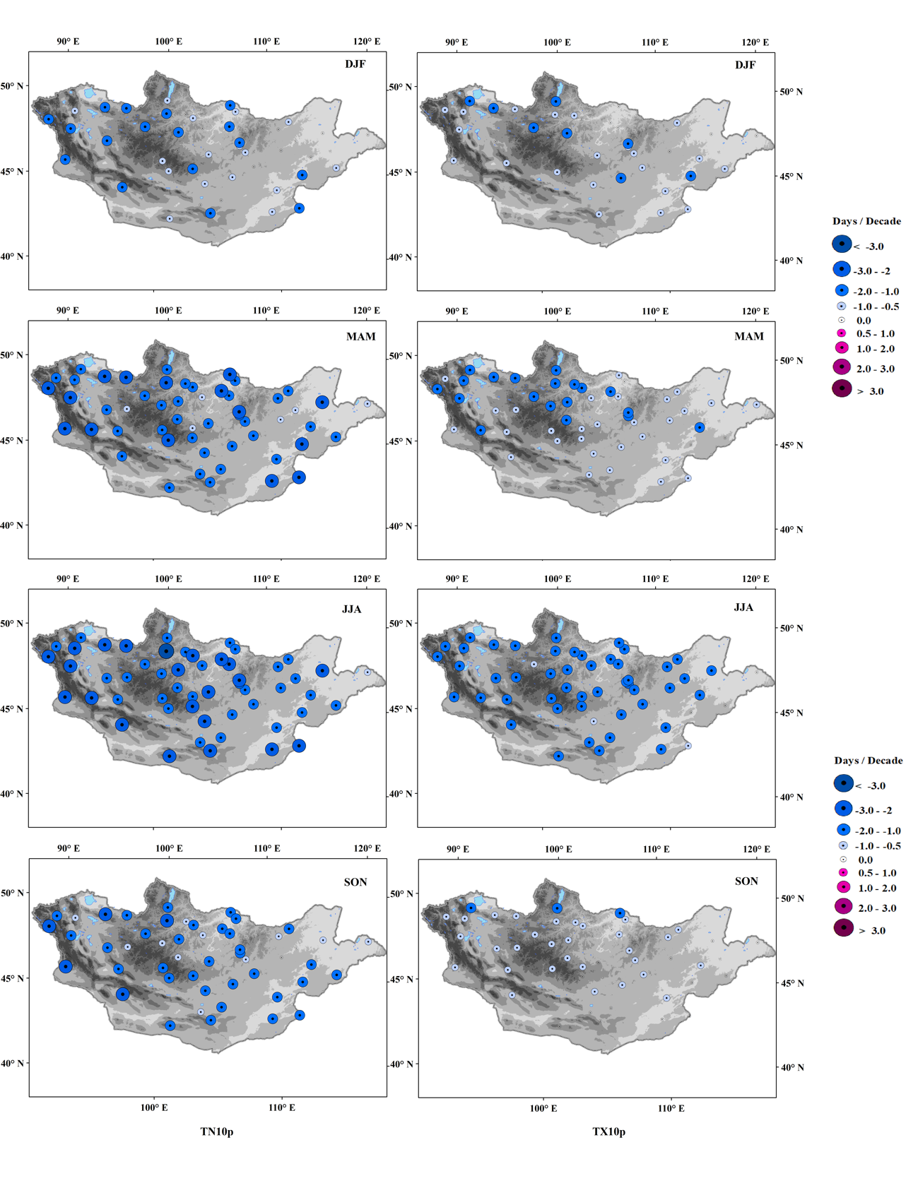
Figure S4: Spatial distributions of the seasonal trends of (left 4 panels) the cool nights (TN10p) and (right 4 panels) cool days (TX10p) for (from the top to bottom) December-February (DJF), March-May (MAM), June-August (JJA), and September-November (SON). Units are days per decade.

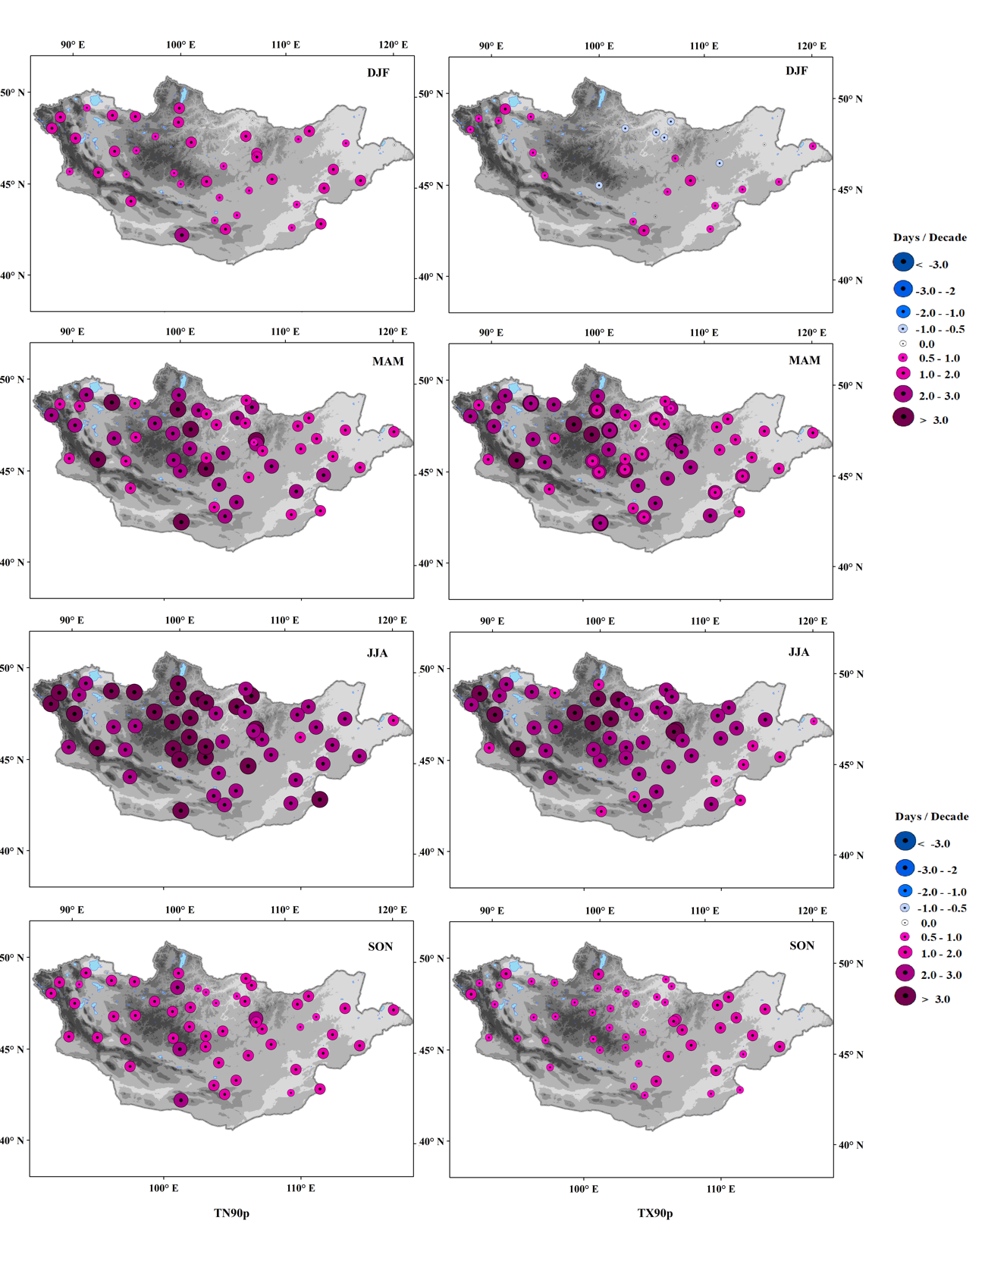
Figure S5: As for Fig. S4, except that the trends for (left 4 panels) the warm nights (TN90p) and (right 4 panels) warm days (TX90p) are shown. (from the top to bottom) December-February (DJF), March-May (MAM), June-August (JJA), and September-November (SON). Units are days per decade.

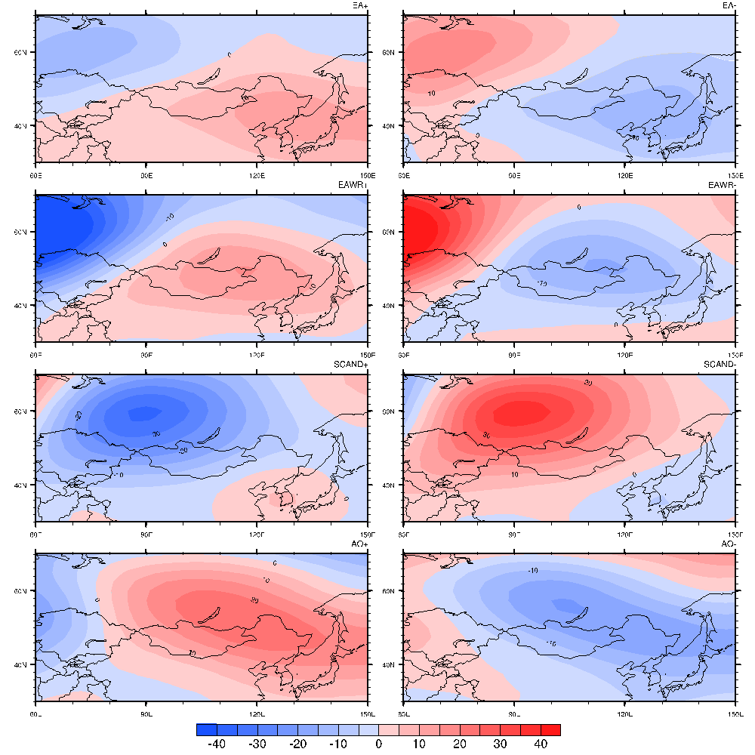
Figure S6: Composites of 500-hPa geopotential height anomalies for (left) positive and (right) negative phases of (from the top to bottom) East Atlantic, East Atlantic Western Russia, Scandinavian teleconnection patterns and Arctic Oscillation. Units are m.

