Supporting Information

Continuously processing waste lignin into high-value carbon nanotube fibers

Fuyao Liu, Qianqian Wang, Gongxun Zhai, Hengxue Xiang*, Jialiang Zhou, Chao Jia*, Liping Zhu, Qilin Wu, Meifang Zhu*

State Key Laboratory for Modification of Chemical Fibers and Polymer Materials, College of Materials Science and Engineering, Donghua University, Shanghai 201620, China

Corresponding Author
* Correspondence to: hengxuexiang@dhu.edu.cn; jiachao0806@dhu.edu.cn; zmf@dhu.edu.cn

This file includes:

Table S1 to S8
Figs. S1 to S20
Legend for Movie S1
References (1 to 22)

Other Supplementary Materials for this manuscript include the following:

Movies S1 Continuously processing waste lignin into high-value carbon nanotube fibers

Table S1. Comparison of the structures and morphologies of our prepared CNTs with those of other reported CNTs.
Biomass | Continuous preparation | Macroscopic morphology | Synthesis temperature  (°C) | I_{G}/I_{D} | Layer number | Micro morphology | Reference
Lignin | Yes  (120 m h⁻¹) | CNT fiber | 1400 | 3.84 | MWNTs | CNT aerogels | This work
Eucalyptus oil | No | powder | 850 | 3.3 | SWNTs/ MWNTs | carbon/CNT mixture | ¹
Turpentine oil | No | powder | 700 | 0.93 | MWNTs | CNT arrays | ²
Sesame oil | No | powder | 900 | 0.98 | MWNTs | CNT arrays | ³
Grass | No | powder | 600 | 2.0 | MWNTs | CNT arrays | ⁴
Plant | No | powder | ＞600 | - | MWNTs | carbon/CNT mixture | ⁵
Poplar leaves | No | powder | 450 | 0.79 | MWNTs | carbon/CNT mixture | ⁶
Lignin | No | powder | 2000 | 1.0 | MWNTs | carbon/CNT mixture | ⁷
Notes: Single wall carbon nanotubes (SWNTs), Multiwalled carbon nanotubes (MWNTs)

Table S2. Assignments of ¹³C-¹H cross signals in the HSQC spectra of lignin.
Label | δC/δH (ppm) | Assignments
B_{β} | 53.5/3.07 | Cβ-Hβ in β-β resinol (B)
OCH₃ | 56.4/3.70 | C-H in methoxyls
Aγ | 59.9/3.35-3.80 | Cγ-Hγ in β-O-4 substructures (A)
Bγ | 71.2/3.82-4.18 | Cγ-Hγ in β-β resinol (B)
Aα | 71.8/4.86 | Cα-Hα in β-O-4 unit (A)
Aβ(G) | 83.4/4.38 | Cβ-Hβ in β-O-4 linked to G (A)
Bα | 84.8/4.66 | Cα-Hα in β-β resinol (B)
S2,6 | 103.9/6.70 | C2,6-H2,6 in syringyl units (S)
S'2,6 | 106.3/7.32 | C2,6-H2,6 in oxidized S units (S')
G2 | 110.8/6.97 | C2-H5 in guaiacyl units (G)
G5 | 114.5/6.70 | C5-H5 in guaiacyl units (G)
G6 | 119.0/6.78 | C6-H6 in guaiacyl units (G)

Table S3. Simulated analysis result of lignin molecule from ChemDraw.
Item | Result
Chemical formula | C₂₀₅H₂₃₄O₈₁
Exact mass | 3991.4
Molecular weight | 3994.0
Elemental analysis | C:61.65, H:5.91, O:32.45

Table S4. Main pyrolysis products of lignin at 800℃ from PY-GCMS.
Number | Time (s) | Area (%) | Formula | CAS Number | Remark
1 | 1.70 | 23.90 |  |  | Multi-component peak
2 | 1.78 | 2.49 | C₅H₈O | 10229-10-4
3 | 1.92 | 31.92 |  |  | Multi-component peak
4 | 1.96 | 0.17 | C₄H₆ | 590-19-2 | Other
5 | 2.00 | 0.55 | C₅H₈ | 78-79-5 | Other
6 | 2.13 | 1.93 | C₅H₆ | 542-92-7
7 | 2.36 | 0.20 | C₅H₆ | 542-92-7 | Other
8 | 2.63 | 0.07 | C₆H₁₀ | 513-81-5 | Other
9 | 2.85 | 0.84 | C₆H₈ | 592-57-4 | Other
10 | 2.89 | 0.65 | C₆H₈ | 96-39-9 | Other
11 | 3.12 | 6.05 | C₆H₆ | 71-43-2
12 | 3.21 | 1.03 | C₄H₄S | 110-02-1
13 | 4.76 | 5.74 | C₇H₈ | 108-88-3
14 | 4.84 | 0.56 | C₅H₆S | 616-44-4 | Other
15 | 4.98 | 0.35 | C₅H₆S | 554-14-3 | Other
16 | 6.40 | 0.50 | C₈H₁₀ | 100-41-4 | Other
17 | 6.54 | 1.53 | C₈H₁₀ | 108-38-3
18 | 6.70 | 0.16 | C₆H₈S | 632-15-5 | Other
19 | 6.92 | 2.07 | C₈H₈ | 100-42-5
20 | 8.01 | 0.25 | C₉H₁₂ | 620-14-4 | Other
21 | 8.31 | 0.28 | C₉H₁₀ | 98-83-9 | Other
22 | 8.50 | 0.91 | C₉H₁₀ | 611-15-4 | Other
23 | 8.56 | 0.36 | C₈H₆O | 271-89-6 | Other
24 | 8.66 | 0.81 | C₆H₆O | 108-95-2 | Other
25 | 9.22 | 1.84 | C₉H₈ | 95-13-6
26 | 9.48 | 2.27 | C₇H₈O | 95-48-7
27 | 9.84 | 0.88 | C₇H₈O | 108-39-4 | Other
28 | 9.91 | 0.96 | C₉H₈O | 17059-52-8 | Other
29 | 9.99 | 0.66 | C₈H₈N₂ | 614-97-1 | Other
30 | 10.07 | 0.89 | C₈H₁₀O | 576-26-1 | Other
31 | 10.54 | 0.89 | C₁₀H₁₀ | 2177-47-1 | Other
32 | 10.63 | 2.22 | C₁₀H₁₀ | 767-59-9
33 | 11.01 | 1.84 | C₁₀H₈ | 91-20-3
34 | 11.13 | 0.15 | C₈H₆S | 270-82-6 | Other
35 | 11.14 | 0.18 | C₉H₁₀N₂ | 582-60-5 | Other
36 | 11.21 | 0.31 | C₉H₁₂O | 2416-94-6 | Other
37 | 12.25 | 1.09 | C₁₁H₁₀ | 91-57-6
38 | 12.43 | 0.70 | C₁₁H₁₀ | 90-12-0 | Other
39 | 13.09 | 0.16 | C₁₂H₁₀ | 92-52-4 | Other
40 | 13.37 | 0.18 | C₁₂H₁₂ | 575-37-1 | Other
41 | 13.51 | 0.18 | C₁₂H₁₂ | 571-58-4 | Other
42 | 13.62 | 0.18 | C₁₂H₁₀ | 827-54-3 | Other
43 | 13.86 | 0.44 | C₁₂H₈ | 259-79-0 | Other
44 | 14.09 | 0.13 | C₁₃H₁₂ | 644-08-6 | Other
45 | 15.50 | 0.31 | C₁₁H₁₀O | 7469-77-4 | Other

Table S5. Composition and proportion of small molecule products from lignin pyrolysis at 800℃ (Split the peaks with retention times 1.697 and 1.92 from Table S4 and Figure S8).
Number |  | Time (s) |  | Area (%) | Formula | CAS Number | Remark
1 |  | 1.70 |  | 23.90 | / | / | Multi-component peak
3 |  | 1.92 |  | 31.92 | / | / | Multi-component peak
Total |  |  |  | 55.82
M/Z | Area (%) |  | Area (%) |  | Formula | CAS Number | Remark
28 | 31.26 |  | 17.45 |  | CO | 630-08-0
44 | 13.00 |  | 7.26 |  | CO₂ | 124-38-9
18 | 48.54 |  | 27.09 |  | H₂O | 7732-18-5
16 | 7.19 |  | 4.02 |  | CH₄ | 74-82-8
Total | 100 |  | 55.82

Table S6. Comparison of thermal conductivity of our CNT fibers and other biomass-derived carbon materials as well as common metals.
Materials | Thermal conductivity  (W m⁻¹ K⁻¹) | Density (g cm⁻³) |  | Reference
Lignin-CNT Film | 42 |  | 0.71 | This work
PMMA/CNT | 3.44 |  | 1.18 | ⁸
Polycarbonate/CNT | 1.27 |  | 1.2 | ⁹
Lignin-based carbon foams | 0.75 |  | 0.68 | ¹⁰
Lignin-based carbon fibers | 24 |  | 2.189 | ¹¹
Lignin-based carbon fibers | 1.8 |  | 2 | ¹²
Lignin aerogels | 0.06 |  | 2.5 | ¹³
Silver (Ag) | 419 |  | 10.49 | ¹⁴
Copper (Cu) | 385 |  | 7.76 | ¹⁴
Aluminum (Al) | 210 |  | 2.7 | ¹⁴
Iron (Fe) | 76.2 |  | 7.87 | ¹⁴

Table S7. Comparison of tensile strength and conductivity of our CNT fibers and other biomass-derived carbon materials.
Materials | Conductivity  (S m⁻¹) |  | Tensile strength  (MPa) |  | Reference
Lignin-CNT fiber |  | 6.28×10⁵ |  | 1351 | This work
Lignin/Nanocellulose Hydrogels  (wet-spun) |  | 1.03×10⁴ |  | 88 | ¹⁵
Softwood kraft lignin (melt-spun) |  | 1.91×10⁴ |  | 369 | ¹⁶
Lignin-based carbon fibers (wet-spinning) |  | 1.41×10⁴ |  | 351 | ¹⁷
Eucalyptus tar pitch |  | 5×10³ |  | 129 | ¹⁸
Lignin/Nanocellulose (Flow-Assisted) |  | 1.85×10⁴ |  | 1648 | ¹⁹
Nanocellulose/silver |  | 2.3×10⁵ |  | 80.3 | ²⁰
Lignin/ PVA /GO |  | 2×10³ |  | 763 | ²¹
Silk/SWNT |  | 1×10³ |  | 590 | ²²
Silk/Graphene |  | 3×10³ |  | 570 | ²²
Silver (Ag) |  | 6.3×10⁷ |  | 140 | ¹⁴
Copper (Cu) |  | 5.8×10⁷ |  | 210 | ¹⁴
Aluminum (Al) |  | 3.5×10⁷ |  | 100 | ¹⁴
Iron (Fe) |  | 1.0×10⁷ |  | 540 | ¹⁴

Table S8. Composition analysis of lignin.
Analysis method | Component | Content (%)
Proximate analysis | Moisture |  | 2.3
 | Ash |  | 1.1
 | Volatiles |  | 59
 | Fixed carbon |  | 37.7
Ultimate analysis | Carbon |  | 61.92
 | Hydrogen |  | 5.68
 | Oxygen |  | 31.92
 | Nitrogen |  | ≤0.05
 | Sodium |  | ≤0.005

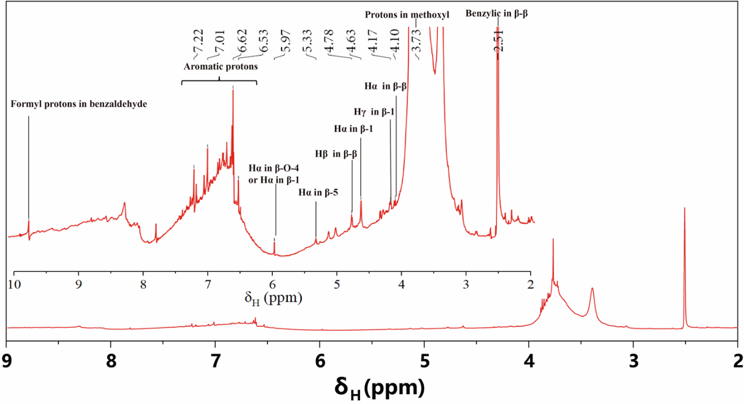
Figure S1. Quantitative ¹H NMR spectrum of lignin.

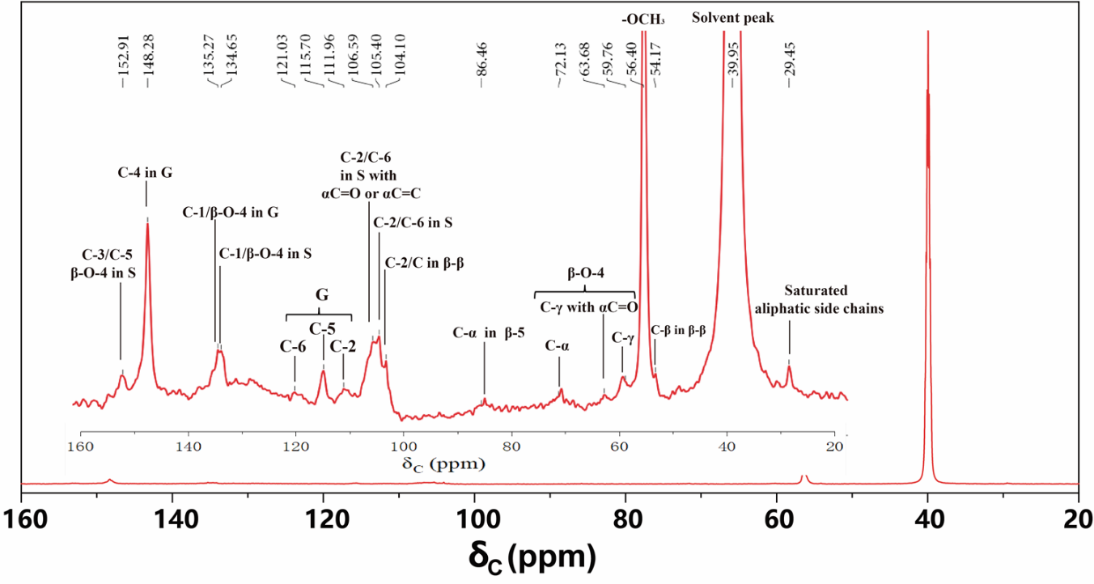
Figure S2. Quantitative ¹³C NMR spectrum of lignin.

Figure S3. HMBC spectra (600 MHz with a cryogenic probe, DMSO-d6) of lignin.

Figure S4. Main linkages of lignin obtained from HMBC spectra.

Figure S5. Molecular structure of lignin deduced from the results of NMR.

Figure S6. Three dimensional structure of lignin molecule simulated by ChemDraw software.

Figure S7. Thermogravimetric (TG) analysis of lignin in a nitrogen atmosphere.

Figure S8. Pyrolysis products of lignin at different temperatures obtained by pyrolysis gas chromatography-mass spectrometry (PY-GCMS).

Figure S9. Main pyrolysis products of lignin at 800°C from PY-GCMS.

Figure S10. Main pyrolysis products (aromatic hydrocarbon) of lignin in the temperature range of 200-800°C from PY-GCMS analysis.

Figure S11. FTIR spectra of pyrolysis products of lignin at 20-1400°C.

Figure S12. FTIR spectra of lignin charcoal at 800-1400°C.

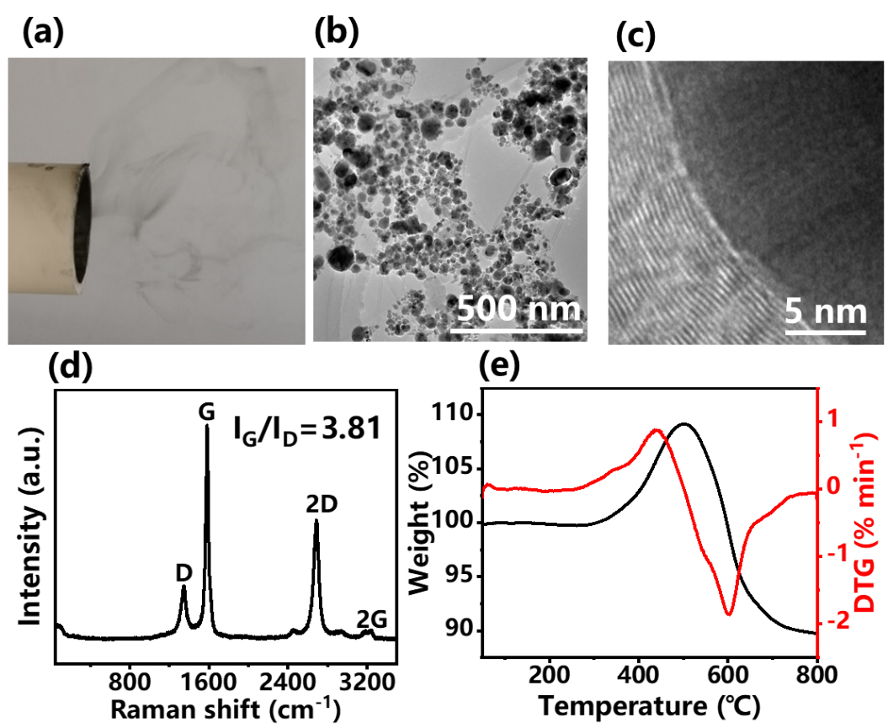
Figure S13. Carbon nanospheres synthesis without sulfur. (a) Digital image and (b, c) TEM images of the carbon nanospheres. (d) Raman spectrum and (e) TGA of the carbon nanospheres prepared without thiophene addition.

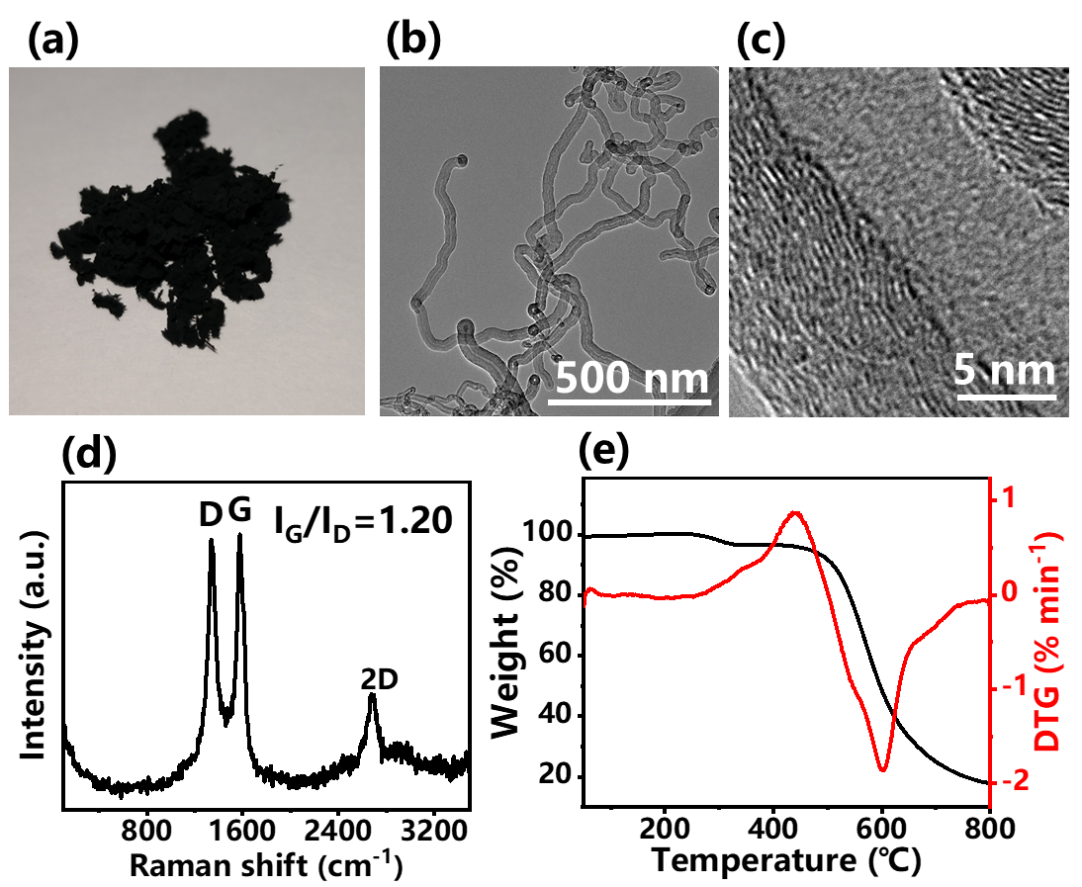
Figure S14. CNT synthesis with excessive sulfur. (a) Digital image and (b, c) TEM images of the curled CNTs. (d) Raman spectrum and (e) TGA of the CNTs prepared with excessive thiophene addition.

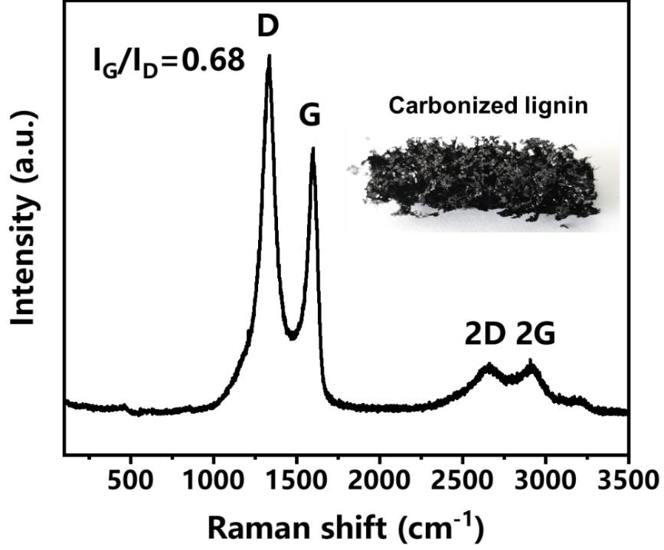
Figure S15. Raman spectrum of black charcoal from the pyrolysis of solid lignin at 1400°C for 30 min in N₂ atmosphere.

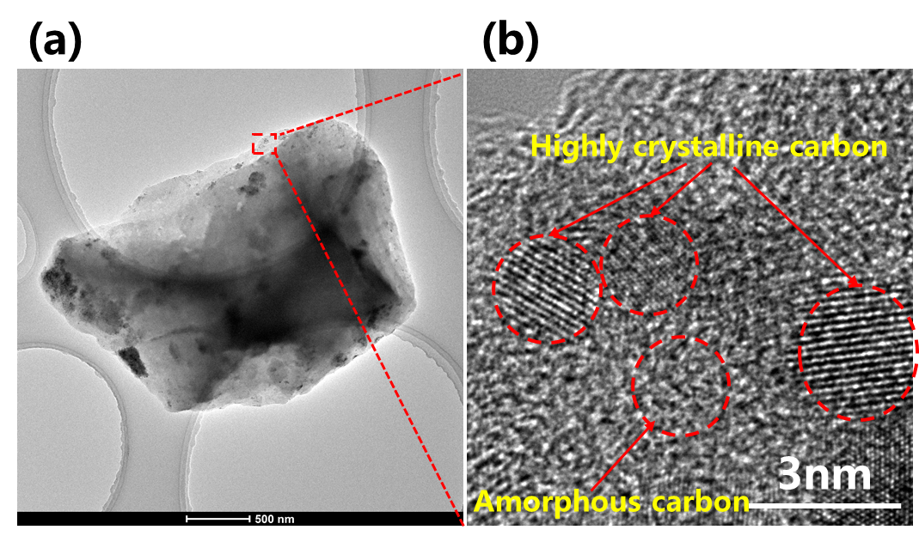
Figure S16. Morphologies of the lignin-drived black charcoal. (a) TEM image and (b) enlarged view of black charcoal from the pyrolysis of solid lignin at 1400°C for 30 min in N₂ atmosphere.

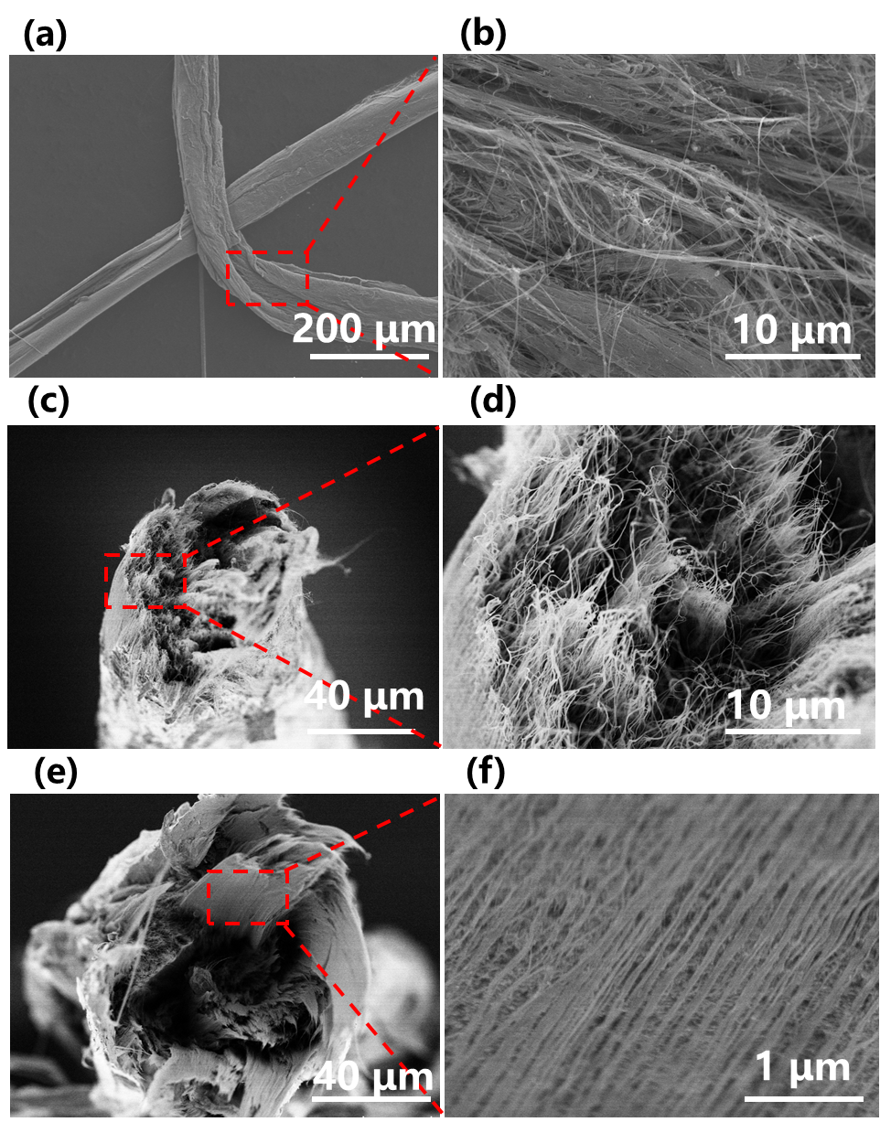
Figure S17. Morphologies of the nascent CNT fibers, twisted CNT fibers and rolled CNT fibers. (a) SEM image of the nascent CNT fibers and (b) magnified SEM image. (c) Cross-sectional SEM image of the twisted CNT fibers and (d) magnified SEM image. (e) Cross-sectional SEM image of the rolled CNT fibers and (d) magnified SEM image.

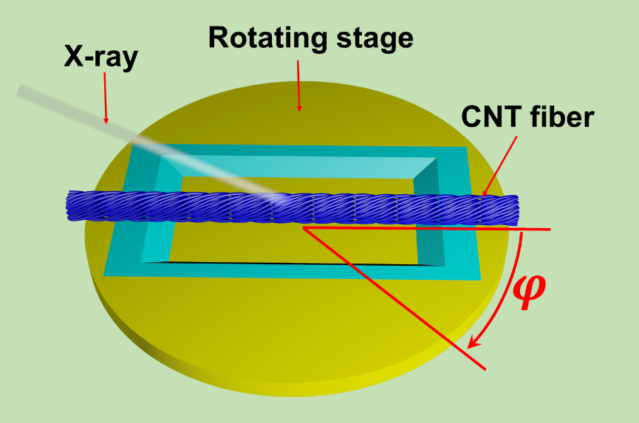
Figure S18. Schematic diagram for the determination of the fiber orientation by WAXD azimuthal scanning.

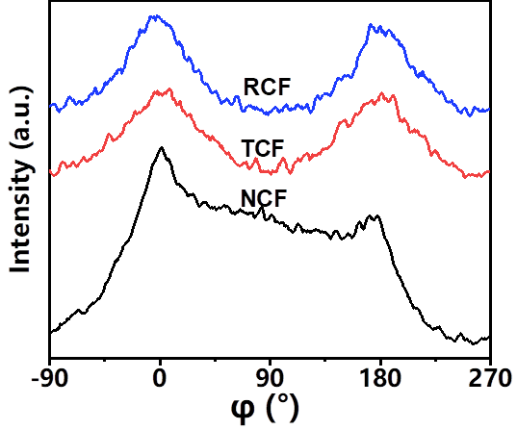
Figure S19. WAXD azimuthal scanning of the NCFs, TCFs and RCFs.

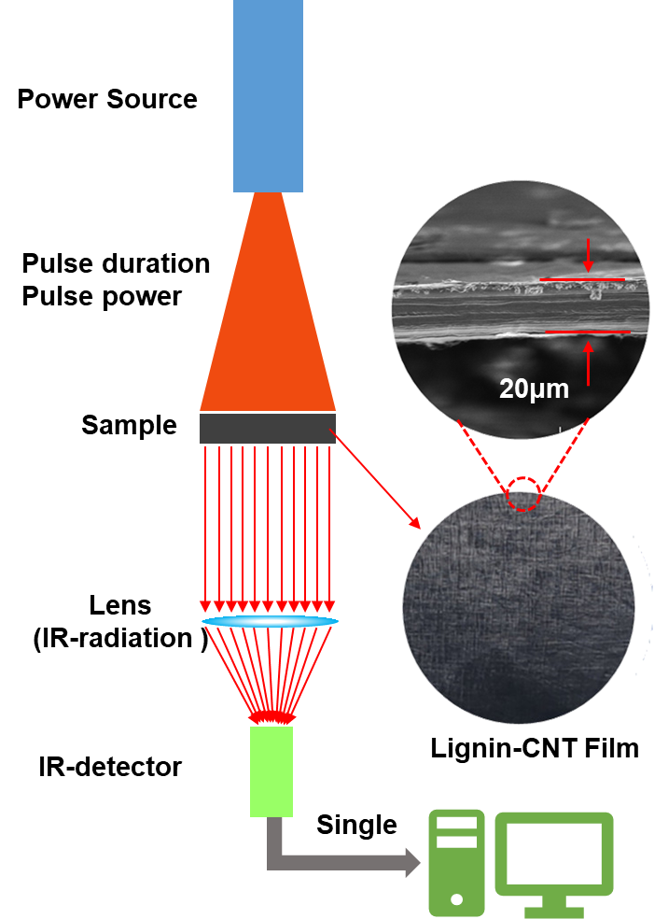
Figure S20. Schematic showing the thermal conductivity measurement of the CNT film.

Movie S1. Continuously processing waste lignin into high-value carbon nanotube fibers

References
- Ghosh P, Afre RA, Soga T, Jimbo T. A simple method of producing single-walled carbon nanotubes from a natural precursor: Eucalyptus oil. Mater. Lett. 61, 3768-3770 (2007).
2. Ghosh P, et al. Vertically aligned carbon nanotubes from natural precursors by spray pyrolysis method and their field electron emission properties. Appl. Phys. A-Mater. 94, 51-56 (2009).
3. Kumar R, Singh RK, Tiwari R. Growth analysis and high-yield synthesis of aligned-stacked branched nitrogen-doped carbon nanotubes using sesame oil as a natural botanical hydrocarbon precursor. Mater. Design 94, 166-175 (2016).
4. Kang Z, Wang E, Mao B, Su Z, Chen L, Xu L. Obtaining carbon nanotubes from grass. Nanotechnology 16, 1192 (2005).
5. Xie X, et al. A method for producing carbon nanotubes directly from plant materials. Forest. Prod. J. 59, (2009).
6. Qu J, Cong Q, Luo C, Yuan X. Adsorption and photocatalytic degradation of bisphenol A by low-cost carbon nanotubes synthesized using fallen leaves of poplar. RSC Adv. 3, 961-965 (2013).
7. Gindl-Altmutter W, et al. Lignin-based multiwall carbon nanotubes. Composites, Part A 121, 175-179 (2019).
8. Hong W-T, Tai N-H. Investigations on the thermal conductivity of composites reinforced with carbon nanotubes. Diam. Relat. Mater. 17, 1577-1581 (2008).
9. Kim HS, Jang J-u, Yu J, Kim SY. Thermal conductivity of polymer composites based on the length of multi-walled carbon nanotubes. Composites, Part B 79, 505-512 (2015).
10. Yan Q, Arango R, Li J, Cai Z. Fabrication and characterization of carbon foams using 100% Kraft lignin. Mater. Design 201, 109460 (2021).
11. Liu J, et al. Thermal conductivity and annealing effect on structure of lignin-based microscale carbon fibers. Carbon 121, 35-47 (2017).
12. Wang R, et al. Anisotropic thermal conductivities and structure in lignin-based microscale carbon fibers. Carbon 147, 58-69 (2019).
13. Grishechko LI, Amaral-Labat Gi, Szczurek A, Fierro V, Kuznetsov BN, Celzard A. Lignin–phenol–formaldehyde aerogels and cryogels. Micropor. Mesopor. Mat. 168, 19-29 (2013).
14. The Online Materials Information Resource. The Online Materials Information Resource (http://www.matweb.com/).
15. Wang L, et al. Conductive Carbon Microfibers Derived from Wet-Spun Lignin/Nanocellulose Hydrogels. ACS Sustain. Chem. Eng. 7, 6013-6022 (2019).
16. Nowak AP, et al. Lignin-based carbon fibers for renewable and multifunctional lithium-ion battery electrodes. Holzforschung 72, 81-90 (2018).
17. Li Q, et al. Microstructure defines the electroconductive and mechanical performance of plant-derived renewable carbon fiber. Chem. Commun. 55, 12655-12658 (2019).
18. Prauchner MJ, Pasa VMD, Otani S, Otani C. Biopitch-based general purpose carbon fibers: Processing and properties. Carbon 43, 591-597 (2005).
19. Kinumoto T, Matsumura T, Yamaguchi K, Matsuoka M, Tsumura T, Toyoda M. Material Processing of Bamboo for Use as a Gas Diffusion Layer in Proton Exchange Membrane Fuel Cells. ACS Sustain. Chem. Eng. 3, 1374-1380 (2015).
20. Wang JF, et al. Wet-spinning of highly conductive nanocellulose-silver fibers. J Mater. Chem C. 5, 9673-9679 (2017).
21. Torres-Canas F, et al. Improved structure and highly conductive lignin-carbon fibers through graphene oxide liquid crystal. Carbon 163, 120-127 (2020).
22. Wang Q, Wang C, Zhang M, Jian M, Zhang Y. Feeding Single-Walled Carbon Nanotubes or Graphene to Silkworms for Reinforced Silk Fibers. Nano Lett. 16, 6695-6700 (2016).

