Selenium speciation in the sediments and the oligochaete Lumbriculus variegatus
Jichen Yang^{a,b#}, Xin Yan^{c#}, Hongsong Liu^{a,b}, Hongxing Chen^{a,b}, Yongzhuang Wang^{d}, Wei Zhang^{e}, Wu Dong^{f}, Dan Li^{a,b*}, Lingtian Xie^{a,b}

a. SCNU Environmental Research Institute, Guangdong Provincial Key Laboratory of Chemical Pollution and Environmental Safety & MOE Key Laboratory of Theoretical Chemistry of Environment, South China Normal University, Guangzhou 510006, China
b. School of Environment, South China Normal University, University Town, Guangzhou 510006, China
c. Guangxi Academy of Fishery Sciences, Nanning 530021, China
d. Key Laboratory of Environment Change and Resources Use in Beibu Gulf, Nanning Normal University, Ministry of Education, Nanning 530001, China
e. Institute of Environmental Research at Greater Bay Area, Key Laboratory for Water Quality and Conservation of the Pearl River Delta, Ministry of Education, Guangzhou University, Guangzhou 510006, China
f. Inner Mongolia Key Laboratory of Toxicant Monitoring and Toxicology, Collage of Animal Science and Technology, Inner Mongolia University for Nationalities, Tongliao 028000, China

* Corresponding author:
Dan Li (dan.li@m.scnu.edu.cn)
School of Environment, South China Normal University, University Town, West Waihuan Road 378, Guangzhou 510006, China
# Jichen Yang and Xin Yan contributed equally to this work.

Figure Legends
Figure S1. Se speciation in the overlying water in the beakers with different levels of Se(IV) at 3 (Panel A), 30 (Panel B), and 100 (Panel C) µg/g for 90 days (mean ± SE, n = 3).
Figure S2. Se speciation in the overlying water in the beakers with different levels of Se-Met at 3 (Panel A), 30 (Panel B), and 100 (Panel C) µg/g for 7 days (mean ± SE, n = 3).
Figure S3. Se speciation in the overlying water in the beakers with different levels of Se(IV) at 0.1 (L, panel A), 0.3 (M, panel B), and 1.0 (H, panel C) µg/g and Se-Met at 0.1 (L, panel D), 0.3 (M, panel E), and 1.0 (H, panel F) for 7 days (mean ± SE, n = 3).

Fig. S1.
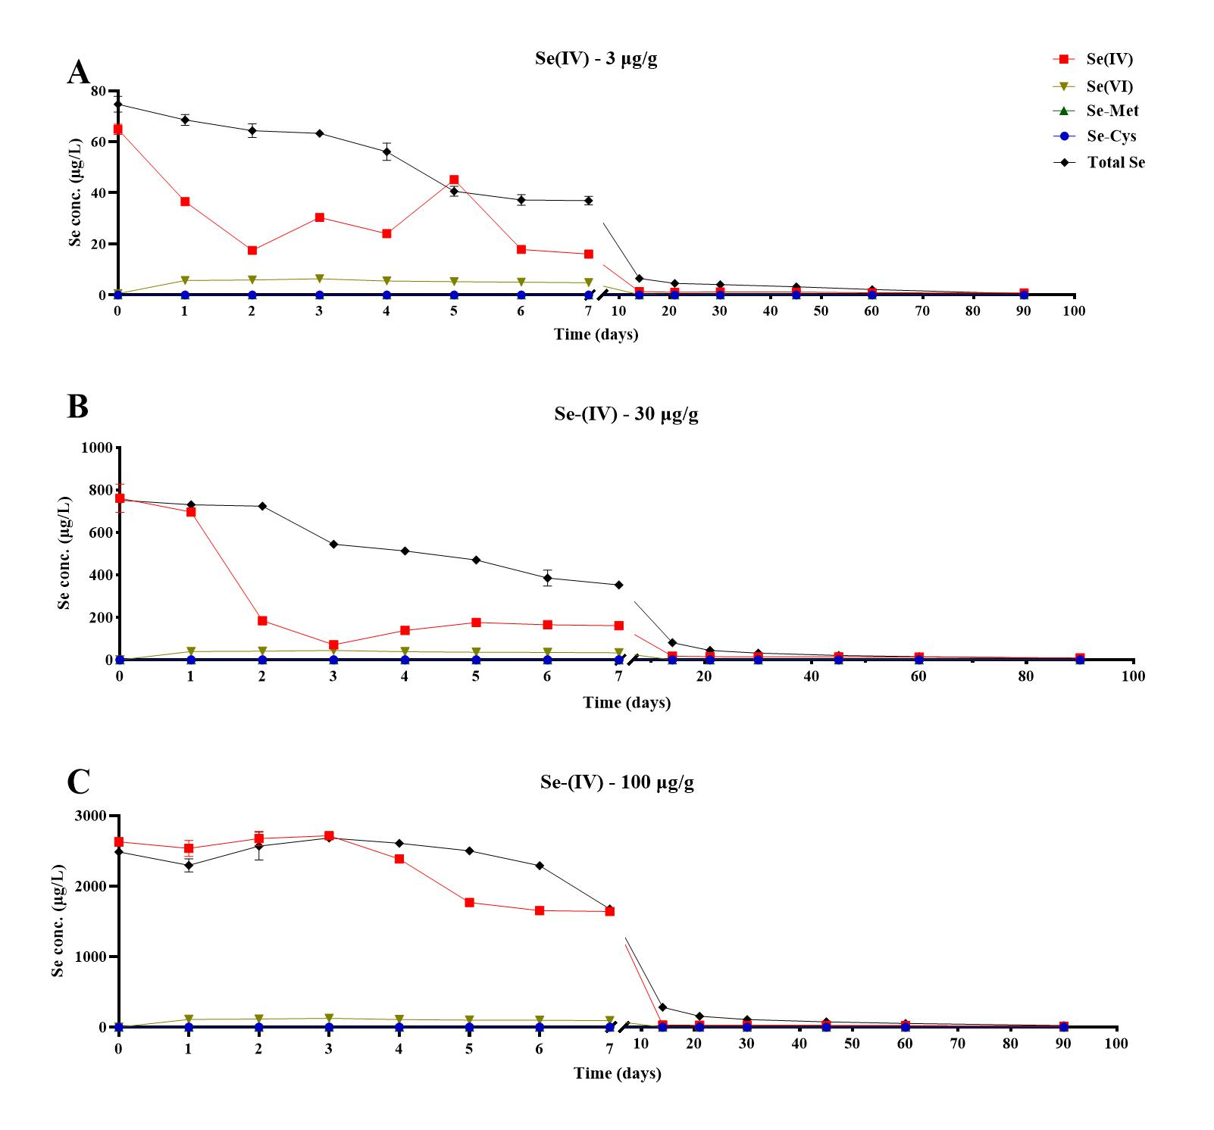

Fig. S2.
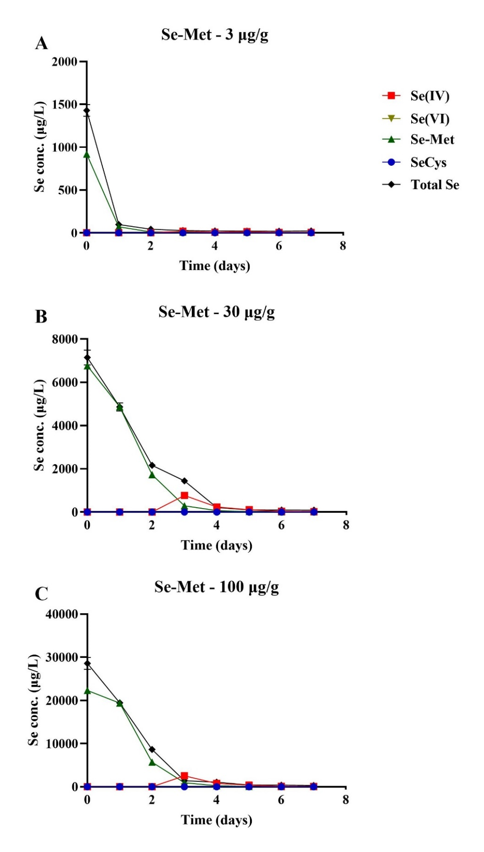

Fig. S3.
