Supporting information:

Synthesis 2-bromo-6-(4,5-diphenyl-1-((1-phenyl-1H-1,2,3-triazol-4-yl)methyl)-1H-imidazol-2-yl)pyridine derivatives : Evaluation of anticancer activity and molecular docking studies

Lakavath Ramdas¹ Dharmasothu Veeranna¹, , Guguloth Ravi¹, SushmithaBujji², Jadhav Ramchader^{1*}
¹Department of Chemistry, University College of Science, Osmania University, Hyderabad, Telangana-500 007, India.
²Department of Pharmacy, University College of Technology, Osmania University, Hyderabad, Telangana-500 007, India.
Corresponding author: Jadhav Ramchader
Email: ramorgchemou@gmail.com

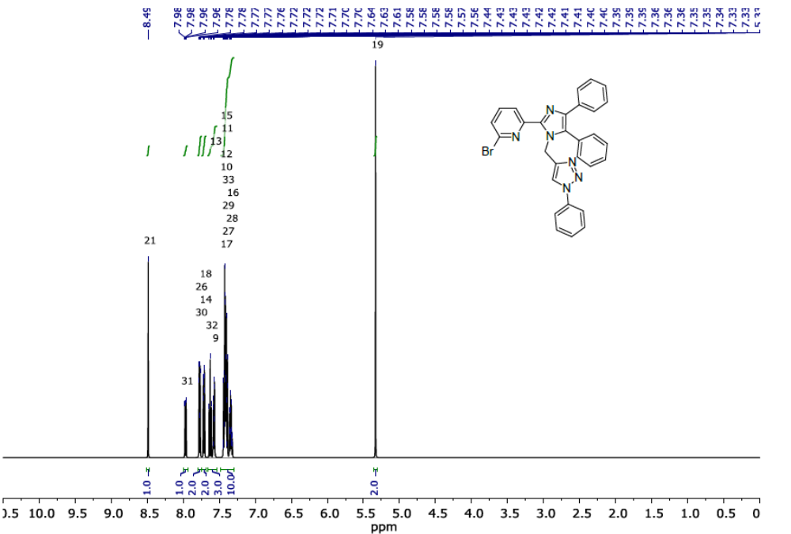
¹H NMR 2-bromo-6-(4,5-diphenyl-1-((1-phenyl-1H-1,2,3-triazol-4-yl)methyl)-1H-imidazol-2-yl)pyridine (7a)

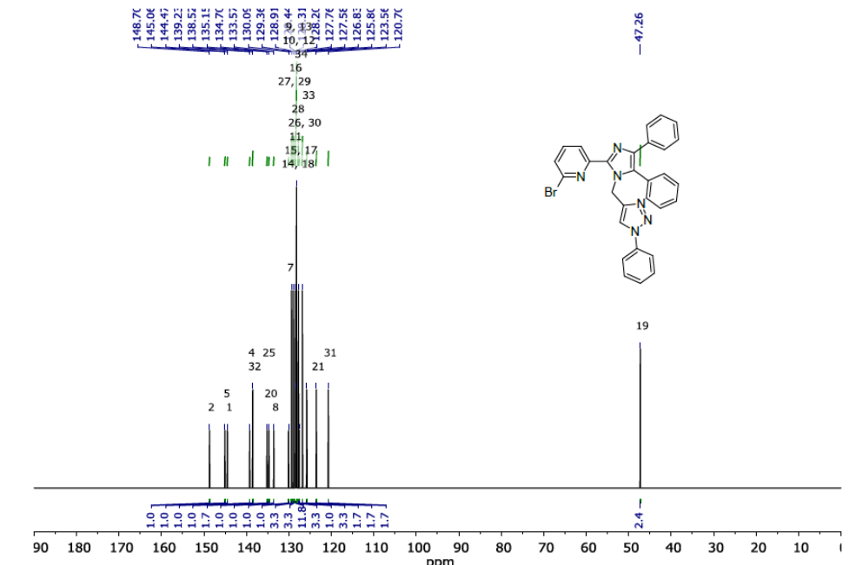
¹³C NMR2-bromo-6-(4,5-diphenyl-1-((1-phenyl-1H-1,2,3-triazol-4-yl)methyl)-1H-imidazol-2-yl)pyridine (7a)
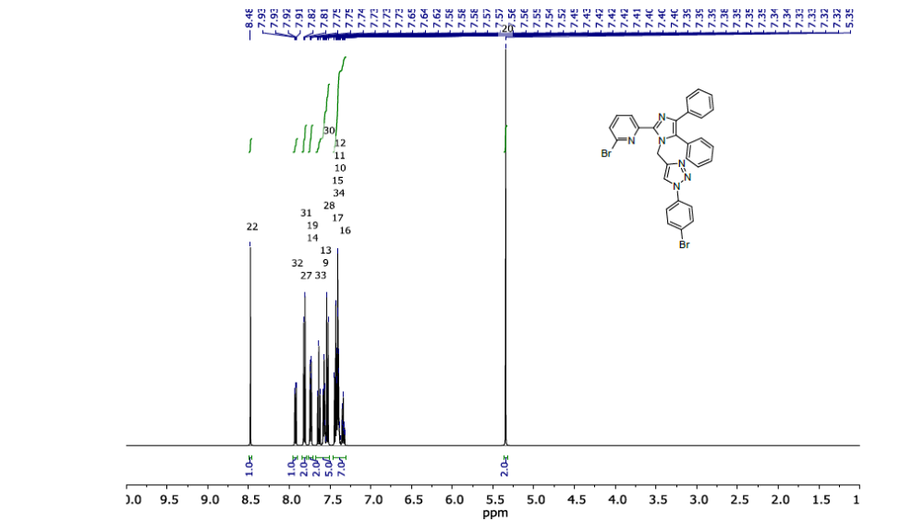
¹H NMR 2-bromo-6-(1-((1-(4-bromophenyl)-1H-1,2,3-triazol-4-yl)methyl)-4,5-diphenyl-1H-imidazol-2-yl)pyridine (7b)
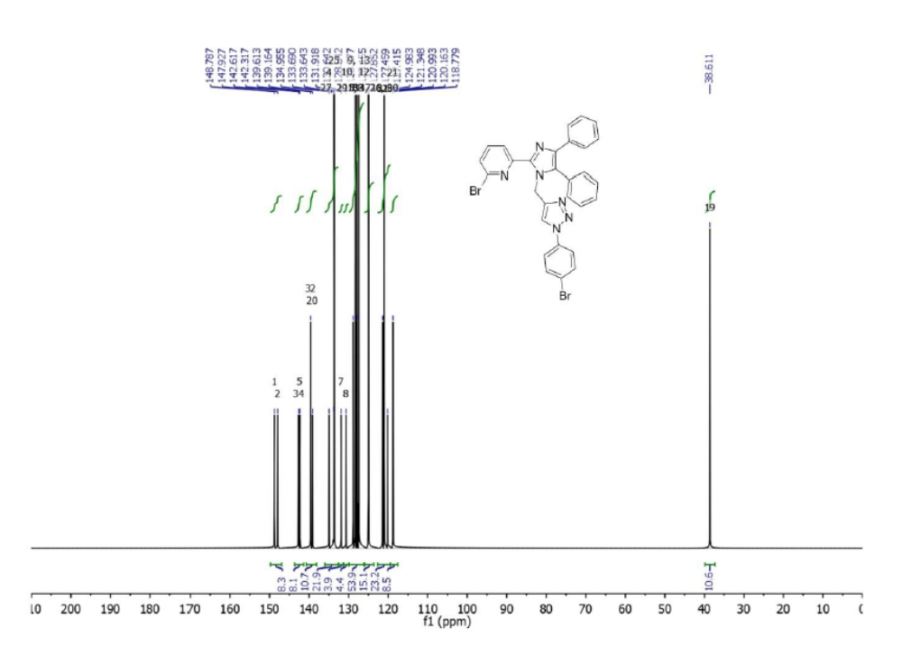
¹³CNMR 2-bromo-6-(1-((1-(4-bromophenyl)-1H-1,2,3-triazol-4-yl)methyl)-4,5-diphenyl-1H-imidazol-2-yl)pyridine (7b)
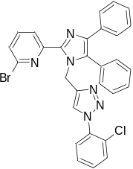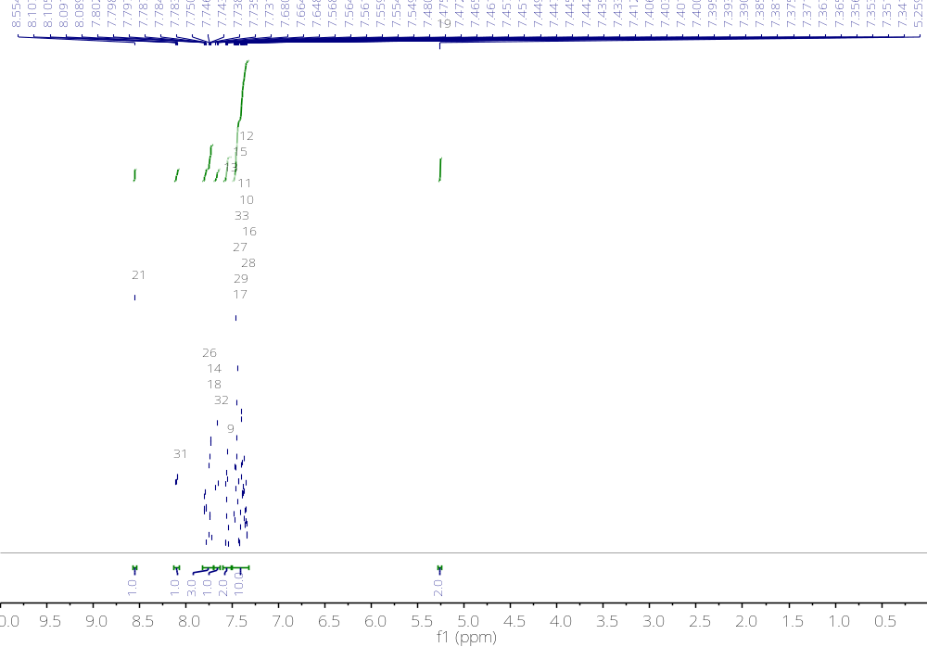
¹H NMR2-bromo-6-(1-((1-(2-chlorophenyl)-1H-1,2,3-triazol-4-yl)methyl)-4,5-diphenyl-1H-imidazol-2-yl)pyridine (7c)
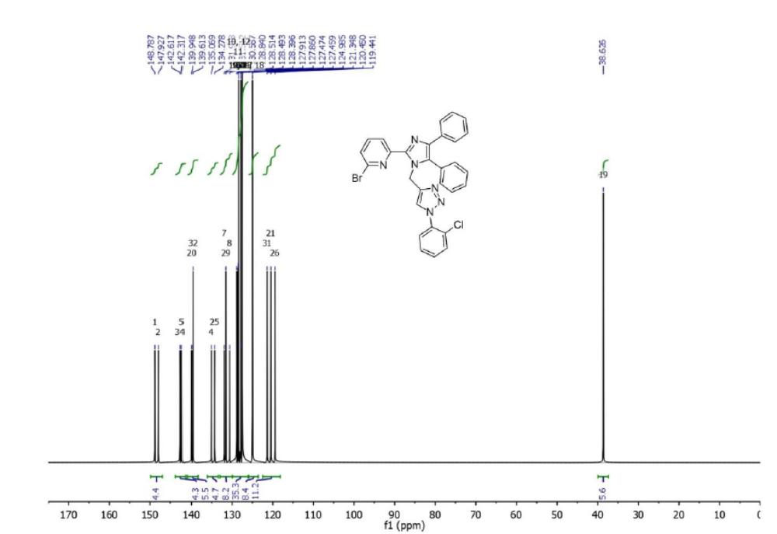

¹³CNMR2-bromo-6-(1-((1-(2-chlorophenyl)-1H-1,2,3-triazol-4-yl)methyl)-4,5-diphenyl-1H-imidazol-2-yl)pyridine (7c)
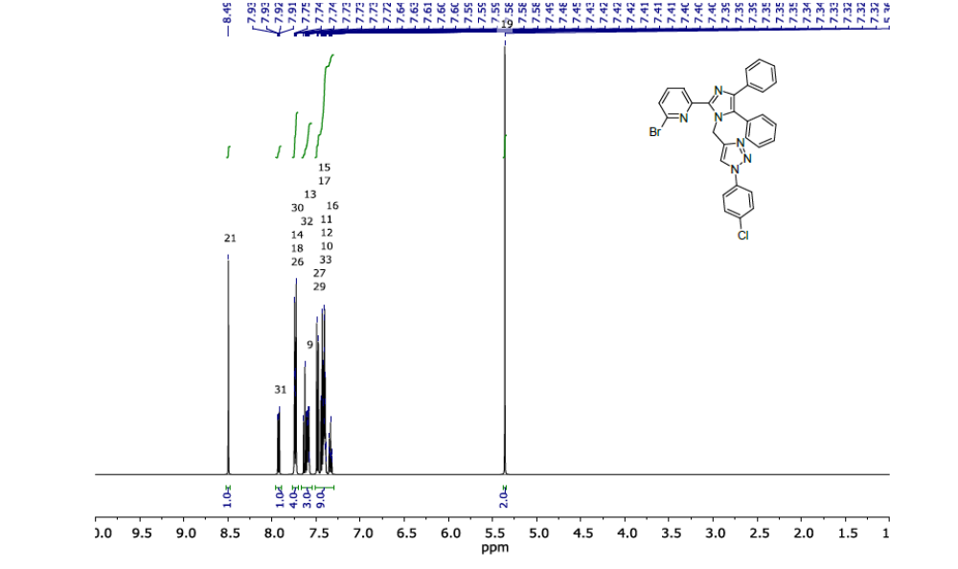
¹HNMR 2-bromo-6-(1-((1-(4-chlorophenyl)-1H-1,2,3-triazol-4-yl)methyl)-4,5-diphenyl-1H-imidazol-2-yl)pyridine (7d)
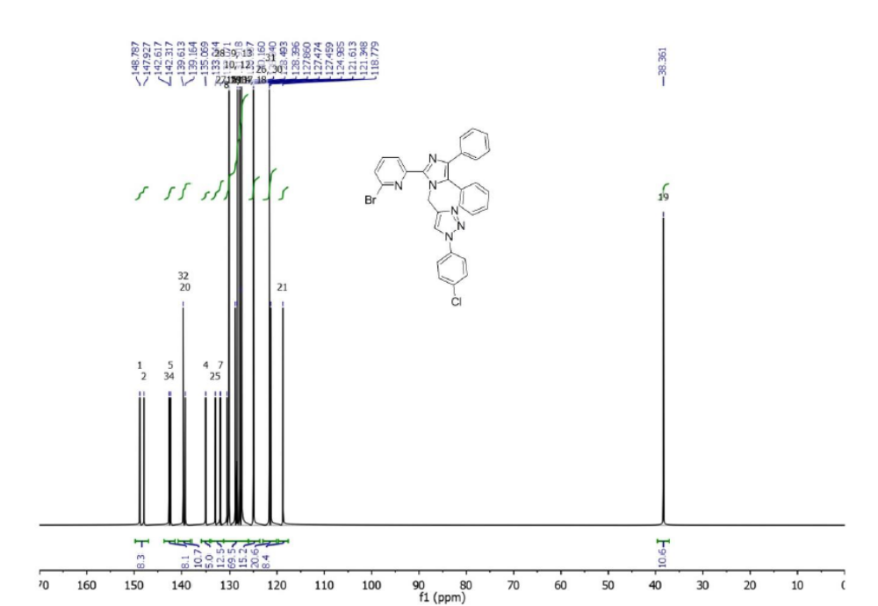

¹³C NMR2-bromo-6-(1-((1-(4-chlorophenyl)-1H-1,2,3-triazol-4-yl)methyl)-4,5-diphenyl-1H-imidazol-2-yl)pyridine (7d)

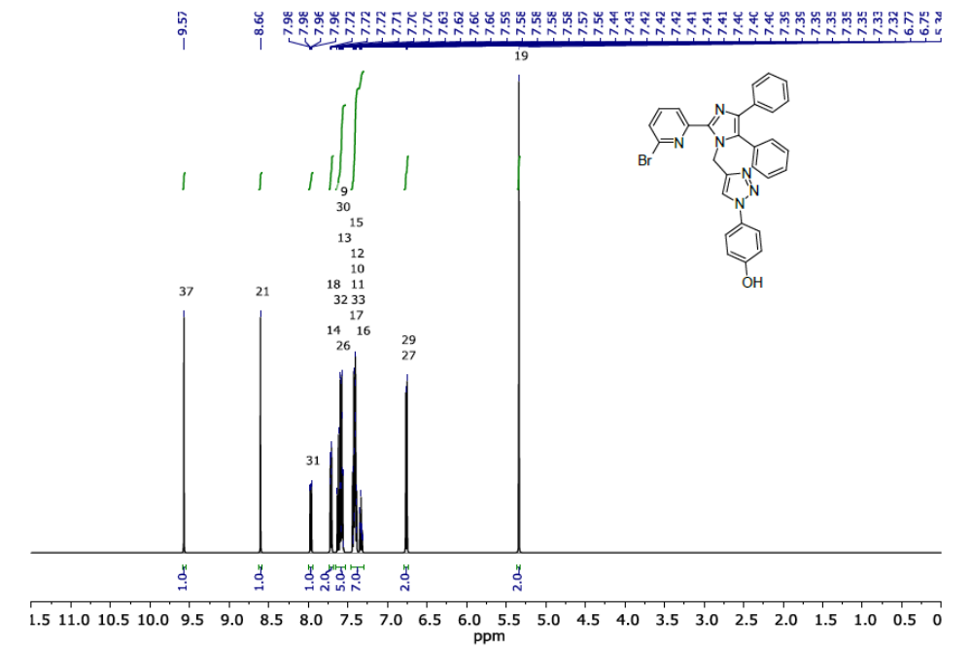
¹H NMR4-(4-((2-(6-bromopyridin-2-yl)-4,5-diphenyl-1H-imidazol-1-yl)methyl)-1H-1,2,3-triazol-1-yl)phenol (7e)
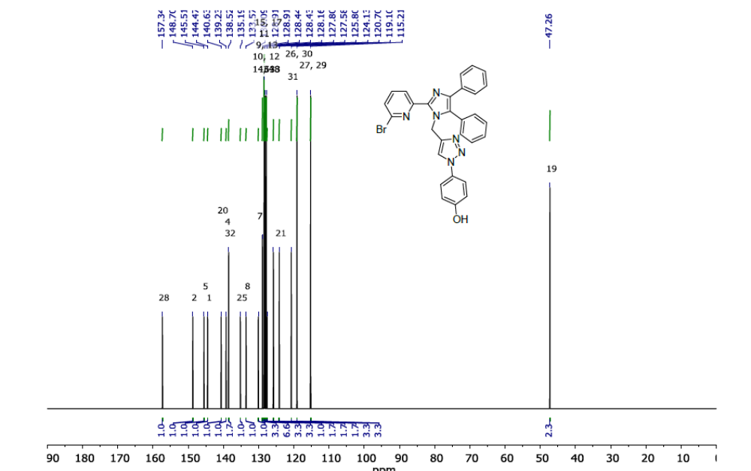
¹³C NMR4-(4-((2-(6-bromopyridin-2-yl)-4,5-diphenyl-1H-imidazol-1-yl)methyl)-1H-1,2,3-triazol-1-yl)phenol (7e)

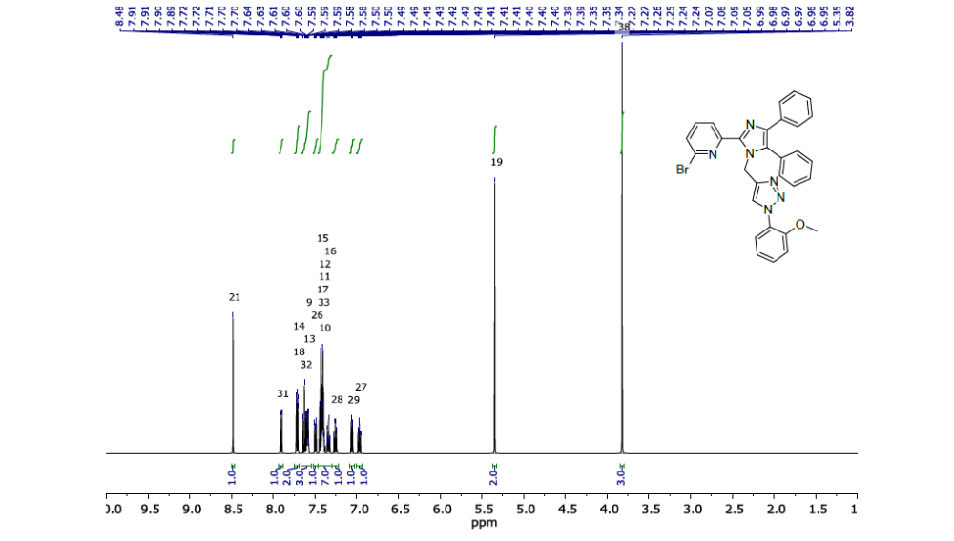
¹H NMR 2-bromo-6-(1-((1-(2-methoxyphenyl)-1H-1,2,3-triazol-4-yl)methyl)-4,5-diphenyl-1H-imidazol-2-yl)pyridine (7f)
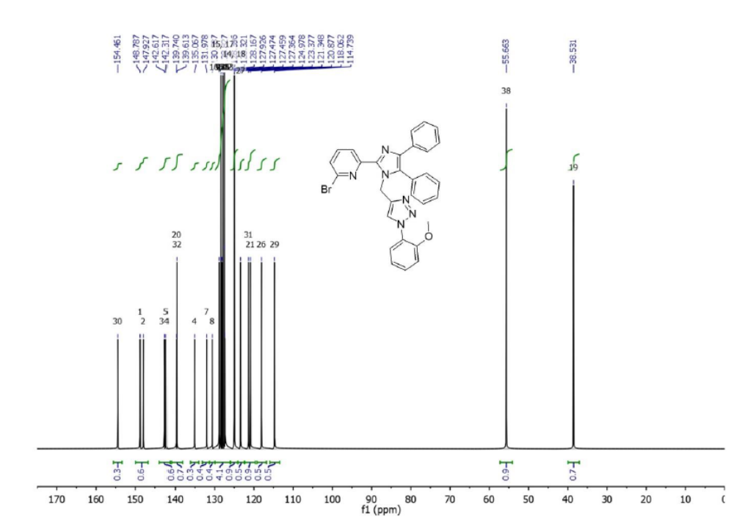
¹³CNMR2-bromo-6-(1-((1-(2-methoxyphenyl)-1H-1,2,3-triazol-4-yl)methyl)-4,5-diphenyl-1H-imidazol-2-yl)pyridine (7f)

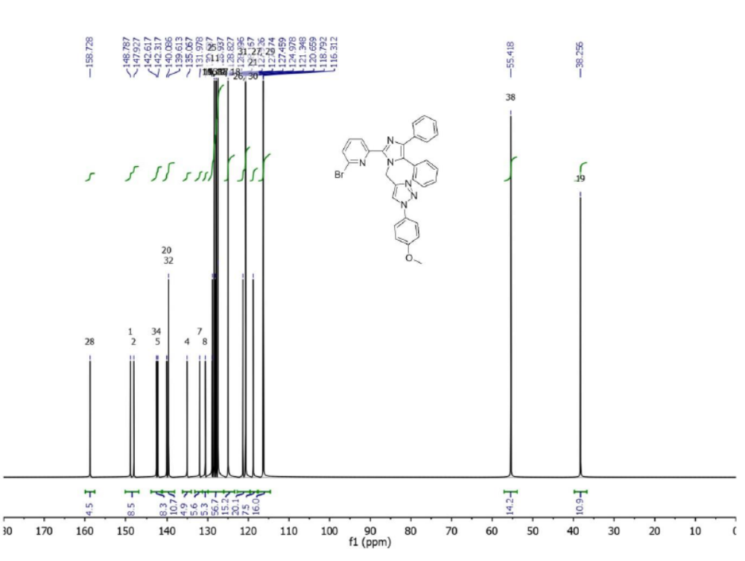
¹C NMR 2-bromo-6-(1-((1-(4-methoxyphenyl)-1H-1,2,3-triazol-4-yl)methyl)-4,5-diphenyl-1H-imidazol-2-yl)pyridine (7g)

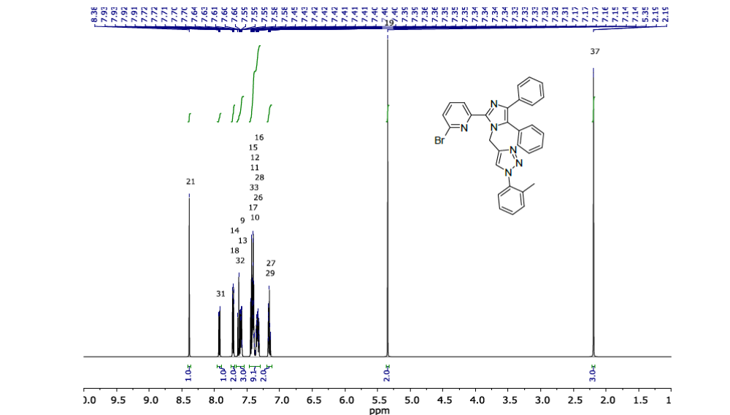
¹H NMR 2-bromo-6-(4,5-diphenyl-1-((1-(o-tolyl)-1H-1,2,3-triazol-4-yl)methyl)-1H-imidazol-2-yl)pyridine (7h)

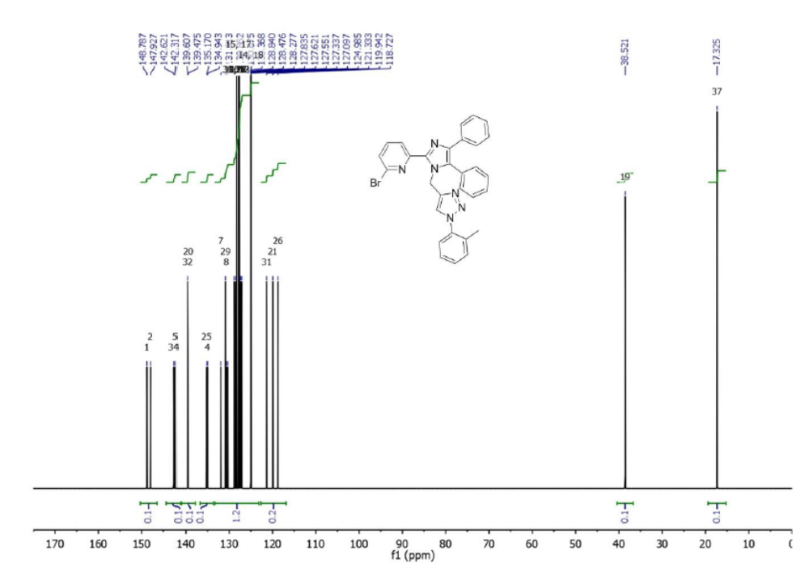
¹³CNMR2-bromo-6-(4,5-diphenyl-1-((1-(o-tolyl)-1H-1,2,3-triazol-4-yl)methyl)-1H-imidazol-2-yl)pyridine (7h)

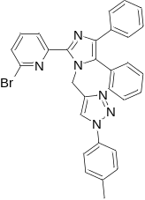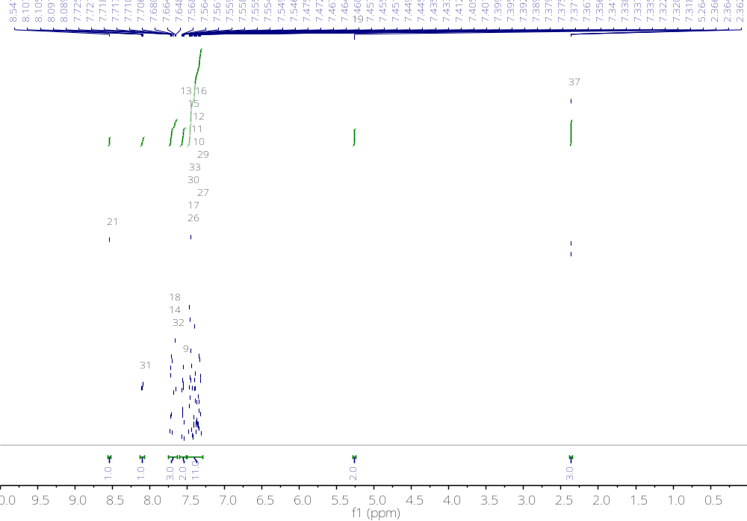
¹H NMR2-bromo-6-(4,5-diphenyl-1-((1-(p-tolyl)-1H-1,2,3-triazol-4-yl)methyl)-1H-imidazol-2-yl)pyridine (7i)
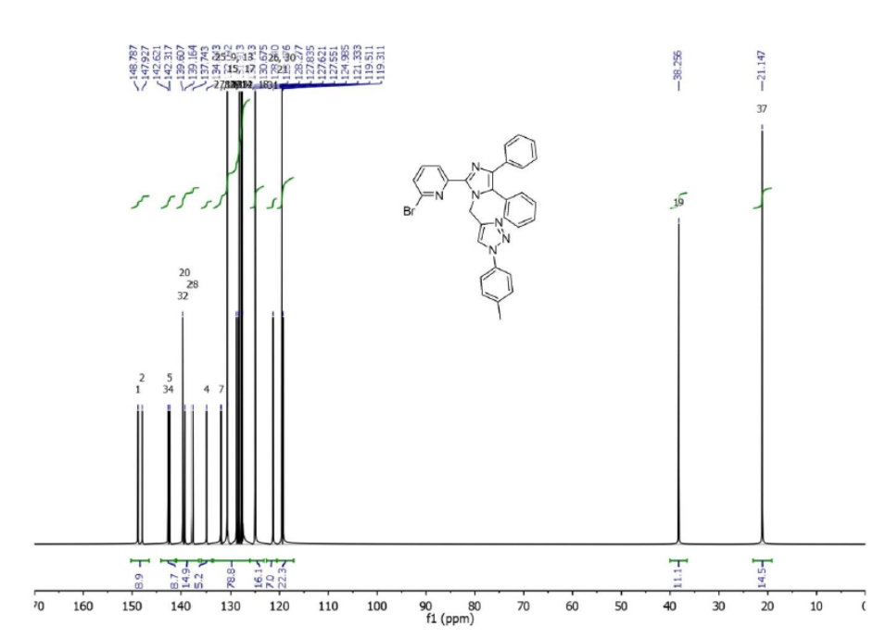
¹³C NMR2-bromo-6-(4,5-diphenyl-1-((1-(p-tolyl)-1H-1,2,3-triazol-4-yl)methyl)-1H-imidazol-2-yl)pyridine (7i)

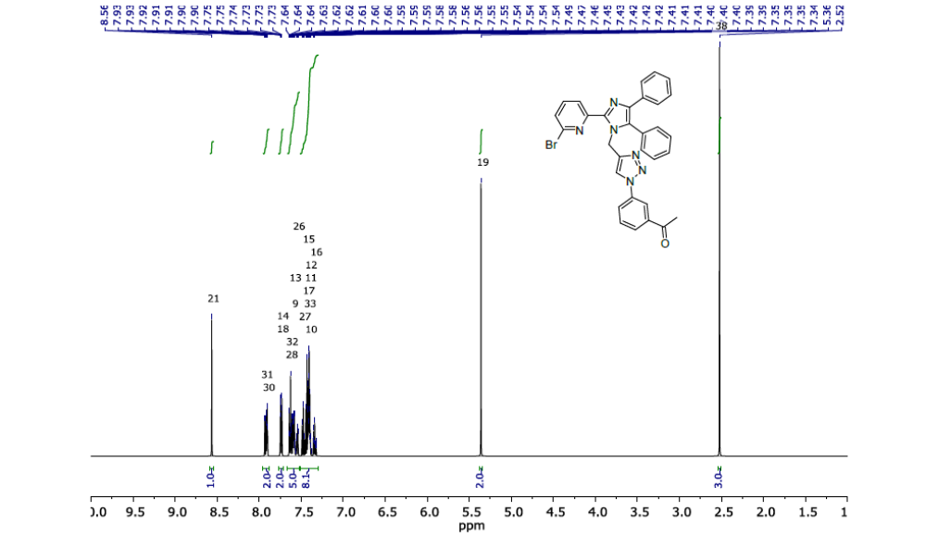
¹H NMR1-(3-(4-((2-(6-bromopyridin-2-yl)-4,5-diphenyl-1H-imidazol-1-yl)methyl)-1H-1,2,3-triazol-1-yl)phenyl)ethan-1-one (7j)

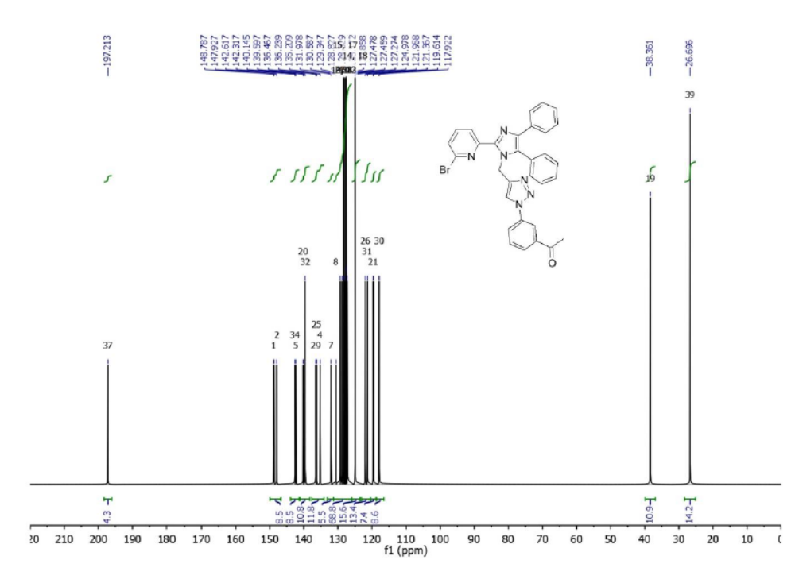

¹³CNMR1-(3-(4-((2-(6-bromopyridin-2-yl)-4,5-diphenyl-1H-imidazol-1-yl)methyl)-1H-1,2,3-triazol-1-yl)phenyl)ethan-1-one (7j)
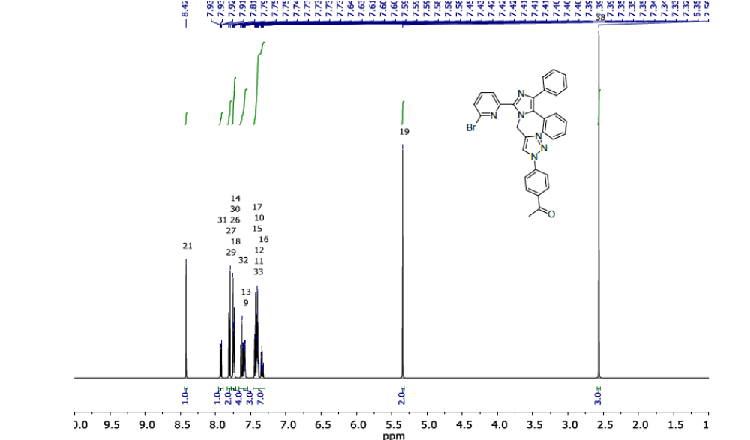
¹H NMR1-(4-(4-((2-(6-bromopyridin-2-yl)-4,5-diphenyl-1H-imidazol-1-yl)methyl)-1H-1,2,3-triazol-1-yl)phenyl)ethan-1-one (7k)
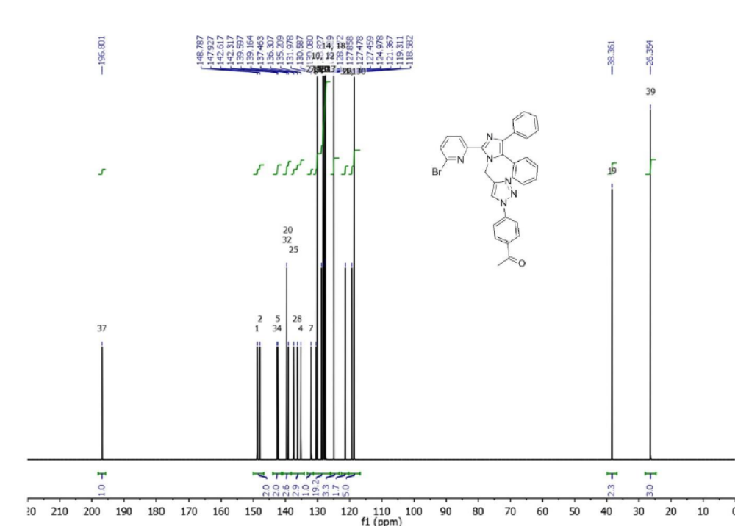

¹³C NMR1-(4-(4-((2-(6-bromopyridin-2-yl)-4,5-diphenyl-1H-imidazol-1-yl)methyl)-1H-1,2,3-triazol-1-yl)phenyl)ethan-1-one (7k)

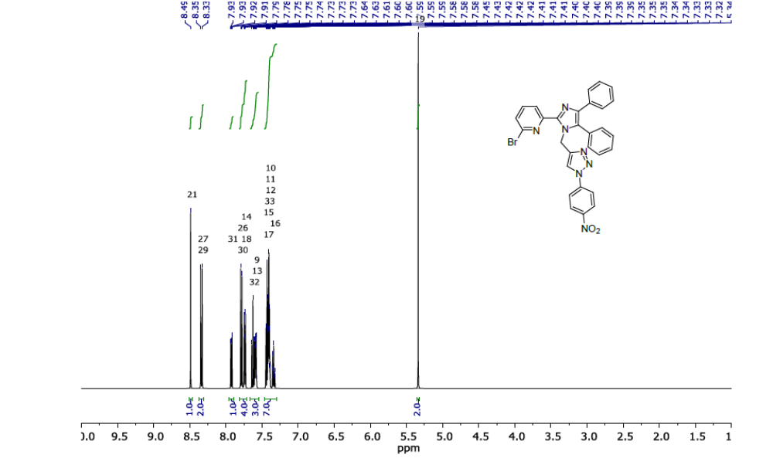
¹H NMR2-bromo-6-(1-((1-(4-nitrophenyl)-1H-1,2,3-triazol-4-yl)methyl)-4,5-diphenyl-1H-imidazol-2-yl)pyridine(7l)

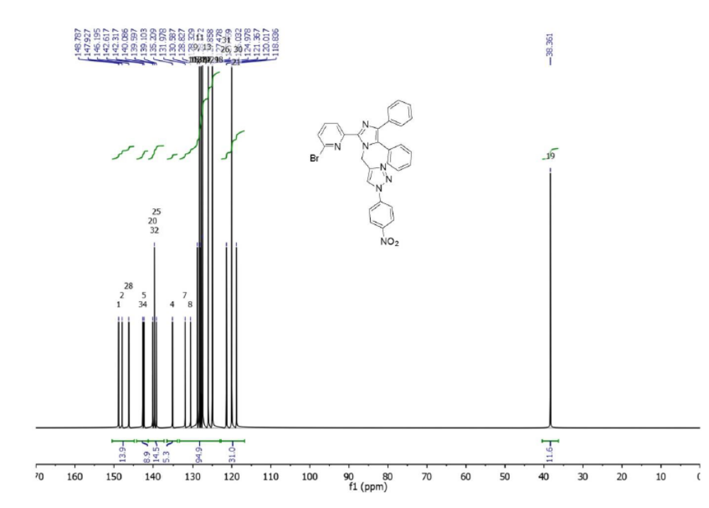
¹³CNMR 2-bromo-6-(1-((1-(4-nitrophenyl)-1H-1,2,3-triazol-4-yl)methyl)-4,5-diphenyl-1H-imidazol-2-yl)pyridine(7l)

