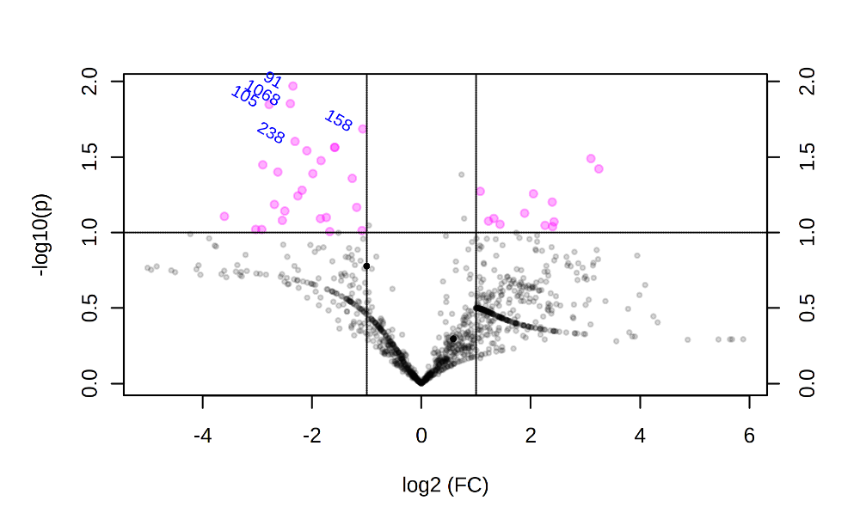
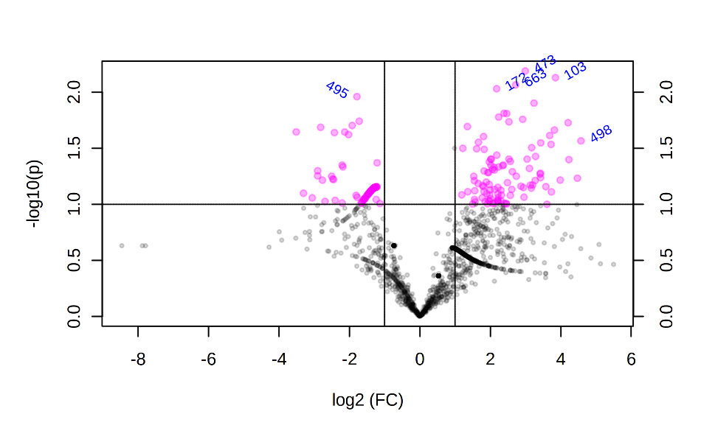
(a)
(b)

Figure 1S: Volcano plot showing the OTUs that differ significantly between groups of study: (a) GNF and GNM (a) and (b) GPF and GPM. The pink points indicate variables-of-interest that display both large-magnitude fold-changes (x-axis) as well as high statistical significance (−log10 of p-value Wilcoxon test, y-axis). The horizontal line shows the p-value cut-off (p-value = 0.10) with points above the line having p-value < 0.10 and points below the line having p-value > 0.1. The vertical lines shows 2-fold changes.

