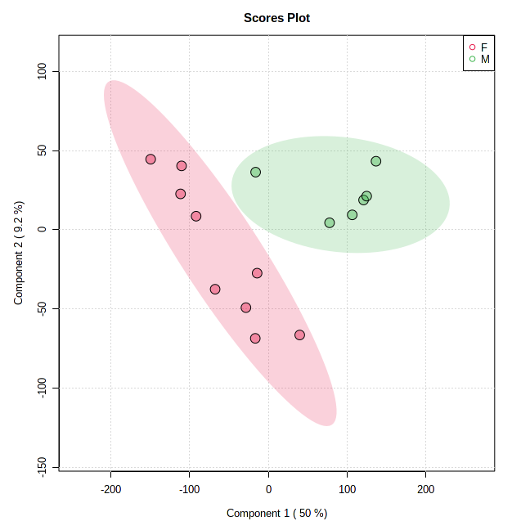
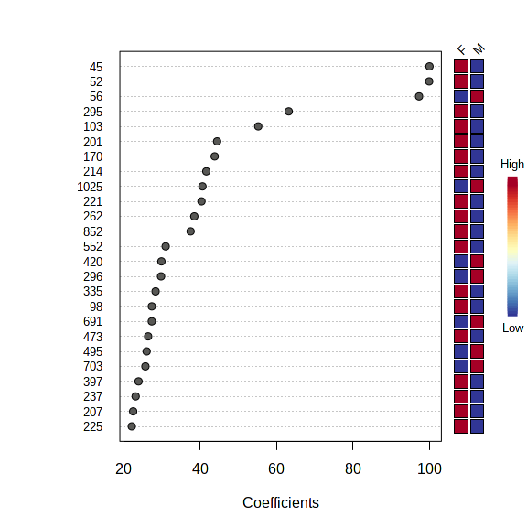
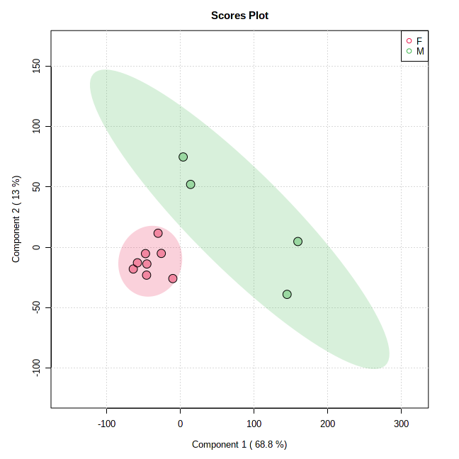
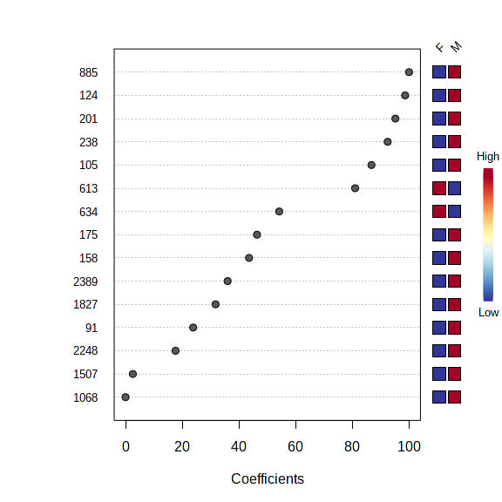
(a)
(b)

Figure 2S: Partial least squares discriminant analysis (PLS-DA) results showing the comparison between OTU data acquired for (a) GNM vs GNF, (b) GPM vs. GPF. On the left, the 2-D PLS-DA scores plots; on the right, the variable importance in projection plots. The most discriminating OTUs are shown in descending order of their coefficient scores. The colour boxes indicate whether OTU is increased (red) or decreased (blue) in Female (F) vs. male (M).

