Supplementary Results
Effect of Wheel of Fortune outcomes on happiness ratings
In the lab-based study (Study 1), there was a significant main effect of WoF outcome on happiness (F(2,64) = 9.388, p < .001) and a significant WoF outcome by assessment time point interaction (i.e. the time point in which participants rated their momentarily happiness, F(2,64) = 33.467, p < .001). Importantly, there was no main effect of training order (e.g. whether participants experienced the win or the loss outcome on the WoF draw, F(5,32) = .964, p = .455) on any of the happiness ratings. As predicted, participants’ self-reported happiness ratings were significantly lower after losing the WoF draw (t = 5.59, p < .001, pairwise comparison of pre-WoF and post-WoF on loss day), whereas they were significantly higher on a WoF win day (t = -8.53, p < .001, pre-WoF vs. post-WoF, win day; Figure 2). These effects on happiness were maintained to the end of the final learning block on the loss day (t = 2.1, p < .05, comparing happiness pre-WoF to happiness at the end of the experiment on the loss day) but not the win day (t = -1.75, p = .088, comparing happiness pre-WoF to happiness at the end of the experiment on the win day), indicating that both winning and losing on the WoF induced significant changes in current happiness but that the effects of losing on the WoF had a longer-lasting impact on happiness than winning. The mood ratings assessed at the end of each day were significantly different between the conditions (F(2,134)=3.45, p=0.035). Pairwise comparisons indicated that happiness ratings were significantly lower at the end of the loss day relative to the win day (t(88)=2.7231, p=.008). Comparisons against the blank WoF were not significant (t(88)=1.5027, p=.137).
In the online study (Study 2), we mostly replicated these effects in a complementary rmANOVA model which suggested a significant main effect of WoF on happiness ratings (F(1, 67)= 5.431, p = .023), with a significant main effect of WoF outcome valence (i.e. win or a loss, F(1, 67)= 96.120, p<.001) and a significant valence by WoF interaction term (F(1, 67)= 133.155, p<.001). Again, there was no main effect of training order on the happiness ratings (F(1, 67)= 2.661, p = .108). Although participants mood ratings recovered from their lowest point which was immediately after a loss on the WoF, these still remained significantly lower on the loss day relative to the win day, even at the end of the experiment (t(136) = 3.675, p<.001, Figure 2B).

Discrete affective events influence human reinforcement learning.
In Study 1, we were only able to partially investigate whether the valence of discrete affective events (i.e. winning, losing or a blank outcome on the WoF) influence human reinforcement learning. A rmANOVA did not reveal any significant main effect of WoF outcome on the probability of choosing the better shape (i.e. the shape associated with higher reward probability) post-WoF. This is illustrated in Supplementary Figure 1A, where we show that valence of the WoF outcome does not influence learning in the post-WoF blocks. Moreover, the interaction term (WoF outcome by reward probability) was not significant and there was no main effect of WoF outcome order (all p > .136). However, in this study (Study 1) we were only able to compare learning behaviour in the post-WoF blocks which were identical in terms of their reward probabilities, but we were not able to understand how learning behaviour might have changed from the pre-WoF baseline, as the reward probability in the pre-WoF block was different (i.e. 70%) and the same baseline block was repeated across all 3 learning days in an effort to reduce the number of shapes that participants need to learn. We addressed this question by improving on the experimental design in Study 2 in which participants completed an identical number of blocks pre-and post-WoF with identical reward probabilities (Figure 1A). We have committed to use the design of the Study 2 (this time also including pupillometry which was not possible for the current manuscript due to COVID19 restrictions at the time of data collection (April 2020)) in our ongoing work which aims to investigate the cognitive effects of ketamine as the Study 2 had a well-balanced design (clinicaltrials.gov identifier: NCT04850911). Due to lack of a significant main effect of WoF on learning behaviour in the blocks subsequent to it, we did not further analyse the data from Study 1 with computational models.
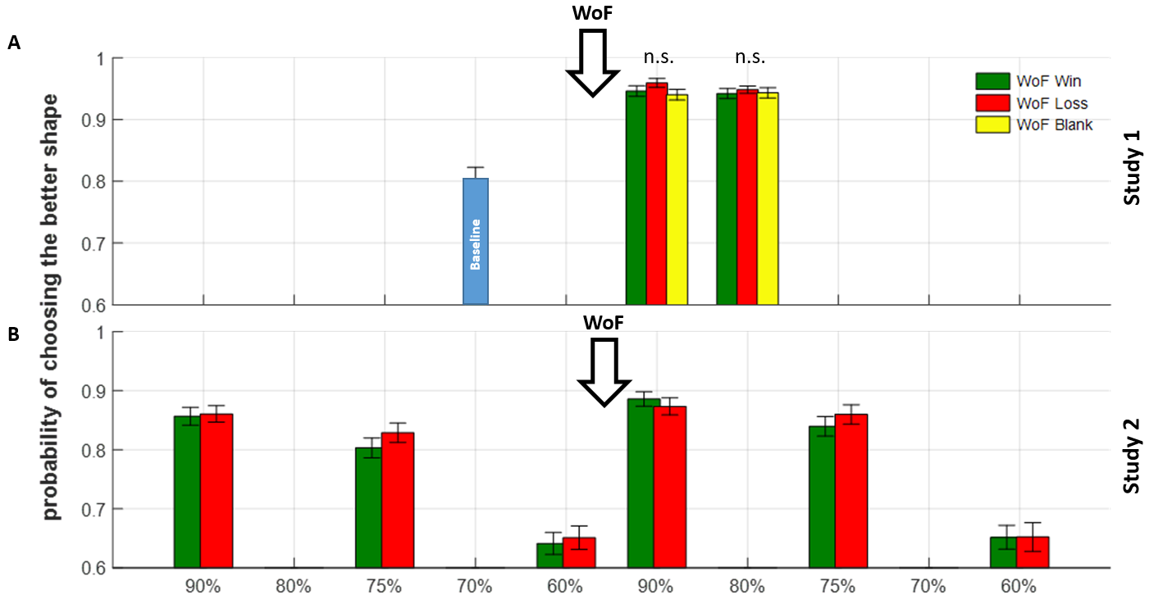
Supplementary Figure 1. Summaries of probability of choosing the higher probability shape (A) In Study 1, there were no significant differences in participant learning behaviour after the WoF, irrespective of the valence of WoF outcome. The single blue bar at 70% before the WoF shows the baseline condition. (B) In Study 2, we were able to compare pre-and-post-WoF learning behaviour. A repeated measures ANOVA model indicated a significant main effect of WoF influencing participant choice behaviour, reflecting an increased probability of choosing the shape associated with a high probability of reward post-WoF, irrespective of valence of the WoF outcome. Downward arrow with WoF indicates the point in which participants experienced the WoF draw within the course of their daily learning sessions. Note that, Study 2 only had win and loss outcomes in the WoF. In both panels, error bars reflect ±1 SEM. Probabilities on x-axis reflect reward probabilities from Figure 1A. Bar face colours: blue (baseline condition, only Study 1), yellow (neutral, only Study 1), green (win, both studies), red (loss, both studies).

In Study 2, a rmANOVA (2 valence x 3 probability levels x 2 phases (i.e. pre versus post WoF RL blocks), also including the win/loss training order as a between-subjects factor) revealed, consistent with Study 1, that there was no significant main effect of valence (F(1,65) = 2.439, p = .123, Supplementary Figure 1B), suggesting that the outcome of the WoF did not affect subsequent learning. There was, however, a significant main effect of phase (F(1,65) = 17.423, p<.001), reflecting an increased probability of participants selecting the shape associated with a high probability of reward post-WoF. There were no significant interactions and no main effect of WoF order (F(1,65) = 1.374, p = .245). In order to understand how discrete affective events influence human reinforcement learning, we further analysed participant choice behaviour in the online study using computational modelling.

Model-based analysis of WoF effects on reinforcement learning.
We modelled participant choice behaviour by fitting 4 different computational models (see Modelling Supplement for details). A well-established model selection method based on computing Bayesian Information Criterion values indicated that participants learned from rewarded and unrewarded outcomes (i.e. negative and positive prediction errors) with separate learning rates and made decisions between the shapes stochastically based on the expected value difference between the higher and lower probability shapes (i.e. Model 1, Supplementary Figure 2).
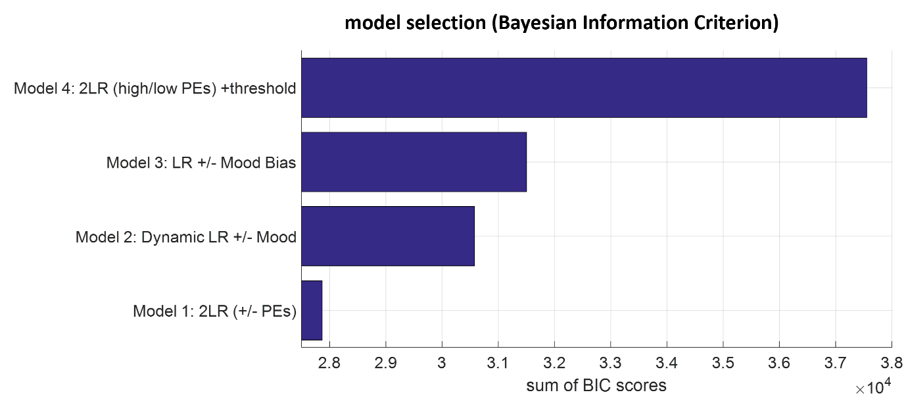

Supplementary Figure 2. Model selection based on group-wise sum of BIC scores comparing reinforcement learning models in the online study in which a model-free behavioural analysis based on participants’ frequency of choosing the better probability shape (in Figure 3B) suggested a significant main effect of WoF on human reinforcement learning. The best fitting model (Model 1) suggest that participants update their reward probability estimates by 2 distinct learning rates for negative and positive prediction errors.

Fitting the same 2x3x2 rmANOVA model to positive learning rates (i.e. learning rate updating positive PEs) indicated a marginally significant main effect of WoF (F(1,65) = 3.904, p = .052), reflecting higher positive learning rates in the post-WoF blocks but no main effect of valence (F(1,65) = .117, p = .733, Supplementary Figure 3A). There were no significant interactions between these factors and no main effect of WoF order (F(1,65) = .094, p = .760). Analysing the negative learning rates in the same manner indicated a significant main effect of WoF (F(1,65) = 4.328, p = .041). There was also a significant main effect of outcome reward probability (F(1,65) =16.277 p<.001) and a marginally significant main effect of valence (F(1,65) = 3.068, p = . 085, Supplementary Figure 3B). Although there was no 3-way interaction, and no main effect of WoF order (F(1,65) = .422, p = .518), there was a significant interaction between outcome reward probability and valence (F(2,130)= 4.066, p = .019). Losing in the WoF reduced learning rates from negative prediction errors in blocks associated with higher expected uncertainty (i.e. reward probabilities 75% and 60%). Finally, repeating the same analysis for the inverse temperature term which governs choice stochasticity during RL indicated a significant main effect of WoF (F(1,65) = 7.503, p = .008) and a significant main effect of outcome reward probability (F(2, 130) = 75.499, p<.001), with no main effect of valence (F(1,65) = 2.162, p = .146, Supplementary Figure 3C). There were no significant interaction terms between these main effects and no main effect of WoF order (F(1,65) = 2.286, p = .135). Overall, inverse temperature estimates were higher in the post-WoF suggesting that participants were less stochastic in their choice behaviour. One might argue that this finding may be an artefact of practice effects, i.e. participants performing the task better in the post-WoF blocks. However, in Study 2 where participants completed 3 blocks of RL before the WoF, this kind of higher order learning about the structure of the task should have happened before the WoF (e.g. at least by the beginning of 3rd block instead of specifically on the 4th block which is immediately after the WoF). Secondly, there may be limited reasons to suspect that after such higher-order learning, the behavioural performance should fall to a baseline the next day and to improve yet again in the post-WoF blocks). The results from a complementary model-free analysis based on participants’ choice switches is also reported below.
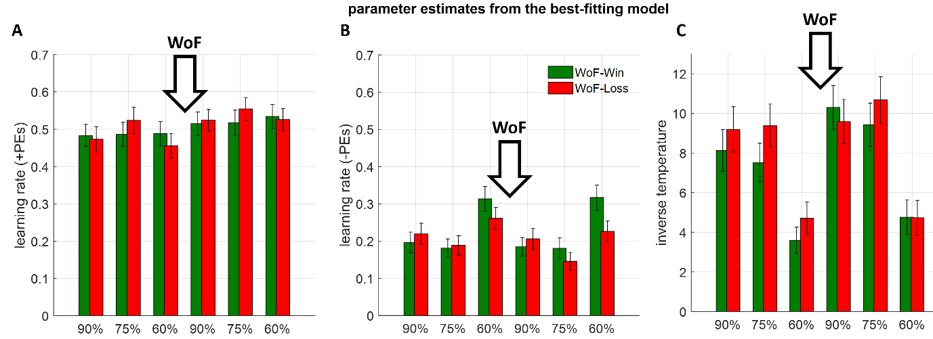
Supplementary Figure 3. Summaries of parameter estimates from the best-fitting computational model (A) Positive learning rates, by which participants update their beliefs about the reward probability following a reward outcome (B) Negative learning rates updating beliefs about the reward probability following a null/unrewarded outcome. (C) Inverse temperature term which governs choice stochasticity during reinforcement learning. Subsequent statistical analysis indicate that discrete affective events more strongly influence negative learning rates and choice stochasticity. Downward arrows with WoF indicate the point in which participants experienced the WoF draw within the course of their daily learning sessions. Therefore, across all panels, bars on the left side of the downward WoF arrows refer to pre-WoF blocks, whereas the bars on the right side of the arrows refer to the post-WoF blocks. Across all panels, error bars reflect ±1 SEM. Results from a complementary model-free analysis focusing on participants probability of choice switches are reported as shown in Supplementary Figure 5.’

Model-free control analysis of WoF effects on reinforcement learning
We conducted a model-free control analysis on the effects of WoF on human learning behaviour, focusing on participants’ probability of choice switch following a “win” or a “no-win” outcome across different probability levels and pre-and post-WoF. In this analysis, probability of switching choice after a win outcome would be similar to the positive learning rates, whereas probability of switching choice after a no-win outcome would be similar to negative learning rates. Here is worthwhile to highlight that, this model-free analysis approach cannot capture the choice stochasticity effects, which are captured by the best fitting RL model. Inherent choice stochasticity commonly observed in human behaviour can confound the model-free analysis of choice switches.
We analysed participant choice behaviour by fitting a comparable 2x3x2 rmANOVA model to choice switch probabilities following a win outcome, which indicated a significant main effect of WoF (F(1,65) = 6.018, p = .017) a significant main effect of valence (F(1,65) = 4.175, p = .045). There was no significant interaction between these factors (F(1,65) = 2.894, p = .094) and no main effect of WoF order (F(1,65) = .871, p = .354). There was a significant main effect of winning in the WoF on choice switch probabilities, which were consistently lower in the post-WoF blocks (F(1,65) = 7.488, p =.008, Supplementary Figure 4A).
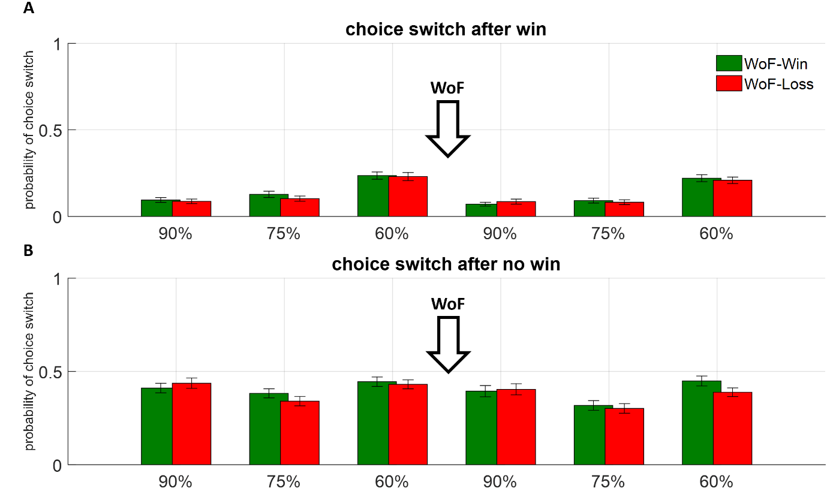

Supplementary Figure 4. Model-free analysis of participant learning behaviour (A) Probability of choice which following a win outcome. (B) Probability of choice which following a no-win outcome. Downward arrows with WoF indicate the point in which participants experienced the WoF draw within the course of their daily learning sessions. Across both panels, error bars reflect ±1 SEM.

Analysing the probability of choice switch after a no-win outcome in the same manner indicated a significant main effect of WoF (F(1,65) = 12.649, p <.001). There was also no significant main effect of valence (F(1,65) = 2.288, p = .135). There was no significant interaction between these factors (F(1,65) = .613, p = .436) and no main effect of WoF order (F(1,65) = .661, p = .419). In line with the model-based analysis indicating lower negative learning rates after losing in the WoF draw, there was a significant main effect of losing in the WoF on choice switch probabilities, which were consistently lower in the post-WoF blocks (F(1,65) = 10.756, p =.002, Supplementary Figure 4B).

Supplementary Discussion

One potential avenue which might improve our understanding of human memory formation and recall might be neuroimaging the habenular complex during RL and value-based decision-making between affective memories. A number of previous studies demonstrated that neurons in lateral habenula, an evolutionarily preserved subcortical structure located in the epithalamus, work in tandem with midbrain dopaminergic neurons during RL, particularly specialised in encoding the magnitude of negative PEs¹⁻³. In the current work, we showed that when participants experience a large magnitude negative event prior to learning, they would be reluctant to update their beliefs when their reward expectations are violated in a novel learning environment (i.e. learning rates that update negative PEs, Supplementary Figure 3B). A recent rodent study demonstrated that injecting ketamine into the lateral habenula attenuates the burst activity of the neurons in this region, rapidly ameliorating depressive symptoms⁴ in an animal model. Our experimental work and corresponding computational modelling suggest that discrete negative events influence components of human reinforcement learning which are shown to be encoded by lateral habenula neurons that can be modulated by NMDA receptor antagonists like ketamine. Therefore, a reverse translation of our experimental approach (i.e. using an instrumental conditioning framework) in rodents and recording the activity of the lateral habenula neurons could address some of the outstanding questions related to ketamine’s rapid antidepressant action such as its effects on affective information processing, and potentially memory formation.

Supplementary Tables and Figures

Supplementary Table 1. Equal value comparisons in the lab-based study (Supplement to SFig5)
Day 1 |  |  | Day 2
Comparisons | t-statistic | p-value | t-statistic | p-value
Win 90% vs Loss 90% | 0.36 | .72 | .51 | .61
Win 10% vs Loss 10% | -.48 | .64 | -.31 | .76
Win 80% vs Loss 80% | .62 | .54 | .57 | .57
Win 20% vs Loss 20% | -2.95 | .005 | -5.45 | <.001*
Loss 90% vs Neutral 90% | 2.94 | .005 | 2.37 | .02
Loss 10% vs Neutral 10% | -2.57 | .01 | -2.34 | .02
Loss 80% vs Neutral 80% | .87 | .39 | 0.22 | .83
Loss 20% vs Neutral 20% | 1.80 | .08 | 2.49 | .017
Win 90% vs. Neutral 90% | 4.79 | < .001* | 4.19 | <.001*
Win 10% vs. Neutral 10% | -2.52 | .02 | -2.21 | .03
Win 80% vs. Neutral 80% | 1.65 | .11 | .98 | .34
Win 20% vs. Neutral 20% | -2.13 | .04 | -2.89 | .006
df = 43, t-test pairwise comparisons, *.0042 (set level for 12 multiple comparisons Bonferroni corrected). Win 90% versus Neutral 90% is the only pairwise comparison which would survive Bonferroni correction over 2 preference tests.

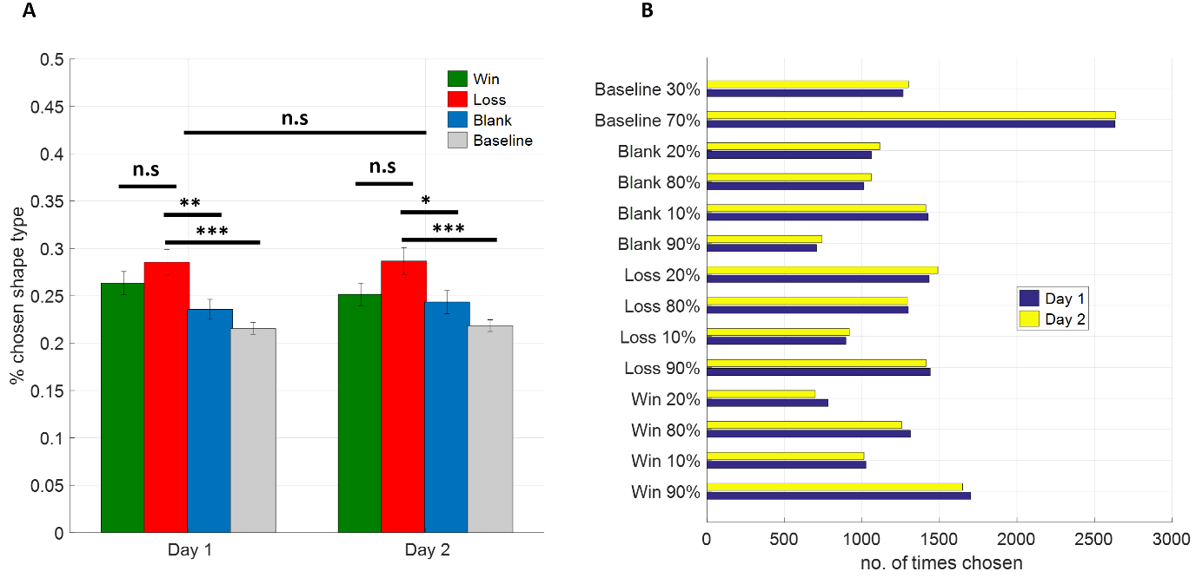
Supplementary Figure 5. Chosen shape types in the lab-based study. (A) Overall summary of chosen shapes between day 1 and day 2, sorted by WoF valence. Loss shapes were selected more frequently than other shapes, whereas there was no significant difference in participant choice behaviour between day 1 and day 2. Error bars denote ±1 SEM. (B) Detailed summary of how frequently individual shapes were chosen. The increase in preference for loss shapes reported in panel A appears to be driven by a stronger preference for Loss 20% shapes relative to Win 20% shapes. Note that the baseline block pre-WoF in Study 1 was repeated identically on all 3 learning/memory encoding days in an effort to reduce the total number of shapes to be learned. This might have contributed to overall preference for baseline shapes, particularly the better probability 70%. ***p<.001, **p<.01, *p<.05, n.s: not significant.

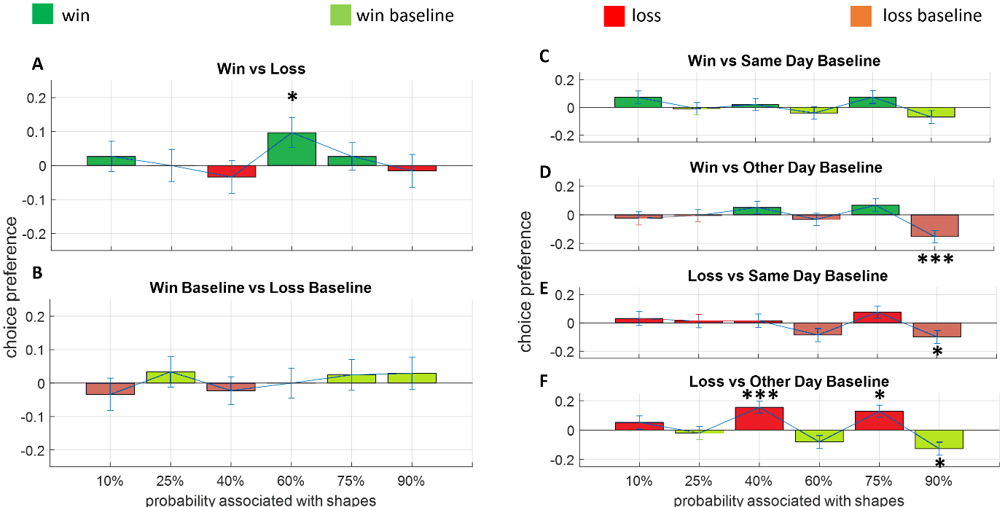
Supplementary Figure 6. Comparisons between equal value shapes. (A) Shapes learned after a win or a loss WoF draw. (B) Shapes learned prior to a win or a loss WoF draw. (C-F) Shapes learned before versus after a win or a loss WoF draw including same and other day baseline comparisons. Values across all panels are normalised, meaning that positive values on the y-axis indicate a preference for affective (i.e. post-WoF) shapes. Across all panels, error bars reflect ±1 SEM. ***p<.001, *p<.05, uncorrected. All reward probabilities are reordered in linearly increasing order. Bar graphic face colours follow the legend above top panels.

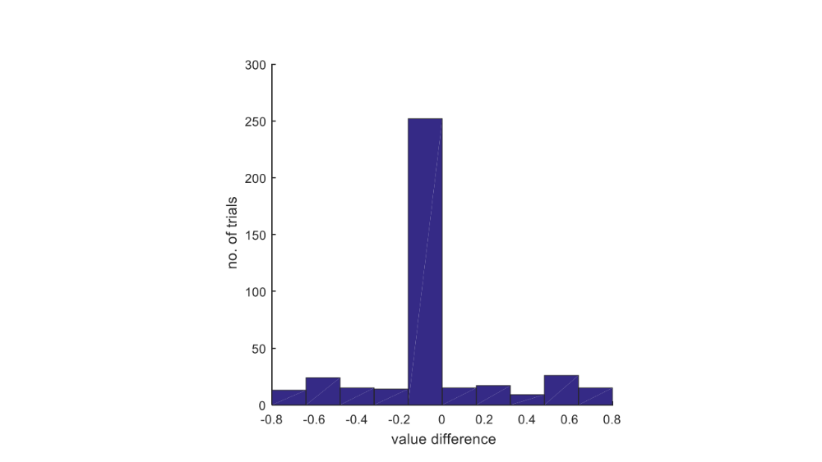

Supplementary Figure 7. Value difference between shape options presented in the preference test. Trials in the preference test were allocated to maximise the number of equal reward probability outcomes (i.e. where the value difference between presented shapes is zero).

Supplementary References

1 Matsumoto, M. & Hikosaka, O. Lateral habenula as a source of negative reward signals in dopamine neurons. Nature 447, 1111-1115 (2007).
2 Matsumoto, M. & Hikosaka, O. Representation of negative motivational value in the primate lateral habenula. Nature neuroscience 12, 77 (2009).
3 Bromberg-Martin, E. S., Matsumoto, M. & Hikosaka, O. Distinct tonic and phasic anticipatory activity in lateral habenula and dopamine neurons. Neuron 67, 144-155 (2010).
4 Yang, Y. et al. Ketamine blocks bursting in the lateral habenula to rapidly relieve depression. Nature 554, 317-322 (2018).

