Supplementary

Table S1. The proportion (95% CI) of patients’ characteristics at baseline, stratified by month of admission.
 | March | April | May | June | July | August | September | October
Total (No.) | 5743 | 37599 | 32483 | 25405 | 53128 | 70187 | 44007 | 2072
Sex (No.,%)
Women | 48.1  (46.8, 49.4) | 48.2  (47.7, 48.8) | 48.6  (48.1, 49.2) | 48.8  (48.2, 49.4) | 49.1  (48.7, 49.6) | 50.8  (50.4, 51.1) | 51.8  (51.3, 52.2) | 52.7  (50.5, 54.8)
Men | 51.9  (50.6, 53.2) | 51.8  (51.2, 52.3) | 51.4  (50.8, 51.9) | 51.2  (50.6, 51.8) | 50.9  (50.4, 51.3) | 49.2  (48.9, 49.6) | 48.2  (47.8, 48.7) | 47.3  (45.2, 49.5)
Age (No. %)
<40 | 25.9  (24.8, 27.1) | 25.5  (25.1, 26.0) | 25.2  (24.7, 25.7) | 27.6  (27.1, 28.2) | 29.9  (29.5, 30.3) | 31.4  (31.0, 31.7) | 32.4  (32.0, 32.9) | 33.2  (31.1, 35.2)
40-49 | 15.2  (14.3, 16.1) | 16.5  (16.1, 16.8) | 16.4  (16.0, 16.8) | 16.5  (16.1, 17.0) | 19.3  (19.0, 19.7) | 20.0  (19.7, 20.3) | 21.0  (20.6, 21.4) | 18.9  (17.3, 20.7)
50-59 | 17.2  (16.2, 18.2) | 19.1  (18.7, 19.5) | 18.5  (18.0, 18.9) | 18.4  (18.0, 18.9) | 20.3  (19.9, 20.6) | 21.0  (20.7, 21.3) | 18.1  (17.8, 18.5) | 16.4  (14.8, 18.0)
60-69 | 18.8  (17.8, 19.8) | 18.7  (18.3, 19.1) | 18.5  (18.0, 18.9) | 18.1  (17.7, 18.6) | 17.9  (17.5, 18.2) | 16.5  (16.3, 16.8) | 13.3  (13.0, 13.6) | 13.5  (12.1, 15.1)
70-79 | 13.5  (12.7, 14.5) | 12.2  (11.9, 12.5) | 12.9  (12.6, 13.3) | 11.7  (11.3, 12.1) | 7.9  (7.6, 8.1) | 7.0  (6.9, 7.2) | 8.9  (8.6, 9.1) | 10.9  (9.6, 12.3)
80-89 | 7.9  (7.2, 8.6) | 6.8  (6.6, 7.1) | 7.2  (7.0, 7.5) | 6.3  (6.0, 6.6) | 4.1  (3.9, 4.2) | 3.4  (3.3, 3.5) | 5.3  (5.1, 5.5) | 6.1  (5.2, 7.3)
>89 | 1.5  (1.2, 1.9) | 1.2  (1.1, 1.3) | 1.3  (1.2, 1.5) | 1.3  (1.2, 1.4) | 0.7  (0.6, 0.8) | 0.7  (0.6, 0.7) | 1.1  (1.0, 1.2) | 1.0  (0.6, 1.6)
Nationality (No.,%)
Iranian | 96.7  (96.2, 97.1) | 97.4  (97.2, 97.5) | 97.6  (97.4, 97.7) | 96.3  (96.0, 96.5) | 96.7  (96.5, 96.8) | 97.3  (97.1, 97.4) | 96.8  (96.6, 96.9) | 96.7  (95.8, 97.4)
Non-Iranian | 3.3  (2.9, 3.8) | 2.6  (2.5, 2.8) | 2.4  (2.3, 2.6) | 3.7  (3.5, 4.0) | 3.3  (3.2, 3.5) | 2.7  (2.6, 2.9) | 3.2  (3.1, 3.4) | 3.3  (2.6, 4.2)
Sign and Symptoms (No.%)
Vomit | 5.2  (4.6, 5.8) | 4.1  (3.9, 4.3) | 4.4  (4.2, 4.6) | 4.5  (4.3, 4.8) | 3.1  (2.9, 3.2) | 2.8  (2.6, 2.9) | 3.3  (3.2, 3.5) | 2.9  (2.3, 3.8)
Diarrhea | 4.6  (4.1, 5.2) | 3.9  (3.7, 4.1) | 3.7  (3.5, 3.9) | 4.0  (3.7, 4.2) | 2.6  (2.5, 2.8) | 2.3  (2.2, 2.4) | 2.3  (2.2, 2.5) | 1.6  (1.1, 2.3)
Anorexia | 10.2  (9.5, 11.1) | 9.5  (9.2, 9.8) | 9.6  (9.3, 9.9) | 9.7  (9.4, 10.1) | 9.0  (8.7, 9.2) | 10.2  (10.0, 10.4) | 9.5  (9.2, 9.8) | 9.3  (8.1, 10.7)
Paralysis | 0.2  (0.1, 0.3) | 0.1  (0.1, 0.1) | 0.1  (0.1, 0.2) | 0.1  (0.1, 0.2) | 0.1  (0.1, 0.1) | 0.1  (0.1, 0.1) | 0.1  (0.1, 0.1) | 0.0  (0.0, 0.2)
Fever | 38.2  (36.9, 39.5) | 36.0  (35.5, 36.5) | 35.2  (34.7, 35.7) | 39.0  (38.4, 39.6) | 40.1  (39.6, 40.5) | 39.7  (39.3, 40.1) | 38.9  (38.5, 39.4) | 34.5  (32.5, 36.6)
Seizure | 0.6  (0.4, 0.8) | 0.3  (0.2, 0.3) | 0.3  (0.3, 0.4) | 0.4  (0.3, 0.5) | 0.3  (0.2, 0.3) | 0.2  (0.2, 0.3) | 0.3  (0.2, 0.3) | 0.6  (0.3, 1.1)
Muscular pain | 37.4  (36.1, 38.7) | 36.2  (35.7, 36.7) | 35.8  (35.3, 36.3) | 34.6  (34.0, 35.2) | 37.8  (37.4, 38.2) | 39.1  (38.7, 39.4) | 40.2  (39.7, 40.6) | 39.0  (36.9, 41.2)
Chest pain | 3.4  (3.0, 4.0) | 3.8  (3.6, 4.0) | 3.1  (2.9, 3.3) | 2.8  (2.6, 3.0) | 2.2  (2.1, 2.3) | 2.4  (2.3, 2.5) | 2.5  (2.3, 2.6) | 2.0  (1.4, 2.7)
Abdominal pain | 2.5  (2.1, 2.9) | 3.1  (2.9, 3.3) | 2.5  (2.3, 2.7) | 2.5  (2.3, 2.7) | 2.2  (2.1, 2.3) | 2.4  (2.3, 2.5) | 2.1  (2.0, 2.2) | 1.4  (1.0, 2.1)
Dyspnea | 46.6  (45.3, 47.9) | 47.6  (47.1, 48.1) | 43.4  (42.8, 43.9) | 39.0  (38.4, 39.6) | 41.4  (41.0, 41.8) | 38.9  (38.6, 39.3) | 37.3  (36.8, 37.7) | 40.1  (38.0, 42.3)
Nausea | 8.4  (7.7, 9.1) | 7.0  (6.7, 7.3) | 6.6  (6.3, 6.9) | 7.2  (6.8, 7.5) | 6.5  (6.2, 6.7) | 7.1  (6.9, 7.3) | 6.8  (6.6, 7.1) | 6.6  (5.6, 7.8)
Headache | 9.0  (8.3, 9.8) | 10.2  (9.9, 10.5) | 10.7  (10.3, 11.0) | 9.7  (9.3, 10.1) | 11.0  (10.7, 11.2) | 11.2  (10.9, 11.4) | 11.4  (11.1, 11.7) | 9.9  (8.7, 11.3)
Cough | 52.2  (50.9, 53.5) | 54.2  (53.7, 54.7) | 54.7  (54.1, 55.2) | 53.5  (52.9, 54.1) | 58.9  (58.5, 59.4) | 63.3  (62.9, 63.6) | 62.0  (61.5, 62.4) | 57.8  (55.6, 59.9)
Vertigo | 3.2  (2.8, 3.7) | 3.6  (3.5, 3.8) | 3.6  (3.4, 3.8) | 3.2  (3.0, 3.4) | 3.1  (3.0, 3.3) | 3.2  (3.1, 3.4) | 3.2  (3.1, 3.4) | 3.9  (3.1, 4.9)
Skin lesion | 0.1  (0.0, 0.2) | 0.1  (0.1, 0.1) | 0.1  (0.1, 0.1) | 0.1  (0.1, 0.1) | 0.1  (0.1, 0.1) | 0.1  (0.1, 0.1) | 0.1  (0.1, 0.1) | 0.1  (0.0, 0.5)
loss of taste | 1.6  (1.3, 2.0) | 1.3  (1.2, 1.4) | 1.3  (1.1, 1.4) | 1.7  (1.5, 1.9) | 1.8  (1.7, 2.0) | 2.2  (2.1, 2.3) | 2.0  (1.9, 2.2) | 1.2  (0.8, 1.7)
Anosmia | 2.1  (1.7, 2.5) | 2.0  (1.9, 2.2) | 3.2  (3.0, 3.3) | 3.1  (2.9, 3.3) | 3.3  (3.1, 3.5) | 3.1  (3.0, 3.2) | 3.8  (3.6, 4.0) | 1.9  (1.4, 2.6)
Comorbidities (No.%)
Heart disease | 10.8  (10.0, 11.7) | 8.7  (8.5, 9.0) | 9.5  (9.2, 9.8) | 9.3  (8.9, 9.6) | 5.7  (5.5, 5.9) | 5.1  (5.0, 5.3) | 5.6  (5.3, 5.8) | 6.3  (5.3, 7.5)
HIV | 0.1  (0.0, 0.2) | 0.0  (0.0, 0.1) | 0.0  (0.0, 0.1) | 0.0  (0.0, 0.1) | 0.0  (0.0, 0.1) | 0.0  (0.0, 0.0) | 0.0  (0.0, 0.0) | 0.0  (0.0, 0.2)
Asthma | 1.0  (0.8, 1.3) | 1.0  (0.9, 1.1) | 0.9  (0.8, 1.1) | 0.9  (0.8, 1.0) | 0.6  (0.6, 0.7) | 0.5  (0.4, 0.5) | 0.5  (0.5, 0.6) | 0.4  (0.2, 0.9)
Neurological disease | 0.9  (0.7, 1.2) | 0.6  (0.5, 0.7) | 0.6  (0.6, 0.7) | 0.6  (0.5, 0.7) | 0.4  (0.3, 0.4) | 0.3  (0.3, 0.4) | 0.4  (0.4, 0.5) | 0.6  (0.3, 1.1)
Hypertension | 13.5  (12.6, 14.4) | 12.2  (11.9, 12.6) | 13.0  (12.6, 13.4) | 12.1  (11.7, 12.5) | 8.3  (8.1, 8.6) | 7.6  (7.4, 7.8) | 7.7  (7.5, 8.0) | 9.7  (8.5, 11.1)
Hematologic diseases | 0.5  (0.3, 0.7) | 0.3  (0.2, 0.3) | 0.3  (0.3, 0.4) | 0.4  (0.3, 0.5) | 0.3  (0.2, 0.3) | 0.3  (0.2, 0.3) | 0.3  (0.3, 0.4) | 0.5  (0.2, 0.9)
Liver disease | 0.5  (0.3, 0.7) | 0.3  (0.3, 0.4) | 0.4  (0.3, 0.5) | 0.4  (0.4, 0.5) | 0.3  (0.2, 0.3) | 0.2  (0.2, 0.3) | 0.3  (0.2, 0.3) | 0.1  (0.0, 0.5)
Kidney disease | 1.6  (1.3, 2.0) | 1.1  (1.0, 1.2) | 1.2  (1.1, 1.4) | 1.3  (1.1, 1.4) | 0.8  (0.7, 0.9) | 0.7  (0.6, 0.8) | 0.7  (0.6, 0.8) | 1.5  (1.0, 2.1)
Diabetes | 11.6  (10.8, 12.5) | 10.2  (9.9, 10.5) | 10.5  (10.2, 10.9) | 10.0  (9.6, 10.3) | 7.3  (7.1, 7.5) | 6.6  (6.4, 6.8) | 7.0  (6.7, 7.2) | 7.3  (6.2, 8.5)
Other chronic diseases | 5.5  (4.9, 6.1) | 4.2  (4.0, 4.4) | 5.0  (4.8, 5.3) | 5.0  (4.7, 5.3) | 3.4  (3.2, 3.5) | 3.0  (2.8, 3.1) | 3.5  (3.3, 3.6) | 4.2  (3.4, 5.2)
Cancer | 1.2  (1.0, 1.5) | 1.1  (1.0, 1.2) | 1.3  (1.2, 1.4) | 1.2  (1.1, 1.4) | 0.7  (0.6, 0.8) | 0.6  (0.5, 0.6) | 0.8  (0.7, 0.9) | 0.9  (0.5, 1.4)
Immunodeficiency | 0.3  (0.2, 0.5) | 0.2  (0.2, 0.2) | 0.3  (0.2, 0.3) | 0.2  (0.1, 0.2) | 0.1  (0.1, 0.2) | 0.1  (0.1, 0.2) | 0.2  (0.2, 0.3) | 0.3  (0.1, 0.7)
No. of comorbidities (No.%)
0 | 69.0  (67.7, 70.1) | 73.2  (72.7, 73.6) | 71.7  (71.2, 72.2) | 73.0  (72.4, 73.5) | 81.1  (80.7, 81.4) | 83.0  (82.7, 83.3) | 82.0  (81.7, 82.4) | 79.0  (77.1, 80.7)
1 | 18.5  (17.5, 19.5) | 16.6  (16.2, 17.0) | 17.1  (16.7, 17.5) | 16.2  (15.8, 16.7) | 12.0  (11.8, 12.3) | 10.8  (10.6, 11.0) | 11.0  (10.7, 11.3) | 13.0  (11.6, 14.6)
2 | 9.2  (8.5, 10.0) | 7.6  (7.4, 7.9) | 8.1  (7.8, 8.4) | 7.8  (7.5, 8.2) | 5.2  (5.0, 5.4) | 4.6  (4.4, 4.7) | 5.2  (5.0, 5.5) | 5.6  (4.6, 6.6)
3 | 2.8  (2.4, 3.3) | 2.2  (2.1, 2.4) | 2.7  (2.5, 2.9) | 2.6  (2.4, 2.8) | 1.4  (1.3, 1.5) | 1.4  (1.3, 1.5) | 1.4  (1.3, 1.6) | 2.1  (1.6, 2.9)
≥4 | 0.6  (0.4, 0.8) | 0.3  (0.3, 0.4) | 0.5  (0.4, 0.5) | 0.4  (0.3, 0.5) | 0.3  (0.2, 0.3) | 0.2  (0.2, 0.3) | 0.3  (0.2, 0.3) | 0.3  (0.1, 0.7)
Pregnancy (No.%)
No | 99.1  (98.8, 99.3) | 99.3  (99.2, 99.4) | 99.4  (99.3, 99.5) | 99.4  (99.3, 99.5) | 99.5  (99.4, 99.5) | 99.5  (99.5, 99.6) | 99.4  (99.4, 99.5) | 99.5  (99.1, 99.8)
Yes | 0.9  (0.7, 1.2) | 0.7  (0.6, 0.8) | 0.6  (0.5, 0.7) | 0.6  (0.5, 0.7) | 0.5  (0.5, 0.6) | 0.5  (0.4, 0.5) | 0.6  (0.5, 0.6) | 0.5  (0.2, 0.9)
Smoking (No.%)
No | 98.2  (97.8, 98.5) | 98.7  (98.5, 98.8) | 98.7  (98.5, 98.8) | 98.4  (98.3, 98.6) | 98.8  (98.7, 98.9) | 99.1  (99.0, 99.1) | 99.0  (98.9, 99.1) | 99.0  (98.5, 99.4)
Yes | 1.8  (1.5, 2.2) | 1.3  (1.2, 1.5) | 1.3  (1.2, 1.5) | 1.6  (1.4, 1.7) | 1.2  (1.1, 1.3) | 0.9  (0.9, 1.0) | 1.0  (0.9, 1.1) | 1.0  (0.6, 1.5)
Drug abuse (No.%)
No | 99.1  (98.8, 99.3) | 99.4  (99.4, 99.5) | 99.4  (99.3, 99.5) | 99.2  (99.1, 99.3) | 99.6  (99.5, 99.7) | 99.7  (99.6, 99.7) | 99.6  (99.5, 99.6) | 99.6  (99.1, 99.8)
Yes | 0.9  (0.7, 1.2) | 0.6  (0.5, 0.6) | 0.6  (0.5, 0.7) | 0.8  (0.7, 0.9) | 0.4  (0.3, 0.5) | 0.3  (0.3, 0.4) | 0.4  (0.4, 0.5) | 0.4  (0.2, 0.9)
CT Scan (No.%)
Negative | 28.5  (27.4, 29.7) | 26.0  (25.5, 26.4) | 26.1  (25.6, 26.6) | 30.1  (29.5, 30.7) | 24.9  (24.5, 25.3) | 23.3  (23.0, 23.6) | 23.0  (22.6, 23.4) | 26.0  (24.1, 27.9)
Positive | 71.5  (70.3, 72.6) | 74.0  (73.6, 74.5) | 73.9  (73.4, 74.4) | 69.9  (69.3, 70.5) | 75.1  (74.7, 75.5) | 76.7  (76.4, 77.0) | 77.0  (76.6, 77.4) | 74.0  (72.1, 75.9)
Ward
Non-ICU treated | 78.0  (76.9, 79.1) | 85.4  (85.0, 85.7) | 86.3  (85.9, 86.6) | 84.9  (84.5, 85.3) | 88.6  (88.3, 88.8) | 91.4  (91.2, 91.6) | 89.5  (89.2, 89.8) | 89.1  (87.7, 90.4)
ICU treated | 22.0  (20.9, 23.1) | 14.6  (14.3, 15.0) | 13.7  (13.4, 14.1) | 15.1  (14.7, 15.5) | 11.4  (11.2, 11.7) | 8.6  (8.4, 8.8) | 10.5  (10.2, 10.8) | 10.9  (9.6, 12.3)
Death status
Survived | 90.1  (89.3, 90.8) | 90.4  (90.1, 90.7) | 92.5  (92.2, 92.8) | 94.0  (93.7, 94.3) | 92.7  (92.5, 92.9) | 93.6  (93.4, 93.8) | 95.2  (95.0, 95.4) | 99.3  (98.8, 99.6)
Deceased | 9.9  (9.2, 10.7) | 9.6  (9.3, 9.9) | 7.5  (7.2, 7.8) | 6.0  (5.7, 6.3) | 7.3  (7.1, 7.5) | 6.4  (6.2, 6.6) | 4.8  (4.6, 5.0) | 0.7  (0.4, 1.2)

Table S2. The proportion (95% CI) of death status in different characteristics of patients stratified by Ward
 | Non-ICU treated |  | EF (p-value) | ICU treated |  | EF (p-value)
 | Survived | Deceased | EF (p-value) | Survived | Deceased | EF (p-value)
Total (No. %) | 96.8  (96.7, 96.8) | 3.2  (3.2, 3.3) |  | 66.0  (65.5, 66.5) | 34.0  (33.5, 34.5)
Sex (No,%) |  |  | 0.02 (<0.001) |  |  | 0.03 (<0.001)
Women | 50.5  (50.3, 50.7) | 44.0  (42.8, 45.1) |  | 46.9  (46.2, 47.6) | 43.7  (42.8, 44.7)
Men | 49.5  (49.3, 49.7) | 56.0  (54.9, 57.2) |  | 53.1  (52.4, 53.8) | 56.3  (55.3, 57.2)
Age |  |  | 0.21 (<0.001) |  |  | 0.23 (<0.001)
<40 | 31.9  (31.7, 32.1) | 7.0  (6.4, 7.6) |  | 20.4  (19.9, 20.9) | 6.6  (6.2, 7.1)
40-49 | 20.0  (19.8, 20.1) | 7.2  (6.6, 7.8) |  | 13.7  (13.3, 14.2) | 8.9  (8.4, 9.5)
50-59 | 19.9  (19.8, 20.1) | 15.1  (14.3, 15.9) |  | 17.7  (17.2, 18.2) | 15.7  (15.0, 16.4)
60-69 | 16.0  (15.8, 16.1) | 24.6  (23.6, 25.6) |  | 21.1  (20.6, 21.7) | 25.2  (24.4, 26.0)
70-79 | 8.0  (7.9, 8.1) | 21.6  (20.6, 22.5) |  | 15.4  (14.9, 15.9) | 21.9  (21.1, 22.7)
80-89 | 3.7  (3.6, 3.8) | 19.6  (18.7, 20.5) |  | 9.7  (9.3, 10.1) | 17.2  (16.5, 18.0)
>89 | 0.6  (0.6, 0.6) | 5.0  (4.5, 5.5) |  | 2.0  (1.8, 2.2) | 4.5  (4.1, 4.9)
Nationality (No.,%) |  |  | -0.1 (<0.001) |  |  | 0.00 (0.651)
Iranian | 97.1  (97.0, 97.2) | 96.0  (95.5, 96.4) |  | 96.7  (96.4, 96.9) | 96.6  (96.2, 96.9)
Non-Iranian | 2.9  (2.8, 3.0) | 4.0  (3.6, 4.5) |  | 3.3  (3.1, 3.6) | 3.4  (3.1, 3.8)
Sign and Symptoms (No.%)
Vomit | 3.6  (3.5, 3.6) | 2.1  (1.8, 2.4) | 0.01 (<0.001) | 3.6  (3.4, 3.9) | 3.4  (3.1, 3.8) | 0.00 (0.390)
Diarrhea | 3.1  (3.0, 3.2) | 1.6  (1.3, 1.9) | 0.02 (<0.001) | 2.4  (2.2, 2.7) | 2.1  (1.9, 2.4) | 0.01 (0.082)
Anorexia | 9.6  (9.5, 9.7) | 7.5  (6.9, 8.1) | 0.01 (<0.001) | 9.2  (8.8, 9.6) | 11.9  (11.3, 12.6) | 0.04 (<0.001)
Paralysis | 0.1  (0.1, 0.1) | 0.2  (0.1, 0.3) | 0.01 (0.001) | 0.2  (0.2, 0.3) | 0.3  (0.2, 0.5) | 0.01 (0.077)
Fever | 39.3  (39.1, 39.5) | 35.1  (34.0, 36.1) | 0.02 (<0.001) | 33.3  (32.7, 33.9) | 33.8  (32.9, 34.7) | 0.00 (0.376)
Seizure | 0.3  (0.2, 0.3) | 0.1  (0.0, 0.2) | 0.01 (0.006) | 0.5  (0.4, 0.6) | 0.2  (0.2, 0.3) | 0.02 (<0.001)
Muscular pain | 38.6  (38.4, 38.8) | 32.0  (31.0, 33.1) | 0.02 (<0.001) | 32.3  (31.6, 32.9) | 34.2  (33.3, 35.1) | 0.02 (<0.001)
Chest pain | 2.3  (2.2, 2.4) | 2.1  (1.8, 2.5) | 0.00 (0.263) | 6.6  (6.2, 6.9) | 4.0  (3.7, 4.4) | 0.05 (<0.001)
Abdominal pain | 2.5  (2.4, 2.6) | 1.8  (1.5, 2.1) | 0.01 (<0.001) | 2.0  (1.8, 2.2) | 2.1  (1.9, 2.4) | 0.00 (0.470)
Dyspnea | 37.9  (37.7, 38.1) | 62.4  (61.3, 63.5) | 0.09 (<0.001) | 54.1  (53.4, 54.8) | 68.5  (67.6, 69.4) | 0.14 (<0.001)
Nausea | 7.1  (6.9, 7.2) | 3.8  (3.4, 4.3) | 0.02 (<0.001) | 6.3  (5.9, 6.6) | 6.6  (6.2, 7.1) | 0.01 (0.230)
Headache | 11.3  (11.2, 11.4) | 5.8  (5.3, 6.3) | 0.03 (<0.001) | 7.8  (7.4, 8.1) | 8.5  (8.0, 9.1) | 0.01 (0.019)
Cough | 60.4  (60.2, 60.6) | 47.3  (46.2, 48.4) | 0.05 (<0.001) | 47.9  (47.3, 48.6) | 51.5  (50.5, 52.4) | 0.03 (<0.001)
Vertigo | 3.3  (3.2, 3.4) | 2.1  (1.8, 2.4) | 0.01 (<0.001) | 3.7  (3.5, 4.0) | 3.8  (3.5, 4.2) | 0.00 (0.648)
Skin lesion | 0.1  (0.1, 0.1) | 0.1  (0.0, 0.2) | 0.00 (0.969) | 0.1  (0.1, 0.2) | 0.1  (0.1, 0.2) | 0.00 (0.788)
loss of taste | 1.8  (1.8, 1.9) | 0.5  (0.4, 0.7) | 0.02 (<0.001) | 2.0  (1.8, 2.2) | 1.5  (1.3, 1.8) | 0.02 (0.005)
Anosmia | 3.2  (3.1, 3.3) | 1.8  (1.5, 2.1) | 0.01 (<0.001) | 2.6  (2.4, 2.8) | 2.8  (2.5, 3.2) | 0.01 (0.196)
Comorbidities (No.%)
Heart disease | 5.3  (5.3, 5.4) | 14.0  (13.2, 14.8) | 0.07 (<0.001) | 15.2  (14.7, 15.7) | 17.4  (16.7, 18.1) | 0.03 (<0.001)
HIV | 0.0  (0.0, 0.0) | 0.1  (0.0, 0.2) | 0.00 (0.047) | 0.1  (0.0, 0.1) | 0.1  (0.1, 0.2) | 0.01 (0.221)
Asthma | 0.6  (0.6, 0.7) | 0.8  (0.7, 1.1) | 0.00 (0.030) | 1.1  (0.9, 1.2) | 1.0  (0.9, 1.3) | 0.00 (0.858)
Neurological disease | 0.4  (0.4, 0.4) | 0.8  (0.6, 1.0) | 0.01 (<0.001) | 0.9  (0.8, 1.0) | 1.3  (1.1, 1.5) | 0.02 (<0.001)
Hypertension | 8.1  (8.0, 8.2) | 15.3  (14.5, 16.1) | 0.05 (<0.001) | 18.1  (17.6, 18.6) | 22.0  (21.2, 22.8) | 0.05 (<0.001)
Hematologic diseases | 0.3  (0.3, 0.3) | 0.5  (0.3, 0.7) | 0.01 (<0.001) | 0.5  (0.4, 0.6) | 0.5  (0.4, 0.7) | 0.00 (0.900)
Liver disease | 0.3  (0.2, 0.3) | 0.7  (0.5, 0.9) | 0.01 (<0.001) | 0.5  (0.4, 0.6) | 0.6  (0.5, 0.8) | 0.01 (0.033)
Kidney disease | 0.7  (0.7, 0.7) | 2.3  (2.0, 2.7) | 0.03 (<0.001) | 1.6  (1.4, 1.8) | 3.4  (3.1, 3.8) | 0.06 (<0.001)
Diabetes | 7.0  (6.8, 7.1) | 15.4  (14.6, 16.2) | 0.06 (<0.001) | 14.3  (13.8, 14.8) | 17.7  (17.0, 18.5) | 0.05 (<0.001)
Other chronic diseases | 3.6  (3.5, 3.7) | 3.7  (3.3, 4.2) | 0.00 (0.675) | 4.6  (4.3, 4.9) | 5.9  (5.5, 6.4) | 0.03 (<0.001)
Cancer | 0.7  (0.6, 0.7) | 2.1  (1.8, 2.5) | 0.03 (<0.001) | 1.6  (1.5, 1.8) | 2.7  (2.4, 3.1) | 0.04 (<0.001)
Immunodeficiency | 0.2  (0.1, 0.2) | 0.2  (0.1, 0.3) | 0.00 (0.448) | 0.3  (0.2, 0.4) | 0.3  (0.2, 0.5) | 0.00 (0.575)
No. of comorbidities (No.%) |  |  | 0.08 (<0.001) |  |  | 0.07 (<0.001)
0 | 81.4  (81.2, 81.5) | 65.9  (64.8, 67.0) |  | 62.9  (62.2, 63.5) | 56.5  (55.6, 57.4)
1 | 12.0  (11.9, 12.2) | 17.8  (17.0, 18.7) |  | 21.0  (20.5, 21.6) | 22.3  (21.5, 23.1)
2 | 5.0  (4.9, 5.1) | 11.7  (11.0, 12.5) |  | 11.4  (11.0, 11.9) | 14.5  (13.9, 15.2)
3 | 1.4  (1.3, 1.4) | 3.7  (3.3, 4.2) |  | 4.0  (3.8, 4.3) | 5.3  (4.9, 5.8)
≥4 | 0.2  (0.2, 0.2) | 0.8  (0.6, 1.1) |  | 0.6  (0.5, 0.8) | 1.4  (1.2, 1.6)
Pregnancy (No.%) |  |  | 0.01 (<0.001) |  |  | 0.04 (<0.001)
No | 99.4  (99.4, 99.4) | 99.9  (99.8, 100.0) |  | 99.4  (99.3, 99.5) | 99.9  (99.8, 100.0)
Yes | 0.6  (0.6, 0.6) | 0.1  (0.0, 0.2) |  | 0.6  (0.5, 0.7) | 0.1  (0.0, 0.2)
Smoking (No.%) |  |  | 0.00 (0.459) |  |  | 0.04 (<0.001)
No | 99.0  (99.0, 99.1) | 99.1  (98.9, 99.3) |  | 96.9  (96.6, 97.1) | 98.2  (97.9, 98.4)
Yes | 1.0  (0.9, 1.0) | 0.9  (0.7, 1.1) |  | 3.1  (2.9, 3.4) | 1.8  (1.6, 2.1)
Drug abuse (No.%) |  |  | 0.01 (<0.001) |  |  | 0.02 (<0.001)
No | 99.7  (99.7, 99.7) | 99.3  (99.1, 99.5) |  | 98.3  (98.1, 98.4) | 98.8  (98.6, 99.0)
Yes | 0.3  (0.3, 0.3) | 0.7  (0.5, 0.9) |  | 1.7  (1.6, 1.9) | 1.2  (1.0, 1.4)
CT Scan (No.%) |  |  | 0.02 (<0.001) |  |  | 0.11 (<0.001)
Negative | 25.2  (25.0, 25.4) | 20.8  (19.9, 21.7) |  | 28.3  (27.7, 28.9) | 18.2  (17.5, 18.9)
Positive | 74.8  (74.6, 75.0) | 79.2  (78.3, 80.1) |  | 71.7  (71.1, 72.3) | 81.8  (81.1, 82.5)
Hospitalization days. median (IQR) | 4 (2, 6) | 4 (2, 9) | 0.13 (<0.001) | 6 (4, 9) | 7 (3,12) | 0.21 (<0.001)

Table S3. The hazard ratio of death due to COVID-19 among hospitalized patients. The Cox proportional model was adjusted for month of admission, sex, age, no. of comorbidities and nationality.
Variable | Levels | N | No. of events | HR (95% CI) | P-value
Month | March (Ref) | 5724 | 569 | 1.00
 | April | 33547 | 3595 | 1.15 (1.05 ,1.25) | 0.003
 | May | 26850 | 2443 | 0.96 (0.88 ,1.05) | 0.385
 | June | 20277 | 1522 | 0.87 (0.79 ,0.96) | 0.005
 | July | 37028 | 3866 | 1.28 (1.17 ,1.40) | <0.001
 | August | 39140 | 4486 | 1.40 (1.28 ,1.52) | <0.001
 | September | 22756 | 2127 | 1.37 (1.25 ,1.50) | <0.001
 | October | 294 | 15 | 4.63 (2.77 ,7.74) | <0.001
Sex | Female (Ref) | 90985 | 8163 | 1.00
 | Male | 94631 | 10460 | 1.17 (1.14 ,1.21) | <0.001
Age | <40 (Ref) | 50632 | 1265 | 1.00
 | 40-49 | 30432 | 1527 | 1.52 (1.41 ,1.63) | <0.001
 | 50-59 | 34435 | 2875 | 2.09 (1.95 ,2.23) | <0.001
 | 60-69 | 34239 | 4643 | 3.10 (2.91 ,3.30) | <0.001
 | 70-79 | 21149 | 4049 | 4.35 (4.08 ,4.64) | <0.001
 | 80-89 | 12313 | 3392 | 6.54 (6.13 ,6.99) | <0.001
 | >89 | 2416 | 872 | 9.61 (8.81 ,10.49) | <0.001
No. of comorbidities | 0 (Ref) | 135034 | 11248 | 1.00
 | 1 | 30567 | 3804 | 1.15 (1.11 ,1.19) | <0.001
 | 2 | 14673 | 2488 | 1.22 (1.17 ,1.27) | <0.001
 | 3 | 4533 | 867 | 1.30 (1.21 ,1.39) | <0.001
 | >=4 | 809 | 216 | 1.59 (1.39 ,1.82) | <0.001
Nationality | Iranian (Ref) | 179403 | 17938 | 1.00
 | Non-Iranian | 6213 | 685 | 1.68 (1.55 ,1.81) | <0.001
Abbreviation: hazard ratio (HR), confidence interval (CI).

Table S4. The unadjusted death proportion (95% confidence interval) due to COVID-19 among hospitalized patients per month.
Group | March | April | May | June | July | August | September | October
Total | 9.9  (9.2, 10.7) | 9.6  (9.3, 9.9) | 7.5  (7.2, 7.8) | 6.0  (5.7, 6.3) | 7.3  (7.1, 7.5) | 6.4  (6.2, 6.6) | 4.8  (4.6, 5.0) | 0.7  (0.4, 1.2)
Non-ICU treated | 4.0  (3.5, 4.6) | 4.9  (4.7, 5.1) | 3.1  (2.9, 3.4) | 2.1  (1.9, 2.3) | 3.6  (3.4, 3.8) | 3.2  (3.1, 3.4) | 2.2  (2.1, 2.4) | 0.2  (0.1, 0.6)
ICU treated | 30.8  (28.3, 33.4) | 36.8  (35.5, 38.1) | 35.0  (33.6, 36.4) | 28.0  (26.6, 29.5) | 35.9  (34.7, 37.1) | 39.8  (38.6, 41.1) | 26.8  (25.6, 28.1) | 4.9  (2.6, 8.8)

Table S5. The mean and median survival time with 95% confidence interval by months
Month | Mean survival time (95 % CI) | Median survival time (95% CI) | P-value*
March | 25.13 (23.48, 26.79) | 23.00 (20.76, 25.25) | <0.001
April | 25.97 (25.13, 26.82) | 22.00 (21.02, 22.98) | <0.001
May | 25.50 (24.48, 26.51) | 23.00 (21.84, 24.16) | <0.001
June | 28.24 (26.50, 29.98) | 24.00 (22.44, 25.56) | <0.001
July | 26.72 (25.65, 27.79) | 23.00 (22.11, 23.89) | <0.001
August | 25.52 (24.51, 26.54) | 22.00 (21.27, 22.74) | <0.001
September | 18.25 (17.76, 18.73) | 19.00 (18.37, 19.63) | <0.001
October | 1.95 (1.93, 1.98) | --- | <0.001
Overall | 25.98 (25.47, 26.49) | 22.00 (21.61, 22.39)
* The log-rank test

Figure S1. The Kaplan-Meier survival curve for both peaks occurred in April and August.

Table S6. The hazard ratio (95% CI) of death due to COVID-19 among hospitalized patients by wards.
Group | Month levels | N | No. of events | HR (95% CI) | P-value
Total Patients
 | March (Ref) | 5724 | 569 | 1.00 | ----
 | April | 33547 | 3595 | 1.15 (1.05, 1.25) | 0.003
 | May | 26850 | 2443 | 0.96 (0.88, 1.05) | 0.385
 | June | 20277 | 1522 | 0.87 (0.79, 0.96) | 0.005
 | July | 37028 | 3866 | 1.28 (1.17, 1.40) | <0.001
 | August | 39140 | 4486 | 1.40 (1.28, 1.52) | <0.001
 | September | 22756 | 2127 | 1.37 (1.25, 1.50) | <0.001
 | October | 294 | 15 | 4.63 (2.77, 7.74) | <0.001
Non-ICU treated
 | March (Ref) | 4471 | 180 | 1.00 | ----
 | April | 28090 | 1569 | 1.38 (1.18, 1.61) | <0.001
 | May | 22418 | 881 | 0.95 (0.81, 1.12) | 0.572
 | June | 16492 | 447 | 0.74 (0.62, 0.88) | 0.001
 | July | 30991 | 1689 | 1.55 (1.32, 1.80) | <0.001
 | August | 33131 | 2075 | 1.72 (1.47, 2.00) | <0.001
 | September | 19030 | 884 | 1.45 (1.23, 1.70) | <0.001
 | October | 269 | 4 | 2.24 (0.83, 6.04) | 0.111
ICU-treated
 | March (Ref) | 1253 | 389 | 1.00 | ----
 | April | 5457 | 2026 | 1.18 (1.06, 1.31) | 0.003
 | May | 4432 | 1562 | 1.14 (1.02, 1.27) | 0.024
 | June | 3785 | 1075 | 1.03 (0.92, 1.16) | 0.577
 | July | 6037 | 2177 | 1.28 (1.15, 1.43) | <0.001
 | August | 6009 | 2411 | 1.44 (1.29, 1.60) | <0.001
 | September | 3726 | 1243 | 1.57 (1.40, 1.76) | <0.001
 | October | 25 | 11 | 15.51 (8.50, 28.31) | <0.001
Note: All models were adjusted using variables including sex, age, no. of comorbidities, and nationality. Abbreviation: hazard ratio (HR), confidence interval (CI).

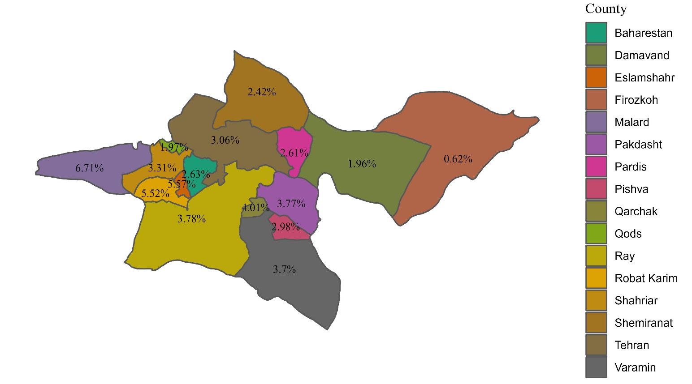

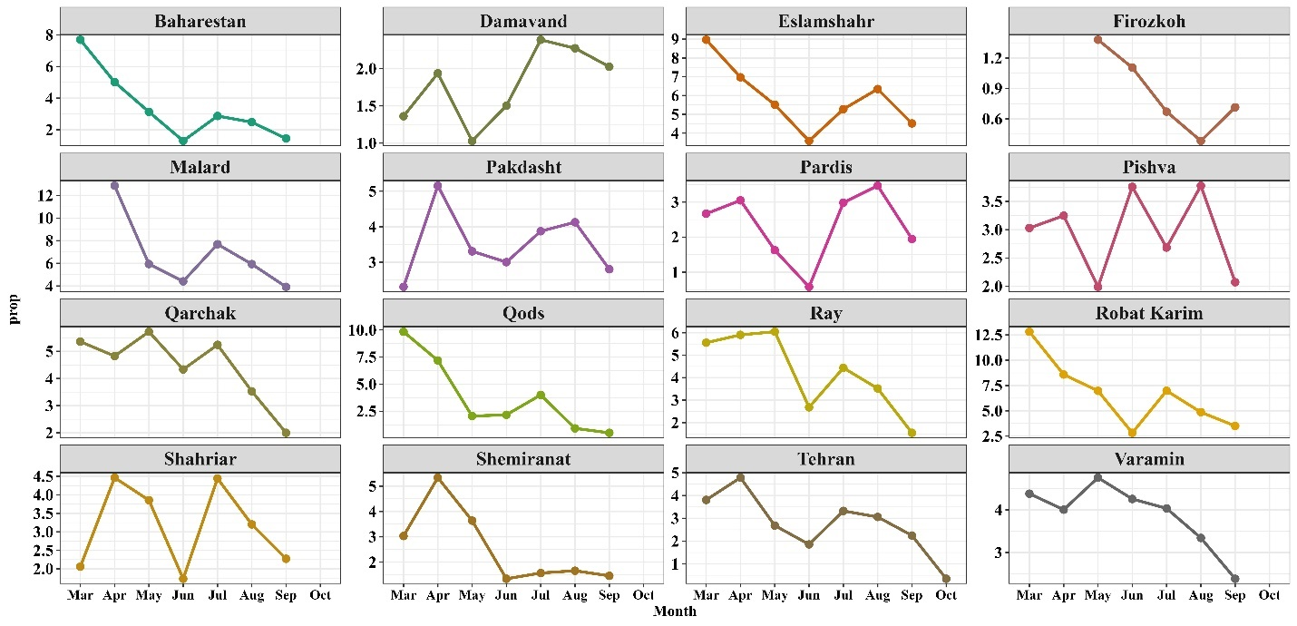
Figure S2. The overall death proportion (%) due to COVID-19 in non-ICU wards by counties of Tehran province (upper panel). The monthly death proportion due to COVID-19 with 95% confidence interval by counties of Tehran province (lower panel).

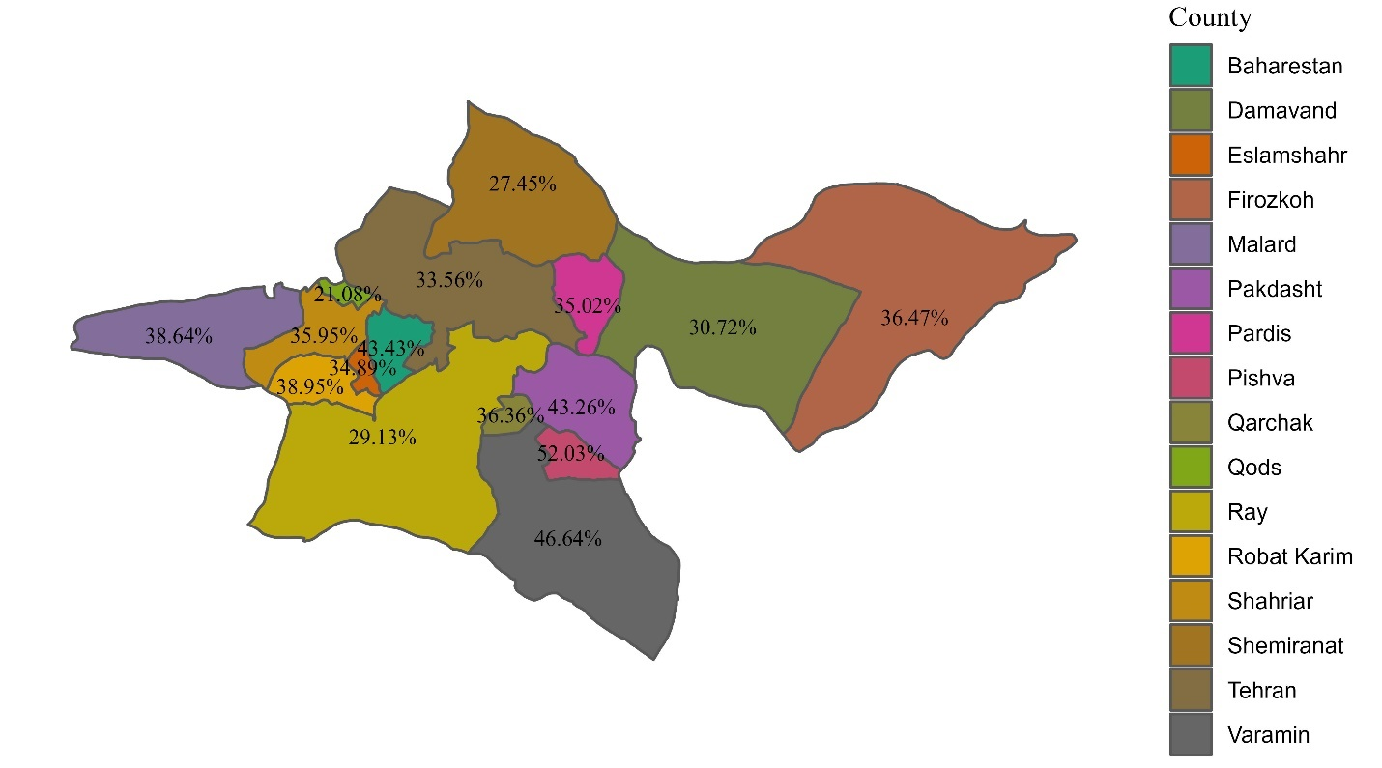

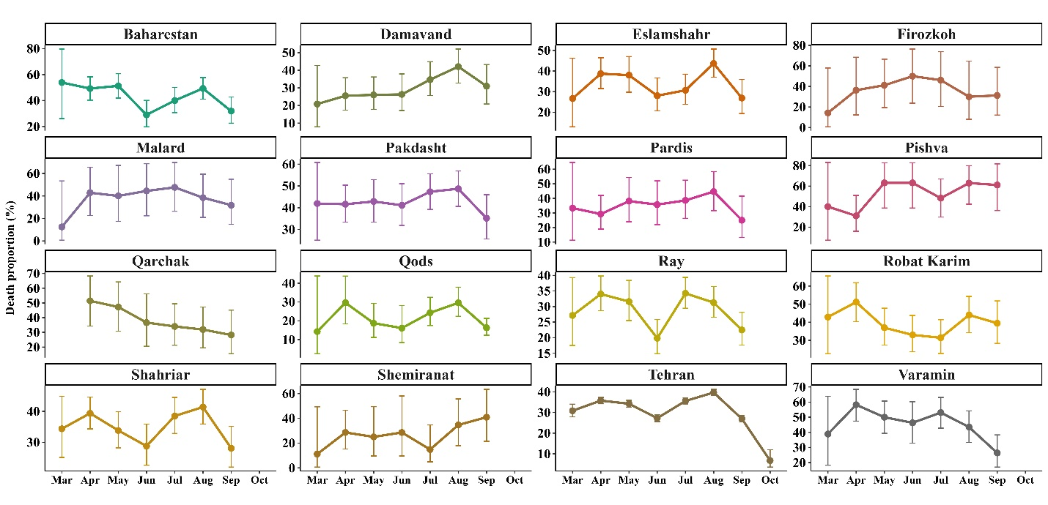
Figure S3. The overall death proportion (%) due to COVID-19 in ICU wards by counties of Tehran province (upper panel). The monthly death proportion due to COVID-19 with 95% confidence interval by counties of Tehran province (lower panel).

Figure S3. The subgroup HR and 95% CI of death among hospitalized COVID-19 patients by different group of age, sex, No. of comorbidities and nationality. [Note: April was the reference category in Month variable]

Table S7. The hazard ratio (95% CI) of death due to COVID-19 among hospitalized patients by wards.
Group | Month levels | N | No. of events | HR (95% CI) | P-value
Total Patients
 | April (Ref) | 33547 | 3595 | 1.00 | ----
 | March | 5724 | 569 | 0.87 (0.80, 0.95) | 0.003
 | May | 26850 | 2443 | 0.84 (0.80, 0.88) | <0.001
 | June | 20277 | 1522 | 0.76 (0.72, 0.81) | <0.001
 | July | 37028 | 3866 | 1.12 (1.07, 1.17) | <0.001
 | August | 39140 | 4486 | 1.22 (1.17, 1.27) | <0.001
 | September | 22756 | 2127 | 1.20 (1.13, 1.26) | <0.001
 | October | 294 | 15 | 4.04 (2.43, 6.72) | <0.001
Non-ICU treated
 | April (Ref) | 28090 | 1569 | 1.00 | ----
 | March | 4471 | 180 | 0.72 (0.62, 0.84) | <0.001
 | May | 22418 | 881 | 0.69 (0.64, 0.75) | <0.001
 | June | 16492 | 447 | 0.53 (0.48, 0.59) | <0.001
 | July | 30991 | 1689 | 1.12 (1.04, 1.20) | 0.001
 | August | 33131 | 2075 | 1.24 (1.16, 1.33) | <0.001
 | September | 19030 | 884 | 1.05 (0.96, 1.14) | 0.271
 | October | 269 | 4 | 1.62 (0.61, 4.33) | 0.334
ICU-treated
 | April (Ref) | 5457 | 2026 | 1.00 | ----
 | March | 1253 | 389 | 0.85 (0.76, 0.95) | 0.003
 | May | 4432 | 1562 | 0.97 (0.90, 1.03) | 0.301
 | June | 3785 | 1075 | 0.88 (0.82, 0.95) | <0.001
 | July | 6037 | 2177 | 1.09 (1.02, 1.16) | 0.006
 | August | 6009 | 2411 | 1.22 (1.15, 1.30) | <0.001
 | September | 3726 | 1243 | 1.33 (1.24, 1.43) | <0.001
 | October | 25 | 11 | 13.18 (7.27, 23.88) | <0.001
Note: All models were adjusted using variables including sex, age, no. of comorbidities, and nationality. Abbreviation: hazard ratio (HR), confidence interval (CI). [Note: April was the reference category in Month variable]

Table S8. The death proportion during study period by age groups
 | April | March  (First peak) | May | June | July | August  (Second peak) | September | October
<40 | 2.09  (1.82 2.40) | 1.95  (1.33 2.82) | 1.46  (1.21 1.75) | 1.35  (1.10 1.66) | 2.08  (1.86 2.31) | 1.45  (1.30 1.62) | 1.16  (1.00 1.36) | 0.73  (0.27 1.79)
40-49 | 4.01  (3.54 4.53) | 4.36  (3.14 6.61) | 2.67  (2.26 3.15) | 2.40  (1.97 2.93) | 3.70  (3.34 4.79) | 3.14  (2.86 3.44) | 1.93  (1.66 2.24)
50-59 | 6.80  (6.23 7.41) | 6.38  (4.97 8.13) | 4.89  (4.36 5.47) | 3.80  (3.27 4.49) | 6.56  (6.10 7.05) | 5.62  (5.25 6.19) | 4.01  (3.59 4.47) | 0.29  (0.02 1.89)
60-69 | 12.47  (11.71 13.27) | 12.69  (10.79 14.85) | 8.60  (7.91 9.35) | 7.40  (6.66 8.29) | 11.32  (10.69 11.98) | 10.62  (10.06 11.26) | 7.92  (7.25 8.65) | 1.07  (0.28 3.36)
70-79 | 19.04  (17.91 27.21) | 19.54  (16.84 22.54) | 15.35  (14.28 16.48) | 12.77  (11.59 14.73) | 17.19  (16.07 18.38) | 17.00  (15.97 18.39) | 11.25  (10.28 12.29) | 0.88  (0.15 3.53)
80-89 | 28.77  (27.03 34.57) | 27.21  (23.21 31.61) | 24.56  (22.85 26.37) | 20.36  (18.43 22.44) | 24.38  (22.59 26.25) | 27.51  (25.73 29.35) | 18.95  (17.38 22.62) | 3.15  (1.01 8.36)
>89 | 37.86  (33.39 42.55) | 31.40  (22.05 42.42) | 34.40  (29.98 39.18) | 31.10  (26.19 36.46) | 34.85  (30.07 39.96) | 35.49  (31.24 39.98) | 26.39  (22.49 36.69)

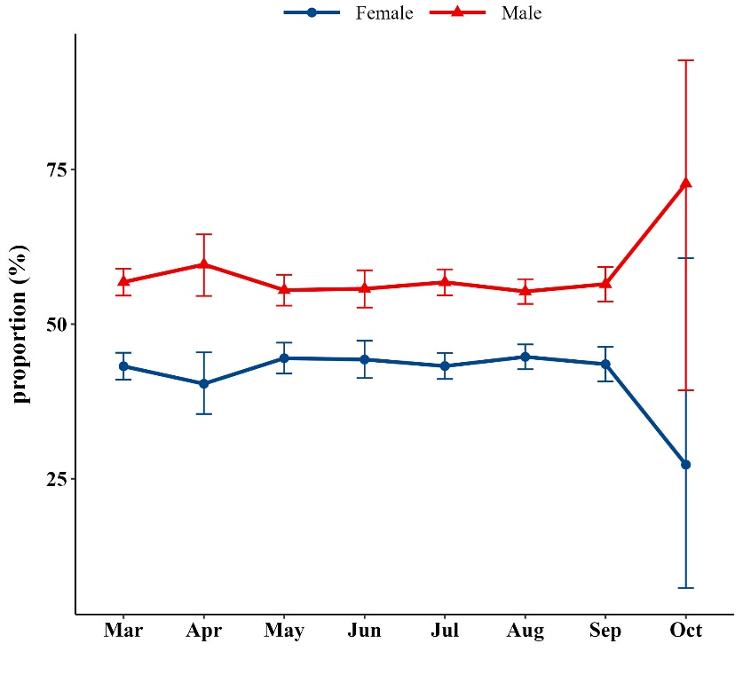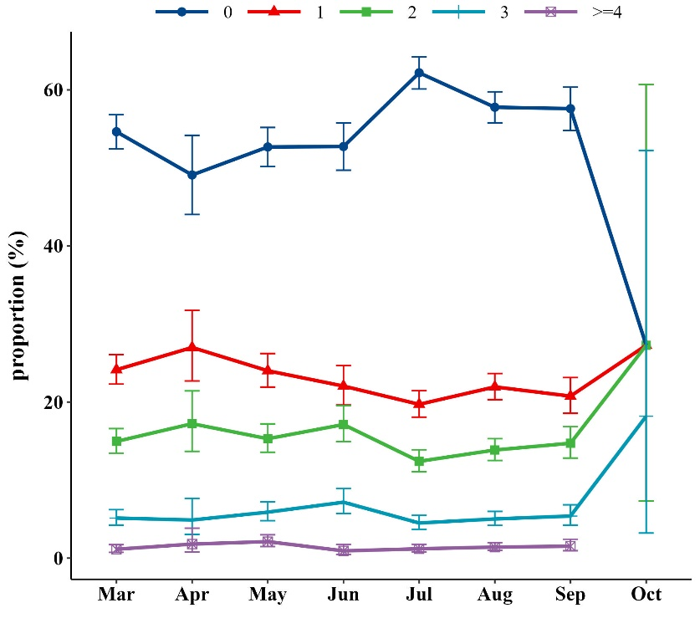

- Sex | - Category of comorbidities

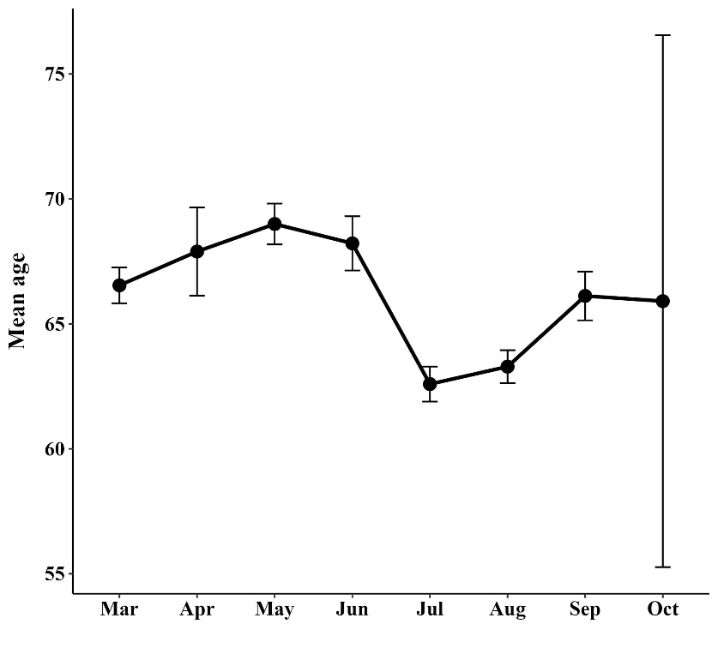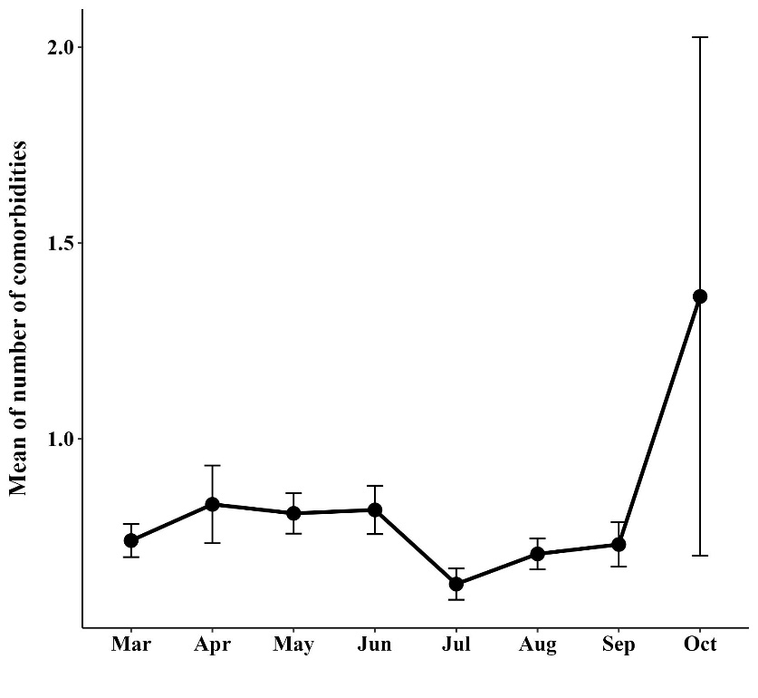
- Mean age | - Mean number of comorbidities

Figure S4. A) the proportion of men and women among ICU-treated by month, B) the proportion of comorbidities among ICU-treated, C) the mean age of patients in ICU by month, D) the mean number of comorbidities among ICU-treated by month

