Supporting Information
Quantification and identification of microplastics in organic fertilizers: the implication for the manufacture and safe application
Jieru Xu, ª Aiping Yang, ª Yu Yan, ª Yuqi Xu, ª Minyi Tang, ª Penghui Li, ª Lanfeng Zhao, ª Xinming Zhang, ^{a, *} Zongling Ren, ^{a, **}
ª Department of Soil Science, College of Natural Resources and Environment, South China Agricultural University, Guangzhou 510642, China
* Corresponding author: xmzhang@scau.edu.cn
zren@scau.edu.cn

Recovery test of MPs from organic fertilizer using Fenton’s reagent
Four common polymer types were used in the recovery test, including PA, PET, PP, and PE (Table S1 and Figure S1). A commercial organic fertilizer (Sample 15), which had fine texture and relatively low abundance of MPs (5743.4 ± 1285.8) (Table 1), was chosen for testing. 10 g of the organic fertilizer was placed into a prewashed 1 L glass beaker, and then spiked with 25 MP pellets. The pellets were mixed with the organic fertilizer thoroughly. The mixed sample in the beaker was partially wetted with Milli-Q water and then air-dried. This wetting and drying procedures were repeated three times to incorporate the MP pellets into aggregates (Hurley et al., 2018). For each polymer type, three replicates were performed.
The spiked samples were subjected to Fenton’s reagent, followed by density separation using saturated NaCl solution (ρ = 1.2 g/cm³) as described in Section 2.2. For low density MPs (PA, PP, and PE), almost all the particles were recovered on the filters in the first extraction with saturated NaCl solution, while the higher density PET pellets were collected with tweezers from the residues. The particles on the filters were rinsed with Milli-Q water and 30% ethanol. The weights and numbers of the particles were recorded before and after treatment. The particles were also photographed using a stereomicroscope (LEICA M165 C) at 10× magnification to assess the extent of degradation.
As shown in Table S2, the overall recovery was very satisfactory and close to 100% for the four types of MPs. Moreover, Fenton’s reagent did not cause significantly degradation of the tested MP particles (Figure S1), confirming this method is suitable for extracting MPs from organic fertilizer samples.

Table S1. Details of the tested reference polymers used in the recovery test. Images of the particles are provided in Figure S1.
 | Manufacturer | Density (g/cm³) ª | Size range (mm) ^{b}
PA pellets | Sigma-Aldrich | 1.08 | ~1.4
PET pellets | Sigma-Aldrich | 1.68 | ~2
PP pellets | Sigma-Aldrich | 0.90 | ~2.5
PE pellets | Alfa Aesar | 0.95 | ~2.5
ª Provided by the manufacturers.
^{b} Estimated based on the particle long axis.

Table S2. The mass loss and recovery for four types of MPs following the treatment of Fenton’s reagent ª
 | Mass loss | Recovery
PA pellets | 2.14 ± 0.18% | 100%
PET pellets | 0.51 ± 0.18% | 100%
PP pellets | -2.64 ± 2.36% | 97.33 ± 2.31%
PE pellets | -1.33 ± 2.21% | 98.67 ± 2.31%
ª Results are presented as the mean ± SD of the three replicates.

Figure S1. Stereomicrograph of PA, PET, PP, and PE particles before and after the extraction of Fenton’s reagent from organic fertilizer.

Table S3. Abundance of MPs in different organic fertilizer samples ª
Sample | Types | Raw materials | Processing procedures | Abundance of MPs (items/kg)
1 | Commercial AOF | Chicken feces | Mechanical shredding and sieving (> 5mm) | 11068.5 ± 1222.0
2 | Commercial AOF | Chicken feces | Mechanical shredding and sieving (< 5mm) | 8400.0 ± 2884.4
3 | Commercial AOF | Chicken feces | Mechanical shredding and sieving (< 5mm) | 9614.9 ± 2000.0
4 | Commercial AOF | Chicken feces | Natural composting | 11333.3 ± 1006.6
5 | Commercial AOF | Sheep feces | Mechanical shredding and sieving (< 5mm) | 11466.7 ± 3629.5
6 | Commercial AOF | Sheep feces | Natural composting | 11600.0 ± 1058.3
7 | Commercial AOF | Sheep feces | Natural composting | 10800.0 ± 1442.2
8 | Commercial AOF | Cattle feces | Mechanical shredding and sieving (> 5mm) | 17469.0 ± 3002.2
9 | Commercial AOF | Cattle feces | Natural composting | 8133.3 ± 3002.2
10 | Commercial AOF | Cattle feces | Natural composting | 6933.3 ± 923.8
11 | Commercial AOF | Pig feces | Natural composting | 10800.0 ± 4059.6
12 | Commercial APOF | Fish wastes and peat, 1:9 w/w | Mechanical shredding and sieving (< 5mm) | 7200.0 ± 1833.0
13 | Commercial APOF | Fish wastes and peat, 1:19 w/w | Mechanical shredding and sieving (< 5mm) | 6133.3 ± 923.8
14 | Commercial APOF | Chicken feces, soybean meal, bone meal, and plant ash | Mechanical shredding and sieving (> 5mm) | 7200.0 ± 800.0
15 | Commercial APOF | Chicken feces, rice bran, and distillers' grains | Mechanical shredding and sieving (< 5mm) | 5743.4 ± 1285.8
16 | Commercial APOF | Chicken feces and mushroom residues | Natural composting | 10266.7 ± 3330.7
17 | Commercial APOF | Pig feces and coconut peat | Mechanical shredding and sieving (< 5mm) | 5629.9 ± 2498.0
18 | Commercial APOF | Pig feces and mushroom residues | Mechanical shredding and sieving (< 5mm) | 4266.7 ± 2274.5
19 | Commercial APOF | Pig feces, coconut peat, and rice husk | Natural composting | 18028.6 ± 2000.0
20 | Commercial APOF | Bone meal, sugarcane bagasse, and peanut press cake | Mechanical shredding and sieving (< 5mm) | 5339.6 ± 3402.0
21 | Commercial APOF | Rabbit feces and mushroom residues | Natural composting | 9333.3 ± 1285.8
22 | Commercial POF | Tobacco leaves | Mechanical shredding and sieving (> 5mm) | 6278.9 ± 1890.3
23 | Commercial POF | Soybean meal | Mechanical shredding and sieving (< 5mm) | 8800.0 ± 1442.2
24 | Farm compost | Cotton straws and mushroom residues | Natural composting | 22450.4 ± 2227.1
25 | Farm compost | Chinese medicine residues and mushroom residues | Natural composting | 26237.8 ± 1665.3
ª Results are presented as the mean ± SD of the three replicates per sample. AOF: animal-derived organic fertilizer; POF: plant-derived organic fertilizer; APOF: organic fertilizer made from the mixture of plant- and animal-derived materials.

Table S4. Size distribution and morphotype of MPs in organic fertilizer samples
Sample | Size factions |  |  |  |  | Morphotypes
Sample | <1 mm (%) | 1~3 mm (%) | 3~5 mm (%) | >5 mm (%) |  | Fibers (%) | Fragments (%) | Films (%) | Pellets (%)
1 | 52.8 | 34.8 | 10.1 | 2.3 |  | 50.6 | 7.2 | 38.6 | 3.6
2 | 45.3 | 39.5 | 7.0 | 8.1 |  | 55.6 | 23.8 | 14.3 | 6.3
3 | 45.5 | 44.2 | 10.1 | 0.1 |  | 61.1 | 18.1 | 19.4 | 1.4
4 | 48.3 | 49.4 | 1.1 | 1.1 |  | 56.5 | 30.6 | 12.9 | 0.0
5 | 33.7 | 58.1 | 5.8 | 2.3 |  | 51.8 | 30.6 | 15.3 | 2.4
6 | 44.1 | 45.1 | 7.8 | 2.9 |  | 54.0 | 23.0 | 17.2 | 5.7
7 | 57.0 | 27.8 | 10.1 | 5.1 |  | 40.7 | 25.9 | 33.3 | 0.0
8 | 28.6 | 46.4 | 17.9 | 7.2 |  | 59.5 | 16.0 | 24.4 | 0.0
9 | 38.6 | 37.1 | 20.0 | 4.3 |  | 47.5 | 24.6 | 13.1 | 14.8
10 | 66.0 | 25.5 | 6.4 | 2.1 |  | 30.8 | 9.6 | 42.3 | 17.3
11 | 52.8 | 30.3 | 10.1 | 6.7 |  | 40.7 | 40.7 | 17.3 | 1.2
12 | 46.3 | 48.1 | 5.6 | 0.0 |  | 44.4 | 7.4 | 38.9 | 9.3
13 | 80.4 | 15.2 | 4.3 | 0.0 |  | 30.4 | 23.9 | 32.6 | 13.0
14 | 64.8 | 31.5 | 0.0 | 3.7 |  | 46.3 | 38.9 | 11.1 | 3.7
15 | 56.2 | 26.5 | 7.8 | 9.5 |  | 44.2 | 41.9 | 14.0 | 0.0
16 | 59.2 | 31.6 | 5.3 | 3.9 |  | 37.7 | 16.9 | 42.9 | 2.6
17 | 50.9 | 37.0 | 4.6 | 7.5 |  | 83.3 | 11.9 | 0.0 | 4.8
18 | 93.5 | 3.2 | 3.2 | 0.0 |  | 40.6 | 12.5 | 21.9 | 25.0
19 | 48.8 | 43.4 | 6.1 | 1.7 |  | 60.7 | 30.4 | 5.2 | 3.7
20 | 65.3 | 30.7 | 3.8 | 0.2 |  | 77.5 | 15.0 | 0.0 | 7.5
21 | 62.9 | 31.4 | 2.9 | 2.9 |  | 55.7 | 31.4 | 12.9 | 0.0
22 | 44.3 | 41.7 | 13.9 | 0.1 |  | 61.7 | 23.4 | 12.8 | 2.1
23 | 43.9 | 36.4 | 19.7 | 0.0 |  | 70.0 | 12.9 | 17.1 | 0.0
24 | 63.5 | 30.3 | 4.8 | 1.4 |  | 72.6 | 23.2 | 2.4 | 1.8
25 | 57.8 | 33.7 | 7.0 | 1.5 |  | 78.1 | 10.2 | 11.7 | 0.0

Table S5. Percentages of MPs with different color in organic fertilizer samples
Sample | Black | Red | Yellow | White | Blue | Transparent | Green
1 | 28.9 | 16.9 | 28.9 | 4.8 | 8.4 | 12.0 | 0.0
2 | 51.2 | 16.3 | 3.5 | 3.5 | 18.6 | 1.2 | 5.8
3 | 62.0 | 13.9 | 16.5 | 0.0 | 1.3 | 5.1 | 1.3
4 | 39.5 | 17.3 | 18.5 | 7.4 | 6.2 | 11.1 | 0.0
5 | 23.3 | 20.9 | 7.0 | 0.0 | 39.5 | 9.3 | 0.0
6 | 42.2 | 17.6 | 7.8 | 2.0 | 6.9 | 14.7 | 8.8
7 | 37.5 | 23.8 | 8.8 | 15.0 | 7.5 | 7.5 | 0.0
8 | 21.4 | 13.4 | 4.5 | 0.0 | 4.5 | 56.3 | 0.0
9 | 21.4 | 34.3 | 32.9 | 4.3 | 7.1 | 0.0 | 0.0
10 | 48.9 | 8.5 | 21.3 | 17.0 | 0.0 | 4.3 | 0.0
11 | 40.4 | 12.4 | 15.7 | 5.6 | 6.7 | 18.0 | 1.1
12 | 31.5 | 5.6 | 0.0 | 24.1 | 25.9 | 13.0 | 0.0
13 | 30.4 | 15.2 | 28.3 | 0.0 | 13.0 | 13.0 | 0.0
14 | 33.3 | 25.9 | 16.7 | 13.0 | 9.3 | 1.9 | 0.0
15 | 54.7 | 17.2 | 6.3 | 0.0 | 7.8 | 14.1 | 0.0
16 | 23.7 | 3.9 | 25.0 | 40.8 | 3.9 | 2.6 | 0.0
17 | 62.8 | 11.6 | 0.0 | 14.0 | 9.3 | 2.3 | 0.0
18 | 29.0 | 0.0 | 19.4 | 9.7 | 22.6 | 19.4 | 0.0
19 | 32.1 | 9.2 | 16.0 | 3.1 | 19.1 | 19.8 | 0.8
20 | 69.2 | 0.0 | 11.5 | 19.2 | 0.0 | 0.0 | 0.0
21 | 34.8 | 5.8 | 31.9 | 0.0 | 17.4 | 10.1 | 0.0
22 | 54.4 | 15.2 | 5.1 | 12.7 | 6.3 | 6.3 | 0.0
23 | 50.0 | 21.2 | 0.0 | 9.1 | 15.2 | 4.5 | 0.0
24 | 30.5 | 24.0 | 11.4 | 12.0 | 19.2 | 0.0 | 3.0
25 | 34.6 | 26.5 | 5.9 | 19.5 | 4.3 | 0.0 | 9.2

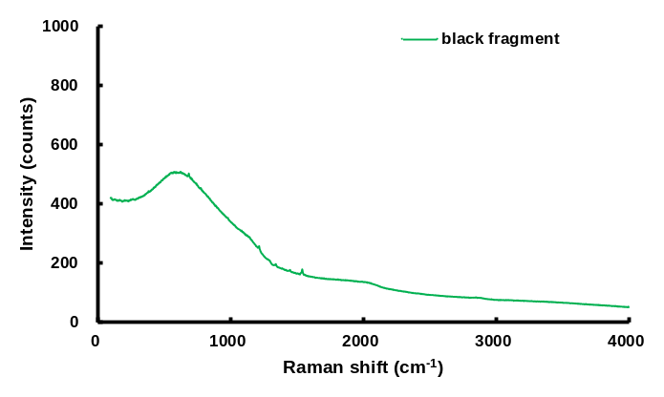
(a)
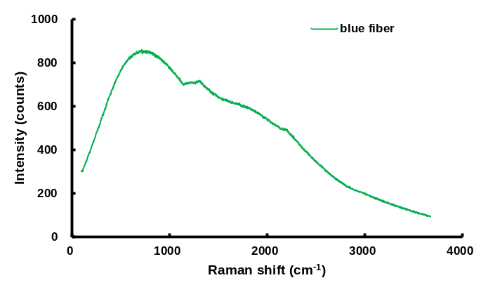
(b)
Figure S2. Raman spectra of the paint MPs: (a) black fragment and (b) blue fiber. The obtained spectra might be generated by the coated pigment or a mixture of several components.

