Supporting Information. Fernández, L. D., C. V. W. Seppey, D. Singer, B. Fournier, D. Tatti, E. A. D. Mitchell, and E. Lara. 202X. Niche conservatism drives the elevational diversity gradient in major groups of free-living soil unicellular eukaryotes. Ecology.

Appendix S1 Characterization of soil protist communities (DNA extraction, PCR and sequencing)
Environmental DNA was extracted using the MoBio PowerSoil DNA isolation kit (Carlsbad, CA, USA) following the manufacturer’s instructions. PCR protocols targeting the SSU rRNA gene V9 region of eukaryotes were done according to Amaral-Zetler et al. (2009). Sequencing was performed with the Illumina HiSeq 2000 technology to obtain paired-end reads (2 x 200 bp) (Fasteris, Geneva, Switzerland). Quality check (Phred score filtering, elimination of reads without perfect forward and reverse primers, and chimera removal) of the reads were performed following de Vargas et al. (2015). Reads were grouped into operational taxonomic units (OTUs) using the clustering algorithm swarm v1.2.5 (Mahé et al. 2014). The curated and updated PR² (Guillou et al. 2013) and SILVA (Pruesse et al. 2007) databases were used to taxonomically assign the OTUs after a selection of the V9 regions according to the primers used for the sequencing. OTUs were considered as undetermined if the percentage of identity did not reach 80%. In order to homogenize sampling effort on all sites and allow diversity comparisons, we randomly subsampled 50,000 reads from each site to account for unequal sample sizes between soil protist communities. From these subsamples, we only selected those assigned to one of the following soil protist taxa, Bacillariophyta, Cercomonadida, Ciliophora, Euglyphida and Kinetoplastida. We also combined all the reads assigned to the abovementioned taxa into a group herein referred to as the “soil protist group”. Species accumulation curves confirmed that sampling effort and sequencing covering were enough to record a significant proportion of the total OTU richness found at each sampling site (Fig. S1).
We defined a community as all OTUs originating from a single beech forest sample. The taxonomic richness within each community was calculated as the total number of OTUs within each community. Phylogenetic alpha diversity within each community was calculated using Faith’s index (Faith 1992) with the R package picante (Kembel et al. 2010). Both measures of alpha diversity were significantly correlated (Fig. S2), and therefore, we only used taxon richness in subsequent analyses. OTU abundances that were inserted in the following models are numbers of reads per OTU. While the reads numbers as obtained in High Throughput Sequencing-based studies cannot be translated directly into actual cell numbers, it has been also shown that both have a high correlation (Giner et al. 2016). This allows the use of reads numbers as semi-quantitative data in the following analyses.
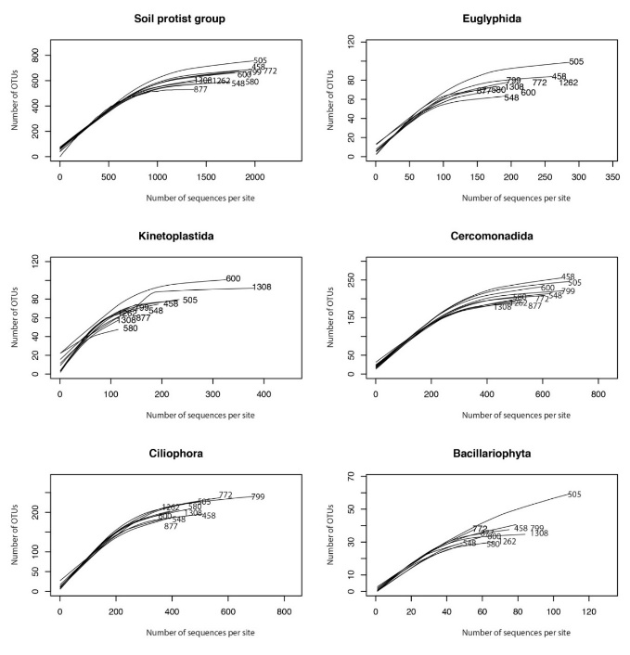

Fig. S1. Species accumulation curves calculated for each eukaryotic microbial group studied. In all cases, species accumulation curves tended to reach a plateau, indicating that sampling and sequencing covering were good at each elevational forest site.

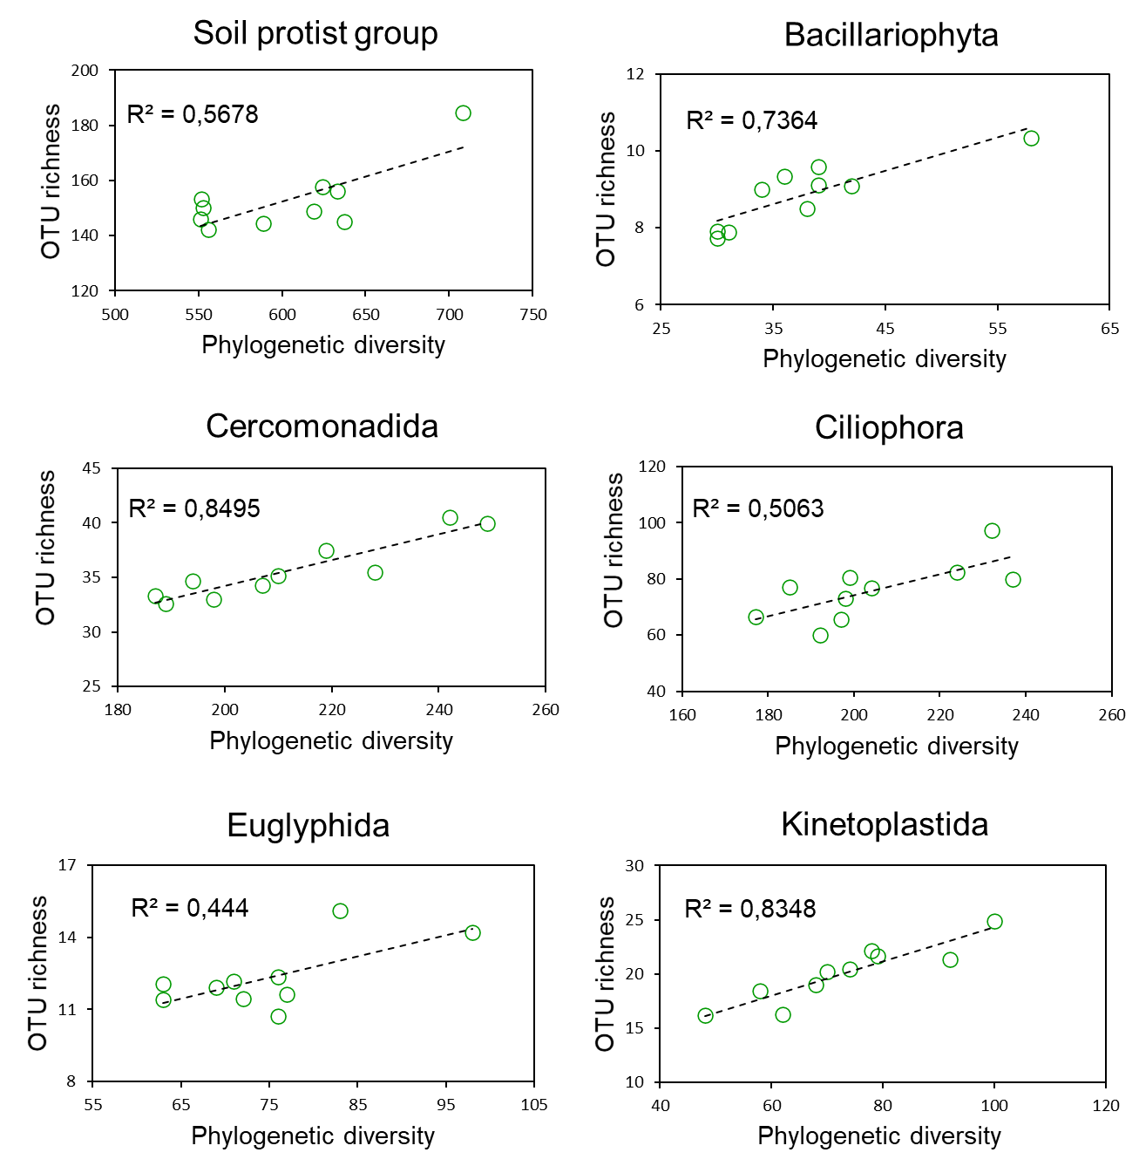
Fig. S2. Simple linear correlation between OTU richness (i.e., number of OTUs per community) and phylogenetic (diversity) richness (i.e., phylogenetic difference between OTUs within a given community) as estimated by Faith’s index of each eukaryotic microbial group.

Literature Cited
Amaral-Zettler, L. A., E. A. McCliment, H. W. Ducklow, and S. M. Huse. 2009. A method for studying protistan diversity using massively parallel sequencing of V9 hypervariable regions of small-subunit ribosomal RNA genes. Plos One 4:e637.
de Vargas, C., et al. 2015. Eukaryotic plankton diversity in the sunlit ocean. Science 22:1261605.
Faith, D. P. 1992. Conservation evaluation and phylogenetic diversity. Biological Conservation 61: 1–10.
Guillou, L., D. et al. 2013. The protist ribosomal reference database (PR²): a catalog of unicellular eukaryote small sub-unit rRNA sequences with curated taxonomy. Nucleic Acids Research 41:597–604.
Giner, C. R., I. Forn, S. Romac, R. Logares, C. de Vargas, and R. Massana. 2016. Environmental sequencing provides reasonable estimates of the relative abundance of specific picoeukaryotes. Applied and Environmental Microbiology 82: 4757–4766.
Kembel, S. W., P. D. Cowan, M. R. Helmus, W. K. Cornwell, H. Morlon, D. D. Ackerly, S. P. Blomberg, and C. O. Webb. 2010. Picante: R tools for integrating phylogenies and ecology. Bioinformatics 26:1463–1464.
Mahé, F., T. Rognes, C. Quince, C. de Varga, and M. Dunthorn. 2014. Swarm: robust and fast clustering method for amplicon–based studies. PeerJ 2:e539.
Pruesse, E., C. Quast, K. Knittel, B. M. Fuchs, W. Ludwig, J. Peplies, and F. O. Glöckner. 2007. SILVA: a comprehensive online resource for quality checked and aligned ribosomal RNA sequence data compatible with ARB. Nucleic Acids Research 35:7188–7196.

