Supplementary Information：
Figure S1. The study of differentially expressed genes in patients with high and low expression of TTC21A. (A) Volcano map of differentially expressed genes in TTC21A high expression group and low expression group. (B) The heat map of the first 10 significantly differentially expressed genes in the high expression and low expression groups. The green dots and red dots represent down-regulated and up-regulated genes, respectively.
Figure S2. The predictive value of TTC21A expression in the diagnosis and clinical prognosis of other cancers. Kaplan-Meier plotter database (A-S) was used to analyze the prognostic significance of high and low expression of TTC21A in different types of tumors. (A-C) Survival curves of OS, PPS, RFS, and DMFs in lung cancer cohort; (D-F) OS, PS, and DFS survival curves of ovarian cancer; (G-I) OS and RFS survival curves of breast cancer; (J-L) OS, PFS of gastric cancer and PPS survival curve.

FigureS1

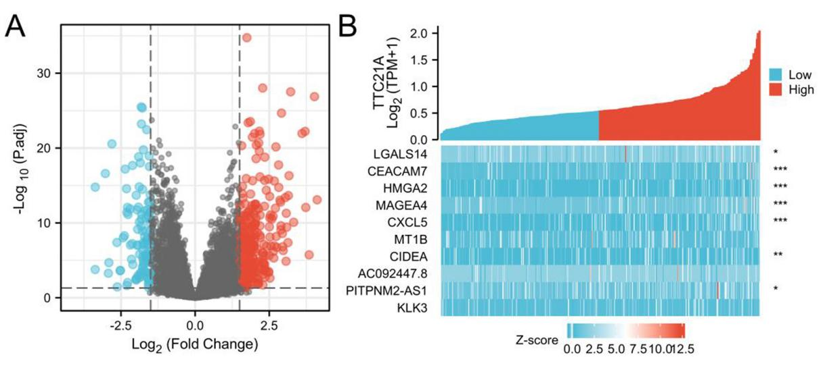

Figure S2
