Table 4: Vibration modes and mode assignments for the ATR FT-IR spectra (Melissa et al., 2018).
Polymer | Chemical structure | Absorption bands  (cm⁻¹) | Assignment
Polypropylene (PP) | 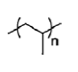 | 2950 | C-H stretch
Polypropylene (PP) |  | 2915 | C-H stretch
Polypropylene (PP) |  | 2838 | C-H stretch
Polypropylene (PP) |  | 1455 | CH₂ bend
Polypropylene (PP) |  | 1377 | CH₃ bend
Polypropylene (PP) |  | 1166 | CH bend, CH₃ rock, C-C stretch
Polypropylene (PP) |  | 997 | CH₃ rock, CH₃ bend, CH bend
Polypropylene (PP) |  | 972 | CH₃ rock, C-C stretch
Polypropylene (PP) |  | 840 | CH₂ rock, C-CH₃ stretch
Polypropylene (PP) |  | 808 | CH₂ rock, C-C stretch, C-CH stretch
Polyethylene (PE) | 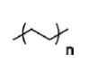 | 2915 | C-H stretch
Polyethylene (PE) |  | 2845 | C-H stretch
Polyethylene (PE) |  | 1467 | CH₂ bend
Polyethylene (PE) |  | 1462 | CH₂ bend
Polyethylene (PE) |  | 1377 | CH₃ bend
Polyethylene (PE) |  | 730 | CH₂ rock
Polyethylene (PE) |  | 717 | CH₂ rock
Polyethylene terephthalate (PET) | 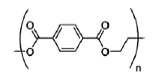 | 1713 | C=O stretch
Polyethylene terephthalate (PET) |  | 1241 | C-O stretch
Polyethylene terephthalate (PET) |  | 1094 | C-O stretch
Polyethylene terephthalate (PET) |  | 720 | Aromatic CH out of plane bend
Ethylene vinyl acetate (EVA) | 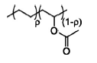 | 2917 | C-H stretch
Ethylene vinyl acetate (EVA) |  | 2848 | C-H stretch
Ethylene vinyl acetate (EVA) |  | 1740 | C=O stretch
Ethylene vinyl acetate (EVA) |  | 1464 | CH₂ bend, CH₃bend
Ethylene vinyl acetate (EVA) |  | 1241 | C(=O)O stretch
Ethylene vinyl acetate (EVA) |  | 1020 | C-O stretch
Ethylene vinyl acetate (EVA) |  | 720 | CH₂ rock
Nylon (all polyamides) | 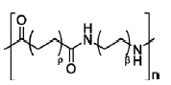 | 3298 | N-H stretch
Nylon (all polyamides) |  | 2932 | CH stretch
Nylon (all polyamides) |  | 2858 | CH stretch
Nylon (all polyamides) |  | 1634 | C=O stretch
Nylon (all polyamides) |  | 1538 | NH bend, C-N stretch
Nylon (all polyamides) |  | 1464 | CH₂ bend
Nylon (all polyamides) |  | 1372 | CH₂ bend
Nylon (all polyamides) |  | 1274 | NH bend, C-N stretch
Nylon (all polyamides) |  | 1199 | CH₂ bend
Nylon (all polyamides) |  | 687 | NH bend, C=O bend

Table 5: ATR FT-IR result for selected microplastic.
Absorption band | ATR FT-IR Result
S1: Polypropylene (PP)  - 2951.05 cm⁻¹  - 2918.44 cm⁻¹  - 2840.72 cm⁻¹  - 1456.21 cm⁻¹  - 1375.96 cm⁻¹  - 1166.81 cm⁻¹  - 998.50 cm⁻¹  - 973.54 cm⁻¹  - 841.12 cm⁻¹  - 808.84 cm⁻¹ | 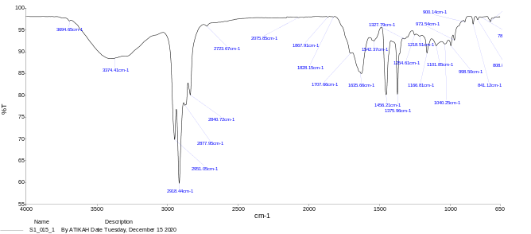  (j)  (i)  (h)  (g)  (f)  (c)  (e)  (d)  (b)  (a)
S2: Polyethylene (PE)  - 2915.83 cm⁻¹  - 2848.14 cm⁻¹  - 1465.05 cm⁻¹  - 1378.43 cm⁻¹  - 717.33 cm⁻¹ | 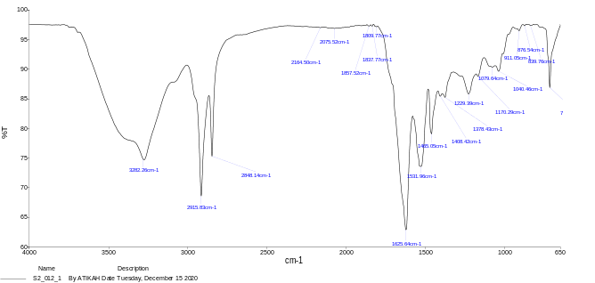  (a)  (e)  (d)  (c)  (b)  PE
S3: Polyethylene terephthalate (PET)  - 1713.25 cm⁻¹  - 1243.68 cm⁻¹  - 1093.66 cm⁻¹  - 724.43 cm⁻¹ | 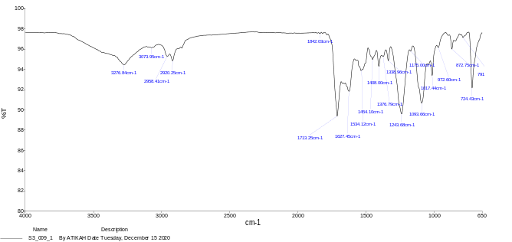  PET  (c)  (d)  (b)  (a)
S4: Ethylene vinyl acetate (EVA)  - 2922.10 cm⁻¹  - 2853.11 cm⁻¹  - 1710.59 cm⁻¹  - 1454.29 cm⁻¹  - 1242.25 cm⁻¹  - 1018.08 cm⁻¹  - 724.93 cm⁻¹ | 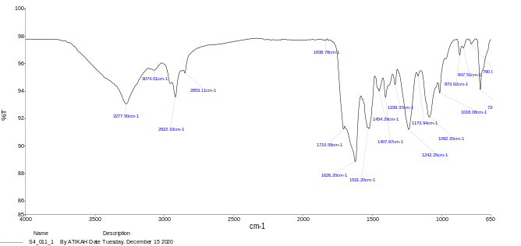  (g)  (f)  (e)  (d)  (b)  (c)  (a)  EVA
S5: Nylon (all polyamides)  - 3273.41 cm⁻¹  - 2922.69 cm⁻¹  - 2853.06 cm⁻¹  - 1623.85 cm⁻¹  - 1528.54 cm⁻¹ | 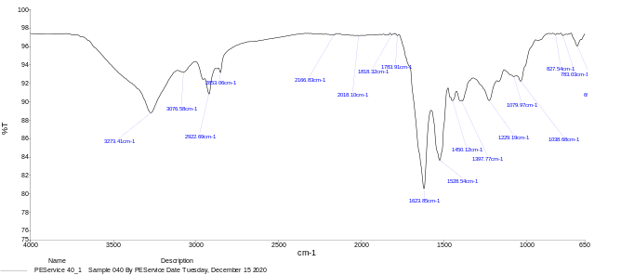  (e)  (d)  (c)  (b)  (a)  Nylon

