Extended Data Figure 1. Visual stimuli.

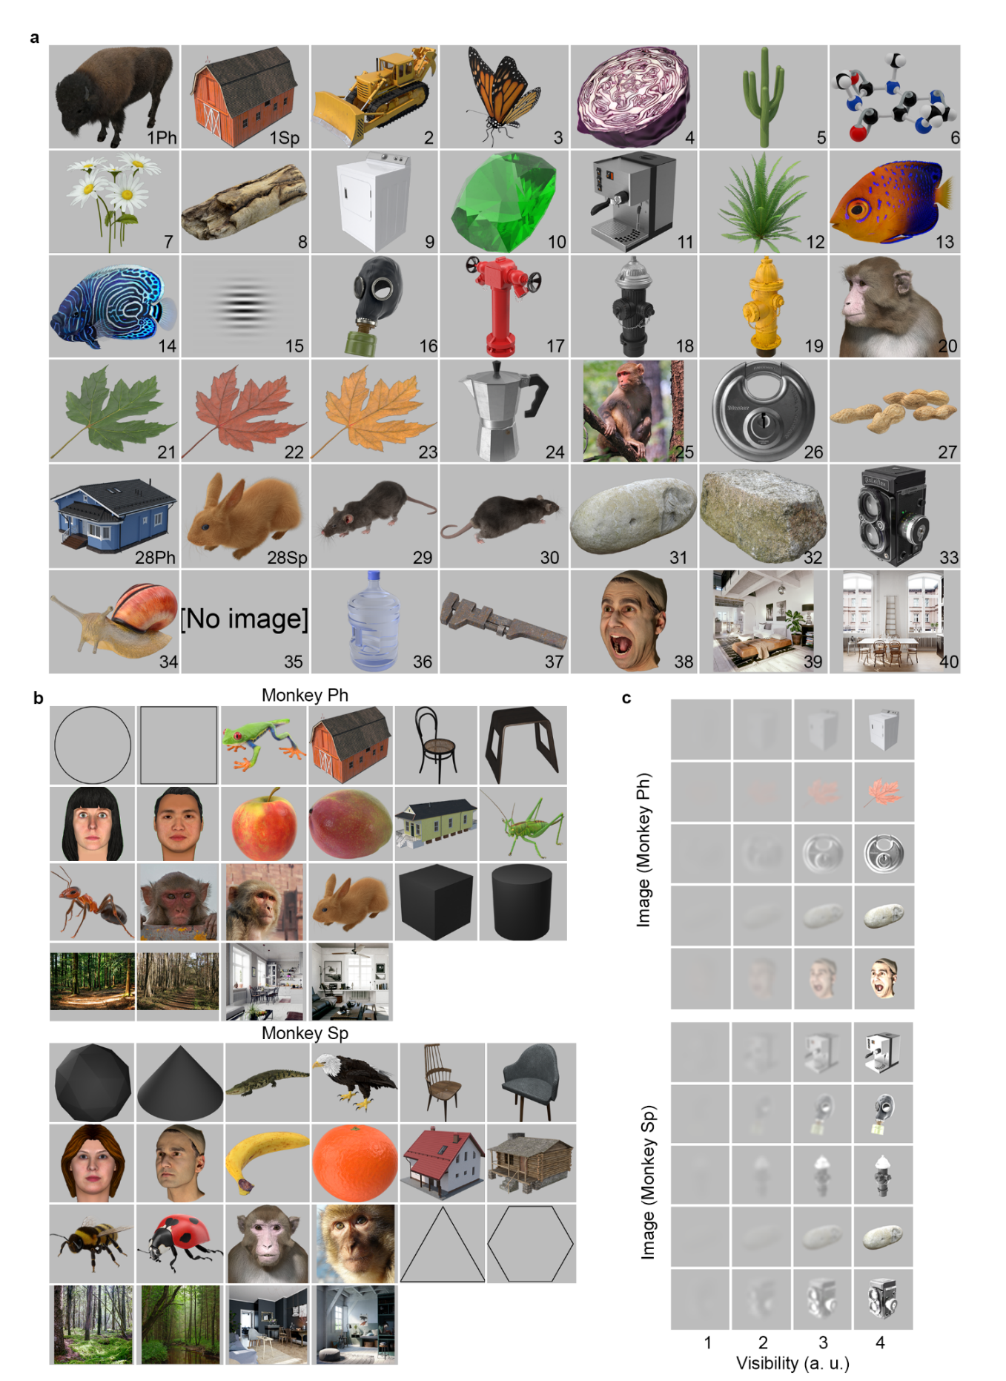
a, the images used in Experiment 1 and 2 for both monkeys. The images appeared as object cut-outs on a gray background as shown here. The images were constrained within an imaginary 8°x8° central square except for Image 39 and 40 which were displayed at 30°x30°. Image 1Ph and 28Ph were only shown to monkey Ph, image 1Sp and 28Sp were only shown to monkey Sp. “Image” 35 was the “no image” condition and the “no image” text did not appear in the experiment. b, Images used during the training phase for each monkey. The last row of images for each monkey were displayed at 30°x30°. c, Image stimulus used in Experiment 3 for each monkey. All images were displayed at 8°x8°.
Extended Data Figure 2. Detection profiles.
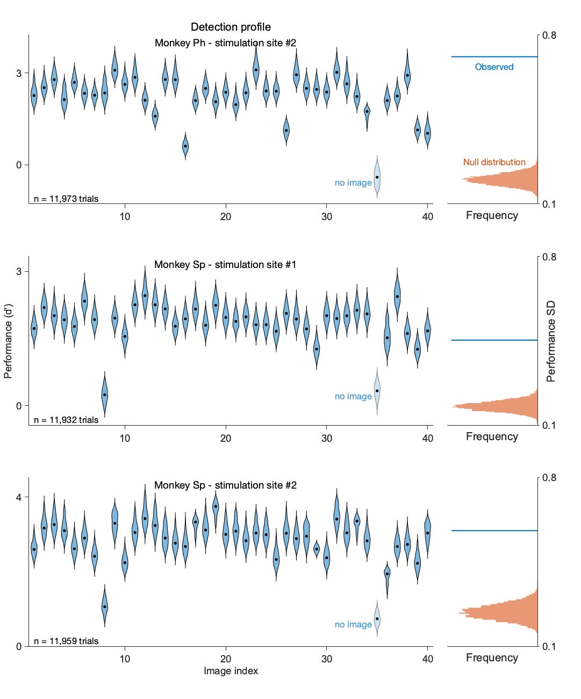
See Figure 2.a
Extended Data Figure 3. Correlation between detection profiles within and between stimulation sites.
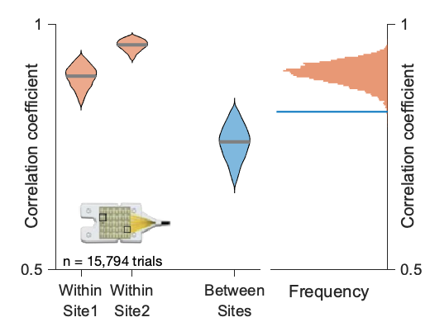
See Figure 2.b

Extended Data Figure 4. Psychometric functions.

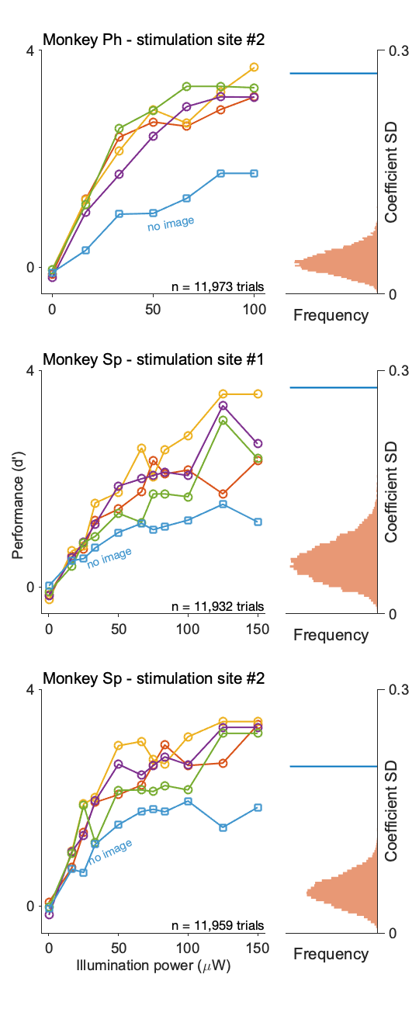
See Figure 2.c
Extended Data Figure 5. Stimulation detection performance is modulated by image visibility.
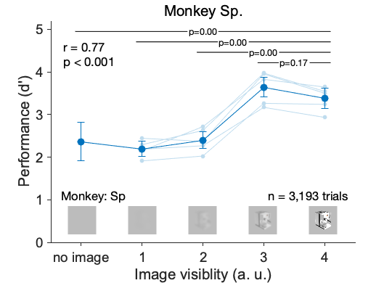
See figure 3.b.

