Fig. 6 A: proteomics analysis of Phellodendron chinense Schneid seeds under water treatment at 0 d

Fig. 6 B: proteomics analysis of Phellodendron chinense Schneid seeds under water treatment at 3 d

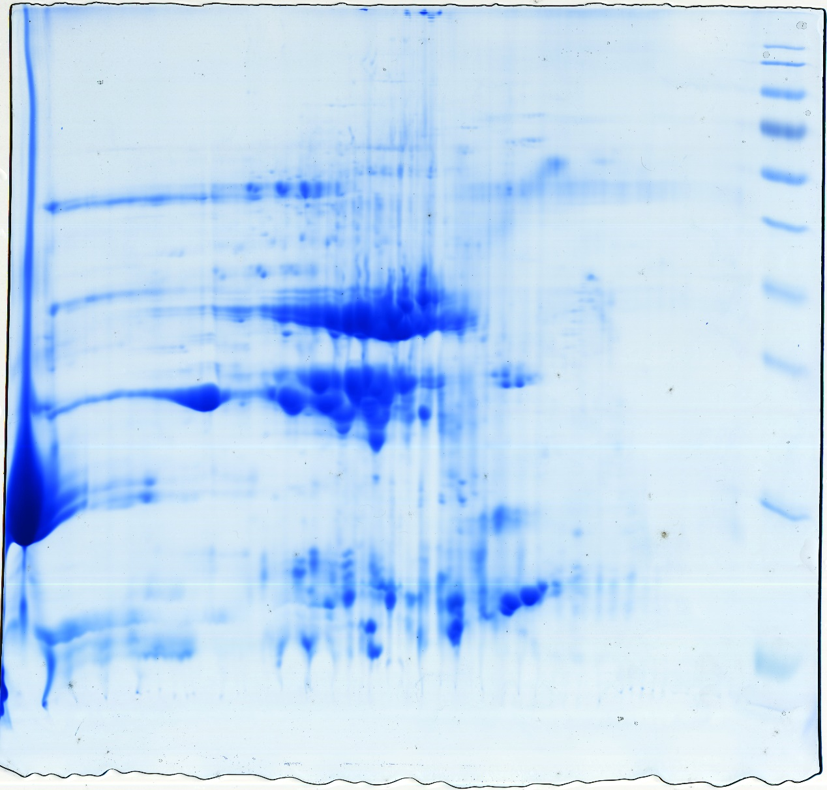
Fig. 6 C: proteomics analysis of Phellodendron chinense Schneid seeds under water treatment at 6 d

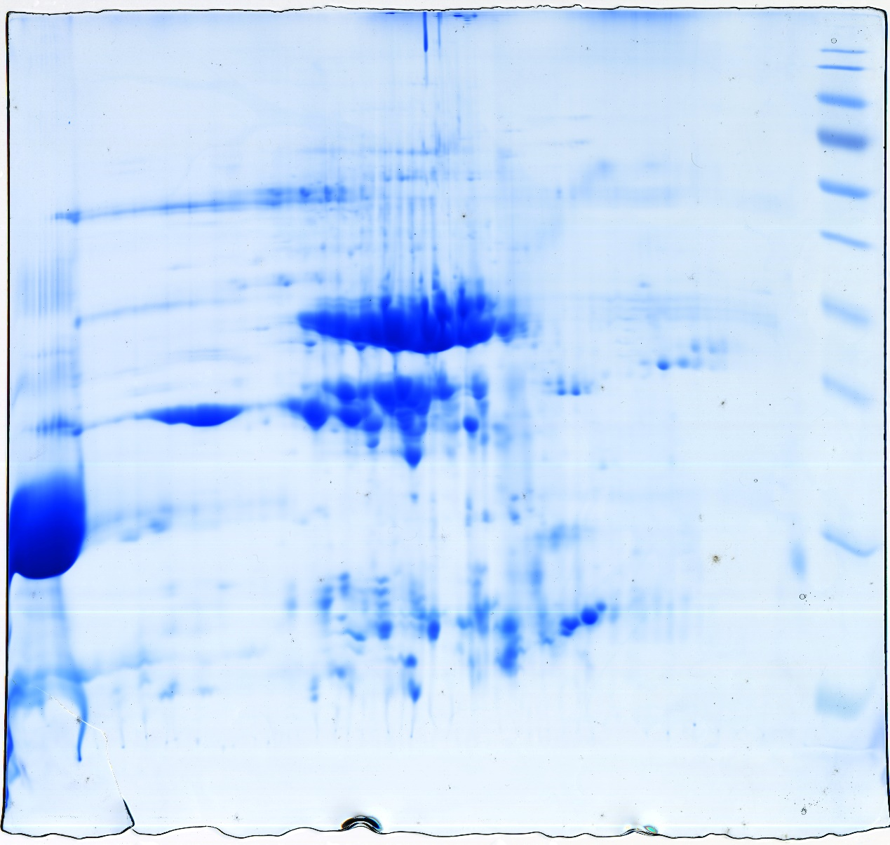
Fig. 6 D: proteomics analysis of Phellodendron chinense Schneid seeds under water treatment at 9 d

Fig. 6 E: proteomics analysis of Phellodendron chinense Schneid seeds under GA₃ treatment at 0 d

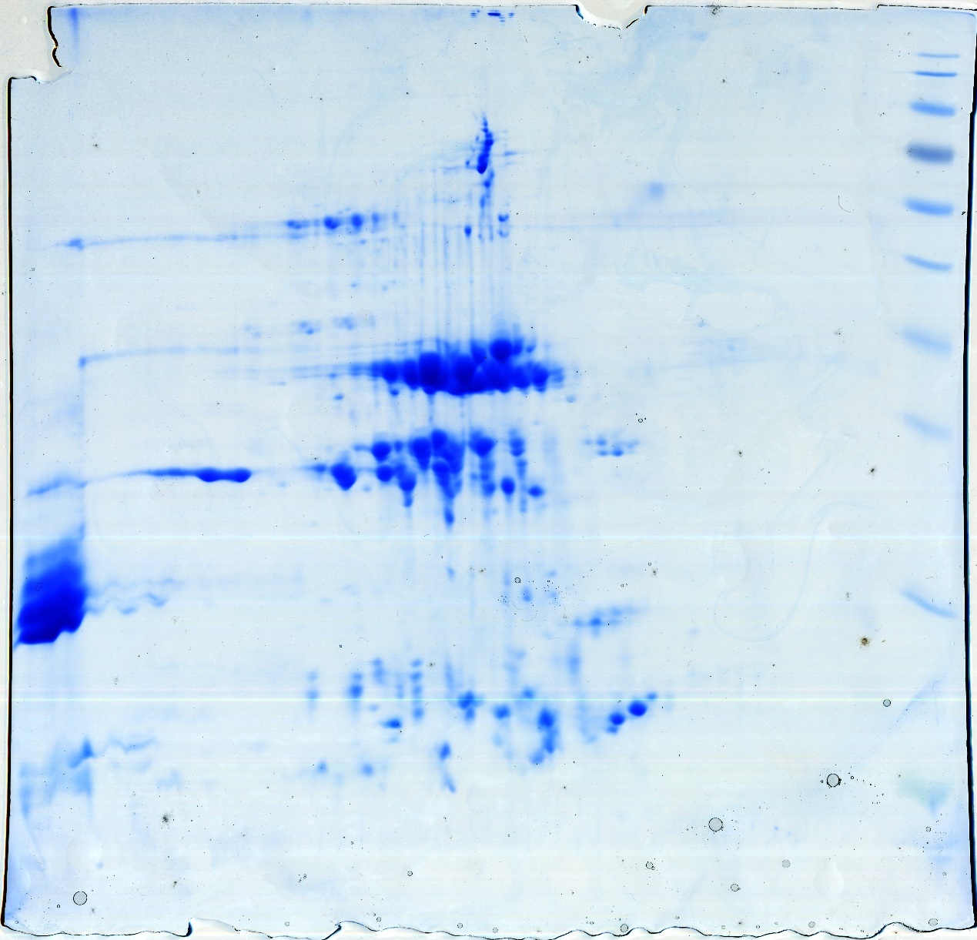
Fig. 6 F: proteomics analysis of Phellodendron chinense Schneid seeds under GA₃ treatment at 3 d

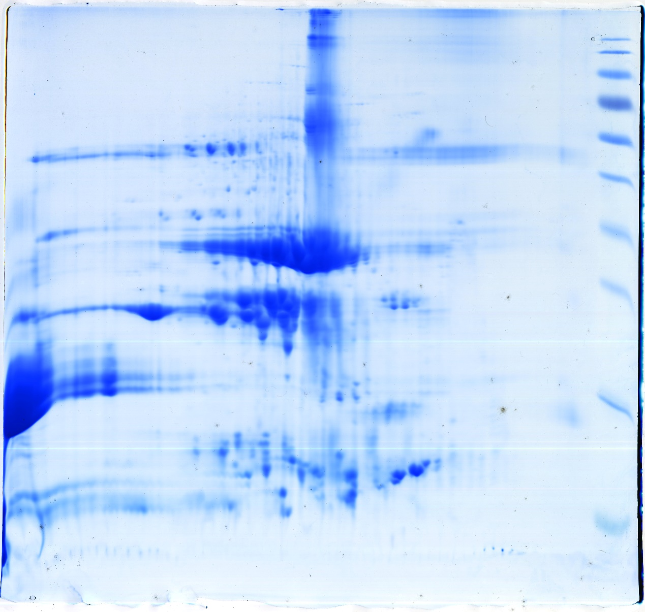
Fig. 6 G: proteomics analysis of Phellodendron chinense Schneid seeds under GA₃ treatment at 6 d

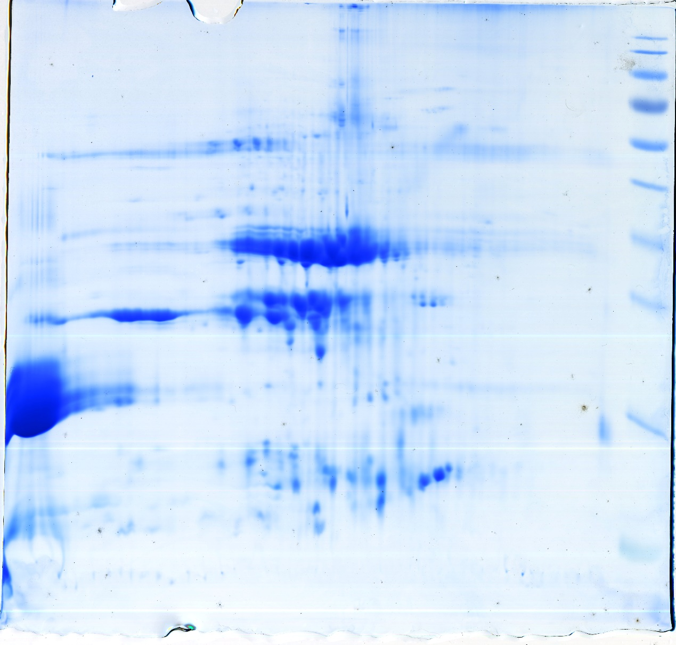
Fig. 6 H: proteomics analysis of Phellodendron chinense Schneid seeds under GA₃ treatment at 9 d

