Figure 1 GC-MS.pdf

Figure 2A. excel
Figure 2B. excel
Figure 2C
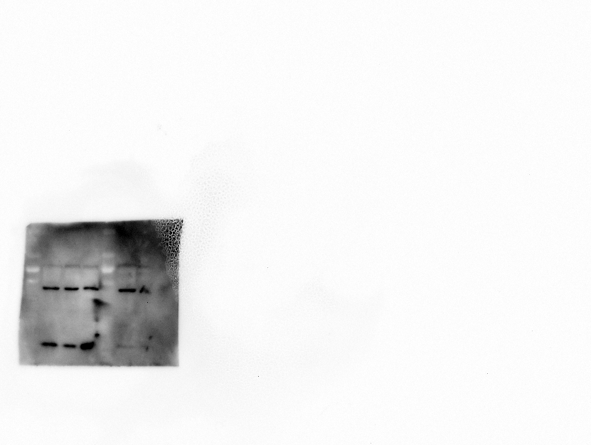
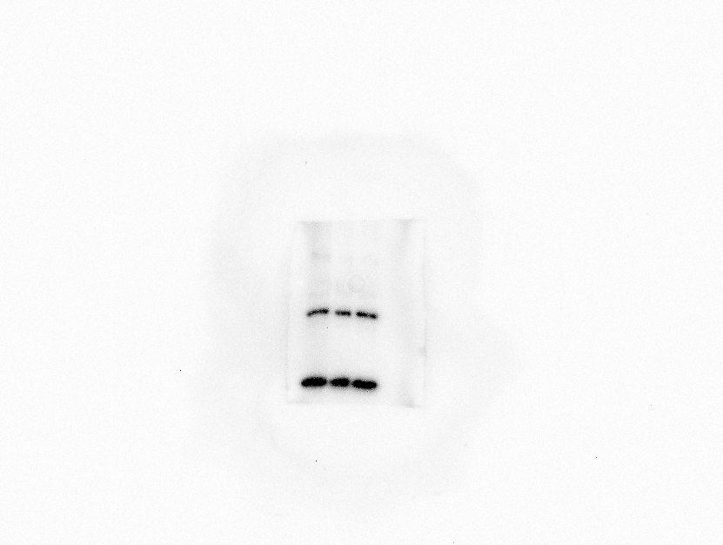
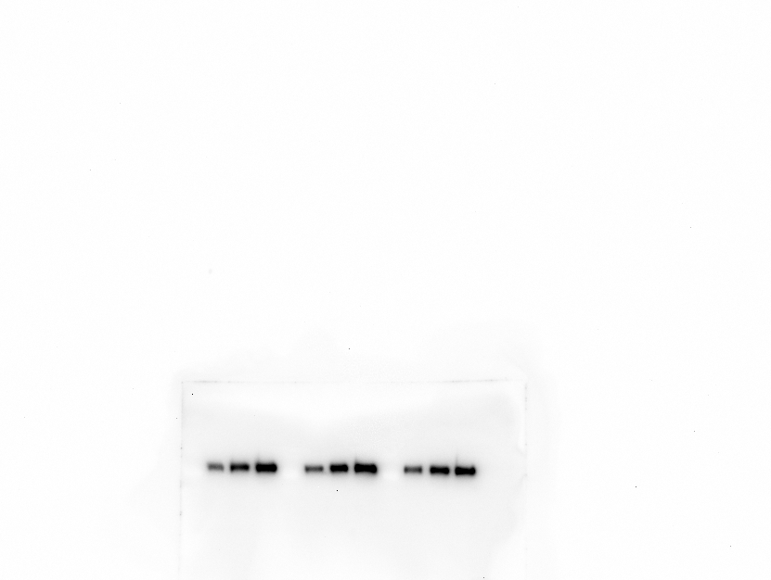
SOX9

COLLAGEN2

AGGRECAN

β-actin

Figure 3A
ADAR1

ADAR2

ADAR3

β-actin

Figure 3B. excel
Figure 3C
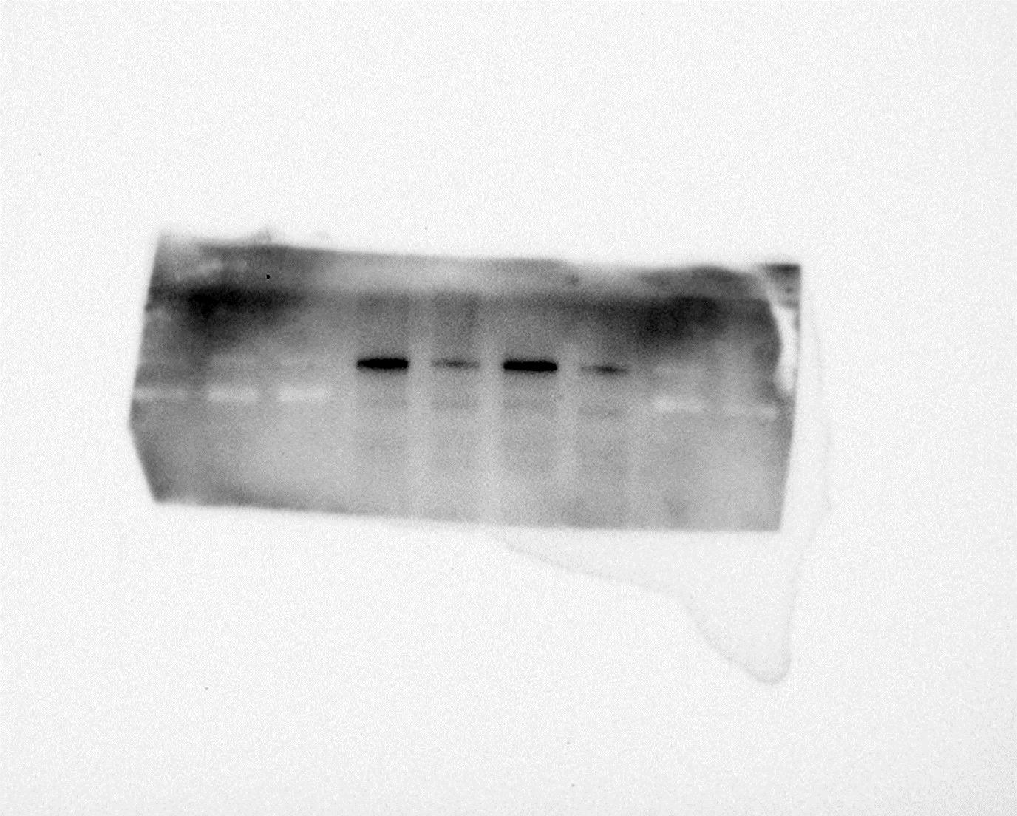
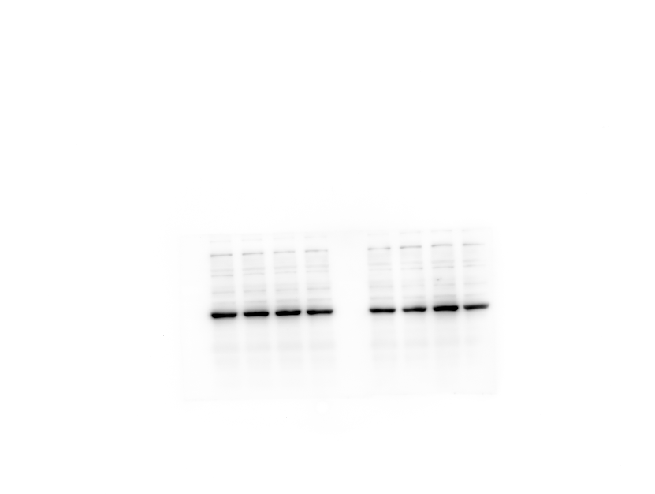
ADAR2

β-actin

Figure 3D
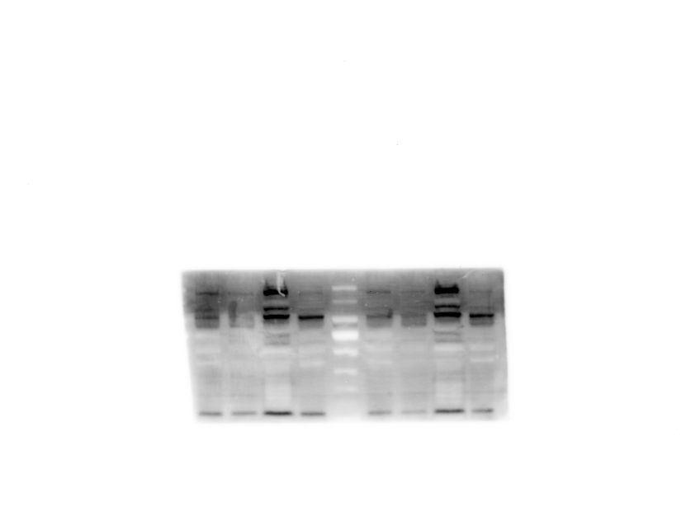
ADAR2

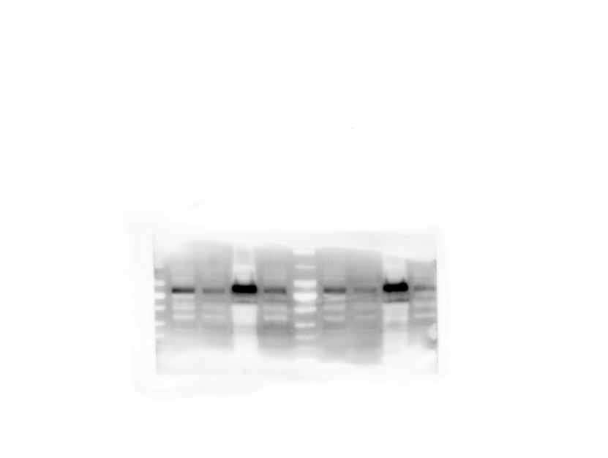
SOX9

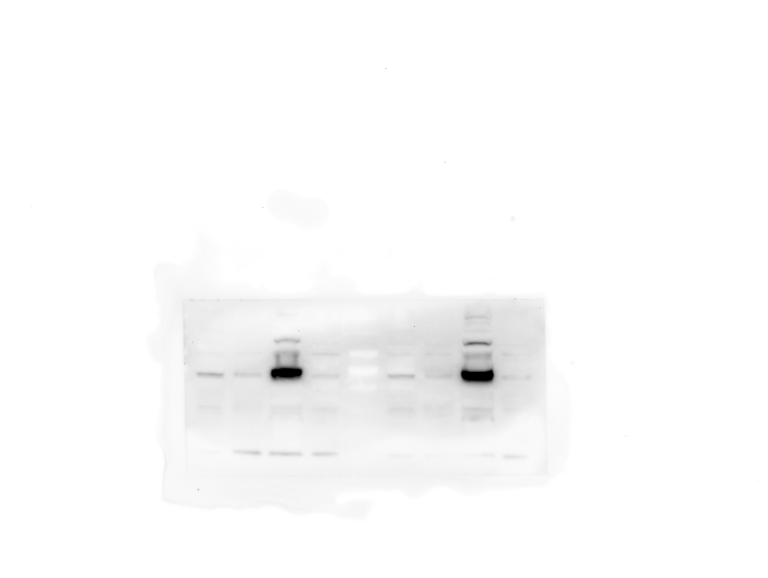
COLLAGEN2
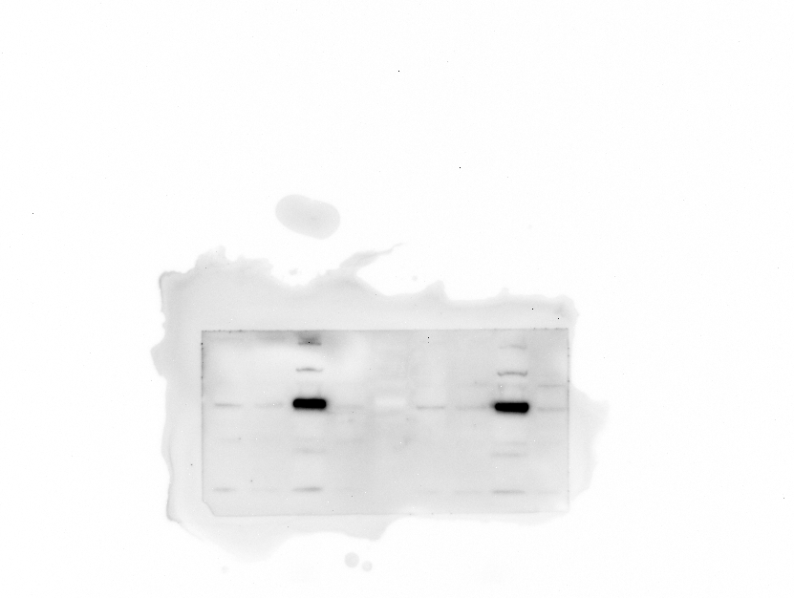
AGGRENCAN

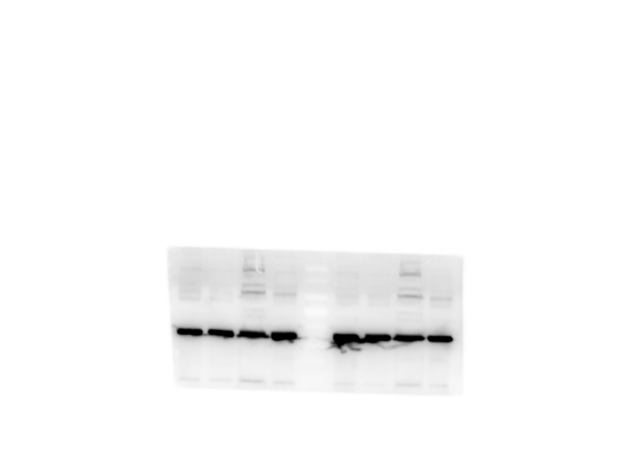
β-actin

Figure 4A. excel
Figure 4B. excel

Figure 5A. excel
Figure 5B
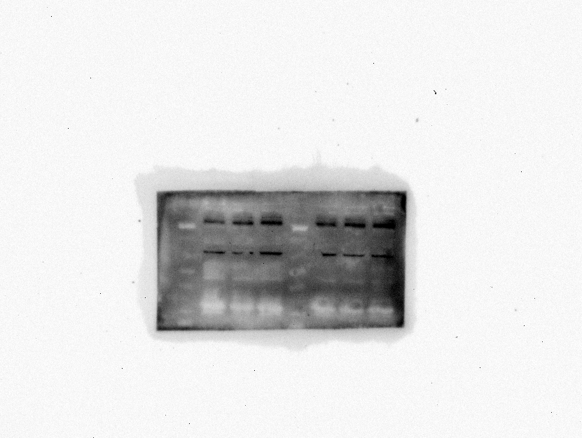
SOX9

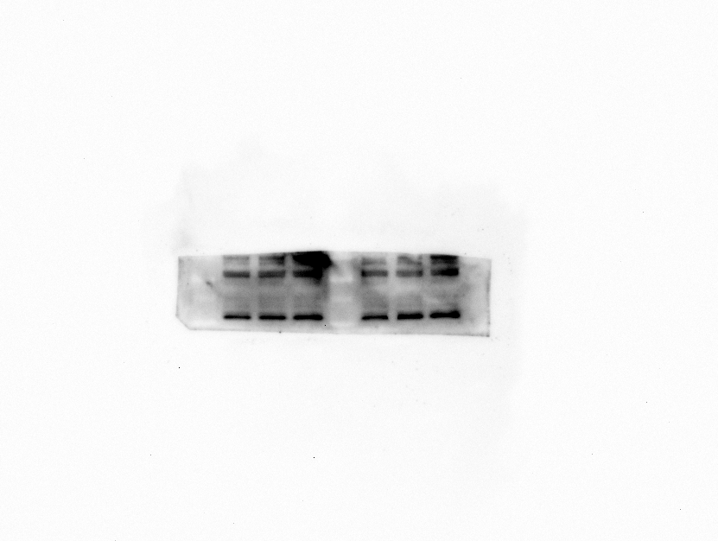
COLLAGEN2

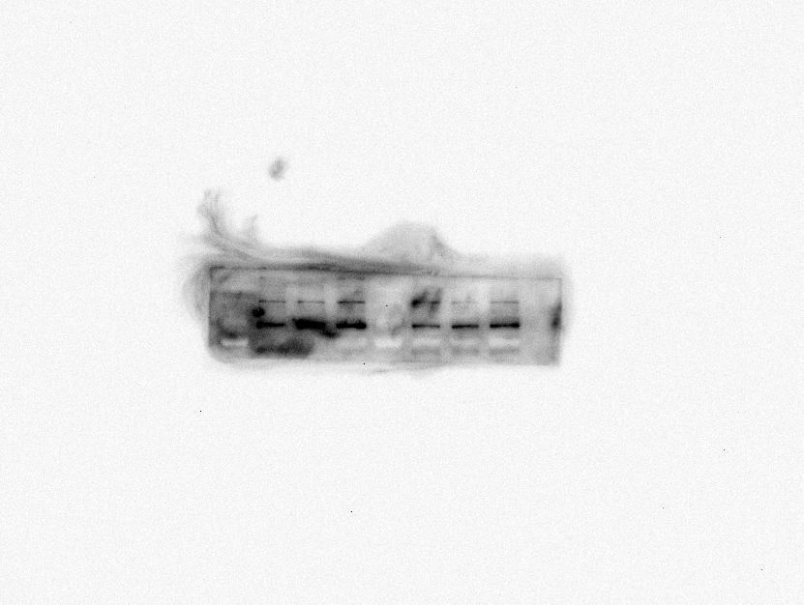
AGGRECAN

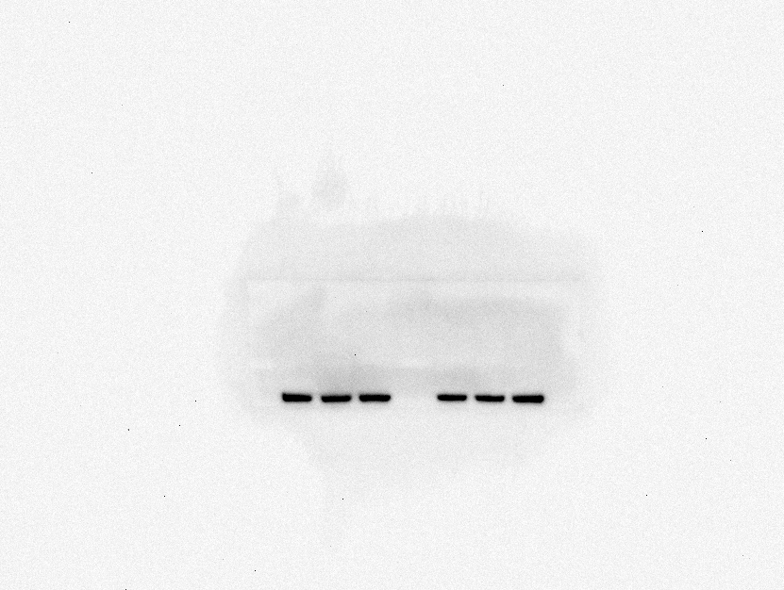
β-actin

Figure 5D. excel

Figure 6A
YY1

β-actin

Figure 6B. excel
Figure 6D
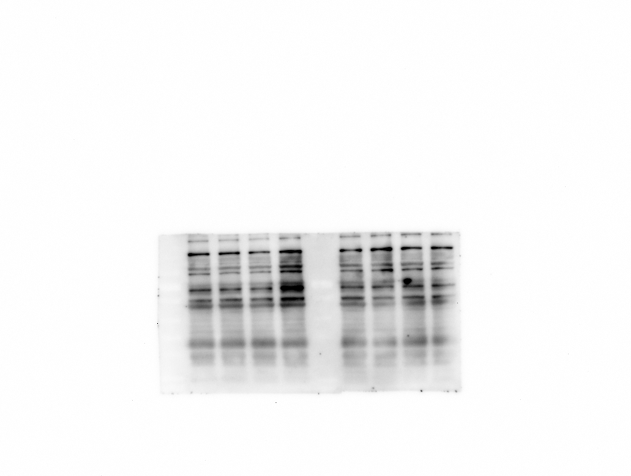
YY1

β-actin

Figure 6E. excel

