Supplemental Methods
Plasmid construction and lentivirus packaging
The lentiCRISPR v2 plasmid and PLKO-1.0 backbone plasmid were gifts from Professor Shi Zhi in Jinan University (Guangzhou, China). The primer sequences of HER3-KO, shCYLD#1 and shCYLD#2 plasmids construction were listed in Supplemental Table 3. Oligos were annealed and ligated with lentiviral backbone vector. The CYLD overexpression lentivirus plasmid was synthesized by GENE Biotechnology (Shanghai, China), and the HER3-FLAG overexpression plasmid was synthesized by YouBio Biotechnology (Changsha, China). All plasmids used in this study were verified by sequencing. Lentiviral transfection was conducted following the manufacturer’s instructions. The stable cell lines were selected by puromycin for 2 weeks.

CCK8 cell survival assay
Cells were seeded into 96-well plates (5×10³ per well) and treated with different doses of cisplatin, TX1-85-1 or Verapamil. After an incubation period of 72h, OD values were measured by CCK-8 Kit (Dojindo Laboratories, Shanghai, China) using a luminometer at absorbance 450 nm, then cell viability levels were analyzed based on the OD value. Experiments were repeated independently for at least three times.

Apoptosis assay
Cells were seeded into 6-well plate at a density of 2×10⁵/well with different treatment. About 48 hours later, cells were harvested and washed twice with PBS, dyed with apoptosis detection kit (BD Biosciences, California, USA). Cell fluorescence were measured by flow cytometry (CyFlow Space/Partec, Germany), and the data were analyzed by Flow Jo.

Immunoprecipitation
The cells were seeded into 10 cm plate at a density of 1×10⁸cells/plate, and transfected with the HER3-FLAG plasmid for 48h. Cells were treated with FLAG Immunoprecipitation Kit (Sigma, Missouri, USA) according to the manufacturer’s protocol. The protein samples were separated by 10% SDS PAGE gel and differential protein bands were detected by enhanced chemiluminescent substrate.

Rhodamine 123 accumulation assay
Indicated cells were seeded into 6-well plates (2×10⁵ per well), and incubated with various concentrations of Rhodamine 123 for 2 hours at 37°C. After washing with PBS for three times, cells were incubated with PBS for different time point. Then cells were analyzed with flow cytometry (CyFlow Space/Partec, Germany), and the fluorescence intensity were analyzed by Flow Jo.

Supplemental Figure legends
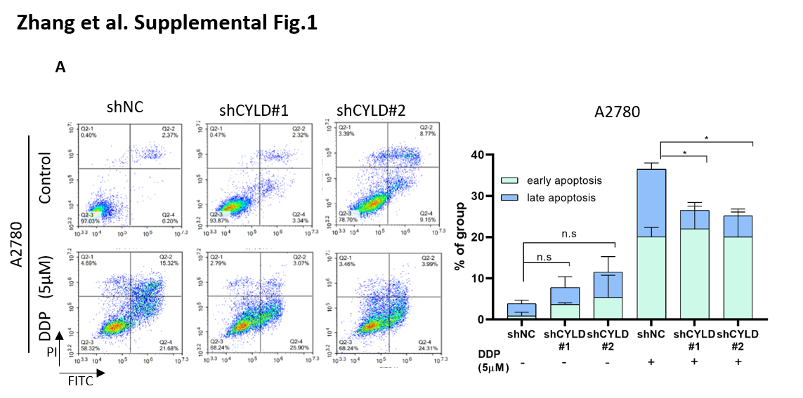Sup.Fig.1 CYLD Knockdown inhibited apoptosis activity in ovarian cancer cells.
(A). After incubated with 5μM DDP or PBS for 48h, the apoptosis rate were detected by flow cytometry in shCYLD cells compared with control cells, and illustrated by the percentage sum of early and late apoptosis rate. Data were statistically analyzed with Student’s t-test and values were shown as mean ± SD. *p < 0.05, **p < 0.01, ***p < 0.001.
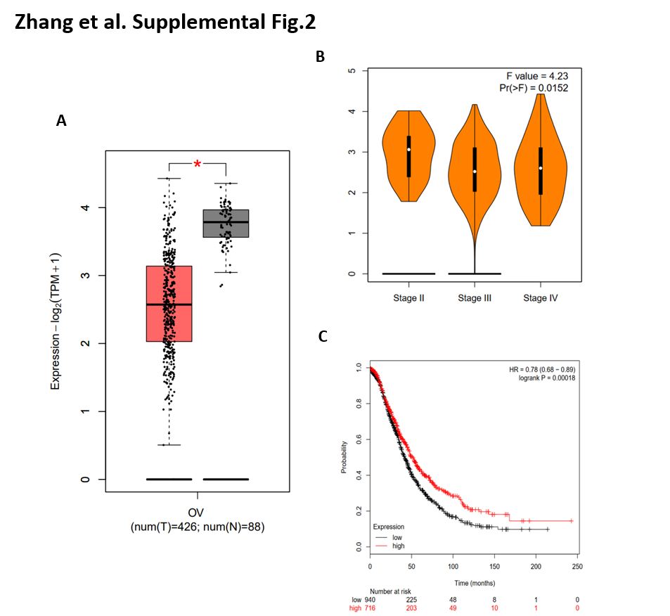
Sup.Fig.2 CYLD was downregulated in ovarian cancer patient samples and correlated with the malignancy and progression of ovarian cancer.
(A). The expression levels of CYLD in ovarian cancer patient samples and normal ovarian samples were analyzed in the GEPIA database (http://gepia.cancer-pku.cn/). (B). As shown in GEPIA database, the expression level of CYLD in Grade III ovarian cancer was lower when compared with Grade II. (C). The higher CYLD expression was implied better survival rate in ovarian cancer patients as suggested in Kaplan-Meier Plotter database (http://kmplot.com/analysis/index.php?p=background).
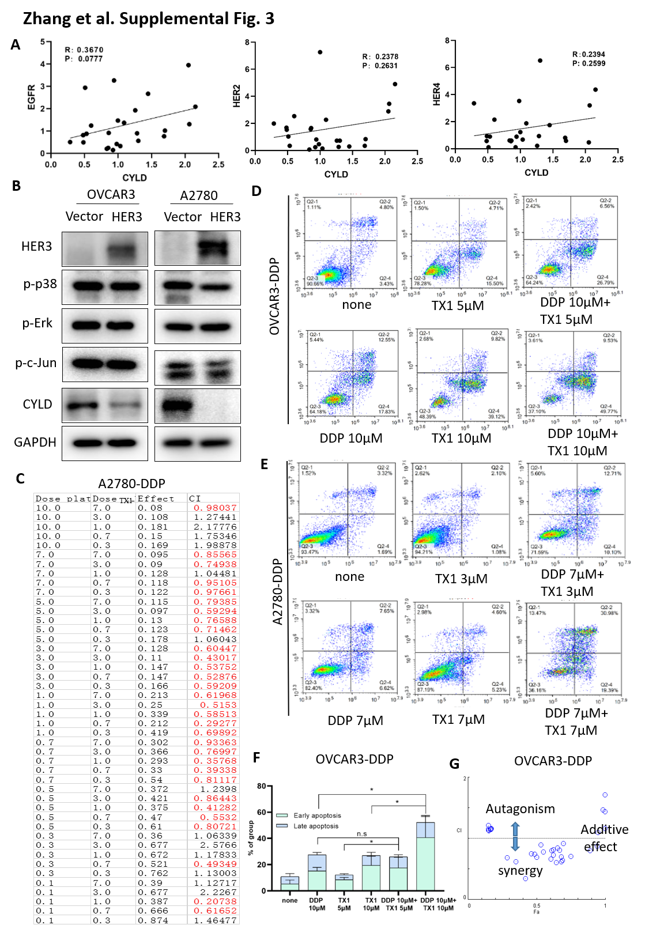
Sup. Fig. 3 HER3 mediated the cisplatin resistance by downregulating CYLD and HER3 inhibitor rendered ovarian cancer cells more sensitive to cisplatin.
(A). The correlation of CYLD and other three ERBB family members (EGFR, HER2, HER4) were measured by Spearman correlation in ovarian cancer patient samples. (B). Western blot analysis showed that protein levels of p-p38, p-Erk and p-c-Jun in HER3 overexpressed OVCAR3/A2780 cells. (C).The combination index (CI) data of different doses of DDP and TX1-85-1 co-treated A2780-DDP were analyzed by CompuSyn software. (D, E). The cell apoptosis of cisplatin resistance ovarian cancer cell line (OVCAR3-DDP and A2780-DDP) co-treated by DDP and TX1-85-1 were detected by Flow cytometry analysis. (F). And the apoptosis rate of OVCAR3-DDP were illustrated by the percentage sum of early and late apoptosis. (G). The drug combination analysis of DDP and TX1-85-1 in OVCAR3-DDP cell were analyzed using CompuSyn software. The Fa-CI plot was shown. Data were statistically analyzed with Student’s t-test and values were shown as mean ± SD. *p < 0.05, **p < 0.01, ***p < 0.001.
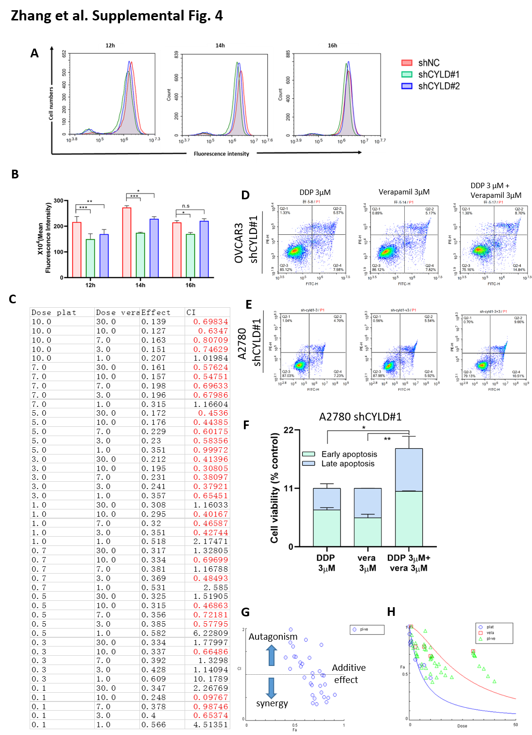
Sup. Fig. 4 CYLD knockdown induced DDP resistance via promoting the expression of drug pump protein ABCB1，and ABCB1 inhibitor reversed cisplatin resistance in ovarian cancer.
(A). OVCAR3 treated with shCYLD1 or shNC were incubated with PBS for different time points (12h, 14h and 16h) at 37°C after pre-treated with 2μM Rhodamine 123 for 2 hours at 37 °C, then the accumulation of Rhodamine 123 in cells by Flow cytometry were measured. (B). The quantified data of OVCAR3 cells treated with shCYLD1 or shNC in Fig.4a were shown. (C). The combination index (CI) data of different doses of DDP and Verapamil co-treated OVCAR3-shCYLD1 were analyzed by CompuSyn software. (D, E). The cell apoptosis of cisplatin resistance ovarian cancer cell line co-treated by DDP and Verapamil were detected by Flow cytometry analysis. (F). And the apoptosis rate of A2780-shCYLD#1 were illustrated by the percentage sum of early and late apoptosis. (G, H). The drug combination analysis of DDP and Verapamil in A2780-shCYLD#1 cells were analyzed using CompuSyn software. The dose-effect curve and Fa-CI plot were shown. Data were statistically analyzed with Student’s t-test and values were shown as mean ± SD. *p < 0.05, **p < 0.01, ***p < 0.001.

Supplemental Tables
Sup. Table 1. The primers used for real-time quantitative PCR
Gene | Sequence
CYLD | Forward: TTGGCAACTGGGATGGAAGA
CYLD | Reverse: TCCTTTCCTGCGTCACACTC
EGFR | Forward: GACAGGCCACCTCGTCG
EGFR | Reverse: CCGGCTCTCCCGATCAATAC
HER2 | Forward: CCGGAGCCGCAGTGAG
HER2 | Reverse: TGTGCCGGTGCACACTTG
HER3 | Forward: CTCCGCTTGACTCAGCTCAC
HER3 | Reverse: ATCTCAGCATCTCGGTCCCT
HER4 | Forward: GTTCAGGATGTGGACGTTGC
HER4 | Reverse: CTGCCGTCACATTGTTCTGC
GAPDH | Forward: TGAACGGGAAGCTCACTGG
GAPDH | Reverse: TCCACCACCCTGTTGCTGTA

Sup. Table 2. The antibodies used for western blot or Immunohistochemistry
Protein | Company | Catalog Number | Application
CYLD | Cell Signaling Technology | #8462s | WB, IHC
HER3 | Abways | CY5270 | WB
RIP | Abways | CY6582 | WB
Bcl-2 | Abways | CY5032 | WB
Bax | Abways | CY5059 | WB, IHC
Bcl-XL | Abways | CY5050 | WB, IHC
Survivin | Abways | CY5070 | WB
Bcl-3 | Proteintech | 23959-1-AP | WB
ABCB1 | Cell Signaling Technology | #13342s | WB
ABCB9 | ZEN Bioscience | 860017 | WB
ABCC1 | Cell Signaling Technology | #72202s | WB
ABCG2 | Abgent | AP1490c | WB
ABCB1 | Proteintech | 22336-I-AP | IHC
GAPDH | Bioword | AP0063 | WB
β-actin | Bioword | AP0060 | WB
p-STAT3(Thr705) | Cell Signaling Technology | #9145s | WB
STAT3 | Cell Signaling Technology | #9139s | WB
Ki-67 | Proteintech | 27309-I-AP | IHC
p-p38 | Cell Signaling Technology | #4511s | WB
p-Erk(p44/42MAPK) | Cell Signaling Technology | #4370s | WB
p-c-Jun(Ser73) | Cell Signaling Technology | #3270s | WB

Sup. Table 3. The primers used for plasmid construction
Plasmid | Sequence
HER3-KO | Forward: CACCGCACTGTACAAGCTCTACGAGG
HER3-KO | Reverse: AAACCTCGTAGAGCTTGTACAGTGC
shCYLD#1 | Forward:CCGGGAAGAAGGTCGTGGTCAAGGTCTCGAGACCTTGACCACGACCTTTTCTTTTTG
shCYLD#1 | Reverse:AATTCAAAAAGAAGAAGGTCGTGGTCAAGGTCTCGAGACCTTGACCACGACCTTCTTC
shCYLD#2 | Forward:CCGGGCCCAATACCAATGGAAGTATCTCGAGATACTTCCATTGGTATTGGGCTTTTTG
shCYLD#2 | Reverse:AATTCAAAAAGCCCAATACCAATGGAAGTATCTCGAGATACTTCCATTGGTATTGGGC

