Supplementary Materials for

Selective Terminal Functionalization of Linear Alkanes

Jeffrey Bruffaerts¹, Keren Buhnik-Rosenblau², Anthony Cohen¹, Inbar Kesten², Morgan Cormier¹, Yuanfei Zhang¹, Guo-Ming Ho¹, Itai Massad¹, Nurit Edri,² Hila Halfon-Verner², Fabian Glaser,³ Guy Horev,³ Yechezkel Kashi^{2*} & Ilan Marek^{1*}

Correspondence to: chilanm@technion.ac.il (IM)

This PDF file includes:

Materials and Methods Page 2
NMR analyses and experimental details Page 10
Table S1 Page 19 Fig. S1 Page 21
Table S2 Page 22
Fig. S2 Page 24
Table S3 Page 25
Fig. S3 Page 26
NMR Spectra Page 27
References Page 56

Materials and Methods

General information
Unless stated otherwise, all tools used in contact with bacterial strains were sterile or sterilized prior use and all manipulation in their presence were conducted next to a gas flame. The mutant strain KSM-B-3M was obtained from the Japanese National Institute of Technology and Evaluation (NITE) under the code name FERM BP-1531 and with the consent of the main depositor of the original patent (Dr. Kenzo Koike, US 5059532).
Unless stated otherwise, chemically based reactions were conducted in flame-dried glassware under a positive pressure of argon. Ether and THF were dried from Pure-Solv® Purification System (Innovative Technology©). All other commercially obtained reagents were used as received. Thin-layer chromatography (TLC) was conducted with E. Merck silica gel 60 F254 pre-coated plates, (0.25 mm) and visualized by exposure to UV light (254 nm) or stained with anisaldehyde, phosphomolybdic acid or potassium permanganate. Column chromatography was performed using Fluka silica gel 60 Å (40-63mm, 230-400 mesh). NMR spectra were recorded on Bruker spectrometers (AVIII400) and are reported relative to residual deuterated solvent signals. Chemical shifts are reported in parts per million (ppm) with respect to the residual solvent signal CDCl₃ (¹H NMR: δ = 7.26; ¹³C NMR: δ = 77.16). Peak multiplicities are reported as follows: s = singlet, bs = broad singlet, d = doublet, t = triplet, dd = doublet of doublets, td = triplet of doublets, m = multiplet. High-resolution mass spectra (HRMS) were obtained by the mass spectrometry facility at Technion. Reactions were monitored by gas chromatography spectrometry (GC) using an Agilent Technologies 7820A GC with an Agilent Technologies 19091J-413 (30 m × 0.3 mm) column.

Optimization of the Rhodococcus biocatalytic n-hexadecane dehydrogenation

The following parameters were optimized to lead to the General Procedure for the dehydrogenation reaction mediated by Rhodococcus mutant strain KSM-B-3M. The time of comparison of all GC conversions was arbitrarily determined after 7 days.

See Table S1

General Procedure for the dehydrogenation reaction mediated by Rhodococcus mutant strain KSM-B-3M

Rhodococcus sp. strain KSM-B-3M cells were grown in a nutrient broth solution (NB n°3; Sigma Aldrich, Israel cat. 70149) for 20-24 h at 30 ºC and under agitation at 180 rpm. 1 mL of bacterial culture was sub-cultured in fresh NB (200 mL) for an additional 20-24 h incubation at 30 ºC under agitation at 180 rpm. Bacterial cells were sedimented at 4800 g for 10 min and washed with saline to remove medium leftovers. One gram of wet KSM-B-3M cells was dissolved in 57.5 mL of freshly prepared sterile medium A (0.46 M KH₂PO₄, 0.32 M K₂HPO_{4,} 21.3 mM MSG, 0.3 mM thiamine hydrochloride and 0.4 mM magnesium sulfate heptahydrate; pH = 6.4) supplemented with 8.5 mmol of the neat substrate in a sterile 250 mL Erlenmeyer flask bearing a breathable cork. Flasks were stirred in a shaker incubator (180 rpm, 30 °C) over the course of several days. Monitoring the progression of the dehydrogenation reaction was conducted by gas chromatograph (GC) analyses of 0.5 mL samples sequentially taken from flasks. After reaction, the phases were separated, and the aqueous phase was extracted with EtOAc (3x20 mL). The combined organic phases were dried over MgSO₄ anhydrous and concentrated under reduce pressure. The desired products were purified through a short pad of silica gel (100% hexane to 1% Et₂O/hexane) for analysis.

For the specific case of n-eicosane as substrate, the protocol differs and is as follow:
One gram of wet KSM-B-3M cells was dissolved in 57.5 mL of freshly prepared sterile medium A (0.46 M KH₂PO₄, 0.32 M K₂HPO_{4,} 21.3 mM MSG, 0.3 mM thiamine hydrochloride and 0.4 mM magnesium sulfate heptahydrate; pH = 6.4) supplemented with 8.5 mmol n-Eicosane dissolved into n-dodecane (8.5 mmol) in a sterile 250 mL Erlenmeyer flask bearing a breathable cork. Flasks were stirred in a shaker incubator (180 rpm, 30 °C) over the course of several days. Monitoring the progression of the dehydrogenation reaction was conducted by gas chromatograph (GC) analyses of 0.5 mL samples sequentially taken from flasks. After reaction, the phases were separated, and the aqueous phase was extracted with EtOAc (3x20 mL). The combined organic phases were dried over MgSO₄ anhydrous and concentrated under reduce pressure. The desired products were purified through a short pad of silica gel (100% hexane to 1% Et₂O/hexane) for analysis.

All alkenes could not be separated from their saturated precursors and were described as mixtures. The dehydrogenation ratios were evaluated by GC (attached chromatograms). Reported yields were corrected according to these dehydrogenation ratios. In all reported cases, only the Z resulting olefins were observed by NMR (Z/E > 99:1). The regioisomeric ratios (determined by GC analyses of the compounds following an ozonolysis treatment) were found to be similar to the previously reported compounds.

Scope of the biocatalytic desaturation with Rhodococcus KSM-3-BM

Using the General Procedure for the dehydrogenation reaction mediated by Rhodococcus mutant strain KSM-B-3M, several other alkanes and alkyl derivatives (unless otherwise stated, 8.5 mmol of substrate were used) were tested and provide lower conversion as described below.

In the presence of the following substrates, the dehydrogenation reaction occurred with a relatively low productivity (GC yield $≈$ 15% after 10 days) using the strain Rhodococcus KSM-3-BM under our standard reaction conditions.

In the presence of the following compounds, no dehydrogenation reaction was observed using the strain Rhodococcus KSM-3-BM under our standard reaction conditions.

General procedure for bacterial recovery and recycling experiments
Following the General Procedure described previously using hexadecane as model substrate, the biphasic suspension was transferred into a falcon tube and centrifuged at 4800 rpm for 10 min until the appearance of three visible phases/layers (see image below).

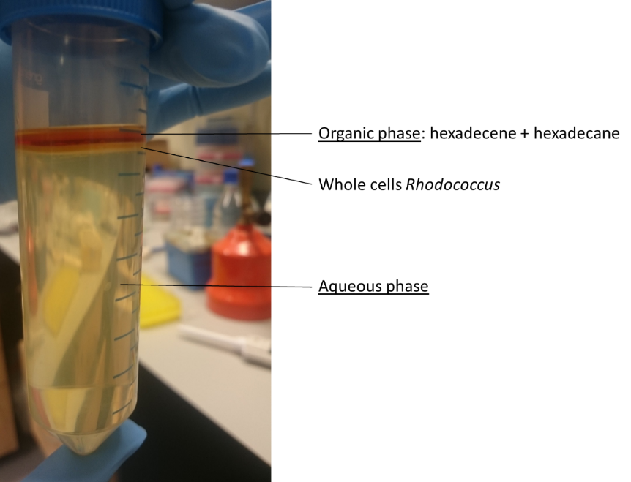

The intermediary phase containing the bacterial strain (see image below) was recovered by carefully removing both organic and aqueous phases with a sterile pipette, resuspended in fresh liquid medium (57.5 mL) containing 8.5 mmol n-hexadecane and incubated as described above in the General procedure for the dehydrogenation of hexadecane.

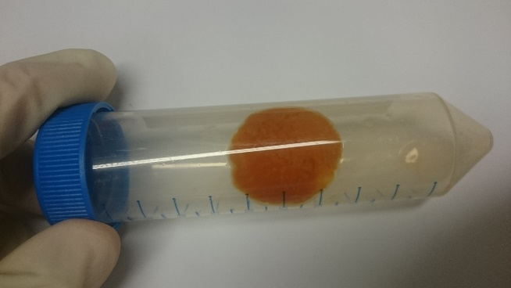

DNA extraction and genome sequence of Rhodococcus KSM B-3M

Gram-positive bacteria treatment of DNeasy Blood and Tissue kit (QIAGEN, Hilden, Germany) was used as the first step of the DNA extraction protocol, with slight modifications prior to cell lysis. Briefly, 100ml of overnight KSM B-3M cultures grown on NB were centrifuged at 4,800xg for 5 min at 15 °C, and the pellet was stored at -20 °C for 1 hr. The thawed pellet was suspended with 200 µl cell lysis containing: 20 mM Tris-Cl at pH = 8, 2 mM sodium EDTA, 1.2% Trition X-100, and 20mg lysozyme, and incubated at 37 °C for 1 hr. Then, samples were treated using the DNeasy protocol, according to the manufacturer’s instructions¹.

Phylogenetic analysis of Rhodococcus strains

To identify the closest Rhodococcus strain to KSM B-3M, whole genome sequencing was performed and assembly of KSM B-3M was generated using SPAdes². We used RealPhy³ to reconstruct the phylogenetic tree that includes unassembled reads of KSM B-3M, the assembly of KSM B-3M, 13 published genomes of Rhodococcus, and two genomes of Nocardia Farcinica strains that served as outgroup. Mapping of the reads was performed with bowtie2⁴. PhyML was used to build the tree⁵. The R package ggtree⁶ was used to generate a phylogram visualization of the tree.

Cell recovery and RNA extraction

RNA was extracted from Rhodococcus sp. KSM B-3M and from Rhodococcus sp. 008 cultures after a six days period either in medium A (see above) with hexadecane or in medium A with dodecane. Systems were set as described at “General Procedure for the dehydrogenation reaction mediated by Rhodococcus mutant strain KSM-B-3M”, see above.

Recovery of Rhodococcus sp. KSM B-3M or Rhodococcus sp. 008 cells from medium A with hexadecane or dodecane.
15 mL portion of each culture was centrifuged at 400g during 1 min at room temperature (RT) to separate the aqueous from the organic phases. The organic phase (0.5 - 1 mL fractions) was centrifuged again (9600g, 1 min, RT) and the aqueous and organic phases leftovers were removed. The intermediate phase containing bacterial cells was dissolved in two volumes of RNAprotect Bacteria Reagent (Cat No. 76506, Qiagen, Israel). Samples were mixed using constant vortex for 5 min followed by bacterial cells sedimentation and removal of the supernatant. All centrifugation steps were conducted at RT to avoid alkane solidification, and therefore calibrated for the shortest duration, to prevent RNA degradation and change in the RNA expression profile.

RNA extraction.
First, cells were treated according to protocol no. 5 (enzymatic Lysis, proteinase K digestion, and mechanical disruption of bacteria) as described at the RNAprotect® Bacteria Reagent Handbook⁷. An enzymatic mixture composed of 100 μl lysozyme (15 mg/ml TE; Cat No. L6876, Sigma Aldrich, Israel) and 20 μl proteinase k (Cat No. 19131, Qiagen, Israel) was added to the bacterial cell pellets for 10 min, while mixing by vortex for 10 sec every 2 min. 700 μl buffer RLT (RNeasy mini kit, Cat No. 74104, Qiagen, Israel) supplied with 0.1% (v/v) 2-mercaptoethanol was added followed by vortex for 10 sec, and mechanical disruption was then achieved by adding 50 mg of acid washed glass beads (Cat No. G8772, Sigma Aldrich, Israel) and constant vortex for 5 min. Samples were centrifuged for 10 sec at maximum speed, and 760 μl of the supernatant was transferred to a new tube. 590 μl Ethanol 80% were added to the supernatant and shaken vigorously. Samples were then subjected to RNA isolation using Rneasy mini kit (Cat No. 74104, Qiagen, Israel) according to the manufacturer’s instructions.

Elimination of DNA contamination.
Pure RNA samples were treated with DNAse (Cat No. 79254, Qiagen, Israel) under conditions ranging from 0.07 – 0.14 Kunitz units/μl and 10-30 min, dependent on the degree of DNA contamination. Lack of DNA contamination was verified based on both DNA fluorimetric quantification (Qubit) and the absent of DNA templet for PCR amplification targeting the 16S sequences of both Rhodococcus strains (F: 5’ TCGTCGGTGATTGTTCATTC 3’, R: 5’ TCCCTGCTGAAAGAGGTTTA 3’). Each PCR mixture contained 0.2 mM deoxynucleoside triphosphates, 0.4 μM forward and reverse primers, 0.02 U/μl of Taq polymerase (SuperNova, JMR Holding, Kent, England), 1× reaction buffer (containing 1.5 mM MgCl₂) and 5 μl of extracted RNA, before or after DNAse treatment, in a total volume of 25 μl. The reactions were carried out in a Veriti 96-well thermal cycler (Applied Biosystems, California, USA) as follows: 95 °C for 3 min; 30 cycles of 30 s at 95 °C, 30 s at 60 °C, and 90 s at 72 °C; 10 min at 72 °C. Presence or absence of PCR amplification products was detected by gel electrophoresis (1.2% agarose; Cat No. A9539, Sigma Aldrich, Israel). Sequencing libraries were prepared starting with total RNA using Illumina ScriptSeq Complete Kit (Bacteria) according to manufacturer instructions. Sequencing was done on Illumina HiSeq 2500 using one 50 SR high output lane. Differential analysis of RNA expression was performed with the R software environment for statistical computing and graphics using the packages RUVseq and DESeq⁸.

Quantitative PCR

RNA was extracted, as described above from Rhodococcus sp. KSM-B 3M and from Rhodococcus sp. 008 cultures after a seven days period in medium A with hexadecane, or after 24 hours on NB. Single stranded cDNA was synthesized with High Capacity cDNA Reverse Transcription Kit (Thermo Fisher Scientific, Lithuania). q-PCR, specific primers for acyl-CoA desaturase (F: 5’ TCTGCGCGTCGTCGATAC 3’; R: 5’ TGGCGTCACTCGCACAAC 3’), ferredoxin reductase (F: 5’-GGTGCAGGAGAAGCAGATTCC-3’; R: 5’-GGCGGCGAGGTGTCATT-3’) and hypothetical gene (F: 5’-TGTCGTCGTGCTCGATGGT-3’; R: 5’-CGGAATCGAGATGCGTGAA-3’) was used with primers for 23s rRNA and 16s rRNA as described before⁹ as internal standards. q-PCR performed with 0.2 ng cDNA and 5µl Fast SYBR™ Green Master Mix (Applied Biosystems, USA). Gene expression was calculated using comparative CT method (2^{-ΔCT}).

Proteolysis and Mass Spectrometry Analysis

The samples were dissolved in 10 mM DTT 100 mM Tris and 5% SDS. Glass beads were added, and the samples were vortexed for 30 minutes in bead bitter. The supernatant was transferred to a clean tube and sonicated twice (5 minutes, 10-10, 90%). The samples were boiled in 95 °C for 10 minutes. The samples were precipitated in 80% acetone in water and washed 3 times with 80% acetone in water. The protein pellets were dissolved in 9 M urea and 400 mM ammonium bicarbonate then reduced with 10 mM DTT (60 ºC for 30 min), carboxymethylated with 35 mM iodoacetamide (room temperature for 30 min in the dark) and digested in 2 M urea, 66 mM ammonium bicarbonate with modified trypsin (Promega), at a 1:50 enzyme-to-substrate ratio, overnight at 37 ºC. An additional second trypsinization was done for 4 hours in 1 M urea.
The resulting tryptic peptides were desalted using C18 stage-tips (homemade from 3 M Empore disks of either C18 or SCX material) dried, re-suspended in 0.1% TFA, and cleaned on SCX stage tips (homemade). The peptides were resolved by reverse-phase chromatography on 0.075 X 180-mm fused silica capillaries (J&W) packed with Reprosil reversed phase material (Dr Maisch GmbH, Germany). The peptides were resolved by reverse-phase chromatography on 0.075 X 180-mm fused silica capillaries (J&W) packed with Reprosil reversed phase material (Dr Maisch GmbH, Germany). The peptides were eluted with a linear gradient of 5 to 28% acetonitrile with 0.1% formic acid for 180 minutes, 15 minutes with a gradient of 28 to 95% and 25 minutes at 95% acetonitrile with 0.1% formic acid in water at flow rates of 0.15 μl/min. Mass spectrometry was performed by Q- Exactive plus mass spectrometer (Thermo) in a positive mode using repetitively full MS scan followed by collision induces dissociation (HCD) of the 10 most dominant ions selected from the first MS scan.
The mass spectrometry data was analyzed using Proteome Discoverer 1.4 software with Sequest (Thermo) algorithm against Rhodococcus-erythropolis proteome from the Uniprot database, with 1% FDR. Semi quantitation was done by calculating the peak area of each peptide based on its extracted ion currents (XICs), and the area of the protein is the average of the three most intense peptides from each protein.
Rhodococcus binding pocket chimera reconstruction
In order to obtain the residues encompassing the binding pocket in Rhodoccocus Acyl-CoA desaturase, we aligned and identified the equivalent residues in Mouse Acyl-CoA desaturase. Then we selected the binding pocket residues in the Mouse structure around the Stearoyl compound co-crystallized in the mouse structure, within a distance of 6 Ang. We then classified them by similarity, and obtain a list identical (9), similar (9) and different (8) residues (see Table S3). To finally obtained the Rhodococcus binding pocket, we retained identical residues 3D positions, replaced similar residues from Mouse by the corresponding in Rhodococcus, and replaced different or misaligned residues in Mouse by Ala, to minimize their interaction. The in-silico mutations necessary to transform mouse crystal structure of Acyl-CoA desaturase (PDB 4ymk, chain A) to the Rhodococcus binding pocket chimera were introduced by the Chimera Extensible molecular system¹⁰ using information from a rotamer library.
Ligand preparation and docking
To perform docking, the ligands were downloaded from the PubChem database¹¹ and processed by the antechamber program¹². Antechamber package, which ships with AmberTools, created the mol2 sybyl format files required as input for the protein-ligand docking experiments. We then conducted all docking experiments using LeDock program¹³, which samples ligand conformations by a combination of simulated annealing and evolutionary optimization. Docking scores were calculated for a 100 poses by the default scoring function within a 40 x 40 x 40 Å box centered on the original position of the Mouse crystal structure stearoyl-CoA desaturase ligand (on PDB 4ymk), and leaving enough room for full conformation sampling in and around the putative chimeric Rhodococcus binding pocket.

NMR analyses
cis-Hexadecenes (2):
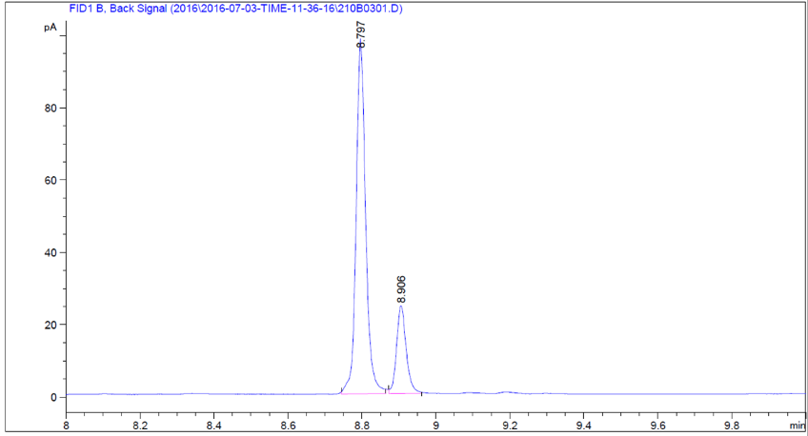
On a 25.5 mmol scale, corrected yield 3453 mg (61%). Dehydrogenation ratio (GC) = 83%. Colorless liquid. E/Z > 99:1. Mixture: ¹H NMR (400 MHz, CDCl₃) δ 5.37 (t, J = 4.6 Hz, 2H), 2.05 (dd, J = 11.9, 6.2 Hz, 4H), 1.29 (m, 21H), 0.91 (t, J = 6.6 Hz, 3H). ¹³C NMR (101 MHz, CDCl₃) δ 130.0, 32.2, 32.1, 30.0, 30.0, 30.0, 29.8, 29.6, 29.6, 29.3, 27.4, 22.9, 22.9, 14.3. HRMS (APCI-MS ES⁺) [M-H]⁺, calculated for C₁₆H₃₃; 249.2556; found 249.2582.

cis-tetradecenes (3):
Corrected yield 283 mg (17%). Dehydrogenation ratio (GC) = 31%. Colorless liquid. E/Z > 99:1. Mixture: ¹H NMR (400 MHz, CDCl₃) δ 5.37 (t, J = 4.7 Hz, 2H), 2.16 – 1.97 (m, 4H), 1.46 – 1.16 (m, 16H), 0.91 (t, J = 6.6 Hz, 6H). ¹³C NMR (101 MHz, CDCl₃) δ 130.1, 130.1, 130.0, 32.3, 32.2, 32.2, 30.1, 30.0, 30.0, 29.8, 29.7, 29.6, 29.6, 27.5, 27.2, 23.0, 22.6, 14.3, 14.2. HRMS (APCI-MS ES⁺) [M-H]⁺, calculated for C₁₄H₂₉; 197.2269; found 197.2278.

cis-pentadecenes (4):
Corrected yield 860 mg (48%). Dehydrogenation ratio (GC) = 74%. Colorless liquid. E/Z > 99:1. Mixture: ¹H NMR (400 MHz, CDCl₃) δ 5.37 (t, J = 4.6 Hz, 2H), 2.11 - 2.01 (m, 4H), 1.41 – 1.24 (m, 18H), 0.96 – 0.87 (m, 6H). ¹³C NMR (101 MHz, CDCl₃) δ 130.3, 130.0, 128.2, 32.2, 32.3, 32.1, 32.1, 31.8, 30.0, 30.0, 29.9, 29.8, 29.7, 29.6, 29.6, 29.6, 29.6, 29.5, 29.5, 29.2, 27.4, 27.4, 22.9, 22.9, 22.9, 22.8, 14.2, 14.2. HRMS (APCI-MS ES⁺) [M-H]⁺, calculated for C₁₅H₃₁; 211.2426; found 211.2401.

cis-heptadecenes (5):
Corrected yield 1180 mg (58%). Dehydrogenation ratio GC = 93%. Colorless liquid. E/Z > 99:1. Mixture: ¹H NMR (400 MHz, CDCl₃) δ 5.43 – 5.34 (m, 2H), 2.11 – 2.00 (m, 4H), 1.46 – 1.22 (d, m, 22H), 0.93 (t, J = 6.8 Hz, 6H). ¹³C NMR (101 MHz, CDCl₃) δ 130.0, 32.2, 32.2, 30.1, 29.9, 29.6, 29.6, 29.6, 29.6, 27.5, 23.0, 14.3. HRMS (APCI-MS ES⁺) [M-H]⁺, calculated for C₁₇H₃₅; 239.2739; found 239.2754.

cis-octadecenes (6):
Corrected yield 735 mg (34%). Dehydrogenation ratio (GC) = 57%. Colorless liquid. E/Z > 99:1. Mixture: ¹H NMR (400 MHz, CDCl₃) δ 5.39 (t, J = 4.7 Hz, 2H), 2.08 (dd, J = 12.0, 6.4 Hz, 4H), 1.33 (m, 24H), 0.94 (t, J = 6.8 Hz, 6H). ¹³C NMR (101 MHz, CDCl₃) δ 130.1, 32.3, 32.3, 30.2, 30.1, 30.1, 29.9, 29.8, 29.7, 29.7, 27.5, 23.0, 14.3. HRMS (APCI-MS ES⁺) [M-H]⁺, calculated for C₁₈H₃₇; 253.2896; found 253.2902.

cis-eicosenes (7):
Corrected yield 695 mg (29%). Dehydrogenation ratio (GC) = 32%. Colorless liquid. E/Z > 99:1. Mixture: ¹H NMR (400 MHz, CDCl₃) δ 5.37 (t, J = 4.6 Hz, 2H), 2.05 (dd, J = 11.8, 6.2 Hz, 4H), 1.29 (s, 28H), 0.91 (t, J = 6.8 Hz, 6H). ¹³C NMR (101 MHz, CDCl₃) δ 130.1, 32.2, 30.1, 30.0, 30.0, 29.7, 29.6, 27.5, 23.0, 14.3. HRMS (APCI-MS ES⁺) [M-H]⁺, calculated for C₁₈H₃₃; 249.2556; found 249.2582.

cis-1,n-hexadecadienes (8):
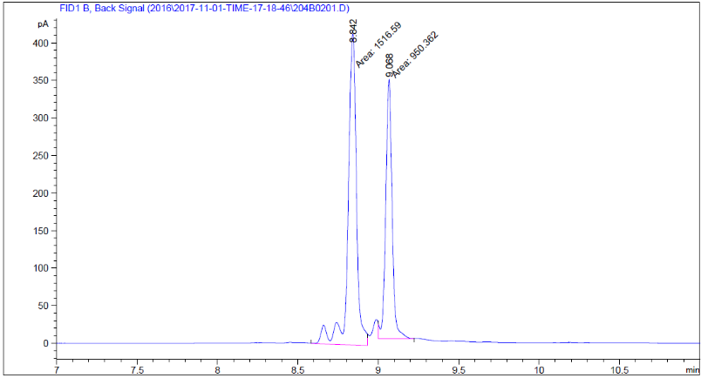
Corrected yield 1197 mg (42%). Dehydrogenation ratio (GC) = 63%. Colorless liquid. E/Z > 99:1. Mixture: ¹H NMR (400 MHz, CDCl₃) δ 5.83 (ddt, J = 16.9, 10.2, 6.7 Hz, 1H), 5.39 (dd, J = 7.3, 3.7 Hz, 2H), 5.02 (d, J = 17.1 Hz, 1H), 4.96 (dd, J = 10.2, 1.0 Hz, 1H), 2.16 – 1.97 (m, 6H), 1.55 – 1.19 (m, 16H), 0.93 (t, J = 6.8 Hz, 3H). ¹³C NMR (101 MHz, CDCl₃) 139.1, 130.2, 130.0, 129.9, 129.7, 114.4, 114.3, 114.3, 34.1, 34.1, 34.0, 32.2, 32.2, 32.1, 30.1, 30.0, 30.0, 30.0, 30.0, 29.9, 29.7, 29.6, 29.6, 29.5, 29.5, 29.4, 29.3, 29.3, 29.3, 29.2, 28.8, 27.5, 27.4, 27.3, 23.0, 23.0, 22.9, 14.3, 14.3. HRMS (APCI-MS ES⁺) [M-H]⁺, calculated for C₁₆H₃₁; 223.2426; found 223.2429.
cis-1,n-octadecadienes (9):
Corrected yield 983 mg (46%). Dehydrogenation ratio (GC) = 77%. Colorless liquid. E/Z > 99:1. Mixture: ¹H NMR (400 MHz, CDCl₃) δ 5.83 (ddt, J = 16.9, 10.2, 6.7 Hz, 1H), 5.48 – 5.23 (m, 2H), 5.02 (dd, J = 17.1, 1.9 Hz, 1H), 4.98 – 4.92 (m, 1H), 2.13 – 1.98 (m, 6H), 1.49 – 1.22 (m, 18H), 0.92 (t, J = 6.8 Hz, 3H). ¹³C NMR (101 MHz, CDCl₃) δ 139.2, 130.1, 129.9, 114.3, 34.0, 32.2, 30.0, 30.0, 29.9, 29.8, 29.6, 29.6, 29.4, 29.3, 29.2, 27.4, 27.4, 22.9, 14.3. HRMS (APCI-MS ES⁺) [M-H]⁺, calculated for C₁₈H₃₃; 249.2556; found 249.2582.

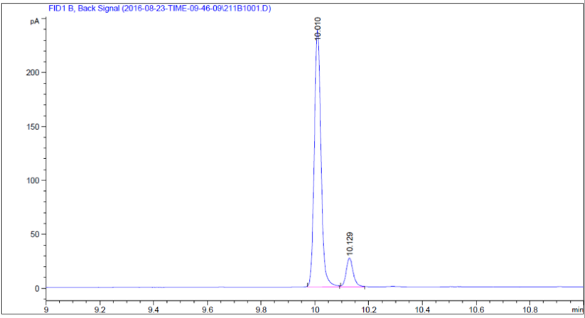
1-methoxy-cis-hexadecenes (10):
Yield 888 mg (41%). Dehydrogenation ratio (GC) = 89%. Colorless liquid. E/Z > 99:1. Mixture: ¹H NMR (400 MHz, CDCl₃) δ 5.36 – 5.25 (m, 2H), 3.32 (t, J = 6.6 Hz, 2H), 3.28 (s, 3H), 2.04 – 1.93 (m, 4H), 1. 57 – 1.47 (m, 2H), 1.36 – 1.17 (m, 20H), 0.85 (t, J = 6.8 Hz, 3H). ¹³C NMR (101 MHz, CDCl₃) δ 130.0, 129.7, 72.9, 58.4, 32.0, 29.9, 29.8, 29.8, 29.7, 29.6, 29.4, 29.2, 27.3, 27.2, 26.2, 22.8, 14.1. HRMS (APCI-MS ES⁺) [M+H]⁺, calculated for C₁₇H₃₅O; 255.2666; found 255.2688.

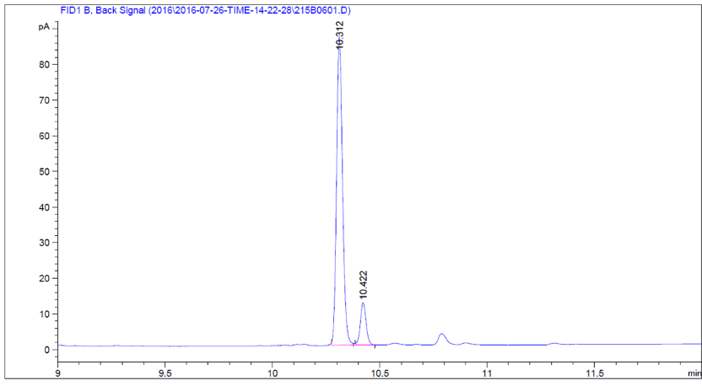
1-chloro-cis-hexadecenes (11):
Corrected yield 752 mg (34%). Dehydrogenation ratio (GC) = 90%. Colorless liquid. Mixture: ¹H NMR (400 MHz, CDCl₃) δ 5.35 (m, 2H), 3.51 (t, J = 6.8 Hz, 2H), 2.08 – 1.94 (m, 4H), 1.83 – 1.69 (m, 2H), 1.50 – 0.99 (m, 18H), 0.89 (t, J = 6.7 Hz, 3H). ¹³C NMR (101 MHz, CDCl₃) δ 130.1, 129.5, 44.9, 32.7, 31.9, 29.8, 29.6, 29.4, 28.5, 27.2, 27.1, 26.8, 22.7, 14.1. HRMS (TOF-MS ES⁺) [M+H]⁺, calculated for C₁₆H₃₂Cl; 259.2191; found 259.2179.

1-chloro-cis-octadecenes (12):
Corrected yield 783 mg (32%). Dehydrogenation ratio (GC) = 48%. Colorless liquid. E/Z > 99:1. Mixture: ¹H NMR (400 MHz, CDCl₃) δ δ 5.41 – 5.28 (m, 2H), 3.51 (t, J = 6.8 Hz, 2H), 2.03 (d, J = 5.8 Hz, 2H), 1.82 – 1.69 (m, 2H), 1.50 – 1.15 (m, 20H), 0.90 (t, J = 6.8 Hz, 3H). ¹³C NMR (101 MHz, CDCl₃) δ 130.1, 129.8, 45.0, 45.0, 32.9, 32.9, 32.1, 32.1, 31.8, 30.0, 29.9, 29.9, 29.9, 29.8, 29.8, 29.7, 29.6, 29.6, 29.6, 29.5, 29.4, 29.1, 29.1, 27.4, 27.3, 27.1, 27.1, 22.9, 22.8, 14.2. HRMS (APCI-MS ES⁺) [M+H]⁺, calculated for C₁₈H₃₆Cl; 287.2505; found 287.2496.

1-fluoro-cis-hexadecenes (13):
Corrected yield 700 mg (34%). Dehydrogenation ratio (GC) = 69%. Colorless liquid. E/Z > 99:1. Mixture: ¹H NMR (400 MHz, CDCl₃) δ 5.40 – 5.26 (m, 2H), 3.51 (t, J = 6.8 Hz, 2H), 2.10 – 1.95 (m, 4H), 1.83 – 1.69 (m, 2H), 1.50 – 1.18 (m, 18H), 0.89 (t, J = 6.7 Hz, 3H). ¹³C NMR (101 MHz, CDCl₃) δ 130.2, 129.6, 45.1, 45.0, 32.8, 32.8, 32.8, 32.1, 32.1, 29.9, 29.9, 29.8, 29.8, 29.7, 29.7, 29.6, 29.5, 29.5, 29.1, 28.7, 27.4, 27.2, 27.1, 26.9, 22.8, 14.2. ¹⁹F NMR (377 MHz, CDCl₃) δ -211.1. HRMS (APCI-MS ES⁺) [M+H]⁺, calculated for C₁₆H₃₂F; 243.2488; found 243.2479.

1-fluoro-cis-octadecenes (14):
Yield 851 mg (37%). Dehydrogenation ratio (GC) = 72%. Colorless liquid. E/Z > 99:1. Mixture: ¹H NMR (400 MHz, CDCl₃) δ 5.42 – 5.27 (m, 2H), 3.51 (t, J = 6.8 Hz, 2H), 2.03 (d, J = 5.8 Hz, 4H), 1.84 – 1.71 (m, 2H), 1.46 – 1.10 (m, 20H), 0.89 (t, J = 6.8 Hz, 3H). ¹³C NMR (101 MHz, CDCl₃) δ 130.0, 129.8, 45.0, 32.8, 32.8, 32.1, 32.1, 29.9, 29.9, 29.9, 29.8, 29.8, 29.7, 29.6, 29.5, 29.5, 29.5, 29.3, 29.1, 27.4, 27.3, 27.1, 27.1, 22.8, 14.2. ¹⁹F NMR (377 MHz, CDCl₃) δ -211.3. HRMS (APCI-MS ES⁺) [M+H]⁺, calculated for C₁₈H₃₆F; 271.2801; found 271.2819.

Typical procedure for the isomerization-hydroboration sequence
In a flamed tube with stir bar under Ar, the cobalt precatalyst (1 mol%) was first added¹⁴. The tube was then evaporated and refilled with Argon for 3 times. Anhydrous toluene (2 mL) was added and the mixture was cooled to -35 ºC. Then, MeLi (2 mol%, 1.6 M in hexane) was added dropwise and stirred at room temperature for 5 min. Then, the mixture of cis-hexadecenes 2 (83% GC purity, 1 equiv, 0.5 mmol, 113 mg) and pinacolborane (0.5 mmol) were successively added. The reaction mixture was stirred at RT for 24 h. The reaction was quenched by exposing the solution to air. The resulting solution was concentrated in vacuum and the crude residue was purified by column chromatography to afford the desired product.
2-Hexadecyl-4,4,5,5-tetramethyl-1,3,2-dioxaborolane (15) was obtained in 60% yield. ¹H NMR (400 MHz, CDCl3) δ 1.36-1.28 (m, 2H), 1.125-1.17 (m, 38H), 0.81 (t, J = 6.8 Hz, 3H), 0.69 (t, J = 7.7 Hz, 2H). ¹³C NMR (101 MHz, CDCl3) δ 82.7, 32.4, 31.9, 29.7, 29.7, 29.7, 29.6, 29.4, 29.4, 24.8, 24.0, 22.7, 14.1. HRMS (TOF-MS ES⁺) [M+H]⁺, calculated for C₂₂H₄₆BO₂; 353.3591; found 353.3590.

General procedure for the isomerization-hydrosilylation sequence
In a sealed tube under Ar, H₂PtCl₆.6H₂O (5 mol%), the mixture of cis-hexadecenes 2 (83% GC purity, 1 equiv, 0.5 mmol, 113 mg) and HSiCl₃ (1 mmol) were successively introduced. The neat reaction mixture was then heated at 130 °C for 18 h. After being cooled down to 0 °C, the reaction was quenched with different nucleophiles (1 mmol) at that temperature then let to stir at room temperature for additional 6 h. Following a work-up protocol, the crude mixture was filtered through a PTFE HPLC filter (0.4 μm) to remove the remaining platinum particles and extensively washed with hexane. The desired product was obtained after concentration under reduced pressure.

Hexadecyltrimethylsilane (16).
Using methylmagnesium bromide (3M in Et₂O, 6 equiv.) for 4 h as nucleophile. Yield 98% (+ 20% remaining hexadecane). Mixture in hexadecane: ¹H NMR (400 MHz, CDCl₃) δ 1.27 (s, 28H), 0.89 (t, J = 6.8 Hz, 3H), 0.49 (m 2H), -0.02 (s, 9H). ¹³C NMR (101 MHz, CDCl₃) δ 33.8, 32.1, 29.9, 29.9, 29.6, 24.1, 22.9, 16.9, 14.3, -1.5. All characterization data matched those reported in the literature for hexadecyltrimethylsilane¹⁵.

Hexadecyltrivinylsilane (17).
Using vinylmagnesium bromide (1M in THF, 6 equiv.), 60 °C for 4 h. Yield 85% (+33% hexadecane). Mixture in hexadecane: ¹H NMR (400 MHz, CDCl₃) δ δ 6.31 – 5.61 (m, 9H), 1.26 – 1.10 (m, 28H), 0.81 (t, J = 6.8 Hz, 3H), 0.69 – 0.48 (m, 2H). ¹³C NMR (101 MHz, CDCl₃) δ 135.6, 135.4, 135.0, 134.9, 134.8, 32.1, 29.9, 29.8, 29.5, 22.9, 14.3, 1.2. ²⁹Si NMR (80 MHz, CDCl₃) δ -21.9. HRMS (APCI-MS ES⁺) [M+H]⁺, calculated for C₂₂H₄₃Si; 335.3134; found 335.3112.

General procedure for the isomerization-hydrozirconation sequence
In a flamed-dried single neck round-bottom flask under Ar was added Cp₂ZrCl₂ (2.3 equiv, 1.25 mmol, 365 mg) in dry THF (10 mL) and this solution was stirred at RT for 10 min until complete dissolution. Then at RT, was slowly added Red-Al® (60 wt% in toluene, 1 equiv, 0.5 mmol, 0.140 mL, 3.5 M) (1 drop/3 s). The resulting reaction was stirred for 2 h at RT. Then cis-hexadecenes 2 (83% GC purity, 1 equiv, 0.5 mmol, 113 mg) in THF (1 mL) was added to the reactional mixture at room temperature. The resulting mixture was stirred overnight (ca. 18 h) at 40 °C. The reactions were monitored by GC analyses of hydrolysed aliquots.

Procedure A: halogenolysis (NCS, Br₂ or I₂)

Following the previously described general procedure for the hydrozirconation reaction, the mixture was cooled down to 0 °C and the electrophile (3 equiv, 1.5 mmol, dissolved in 1 mL of dry THF), was slowly added. The mixture was stirred for 3 h at room temperature. Then, the solution was quenched with a saturated solution of sodium thiosulfate (5 mL) and extracted with Et₂O (3x10 mL). The crude solution was evaporated under vacuum and the mixture was filtrated on a short pad of silica with hexane to yield the desired product. Yields were evaluated by GC analyses on the crude residue either using dodecane or hexadecane as internal standards.

1-chlorohexadecane (18).
Performing the electrophilic trapping with N-chlorosuccinimide (3 equiv, 1.5 mmol, 200 mg) afforded 1-chlorohexadecane in 86 % GC yield as a mixture with remaining hexadecane. All related spectroscopic data matched with commercially available pure 1-chlorohexadecane.

1-bromohexadecane (19).
Performing the electrophilic trapping with Br₂ (3 equiv, 1.5 mmol, 238 mg) afforded 1-bromohexadecane in 95 % GC yield as a mixture with remaining hexadecane. All related spectroscopic data matched with commercially available pure 1-bromohexadecane.

1-Iodohexadecane (20).
Performing the electrophilic trapping with I₂ (3 equiv, 1.5 mmol, 379 mg) afforded 1-iodohexadecane in 76 % GC yield as a mixture with remaining hexadecane. All related spectroscopic data matched with commercially available pure 1-iodohexadecane.

Procedure B: oxidation (tBuOOH)

Following the previously described general procedure for the hydrozirconation reaction, the solution was cooled down to 0 °C and tBuOOH (3 equiv, 1.5 mmol, 0.3 mL, 5 M in decane) was slowly added. The mixture was stirred 2 h at room temperature (TLC monitoring). Then, water (5 mL) was added and the resultant mixture was extracted with Et₂O (3x10 mL). The combined organic layers were washed with brine (10 mL), dried (Na₂SO₄), and filtered. The volatiles were removed under reduced pressure and the residue obtained was purified by flash chromatography (hexane/Et₂O, 7:3) affording 72 mg of 1-hexadecanol as a white waxy solid, yield 59%.

1-Hexadecanol (21).
The NMR spectra matched with commercially available pure 1-hexadecanol.

Procedure C: electrophilic amination

Following the previously described general procedure for the hydrozirconation reaction, the solution was cooled down to room temperature and NH₂OSO₃H or MeNH₂OSO₃H¹⁶ (2.5 equiv, 1.25 mmol) was added in one portion. The resulting suspension was vigorously stirred for 3 h at 50 ºC. After completion, aqueous 1 M NaOH (5 mL) was added. The mixture was transferred to a separatory funnel and extracted with Et₂O (3x10 mL). The combined organic phases were washed with brine, dried over Na₂SO₄, and concentrated in vacuo. The crude residue was purified by column chromatography to afford the desired products.

1-Hexadecylamine (22).
White solid (78.4 mg, 65%). ¹H NMR (400 MHz, CDCl3) δ 2.63 (s, 2H), 2.23 (s, 2H), 1.41-1.36 (m, 1H), 1.21-1.19 (m, 26H), 0.81 (t, J = 6.8 Hz, 3H). ¹³C NMR (101 MHz, CDCl3) δ 42.0, 33.4, 31.9, 29.7, 29.6, 29.5, 29.3, 26.9, 22.7, 14.1. The NMR spectra matched those previously reported in the literature¹⁷.

N-methyl,1-hexadecylamine (23).
Pale yellow solid (89.5 mg, 70%), ¹H NMR (400 MHz, CDCl3) δ 3.39 (s, 1H), 2.58 (t, J = 7.0 Hz, 2H), 2.43 (s, 3H), 1.56-1.43 (m, 2H), 1.23 (m, 26H), 0.84 (t, J = 6.8 Hz, 3H). ¹³C NMR (101 MHz, CDCl3) δ 51.6, 35.7, 31.8, 29.6, 29.6, 29.5, 29.5, 29.4, 29.3, 29.1, 27.1, 22.6, 14.0. The NMR spectra matched those previously reported in the literature¹⁸.

Procedure D: cyanation

Following the previously described general procedure for the hydrozirconation reaction, TMSCN (1.5 mol, 3 equiv) was added and the reaction mixture was heated at 60 ºC for 24 h. The solution was then cooled down to 0 ºC and a solution of iodine (1.5 mmol, 3 equiv) in THF (1 mL) was added. The reaction mixture was then stirred for 3 h at RT. The solution was quenched with a saturated aqueous solution of sodium thiosulfate (5 mL) and extracted with Et₂O (3x10 mL). The combined organic phases were washed with brine, dried over Na₂SO₄, and concentrated in vacuo. The crude residue was purified by column chromatography to afford the desired product.

1-heptadecanitrile (24).
¹H NMR (400 MHz, CDCl3) δ 2.31 (t, J = 7.1 Hz, 2H), 1.68-1.58 (m, 2H), 1.44-1.39 (m, 2H), 1.24 (m, 24H), 0.86 (t, J = 6.8 Hz, 1H). ¹³C NMR (101 MHz, CDCl3) δ 119.7, 31.8, 29.6, 29.6, 29.5, 29.5, 29.5, 29.5, 29.4, 29.2, 29.2, 28.6, 28.5, 25.3, 22.6, 17.0, 14.0. The NMR spectra matched those previously reported in the literature¹⁷.

Procedure D: copper-catalyzed allylation reactions

Following the previously described general procedure for the hydrozirconation reaction, the solution was cooled down to 0 °C and CuI (0.2 equiv, 20 mg, 0.1 mmol) and flame-dried LiCl (0.4 equiv, 9 mg, 0.2 mmol) dissolved in THF (3 mL) were added and stirred 30 min at this temperature. Then, the electrophile (3 equiv, 1.5 mmol), dissolved in THF (1 mL), was slowly added at 0 °C. The resulting solution was stirred for 24 h at room temperature. Then, the solution was quenched with saturated solution of ammonium chloride (5 mL) and extracted with Et₂O (3x10mL). The crude solution was dried and evaporated under vacuum. Yields were evaluated by GC analyses on the crude residue using dodecane as internal standard.

Nonadec-1,2-diene (25).
Using freshly distilled allyl bromide (3 equiv, 1.5 mmol, 180 mg, 0.13 mL) after transmetallation with CuI•2LiCl afforded nonadec-1,2-diene in 50 % GC yield as a mixture with hexadecane (also used as internal reference). ¹H NMR (400 MHz, CDCl₃) δ 5.13-5.06 (m, 1H), 4.66-4.62 (m, 2H), 2.02-1.95 (m, 2H), 1.35-1.18 (m, 28H), 0.88(t, J = 6.8 Hz, 3H). ¹³C NMR (101 MHz, CDCl₃) δ 90.3, 74.7, 32.1, 29.8, 29.7, 29.6, 29.5, 29.3, 29.2, 28.4, 14.3. HRMS (APCI-ES+): m/z calcd for C₁₉H₃₇ ([M + H]⁺): 265.2877, found 265.2895.

1-nonadecene (26).
Using freshly distilled allyl bromide (3 equiv, 1.5 mmol, 180 mg, 0.13 mL) after transmetallation with CuI•2LiCl afforded 1-nonadecene in 52 % GC yield as a mixture with hexadecane (also used as internal reference).
The NMR spectra matched with commercially available pure 1-nonadecene (CAS numb: 18435-45-5)¹⁹. ¹H NMR (400 MHz, CDCl₃) δ 5.87-5.77 (m, 1H), 5.02-4.91 (m, 2H), 2.07-2.01 (m, 2H), 1.38-1.20 (m, 30H), 0.89 (t, J = 6.6 Hz, 3H). ¹³C NMR (101 MHz, CDCl₃) δ 139.4, 114.2, 34.0, 32.1, 29.9, 29.8, 29.7, 29.6, 29.4, 29.1, 22.9, 14.3

Ethyl-2-methylenenonadecanoate (27).
Using ethyl 2-(bromomethyl)acrylate (3 equiv, 1.5 mmol, 290 mg) after transmetalation with CuI•LiCl to afford 81 mg of ethyl-2-methylenenonadecanoate as white waxy solid in 48 % isolated yield after purification on flash chromatography (hexane/Et₂O, 95:5). ¹H NMR (400 MHz, CDCl₃) δ 6.13 – 6.11 (m, 1H), 5.50 (dd, J = 2.8, 1.4 Hz, 1H), 4.20 (q, J = 7.1 Hz, 2H), 2.32 – 2.24 (m, 2H), 1.44 (d, J = 8.4 Hz, 2H), 1.33 – 1.21 (m, 31H), 0.87 (t, J = 6.8 Hz, 3H). ¹³C NMR (101 MHz, CDCl₃) δ 167.6, 141.3, 124.3, 60.7, 32.1, 32.0, 29.9, 29.8, 29.8, 29.7, 29.6, 29.5, 29.4, 28.6, 22.8, 14.4, 14.3.

Typical procedure for the isomerization-hydroarylation sequence

To a flamed-dried tube was added NiBr₂ (5 mol%), 2-(6-methylpyridin-2-yl)-4,5-dihydrooxazole²⁰ (6 mol%), KF (1.25 mmol, 2.5 equiv) and the vessel was purged 3 times with argon. Anhydrous DMF (1 mL) was added and the resulting suspension was stirred at RT for 10 min. Then, (EtO)₂MeSiH (1.25 mmol, 2.5 equiv) was added dropwise and stirred at RT for 5 min. After that, cis-hexadecenes 2 (83% GC purity, 1 equiv, 0.5 mmol, 113 mg) and (3-iodopropyl)benzene²¹ (1.25 mmol, 2.5 equiv) were added. The reaction mixture was stirred at room temperature for 24 h. After completion, water (20 mL) was added to the reaction mixture, transferred into a separatory funnel and extracted with Et₂O (3x10 mL). The combined organic phases were washed with brine, dried over Na₂SO₄, and concentrated in vacuo. The crude residue was purified by column chromatography to afford the desired product as 45% yield.

1-nonadecylbenzene (28).
¹H NMR (400 MHz, CDCl3) δ 7.41-7.35 (m, 2H), 7.31-7.26 (m, 3H), 2.73-2.68 (m, 2H), 1.72 (dt, J = 15.0, 7.4 Hz, 2H), 1.52-1.26 (m, 32H), 1.00 (t, J = 6.8 Hz, 3H). ¹³C NMR (101 MHz, CDCl3) δ 142.9, 128.3, 128.1, 125.5, 36.0, 31.9, 31.5, 29.7, 29.6, 29.6, 29.5, 29.3, 29.3, 22.7, 14.1. HRMS (TOF-MS ES⁺) [M+H]⁺, calculated for C₂₅H₄₄; 344.3438; found 344.3442.

General procedure for the [Ru]-catalyzed isomerization / [Ni]cross-coupling sequence of alkenyl methyl ether

To a flame-dried Schlenk flask equipped with a reflux condenser, RuHCl(CO)(PPh₃)₃ (5 mol%, 0.022 mmol, 21 mg) and a solution of 10 (0.433 mmol, 110 mg) in THF (1.5 mL) were added under an inert atmosphere of argon. The mixture was stirred vigorously at 90 °C for 48 h, and then allowed to cool to ambient temperature. Then, followed by to a second flame-dried Schlenk flask equipped with a septum and stirrer bar was added NiCl₂(PPh₃)₂ (10 mol%, 0.043 mmol, 28 mg) and the flask was purged with argon. Toluene (1.5 mL), and phenylmagnesium bromide (1.1 M in ether, 0.866 mmol, 0.8 mL) were introduced by a syringe, and then the reaction mixture was stirred at ambient temperature for 15 min. After this time, the solution of resulting vinyl methyl ether intermediate in the first Schlenk flask was added dropwise to the second reaction mixture via syringe under argon, and then the second reaction flask was sealed with a new septum. The resulting mixture was heated at 90 °C for 16 h. Then the reaction was cooled to ambient temperature, quenched with an aqueous saturated solution of NH₄Cl and extracted with Et₂O (3x3 mL). The combined organic phase was filtered through a pad of silica gel with copious washing by Et₂O and concentrated. The residue was purified by column chromatography on silica gel (eluent, hexane/toluene = 20/1) to give a mixture of E- and Z-olefin 29 (66 mg, 51% yield, E/Z = 89:11) as a colorless oil. The E/Z ratio of the crude products was determined by ¹H NMR in CDCl₃. Integration of the signal due to vinyl protons of the E-olefin (δH 6.22 ppm) versus that of Z-olefin (δH 5.65 ppm) gave the crude E/Z ratio as 89:11. E-olefin: ¹H NMR (400 MHz, CDCl₃) δ 7.34 (d, J = 7.4 Hz, 2H; Ph-H), 7.28 (t, J = 7.6 Hz, 2H; Ph-H), 7.18 (t, J = 7.2 Hz, 1H; Ph-H), 6.37 (d, J = 15.8 Hz, 1H; olefin-H), 6.22 (dt, J = 15.8, 6.8 Hz, 1H), 2.20 (q, J = 7.1 Hz, 2H), 1.50−1.43 (m, 2H), 1.30−1.26 (m, 20H), 0.88 (t, J = 6.7 Hz, 3H); ¹³C NMR (100 MHz, CDCl₃) δ 138.0 (C), 131.3 (CH), 129.7 (CH), 128.5 (CH × 2), 126.8 (CH), 125.9 (CH × 2), 33.1 (CH₂), 32.0 (CH₂), 29.8 (CH₂× 3), 29.7 (CH₂ × 3), 29.6 (CH₂), 29.5 (CH₂), 29.4 (CH₂), 29.3 (CH₂), 22.8 (CH₂), 14.2 (CH₃); HRMS (APCI): m/z calcd for C₂₂H₃₅ ([M - H]⁺): 299.2733, found 299.2749. Z-olefin: ¹H NMR (400 MHz, CDCl₃) δ 7.24−7.14 (m, 5H, Ph-H), 6.38 (d, J = 11.6 Hz, 1H; olefin-H), 5.65 (dt, J = 11.6, 7.2 Hz, 1H), 2.31 (q, J = 7.2 Hz, 2H), 1.46−1.39 (m, 2H), 1.28−1.24 (m, 20H), 0.86 (t, J = 7.0 Hz, 3H); ¹³C NMR (100 MHz, CDCl₃) δ 137.8 (C), 133.3 (CH), 128.7 (CH × 2), 128.6 (CH), 128.1 (CH × 2), 126.4 (CH), 31.9 (CH₂), 30.0 (CH₂), 29.7 (CH₂ × 3), 29.6 (CH₂ × 3), 29.5 (CH₂), 29.4 (CH₂), 29.2 (CH₂), 28.6 (CH₂), 22.7 (CH₂), 14.1 (CH₃); HRMS (APCI): m/z calcd for C₂₂H₃₅ ([M - H]⁺): 299.2733, found 299.2749.

Table S1:
Study of the experimental conditions for the dehydrogenation of hexadecane

Entries | Quantity wet cells KSM-B-3M (g) | Volume hexadec-ane  (mL) | Total volume (mL) | Erlenmeyer (mL) | Temp (°C) | Phosphate buffer (mol/L) | Amino acid (g/L) | Thiamine.  HCl (g/L) | MgSO₄.  7H₂O (g/L) | pH | GC conversion  rate alkenes/  alkane  (%, 7 days)
1 | 1 | 5 | 25 | 250 | 26 | 0.25 | MSG  (1 g/L) | 0.1 | 0.1 | nd | 5.9
2 | 1 | 5 | 25 | 250 | 30 | 0.25 | MSG  (1 g/L) | 0.1 | 0.1 | nd | 11.7
3 | 1 | 10 | 25 | 250 | 30 | 0.25 | MSG  (1 g/L) | 0.1 | 0.1 | nd | 3.8
4 | 1 | 2.5 | 25 | 250 | 30 | 0.25 | MSG  (1 g/L) | 0.1 | 0.1 | nd | 33.4
5 | 1 | 2.5 | 25 | 250 (rigged flask) | 30 | 0.25 | MSG  (1 g/L) | 0.1 | 0.1 | nd | 5.3
6 | 1 | 1.25 | 25 | 250 | 30 | 0.25 | MSG  (1 g/L) | 0.1 | 0.1 | nd | 13.5
7 | 2 | 5 | 25 | 250 | 30 | 0.25 | MSG  (1 g/L) | 0.1 | 0.1 | nd | 21.7
8 | 1 | 2.5 | 25 | 250 | 28 | 0.25 | MSG  (1 g/L) | 0.1 | 0.1 | nd | 11.8
9 | 1 | 2.5 | 25 | 250 | 32 | 0.25 | MSG  (1 g/L) | 0.1 | 0.1 | nd | 5.5
10 | 1 | 2.5 | 25 | 250 | 34.5 | 0.25 | MSG  (1 g/L) | 0.1 | 0.1 | nd | 0
11 | 1 | 2.5 | 60 | 250 | 30 | 1 | MSG  (4 g/L) | 0.4 | 0.4 | nd | 43.0
12 | 1 | 2.5 | 60 | 250 | 30 | 2 | MSG  (8 g/L) | 0.8 | 0.8 | nd | 0
13 | 1 | 2.5 | 100 | 500 | 30 | 1 | MSG  (4 g/L) | 0.4 | 0.4 | nd | 19.0
14 | 1 | 2.5 | 60 | 250 | 30 | 0.25 | MSG  (4 g/L) | 0.4 | 0.4 | nd | 37.0
15 | 1 | 2.5 | 60 | 250 | 30 | 1 | MSG  (1 g/L) | 0.4 | 0.4 | nd | 10.9
16 | 1 | 2.5 | 60 | 250 | 30 | 1 | MSG  (4 g/L) | 0.1 | 0.4 | nd | 35.8
17 | 1 | 2.5 | 60 | 250 | 30 | 1 | MSG  (4 g/L) | 0.4 | 0.1 | nd | 34.3
18 | 1 | 2.5 | 60 | 250 | 30 | 0.8 | MSG  (4 g/L) | 0.1 | 0.1 | 6.4 | 48
19 | 1 | 2.5 | 60 | 250 | 30 | 1 | Glycine  (4 g/L) | 0.4 | 0.1 | nd | 0.7
20 | 1 | 2.5 | 60 | 250 | 30 | 1 | MSG  (4 g/L) | 0.4 | 0.1 | 5.8 | 0
21 | 1 | 2.5 | 60 | 250 | 30 | 1 | MSG  (4 g/L) | 0.4 | 0.1 | 7 | 0
N.B.: MSG = Monosodium glutamate monohydrate, nd = not determined

Fig. S1:
Organic phase utilization (left) and biomass accumulation (right) obtained by strains KSM B-3M and sp. 008 grown on hexadecane during a 21 days experiment. Sp. 008 strain utilized the hexadecane to a near complete extent after 21 days producing significantly more biomass compared to KSM B-3M, indicating that the utilization process of hexadecane by strain sp. 008 is more efficient than that conducted by strain KSM B-3M.

Table S2:
Go Terms Enrichment of proteins expressed significantly higher insp. 008 identified by proteomics. Four KEGG pathways (“Fatty acid degradation”, “Valine, leucine and isoleucine degradation”, “Fatty acid metabolism”, “Propanoate metabolism”) and one COG ontology (“lipid metabolism”) were highlighted, based on fourteen genes, most of them common among the pathways.

Term | Benjamini | Genes
Fatty acid degradation | 2.57E-04 | acetyl-CoA acetyltransferase (RER_RS01750)
 |  | acetyl-CoA acetyltransferase (RER_RS01720)
 |  | acetyl-CoA acetyltransferase (RER_RS30210)
 |  | acyl-CoA dehydrogenase (RER_RS28070)
 |  | alcohol dehydrogenase (RER_RS01200)
 |  | hypothetical protein (RER_RS04060)
 |  | acyl-CoA dehydrogenase (RER_RS01735)
 |  | fatty-acid--CoA ligase (RER_RS02370)
 |  | enoyl-CoA hydratase (RER_RS30095)
 |  | acetyl-CoA acyltransferase (RER_RS28150)
Valine, leucine and isoleucine degradation | 3.24E-04 | acetyl-CoA acetyltransferase (RER_RS01750)
 |  | acetyl-CoA acetyltransferase (RER_RS01720)
 |  | acetyl-CoA acetyltransferase (RER_RS30210)
 |  | acyl-CoA dehydrogenase (RER_RS28070)
 |  | succinyl-CoA--3-ketoacid CoA-transferase subunit beta (RER_RS07970)
 |  | hypothetical protein (RER_RS04060)
 |  | dihydrolipoamide dehydrogenase (RER_RS25075)
 |  | acyl-CoA dehydrogenase (RER_RS01735)
 |  | enoyl-CoA hydratase (RER_RS30095)
 |  | acetyl-CoA acyltransferase (RER_RS28150)
Fatty acid metabolism | 1.25E-03 | acetyl-CoA acetyltransferase (RER_RS01750)
 |  | acetyl-CoA acetyltransferase (RER_RS01720)
 |  | acetyl-CoA acetyltransferase (RER_RS30210)
 |  | acyl-CoA dehydrogenase (RER_RS28070)
 |  | hypothetical protein (RER_RS04060)
 |  | acyl-CoA dehydrogenase (RER_RS01735)
 |  | fatty-acid--CoA ligase (RER_RS02370)
 |  | enoyl-CoA hydratase (RER_RS30095)
 |  | acetyl-CoA acyltransferase (RER_RS28150)
Propanoate metabolism | 1.79E-02 | acetyl-CoA acetyltransferase (RER_RS01750)
 |  | acetyl-CoA acetyltransferase (RER_RS01720)
 |  | acyl-CoA dehydrogenase (RER_RS28070)
 |  | hypothetical protein (RER_RS04060)
 |  | acyl-CoA dehydrogenase (RER_RS01735)
 |  | enoyl-CoA hydratase (RER_RS30095)
 |  | acetyl-CoA acyltransferase (RER_RS28150)
Lipid metabolism | 4.11E-02 | acyl-CoA dehydrogenase (RER_RS28070)
 |  | acyl-CoA carboxylase (RER_RS02570)
 |  | stearoyl-CoA 9-desaturase (RER_RS12830)
 |  | hypothetical protein (RER_RS04060)
 |  | acyl-CoA dehydrogenase (RER_RS01735)
 |  | fatty-acid--CoA ligase (RER_RS02370)
 |  | enoyl-CoA hydratase (RER_RS30095)

Fig. S2:
Down-regulation of the beta oxidation pathway in KSM B-3M as observed by the DAVID database based on a KEGG pathway map. Red stars represent proteins detected at significantly lower abundance in the KSM B-3M proteome.
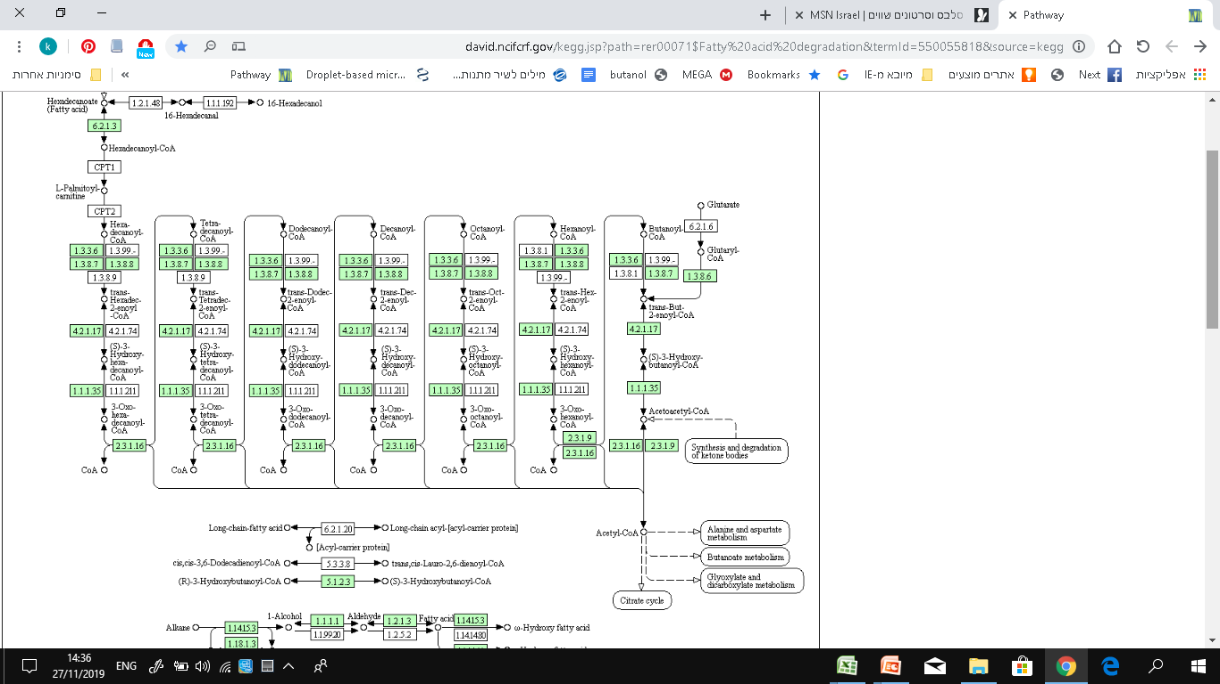
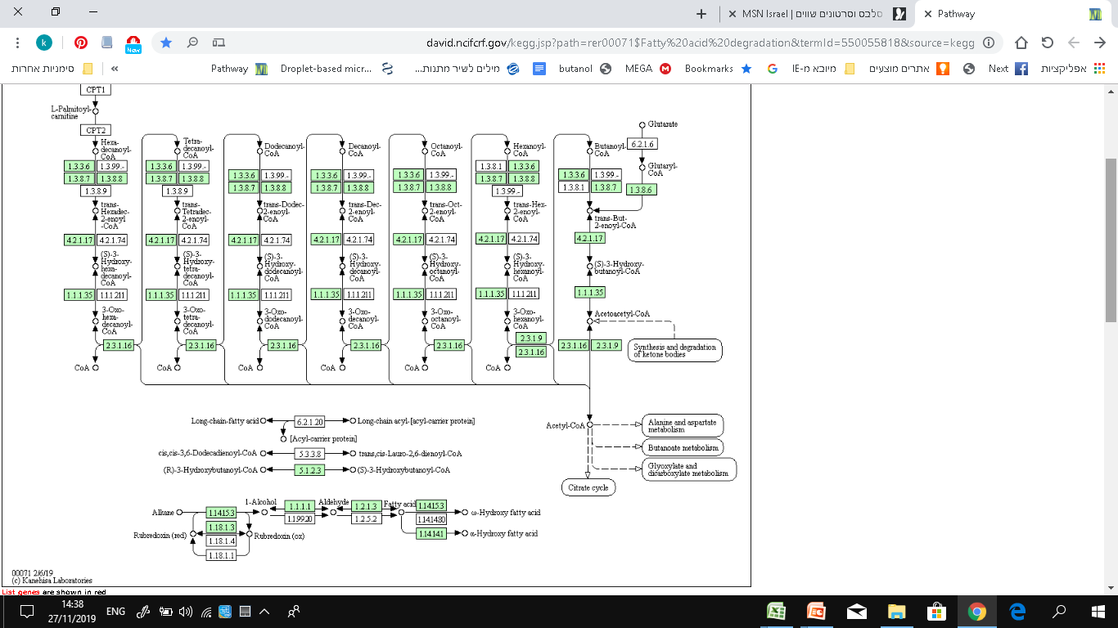
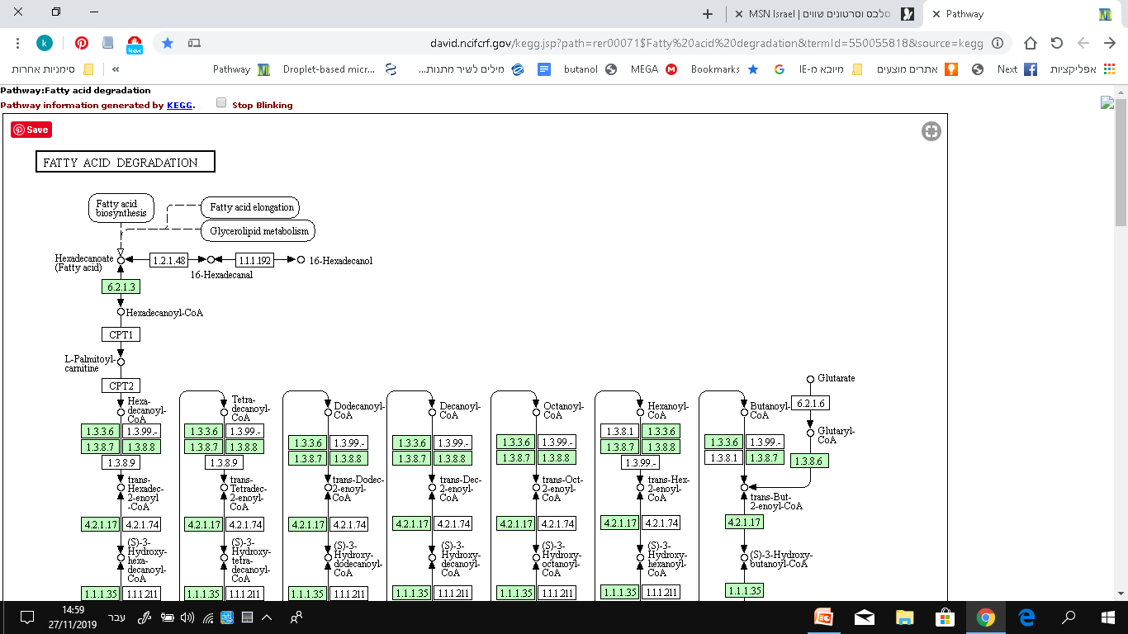

Table S3:
Mouse and Rhodococcus identical, similar and different residues found within the HHpred alignment.
To generate the chimera binding pocket of Rhodococcus, identical residues were kept, similar residues were replaced by those in Rhodococcus and different (deletion or insertion) were replaced by Ala, in order to minimize interaction with the binding site.

Fig. S3:
Pairwise sequence alignment between Rhodococcus and Mouse acyl-CoA, obtained by HHpred²² and manually curated²³. Residues are colored coded by Zappo scheme.

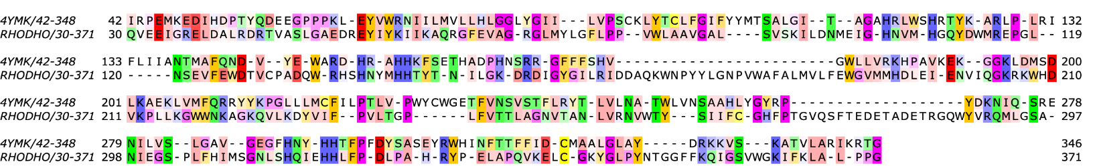

NMR spectra
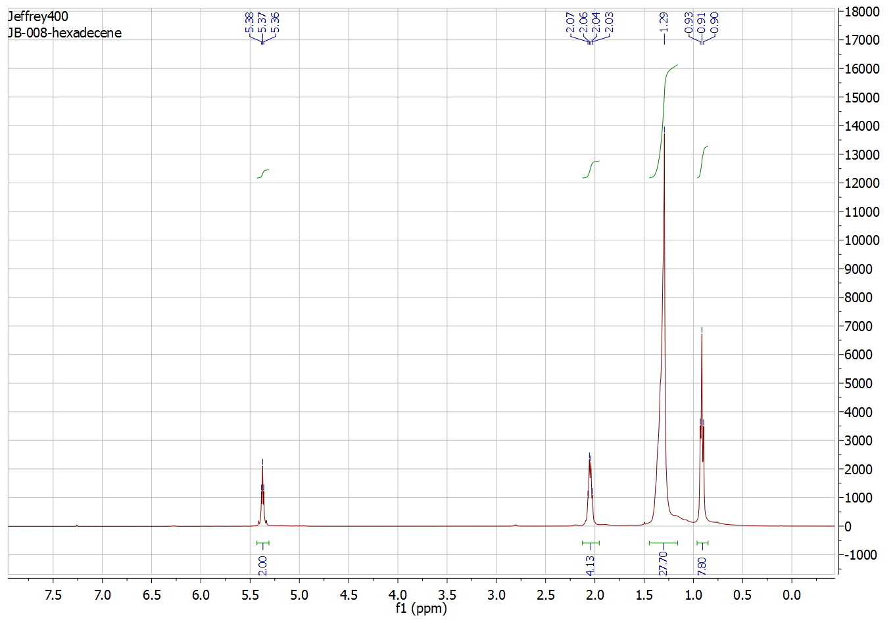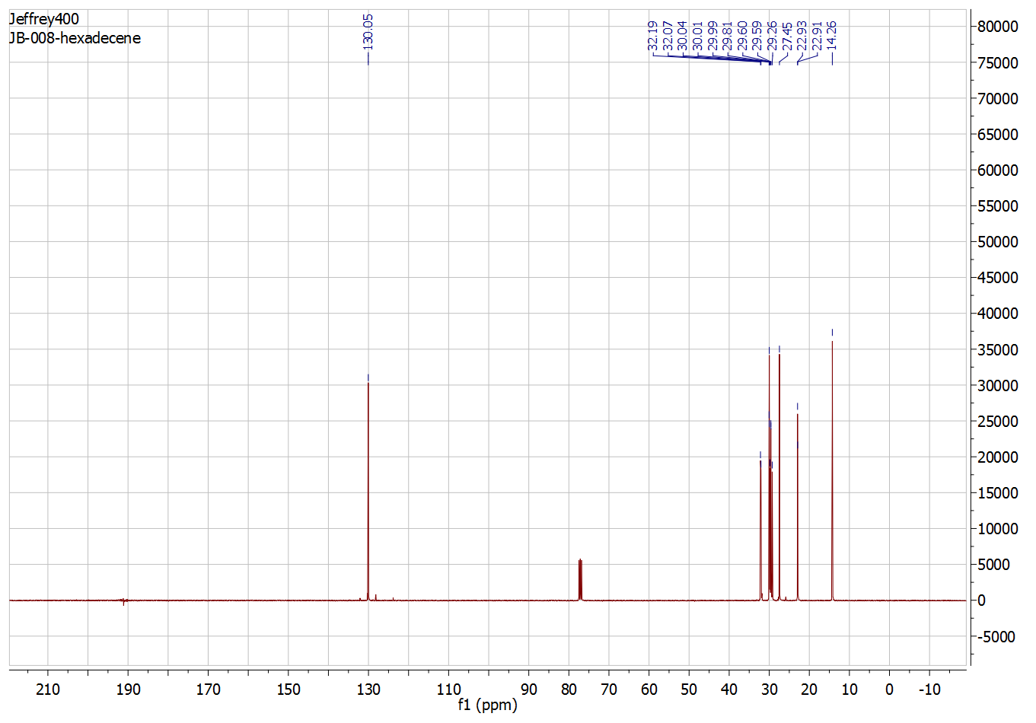
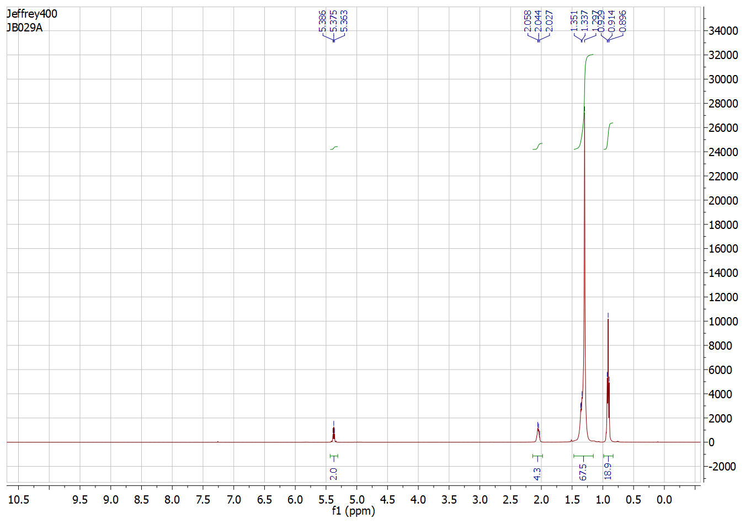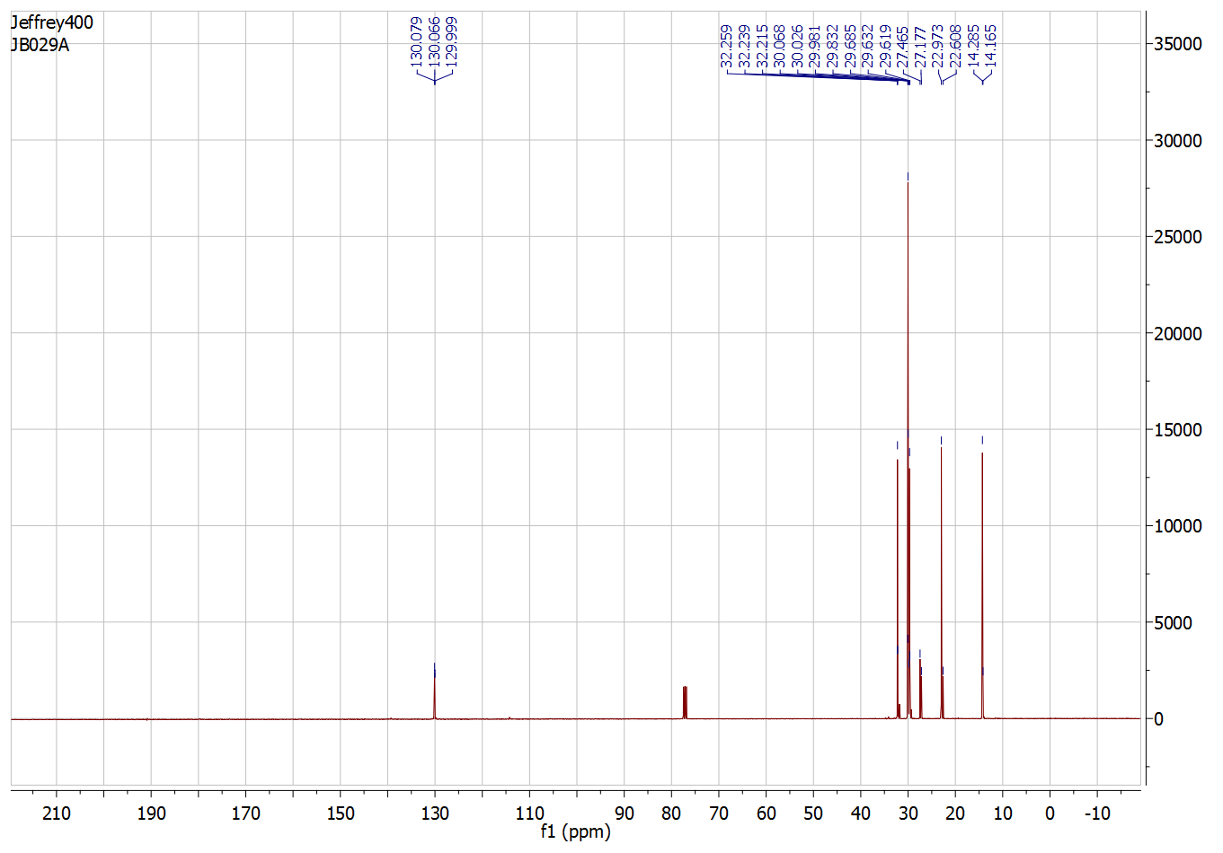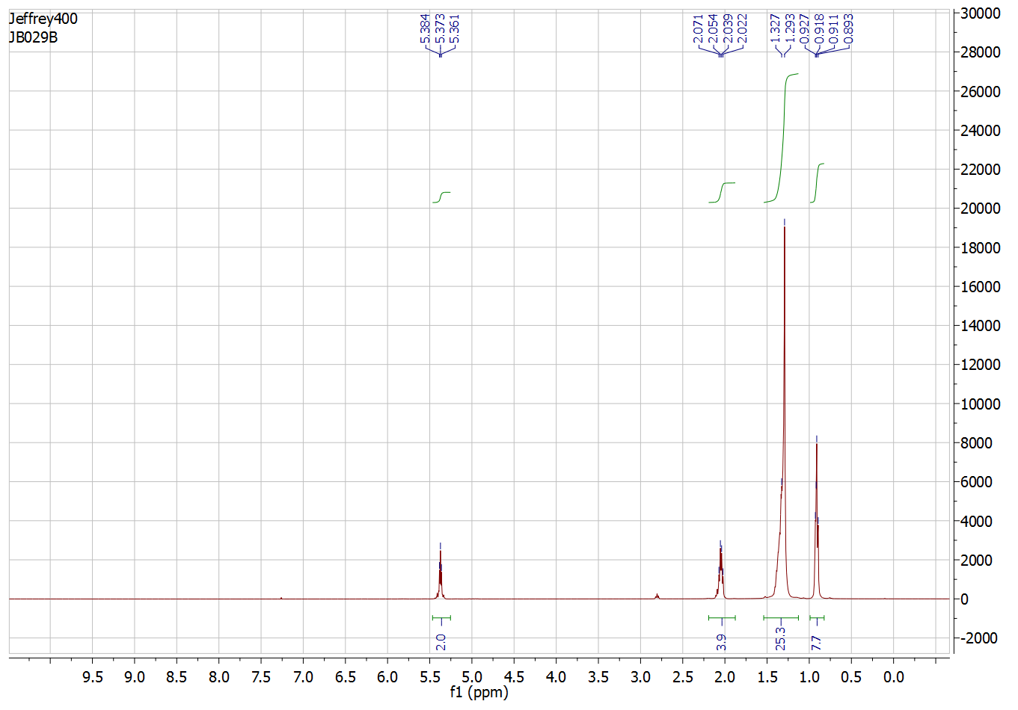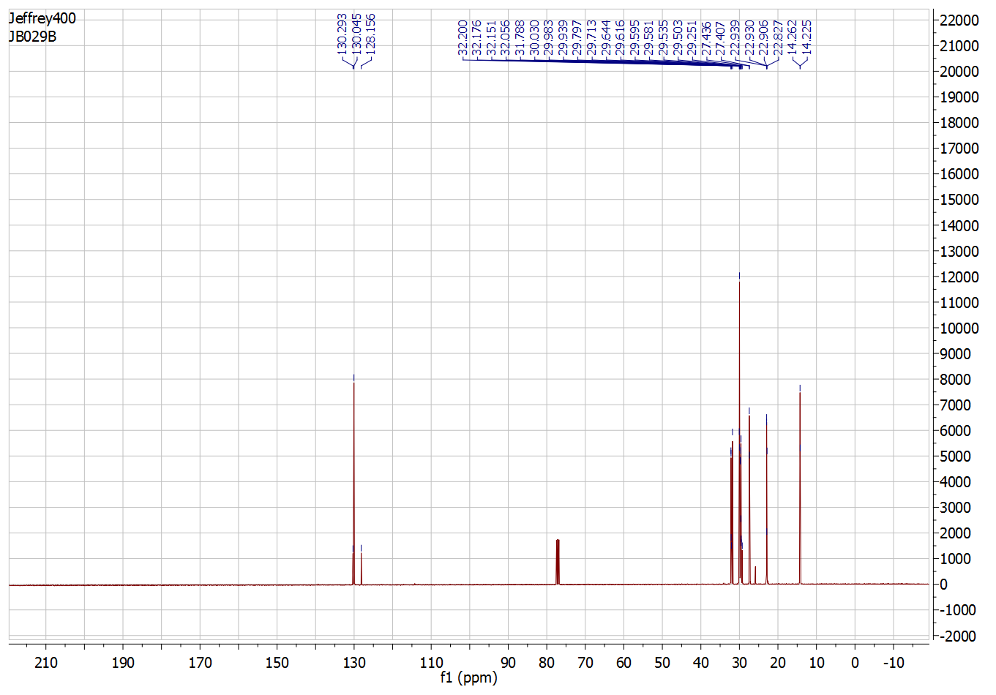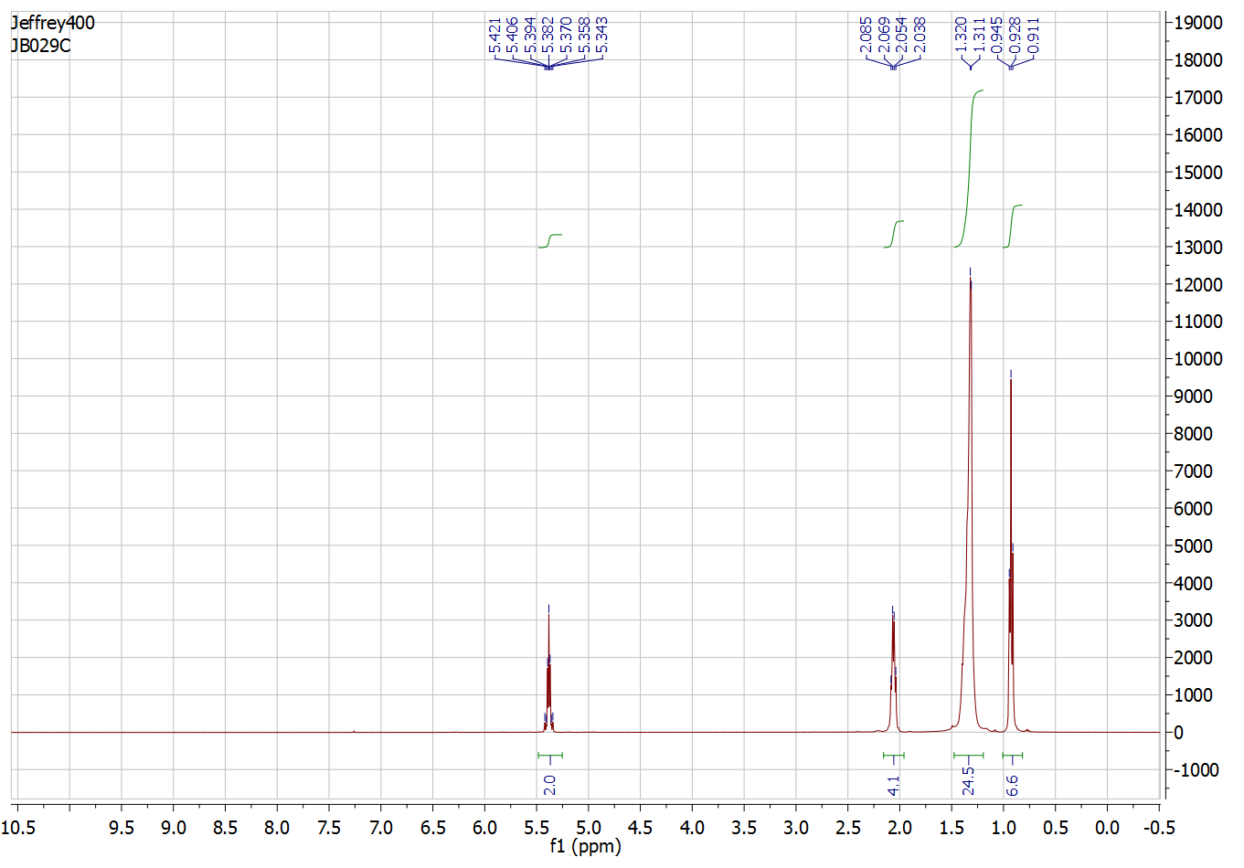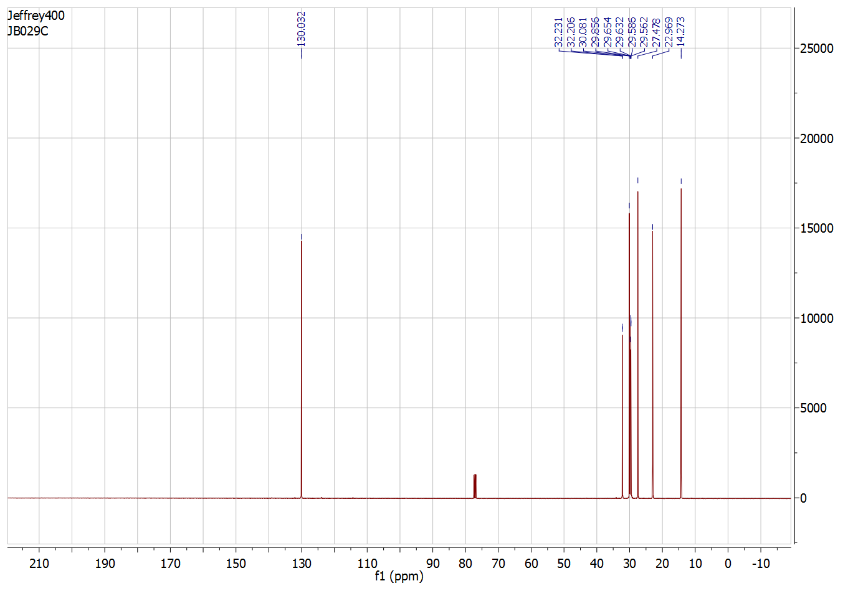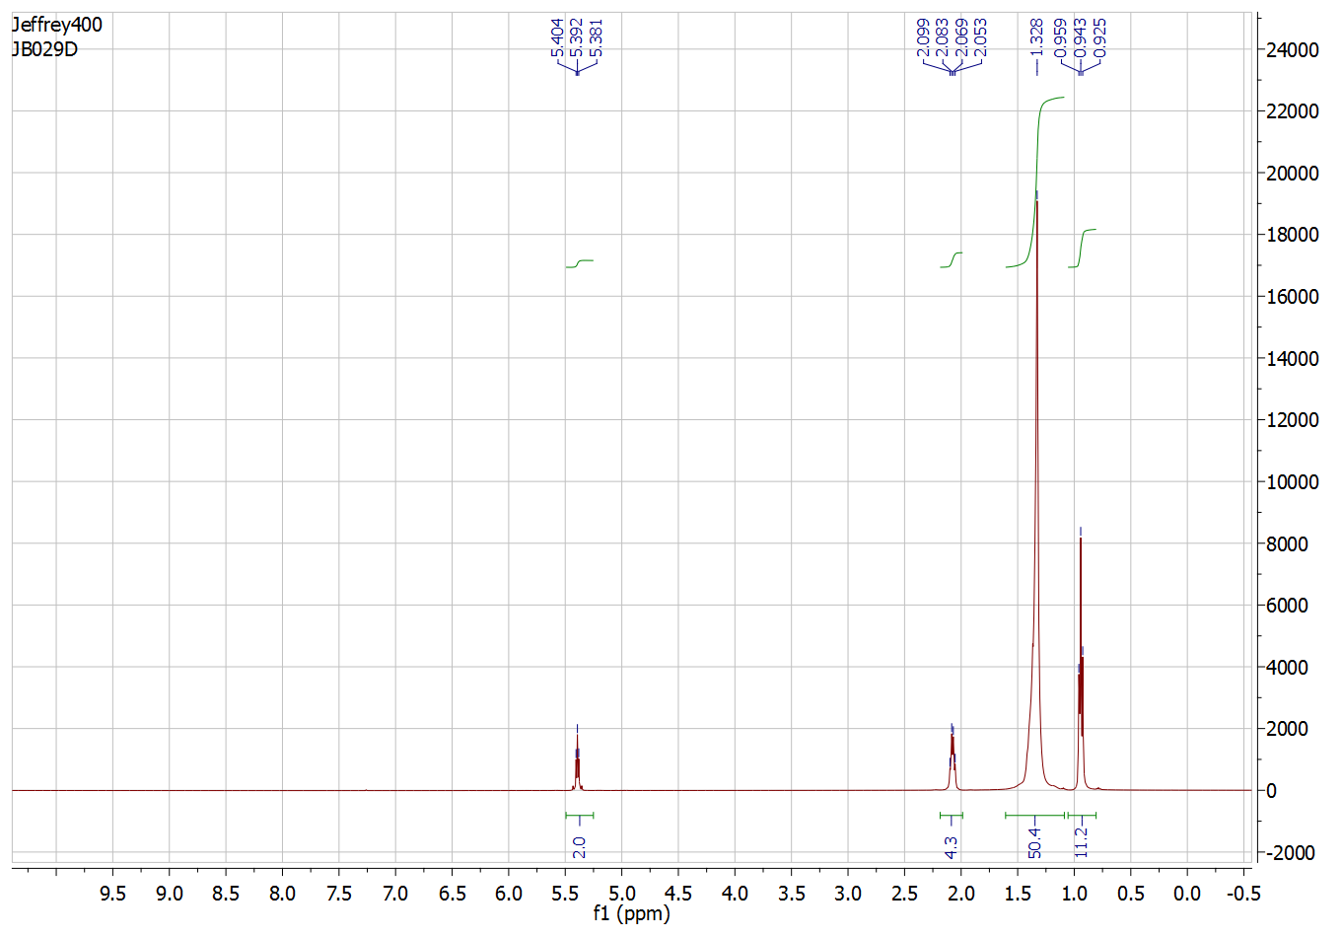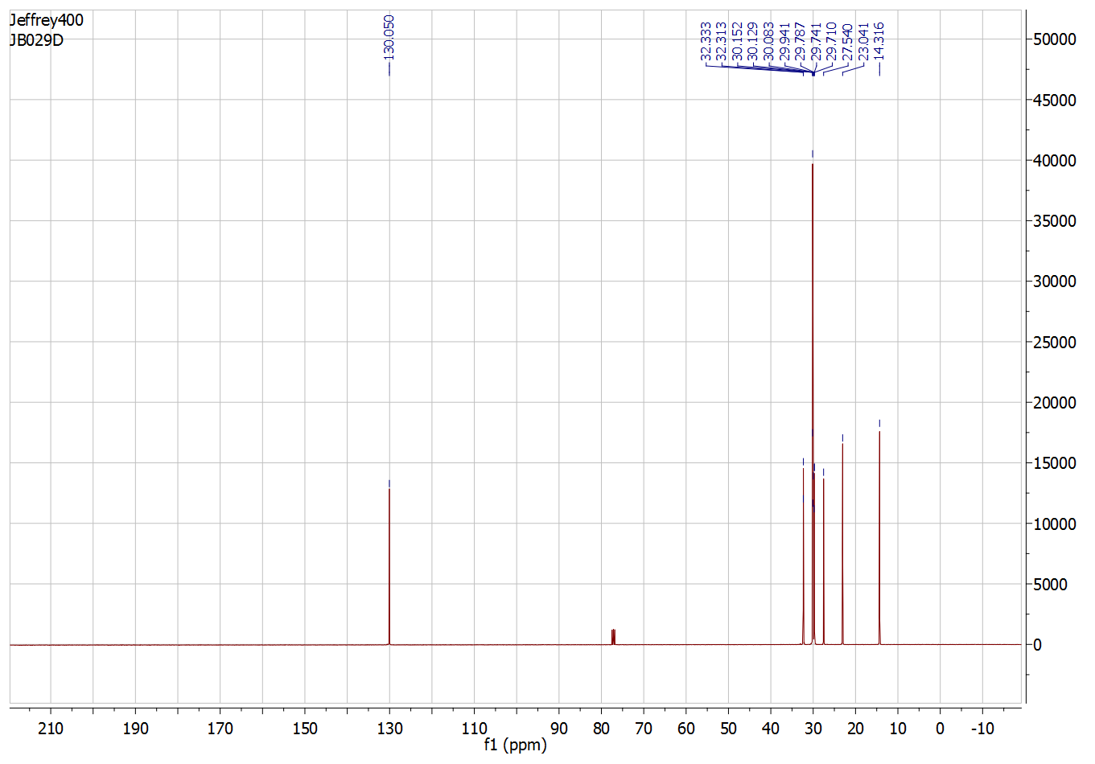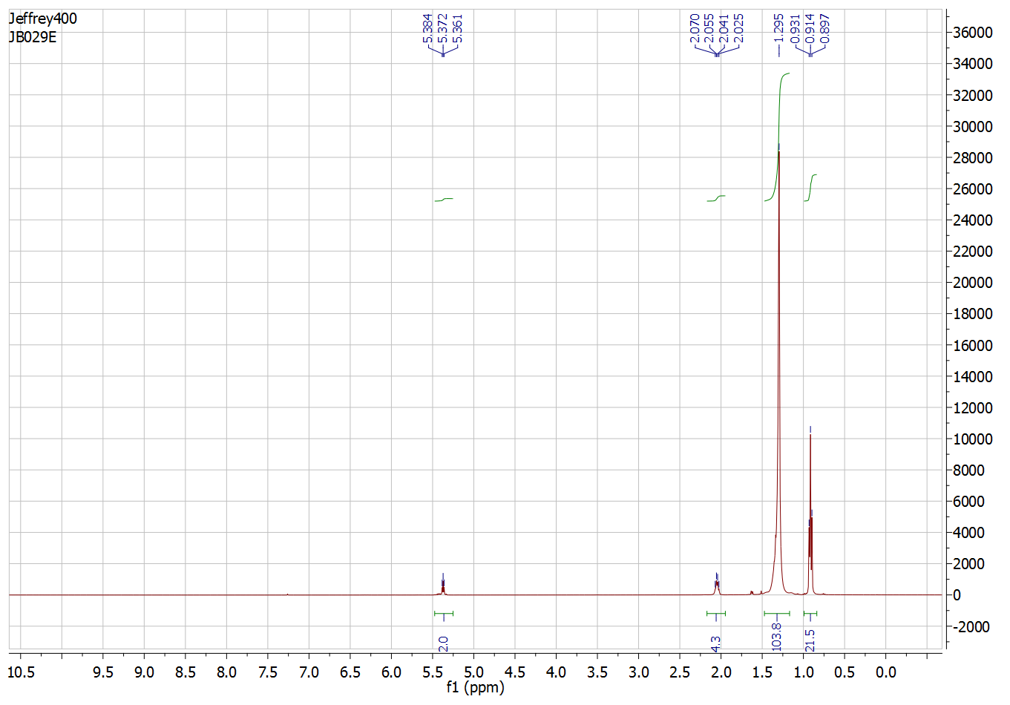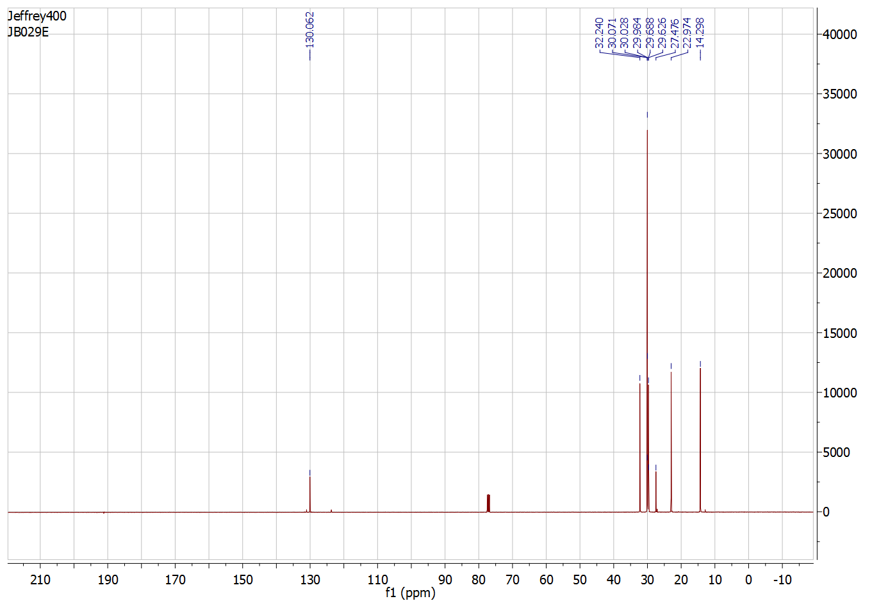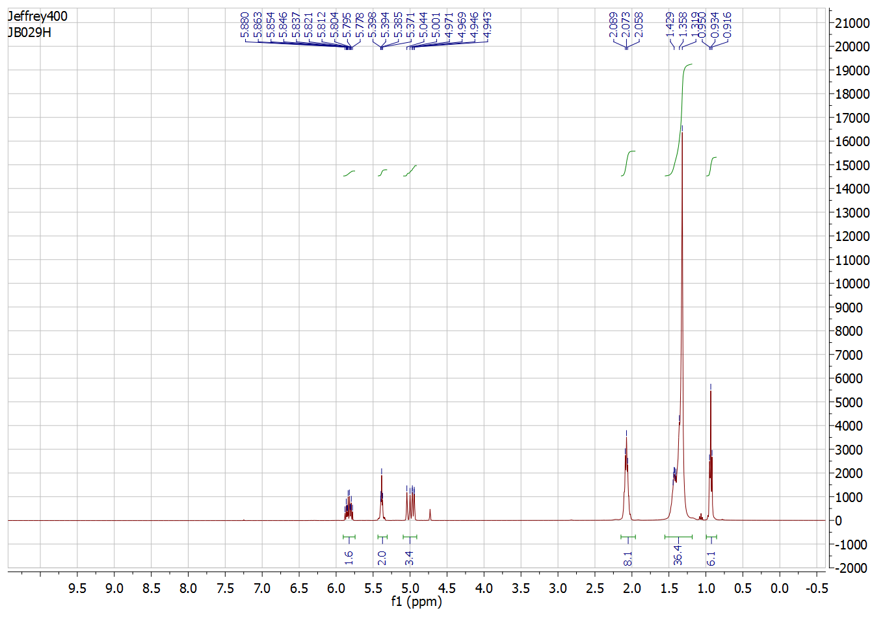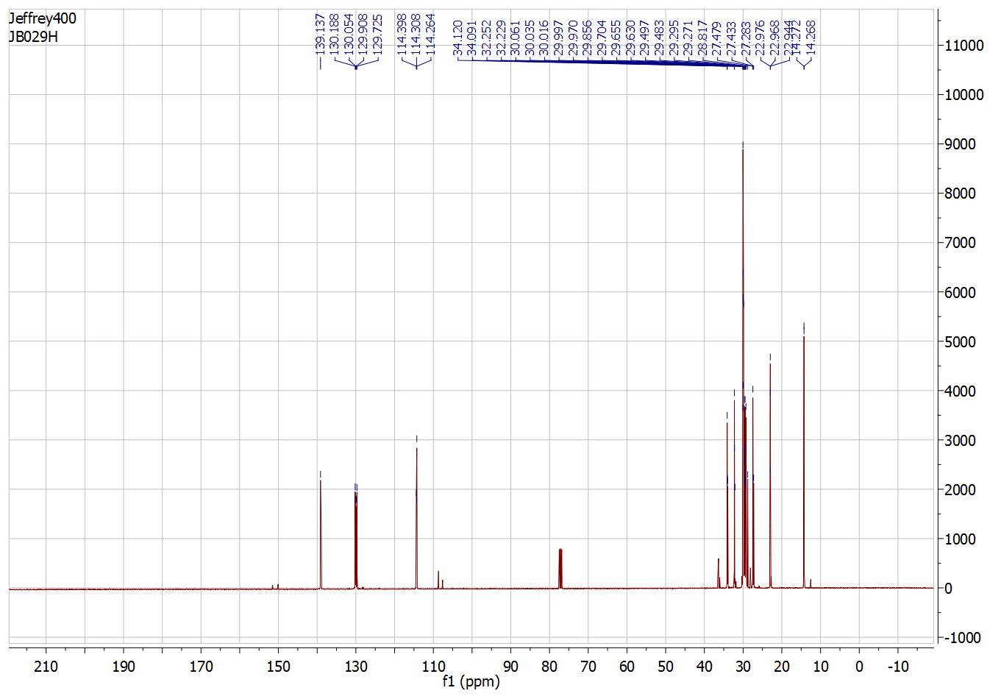
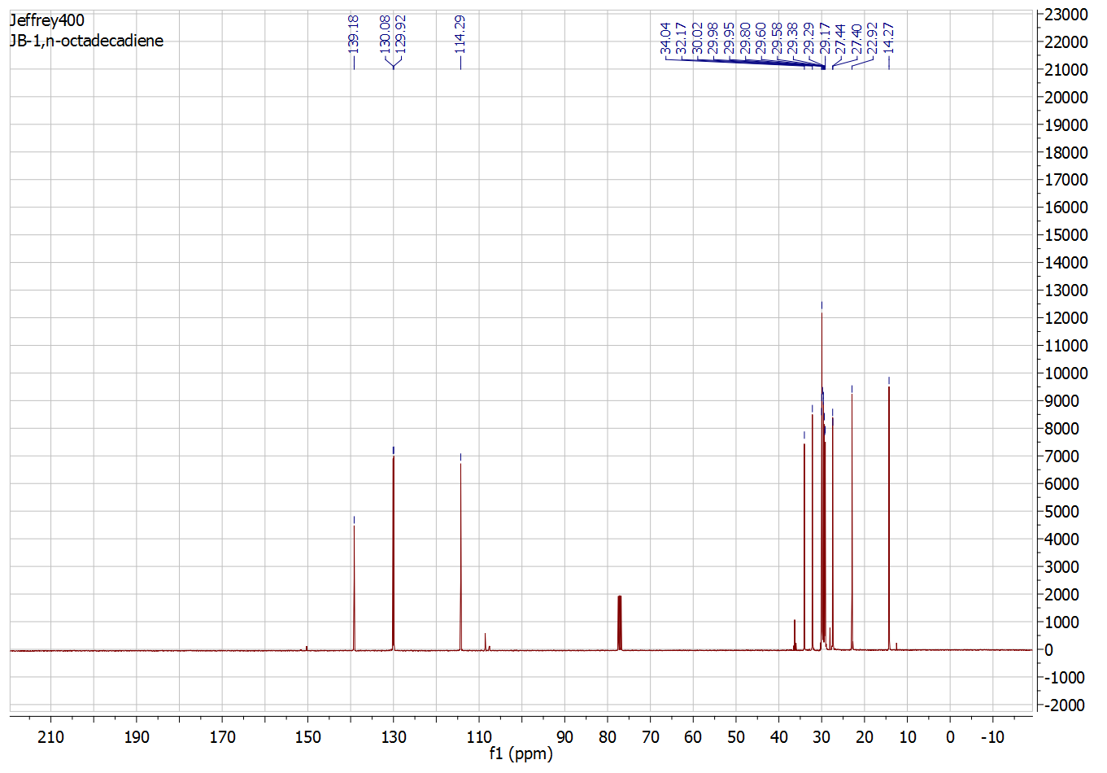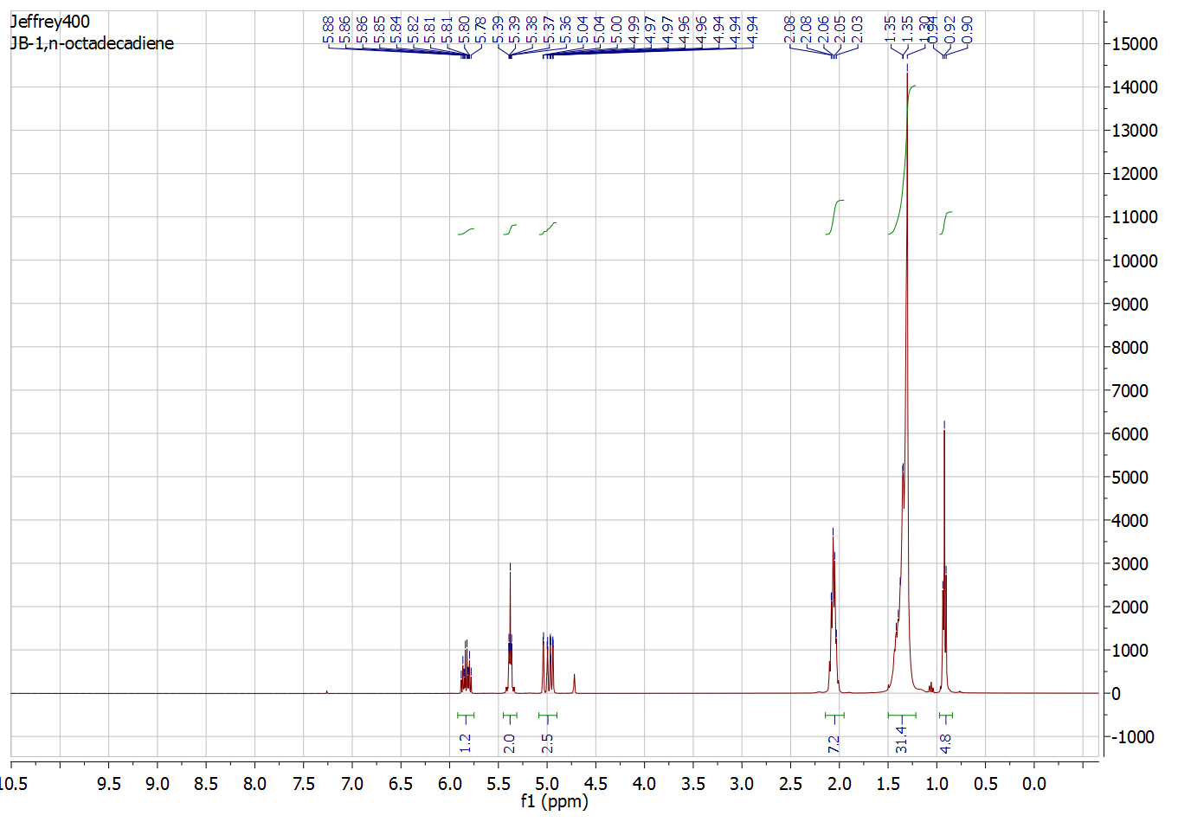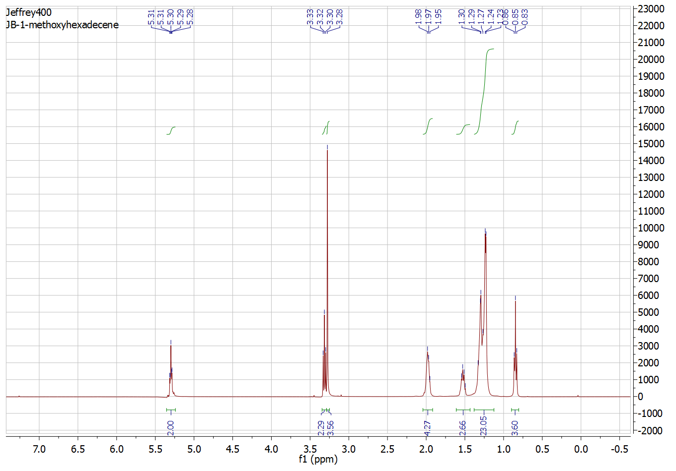
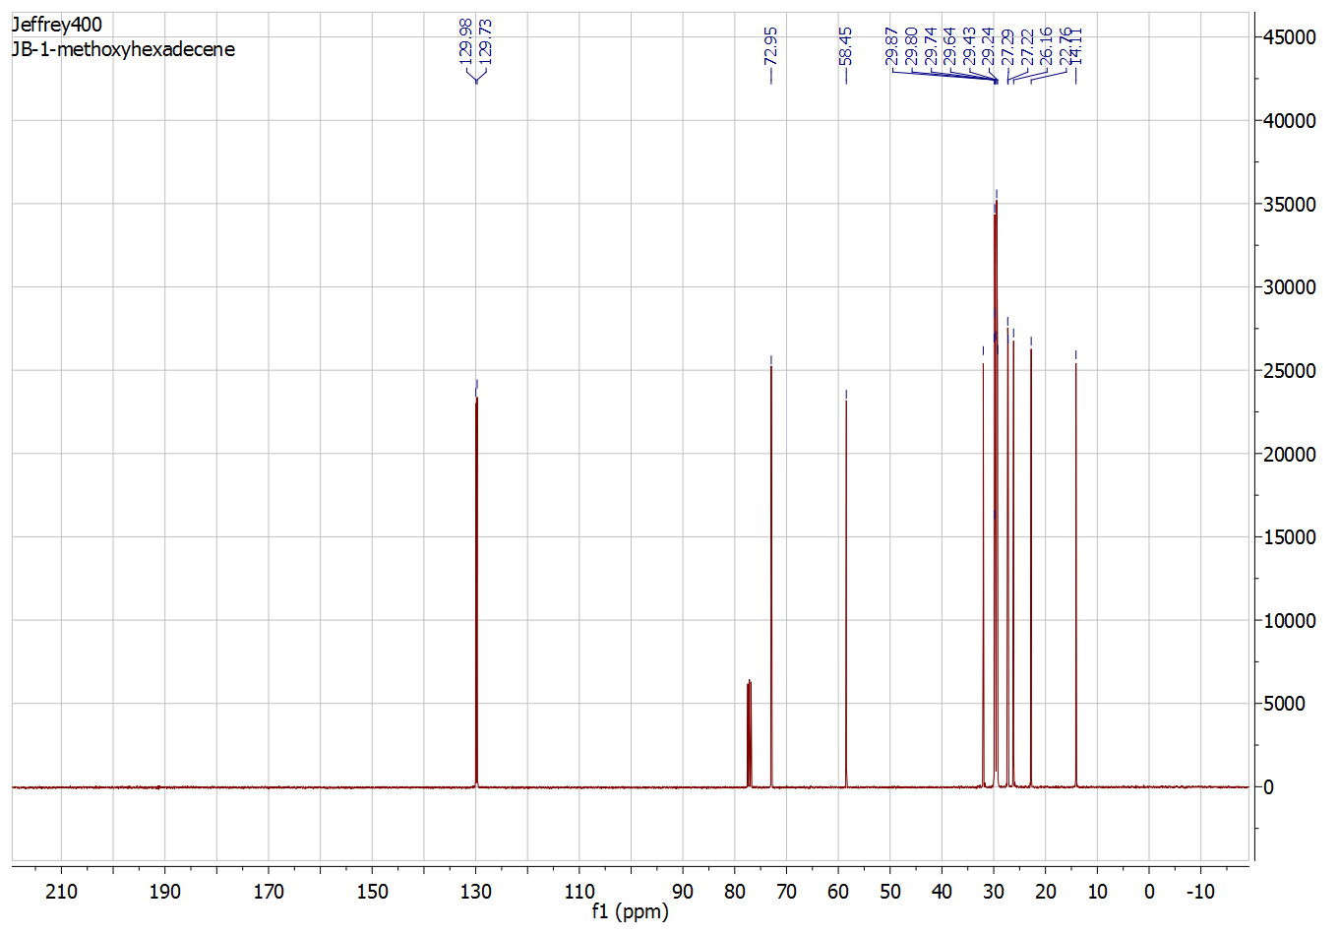
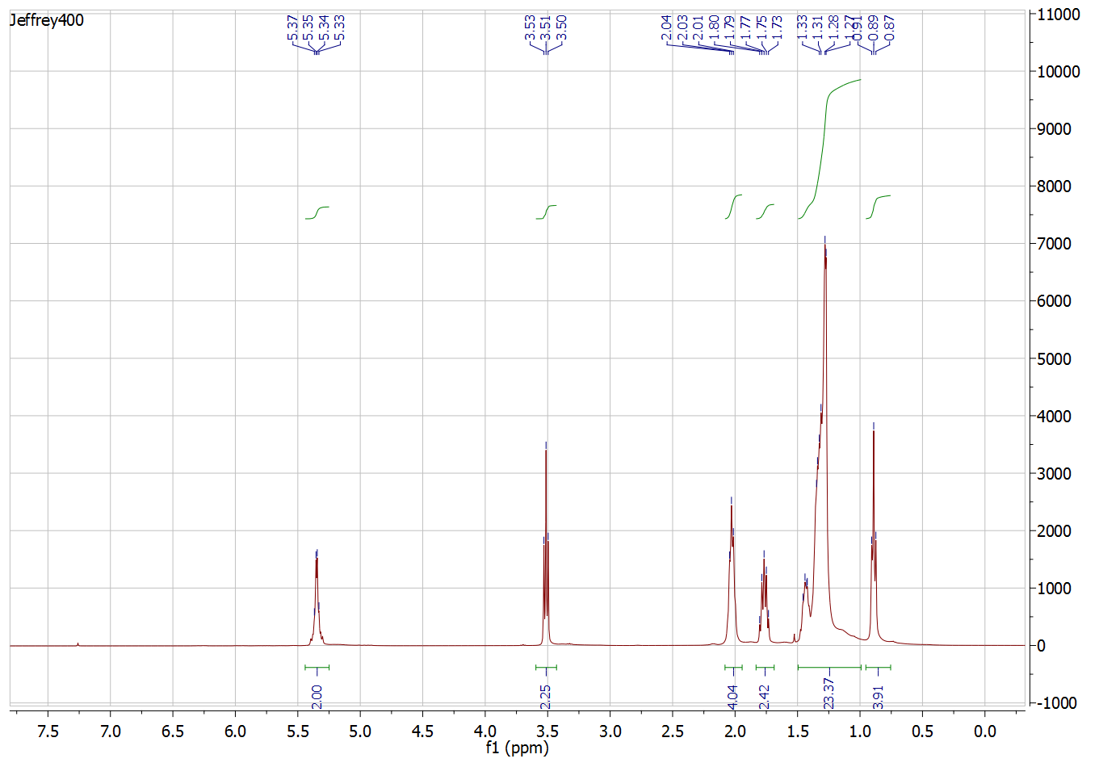
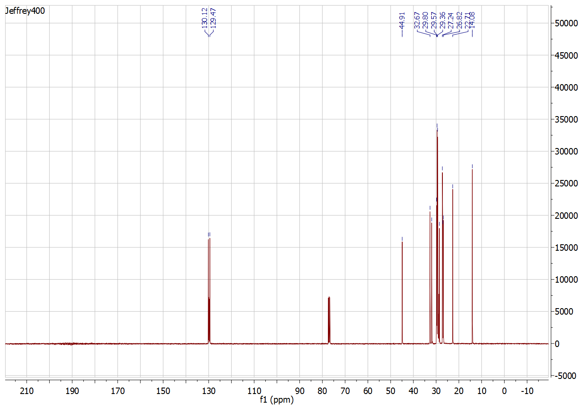
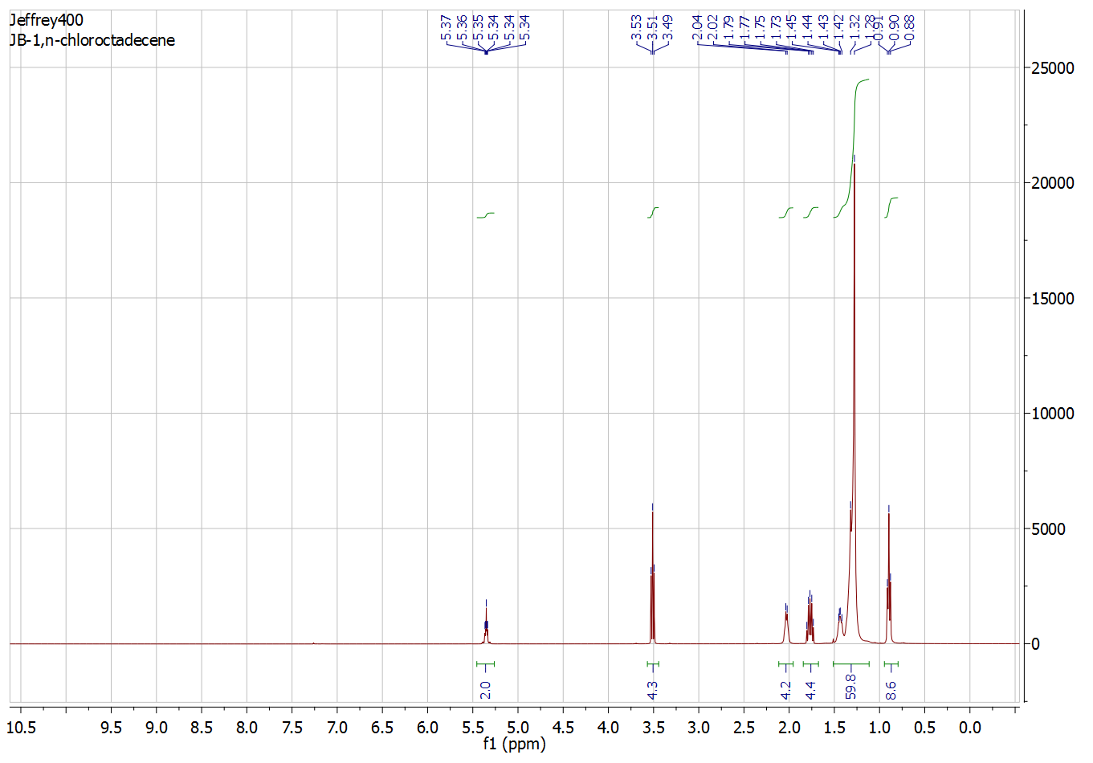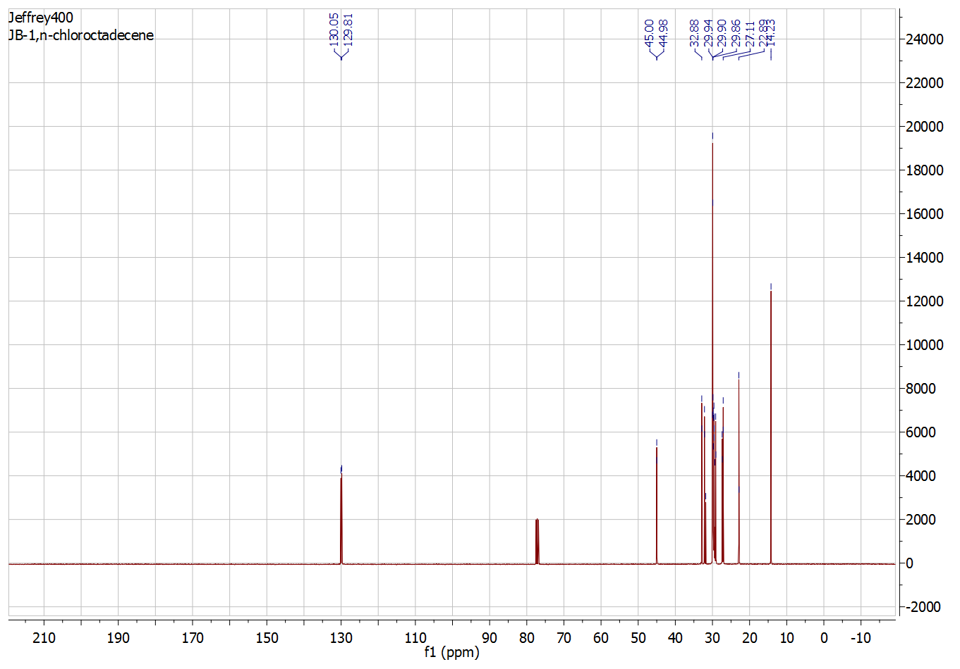
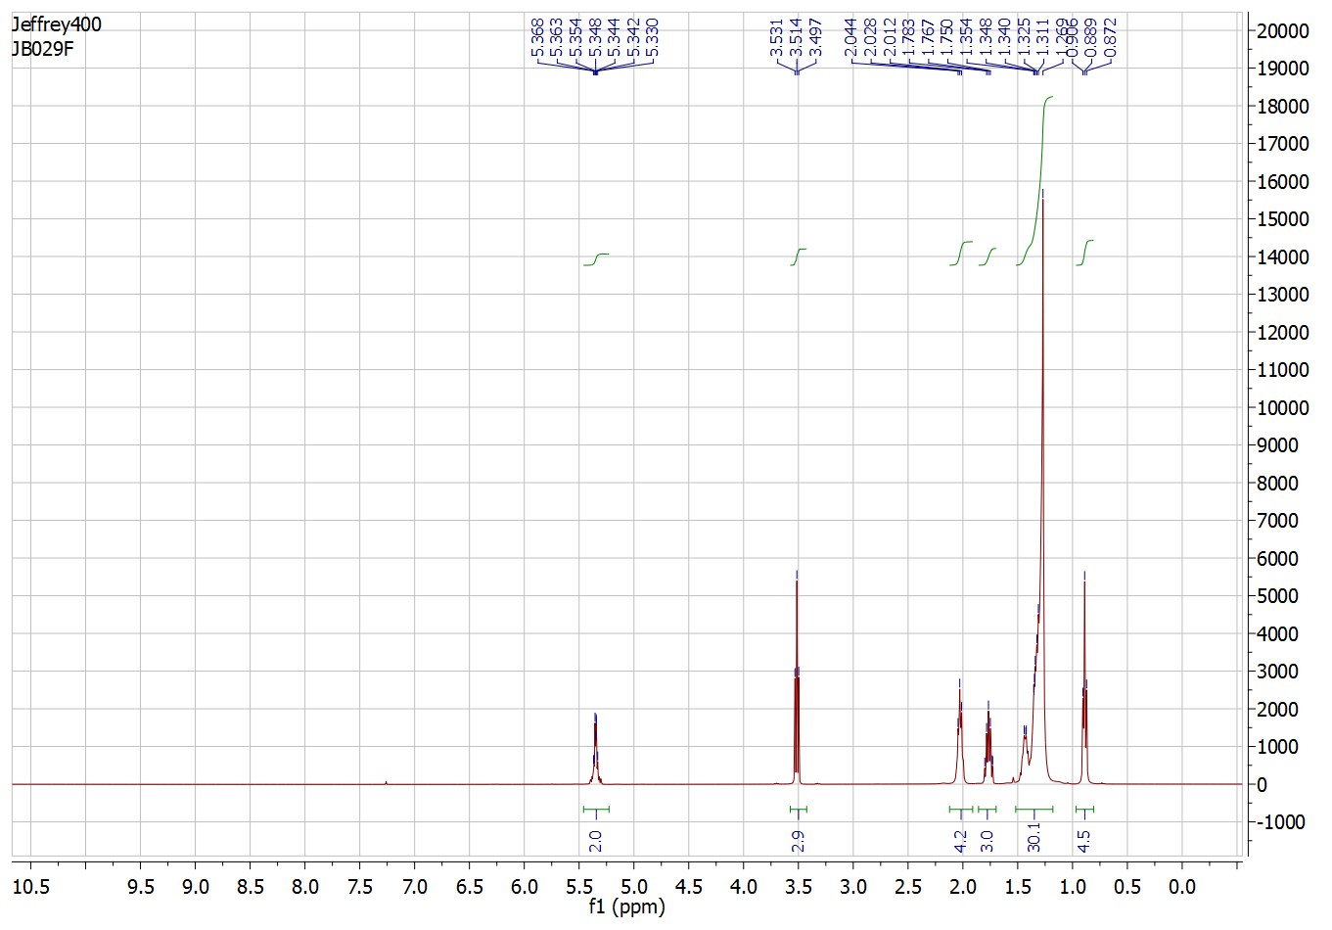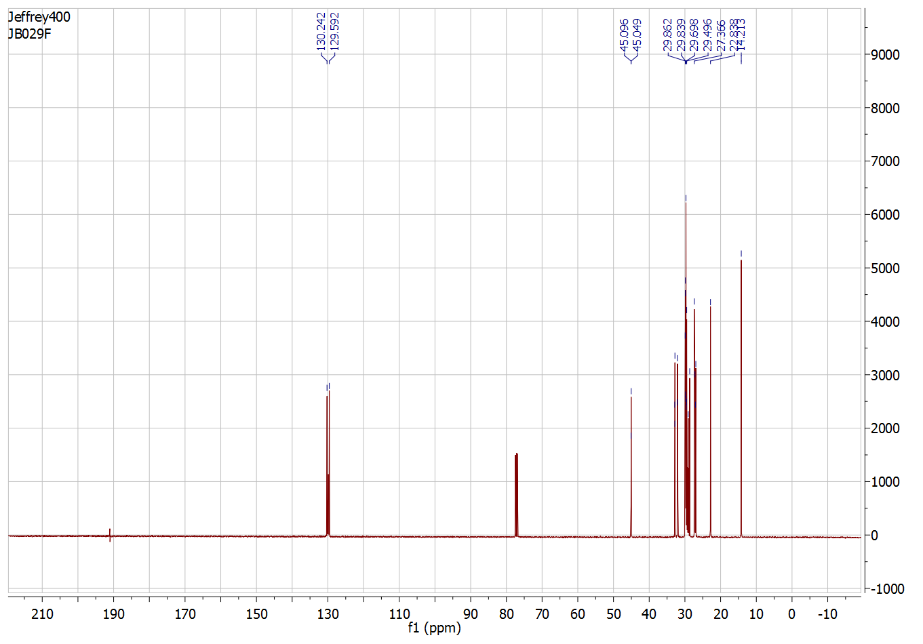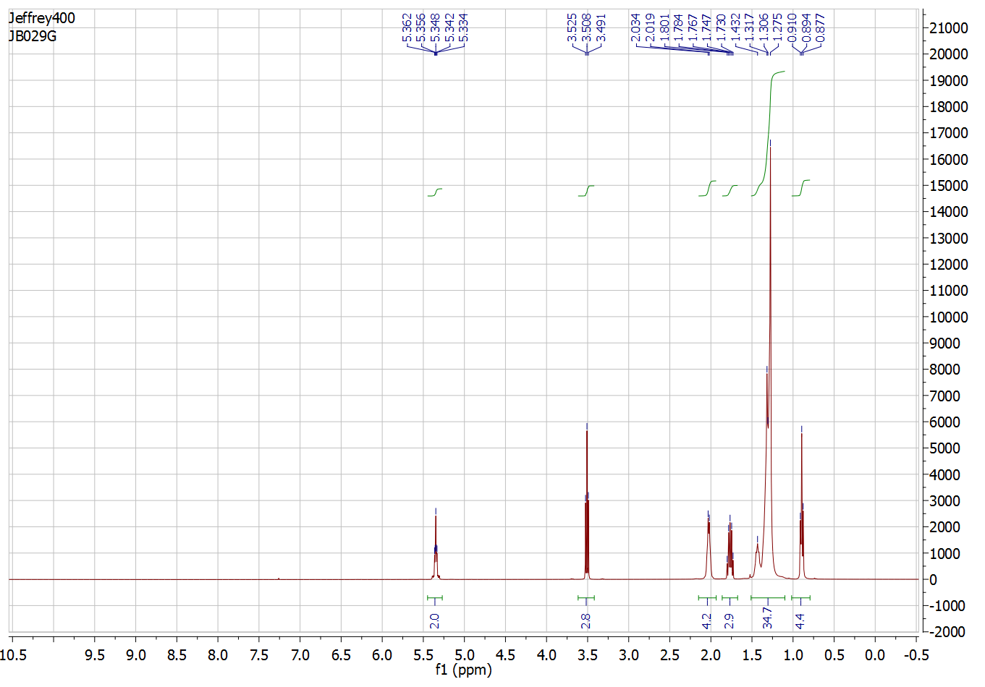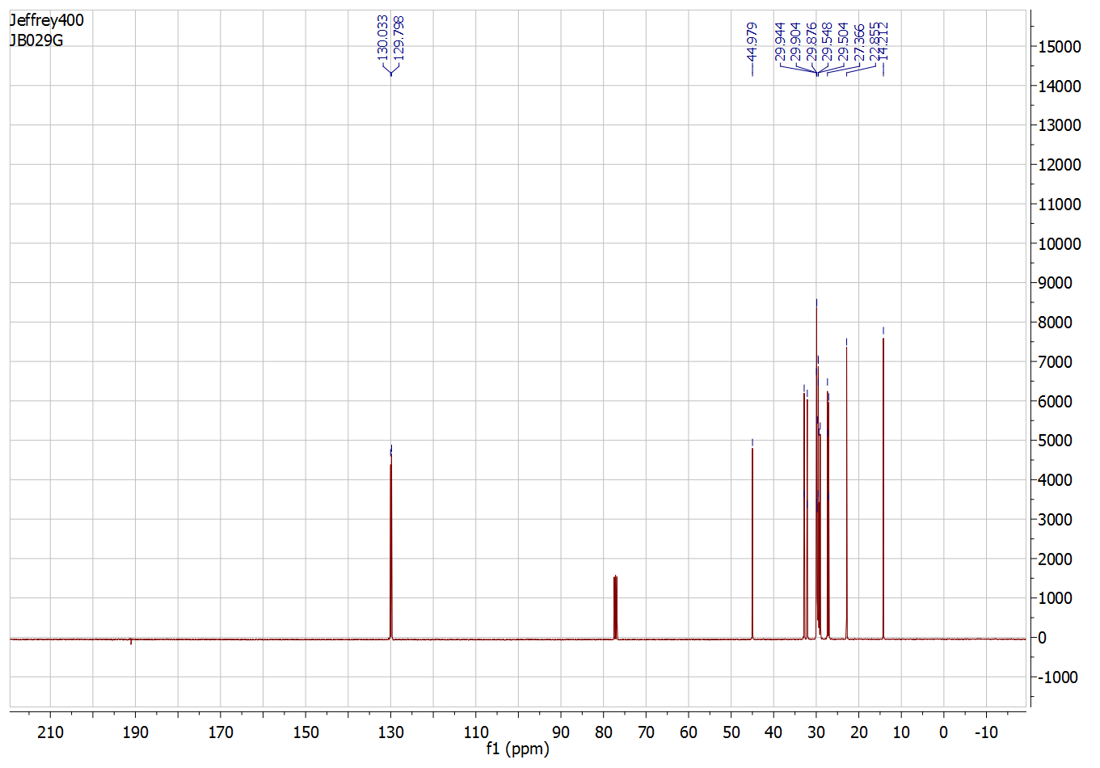
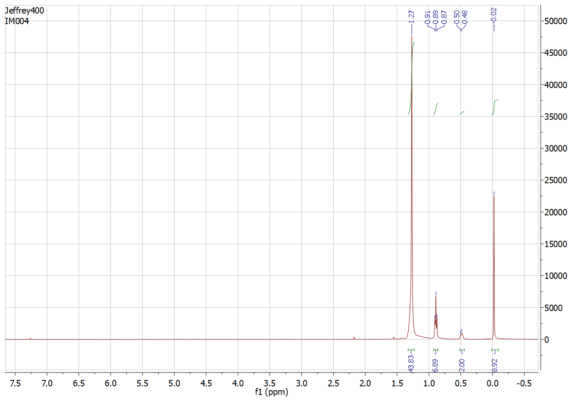
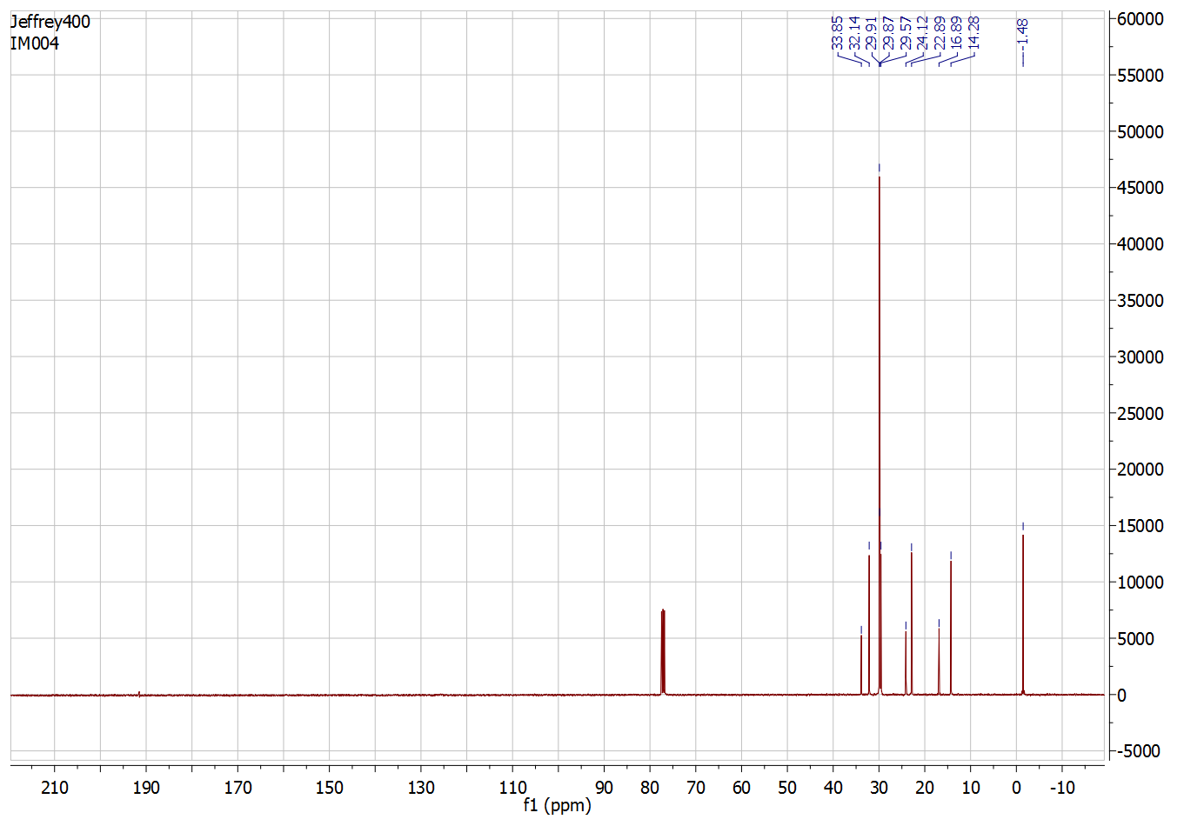
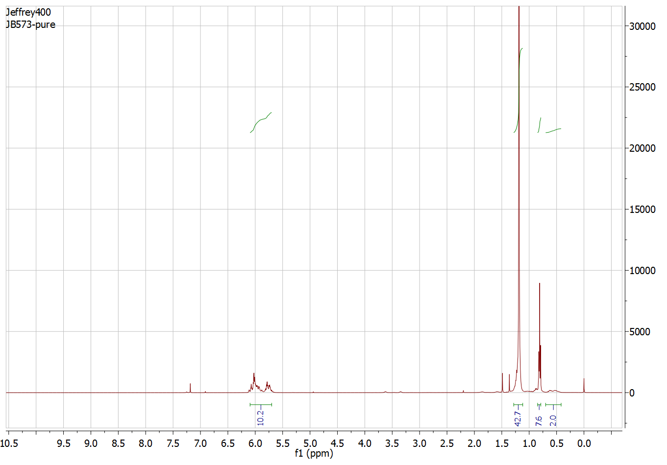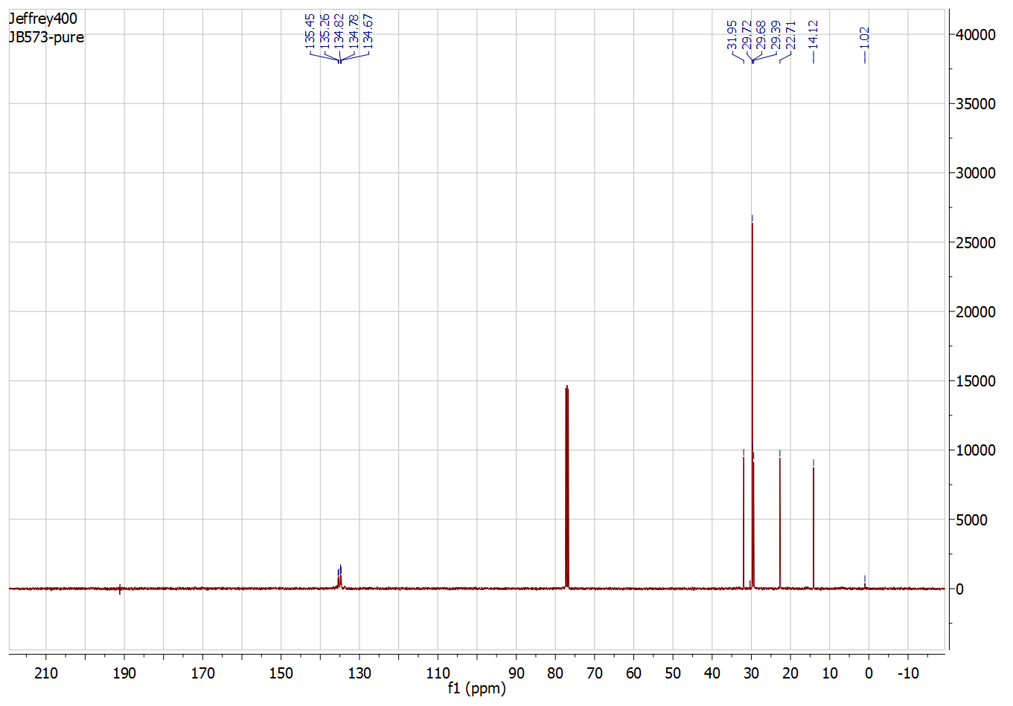
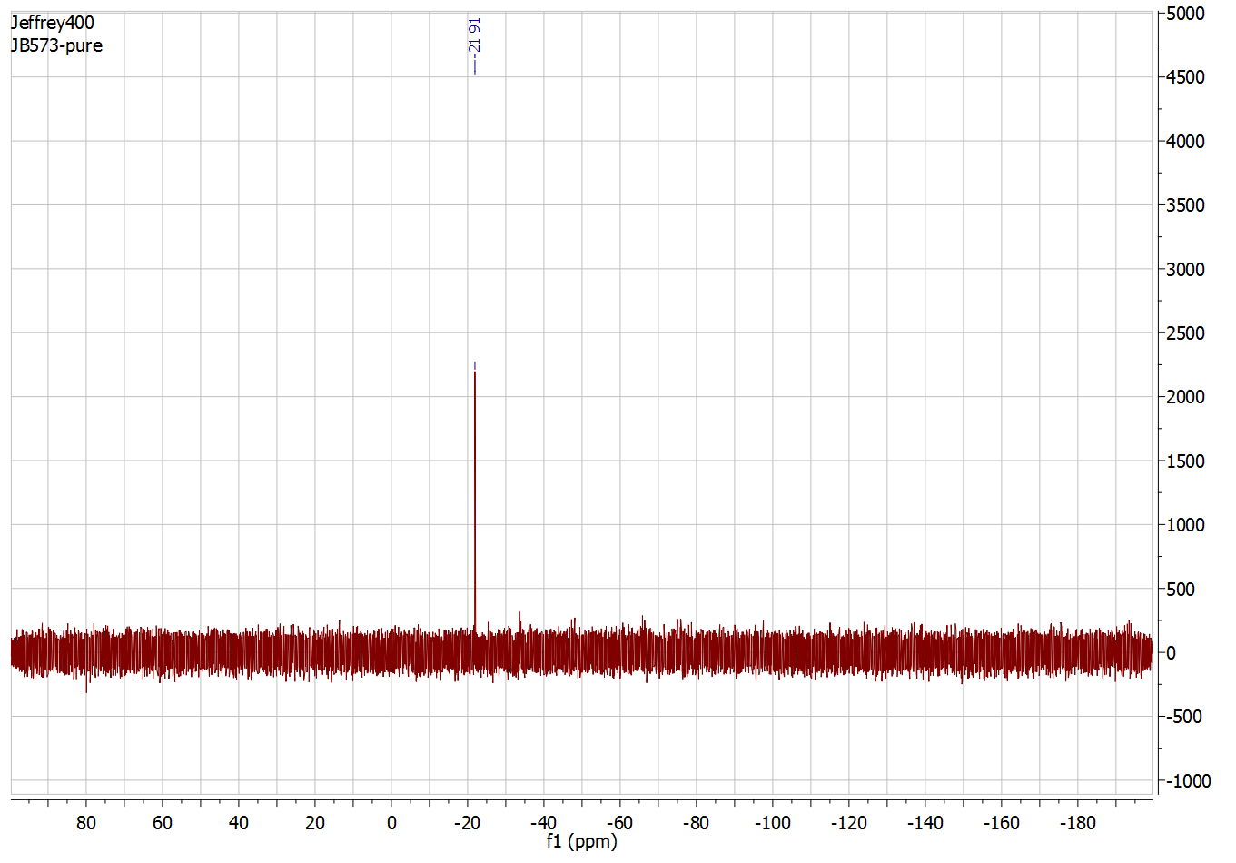

a

References

- DNeasy Blood & Tissue Handbook, 2006 Qiagen.
2. Nurk, S. et al. Assembling genomes and mini-metagenomes from highly chimeric reads. in research in computational molecular biology, RECOMB 2013. Lecture Notes in Computer Science, vol 7821, Deng, M., Jiang, R., Sun, F. & Zhang, X. Eds. (Springer, Berlin, Heidelberg, 2013).
3. Bertels, F., Silander, O. K., Pachkov, M., Rainey, P. B., & van Nimwegen, E. Automated reconstruction of whole genome phylogenies from short sequence reads. Mol. Biol. Evol. 31, 1077-1088 (2014).
4. Langmead, B. & Salzberg, S. L. Fast gapped-read alignment with Bowtie 2. Nat. Methods, 9, 357–359 (2012).
5. Guindon, S., Dufayard, J. F., Lefort, V., Anisimova, M., Hordijk, W. & Gascuel, O. New algorithms and methods to estimate maximum-likelihood phylogenies: assessing the performance of PhyML 3.0. Syst, Biol. 59, 307-21 (2010).
6. Yu, G., Smith, D., Zhu, H., Guan, Y. & Lam, T. T.-Y. ggtree: an R package for visualization and annotation of phylogenetic trees with their covariates and other associated data. Methods in Ecology and Evolution 8, 28-36 (2017).
7. RNAprotect Bacteria Reagent Handbook, 2020 Qiagen.
8. Love M. I., Huber, W. & Anders, S. Moderated estimation of fold change and dispersion for RNA-seq data with DESeq2. Genome Biology, 15, 550-571 (2014).
9. DeLorenzo, D. M. & Moon, T. S. Selection of stable reference genes for RT-qPCR in Rhodococcus opacus PD630. Scientific reports, 8,1-9 (2018).
10. Pettersen, E. F., Goddard, T. D., Huang, C. C., Couch, G. S., Greenblatt, D. M., Meng, E. C. & Ferrin, T. E. UCSF Chimer $–$a visualization system for exploratory research and analysis. J Comput. Chem. 25, 1605-1612 (2004).
11. Kim, S. et al. PubChem 2019 update: improved access to chemical data. Nucleic Acids Res. 47, D1102–D1109 (2019).
12. Wang, J., Wang, W., Kollman, P. A. & Case, D. A. Automatic atom type and bond type perception in molecular mechanical calculations. J. Mol. Graphics and Modelling, 25, 247-260 (2006).
13. Liu, N. & Xu, Z. Using LeDock as a docking tool for computational drug design. IOP Conf. Ser.: Earth Environ. Sci. 218, 012143 (2019).
14. Obligacion, J. V. & Chirik, P. J. Bis(imino)pyridine cobalt-catalyzed alkene isomerization-hydroboration: A strategy for remote hydrofunctionalization with terminal selectivity. J. Am. Chem. Soc. 135, 19107-19110 (2013).
15. Zhang, X. L., Penfold, J., Thomas, R. K., Ian, M., Petkov, J. T., Bent. J. & Cox, A. Adsorption behavior of hydrophobin & hydrophobin/surfactant mixtures at the solid solution interface. Langmuir 27, 10604-10474 (2011).
16. Strom, A. E. & Hartwig, J. F. One-pot anti-Markovnikov hydroamination of unactivated alkenes by hydrozirconation and amination. J. Org. Chem. 78, 8909-8914 (2013).
17. Wang, L., Li, P., Chen, J. & Yan, J. A novel reduction of azides to amines with tellurium metal in near-critical water. Phosphorus Sulfur Silicon Relat. Elem. 178, 1807-1813 (2003).
18. Wong, Y. I., Hubiecki, M. P., Curfman, C. L., Doncel, G. F., Dudding, T. C., Savle, P. S. & Gandoura, R. D. A Structure-activity study of spermicidal and anti-HIV properties of hydroxylated cationic surfactants. Bio. & med. Chem. 10, 3899-3608 (2002).
19. Lu, C., Shen, F., Wang, S., Wang, Y., Liu, J., Bai, W.-J. & Wang, X. An engineered self-sufficient biocatalyst enables scalable production of linear α-olefins from carboxylic acids. ACS Catalysis 8, 5794-5798 (2018).
20. Zhou, F., Zhu, J., Zhang, Y. & Zhu, S. NiH-catalyzed reductive relay hydroalkylation: A strategy for the remote C(sp3)-H alkylation of alkenes. Angew. Chem. Int. Ed. 57, 4058-4062 (2018).
21. Zhu, R.-Y., He, J. & Yu, J.-Q. Ligand-promoted alkylation of C(sp3)-H and C(sp2)-H bonds. J. Am. Chem. Soc. 136, 13194-13197 (2014).
22. Zimmermann, L. et al . A completely reimplemented MPI bioinformatics toolkit with a new HHpred server at its core. J. Mol. Biol. 430, 2237-2243 (2018).
23. Waterhouse, A. M., Procter, J. B., Martin, D. M. A., Clamp, M. & Barton, G. J. Jalview version 2—a multiple sequence alignment editor and analysis workbench. Bioinformatics, 25, 1189-1191 (2009).

