Supplementary information

Massive drift of pumice stones might trigger coastal ecological transitions

Yoshikazu Ohno¹, Akira Iguchi^{2*}, Mariko Ijima^{2*}, Ko Yasumoto³＆Atsushi Suzuki²

¹ Independent scholar, Uruma, Okinawa 904-2231, Japan
² Geological Survey of Japan, National Institute of Advanced Industrial Science and
Technology, 1-1-1 Higashi, Tsukuba, Ibaraki 305-8567, Japan
Research Laboratory on Environmentally Conscious Developments and Technologies
[E-code], National Institute of Advanced Industrial Science and Technology, Tsukuba,
Ibaraki 305-8567, Japan
³School of Marine Biosciences, Kitasato University, 1-15-1 Kitasato, Minami, Sagamihara,
Kanagawa 252-0373, Japan

Correspondence and requests for materials should be addressed to A. I.
Email address: iguchi.a@aist.go.jp

Supplementary Figure 1
Supplementary Figure 2
Supplementary Figure 3
Supplementary Table 1
Supplementary Table 2
Supplementary Video 1
Supplementary Video 2
Supplementary Video 3
Supplementary Video 4
Supplementary Video 5
Supplementary Video 6
Supplementary Video 7
Supplementary Video 8
Supplementary Video 9
Supplementary Video 10

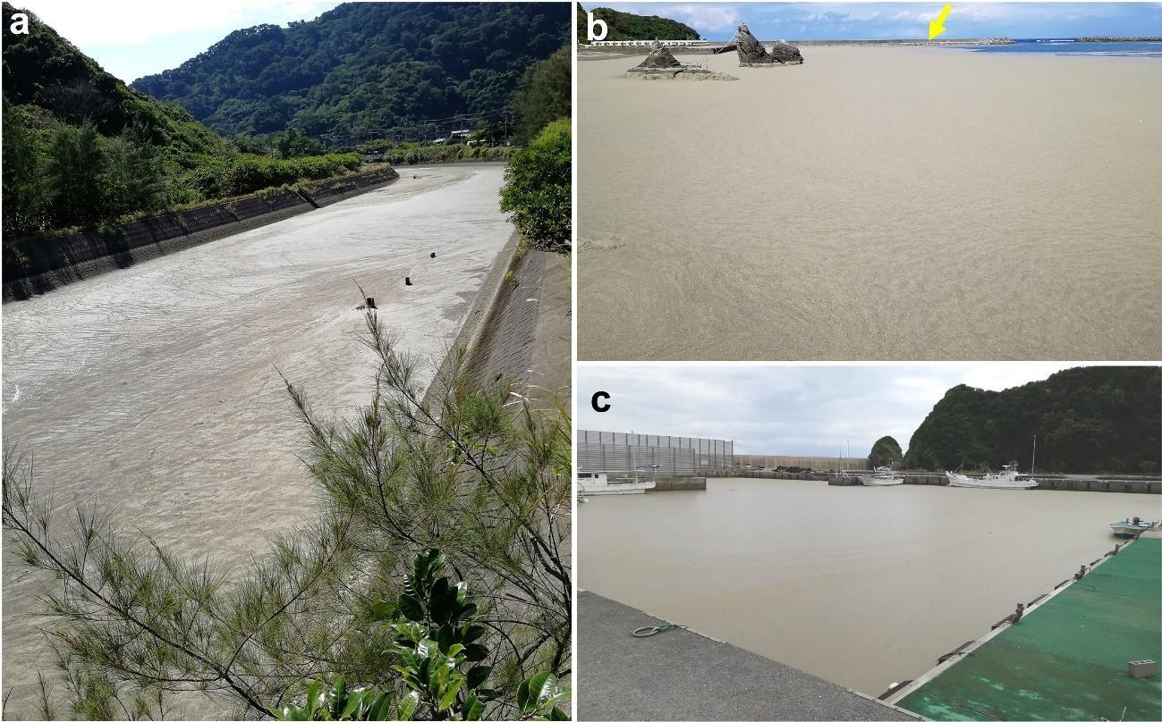
Supplementary Figure 1: View of Oku River, Oku and Ada harbors where the pumice stones washed ashore on northern Okinawa Island
(a) A photo of the Oku River taken looking upstream from a point 200–300 m from the river mouth near the Oku fishing port in (b). The surface of the river between the dikes was almost completely covered with pumice. (b) The pumice-covered Oku fishing harbor is shown, more than 10 km north of (c). The yellow arrow points to the seawall in the bay, approximately 200 m away from the photographer. (c) The fishing boats were surrounded by floating pumice stones and could not be operated on. The thickness of the floating pumice stone layer was approximately 10 cm. The surface was smooth like dried sand, without a slimy feeling when the pumice layer was touched. All photos were taken on 24 October 2021.

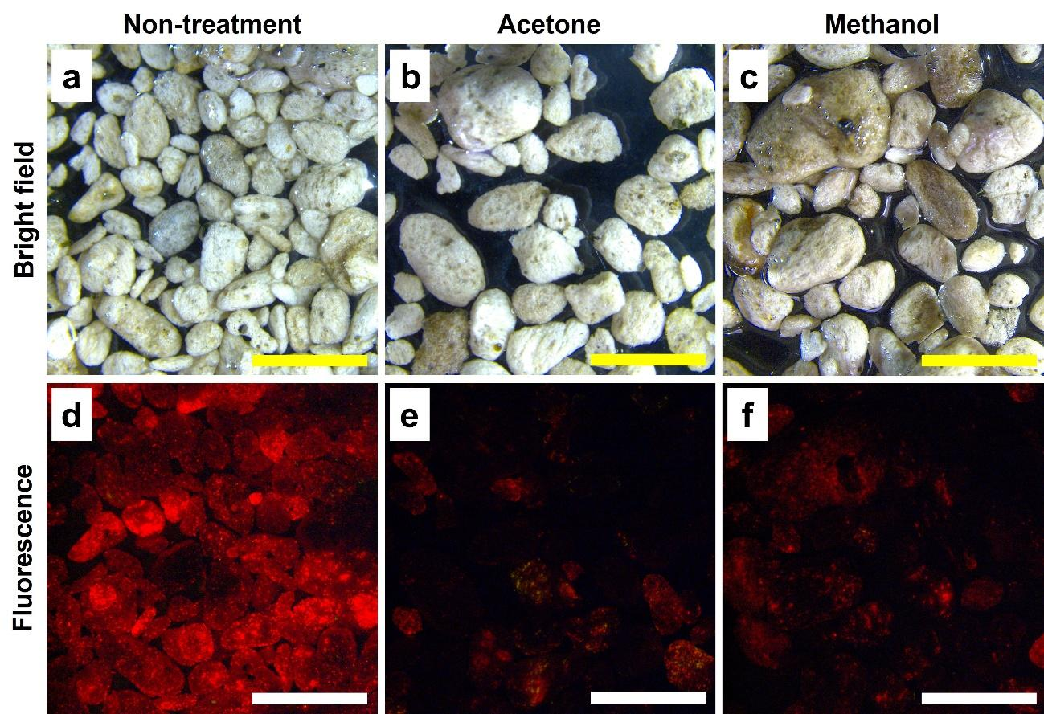
Supplementary Figure 2: Decrease of fluorescence signal by organic solvent treatment
(a-c) The upper row shows brightfield images corresponding to (d-e) each, showing fluorescence images. (a, d) Non-treatment sample, but vivid fluorescent signals were detected. (b, e) Pebbles were treated with 90% of acetone for 10 min at room temperature. (e, f) Treated with 100% of methanol for 10 min at room temperature. All scale bar: 5 mm. The extracts with remaining chlorophyll were washed off and images were taken. A Leica M165 stereo microscope was used to take these images. Pebbles were excited 485/10 nm by using ET GFP3/CY3 filter and the signal was detected by a color digital camera. The red fluorescence was clearly reduced, but it was difficult to expunge it from the pumice even after each treatment (e, f), suggesting that the microalgae has invaded the air-trap pores of the pumice pebbles. The green autofluorescence from pumice, which may have come from the mineral, is minimal or absent under fluorescent microscopy.

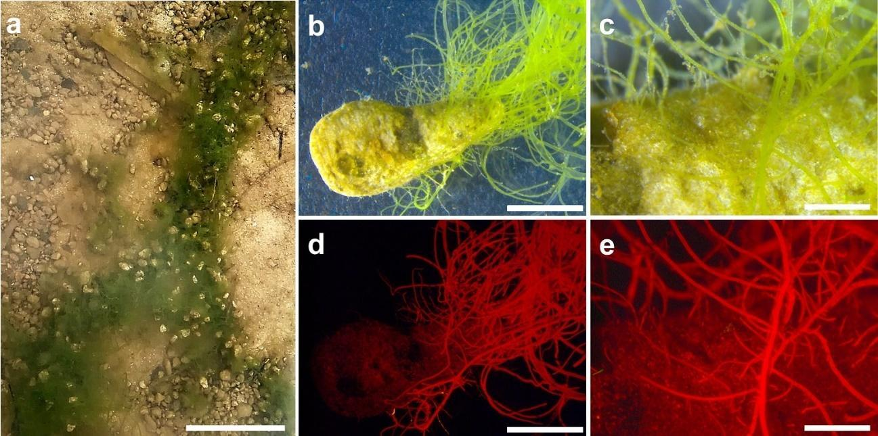
Supplementary Figure 3: Pumice pebbles covered in benthic filamentous algae
(a) Pumice pebbles on the river bottom are beginning to be covered with filamentous algae. The photo was taken on 15 January 2022 near a brackish water estuary off the Ibu coast (Figure 8). Scale bar 10 cm. (b) Microscopic image of a pumice pebble from (a). Filamentous algae are growing from the pumice surface. Scale bar 5 mm. (c) Enlarged image of the center of the figure of (b) shows not only the filamentous algae but also an area slightly browned in sheet form. Scale bar 1 mm. (d) Chlorophyll fluorescence image corresponds to (b). Scale bar 5 mm. (e) Larger image of (c) matches the shape of algae. Scale bar 1 mm.

Supplementary Table 1: Survey areas conducted in Kunigami district
Name of place | Latitude (N) | Longitude (E) | Corresponding figure
Ibu beach | 26°75′57.88″ | 128°32′23.32" | Fig. 2, Fig. 4  Supplementary Figure 2  Supplementary Video 2
Sate Coast | 26°78′84.56″ | 128°22′30.57″ | Fig. 3a and 3b  Supplementary Video 1
Uka coastal area | 26°80′83.25″ | 128°23′38.56″ | Fig. 3c and 3d
Hentona fishing harbor | 26°74′83.84″ | 128°17′76.33″ | Fig. 5
Iji coastal area | 26°46'00.2″ | 128°11'35.3" | Fig. 6, Fig. 7  Supplementary Video 3  Supplementary Video 4  Supplementary Video 5
Oku harbor | 26°84′97.37″ | 128°28′99.49″ | Supplementary Figure 1b
Ada harbor | 26°74′15.83″ | 128°31′86.20″ | Supplementary Figure 1c

Supplementary Table 2: Information of shell size of Lepas and pumices
Date | Pumice ID | Shell size
2021/10/31 | A | 5
2021/10/31 | B | 4
2021/10/31 | B | 4
2021/10/31 | B | 2
2021/10/31 | C | 4
2021/10/31 | D | 4
2021/10/31 | D | 4
2021/10/31 | D | 3
2021/10/31 | D | 3
2021/10/31 | D | 3
2021/10/31 | D | 3
2021/10/31 | D | 2
2021/10/31 | D | 2
2021/10/31 | D | 2
2021/10/31 | E | 6
2021/10/31 | E | 4
2021/10/31 | E | 3
2021/10/31 | F | 5
2021/10/31 | F | 3
2021/10/31 | F | 3
2021/10/31 | G | 3
2021/11/13 | H | 13
2021/11/13 | H | 11
2021/11/13 | H | 10
2021/11/13 | H | 9
2021/11/13 | H | 6
2021/11/13 | H | 5
2021/11/13 | H | 4
2021/11/13 | H | 4
2021/11/13 | H | 4
2021/11/13 | H | 4
2021/11/13 | H | 4
2021/11/13 | H | 3
2021/11/13 | H | 3
2021/11/13 | H | 3
2021/11/13 | H | 3
2021/11/13 | H | 3
2021/11/13 | H | 3
2021/11/13 | H | 3
2021/11/13 | H | 3
2021/11/13 | H | 3
2021/11/13 | H | 3
2021/11/13 | H | 3
2021/11/13 | H | 3
2021/11/13 | H | 3
2021/11/13 | H | 3
2021/11/13 | H | 3
2021/11/13 | H | 3
2021/11/13 | H | 3
2021/11/13 | H | 3
2021/11/13 | H | 3
2021/11/13 | H | 3
2021/11/13 | H | 3
2021/11/13 | H | 3
2021/11/13 | H | 2
2021/11/13 | H | 2
2021/11/13 | H | 2
2021/11/13 | H | 2
2021/11/13 | H | 2
2021/11/13 | H | 2
2021/11/13 | B1 | 15
2021/11/13 | B1 | 13
2021/11/13 | B1 | 12
2021/11/13 | B1 | 9
2021/11/13 | B1 | 9
2021/11/13 | B1 | 8
2021/11/13 | B1 | NA
2021/11/13 | B1 | NA
2021/11/13 | C1 | 13
2021/11/13 | C1 | 11
2021/11/13 | C1 | 9
2021/11/13 | C1 | 9
2021/11/13 | C1 | 8
2021/11/13 | C1 | 6
2021/11/13 | C1 | 4
2021/11/13 | C1 | 2
2021/11/13 | D1 | 11
2021/11/13 | D1 | 10
2021/11/13 | D1 | 10
2021/11/13 | D1 | 10
2021/11/13 | D1 | 6
2021/11/13 | E1 | 14
2021/11/13 | E1 | 13
2021/11/13 | E1 | 13
2021/11/13 | E1 | 11
2021/11/13 | E1 | 10
2021/11/13 | E1 | 9
2021/11/13 | E1 | 3
2021/11/13 | E1 | 3
2021/11/13 | E1 | 2
2021/11/13 | E1 | 2
2021/11/13 | G1 | 10
2021/11/13 | G1 | 7
2021/11/13 | G1 | 6
2021/11/13 | G1 | 6
2021/11/13 | G1 | 3
2021/11/13 | G1 | 3
2021/11/13 | G1 | 2
2021/11/13 | G1 | NA
2021/11/13 | G1 | NA
2021/11/13 | G1 | NA

Video Legends
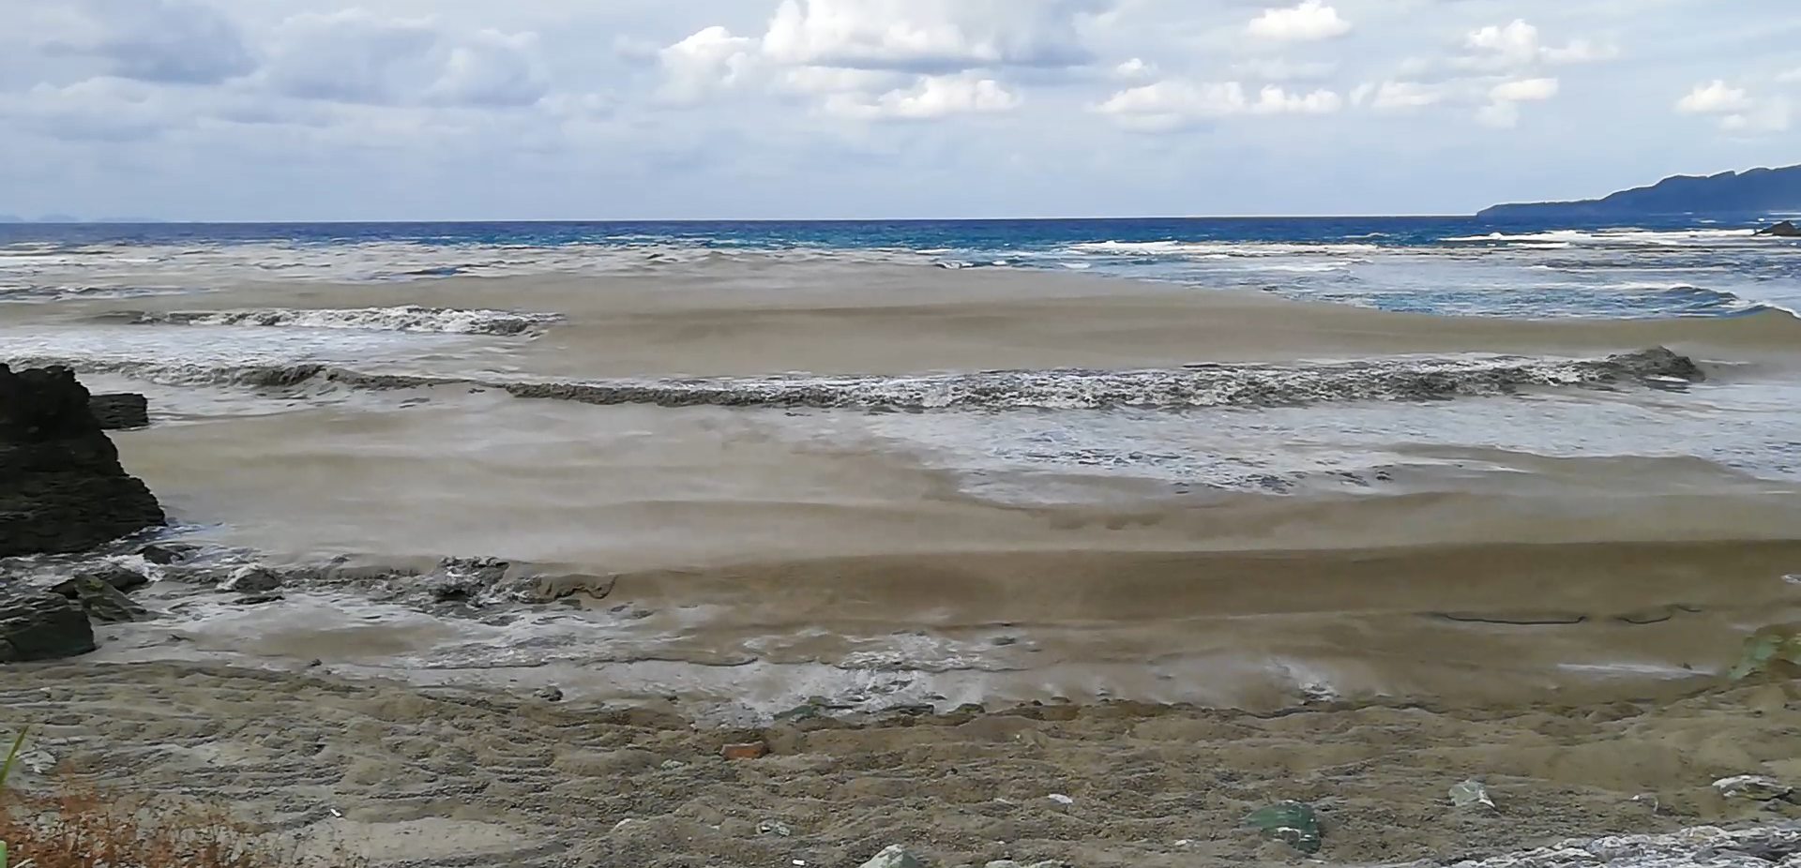
Supplementary Video 1: Pumice stones being washed ashore by the north wind
The video recording of the same place as in Figure 3a was taken on 24 October 2021.

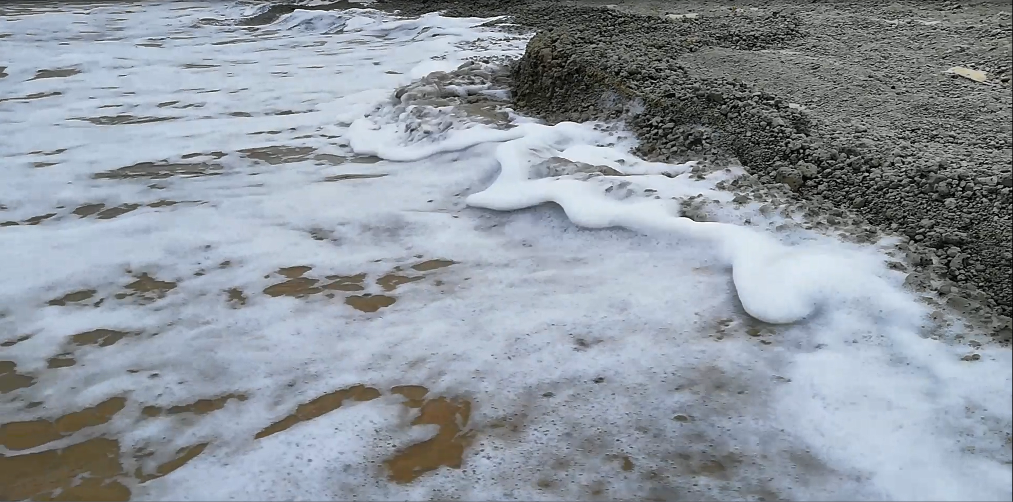
Supplementary Video 2: A pumice deposit layer collapsing at high tide
A layer of pumice deposited on the shoreline and broken up by the waves. It is thought that such vigorous wave dynamics are necessary for the removal of pumice stacks from the beach. This Video was recorded on Ibu Beach on 2 November 2021.

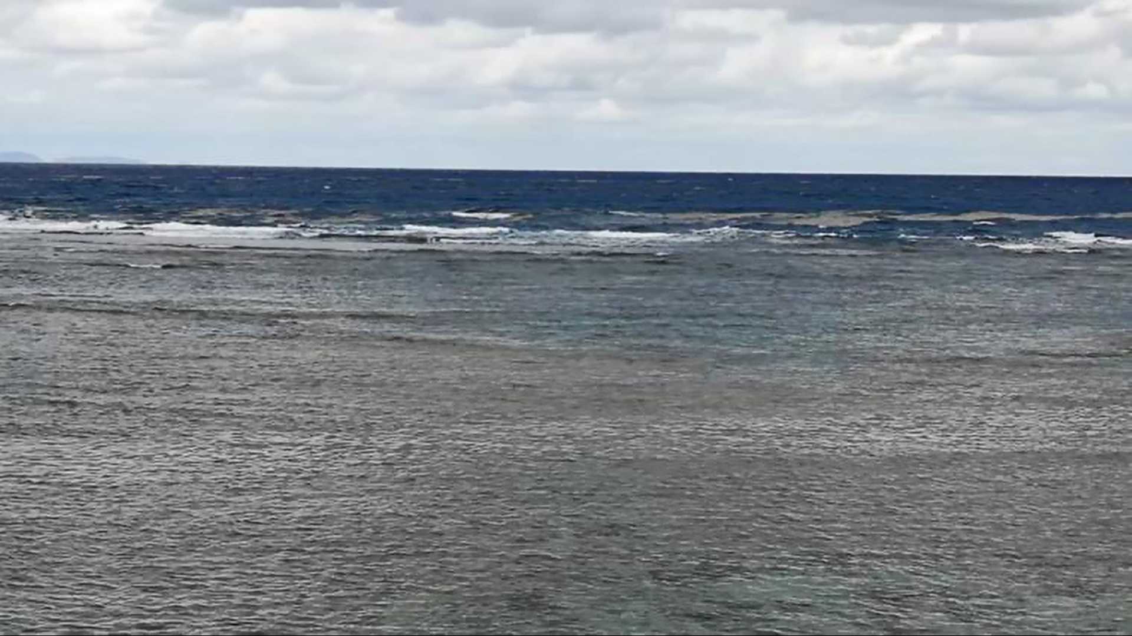
Supplementary Video 3: Pumice raft washed ashore and smashed by the waves on the reef edge
This video was taken on 14 November 2021. Underwater view is described In Figure 6,

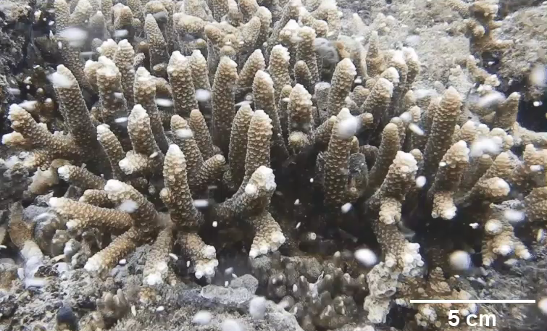
Supplementary Video 4: Pumice stones hit the coral at the reef edge
Numerous small pumice stones hit Acropora coral branches due to wave currents. This data corresponds to Fig. 7a.

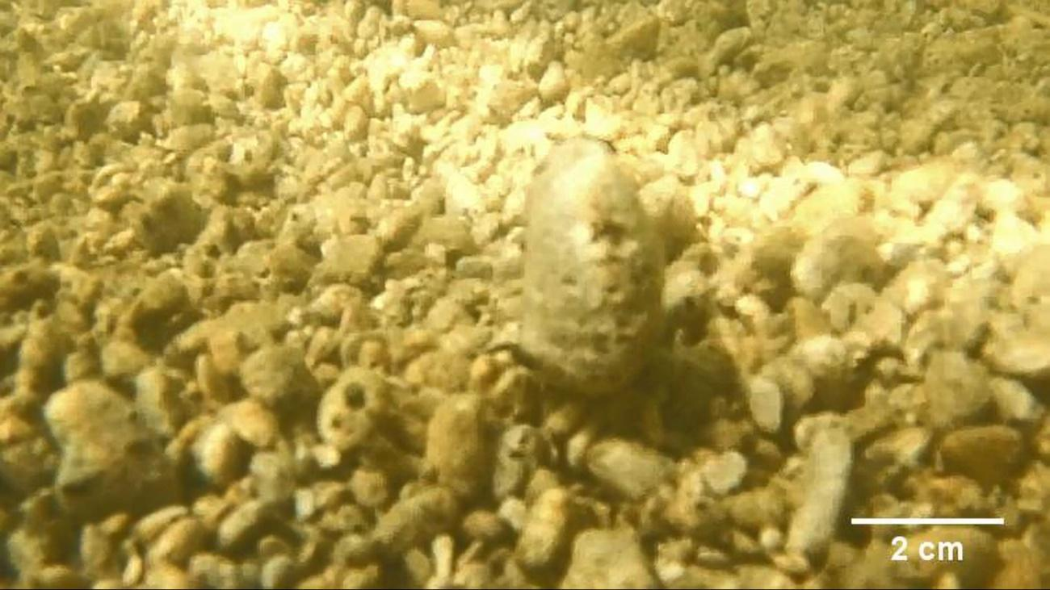
Supplementary Video 5: Pumice stones sink to the bottom of the river
Pumice stones sink to the bottom of the river and sway slowly with the current. This data was recorded at the same site as Figure 8b on 2 November 2021. Filamentous algae could not be seen on the pumice surface on that date.
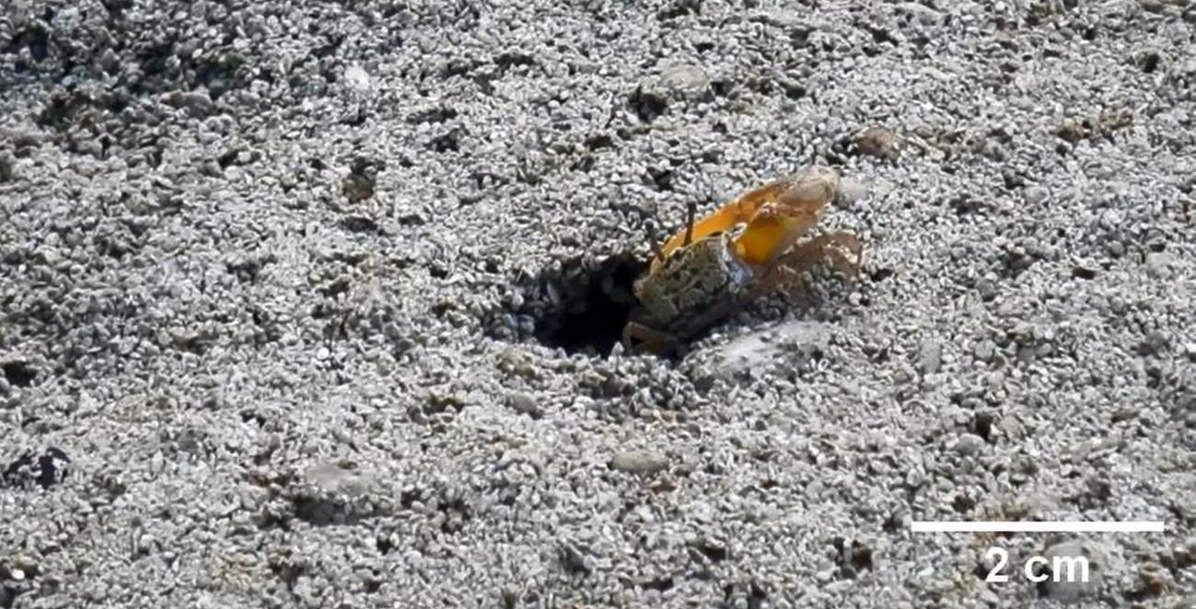
Supplementary Video 6: Fiddler crab hesitant to return to the pumice-covered burrow
The layer of small pumice stones is easily broken down, and the surface of the nest is blocked by the pumice stones. One of the male Uca lactea lacteal tried twice to enter the burrow by changing the position of its body but was unsuccessful. This movie was recorded on 21 November 2021.

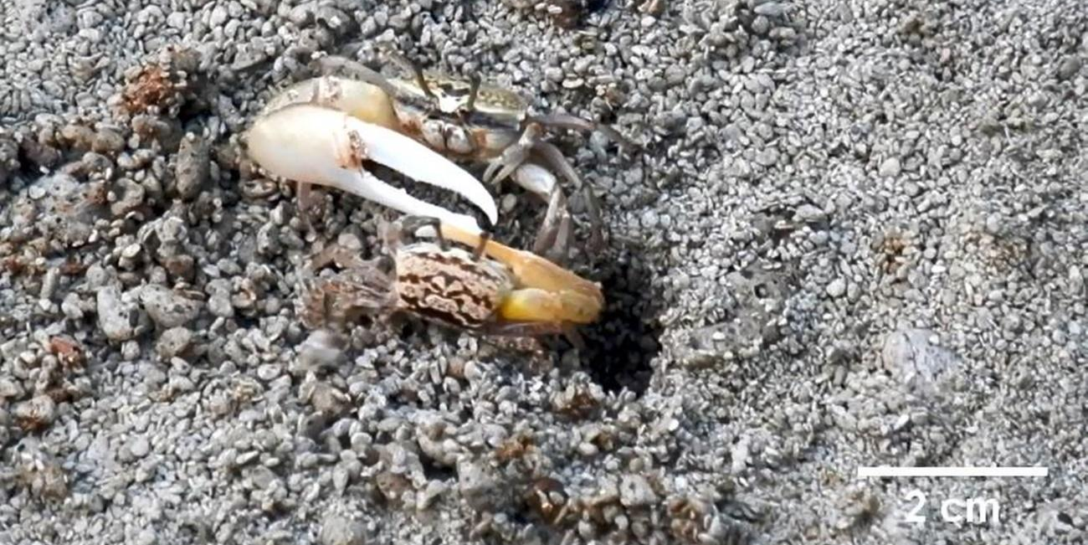
Supplementary Video 7: Intraspecific competition to acquire burrows
A larger Uca lactea lacteal pulls out a smaller crab that was originally in the burrow. The larger crabs began digging their own nests after the smaller crabs were driven out. This video was recorded on 21 November 2021.
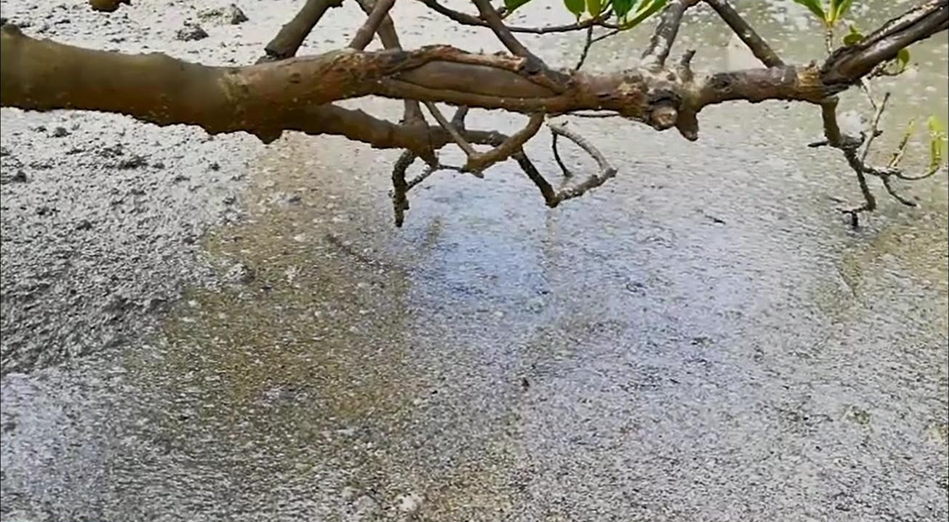
Supplementary Video 8: Mudskipper prevented moving properly on pumice-covered water
This video shows that the mudskipper could not bounce and move on the surface of the water properly because the pumice particles covered the water surface. Another goby was trying to poke its head out of the pumice-covered water in the second half of this video. This movie was recorded on 2 November 2021.

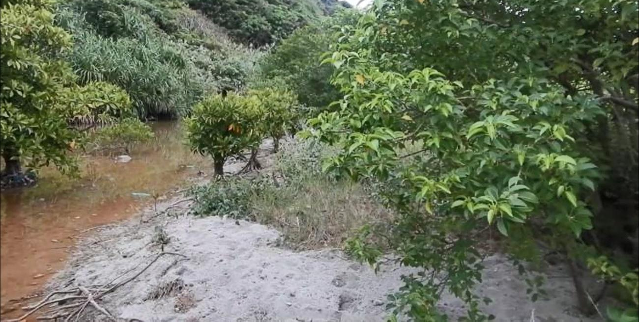
Supplementary Video 9: Birdsong of Okinawa rail (Hypotaenidia okinawae)
H. okinawae singing in a high-pitched tone was recorded in the evening of 25 November 2021 near the mouth of the Ibu mangrove forest. In this video, we recorded the song of a single bird, but it seems that there were five or six birds living in the surrounding area from the direction of the birdsongs.
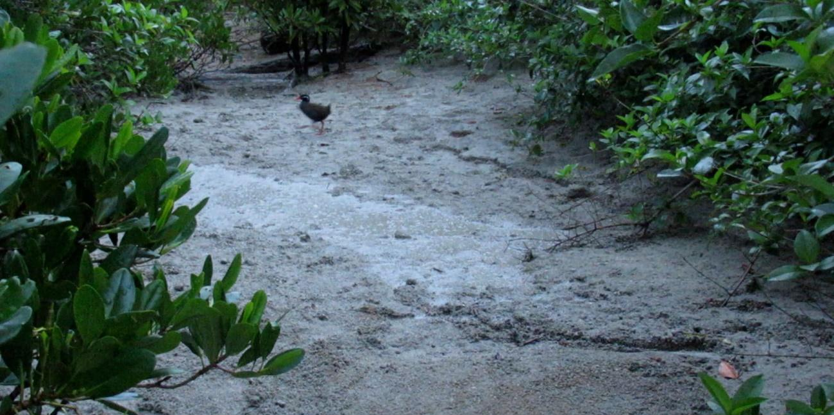
Supplementary Video 10: Okinawa rail crossing a pumice-covered mangrove mudflat
H. okinawae cautiously moved over a pumice-covered mangrove early in the morning on 28 November 2021. We could see the bird's characteristic dark red bill and legs. H. okinawae is a flightless bird with well-developed legs that sometimes moves very fast, so video playback was carried out at half speed (15 fps).

