Supplementary information
Supplementary Methods
Construction of the synthetic naïve nanobody library designated 'Naïve NBlib'
Based on the solved crystal structure of NB37 (6XXP-pdb) (1), a nanobody previously developed in our laboratory, certain positions within the CDR loops (i.e., antigen-binding domains) were randomized to all 20 amino acids. Specifically, CDR1 was randomized at positions 25-34, CDR2, at positions 52-68, and CDR3, at positions 98-114. The gene library was prepared using NNS degenerate codons (where N = A, C, T, or G and S = C or G) for positions within the three CDR loops, except for three positions in CDR1 that remained unmodified while the six neighboring positions were randomized, according to the arrangement 'xxxxxTYSx' (where x designates any one of the 20 amino acids). CDR2 and CDR3 were randomized entirely at the given positions by using the same approach (Supplementary Table S1). Based on the NB37 gene sequence (1), a nanobody gene library was generated using nine ultramers (Supplementary Table S1) (IDT, Coralville, IA, USA). The ultramers were designed to include (following their assembly) the entire nanobody sequence, and the NNS degenerate codons were positioned in place of the CDR loops, as described in Supplementary Fig. S1A. Each assembled pair of ultramers had an overlapping sequence, and the assembly of all the pairs produced the complete nanobody library. In addition, the two ultramers that span the gene library, one on each side (i.e., the fourth ultramer pair, Supplementary Fig. S1A), exhibited homology to the pCTCON vector (a generous gift from Dane Wittrup, MIT). Overall, to generate the library, four sequential assembly PCRs were performed using these four ultramer pairs, a Q5 polymerase (New England Biolabs, Ipswich, MA, USA), and the generated intermediate PCR products as templates for the different PCRs. The conditions for each PCR were: annealing temperature 62 °C, 1 ng DNA template, 2.5 µL of forward primer, 2.5 µL of reverse primer, 10 µL of Q5 buffer, 1 µL of 10 mM dNTPs, and 0.5 µL of Q5 polymerase (New England Biolabs (UK), Hitchin, UK) in doubly distilled water. The gene products derived from the assembly PCR were then amplified using Assemblyseq (forward and reverse) primers (Supplementary Table S1) to generate high quantities of the final DNA library to be used as an insert. The insert DNA library was purified using 1.5% agarose gel and a Gel/PCR Fragments Extraction Kit (RBC Bioscience, New Taipei City, Taiwan). The pCTCON vector was digested with BamHI-HF and NheI-HF (New England Biolabs) overnight at 37 °C, and its linear fraction was purified using 1.5% agarose gel and a Gel/PCR Fragments Extraction Kit. Thereafter, the gene library was transformed into a competent Saccharomyces cerevisiae EBY100 yeast strain, along with a linear pCTCON plasmid, by using a MicroPulser electroporator (Bio-Rad, CA, USA), as described previously by Wittrup and his co-workers (2). The library size was approximately 1×10⁸ transformants, as was estimated by dilution plating on a selective SDCAA medium (2% dextrose, 1.47% sodium citrate, 0.43% citric acid monohydrate, 0.67% yeast nitrogen base, and 0.5% casamino acids, pH 4.5). The library was incubated overnight in SDCAA at 30 °C, with shaking at 250 rpm. Freezing and storage of the library (in yeast) was performed according to Wittrup et al. (2). To determine the quality of the library, plasmids were extracted from the yeast using ZymoprepTM yeast plasmid miniprep I kit (Zymo Research, Irvine, CA, USA) and then amplified again by transformation into Escherichia coli, followed by isolation from the bacteria with a HiYield plasmid mini kit (RBC Bioscience) and sequencing of randomly selected clones [DNA Microarray and Sequencing Unit, National Institute for Biotechnology in the Negev (NIBN), Ben-Gurion University of the Negev (BGU), Beer-Sheva, Israel]. This library was designated 'Naïve NBlib'.

Affinity maturation of the Naïve NBlib library by FACS
To isolate high-affinity binders for the recombinant human Tie1 extracellular domain (designated Tie1-ECD), FACS was used to screen three different yeast surface display (YSD) libraries, namely, the above-described Naïve NBlib library, and two other libraries that are described below, i.e., 'Naïve NBlib' treated with chymotrypsin (3) during the screening process, and then designated 'CT-NBlib', and a computationally predesigned library, designated 'Predes NBlib,' that was previously developed by McMahon et al. (4). The following procedure was used to express 'Naïve NBlib' on the surface of yeast cells (and to generate and express 'CT-NBlib'): Naïve NBlib (and CT-Nblib) were grown in a tryptophan-selective SDCAA medium and then transferred to SGCAA medium (2% galactose, 0.67% yeast nitrogen base, 0.5% Bacto™ casamino acids, 1.47% sodium citrate, 0.429% citric acid monohydrate) for an overnight incubation (i.e., induction) at 30 °C until the culture reached OD₆₀₀ = 10.0 (10⁸ cells/mL). Yeast cells, equal in number to 10 times the library size, were washed with 1 mL of phosphate-buffered saline (PBS) containing 1% bovine serum albumin (PBSA) and centrifuged, and the supernatant was then removed. The induced yeast cells were incubated with the mouse anti-c-myc antibody 9E10 (Abcam, Cambridge, MA, USA) in a 1:50 ratio and different concentrations of soluble Fc-conjugated recombinant human Tie1 (R&D Systems, Minneapolis, MN, USA) for 1 h at room temperature. Naïve NBlib was screened against Tie1-ECD at concentrations of 500, 250, 100, 75, 50, 25, and 10 nM. After an additional washing step with PBSA, cells were labeled with a secondary phycoerythrin (PE)-labeled anti-mouse antibody (Sigma-Aldrich, St. Louis, MO, USA), and FITC-labeled goat anti-human Fc antibodies (Sigma-Aldrich) for 30 min at 4 °C in the dark. A total of five rounds of affinity maturation sorting against Tie1-ECD were performed on Naïve NBlib by using a BD FACSARIA III cytometer [Ilse Katz Institute for Nanoscale Science & Technology, BGU]. In each round, a diagonal sorting gate was used with the aim to enrich for the nanobody population conferring the highest affinity relative to its expression. Using this selection criterion for each subsequent sort, 1–3% of the population were collected into a new tube containing SDCAA medium. The first sort was performed against 500 nM Tie1-ECD (sort 1), and the subsequent sorts were performed against decreasing concentrations of Tie1-ECD (500-10 nM).

Sorting the Naïve NBlib library pretreated with chymotrypsin (designated CT-NBlib)
The Naïve NBlib library was treated with either trypsin or chymotrypsin to eliminate sequences highly enriched in positively charged residues in the nanobody CDR regions and to eliminate nanobody variants that were unfolded (thereby exposing their hydrophobic surfaces to digestion). As previously described (with some modifications) (3), 104 µM trypsin (Biological Industries, Israel) and 40 µM chymotrypsin (Sigma-Aldrich) stock solutions were first prepared in PBS and Tris-buffered saline (TBS), respectively. The Naïve NBlib library was incubated overnight in SDCAA medium at 30 °C, with shaking at 290 rpm. From this culture, 10⁷ cells were sedimented and resuspended at room temperature in 250 µL of PBS, pH 7.4, or TBS, pH 8.0 for the reactions with trypsin or chymotrypsin, respectively. S. cerevisiae yeast cells were incubated with each of six dilutions of the stock solutions (1:3, 1:9, 1:27, 1:81, 1:243, 1:729 v/v) for 5 min at room temperature and then washed four times with 1 mL of the relevant buffer [TBS+1% bovine serum albumin (BSA) or PBS+1% BSA for reactions with chymotrypsin and trypsin, respectively]. Next, flow cytometry sorting and analysis were performed using 9E10 mouse anti C-myc antibody (Abcam, Cambridge, UK), followed by goat anti-mouse antibody conjugated to PE (Sigma-Aldrich), as described in the 'Affinity maturation of Naïve NBlib by FACS' section above. After analyzing the expression levels after protease (either chymotrypsin or trypsin) treatment by using flow cytometry (as described above), the condition that resulted in mild proteolysis was chosen as the treatment condition to be used for further sorting, based on the criterion (i.e., levels of protein display on the yeast surface) previously determined by Rocklin et al. (3). These conditions were found to be chymotrypsin at 30 nM. Thus, for sorting, yeast cells expressing the Naïve NBlib library (10-fold library size) were centrifuged and treated with 30 nM chymotrypsin, as described above. After treatment, the c-myc expression tag was used in the sorting for clones exhibiting high expression and resistance to proteolysis on a BD FACSARIA III instrument (Ilse Katz Institute for Nanoscale Science & Technology, BGU). Sorted cells were allowed to recover overnight at 30 °C, with shaking at 290 rpm in 10 mL of SDCAA. Thereafter, the CT-NBlib product was subjected to five rounds of sorting for binding to recombinant human Tie1-ECD (each round against a different Tie1-ECD concentration, ranging from 500 nM to 25 nM).

Screening the predesigned nanobody library designated 'Predes Nblib'
For this protocol, we used S. cerevisiae yeast transformed with a pYDS649 plasmid (for yeast surface display) comprising the pre-designed nanobody library (designated Predes Nblib) previously generated by McMahon et al. (4). To this end, a frozen aliquot of the yeast library containing 10 times the number of cells as in the initial library (of size 1×10⁸ cells) was thawed and allowed to recover overnight at 30 °C (220 rpm shaking) in -Trp+glucose medium [comprising 0.38% (w/v) -Trp drop-out medium, 0.67% yeast nitrogen base, 1% penicillin-streptomycin, and 2% glucose, pH 6.0]. For the expression of the library clones, under the control of the GAL1 promotor, the library was incubated for 48 h in -Trp+galactose medium (containing 2% galactose instead of glucose), at 30 °C with shaking at 220 rpm. Next, the expression levels of the library were detected by targeting the HA-tag expressed at the C-terminus of the proteins displayed on the yeast surface. For this purpose, a mouse anti-HA antibody (BioLegend, San Diego, CA, USA) was used as the primary antibody, and PE anti-mouse (Sigma-Aldrich) was used as the secondary antibody. The Predes NBlib library was then sorted for Tie1-ECD binding using the same method as described in the 'Affinity maturation of Naïve NBlib by FACS' section above. Five rounds of affinity maturation were performed with Tie1-ECD at different concentrations (500 nM, 250 nM, 100 nM, 75 nM and 25 nM) as the target.

Expression and binding analysis of yeast-displayed libraries and selected clones by using flow cytometry
To follow Tie1-ECD affinity enrichment in each of the three libraries, each library was analyzed for binding to Tie1-ECD following each sort (using an Accuri C6 flow cytometry analyzer; BD Biosciences, San Jose, CA, USA). Thereafter, 20 isolated clones from the final sorts of each of the three libraries (Naïve NBlib seventh sort, CT-NBlib and Predes Nblib fifth sort, each) were sequenced by extraction of plasmid DNA from the yeast clones with a Zymoprep kit (Zymo Research) and transformed into electrocompetent E. coli cells for plasmid miniprep isolation (RBC Bioscience) and DNA sequencing (DNA Microarray and Sequencing Unit, NIBN, BGU). Yeast cells displaying these clones were evaluated for their intrinsic binding affinity towards Tie1-ECD by dividing the mean fluorescence intensity (MFI) of the Tie1-ECD-binding signal by the MFI that reflects the expression levels of each clone. To evaluate the expression levels of each library and of individual clones from the Naïve NBlib and CT-NBlib libraries, 9E10 mouse anti c-myc antibody (Abcam) and goat anti-mouse antibody conjugated to PE (Sigma-Aldrich) were used as the primary and secondary antibodies, respectively. For the Predes Nblib library and derived individual clones, mouse anti-HA antibody (BioLegend) and PE anti-mouse (Sigma-Aldrich) were used. The binding detection in all three libraries and their individual selected clones was performed in the same way using soluble Fc-conjugated recombinant human Tie1-ECD and FITC-labeled goat anti-human Fc antibodies (Sigma-Aldrich). The clones that exhibited the highest intrinsic affinity to Tie1 (affinity normalized to expression) were cloned into expression vectors, as described in the 'Protein expression and purification' section below.

Protein expression and purification
The nanobody clone designated NB19, which was identified from Predes NBlib screens, was expressed using a Multi-Copy Pichia Expression Kit (Invitrogen, Carlsbad, CA, USA), as described in previous studies (5). The DNA sequence of the NB19 gene fused within the pYDS649 plasmid (i.e., pYDS649_NB19) was extracted, and the gene was digested with EcoRI and AVRII restriction enzymes (New England Biolabs, MA, USA) and ligated to a pPIC9K expression plasmid (Invitrogen), which was pre-digested with the same enzymes. The ligation product (i.e., pPIC9K_NB19) was confirmed by transformation into E. coli and sequencing of the extracted DNA (DNA Microarray and Sequencing Unit, NIBN, BGU). The pPIC9K_NB19 plasmid was then linearized by a SacI restriction enzyme (New England Biolabs, MA, USA) and transformed into a Pichia pastoris yeast by electroporation. The transformed yeast cells were grown for two days at 30 °C on RDB plates [18.6% sorbitol, 2% dextrose, 1.34% yeast nitrogen base, 4×10⁻⁵% biotin, and l-glutamic acid, l-methionine, l-lysine, l-leucine, and l-isoleucine (0.005% each)], and for further selection of multiple copies they were plated on YPD-Geneticin plates (4 mg/mL, Invitrogen) for two days at 30 °C. Several Geneticin-resistant colonies were picked out. The genomic DNA of the selected pPIC9K_NB19 containing yeast cells was sequenced (DNA Microarray and Sequencing Unit, NIBN, BGU). After confirming the nanobody sequence of NB19, the selected yeast colonies were grown overnight at 30 °C with shaking at 300 rpm in 5 mL of BMGY medium (2% peptone, 1% yeast extract, 0.23% K₂H(PO₄), 1.1812% KH₂(PO₄), 1.34% yeast nitrogen base, 4×10⁻⁵% biotin, 1% glycerol). Expression was then induced by growing the cells for three days in a 5 mL of BMMY medium (same as BMGY, but with 0.5% methanol instead of glycerol), adding daily doses of 0.5% methanol. The cells were then centrifuged, and the expression of the NB19 clone was tested by dot blot. For this test, several induced yeast colonies were selected. The supernatant of each colony culture sample (4 µL) was blotted over a nitrocellulose membrane, and the membrane was subsequently blocked for 1 h with 5% skim milk in TBST (Tris buffered saline with 0.1% Tween 20), before incubation with a 1:1000 ratio of mouse anti-FLAG primary antibody (Sigma-Aldrich), a 1:5000 ratio of anti-mouse secondary antibody conjugated to alkaline phosphatase (Jackson ImmunoResearch, West Grove, PA, USA), and 2 mL of the 5-bromo-4-chloro-3-indolyl phosphate reagent for signal development (Sigma-Aldrich). The yeast colonies that exhibited NB19 protein expression were then inoculated into 50 mL of BMGY medium, grown overnight at 30 °C with shaking at 300 rpm (until an OD₆₀₀ of 10.0 was reached) and then transferred to 500 mL of BMMY medium for three days, with 0.5% methanol added daily. After induction, the cells were removed by centrifugation, and the supernatant was filtered off through a 0.22-µm filter (Millipore, Burlington, MA, USA). The pH of the filtered supernatant was adjusted to 8.0; 300 mM NaCl and 5 mL of 1.0 M imidazole (final imidazole concentration of 10 mM) were added; and the supernatant was incubated for 1 h at 4 °C. Thereafter, the NB19 nanobody variant was purified by Ni-NTA affinity chromatography. After washing the column with a washing buffer (PBS, 10 mM imidazole, pH 8.0), the protein was eluted with an elution buffer (PBS, 500 mM imidazole, pH 8.0). The eluted protein was concentrated by using Vivaspin with a 5-kDa cutoff (Vivaproducts, Littleton, MA, USA). Subsequently, the clone was purified on a Superdex 75 16/600 size-exclusion column (GE Healthcare, Chicago, IL, USA) in an ÄKTA start instrument (GE Healthcare) equilibrated with running buffer (20 mM Hepes, 150 mM NaCl, pH 7.2). Protein expression and purity were evaluated using 15% SDS-PAGE. Protein concentrations were determined by UV-Vis absorbance at 280 nm and an estimated extinction coefficient (ε₂₈₀) of 31,985 M⁻¹cm⁻¹. The molecular weight of the purified protein was determined using a MALDI-TOF REFLEX-IV (Bruker) mass spectrometer (Ilse Katz Institute for Nanoscale Science & Technology, BGU).
Attempts to produce the clones that were obtained from the other two libraries (i.e., Naïve NBlib and CT-NBlib) were undertaken using the same protocol.

Supplementary Figures and Tables

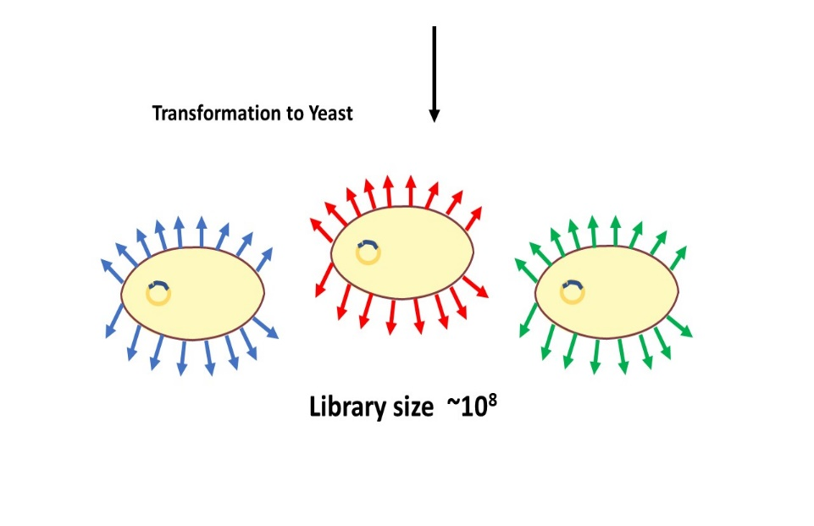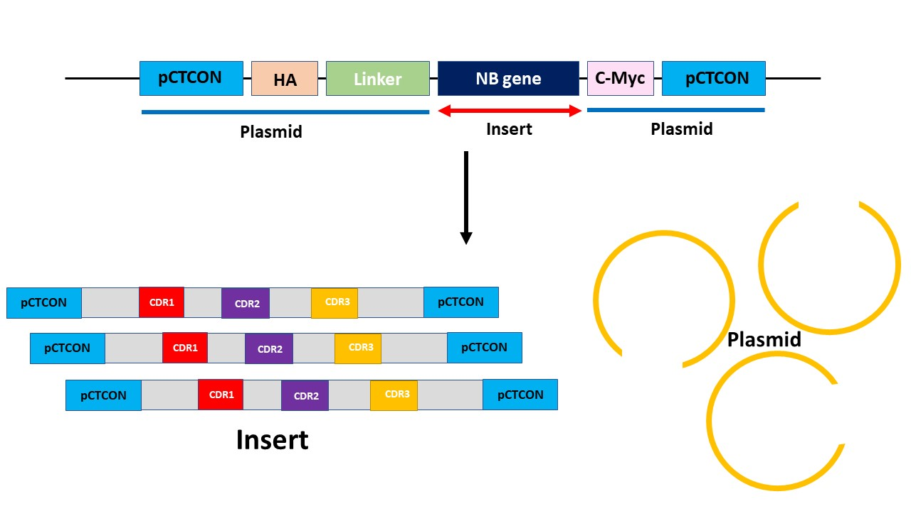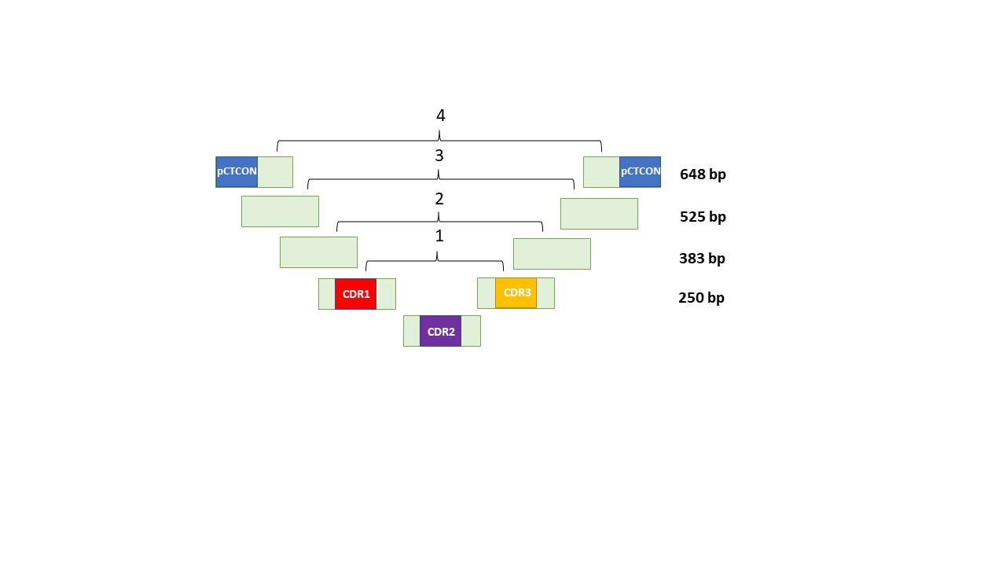
A
B
C
Supplementary Fig. S1. Generation of the naïve nanobody library Naïve NBlib. A) PCR assembly. Each PCR product for each step was used as a template for the subsequent assembly of the NNS-bearing ultramer pair. B) A diagnostic DNA gel showing the PCR products for each assembly step (1:250 bp, 2:383 bp, 3:525 bp, 4:648 bp). C) Schematic representation of the YSD library construction. Naïve NBlib contains pCTCON homology sequences on each side (light blue). Together with the pre-digested pCTCON vector, it was transformed into the S. cerevisiae EBY100 yeast strain, creating a library, which upon induction, was displayed on the yeast cell surface, where different clones (colored dark blue, green, and red) were displayed on different cells.
Supplementary Fig. S2. Screening of the Naïve NBlib library against soluble Tie1. (A-G) Yeast displayed nanobody library expression and binding to decreasing concentrations of Tie1. For sorting of the library (first round sorting gate is shown in red), Naïve NBlib was incubated with decreasing concentrations of Tie1, namely, 500 nM (A), 250 nM (B), 100 nM (C), 75 nM (D), 50 nM (E), 25 nM (F) and 10 nM (G). For all panels (A-G), the analysis was conducted with 50 nM Tie1. H) Schematic representation of the YSD system.

Supplementary Fig. S3. YSD nanobody clones bind strongly to Tie1. A) Binding (normalized to expression) of randomly selected YSD nanobody clones to soluble Tie1. B) CDR sequences of clones 7.16 and 7.20. Green, purple, blue, red, and black letters represent polar, neutral, basic, acidic, and hydrophobic amino acids, respectively. The logos were generated by the WebLogo sever. C) YSD affinity titration curves for clones 7.16 (blue) and 7.20 (red). The affinity of clones 7.16 and 7.20 displayed on the yeast surface to soluble Tie1 (determined using Tie1 at concentrations of 1-250 nM) followed sigmoidal curves.

Supplementary Fig. S4. Treatment of the Naïve NBlib library with chymotrypsin before sorting to identify stable nanobody variants. A) Each yeast cell displays many copies of a single variant. The C-terminal c-Myc tag is labeled with mouse anti-c-Myc followed by anti-mouse PE antibodies, indicating complete expression of an intact nanobody clone. Protease cleavage of an unfolded nanobody variant results in the loss of the c-Myc tag and hence a loss of PE fluorescence. Expression levels of the untreated Naïve NBlib and of Naïve NBlib after treatment with decreasing concentrations of trypsin and chymotrypsin are shown in (B) and (C), respectively. The values above each panel represent the protease concentration used to treat the sample.

Supplementary Fig. S5. Screening of the CT-NBlib library against soluble Tie1. A) Chymotrypsin-resistant population enrichment prior to and following the c-myc expression sort. Red signal indicates the population of yeast cells that express c-myc following treatment with chymotrypsin. The population expessing the c-myc tag following treatment with chymotrypsin (indicated by the black rectangle) was sorted, resulting in the population represented as a blue fluorescence signal. The blue (vs. red) signal indicates the enhancement in the c-myc-expressing population upon treatment with chymotrypsin. (B-F) CT-NBlib expression and binding to 100 nM Tie1 after sorting with decreasing concentrations of Tie1: (B) 500 nM, (C) 200 nM, (D) 75 nM, (E) 25 nM and (F) 10 nM. The sorting gate for the first sort is shown in panel B in red; gates for the other sorts are identical to the one shown in panel B. G) Levels of binding to Tie1 of randomly selected nanobody clones from the fifth sort. The Tie1 binding fluorescence signal for each clone was divided by its expression signal.

B
C
A

Supplementary Fig. S6. Purification and characterization of NB19. A) SDS-PAGE gel showing the NB19 fractions following affinity chromatography and size-exclusion chromatography (SEC). B) Purification of NB19 by SEC. Arrow indicates the pure protein fraction. C) MS analysis of the purified NB19 protein indicates a molecular weight of 15.7 kDa.

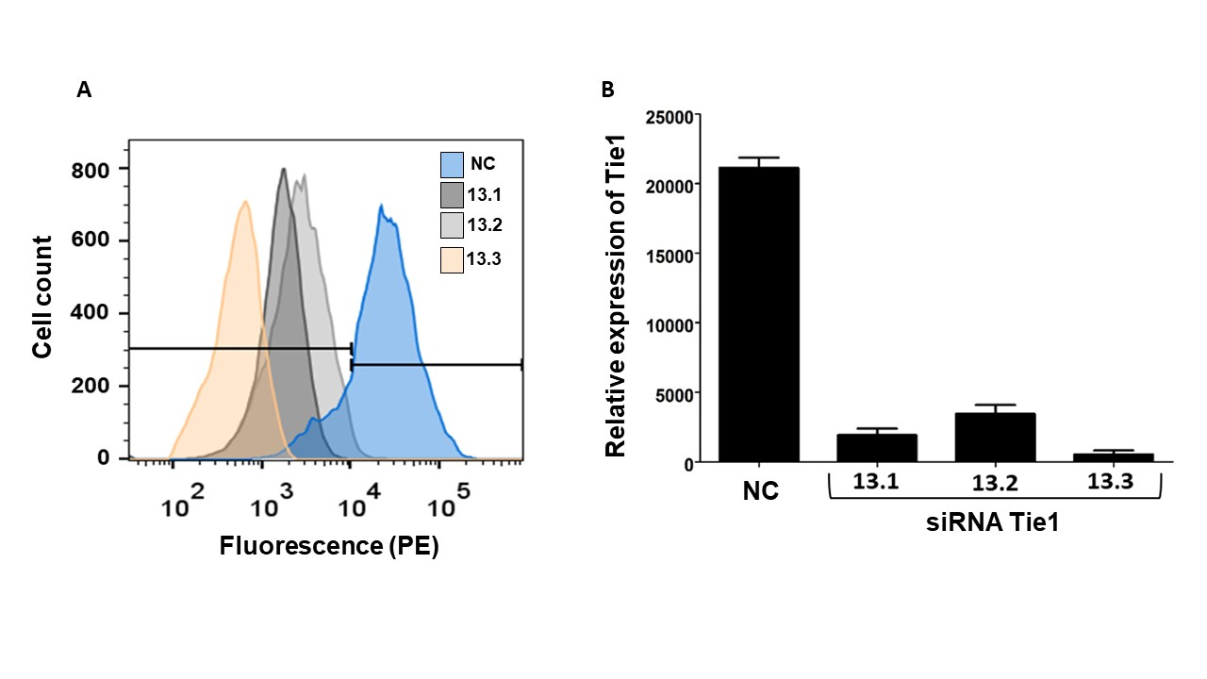
Supplementary Fig. S7. Tie1 knockdown by small interfering RNA (siRNA). For Tie1 expression knockdown by siRNA, TIME cells were plated at 80% confluency one day before transfection with Tie1 siRNA or scrambled nonspecific siRNA using the TriFECTa RNAi kit with the Lipofectamine 3000 reagent, according to the manufacturer’s instructions. A) Cell fluorescence profile upon treatment with three siRNAs (namely, 13.1, 13.2 and 13.3). To determine the expression levels of Tie1 in TIME cells, cells were centrifuged and resuspended in 100 μL of PBSA with 1:100 PE-labeled anti-human Tie1 antibody, incubated at 4 °C for 30 min, and washed three times with 100 μL of PBSA before flow cytometry analysis. A negative control (NC) was used to determine the levels of fluorescence when siRNA was not applied, and siRNA 13.3 was chosen for follow up experiments. B) Quantitative presentation of the data presented in A.

Supplementary Table 1: DNA primers used to generate the naïve nanobody library designated Naïve NBlib. The naïve nanobody library was generated using nine ultramers that cover the entire nanobody sequence, and NNS degenerate codons were positioned in place of the CDR loops. Each ultramer had an overlapping sequence with one other ultramer sequence, with which it was assembled to generate the complete nanobody library. In addition, the two ultramers that span the library from each side exhibited homology to the pCTCON vector.
Name | Sequence
NB37 protein sequence | QVQLQESGGGSVEAGGSLRLSCARSWPYSTYSMNWFRQAPGKEREAVAGISSTMSGIIFAESKAGQFTISQDNAKNTVYLQMNNLKPEDTAIYYCAARRDYSLSSSSDDFDYWGQGTQVTVSSAAAYPYDVPDYGS
Ultramers used (DNA sequences)
Ultramer 1 Fwd | GATACCCATACGACGTTCCAGACTACGCTCTGCAGGCTAGTGGTGGTGGTGGTTCTGGTGGTGGTGGTTCTGGTGGTGGTGGTTCTGCTAGCGAATTC
Ultramer 2 Fwd | GTGGTTCTGCTAGCGAATTCCAGGTGCAGCTGCAGGAGTCTGGAGGAGGCTCGGTGGAGGCTGGAGGGTCTCTGAGACTCTCCTGTG
Ultramer 3 Fwd | GGTCTCTGAGACTCTCCTGTGCACGTTCTNNSNNSNNSNNSNNSACCTATTCTNNSAATTGGTTCCGCCAGGCTCCAGGGAAGGAGCGTGAGGC
Ultramer 4 Fwd | AGGGAAGGAGCGTGAGGCGGTCGCAGGTATTNNSNNSNNSNNSNNSNNSNNSNNSNNSNNSNNSNNSNNSNNSNNSNNSNNSACCATCTCCCAAGACAACG
Ultramer 5 template | ACCATCTCCCAAGACAACGCCAAGAATACGGTGTATTTGCAAATGAACAACCTGAAACCTGAGGACACGGCCATCTATTACTGTG
Ultramer 6 Rev | GTGACCTGGGTCCCCTGGCCCCANNSNNSNNSNNSNNSNNSNNSNNSNNSNNSNNSNNSNNSNNSNNSNNSCGCACAGTAATAGATGGCCGTG
Ultramer7 Rev | TGGCAAGGATCCCCTAGGGGAACCGTAGTCCGGAACGTCGTACGGGTATGCGGCCGCTGAGGAGACGGTGACCTGGGTCCCCTGG
Ultramer 8 Rev | AGATCTCGAGCTATTACAAGTCCTCTTCAGAAATAAGCTTTTGTTCAGATGGATCTTGGAAAGCCAATGGTTTATCTGGCAAGGATCCCCTAGG
Ultramer 9 Rev | CAGTGGGAACAAAGTCGATTTTGTTACATCTACACTGTTGTTATCAGATCTCGAGCTATTACAAGTCC
Primers
Assembly seq Fwd | TTCCAGACTACGCTCTGC
Assembly seq Rev | GATTTTGTTACATCTACACTGTTG

The three CDR domains in NB37 are underlined. Ultramar sequences that are underlined and colored red designate CDR domain sequences that include NNS degenerate codons (coding for any of the 20 amino acids).

Supplementary Table 2. Sequences and pI values of high-affinity clones in the Predes NBlib library

Clone | pI | Sequence
NB4 | 8.98 | QVQLQESGGGLVQAGGSLRLSCAASGNISPRFSMGWYRQAPGKEREFVAGIAGGTITYYADSVKGRFTISRDNAKNTVYLQMNSLKPEDTAVYYCAAWYSQGQVLVYWGQGTQVTVSS
NB5 | 8.98
NB7 | 8.98
NB8 | 8.98
NB2 | 8.98
NB15 | 8.98
NB16 | 8.98
NB19 | 4.96 | QVQLQESGGGLVQAGGSLRLSCAASGTIFDSYIMGWYRQAPGKERELVAGITNGATTYYADSVKGRFTISRDNAKNTVYLQMNSLKPEDTAVYYCAVYGVYRDEGYADYYDVYIYWGQGTQVTVSS
NB1 | 9.17 | QVQLQESGGGLVQAGGSLRLSCAASGYISPLRSMGWYRQAPGKEREFVAGIAEGTITYYADSVKGRFTISRDNAKNTVYLQMNSLKPEDTAVYYCAAYLSRNRFYSYWGQGTQVTVSS

Supplementary References:
1. Rosenfeld L, Sananes A, Zur Y, Cohen S, Dhara K, Gelkop S, et al. Nanobodies Targeting Prostate-Specific Membrane Antigen for the Imaging and Therapy of Prostate Cancer. J Med Chem [Internet]. American Chemical Society; 2020;63:7601–15. Available from: https://dx.doi.org/10.1021/acs.jmedchem.0c00418
2. Boder ET, Wittrup KD, Kieke MC, Cho BK, Boder ET, Kranz DM, et al. Engineering Antibody Affinity by Yeast Surface Display. Methods Enzymol. 2004;388:348–58.
3. Rocklin GJ, Chidyausiku TM, Goreshnik I, Ford A, Houliston S, Lemak A, et al. Global analysis of protein folding using massively parallel design, synthesis, and testing. Science (80- ). 2017;357:168 LP – 175.
4. McMahon C, Baier AS, Pascolutti R, Wegrecki M, Zheng S, Ong JX, et al. Yeast surface display platform for rapid discovery of conformationally selective nanobodies. Nat Struct Mol Biol. 2018;25:289–96.
5. Shlamkovich T, Aharon L, Koslawsky D, Einav Y, Papo N. Targeting the Tie2-αvβ3 integrin axis with bi-specific reagents for the inhibition of angiogenesis. BMC Biol. 2018;16:92.

